AATC_Create_Graph_Testing
TestID | Description | Test Data | Expected outcome
1 | Program only runs on import. This check would ensure that the file can be imported by another program in order to be called from there, not running on import. | Launching file and importing file | When launched the program should run, if it is imported it should not run until the procedure is called.
2 | Program accepts integers and floats and correctly iterates on them. This is to ensure the program generates each coordinate correctly as a normal in range loop only works with integers in python. | Entering details for (0,0,0) → (1,1,400) with (0.01,0.01,50.0) stepping. | The program should run without issues and output a series of incrementing coordinates in the sizes given in.
3 | Testing that the program saves to the correct folder. This checks that the graph was saved to the correct folder in the correct pattern with all required contents. | Entering details for (0,0,0) → (1,1,400) with (0.01,0.01,50.0) stepping. Then viewing the contents of the GraphFolder. | The graph folder should be filled with hundreds of files all ~ 10-100kb in size.
4 | Overwriting an old graph with a new graph. This checks that overwriting the graph will not have any adverse effects i.e. cannot overwrite file . | Entering details for (0,0,0) → (1,1,200) with (0.01,0.001,100.0) stepping. Then viewing the contents of the GraphFolder. | This will overwrite any data in of the old graphs. An Astar search with the new data should allow a search to nodeID up to 200000 without a crash as the previous only contained nodes to 80000.

1.
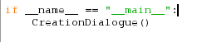

This if statement prevents the program from running when imported , it should only run if it is the main program or the CreationDialogue procedure was called.
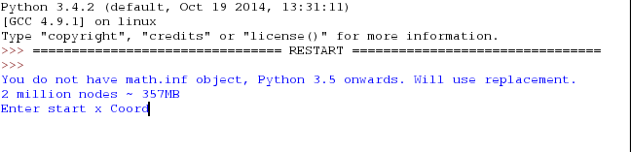
When the program is started the procedure is started.

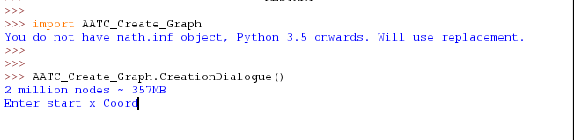
When the file is imported the procedure is not run. The initial text output is due to the AATC_Astar module alerting that the version of python used does not support all features required.

2. A print statement printing the current x,y,z coordinates will be added to show that the iteration is completing sucessfully.
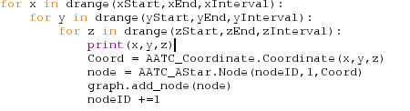

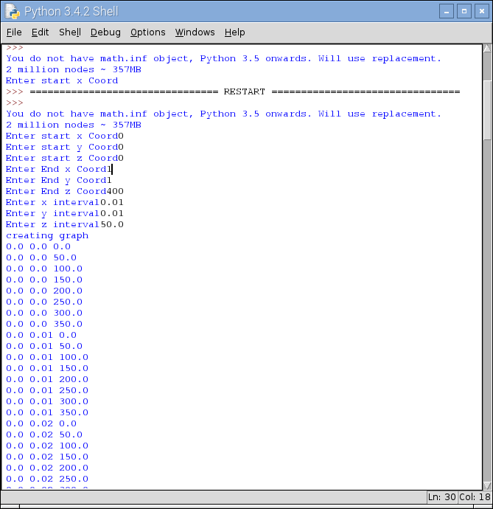
The result is as expected, correctly iterating through each coordinate. The z coordinates repeats before the y which repeats before the x coordiante. The change in x coordinate is not shown as this would occur on line 400 or further. The printed output is only shown in order to prove the loops are iterating correctly.

3. GraphFolder is initally empty
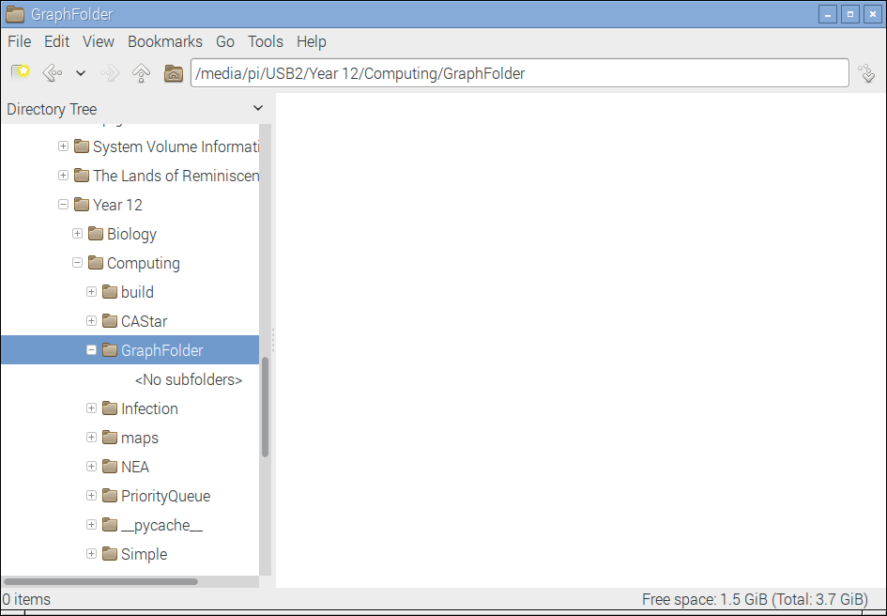
The program is then run:
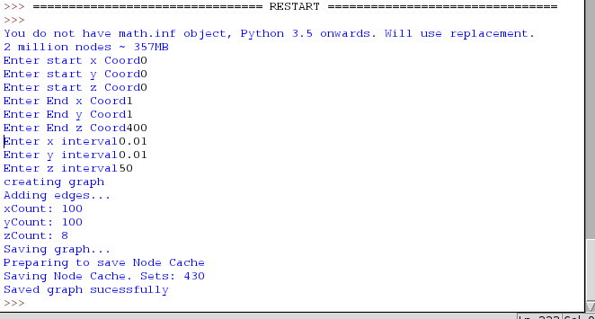
The filled graph folder

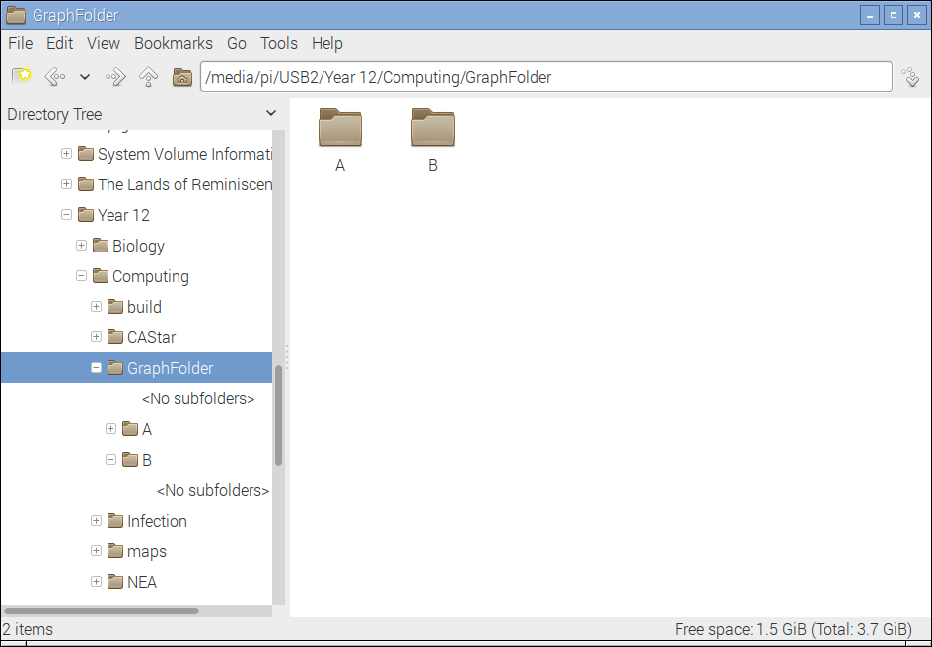
Filled subfolder :
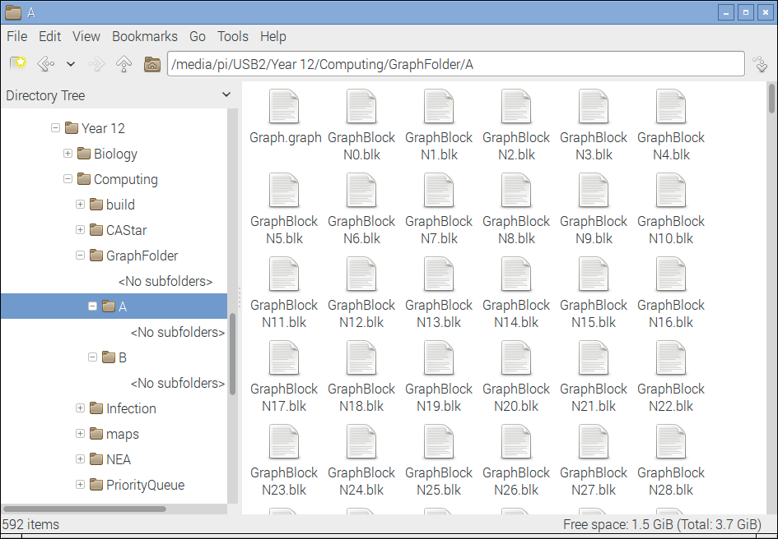

Properties of a file: Each file contains around 500 nodes.
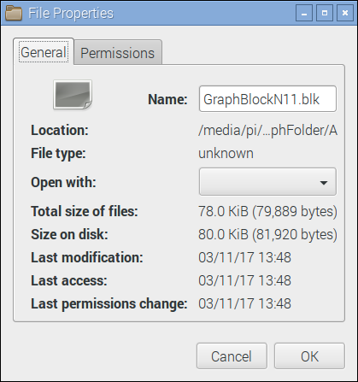
Astar search on the graph :
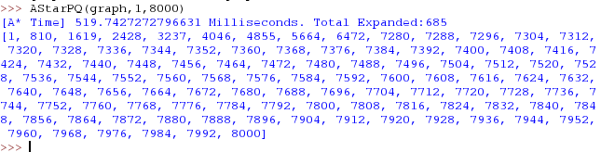
This shows the graph was successfully saved and that the permenant storage of the graph functions correctly, allowing searches to take place.

4. Previous folder details:
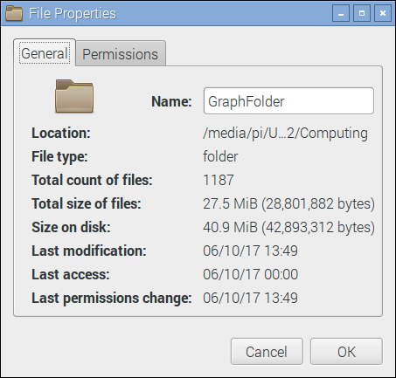
Memory usage while the graph is being generated :

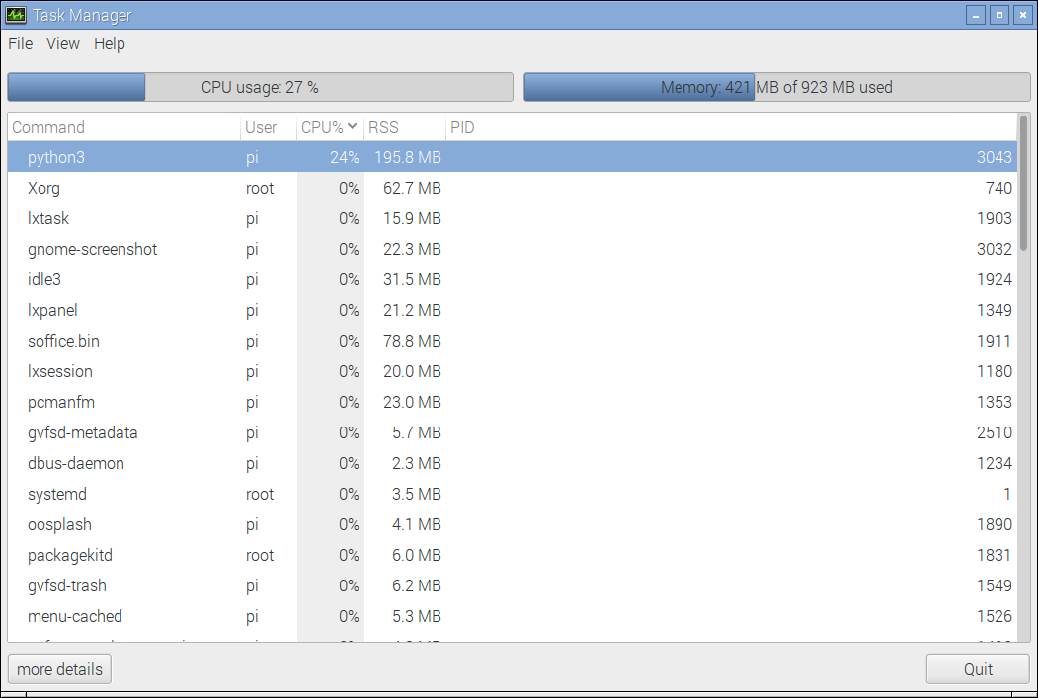
New folder :
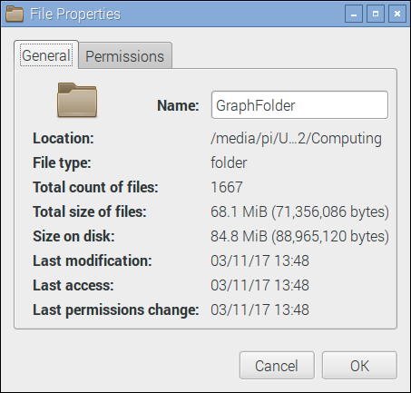
Astar search. Only to top section of the results is shown. If there had been an error there would have been an error message.
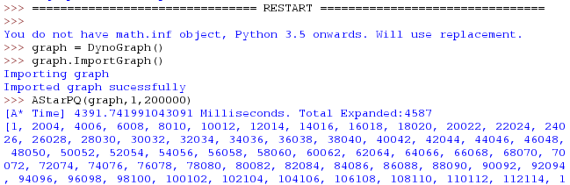
This shows that is it possible to overwrite a graph correctly without consistancy errors.

