AATC_CryptoBeta_Testing
TestID | Description | TestData | Expected outcome
1 | Generate a new certificate. Certificates are required in order to validate the identity of a server and therefore generation must function correctly. | Create a new certificate with a new public key. | A new certificate dictionary should be returned.
2 | Validate Certificate. This function is used to detect if a certificate is valid or not. This vailidity depends on if the certificate is currently valid (i.e. has not expired or is not premature). It also depends on the hash value of the certificate, which is signed by the issuers private key. Only the issuer knows the private key and so only they can sign it, any forgery cannot be signed by the issuer and therefore is detected as invalid. | Use the function ValidateCertificate to validate if the certificate is valid. | The Certificate should return True because it is valid.
3 | Modifiy certificate and validate. This is a to check that the validation of a certificate is able to detect if a value on a certificate has been changed. For example changing the public key to another would allow an attacker to break the encryption between the server and client by placing themselves in the middle via the Man in the Middle attack. This alteration can be detected and the client warned. | Attempt to forge a certificate by altering the public key in the certificate. This would imitate the attacker attempting to modify the certificate. | The validation should identifiy the certificate a forgery. This should return false.
4 | Forge certificate. This is to test that the program will not accept certificates which are valid as such, the signature is correct and signed, however the signing entity is not a trusted source such as a root certificate holder. | Attempt to imitate a certificate by acting as same entity but signing with a different private key and with different public key. | Should identify certificate as forgery. This should return false as the certificate is not genuine.
5 | NotAfter checking. This check detects if the program can detect if a certificate has expired i.e. if a server is using an invalid certificate. | Attempt to pass a certificate which has expired as valid. | Should identify certificate as invalid. This will return false.
6 | NotBefore checking. This ensures that a certificate which has not yet become valid will not be accepted. | Attempt to pass a certificate which is not yet valid. | Should identify certificate as invalid.
7 | Create Test Chain. This test ensures that chains can be made using the Test Chain function and these are valid. Chains are used in order to remove the need for the root certificate authority to sign every certificate created, instead an owner of a certificate can generate their own sub certificates signed by them and as every certificate in the chain is valid the chain is valid and can be accepeted. | Create test chain with various lengths and validate | All generated chains should be valid and return the relevant public key.
8 | Disallow chains longer than 20. Chains longer than 20 could be a method to attack clients by requiring them to validate chains of great length, taking a very long time to process. This check ensures that chains of length greater than 20 will be accepted and processed. | Check at lengths of a chain of 20 and 21. | Only 20 should be valid.
9 | Hostname validation. This checks that the certificate name matches that the client connects to. For example a server owner could buy a domain and generates the certificates with that domain name. If a 3rd party attempts to force the connection to their counterfeit server the domain name would be different, identifying the server as invalid. | Use valid hostname certificate (localhost) | Certificate should be accepted.
10 | Hostname validation. This checks that the server will be able to detect discrepancies in the hostname compared to the server name. | User invalid hostname certificate (localhostssssss) | Certificate should be accepted if ALLOW_FAILED_DOMAIN_LOOKUP == True. If not if AUTO_GENERATE_FALLBACK == True let the keys be generated. Else raise exception and cancel.

NOTE: All tests will be carried out by the private key in the PRIVATE_KEY variable unless it is declared otherwise. This is a test key and is marked per default as a Root CA in AATC_Config. It is not secure however ! REMOVE IF USING THIS IS A NON TEST APPLICATION.

NOTE 2: The GetKey function used is a tempory function used to generate RSA keys without having to repeatedly enter the code to generate them. Not part of main program.

NOTE 3: Most tests will be run at 1024 bit length, 2048+ is recommended if being used in security consious applications and is the default key size for the program. 1024 bit is used due to the time it takes to generate the keys. Verification is much faster and 4096-2 chain takes ~ 0.05 seconds to verify on an A53 @1.2Ghz.

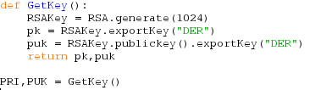
1.
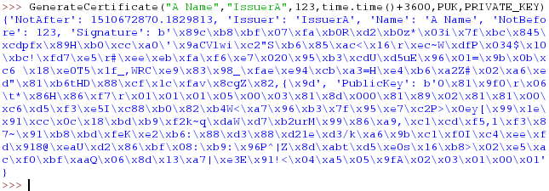
Certificate correctly generated. This returns a dictionary certificate with all required details , signed by the root private key.

2.
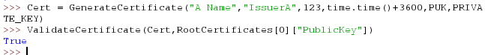
Certificate correctly shown as True. This shows that the certificate generated is valid.

3.
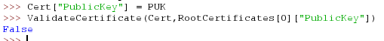
Certificate identified as a forgery. The public key was changed, the program correctly identified the certificate was modified and therefore is invalid.

4.
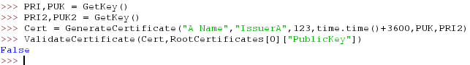
Certificate correctly identified as forgery. This time the fact that the certificate was not signed by the root certificate authority private key identified that the certificate was a forgery.

5.
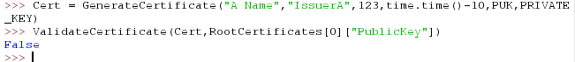
Certificate correctly shown as invald due to the certificate having expired 10 seconds before. Therefore old comprimised certificates cannot be used.

6.
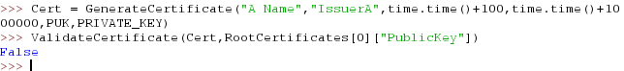
Certificate correctly identified as invalid due to the certificate only becoming valid a short time later.

7.
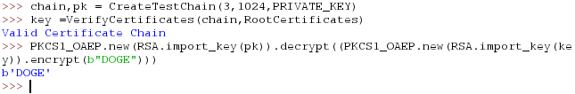
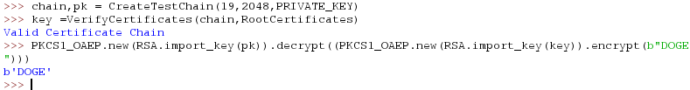
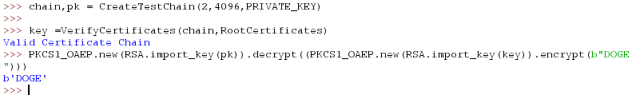
All chains are valid and function correctly. Each chain correctly is created and can be used to encrypt and decrypt data correctly.

8.
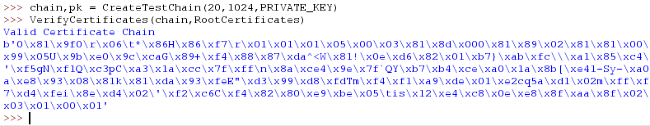
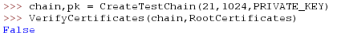
Only the <=20 chain is allowed. This prevents extremly long chains being used which otherwise would take a very long time to validate.

9.
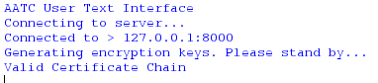
Certificate accepted as the client is connecting to a server on 127.0.0.1 or localhost, therefore the hostname and certificate name match.

10.1.
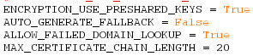
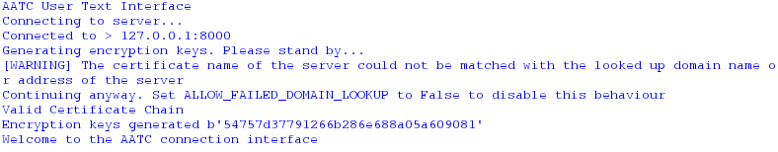
Certificate accepted as the flag allows failed domain lookups, common if the server is only linked via an IP address. A warning message is shown to alert the client that the certificate name did not match the hostname.

10.2
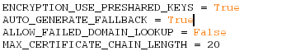
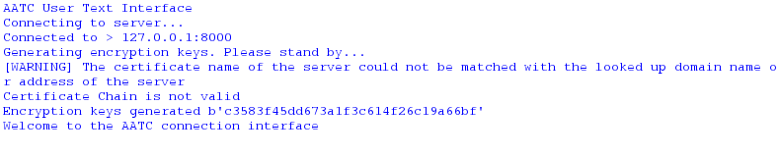
Certificates rejected, new RSA keys generated (time delay when connecting). The encryption parameters are passed via a new RSA key pair, vunrable to the man in the middle attack but will not use the possibly comprimised certificate.

10.3
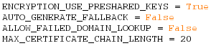
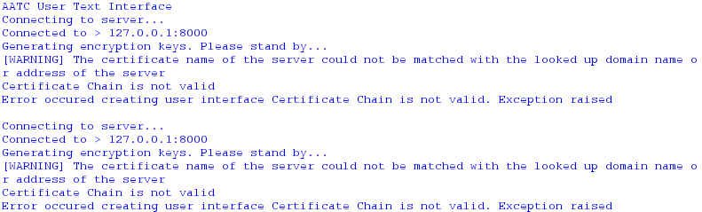
The certificate is rejected and connection closed (restarting will not change this). Reduces probability of MITM attack as will not connect unless a compeltly valid certificate is received.

