AATC_Crypto_Testing
TestID | Description | Test Data | Expected outcome
1 | Check if mode checking is working. The only modes allowed are CLIENT and SERVER, any other mode would cause the GenerateKeys method to fail as the program would not be able to identify which role it would place in the key exchange process. | Enter “CLIENT”,”SERVER” and “NOTAMODE”. | Only the valid modes should be accepted, the other should raise an error.
2 | Disabling autogenerate . Autogeneration is enabled and sets up the encryption keys automatically by default ,however some configurations would require this to be disabled. | Set the AutoGenerate paramter to false. | Keys should not be generated automatically.
3 | Enable PRE_SET_ENCRYPTION_KEYS. This causes the AES key and IV stored in the config file to be used instead of generated keys. This may be desired if the server owner trusts all clients and can securely transfer the keys to each client. | Enabling this should use the preset AES keys. | Should encrypt with set AES keys (no certificate validation or RSA key generation). Key should be that set in the Config file.
4 | Pre shared key exchange. In order to prevent a Man in the Middle attack the preshared certificate mode uses pre shared root certificates which the server trusts. A chain of certificates are used to verify the identity of the server and the AES and IV keys are encrypted using the servers public key and sent to the server where they are decoded by the server, no one other that the server has access to the server’s private key and so only the server can decode the keys. | Launch with preshared certificates. | Server and Client should end up with same encryption keys. Valid certificate notification.
5 | Key exchange. This key exchange method is used either if enabled or the certificate based scheme fails and falls back on this method. The method involves the client sending the public key of a newly generated RSA key pair to the server , which then encrypts randomly generated AES and IV keys using the key and sends them back to the client where the message is decrypted and the keys extracted. | Launch with generating new RSA keys. | Server and Client should end up with same encryption keys. Pause will occur while generating RSA keys.
6 | Change RSA key size. A client may want to use RSA keys of a larger size in order to make it harder to find the private key using the public key via factorisation. Alternatively a client may want to decrease the RSA key size in order to reduce the key generation time. | Launch with generating 4096 RSA keys. | Server and Client should end up with same encryption keys. Pause will occur while generating RSA keys. Longer pause than previous.
7 | Change AES keysize. A client may want to change the AES key size (default 32 bytes / 256 bits) to a different value. | Change AES keysize to 16 bytes. | Key displayed should be 16 bytes long.
8 | Change allowed key size. A server may want to disable the use of small key sizes in order to improve security i.e. a 256 bit key instead of a 128 key. | Disable use of 16 byte keys. | 16 byte keys should be rejected.
9 | Change allowed key size. A client may want to disable the use of small key sizes for security reasons. i.e. a 256 bit key instead of a 128 bit key. | Disable use of 16 byte keys.  Client side checking | 16 byte keys should be rejected.

NOTE 1: These tests were either done while the module was implemented into other programs where everything would work as expected or used as a python script in which case placeholders may be required to allow the program to run but would not allow the program to function. Example : using string placeholder instead of a connection object to check modes.

NOTE 2: Most of the testing of the preshared certificate exchange takes place in AATC_CryptoBeta.

1.
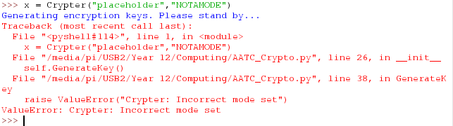
The invalid mode is not accepted. If an invalid mode were to be accepted the program would not be able to partake in the key exchange process required.

2.
Keys are not generated automatically. A server or client could call this function later once other required changes have been completed.

3.
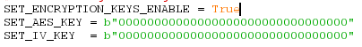
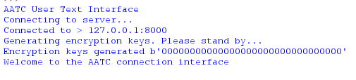
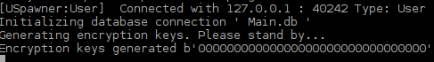
Keys correctly set. The keys displayed on the server and client sides are the same as in the configuration file.

4.
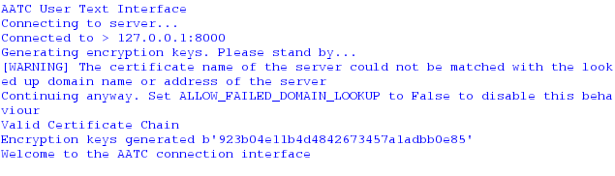
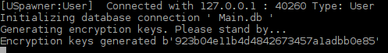
Keys correctly exchanged. The certificate was correctly verified and a warning shown because the hostname and certificate name did not match.

5.
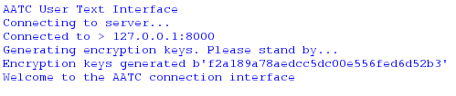
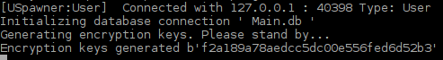
Keys correctly obtained. A pause occurs while the RSA keys are generated, the time of which depends on the RSA key size and the speed of the processor. Both entities have the same encryption key.

6.
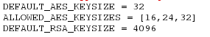
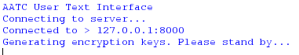
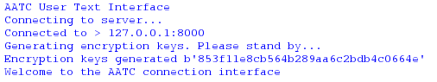
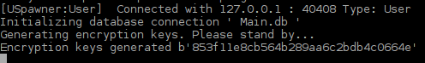
Keys correctly generated, longer pause than 2048 (15+ seconds estimate). The time taken increases rapidly with key size, however a larger key size is means the key is harder to factorise.

7.
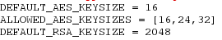
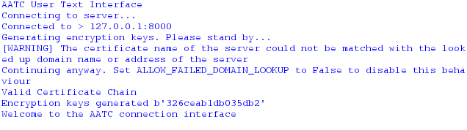
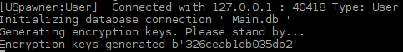
Keys were correctly exchanged. The key is now half the original length at 16 bytes / 128 bits.

8.

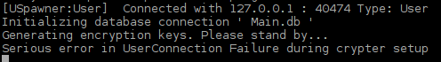
Note: Client side checking overridden to check server side checking. The client is shown an error message displaying that they need to change their key size.

9.
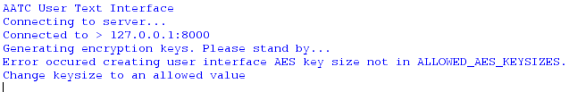
Key correctly denied due to being of too small a size. The server attempted to use a AES size of 16 which is not allowed by the settings of the client.

