AATC_Drone_Testing
TestID | Test description | Test data | Expected outcome
1 | Create a drone interface. This checks if the creation of the main interface object functions sucessfully. | Create drone interface | Returns a connected drone interface
2 | Login. This validates the drones Identity , to ensure only that drone can access it's information. | Login with valid credentials | Sucessfully log in
3 | Login invalid. This checks that the server will not accept invalid logins and that the drone should be notified of this. | Login with invalid credentials | Should not complete sucesfully
4 | Access commands not logged in. This checks that the drone is not allowed to use certain commands which are for logged in drones only. | Attempt to use commands while not logged in | Should not allow access.
5 | Update drone status. This is to check that the drone can send information about it's current location to the server. | Update the drones status | Should be updated on the server.
6 | Get Drone info. This is to check that the drone can obtain information about itself. This is most important for the simulation drone, however it also provides a way for drones to be speed limited and other variables sent to the drone at this time. | Get the information about the drone | Should return the information about the drone.
7 | Check for flight. This is used by the drone to check if there is a flight available and if there is one or more flights obtain the next one. This test checks that the drone will not start a flight when none are available. | Check for flight when no flight exists | Should not return a valid FlightID
8 | Check for flight when available. See other Check flight test. This test checks the same functionality however this time when a flight is available. | Check for flight when a flight exists | Should return a valid flightID
9 | Obtain the nearst flight. This checks that the nearest flight to the current time is obtained. | Should obtain the nearest flight out of multiple flights | Should obtain the nearest flight out of multiple flights
10 | Get Flight. This should obtain the information about the flight the drone needs including flightID, distance ,start,end. | Call GetFlight | Should obtain the details of the flight.
11 | Get Flight waypoints. This should obtain all waypoint for a flight such that the drone may fly using these waypoints. | Get the flight waypoints | Should return the flight waypoints of the flight
12 | Mark a flight complete. This checks that the flight may be marked complete in order to mark that it is complete. | Mark a flight complete | The flight should be marked complete
13 | Mark a flight complete invalid. This ensures that a drone cannot mark the flight of another drone as completed by accident. | Mark a flight complete which one does not own. | Should deny permission.
14 | Exit. This ensures the drone can choose to exit communications with the server gracefully. | Call exit | Should exit connection.
15 | Get Flight object. This checks that the Get flight object function will return a working flight object which is used by drone logic to fly the flight. | Create a flight object | Should return a flight object
16 | Get Flight waypoints. This checks that waypoint objects can be created sucesfully . Required by drone logic to fly the flight. | Create the waypoints objects | Should return flight waypoint objects.
17 | MakeDroneInfo. This checks that the MakeDroneInfo function works correctly and returns a valid drone information object, required mainly for the drone simulation to immitate the drone. | Make the drone information object | Should return a drone information object

1.
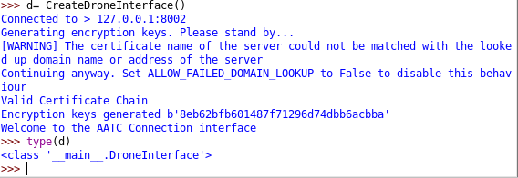
Correctly created a drone interface object connected to the server. This shows the object now can be used to communicate with the server.

2.
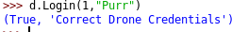
Sucessfully logged in. The relevant drone is now logged in.

3.
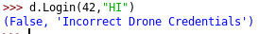
Correctly did not log in. This ensures invalid drone credentials may not be accepted.

4.
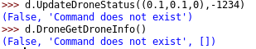
Sucessfully denied access. This ensures drones may only use certain functions once logged in.

5.
Status updated. This allows users and monitors to track the drone.

6.
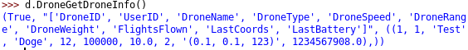
Correctly returns information about the drone. Allows the drone simulation to immitate the drone.

7.
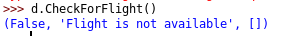
No FlightID correctly returned. This shows a flight is unavailable.

8.
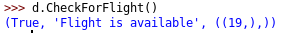
Correctly obtained the flightID. This is the correct flightID.

9.
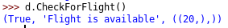
Obtained correct flight. This is the nearest flight available.

10.
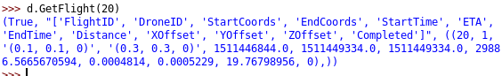
Obtained the details of the flight. This provides information about the flight which is required by the drone.

11.
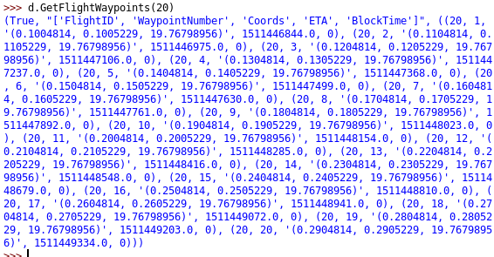
Correctly obtained all waypoints. Contains all coordinates which must be passed.

12.
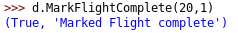
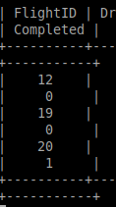
Correctly marked as complete. This marks it complete for future reference.

13.
Correctly denied permission to mark as complete. This prevents other drones from marking a drones flight complete.

14.
Correctly exited. This allows the connection to be gracefully terminated.

15.
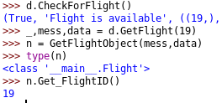
Correctly created flight object. This contains all the information about the flight the drone needs.

16.
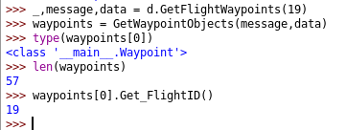
Correctly obtained waypoint objects. These are used to control the flight of the drone.

17.
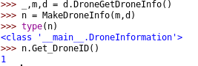
Correctly obtained drone information object. This is used by the drone to improve the simulation of the drone.

