AATC_Monitor

TestID | Test description | Test data | Expected outcome.
1 | Loging in with correct credentials. This ensures any object using the Monitor interface can login if they have the correct credentials. | Entering correct credentials. | Sucessfully logged in. Can access functions.
2 | Loging in without correct credentials. This check ensures that only those can login who have valid credentials. | Entering incorrect credentials | No login should suceed. Cannot access restricted functions.
3 | Changing password. This allows monitors to change passwords if desired. | Change password | Password sucessfully changed.
4 | Attempting to change password with incorrect previous credentials. This should not be allowed as this would assume that someone else is attempting to change the password using a logged in session of another monitor. This should be denied. | Use incorrect password | Failure to change password
5 | Get no fly zones. This is used to get the details of all the no fly zones which the monitor can then use to render. | Get the no fly zones from the server. | No Fly zones returned.
6 | Get drones all. This obtains the details of all the publicly visible drones so that the monitor can render them. | Get all publicly visible drones. | Should return all publicly visible drones.
7 | Get userId. This is used to get the userID of a username. This may be desired if a monitor wants to check if a user who is known by their username has a drone / owns a no fly zone / has provided a monitor permission. | Get UserID of a username which exists. | Should return userID of that username.
8 | Get UserID of username which does not exist. This is to check that the server will not return an incorrect UserID if the user does not exist. | Attempt to get UserID of username which does not exist | Should not return a UserID
9 | Get Username. This is used to check that a monitor can get a username from a userID. A monitor may want to do this to link a UserID shown on a drone / no fly zone to a username. | Get the username of a valid UserID | Should return username
10 | Get Username invalid. This is to check that the server will not return an invalid username if the user does not exist for example null or none. This should return an empty list instead. | Get the username of an invalid UserID | Should not return a username
11 | Add monitor. This is used to add a new monitor. This is used to create new monitor accounts. | Add a monitor which does not exist | Monitor should be added
12 | Add monitor invalid. This is to check that creating a monitor which already exists cannot be overwritten by creating a new monitor in the same name. This should be denied. | Add monitor which already exists | Monitor should not be added
13 | Get monitor drones. This is used to obtain all the drones which are explicitly provided by a monitor permission for that monitor. | Get drones which the monitor may view due to permission. | Should return drones monitor specifically is allowed to view.
14 | GetMonitorFlights. This is used to obtain all the flights which are explicitly provided by a monitor permission for that monitor. | Get flights which the monitor may view due to permission. | Should return the flights
15 | Get Monitor Flight Waypoints. This is used to obtain all the waypoints which are explicitly provided by a monitor permission for that monitor. | Get waypoints which the monitor may view due to permission. | Should return the waypoints.
16 | Get Monitor Id. This is used to obtain a monitorID using a monitor name. An example of this use would be to get the name of another monitor. | Get the monitor ID of a monitor name | Should return the monitor name
17 | Get monitor ID invalid. This is to check that obtaining a monitorID for an invalid monitor name will not return an invalid ID. | Attempt to get the monitor ID of a monitor name which does not exist | Should not return a monitor name
18 | Get MonitorName. This is used to obtain a monitor name using a monitorID. This may be used to get the monitor name of other monitors if one wishes to do so. | Get the monitor name of a monitor Id | Should return the monitor ID
19 | Get Monitor Name invalid. This is to check that attempting to obtain a monitor name using an Invalid MonitorID will not return an invalid monitor name. | Attempt to get the monitor ID of a monitor which does not exist | Should not return a monitor ID.
20 | Remove a monitor permission. This is used to delete a monitor permission. A user may want to do this to get rid of a now useless monitor permission or did not desire that monitor permission. | Remove a monitor permission for that monitor | Should remove the monitor permission.
21 | Get monitor permissions. This is used to get all monitor permissions for that monitor. This could be used to observe who has provided permission to view flights. | Get the monitor permissions | Should return all monitor permissions for that monitor
22 | Get Flights all. This method is used to obtain all publicly visible flights which the monitor may then render. | Get all the publicly available flights | Should obtain all publicly available flights
23 | Get Flight waypoints all. This method is used to get all publicly available flight waypoints which the monitor then may render. | Get all the publicly available flights | Should obtain all the publicly available waypoints
24 | Exit. This is used to gracefully exit the connection between the server and the monitor. | Send exit command. | Connection should sucessfully exit
25 | CreateMonitorInterface. This is used to create a monitor interface instance. | Create a monitor interface | Should return a valid monitor interface.

Note: When invalid name or ID is references this means one which does not exist / is of incorrect form. An example could be an SQL search returning None if a search for an invalid monitor name is made, returning a None Type rather than an integer or nothing at all.

1.
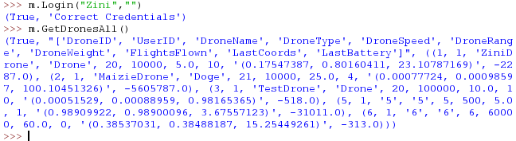
Correctly logged in and can use functions. This then allows the monitor to use all available functions.

2.
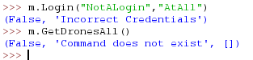
Failed to login, sucessfully denied access to restricted functions. This ensures that the monitor cannot use functions which would require them to be logged in.

3.
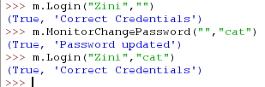
Sucessfully changed password. This means that the monitor can change their password if they still remember the old password.

4.
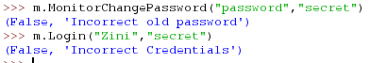
Sucessfully denied permission to change password. Password not changed. This shows that if another person attempted to modify the password while the monitor was logged in they would not be able to because they do not know the old pasword.

5.
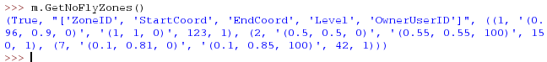
Sucessfully obtained no fly zones. These details can be used to render a graphical representation of each no fly zone.

6.
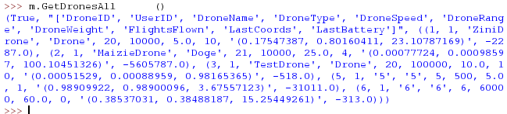
All public drones obtained. These details cam be used to render represenations of each drone. Each tuple inside the data tuple contains the information for a drone.

7.
Sucessfully obtained userID. The userID is contains in the first tuple of the data tuple.

8.
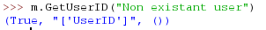
Did not obtain userID. The lack of a tuple inside the data tuple indicates that no valid UserID was found.

9.
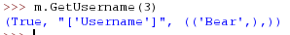
Sucessfully obtained username. The username is contained in the first tuple of the data tuple.

10.
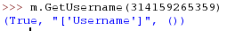
Username correctly not obtained. The lack of a username tuple in the data tuple indicates that no valid username was found for that uerID.

11.
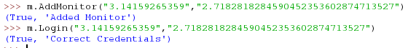
Monitor correctly added. The monitor was created and the monitor can log on using those credentials.

12.
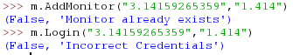
Monitor correctly not added. The monitor already existed so the addition was denied. The password was not overwritten.

13.
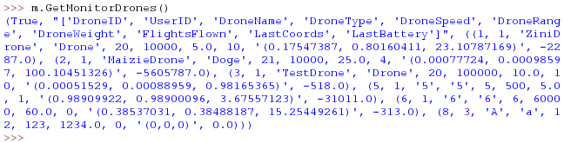
Correctly obtained relevant drones. Each tuple in the data tuple contains information about a drone.

14.
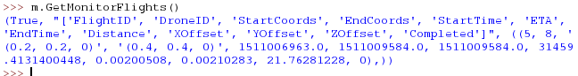
Correctly obtained relevant flights. This shows the method correctly obtain information for each of the flights which are made available through a monitor permission.

15.
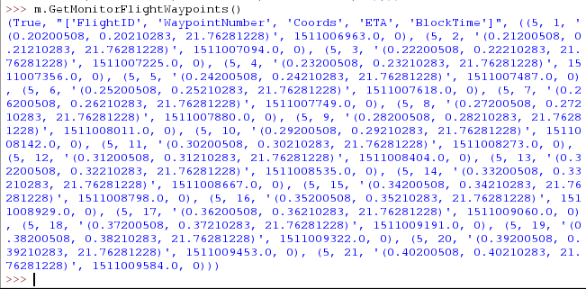
Correctly obtained the flight waypoints. This contains all the waypoints in the data tuple which were made available by a monitor permission.

16.
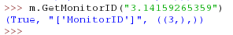
Obtained monitor ID correctly. The monitorID is stored in the first tuple of the data tuple.

17.
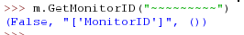
Correctly did not obtain monitor ID. As the data tuple is empty there was no such monitor name in existance.

18.
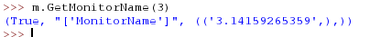
Obtained monitor name correctly. The monitor name is stored in the first tuple of the data tuple.

19.
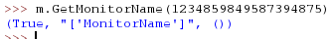
Correctly did not obtain a monitor name. The data tuple is empty signaling that there is no such monitorID.

20.
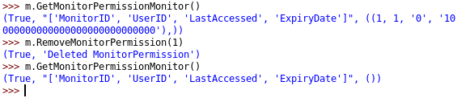
Correctly removed the monitor permission, the monitor will no longer be able to use that monitor permission as a source of information about that user’s drones.

21.
Correctly obtained all monitor permissions. The monitor permissions can then be viewed and removed if desired.

22.
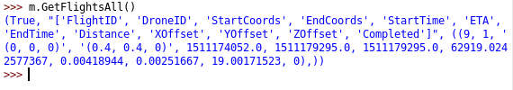
Correctly obtained all flights. Each tuple in the data tuple contains the information about a publicly visible flight.

23.
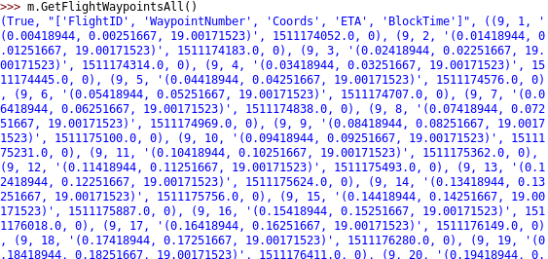
Obtained all flight waypoints which were publicly visible in the data tuple. Each tuple in the data tuple contains the information about the waypoint.

24.
Correctly exited. This allows both sides of the connection to gracefully exit without errors.

25.
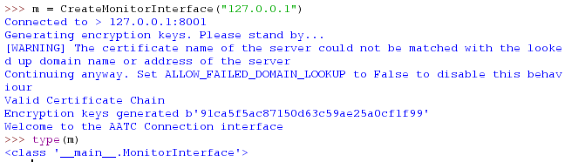
Correctly created and return monitor interface. This interface can be used to communicate with the server via it’s methods, simplifying the communication.

