AATC_Monitor_Viewer_Testing
TestID | Test description | Test data | Expected outcome
1 | Correct connection and obtaining of data. This shows that the monitor can connect to the server and obtain the information about the current state of each drone, waypoint, flight and no fly zone. | Startup the program | Should obtain the data and open pygame window.
2 | Moving up. This checks that the camera can move up. | Press w | Should move the camera up
3 | Moving down. This checks that the camera can move down. | Press s | Should move camera down
4 | Moving left. This checks that the camera can move left. | Press a | Should move camera left
5 | Moving right. This checks that the camera can move right. | Press d | Should move camera right
6 | Move diagonally. This checks that the camera can move diagonally. | Press w and a | Should move camera up and left.
7 | Zoom in. This checks that the camera can zoom in. | Press e | Should zoom in
8 | Zoom out. This checks the camera can zoom out. | Press q | Should zoom out
9 | Rendering small items. This checks that the monitor will not render items which are below pixel in size. Items below this size are not drawn on-screen to improve performance. | Move between the two zoom levels at which the items are rendered and not rendered | If smaller than 1 pixel should not be rendered.
10 | Text render. This checks the monitor will only render text above a specific size. Rendering small text would be pointless so any visible objects which result in a small text size do not have their descriptive text rendered. | Text should only be rendered when at a specific size | Small items without text, large with.
11 | Render NoFlyZone. This checks that the NoFlyZone is draw onscreen correctly. | Find a no fly zone | Grey box labeled no fly zone and details
12 | Render waypoint, This checks that the waypoints are drawn onscreen correctly. | Find a waypoint | Green box labeled waypoint with details
13 | Render drone. This checks that drones are drawn onscreen correctly. | Find a drone | White box labeled with details.
14 | Render start point. This checks that the start points of a flight is drawn onscreen correctly. | Find start point | Blue box labeled with details.
15 | Render end point. This test checks that the end point of a flight is drawn correctly. | Find end point | Red box labled with details.
16 | Demonstration of pathfinding system. This is a demonstration that the pathfinding system correctly avoids no fly zones and the relevant items are drawn correctly. | Two flights were created, one before adding a no fly zone and one after. | The waypoints of the first may cross the no fly zone as it did not exist at that time while the second may not.

1.
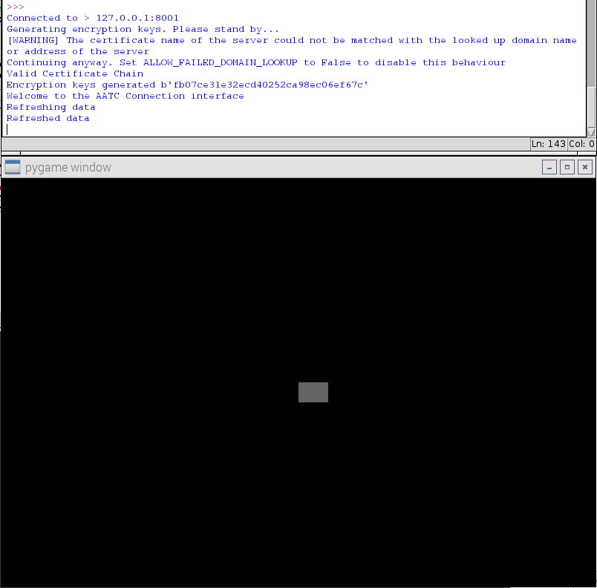
Correctly started up and rendered. This shows that the information obtained from the server was correct.

2.
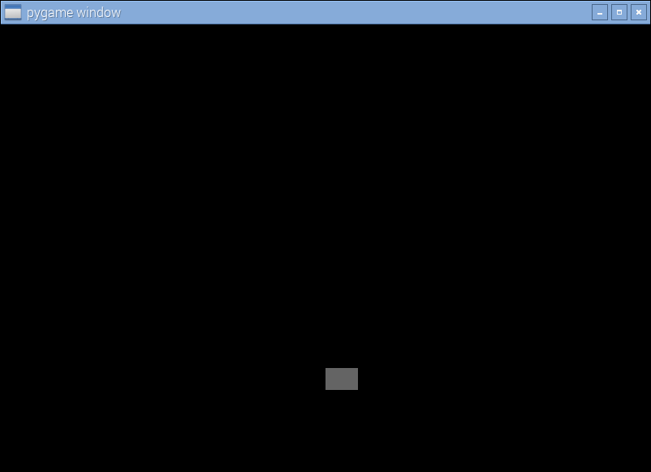
Sucessfully moved camera up. The NoFlyZone has moved down, so the camera must have moved up.

3.
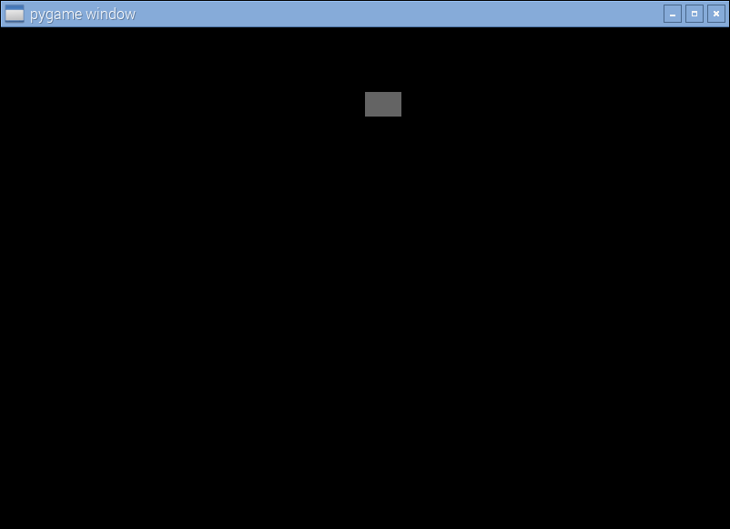
Sucessfully moved camera down. The NoFlyZone has moved up, therefore the camera must have moved down.

4.
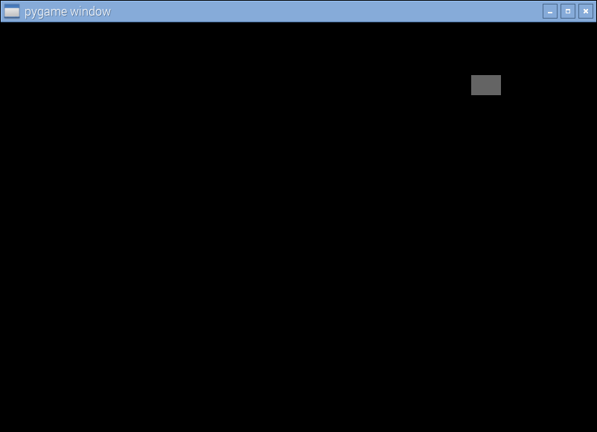
Sucessfully moved camera left. The NoFlyZone has moved right so the camera must have moved left.

5.
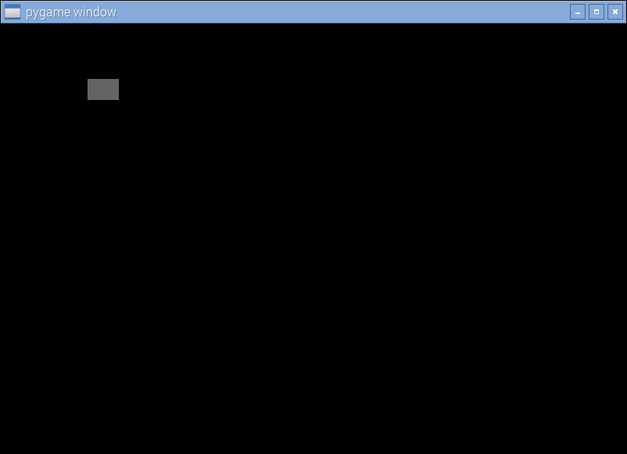
Sucessfully moved camera right. The NoFlyZone has moved left so the camera must have moved right.

6.
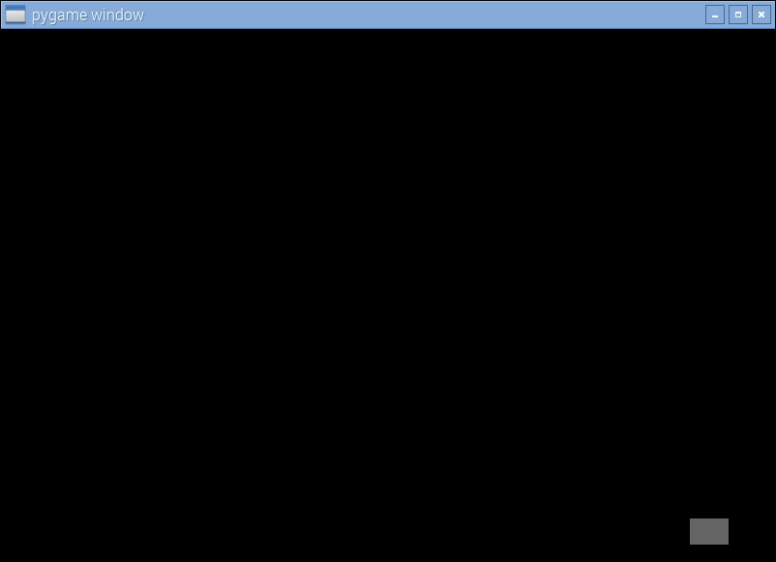
Sucessfully moved diagonally. The NoFlyZone has moved diagonally down-right so the camera must have moved diagonally up-left.

7.
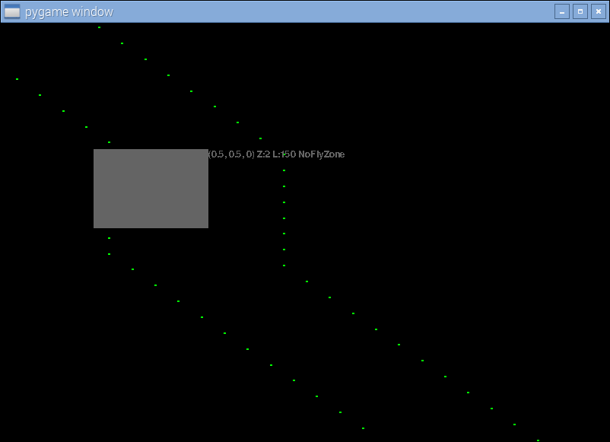
Sucessfully zoomed in. The NoFlyZone is now larger and flight waypoints are now visible.

8.
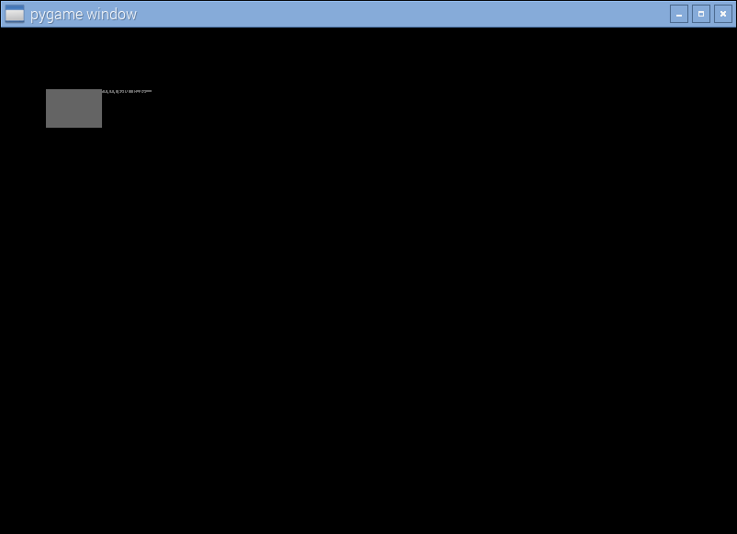
Sucessfully zoomed out. The NoFlyZone is now smaller and waypoints are no longer visible.

9.
Not rendered and rendered respectively. This first image has a small NoFlyZone so text is not rendered at that zoom level while the second image shows the no fly zone large enough so the text is rendered.

10.
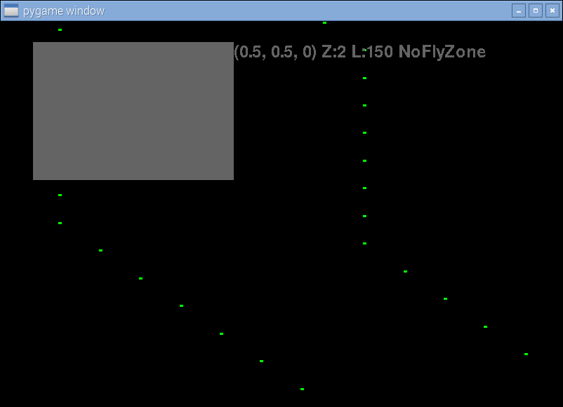
Sucessfully rendered only correct text. Only the no fly zone which is large enough has rendered text while the waypoints do not.

11.
Rendered no fly zone. Note the relevant label with details.

12.
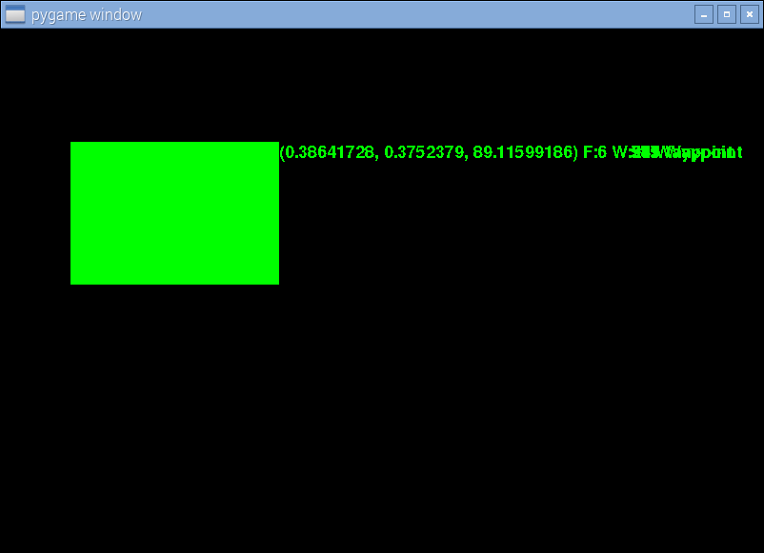
Rendered waypoint. Text is illegible at points as there are approximately 8 waypoints of the same flight in the same location (i.e. the flight looped between the points), in a normal environment this would not be the case. Note the relevant label with details.

13.
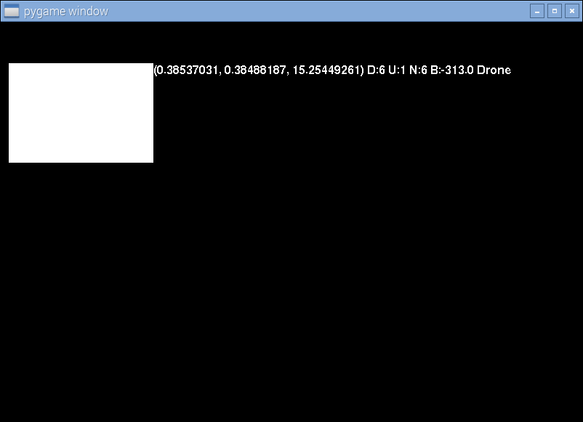
Rendered drone correctly. Note the relevant label with details.
14.
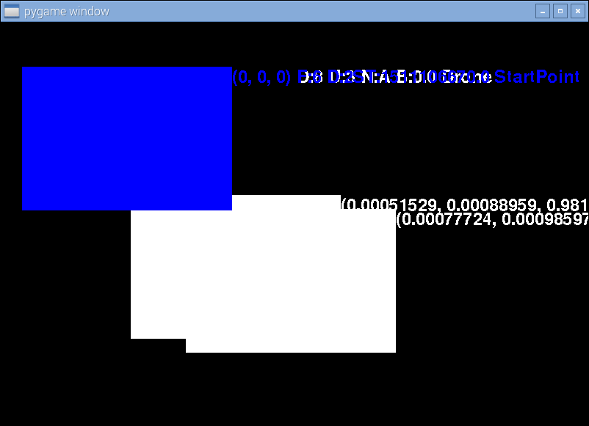
Correctly rendered start point. Note the relevant label with details.

15.
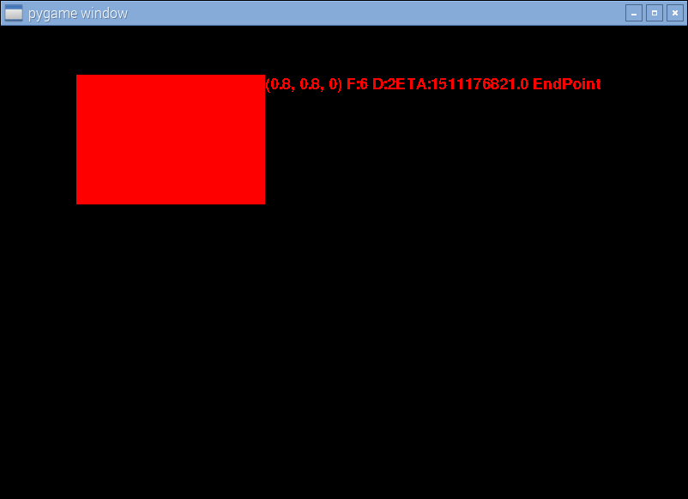
End point correctly rendered. Note the relevant label with details.

16.
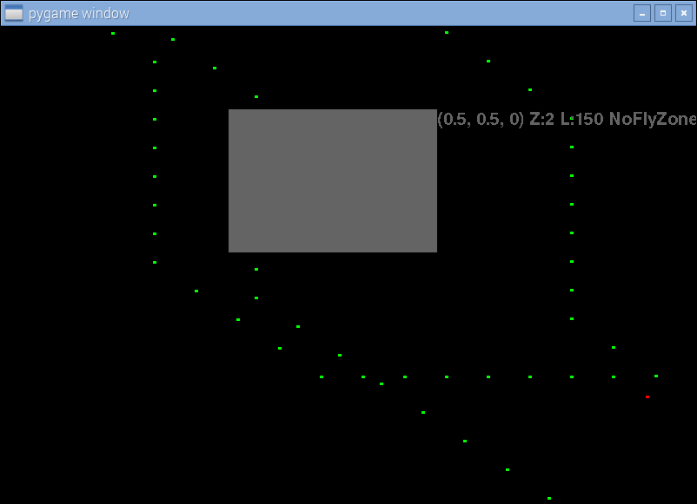
Correctly laid out pathing (left most path is that of the second one, the middle and left paths( as viewed horizontally from the top of the no fly zone) belong to the first flight. This shows the path finding algorithm and rendering program are both functioning correctly.

