Hedabot_Testing
TestID | Description | Test Data | Expected outcome
1 | Testing that is it possible to log in the the server. Users must be able to log into the server in order to use specific functions. | Entering one functioning login and one non functioning login. | The functioning login should login in correctly while the non functional version should not.
2 | A non authenticated User should not be able to access any other function but Exit,Login,AddNewUser | Fail to login using incorrect credentials and attepmt to run various authenticated only commands, Then some commands which can be used without logging in. | The authenticated only commands should return failure while the others should function correctly.
3 | Testing if adding a User functions. A user must be added in order to user one. | Add a new user | The user should be added.
4 | Testing Adding a User which already exists. A new user should not overwrite an existing user. A message should be shown that the username is already in use. | Adding an already created user. | The adding of a User who already exists should fail with the error that the user already exists.
5 | The function GetNoFlyZones works correctly. This function is used to get the information for each NoFlyZone. | Run the GetNoFlyZones function on a logged in user. | Should return all no fly zones
6 | Adding a NoFlyZone. A user should be able to add a no fly zone. A NoFlyZone is used to prevent/ discourage drones from entering that area. | Enter a valid no fly zone | No Fly zone should be added
7 | Adding NoFlyZone without ZoneCreatorPermission (with permission demonstrated previously). Only users with the ZoneCreators permission should be able to add NoFlyZones. This prevents arbitary users signing up and adding NoFlyZones in order to ruin the performance of the server. | Using a user without the ZoneCreator Permission attempt to add a valid NoFlyZone. | The attempt should fail with the permission error message.
8 | Removing a NoFlyZone which belongs to oneself. Any user should be able to remove their own NoFlyZones regardless of if they have the ZoneRemoverPermission. | Remove a NoFlyZone which was created by that User. With and without the ZoneRemoverPermission. | The User should be able to remove the NoFlyZone even if they don't have the ZoneRemoverPermission.
9 | Removing another user's NoFlyZone. Only those users with the ZoneRemoverPermission should be able to remove other user's NoFlyZones. This allows moderating of the NoFlyZones but prevents the ability of anyone being able to remove another user's NoFlyZones. | Two attempts to remove the NoFlyZone. With the ZoneRemoverPermission and without. | When ZoneRemoverPermission is set to 0 the attempt should fail. When set to 1 it should suceed.
10 | Modifing an NoFlyZone which belongs to oneself. User's should be able to edit the level of their NoFlyZone regardless of the ZoneModifierPermission. | Two attempts to modify. With and without ZoneModifierPermission. | Both occasions should allow the NoFlyZone to be modified.
11 | Modifing a NoFlyZone which belongs to another User. User's with the ZoneModifier Permission should be able to edit other User's NoFlyZones in a moderation role, however arbitary users may not do this. | Two attempts to modify. With and without ZoneModifierPermission. | Only with ZoneModifierPermission is set to 0 should the NoFlyZone be modified.
12 | Adding a new drone. Drones must be added in order to create flights etc for that Drone. | Data for a new Drone “drone” with password “fly” , type “Flying thing” , speed 16 m/s , range 50000 m and weight 1.5 kg | Drone should be added sucessfully
13 | Removing a drone belonging to oneself. Any user should be able to remove their own drones. | Remove a drone owned by the users | The confirmations should show the drone was removed as well
14 | Attempting to remove a drone which does not belong to oneself. A user should not be able to remove another user's drones. | Attempt to remove a drone which belongs to another user. | The drone should not be removed and an appropriate message must be returned.
15 | Get the DroneID of a drone. This is used to get the droneID of a drone by the name of the drone. This search is local to the user’s drones. The drones of the same name belonging to other users will not be included. | Get the DroneID of two drones, one which exists, one which doesn’t. | The existing drone should have it’s ID returned while the non existant one should not.
16 | Get the DroneCredentials of a drone which one owns. This is used to get the password of that drone belonging to the user. The credentials are stored in plaintext on the server so they can be accessed by the Owner rather than having them hashed and therefore unreadable to the owner. | Get the DroneCredentials of a drone which one owns. | The Drone credentials should be returned for that drone.
17 | Attempt to get the DroneCredentials of a drone which does not belong to oneself. This is to check that other user’s cannot access the DroneCredentials of other User’s drones. If this were the case they could login as that drone and obtain all the information about that drone and / or spoof it’s last location. | Attempt to get credentials of drones which one doesnt own. | No credentials should be returned.
18 | Change the drone credentials of a drone which one owns. It is recommended to frequently change the passwords belonging to drones as the drones can be intercepted and the password extracted ( the drone must have knowledge of the password in order to verify itself. | Change the drone credentials of a drone which one owns. | The Drone credentials should have been changed.
19 | Attempt to change the drone credentials of another users drone. This must not be allowed as otherwise users could alter the logins of other user’s drones. | Change the drone credentials of another users drone | The drone credentials must not be able to be changed, error message should be shown.
20 | Check drone ownership. This is used to check if a given UserID is the owner of a given DroneID or not. Returns 1 if True. | Check ownership of a drone which belongs to user and a drone which does not. | User’s drone should be 1 while the other one should not.
21 | Get the drone info of a drone owned by the user. This is used to obtain the information of a single drone to the user i.e. last known coordnates, weight , speed. | Get the drone info of a drone owned by the user. | Should return the information of that drone to the user.
22 | Get the drone info of a drone not owned by the user. Users should not be able to obtain the information of other users drones as this would be a method to track all the other users. | Get the drone info of a drone not owned by the user. | Should not return the information of that drone to the user.
23 | Get Drones User. This is used to obtain all the drones belonging to that user. | Get all the drones for a single user. | Should return all the drones of that user.
24 | Get Drones all. This is used to obtain all the drones which are publicly visible. | Get all publicly visible drones. | Should return all publicly visible drones.
25 | Get UserID. This is used to get the UserID for a specific username. | Get the userID a username which exists | Should return the userID
26 | Get UserID of non existant username. This is to check that the request will not return an invalid UserID if the username does not exist. | Attempt to get the UserID of a non existant username. | Should not return a UserID
27 | Get Username. This is used to obtain the Username asociated with that UserID. | Get the username of an existing UserID | Should return the UserID of that user.
28 | Get Username of user who does not exist. This is to check that requesting the Username for a non existant UserID will not return an invalid value. | Attempt to get the Username of a non existant user. | Should not return the Username.
29 | Set flight visibility to 1. This is used to toggle if the drones, flights and flight waypoints for that user are publicly visible. 1 makes this information public. | Set Flight visibility to 1 and see if other user can see drones etc | Sucessfully set flight visibility
30 | Set Flight visibility to 0. This is used to toggle if the drones, flights and flight waypoints for that user are publicly visible. 0 prevents others accessing this information unless permission is passed to them. | Set Flight visibility to 0 and see if other users cannot see drones etc | Should sucessfully set flight visibility
31 | Change Account Type. The account type command is used to set the value of certain permissions for an account. For example the ZoneCreatorPermission could be set to 1. | Change the account type of the user. | Should change account type
32 | Changing password. This is used to change the user’s password. | Change users password. | Password should be changed
33 | Attempt to change password with incorrect old password. This is to check only someone who knows the old password can set a new password. | Attempt to change password with incorrect old password | Password should not be changed.
34 | Get Flights User. This function is used to obtain all the details for a flight created by the user. | Get all the flights of the user | Shoudl return all the flights of the user.
35 | GetFlights all. This is used to obtain all flights which are publicly available. | Get Flights of all publicly visible accounts. | Should return all publicly visible flights.
36 | AddFlight. This is used to add a flight, for a certain DroneID through a set of coordinate points at start time T where T is either the time till launch in seconds. If T < 2.5 million ( seconds in a month) then T is time till launch, If not T is read as time since 1/1/1970 and Time to Start is calculated as T-Current Time. This calculates a flight path for the drone if the points the drone must pass through (HighPoints) are all not in NoFlyZones. | Add a flight of a drone belonging to the user | A new flight should be added and details returned.
37 | Attempt to add other usre's drone to flight. This should be denied as users should not be able to launch other user’s drones. | Attempt to user another user's drone when creating a flight. | Flight should not be created / failure returned.
38 | Remove a flight. This is used to remove an added flight. This may be used to cancel a flight which is no longer desired. | Remove a flight created by the user. | Flight should be removed.
39 | Remove a flight of another user. This should not be allowed as users should not be able to alter the flights of other users. | Attempt to remove the flight of another user. | Flight should not be removed due to a lack of ownership.
40 | Get Flight waypoints of the user. This obtains all the flight waypoints belonging to a user. | Obtain the flight waypoints of the user. | Return the waypoints of the user.
41 | Get Flight waypoints all. This obtains all the flight waypoints which are publicly available. | Obtain all the flight waypoints made visible. | Return all publicly visible waypoints.
42 | Get MonitorID. This is used to obtain the MonitorID linked to a given Monitor name. | Get the monitor ID of a monitor which exists. | Should return the ID of the monitor.
43 | Get MonitorID of non existant monitor. This is to check that attempting to obtain a MonitorID of a non existant monitor will not return an invalid MonitorID. | Attempt to get the monitorID of a monitor which does not exist. | An ID should not be returned.
44 | Get Monitor Name. This is used to obtain a monitor name for a given monitor ID. This might be needed in order to identify a monitor by their monitorID. | Get the monitor name using a MonitorID | Should return the name of the Monitor
45 | Get Monitor Name of non existant monitor should not return an invalid monitor name. | Attempt to get the monitor name of a monitor which does not exist. | Should not return a name.
46 | Add a monitor permission. This is used to give a monitor permission to view the drones, flights and flight waypoints of that user. This permission has an expiry date at which it will automatically become invalid. | Add a monitor permission | Should sucessfully add a monitor permission.
47 | Remove a monitor permission. This is used to remove a monitor permission early. The monitor permission with the UserID,MonitorID composite primary key will be removed. | Remove a monitor permission | Shoudl sucessfully remove a monitor permission
48 | Modify Monitor Permission. This is used to alter the expiry date of the permission i.e. to extend the permission if required. | Alter a monitor permisison expiry date | The expiry date should be changed.
49 | Get Monitor Permissions User. This is used to obtain all the monitor permissions which that User has created. | Get the monitor permissions for a user. | Returns the monitor permissions for that user.
50 | Help menu. This is used to display all the possible commands the user can use. Clicking on a command automatically sends the command (clicking functionality build into Telegram, no testing needed). | Enter help | Should return all possible commands.
51 | Incorrect input. This is used to check that the program will be able to recover if the user enters an incorrect command. This command cannot be processed and therefore a help menu is returned. | If one enters a non registered command | Should return help menu
52 | Cancel. This is used to cancel the current command. | Cancel a command | Should cancel the command

NOTE: The depth of the testing of this module will be much less than that of the AATC_Client and AATC_Client_Text_UI. This is because the bot is merely processes the transfer of commands and arguments into a packet which the main server can run. Therefore if each function works in one state , given that the logic of the program has not been altered between the two modules the response will be the same. i.e. if a user is added, then it will not be demonstrated that the user can login after as this was already tested in the AATC_Client and Text_UI testing section.

1.
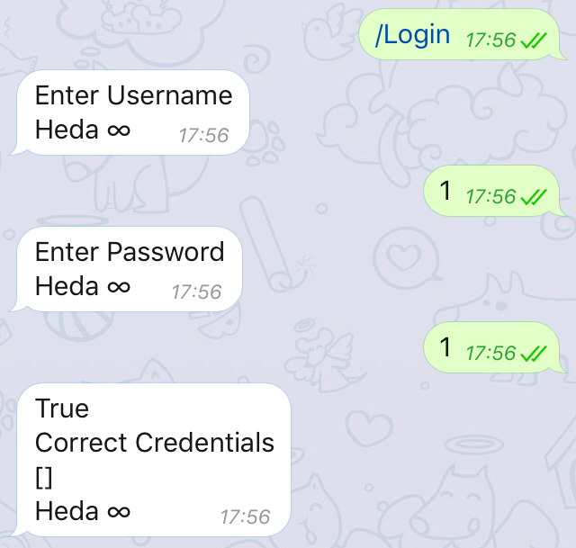

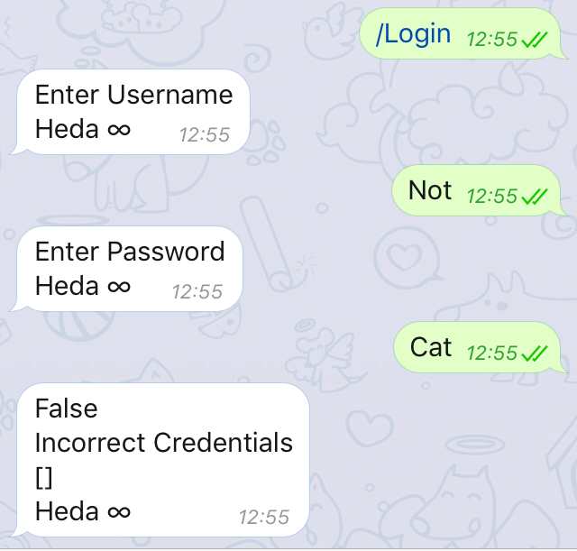
Correctly only allows the valid login to be accepted. This prevents other users logging in when they are not supposed to.

2.
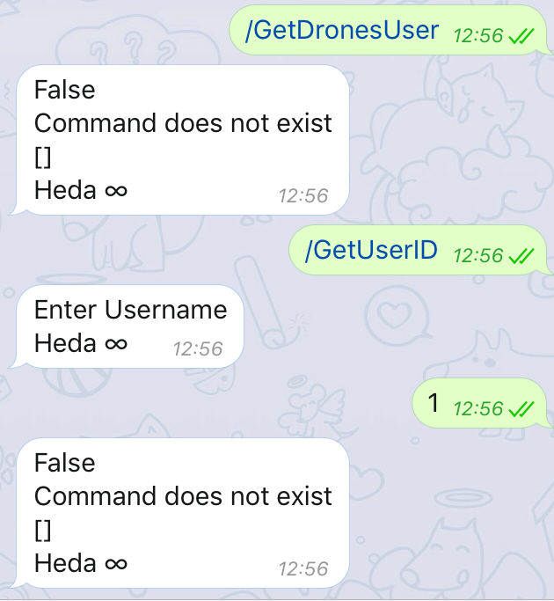
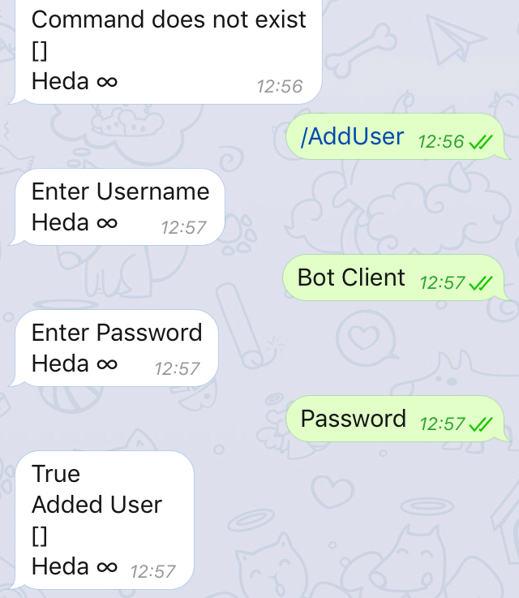

As the user is not logged on they do not have access to restricted functions. These functions require the user to be logged in and so users who are not logged in may not use them.

3.
User added successfully. The user is now in existence and may be used to perform various tasks.

4.
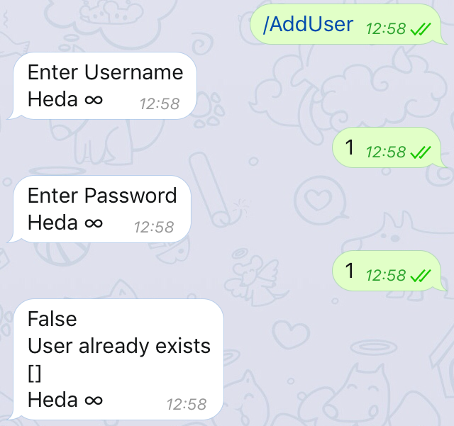
User not added as already exists. This prevents users with the same username being created. The old user is not overwritten and this cannot be used to capture a username.

5.
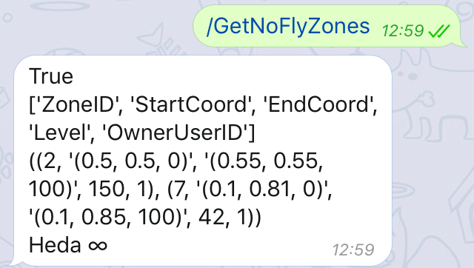
Sucessfully obtained no fly zones. These no fly zones can then be added to or removed or used to detect if a specific location may be flown through.

6.
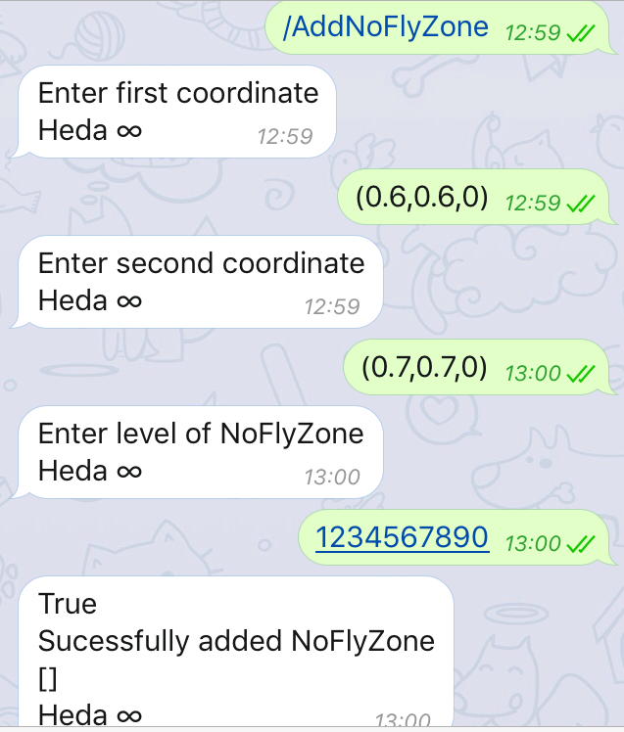
Correctly added a no fly zone. The no fly zone will now prevent drones flying in that location if possible.

7.
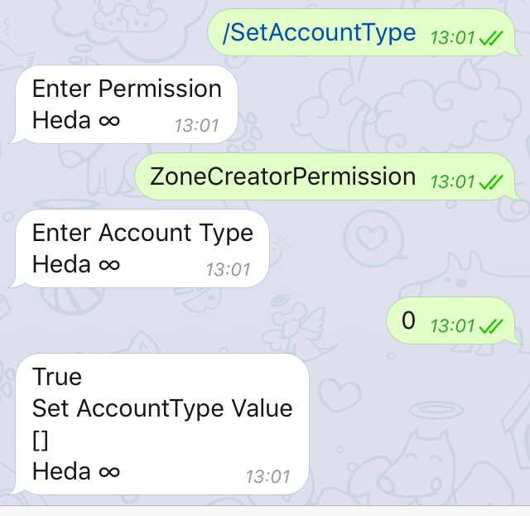
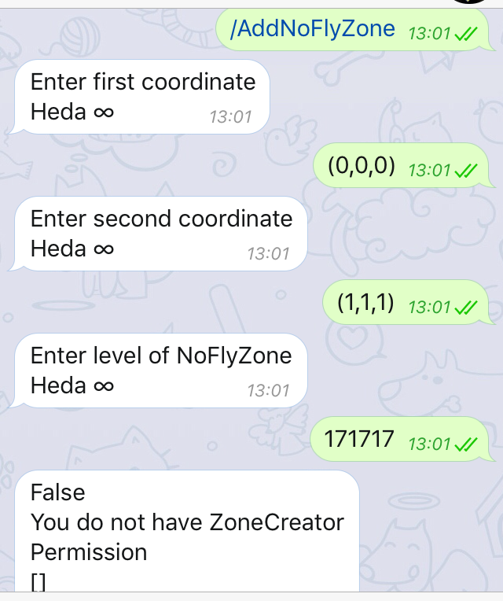
Sucessfully did not add no fly zone. This prevents unauthorised users creating these no fly zones to lower the performance of the server.

8.
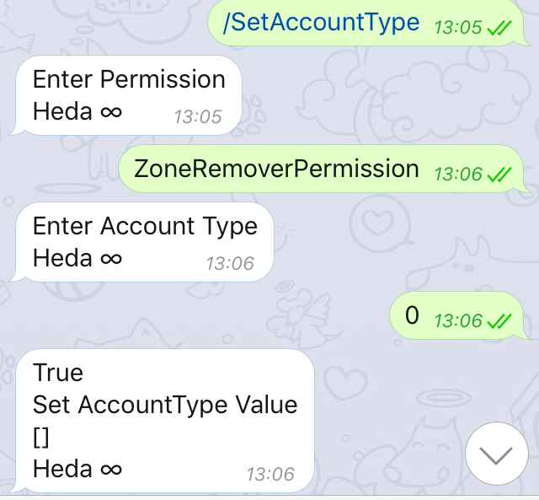

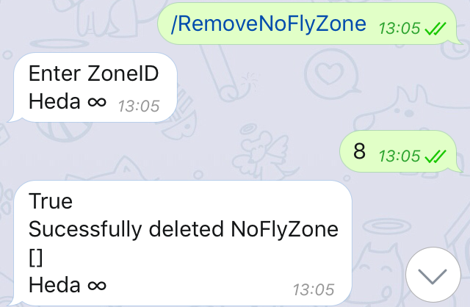
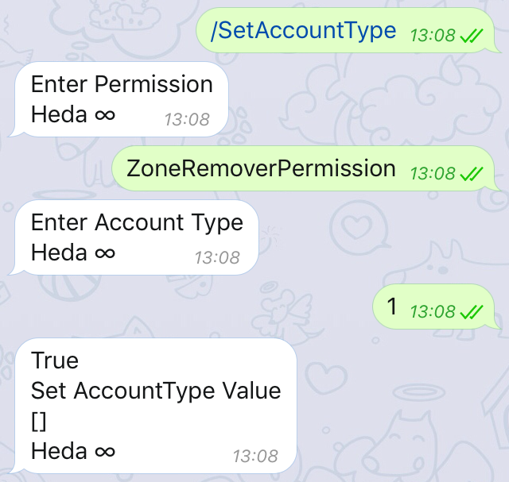

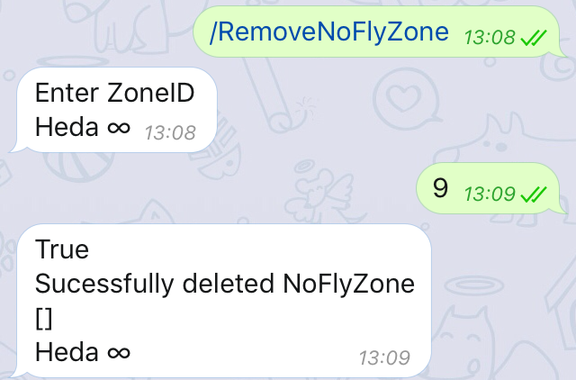
Sucessfully removed no fly zones on both occasions. This shows that a user may remove the no fly zones belonging to them regardless of the ZoneRemoverPermssion.

9.

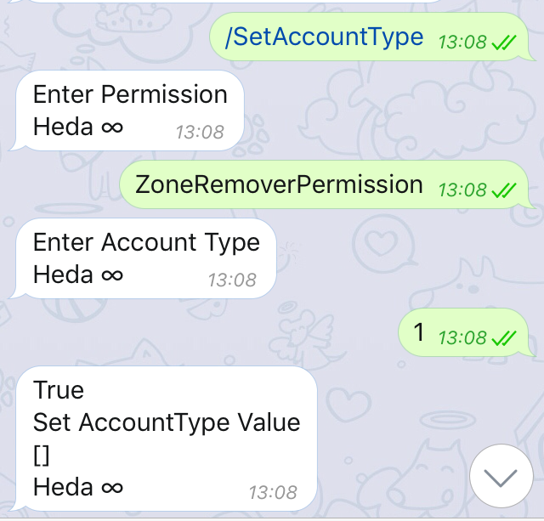

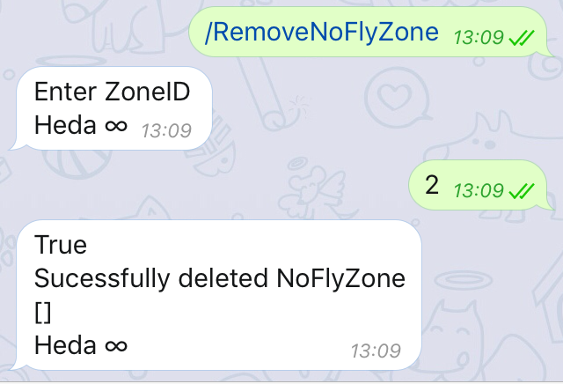
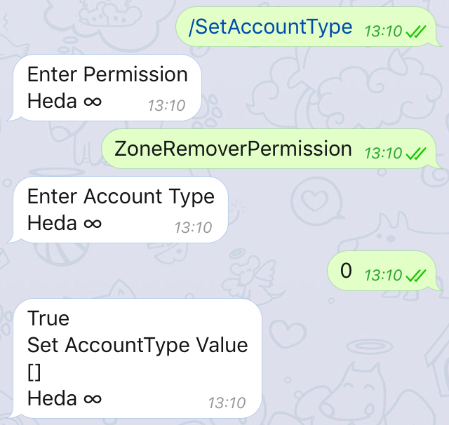

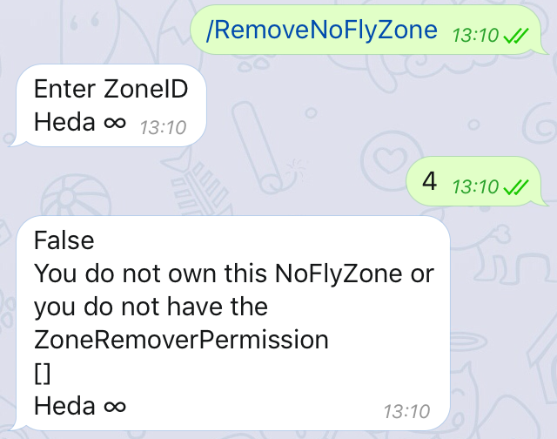
Operated as expected. This means only users who have the correct permission may remove no fly zones.

10.
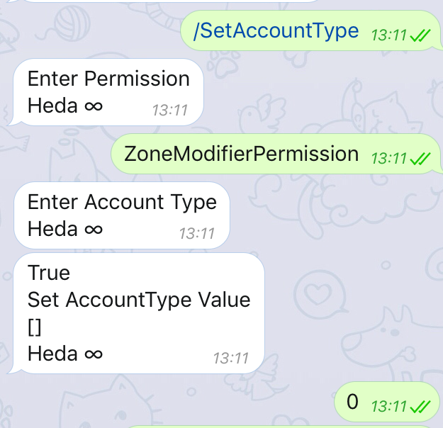
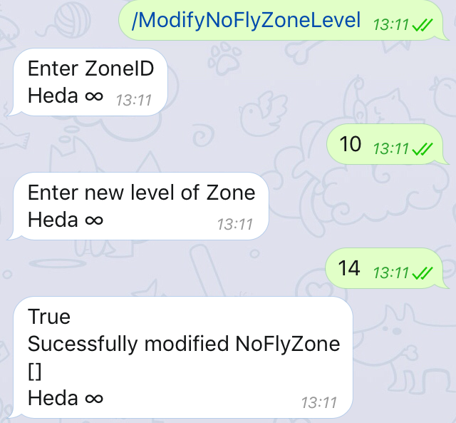

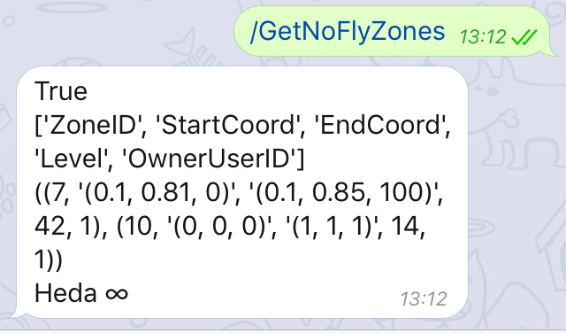

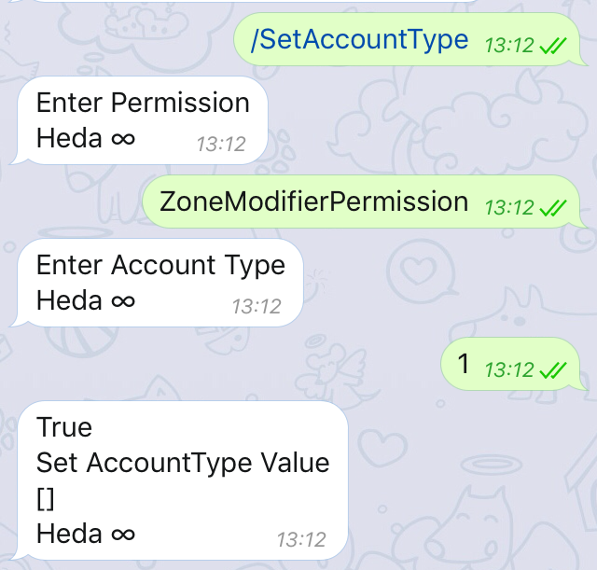
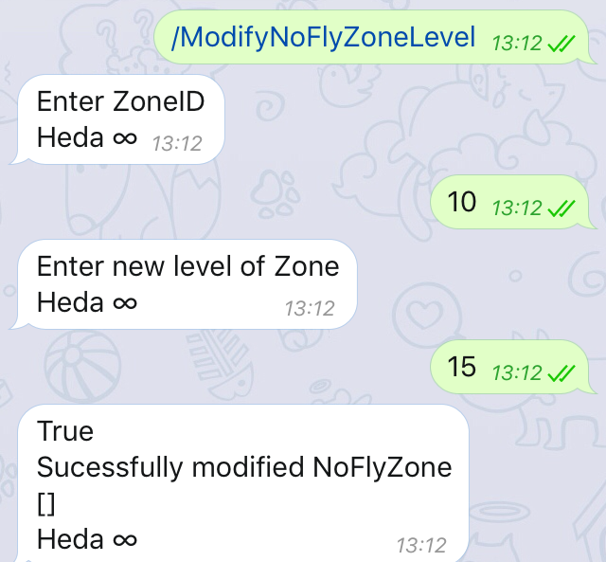
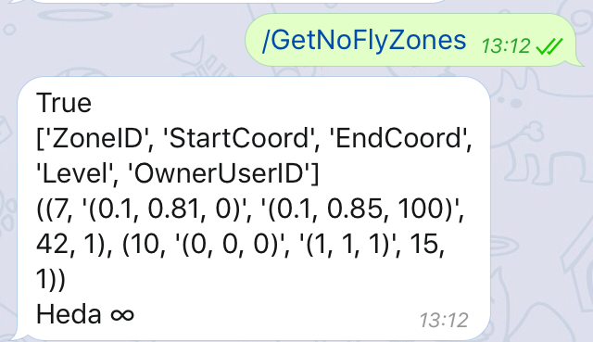
Correctly modified no fly zone. This may be used to later alter the level of a no fly zone. As the user owns this no fly zone they may modify it regardless of the Zone modifier permission.

11.

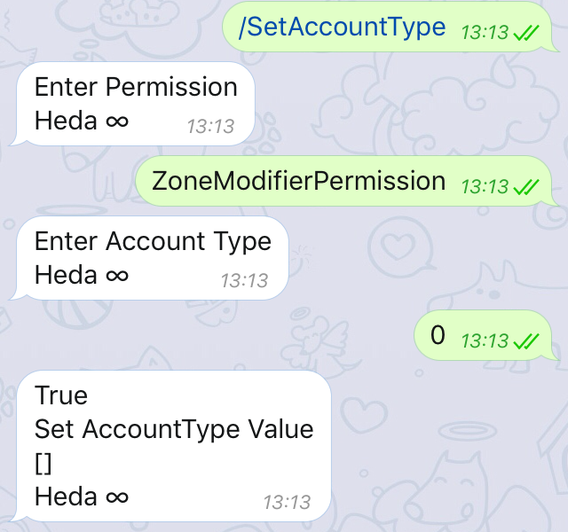

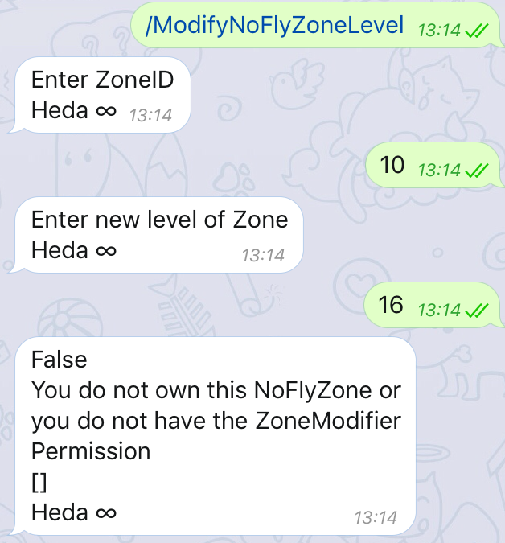

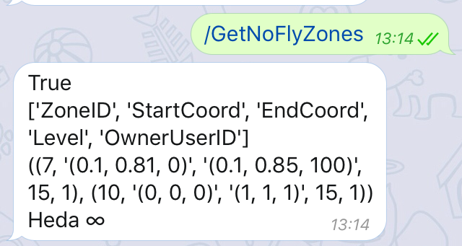

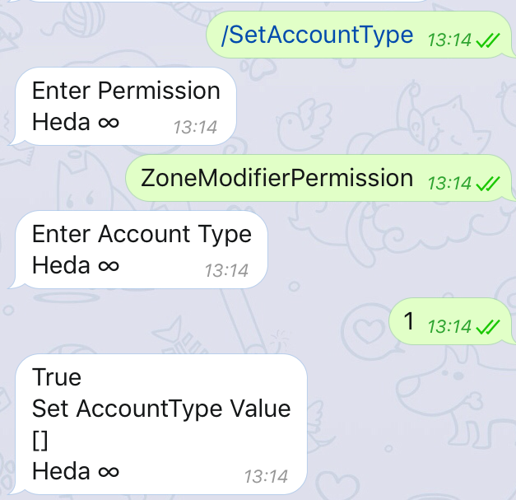
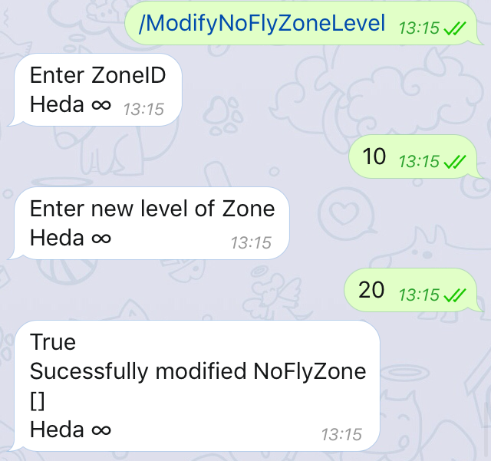

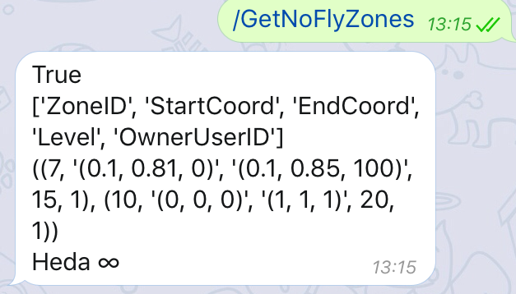
The no fly zone was only modified when the user had the ZoneModifier permission. This prevents arbitary users editing other user’s No Fly zones.

12.
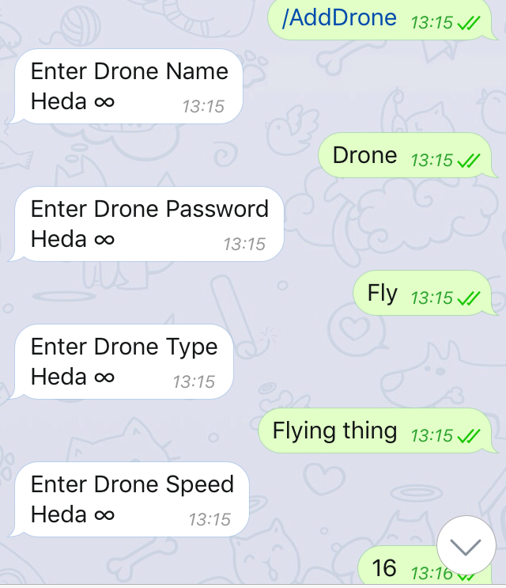
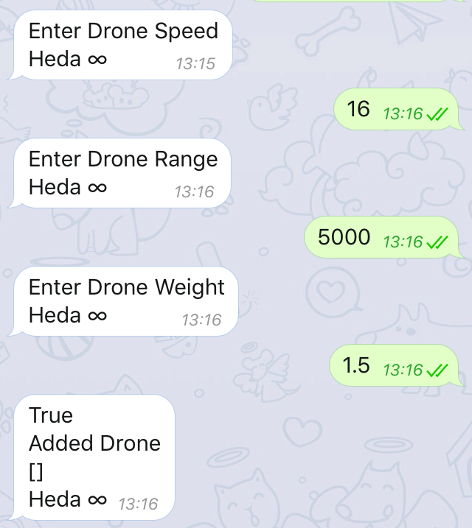
The drone was sucessfully added. The drone may now perform flights , register it’s status etc with the server.

13.
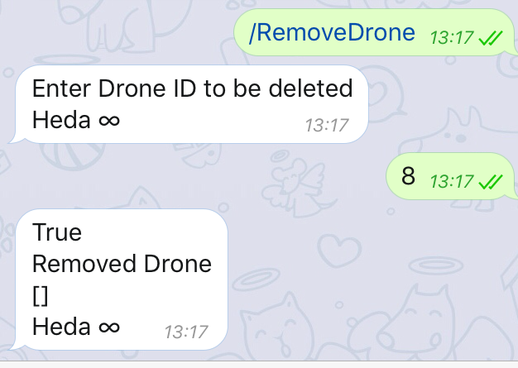
The drone was correctly removed as it belonged to the user. This can be used to remove obsolete drones from the system.

14.
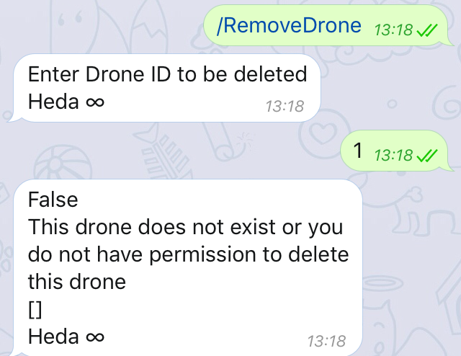
This shows that other users may not remove drones which do not belong to them. This prevents damage to the system through users.

15.
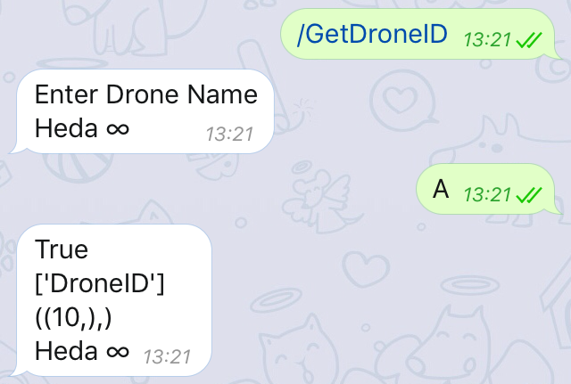

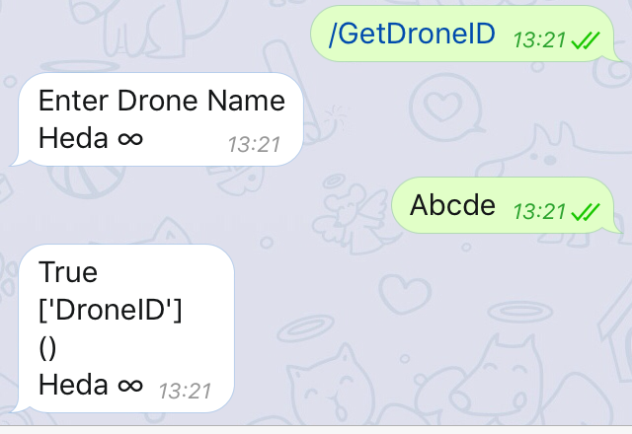
Sucessfully obtained the DroneID for the existing drone and not for the other drone. This allows the user to obtain the droneID for a given drone.

16.
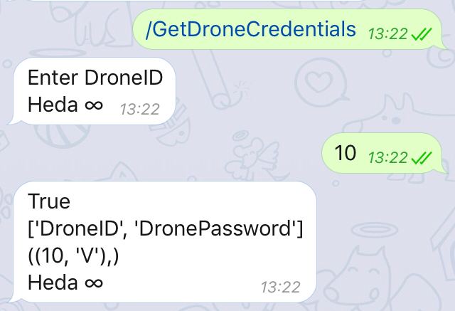
The drone credentials were sucessfully returned to the user. These can be used to allow the drone to authenticate itself with the server.

17.
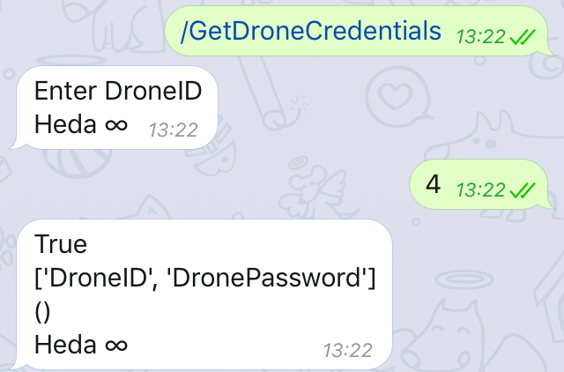
The drone credentials were correctly not returned. This prevents other users acessing the credentials of the drone in order to log in as that drone in order to obtain data on the flights of that drone or to spoof it’s status.

18.
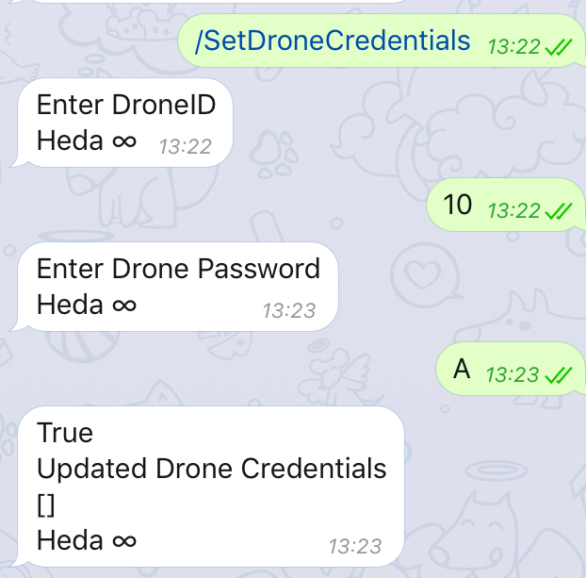
Sucessfully updated the drone credentials. This can be used to change the credentials for a drone i.e. for security purposes.

19.
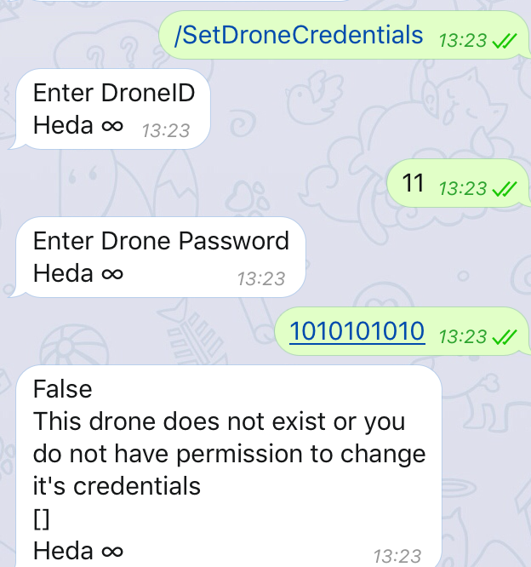
Correctly denied changes to the drone credentials. This prevents other users changing the drone credentials which would otherwise be a large security issue.

20.
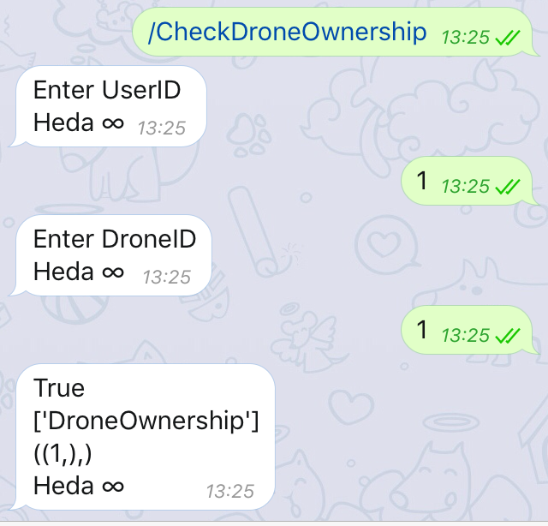
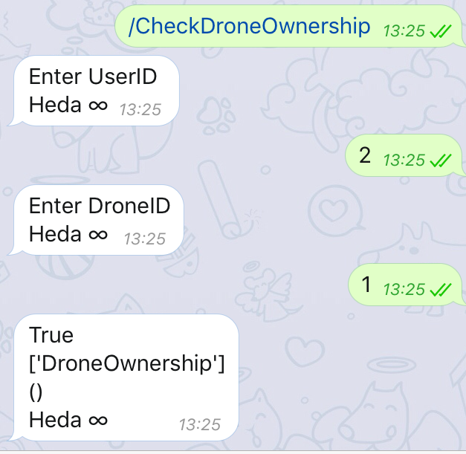
Sucessfully obtained drone ownership in both cases with the correct result. This can be used to check if a given UserID owns a drone with a specific DroneID.

21.
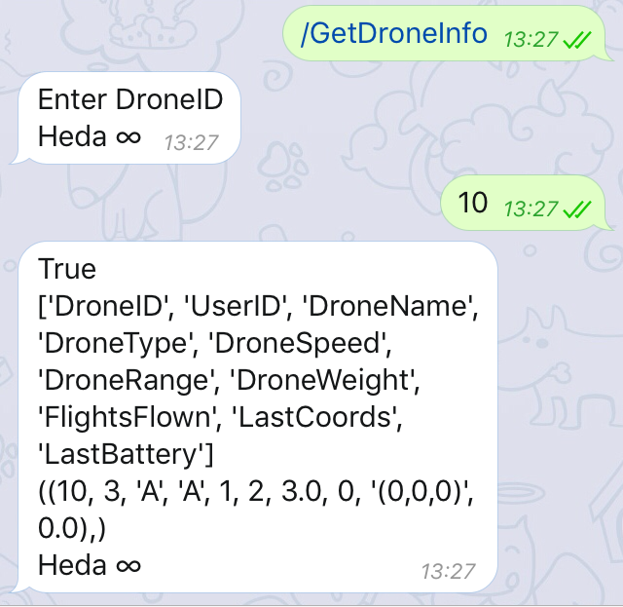
Successfully obtained the information about that drone. This can be used to view the information about a specific drone.

22.
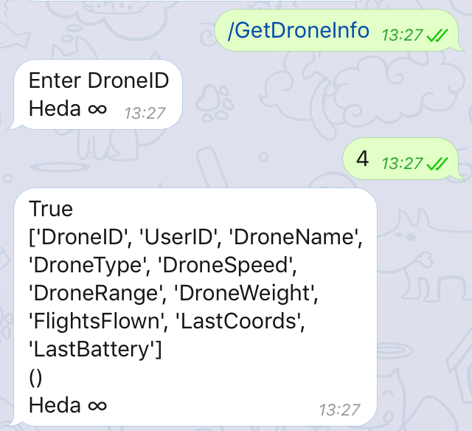
Correctly did not return information about the drone. This is to prevent other users obtaining information about drones which they do not own.

23.
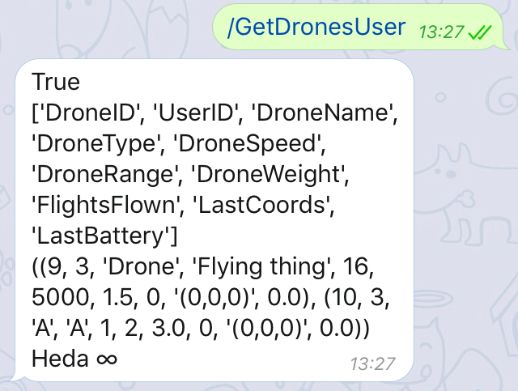
This is used to obtain the drones which the user owns. This successfully returned the information about all the drones the user owns.

24.
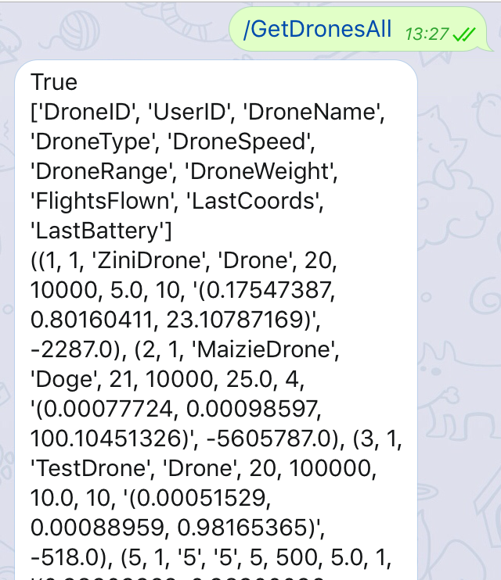
Successfully obtained all public drones. This command obtains all the publicly visible drones.

25.
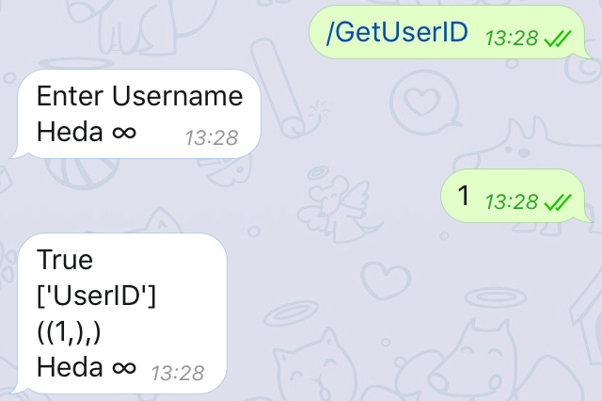
Successfully obtained the user ID for the Username. This is used to obtain the UserID related to the Username passed.

26.
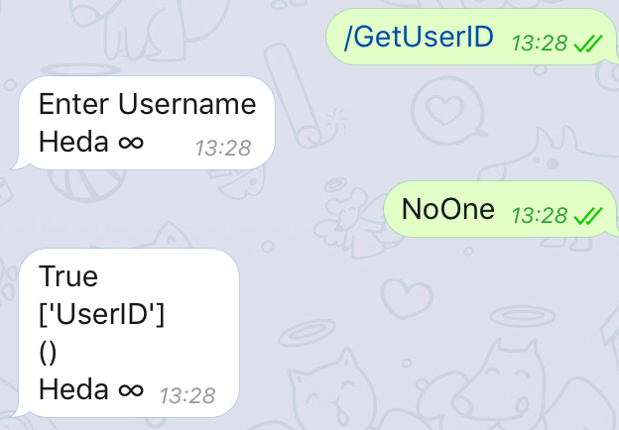
Correctly did not return a UserID. This shows the command will not return an invalid result if the username is not valid.

27.
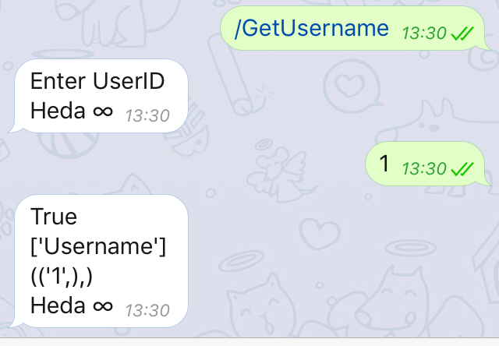
Correctly obtained the Username for a given UserID. This can be used to obtain the username linked to that UserID.

28.
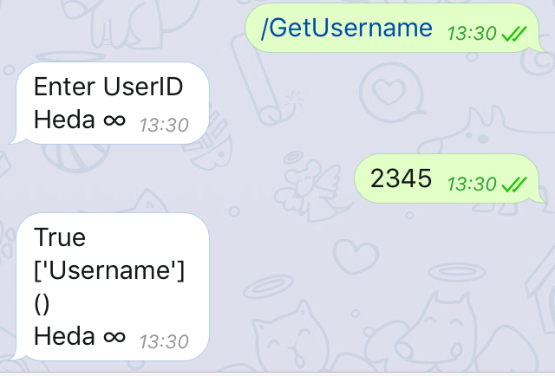
Correctly did not return a Username. This shows the function correctly does not return an invalid username if the UserID is invalid.

29.
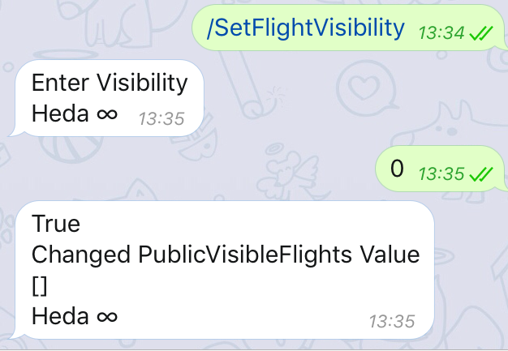
Correctly changed flight visibility. This is used to change the visibility setting of the user account 1 = public, 0 = private.

30.
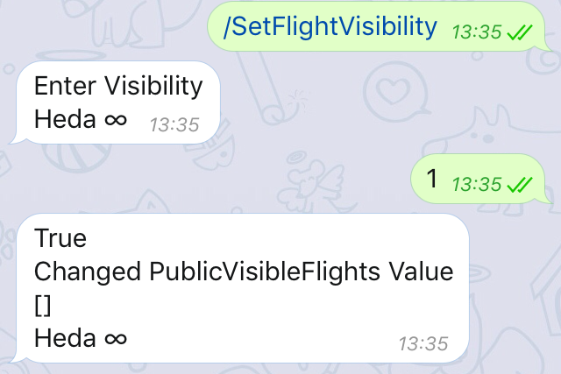
Correctly changed flight visibility. This is used to change the visibility setting of the user account 1 = public, 0 = private.

31.
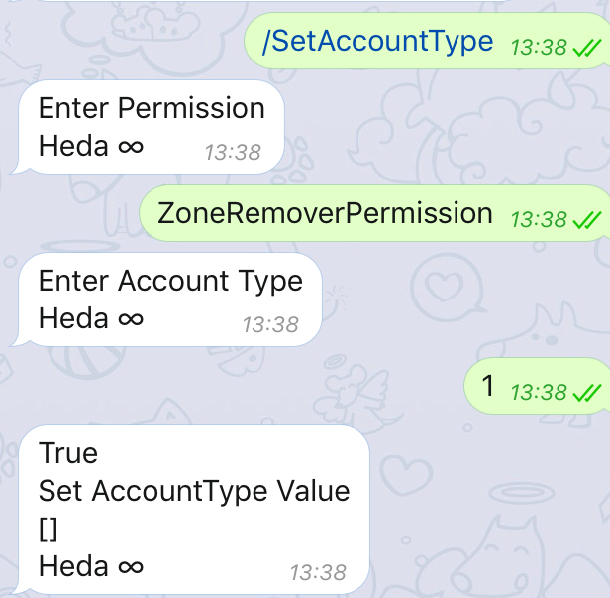
Correctly set the user account type for the ZoneRemoverPermission. This command is used to change the account permissions if the account is allowed to edit it’s permissions.

32.
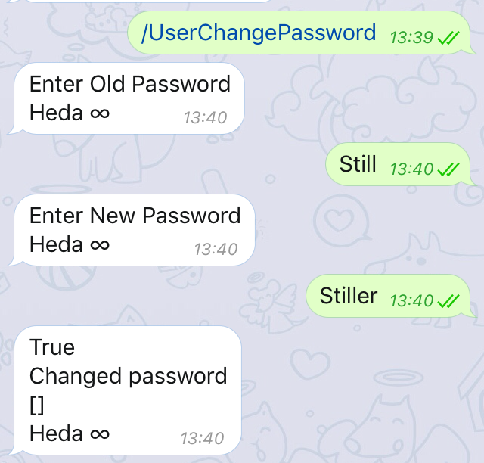
This is used to change the password for the user. This may be as a good security practice/ to prevent the account being compromised.

33.
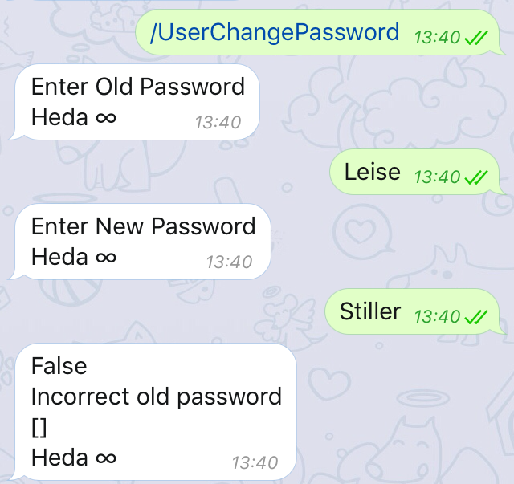
Correctly denied changes. This shows that the password may not be changed if the old password is not correct.

34.
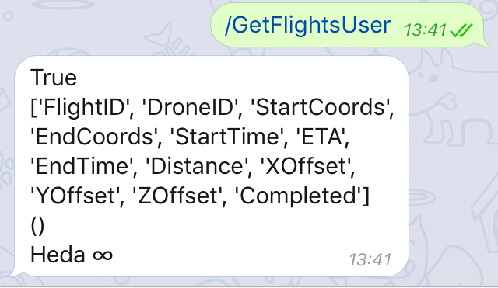
Sucessfully obtained the users flights. This may be used to observe the currently scheduled flights and if these flights have been completed or not for that user.

35.
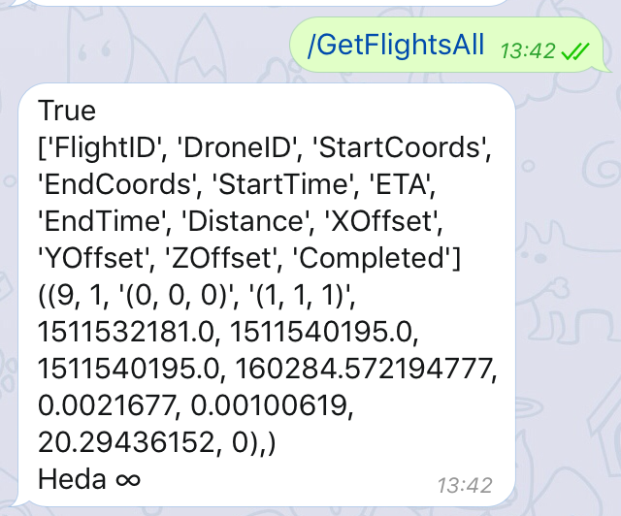
Sucessfully obtained all public flights. This may be used to observe the currently scheduled flights and if these flights have been completed or not.

36.
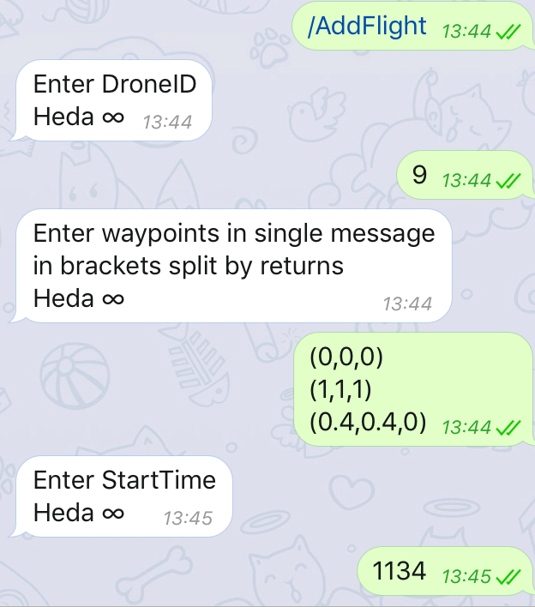
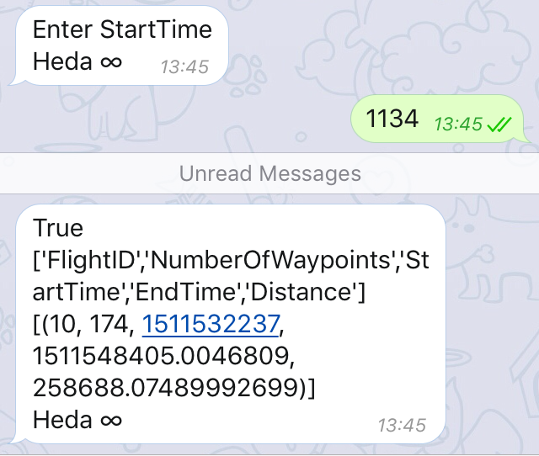
Correctly added flight. This creates a new flight and calculates the flight path, returning the general details of which to the user.

37.

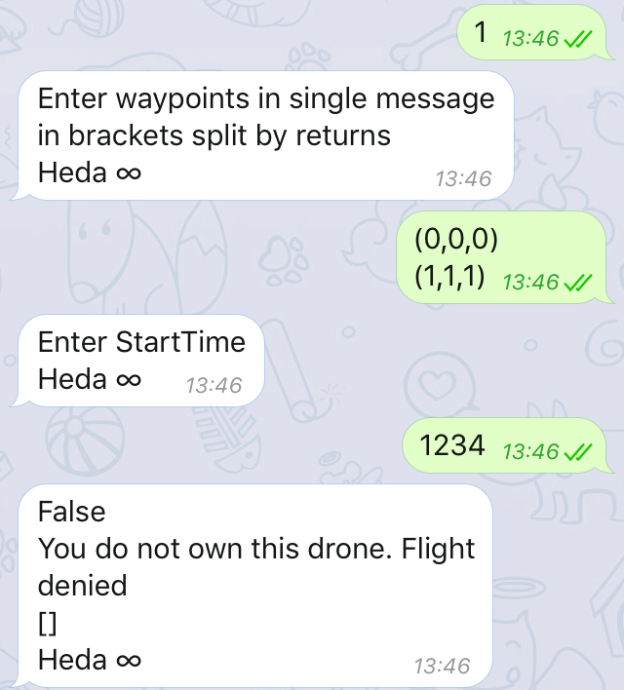
Correctly denied creating a flight. This shows the program will not allow the user to launch drones which do not belong to them.

38.
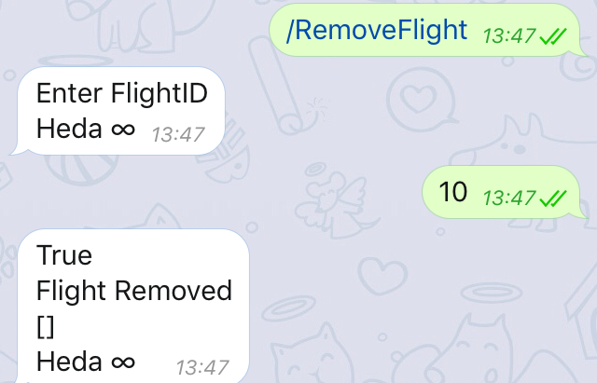
Correctly removed flight. This allows the flight to be cancelled if desired.

39.
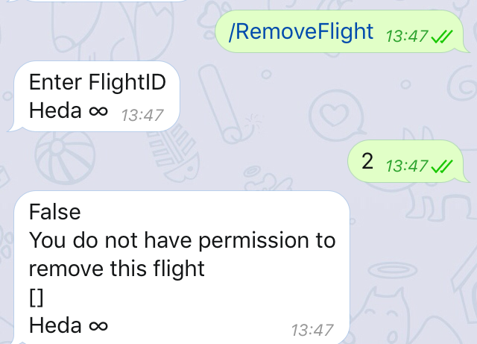
Correctly denied the removal of the flight. This prevents users from cancelling other user’s flights.

40.
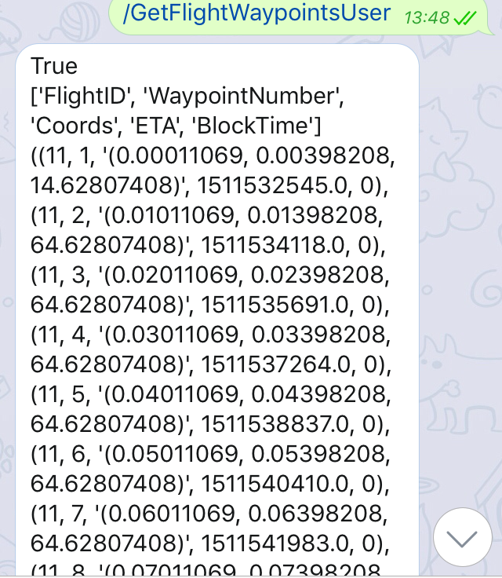
Correctly obtained waypoints. This is used to display all the waypoints belonging to flights belonging to the user.

41.
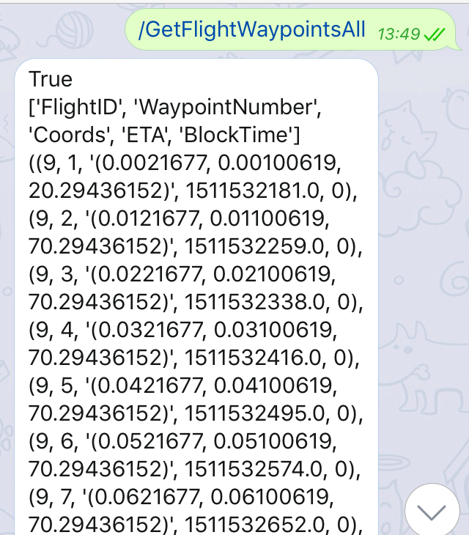
Correctly obtained all public waypoints. This returns the details of all the publicly visible flight waypoints.

42.
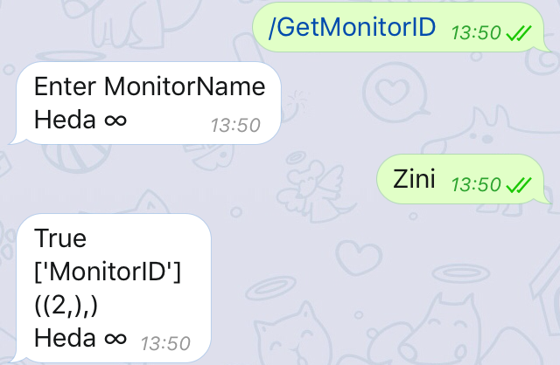
Correctly obtained monitor ID. This can be used to identify the monitor ID required for adding a monitor permission.

43.
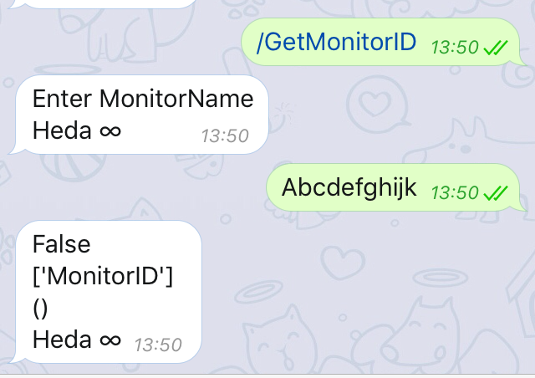
Correctly did not obtain the monitor ID. As the monitor with that name does not exist the program correctly returned nothing , this value cannot be interpreted as a monitor ID.

44.
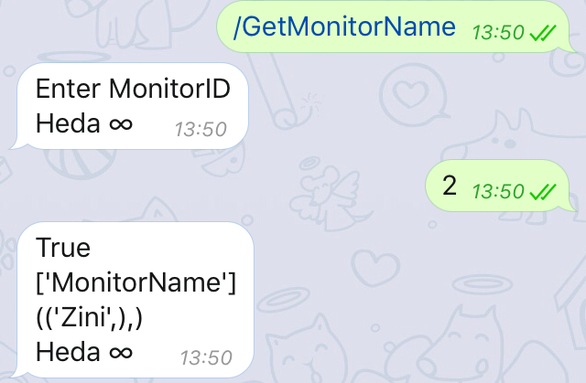
Correctly obtained monitor name This correctly obtained the monitor name for the given monitor ID.

45.
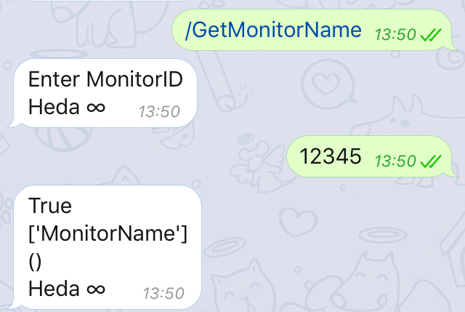
Correctly did not obtain the monitor name for a non existent monitor ID. The program correctly did not return an invalid MonitorName.

46.
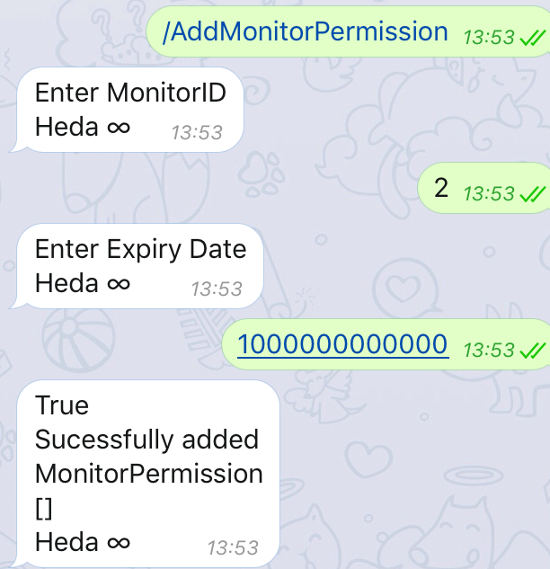
Correctly added monitor permission. This permission allows the monitor to view all the drones, flights and waypoints belonging to that user.

47.
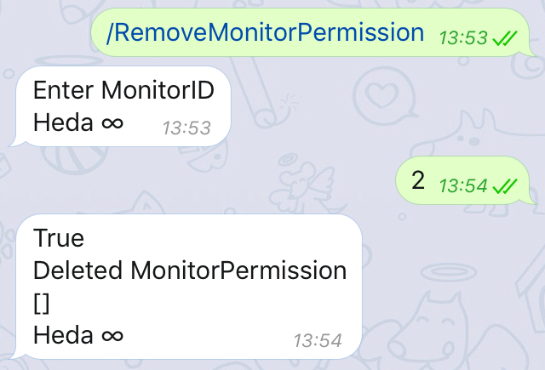
Correctly removed the monitor permission. This can be used to remove a permission early if desired.

48.
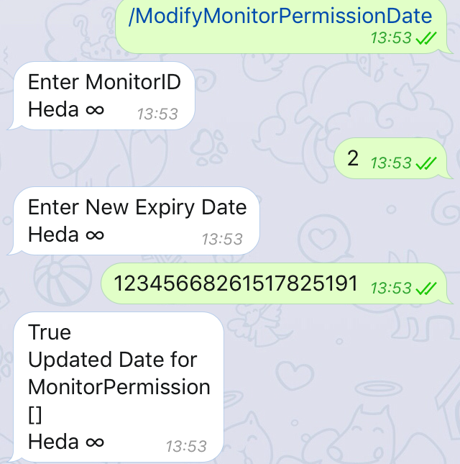
Correctly modified the monitor permission. This can be used to extend or reduce the duration of a monitor permission.

49.
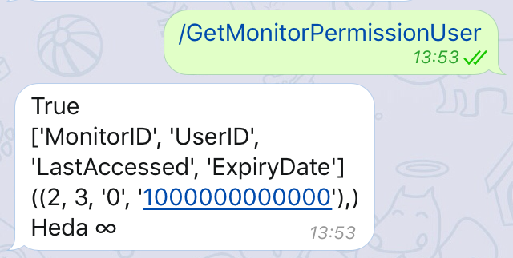
Correctly obtained the monitor permissions. This can be used to view all current monitor permissions for that user.

50.
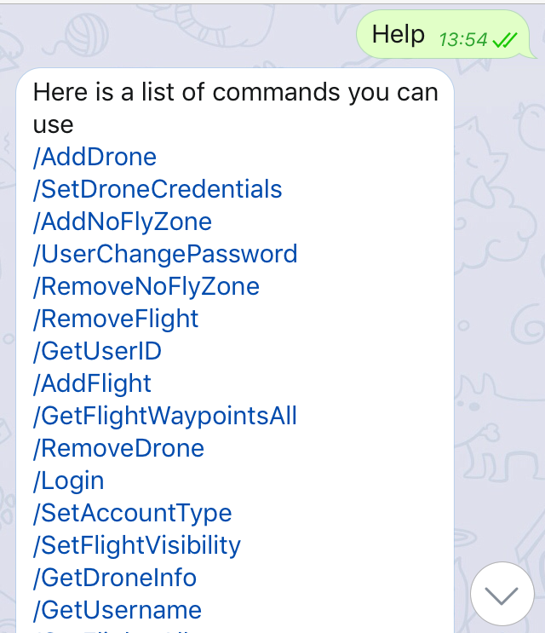
Correctly obtained help menu. This contains all the commands which the user can use and can contain other help instructions.

51.
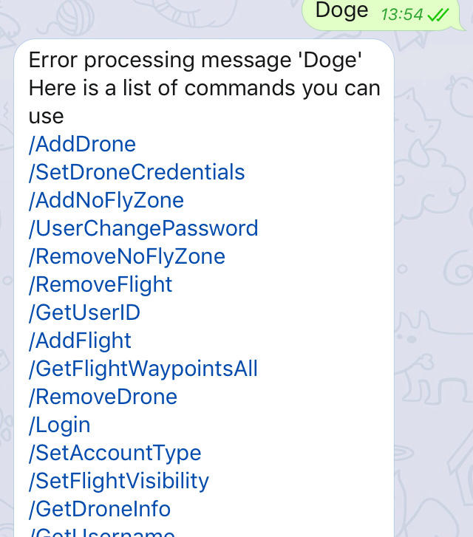
Correctly dealt with incorrect input. This allows the user to be notified if a command was incorrectly written i.e. a spelling mistake or forgetting the slash.

52.
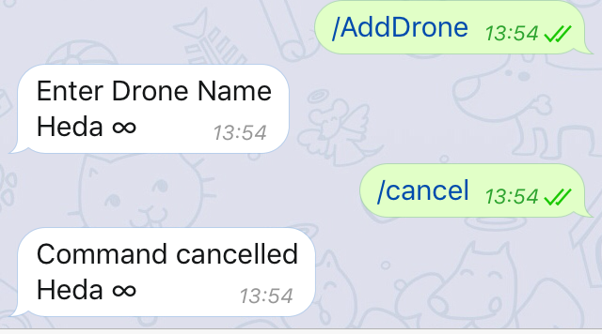
Correctly cancelled command. This can be used to cancel the command if the user does not want to continue with the previous command.

