AATC_Client_AND_Text_UI_Testing
TestID | Description | Test Data | Expected outcome
1 | Testing that the program forms a connection with server and returns a UserInterface object. This object is then used to communicate with the server. | Run CreateUserInterface with default parameters. | Text should appear showing a connection was formed and a UserInterface object should be returned.
2 | Testing that is it possible to log in the the server. Users must be able to log into the server in order to use specific functions. | Entering one functioning login and one non functioning login. | The functioning login should login in correctly while the non functional version should not.
3 | A non authenticated User should not be able to access any other function but Exit,Login,AddNewUser. | Fail to login using incorrect credentials and attepmt to run various authenticated only commands, Then some commands which can be used without logging in. | The authenticated only commands should return failure while the others should function correctly.
4 | Testing if adding a User functions. A user must be added in order to user one. | Add a new user and attempt to use an authenticated only function and then login and run the same function again. | The user should be added , but not logged on, and therefore the function should not work. Once logged on the function should work.
5 | Testing Adding a User which already exists. A new user should not overwrite an existing user. A message should be shown that the username is already in use. | Adding an already created user. | The adding of a User who already exists should fail with the error that the user already exists.
6 | The function GetNoFlyZones works correctly. This function is used to get the information for each NoFlyZone. | Run the GetNoFlyZones function on a logged in user. | The function should return True, A message list and a tuple with the no flyzones.
7 | Adding a NoFlyZone. A user should be able to add a no fly zone. A NoFlyZone is used to prevent/ discourage drones from entering that area. | Entering a valid no flyzones (a <= b for all dimentions ), a boundary test a=b(valid) and a non valid no fly zone (a>b in 1<= dimensions). Subsequent fetching of the noflyzones. | The valid no fly zones should be added while the non valid no fly zone should be rejected with an error. When fetching noflyzones only the valid noflyzones should have been added. With the boundary test only a=b should be accepted
8 | Adding NoFlyZone without ZoneCreatorPermission (with permission demonstrated previously). Only users with the ZoneCreators permission should be able to add NoFlyZones. This prevents arbitary users signing up and adding NoFlyZones in order to ruin the performance of the server. | Using a user without the ZoneCreator Permission attempt to add a valid NoFlyZone. | The attempt should fail with the permission error message.
9. | Removing a NoFlyZone which belongs to oneself. Any user should be able to remove their own NoFlyZones regardless of if they have the ZoneRemoverPermission. | Remove a NoFlyZone which was created by that User. With and without the ZoneRemoverPermission. | The User should be able to remove the NoFlyZone even if they don't have the ZoneRemoverPermission.
10. | Removing another user's NoFlyZone. Only those users with the ZoneRemoverPermission should be able to remove other user's NoFlyZones. This allows moderating of the NoFlyZones but prevents the ability of anyone being able to remove another user's NoFlyZones. | Two attempts to remove the NoFlyZone. With the ZoneRemoverPermission and without. | When ZoneRemoverPermission is set to 0 the attempt should fail. When set to 1 it should suceed.
11 | Modifing an NoFlyZone which belongs to oneself. User's should be able to edit the level of their NoFlyZone regardless of the ZoneModifierPermission. | Two attempts to modify. With and without ZoneModifierPermission. | Both occasions should allow the NoFlyZone to be modified.
12 | Modifing a NoFlyZone which belongs to another User. User's with the ZoneModifier Permission should be able to edit other User's NoFlyZones in a moderation role, however arbitary users may not do this. | Two attempts to modify. With and without ZoneModifierPermission. | Only with ZoneModifierPermission is set to 0 should the NoFlyZone be modified.
13 | Adding a new drone. Drones must be added in order to create flights etc for that Drone. | Data for a new Drone “drone” with password “fly” , type “Flying thing” , speed 16 m/s , range 50000 m and weight 1.5 kg | A confirmation should indicate that the drone was added and the drone should turn up in the users drone list.
14 | Removing a drone belonging to oneself. Any user should be able to remove their own drones. | Remove a drone owned by the users | The confirmations should show the drone was removed as well
15 | Attempting to remove a drone which does not belong to oneself. A user should not be able to remove another user's drones. | Attempt to remove a drone which belongs to another user. | The drone should not be removed and an appropriate message must be returned.
16 | Get the DroneID of a drone. This is used to get the droneID of a drone by the name of the drone. This search is local to the user’s drones. The drones of the same name belonging to other users will not be included. | Get the DroneID of two drones, one which exists, one which doesn’t. | The existing drone should have it’s ID returned while the non existant one should not.
17 | Get the DroneCredentials of a drone which one owns. This is used to get the password of that drone belonging to the user. The credentials are stored in plaintext on the server so they can be accessed by the Owner rather than having them hashed and therefore unreadable to the owner. | Get the DroneCredentials of a drone which one owns. | The Drone credentials should be returned for that drone.
18 | Attempt to get the DroneCredentials of a drone which does not belong to oneself. This is to check that other user’s cannot access the DroneCredentials of other User’s drones. If this were the case they could login as that drone and obtain all the information about that drone and / or spoof it’s last location. | Attempt to get credentials of drones which one doesnt own. | No credentials should be returned.
19 | Change the drone credentials of a drone which one owns. It is recommended to frequently change the passwords belonging to drones as the drones can be intercepted and the password extracted ( the drone must have knowledge of the password in order to verify itself. | Change the drone credentials of a drone which one owns. | The Drone credentials should have been changed.
20 | Attempt to change the drone credentials of another users drone. This must not be allowed as otherwise users could alter the logins of other user’s drones. | Change the drone credentials of another users drone | The drone credentials must not be able to be changed, error message should be shown.
21 | Check drone ownership. This is used to check if a given UserID is the owner of a given DroneID or not. Returns 1 if True. | Check ownership of a drone which belongs to the user and one which does not.  Repeat with swapped UserIDs | User’s drone should be 1 while the other one should not.
22 | Get the drone info of a drone owned by the user. This is used to obtain the information of a single drone to the user i.e. last known coordnates, weight , speed. | Get the drone info of a drone owned by the user. | Should return the information of that drone to the user.
23 | Get the drone info of a drone not owned by the user. Users should not be able to obtain the information of other users drones as this would be a method to track all the other users. | Get the drone info of a drone not owned by the user. | Should not return the information of that drone to the user.
24 | Get Drones User. This is used to obtain all the drones belonging to that user. | Get all the drones for a single user. | Should return all the drones of that user.
25 | Get Drones all. This is used to obtain all the drones which are publicly visible. | Get all publicly visible drones. | Should return all publicly visible drones.
26 | Get UserID. This is used to get the UserID for a specific username. | Get the userID a username which exists | Should return the userID
27 | Get UserID of non existant username. This is to check that the request will not return an invalid UserID if the username does not exist. | Attempt to get the UserID of a non existant username. | Should not return a UserID
28 | Get Username. This is used to obtain the Username asociated with that UserID. | Get the username of an existing UserID | Should return the UserID of that user.
29 | Get Username of user who does not exist. This is to check that requesting the Username for a non existant UserID will not return an invalid value. | Attempt to get the Username of a non existant user. | Should not return the Username.
30 | Set flight visibility to 1. This is used to toggle if the drones, flights and flight waypoints for that user are publicly visible. 1 makes this information public. | Set Flight visibility to 1 and see if other user can see drones etc | Other user should be able to see drones
31 | Set Flight visibility to 0. This is used to toggle if the drones, flights and flight waypoints for that user are publicly visible. 0 prevents others accessing this information unless permission is passed to them. | Set Flight visibility to 0 and see if other users cannot see drones etc | Others should not be able to see drones.
32 | Change Account Type. The account type command is used to set the value of certain permissions for an account. For example the ZoneCreatorPermission could be set to 1. | Change the account type of the user. | Should change account type
33 | Change Account type with Permission adder <= 2. In order to prevent anyone changing these permissions the PermissionAdder for that user account must be greater than 2, if it less that user cannot change the permissions. This test is to check that this barrier to changing permissions exists. | Attempt to change the account type of the user. | Should not change account type.
34 | Change account type with non registered column. As the user can enter any text the function could be used for SQL injection or altering other values in the database. To prevent this only certain strings are allowed, if the value passed does not match a string in the allowed list then the request is denied. | Attempt SQL injection by using the account type “ Username = “1”; CREATE TABLE injection; SELECT 1 FROM User WHERE Username” | Should not be allowed. Warning returned.
35 | Changing password. This is used to change the user’s password. | Change users password. | Password should be changed
36 | Attempt to change password with incorrect old password. This is to check only someone who knows the old password can set a new password. | Attempt to change password with incorrect old password | Password should not be changed.
37 | Get Flights User. This function is used to obtain all the details for a flight created by the user. | Get all the flights of the user | Shoudl return all the flights of the user.
38 | GetFlights all. This is used to obtain all flights which are publicly available. | Get Flights of all publicly visible accounts. | Should return all publicly visible flights.
39 | AddFlight. This is used to add a flight, for a certain DroneID through a set of coordinate points at start time T where T is either the time till launch in seconds. If T < 2.5 million ( seconds in a month) then T is time till launch, If not T is read as time since 1/1/1970 and Time to Start is calculated as T-Current Time. This calculates a flight path for the drone if the points the drone must pass through (HighPoints) are all not in NoFlyZones. | Add a flight of a drone belonging to the user | A new flight should be added and details returned.
40 | Attempt to add other user's drone to flight. This should be denied as users should not be able to launch other user’s drones. | Attempt to user another user's drone when creating a flight. | Flight should not be created / failure returned.
41 | Remove a flight. This is used to remove an added flight. This may be used to cancel a flight which is no longer desired. | Remove a flight created by the user. | Flight should be removed.
42 | Remove a flight of another user. This should not be allowed as users should not be able to alter the flights of other users. | Attempt to remove the flight of another user. | Flight should not be removed due to a lack of ownership.
43 | Get Flight waypoints of the user. This obtains all the flight waypoints belonging to a user. | Obtain the flight waypoints of the user. | Return the waypoints of the user.
44 | Get Flight waypoints all. This obtains all the flight waypoints which are publicly available. | Obtain all the flight waypoints made visible. | Return all publicly visible waypoints.
45 | Get MonitorID. This is used to obtain the MonitorID linked to a given Monitor name. | Get the monitor ID of a monitor which exists. | Should return the ID of the monitor.
46 | Get MonitorID of non existant monitor. This is to check that attempting to obtain a MonitorID of a non existant monitor will not return an invalid MonitorID. | Attempt to get the monitorID of a monitor which does not exist. | An ID should not be returned.
47 | Get Monitor Name. This is used to obtain a monitor name for a given monitor ID. This might be needed in order to identify a monitor by their monitorID. | Get the monitor name using a MonitorID | Should return the name of the Monitor
48 | Get Monitor Name of non existant monitor should not return an invalid monitor name. | Attempt to get the monitor name of a monitor which does not exist. | Should not return a name.
49 | Add a monitor permission. This is used to give a monitor permission to view the drones, flights and flight waypoints of that user. This permission has an expiry date at which it will automatically become invalid. | Add a monitor permission | Should sucessfully add a monitor permission.
50 | Remove a monitor permission. This is used to remove a monitor permission early. The monitor permission with the UserID,MonitorID composite primary key will be removed. | Remove a monitor permission | Shoudl sucessfully remove a monitor permission
51 | Modify Monitor Permission. This is used to alter the expiry date of the permission i.e. to extend the permission if required. | Alter a monitor permisison expiry date | The expiry date should be changed.
52 | Get Monitor Permissions User. This is used to obtain all the monitor permissions which that User has created. | Get the monitor permissions for a user. | Returns the monitor permissions for that user.
53 | Exit. This is used to gracefully exit the connection between the server and the user. | Called the exit function. | Connection should close.

Note: These tests contain the testing for both AATC_Client and AATC_Client_Text_UI as both are very similar. The test for the Text_UI may have formatting issues due to a larger screen width being required for certain large tables.

1:
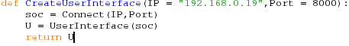
This should connect to 192.168.0.19 and return a UserInterface object.
This function operated correctly as a working UserInterface object was returned.
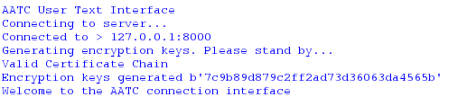
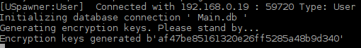
Confirmation on the server side that the User connected correctly.

2:

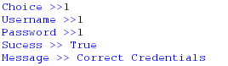
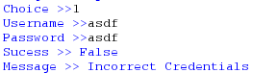
The correct login above indicated that is sucessfully logged in while the non valid login did not. Both returned relevant messages and success values.

3:
Until the user has logged in the server should not allow the user to access forbidden functions.
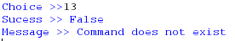
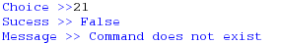
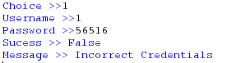
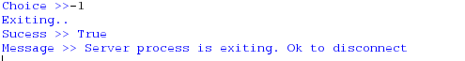
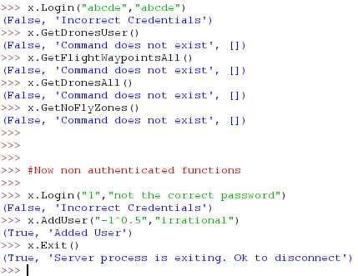
Only the non authenticated functions were run, the others indicated that the command was not accessible.

4:
The program correctly only allows access once logged in.
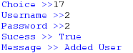
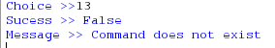
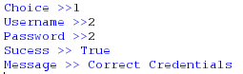
The user is correctly added and is able to login and call the function again, this time sucessfully.

5:
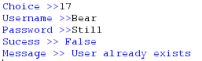

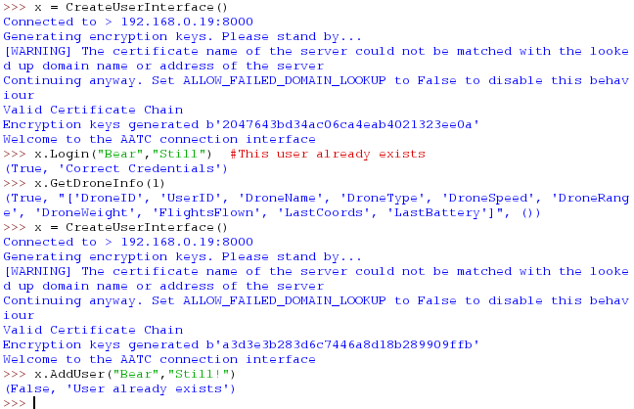
The User is shown to exist. Attempting to add the user returns a failure message displaying that that user already exists.

6.

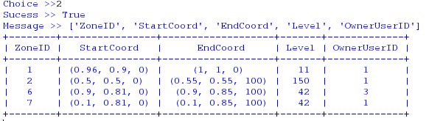
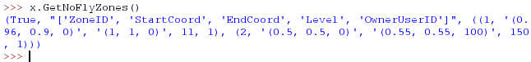
The function sucessfully obtains the NoFlyZones and the table headers for the table in string form.

7.
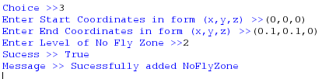
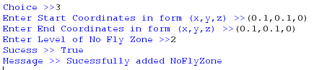
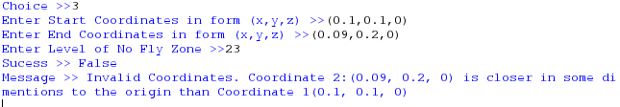
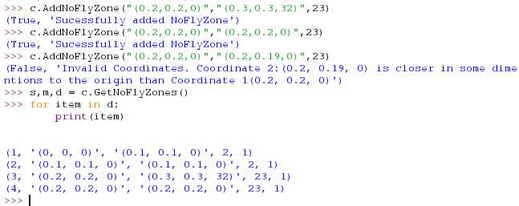
The valid NoFlyZones are added, the invalid ones are not. Only the valid NoFlyZones have been added to the NoFlyZone table ( first two of each set).

8.
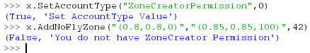
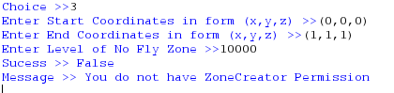
When the ZoneCreatorPermission is set to 0 one is not allowed to add NoFlyZones. In this test the adding of a NoFlyZone fails if the ZoneCreatorPermission is set to 0 as expected.
9.

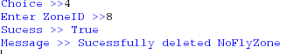
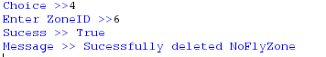
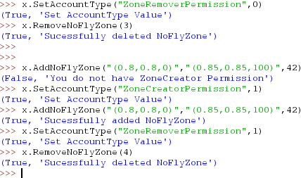
Both with and without the ZoneRemoverPermission the User is able to remove their own NoFlyZone.

10.
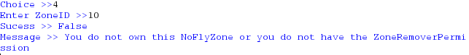
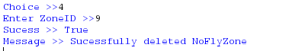
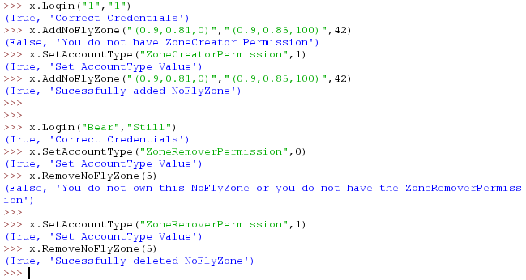
Only was able to sucessfully remove NoFlyZone when ZoneRemoverPermission was set to 1. Relevant message was sent on both occasions.

11.
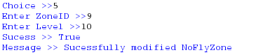
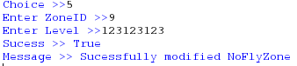

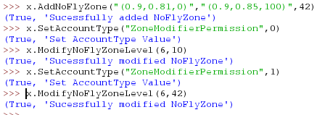
The NoFlyZone level was correctly modified on each occasion.

12.
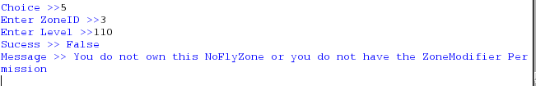

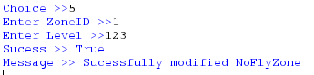
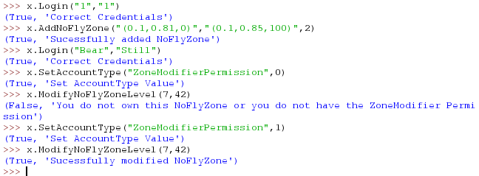
The NoFlyZone was only modified on the occasion where ZoneModifierPermission was set to 1. A relevant message was sent on both occasisons.

13.
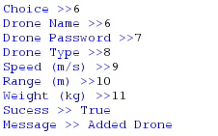
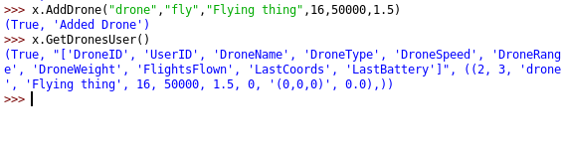
The Drone was correctly added to the users drone list with the details set in the command.

14.
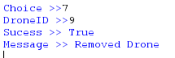
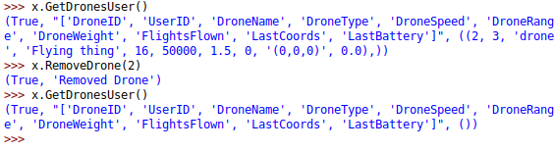
The Drone is sucessfully removed if the user owns the drone.

15.
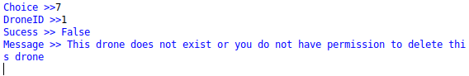
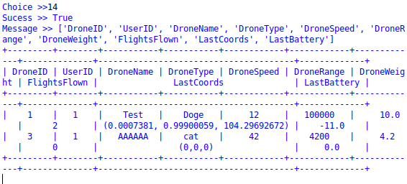
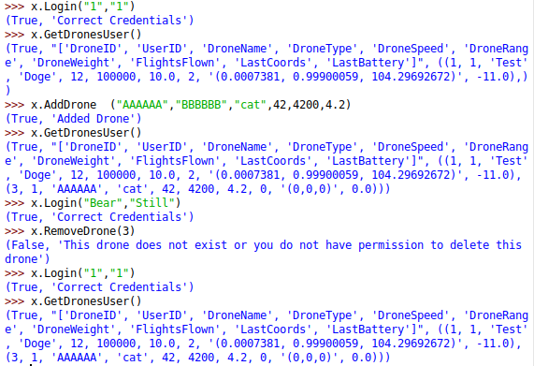
The first user logs in and creates a drone (ID = 3). The other user then logs in and attempts to remove the drone, but fails receiving an appropriate error message. The Drone still exists after.

16.
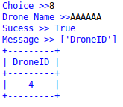
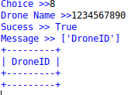

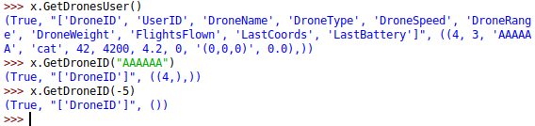
The drone which exists is identified while the one which doesnt is not identified and a DroneID is not returned, as expected.

17.
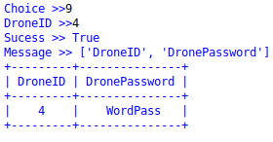
The drone credentials are correctly returned to the user in plain text format. This password must be stored on the drone in order for the drone to be able to identify itself.

18.

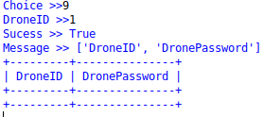
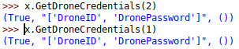
The credentials are correctly not returned. This would prevent another user obtaining the drone credentials if the drone does not belong to them.

19.
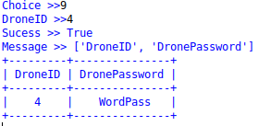
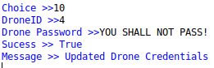
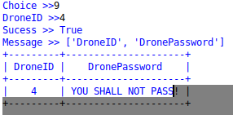
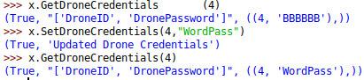
The drone credentials are correctly changed. Changing these values frequently would be a good security practice.

20.
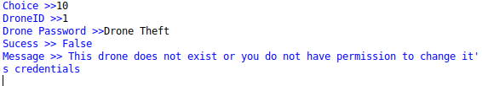
The Drone credentials were not changed, warning message shown.

21.
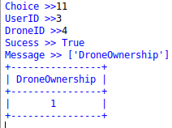
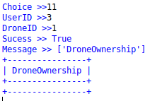
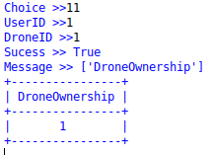
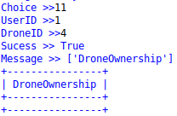
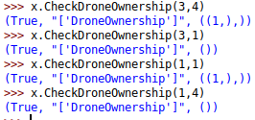
Ownership was correct in all cases. This allows a user to identify which drones are linked to certain userIDs.

22.
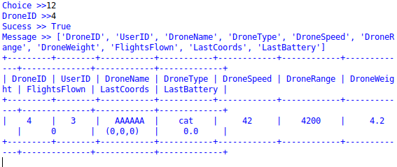
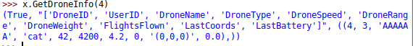
Sucessfully obtained information. The data tuple contains a tuple with the information about the drone.

23.
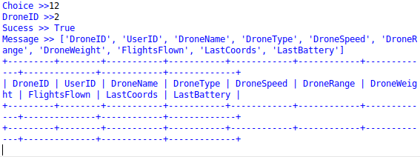

Did not obtain information as expected. This would prevent theft of drone information by another user.

24.

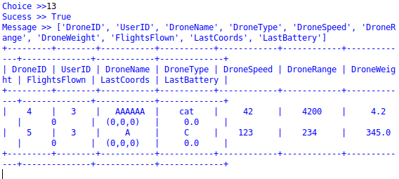
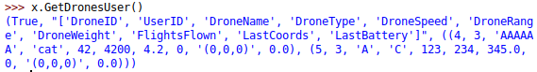
Obtained all drones for current user. Each drone is shown with the relevant information about the drone.

25.
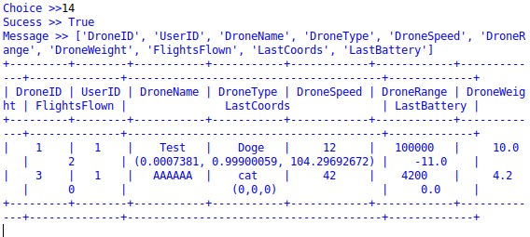
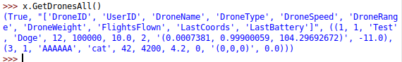
Sucessfully obtained all publicly visible drones. This allows the drones to be viewed by other users.

26.
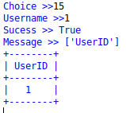
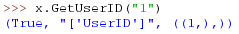
UserID correctly obtained. This could be used to check if a given username actually linked to a specific UserID.

27.
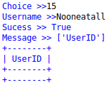
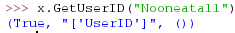
UserID is not returned as desired. This function can also be used to check which Usernames and therefore users exist.

28.
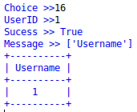
Username correctly obtained. This returns the username of the UserID. This could be used to obtain the username of a found UserID.

29.
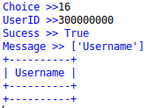
Username correctly not obtained. This could be used to check if a given userID is in use or to find out how many Users are registered.

30.
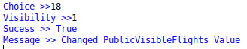
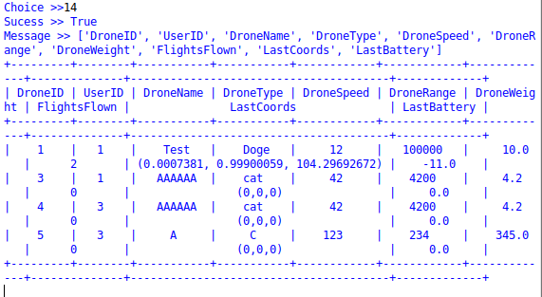

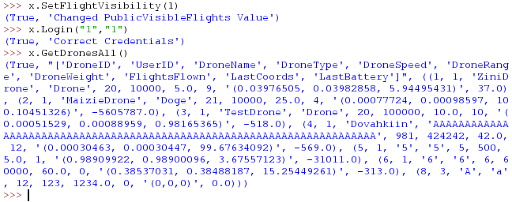
Drones are correctly visible (last drone belongs to the new public user). The information of these drones are now shown to any other users.

31.
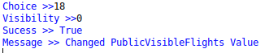
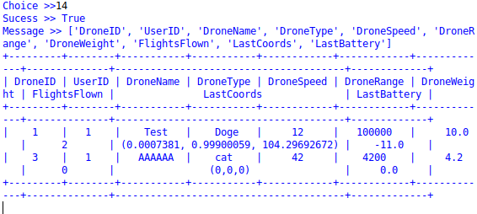
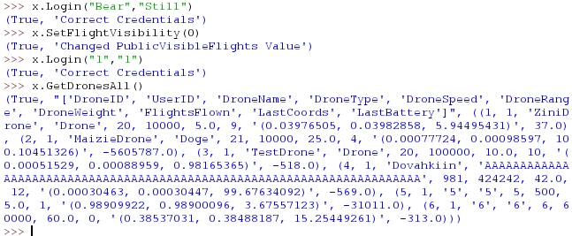
The drones belonging to the user are no longer visible to user “1”. The other users now cannot view the information about these drones.

32.
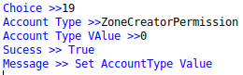
ZoneCreatorPermission correctly changed. This user may now create NoFlyZones.

33.
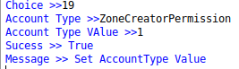
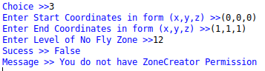
Permission was not changed as the PermissionAdder value was less than or equal to 2 and so may not change their permissions.

34.
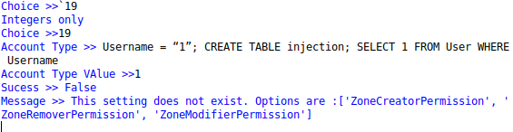
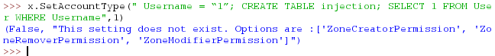
Injection was prevented by whitelisting possible values. A user cannot use this to access the database.

35.
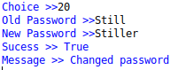
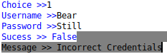
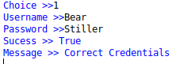
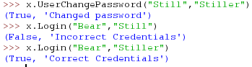
Password correctly changed. Changing passwords would be recommened to take place frequently.

36.
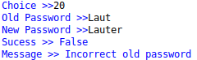
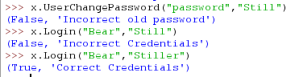
Password was correctly not changed. This prevents someone who has access to the logged in user session to alter the password.

37.
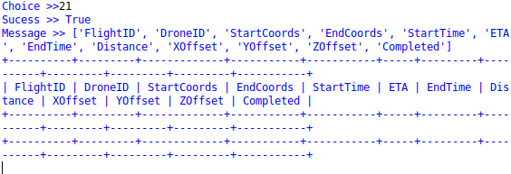
Flights of the user are obtained (non at this point in time). All the details of the flights are returned.

38.
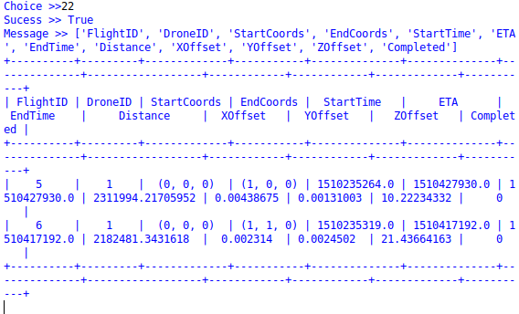
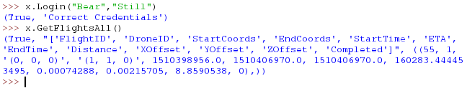
Obtained public flights. All flights can be observed by the User and / or used for other tasks.

39.
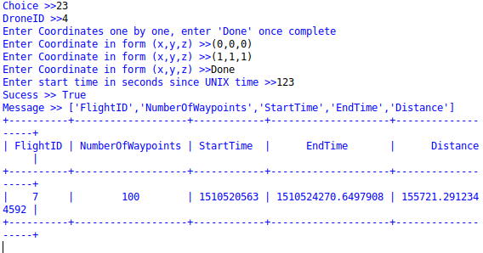
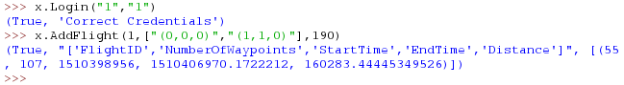
Correctly added a flight. The flights paths are calculated and general details of which are returned i.e. the number of waypoints, the ETA and flightID.

40.
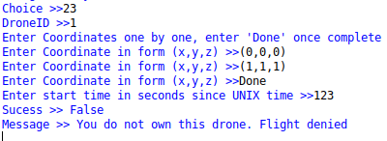
Flight was denied due to lack of ownership. This prevents other users launching drones which do not belong to them.

41.
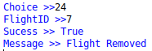
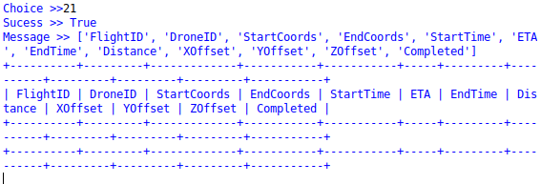
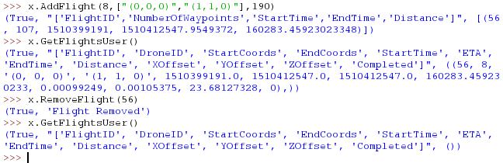
Flight correctly removed. The flight may be cancelled in this manner if the drone has not yet started the flight.

42.
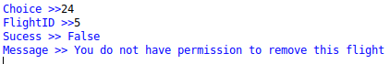
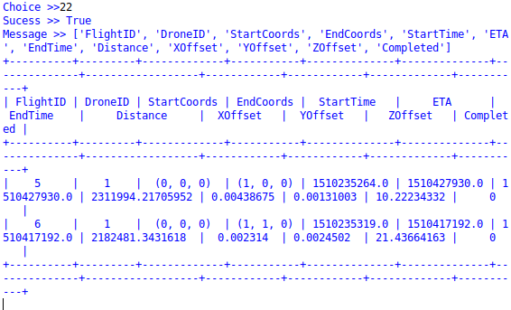
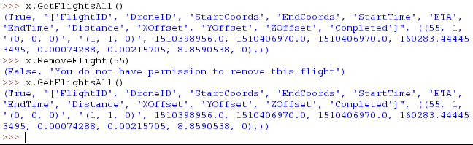
Flight is not removed as the user does not have the permission to remove the flight. This prevents other users cancelling flights which do not belong to them.

43.
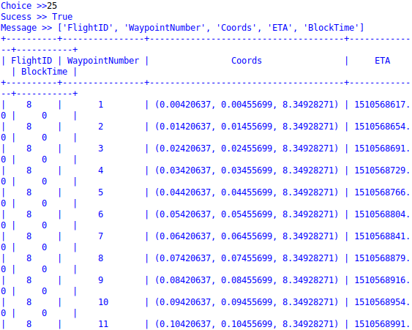
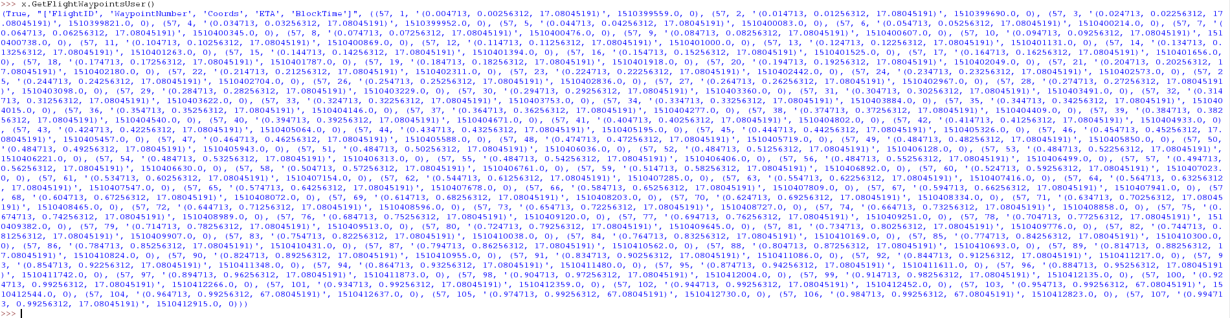
Correctly obtained all flight waypoints. These are all the flight waypoints for flights belonging to the user. This can be used to observe the path the drone will take.

44.
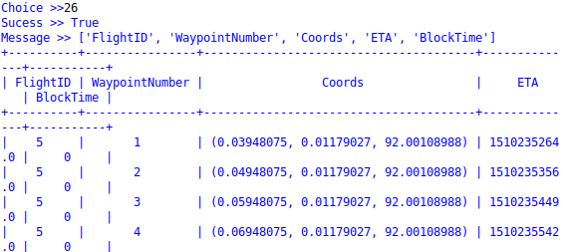
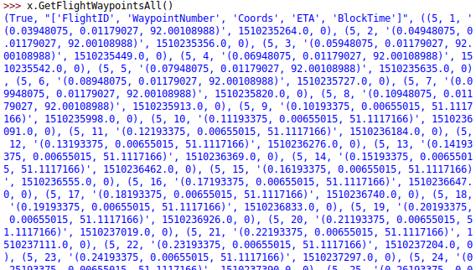
Correctly obtained all public waypoints. These contain the details for each of the public waypoints.

45.
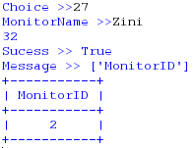
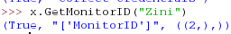
Correctly obtained the monitor ID. This can be used to obtain the MonitorID from a MonitorName to add a monitor permission.

46.
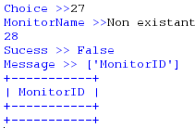
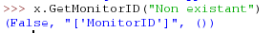
Correctly did not obtain the monitor ID. This can be used to check if a monitor exists.

47.
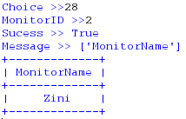
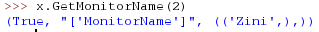
Correctly obtained the monitor name. This can be used to obtain a monitor name from a monitorID i.e. to identify which monitors have monitor permissions from that User.

48.
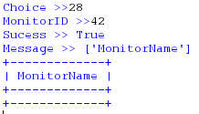
Correctly did not obtain a monitor name. This can be used to check if a monitorID is linked to an existant monitor.

49.
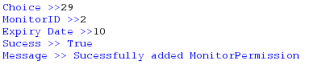
Monitor permission correctly added. This monitor may now access the drones, flights and flight waypoints belonging to that user.

50.
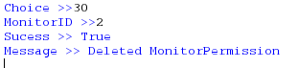
Monitor permission correctly added. This can be used to cancel a permission early.

51.
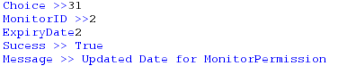

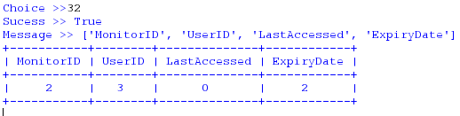
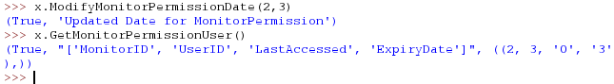
Correctly modified the monitor permission dates for that Monitor Permission. This can be used to extend or shorten the duration of a permission.

52.
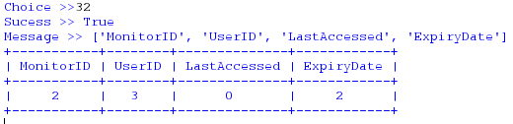
Correctly obtained the monitor permissions for that user. This can be used to view each permission for that user.

53.
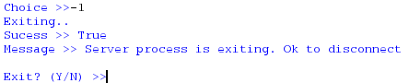
If Y is entered the program will close, if N the program will restart.

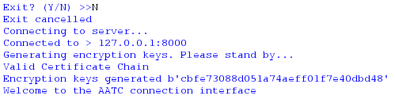
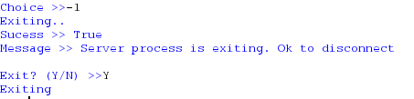
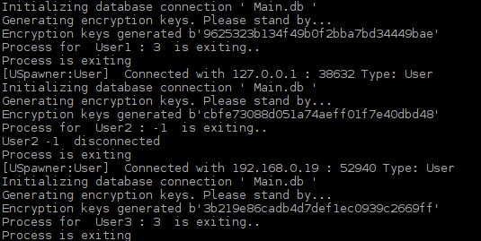
All correctly exited. This allows the connection to be gracefully exited, ensuring both sides are ready to exit communications.

