Setup

1. Install python 3 using the latest installer or a package manager of choice.
2. Install the required packages
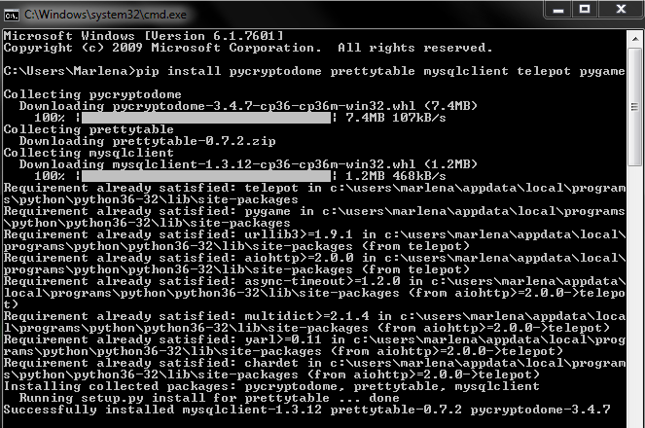
3. Install Mysql Server
Linux :sudo apt-get install mysql-server
Windows: Install the .Net Framework and the MySQL server

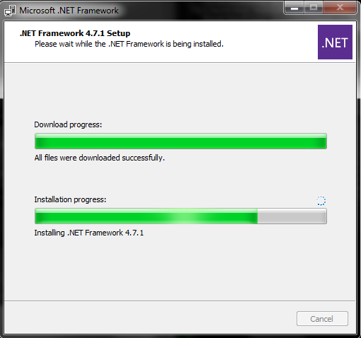

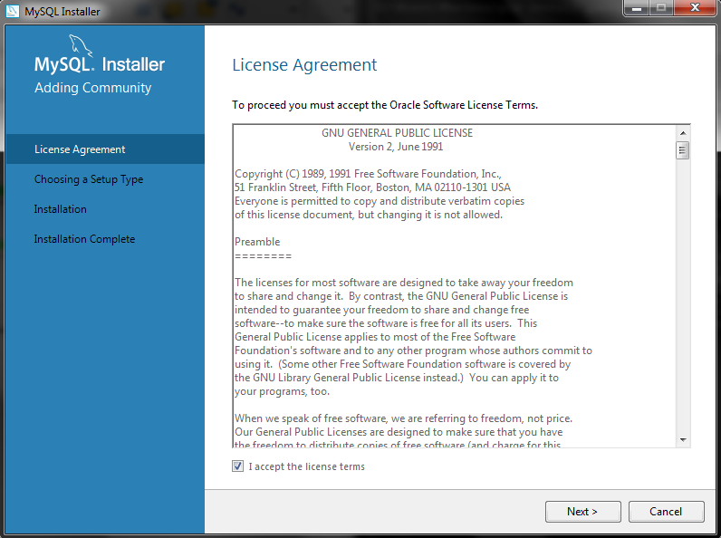
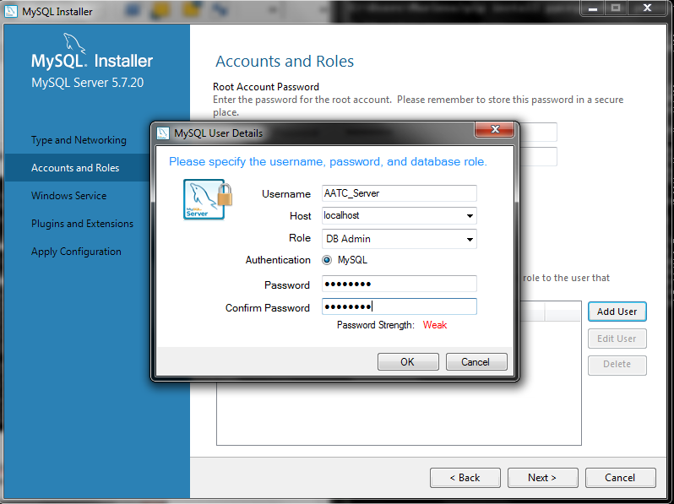
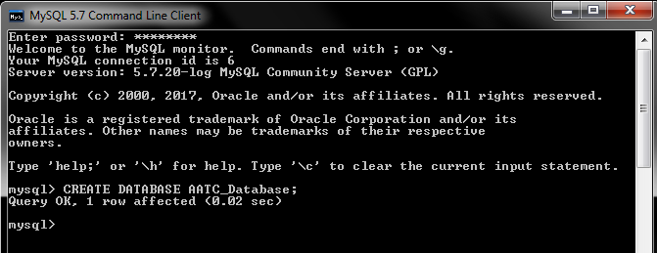

4. Launching server. If launching the server for the first time one must initialise the database using the AATC_DB.py file. Run the commands below to setup all tables.

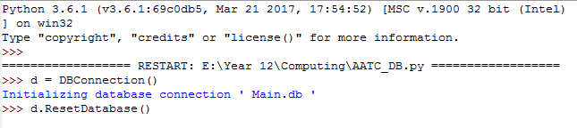
Then launch the AATC_Server_Starter.py file in the command line.
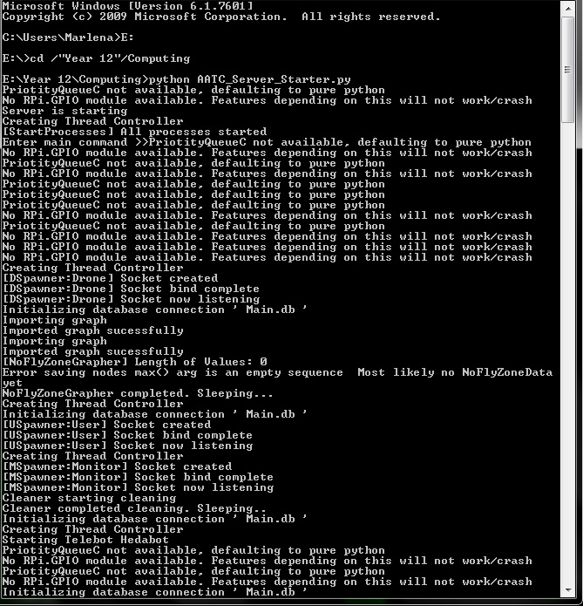

5. Creating a graph. Create a folder called GraphFolder in the same directory as the main files. Then launch AATC_Create_Graph.py Enter the desired settings and wait for the graph to be created.

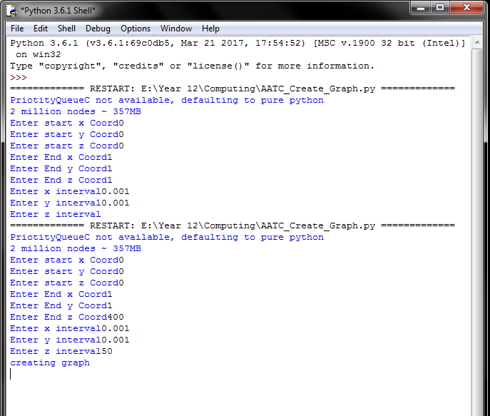

The server should now be setup.

