TestID | Description | Test Data | Expected outcome
1 | Testing that the program forms a connection with server and returns a UserInterface object | Run CreateUserInterface with default parameters. | Text should appear showing a connection was formed and a UserInterface object should be returned.
2 | Testing that is it possible to log in the the server. | Entering one functioning login and one non functioning login. | The functioning login should login in correctly while the non functional version should not.
3 | A non authenticated User should not be able to access any other function but Exit,Login,AddNewUser | Fail to login using incorrect credentials and attepmt to run various authenticated only commands, Then some commands which can be used without logging in. | The authenticated only commands should return failure while the others should function correctly.
4 | Testing if adding a User functions. | Add a new user and attempt to use an authenticated only function and then login and run the same function again. | The user should be added , but not logged on, and therefore the function should not work. Once logged on the function should work.
5 | Testing Adding a User which already exists | Adding an already created user. | The adding of a User who already exists should fail with the error that the user already exists.
6 | The function GetNoFlyZones works correctly. | Run the GetNoFlyZones function on a logged in user. | The function should return True, A message list and a tuple with the no flyzones.
7 | Adding a NoFlyZone | Entering a valid no flyzones (a <= b for all dimentions ) and a non valid no fly zone. Subsequent fetching of the noflyzones. | The valid no fly zone should be added while the non valid no fly zone should be rejected with an error. When fetching noflyzones only the valid noflyzone should have been added.
8 | Adding NoFlyZone without ZoneCreatorPermission (with permission demonstrated previously) | Using a user without the ZoneCreator Permission attempt to add a valid NoFlyZone. | The attempt should fail with the permission error message.
9. | Removing a NoFlyZone which belongs to oneself. | Remove a NoFlyZone which was created by that User. With and without the ZoneRemoverPermission. | The User should be able to remove the NoFlyZone even if they don't have the ZoneRemoverPermission.
10. | Removing another user's NoFlyZone. | Two attempts to remove the NoFlyZone. With the ZoneRemoverPermission and without. | When ZoneRemoverPermission is set to 0 the attempt should fail. When set to 1 it should suceed.
11 | Modifing an NoFlyZone which belongs to oneself. | Two attempts to modify. With and without ZoneModifierPermission. | Both occasions should allow the NoFlyZone to be modified.
12 | Modifing a NoFlyZone which belongs to another User. | Two attempts to modify. With and without ZoneModifierPermission. | Only with ZoneModifierPermission is set to 0 should the NoFlyZone be modified.
13 | Adding a new drone | Data for a new Drone “drone” with password “fly” , type “Flying thing” , speed 16 m/s , range 50000 m and weight 1.5 kg | A confirmation should indicate that the drone was added and the drone should turn up in the users drone list.
14 | Removing a drone belonging to oneself | Remove a drone owned by the users | The confirmations should show the drone was removed as well
15 | Attempting to remove a drone which does not belong to oneself. | Attempt to remove a drone which belongs to another user. | The drone should not be removed and an appropriate message must be returned.
16 | Get the DroneID of a drone. | Get the DroneID of two drones, one which exists, one which doesn’t. | The existing drone should have it’s ID returned while the non existant one should not.
17 | Get the DroneCredentials of a drone which one owns | Get the DroneCredentials of a drone which one owns. | The Drone credentials should be returned for that drone.
18 | Attempt to get the DroneCredentials of a drone which does not belong to oneself. | Attempt to get credentials of drones which one doesnt own. | No credentials should be returned.
19 | Change the drone credentials of a drone which one owns. | Change the drone credentials of a drone which one owns. | The Drone credentials should have been changed.
20 | Attempt to change the drone credentials of another users drone | Change the drone credentials of another users drone | The drone credentials must not be able to be changed, error message should be shown.
21 | Check drone ownership | Check ownership of a drone which belongs to the user and one which does not.  Repeat with swapped UserIDs | User’s drone should be 1 while the other one should not.
22 | Get the drone info of a drone owned by the user. | Get the drone info of a drone owned by the user. | Should return the information of that drone to the user.
23 | Get the drone info of a drone not owned by the user. | Get the drone info of a drone not owned by the user. | Should not return the information of that drone to the user.
24 | Get Drones User. | Get all the drones for a single user. | Should return all the drones of that user.
25 | Get Drones all. | Get all publicly visible drones. | Should return all publicly visible drones.
26 | Get UserID | Get the userID a username which exists | Should return the userID
27 | Get UserID of non existant username | Attempt to get the UserID of a non existant username. | Should not return a UserID
28 | Get Username | Get the username of an existing UserID | Should return the UserID of that user.
29 | Get Username of user who does not exist | Attempt to get the Username of a non existant user. | Should not return the Username.
30 | Set flight visibility to 1 | Set Flight visibility to 1 and see if other user can see drones etc | Other user should be able to see drones
31 | Set Flight visibility to 0 | Set Flight visibility to 0 and see if other users cannot see drones etc | Others should not be able to see drones.
32 | Change Account Type | Change the account type of the user. | Should change account type
33 | Change Account type with Permission adder <= 2 | Attempt to change the account type of the user. | Should not change account type.
34 | Change account type with non registered column | Attempt SQL injection by using the account type “ Username = “1”; CREATE TABLE injection; SELECT 1 FROM User WHERE Username” | Should not be allowed. Warning returned.
35 | Changing password. | Change users password. | Password should be changed
36 | Attempt to change password with incorrect old password | Attempt to change password with incorrect old password | Password should not be changed.
37 | Get Flights User | Get all the flights of the user | Shoudl return all the flights of the user.
38 | GetFlights all | Get Flights of all publicly visible accounts. | Should return all publicly visible flights.
39 | AddFlight | Add a flight of a drone belonging to the user | A new flight should be added and details returned.
40 | Attempt to add other usre's drone to flight | Attempt to user another user's drone when creating a flight. | Flight should not be created / failure returned.
41 | Remove a flight | Remove a flight created by the user. | Flight should be removed.
42 | Remove a flight of another user. | Attempt to remove the flight of another user. | Flight should not be removed due to a lack of ownership.
43 | Get Flight waypoints of the user. | Obtain the flight waypoints of the user. | Return the waypoints of the user.
44 | Get Flight waypoiints all | Obtain all the flight waypoints made visible. | Return all publicly visible waypoints.

1:
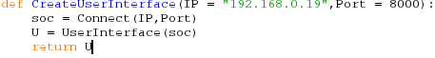
This should connect to 192.168.0.19 and return a UserInterface object.
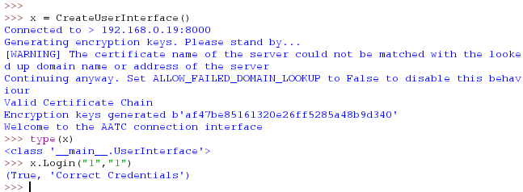
This function operated correctly as a working UserInterface object was returned.
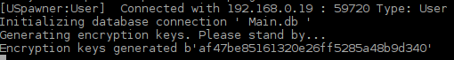
Confirmation on the server side that the User connected correctly.

2:
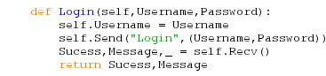
This should return True if the login suceeded and False if it did not, with appropriate messages for both outcomes.

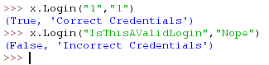
The correct login above indicated that is sucessfully logged in while the non valid login did not. Both returned relevant messages and success values.

3:
Until the user has logged in the server should not allow the user to access forbidden functions.

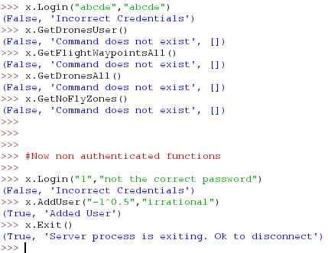
Only the non authenticated functions were run, the others indicated that the command was not accessible.

4:
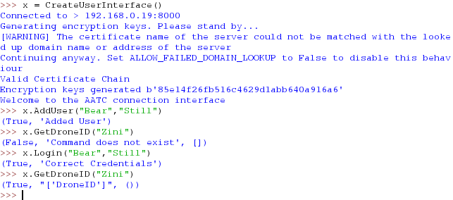
The program correctly only allows access once logged in. The user is correctly added and is able to login and call the function again, this time sucessfully.

5:
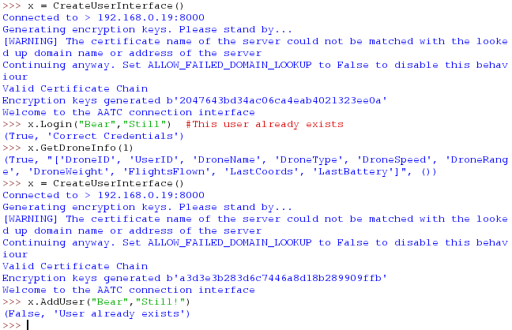
The User is shown to exist. Attempting to add the user returns a failure message displaying that that user already exists.

6.
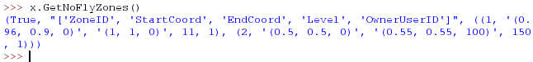
The function sucessfully obtains the NoFlyZones and the table headers for the table in string form.

7.
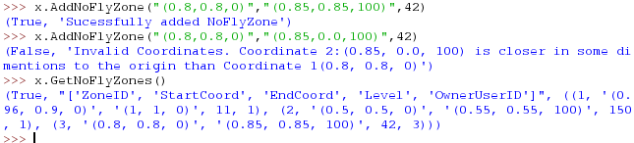
The valid NoFlyZone is added, the invalid one is not. Only the valid NoFlyZone has been added to the NoFlyZone table.

8.
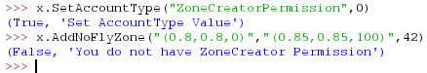
When the ZoneCreatorPermission is set to 0 one is not allowed to add NoFlyZones. In this test the adding of a NoFlyZone fails if the ZoneCreatorPermission is set to 0 as expected.
9.
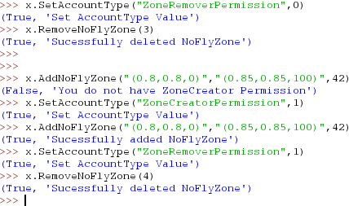
Both with and without the ZoneRemoverPermission the User is able to remove their own NoFlyZone.

10.
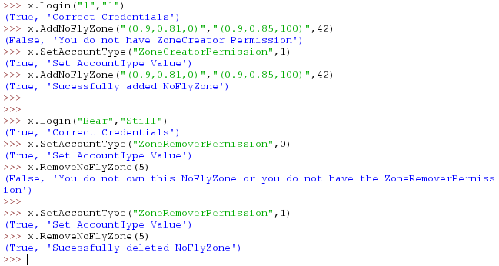
Only was able to sucessfully remove NoFlyZone when ZoneRemoverPermission was set to 1. Relevant message was sent on both occasions.

11.
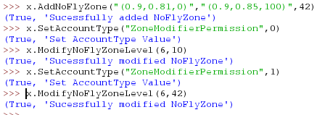
The NoFlyZone was correctly modified on both occasions.

12.
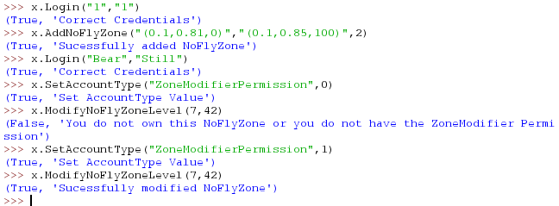
The NoFlyZone was only modified on the occasion where ZoneModifierPermission was set to 1. A relevant message was sent on both occasisons.

13.
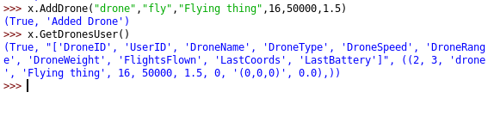
The Drone was correctly added to the users drone list.

14.
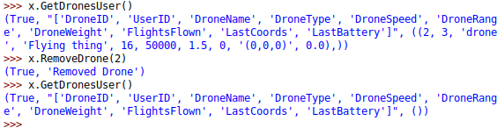
The Drone is sucessfully removed if the user owns the drone.

15.
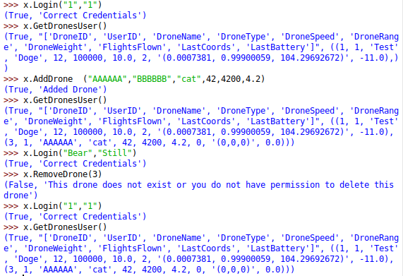
The first user logs in and creates a drone (ID = 3). The other user then logs in and attempts to remove the drone, but fails receiving an appropriate error message. The Drone still exists after.

16.
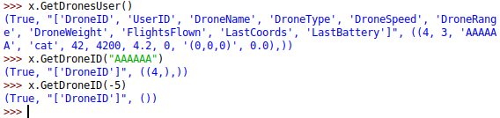
The drone which exists is identified while the one which doesnt is not identified.

17.
The drone credentials are correctly returned.

18.
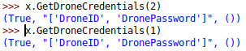
The credentials are correctly not returned.

19.
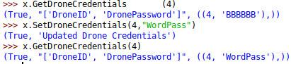
The drone credentials are correctly changed.

20.
The Drone credentials were not changed, message shown.

21.
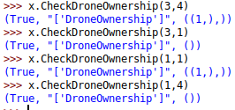
Ownership was correct in all cases.

22.
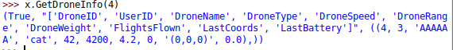
Sucessfully obtained information

23.
Did not obtain information as expected.

24.
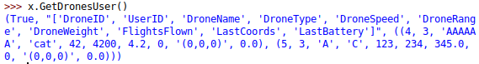
Obtained all drones for current user.

25.
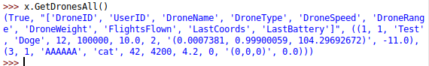
Sucessfully obtained all publicly visible drones.

26.
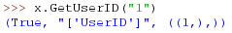
UserID correctly obtained

27.
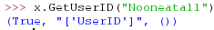
UserID is not returned as desired.

28.
Username correctly obtained.

29.
Username correctly not obtained.

30.
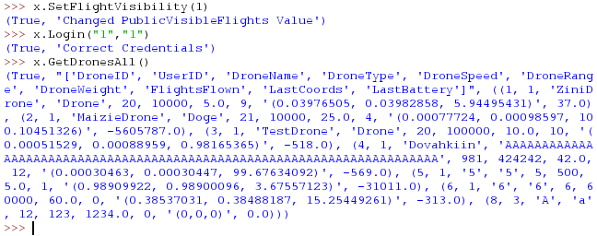
Drones are correctly visible (last drone belongs to the public user)

31.
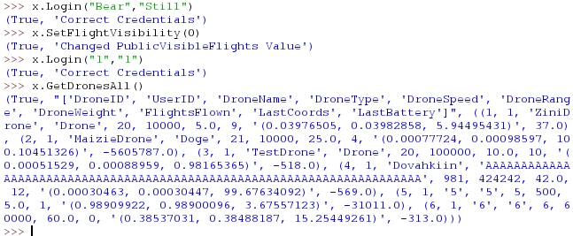
The drones belonging to the user are no longer visible to user “1”

32.
ZoneCreatorPermission correctly changed

33.
Permission was not changed

34.
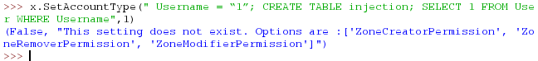
Injection was prevented by whitelisting possible values.

35.
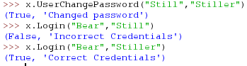
Password correctly changed.

36.
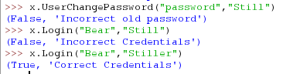
Password was correctly not changed.

37.
Flights of the user are obtained (non at this point in time])

38.
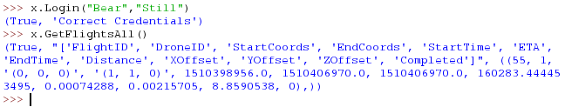
Obtained public flights.

39.
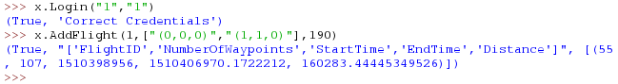
Correctly added a flight

40.
Flight was denied due to lack of ownership.

41.
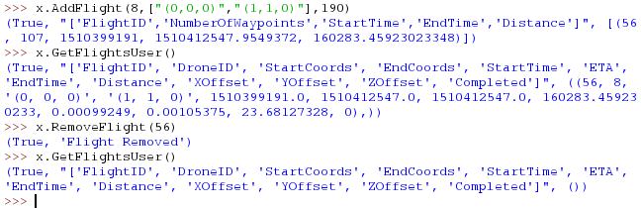
Flight correctly removed.

42.
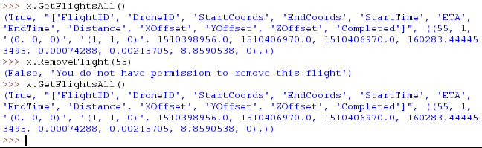
Flight is not removed as the user does not have the permission to remove the flight.

43.
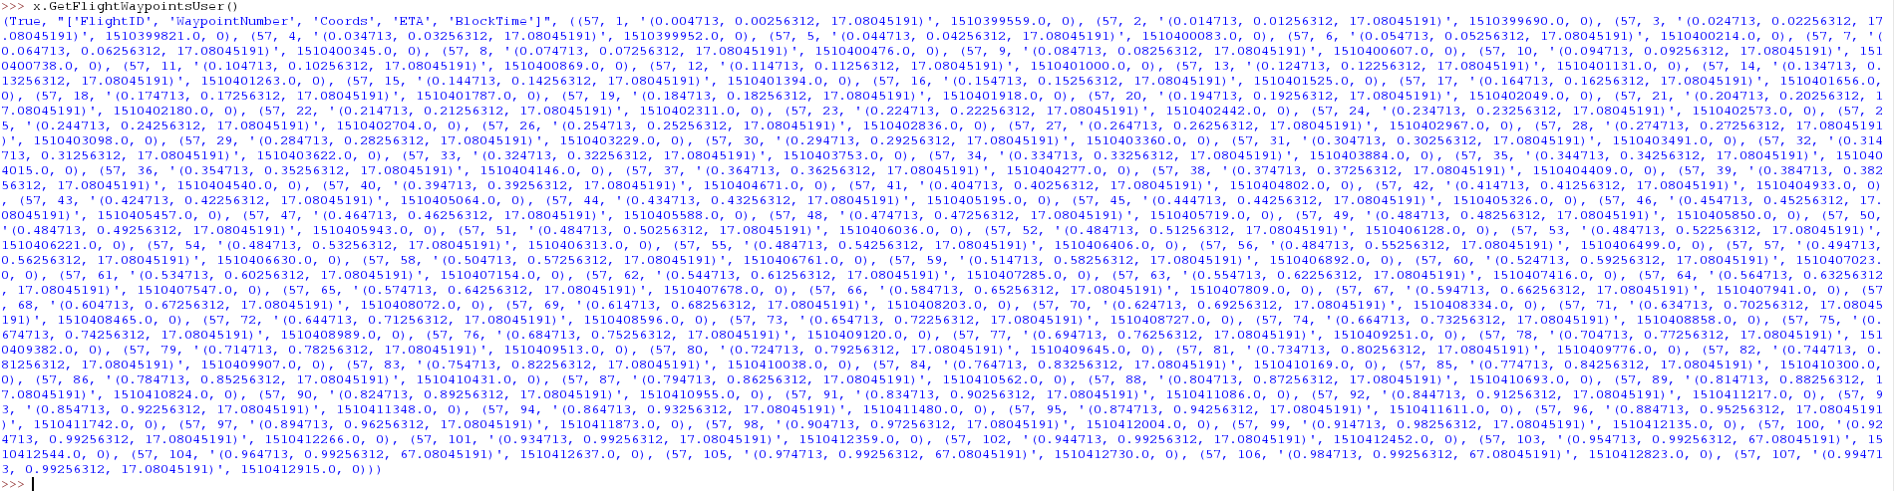
Correctly obtained all flight waypoints.

