AATC_Drone_Logic.py
TestID | Test Description | Test Data | Expected outcome.
1 | Startup.  The startup function starts the main components for Drone_Logic to function. This involves connecting and logging into the server with the passed credentials. | Startup the drone with a valid login | The drone should connect and login sucesfully.
2 | Startup with an invalid login. This is to test that a drone which does not know the correct DroneID or password cannot log in. | Launch the drone startup with an invalid login. | The drone should connect, display a login error and wait 30 seconds to retry.
3 | Wait for button enable. This causes the drone to wait for the GPIO button to be pressed before it searches for a flight. | The enable button is set to wait for 1. | The program should not continue until the button is pressed. Yellow LED should be flashing.
4 | Flight Check mode indication. This is when the drone is waiting for a flight. A print statement should indicate the state of the LED, switching in a pattern of 5 seconds on, 1 second off. | Enter flight check mode with no flight available. | Output should mimic the LED indicator, waiting until a flight is available.
5 | Obtain flight. The drone must be able to request the information for a flight from the server, then reconnecting to the server when it switches to Run Flight mode. | Create a flight and startup drone. | Drone should collect flight information and enter flight run mode.
6 | During flight location indicator. This will show the current waypoints the drone has passed, showing the drone is moving along the correct path. | Run flight and allow drone to pass waypoints | Drone should pass through waypoints and indicate current waypoint.
7 | Update status during flight. The drone should send the current coordinates and battery level to the server so that users can track their drones. | During flight the status should be updated. User should check coords are on flight path | The coordinates of the drone should be on the flight path.
8 | During flight failure of connection to server. During flight the server may loose connection to the drone such as flying into an area of no service. The drone should be able to recover from this error. | Crash the server and observe the drones response. The crashing of the server simulates the loss of connection to the server. | Drone should recover and reconnect.
9 | Flight completion procedure. In order to prevent a flight being flown again / to be able to check a flight has been flown the flight should be marked as complete once completed. | When flight completes observe drone behaviour. | Flight should be marked complete, drone should return to checking mode.
10 | Failure during check for flight. Flight Check is a seperate subroutine to Run flight the recovery system must work independantly. The drone must be able to recover from this. | Crash the server while the drone is in flight check mode and observe. | Should recover from error and reconnect.

Note: Some GPIO warnings may occur due to other items interfering with the settings of the GPIO pins. If these are not cleared then a warning will appear I.e if another drone has setup that pin and was force killed to perform the next test (cannot kill a thread within IDLE).

Note 2: Time delays cannot be shown for example in the case of waiting for the enable button.

Note 3: The battery level of the drones will often be far below 0. This is because they are being flown over 200km when a range is set to ~ 40km.

1.
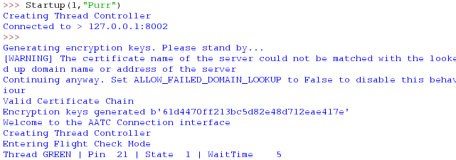
Sucessfully connected and logged in (Entering flight check mode only occurs on a successful login).

2.
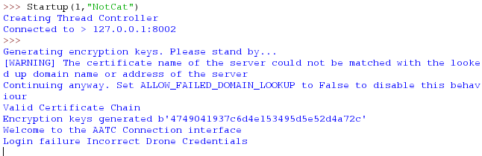
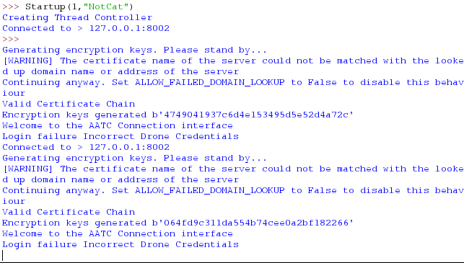
Sucessfully connected and started, failed login discovered and restart attempted. Logging in with incorrect credentials must not be allowed. However the drone must attempt again in case the user later changes the credentials and the drone can login without a restart required.

3.
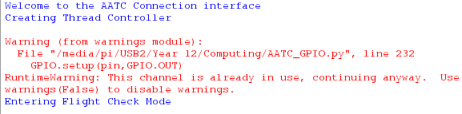
Sucessfully waited until button pressed. (Warning was due to the channel being setup before). This button must be waited for in order to add a way to prevent starting of flights such as for maintainance.

4.
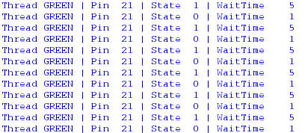
Sucessfully indicating waiting for flight. This represents the LEDs on the drone and signifies to any observer that the drone is active.

5.
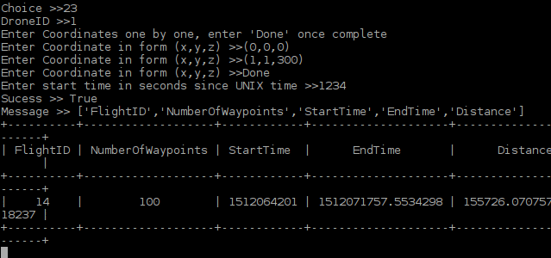
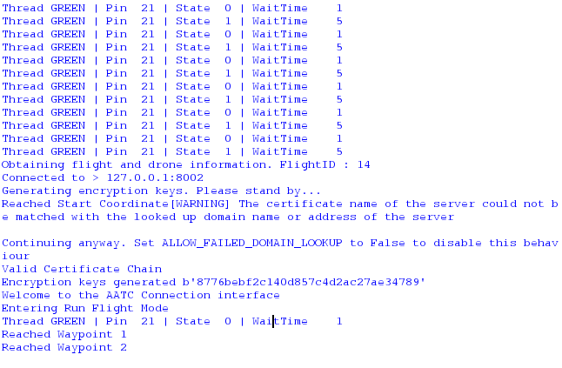
Correctly obtained flight details and started flight. This is required to follow the points which the server calculated.

6.
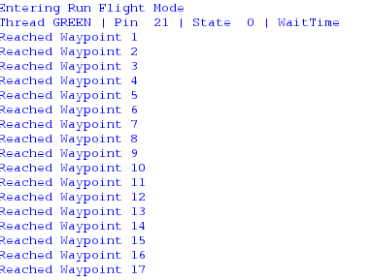
Drone sucessfully passing waypoints. This shows the drone is flying along the correct path (if the drone did not follow this path the messages would not appear).

7.
Sucessfully updated status. Coordinates on the flight path. This allows the user or monitor to trace the location of the drone during flight to aid management and recovery.

8.
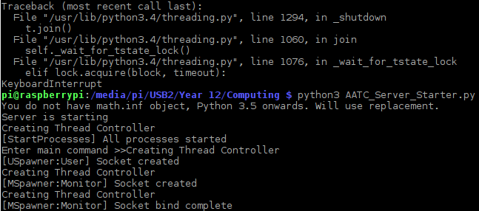
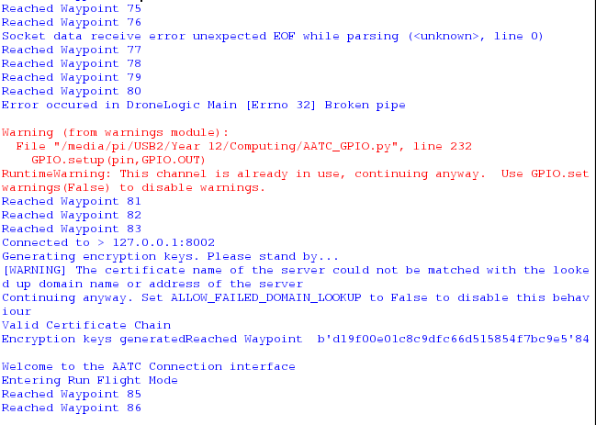
Correctly recovered from failure. Drone still transmitting status after recovery. This ensures that the drone remains functional even during a netowrk failure.

9.
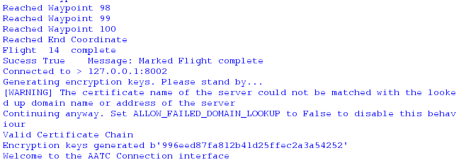
Flight sucessfully completed and marked as complete. This ensures the drone will not take the same flight again.

10.
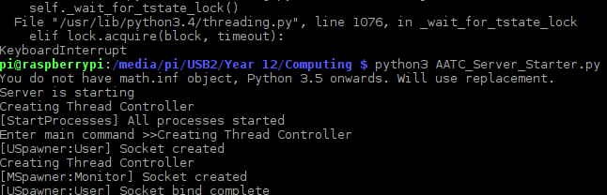
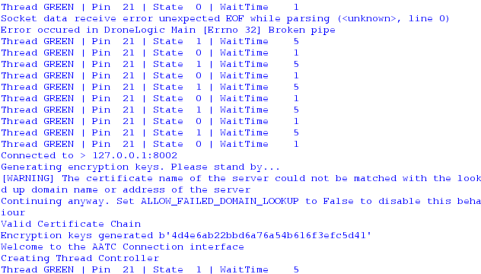
Sucessfully recovered from disconnect. The program sucessfully recovered from a failure in the connection during flight check.

