TestID | Test description | Test data | Expected outcome
1 | Starting no fly zone grapher. The NoFlyZone grapher once launched will remain active until it recieves an exit signal from the server. This check ensures the program starts and remains running, going to sleep once it completes its writing. | Start the no fly zone grapher | No fly zone grapher should be started.
2 | Updating costs. In order to map the No fly zones onto the graph the NoFlyZone grapher must obtain all nodes which are in a no fly zone and write the highest cost of each no fly zone which contains that node to the node file. Once the no fly zone grapher has completed the costs of the nodes in the no fly zone should be increased. | Find a node in the no fly zone (0.6,0.6,0),(0.7,0.7,200) and check it’s cost. | The cost should be 123.
3 | Other nodes cost. The nodes not covered by a no fly zone should have default cost of 1. This ensures that these nodes remain identical to all other nodes which are not in the no fly zone and remain at the default cost of 1 with which the search algorithm works. Any cost greater than 1 is seen by the search algorithm as an obstacle. | Check another node’s cost | The cost should still be 1.
4 | No NoFlyZones. When the no fly zone grapher is run without any NoFlyZones in the database the program normally would crash as a specific function max is required in the saving of the graph nodes. This function obtains the maximum NodeID stored in the DynoGraph Node dictionary, should this be empty i.e. because the NoFlyZoneGrapher did not load any nodes the program would crash. This is to check that this error will be caught and a relevant message displayed. | Remove all no fly zones and run NoFlyZoneGrapher. | The program shouldn’t crash because of a lack of items for the max function in save nodes.

Note: This system normally requires a ThreadName and ThreadQueue as arguments when started in order to communicate with the thread controller. It is not possible to test this in this situation without starting the server , however the server cannot be used to test the functioning of the system as access to the functions of the class would be required.

1.
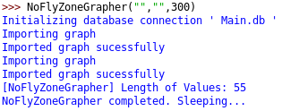
Sucessfully started no fly zone grapher. The grapher wrote the details for 55 of the nodes and went to sleep, to restart again in a specific amount of time.

2.
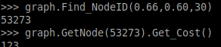
Cost is correctly set to 123. This node is in the no fly zone and therefore has had it's cost increased to that of the no fly zone.

3.
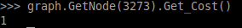
Cost is still correctly at 1. This node is outside of the No Fly Zone and therefore will not have it's cost increased from the default of 1.

4.
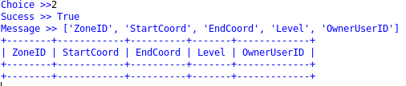

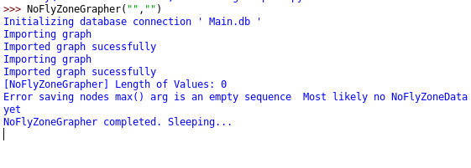
Correctly did not crash due to a lack of no fly zones. A relevant message is displayed showing the error and it's probable reason. The NoFlyZone grapher recovers from the error and continues to function.

