TestID | Test Description | Test Data | Expected outcome
1 | Server Start-up. This is to check that the server correctly starts. | Starting up the server | Server should set itself up.
2 | User connects. This is to show that a user may connect and that the server will display this fact. | Connect a user to the server | Server should show the user connects.
3 | User uses unregistered command. This is enable d to display if a user uses unregistered commands as either the server may not be correctly configured or the user may be using an incompatible version of the client program. | The user should use an unregistered command | The server should display this event
4 | User disconnects. The server will display when a user disconnects. | Call exit on user side | Should display the user is exiting.
5 | Monitor connects. This is to show that a monitor has connected. | Connect a Monitor to the server | Server should show the Monitor connects.
6 | Monitor uses unregisted command. This is enable d to display if a monitor uses unregistered commands as either the server may not be correctly configured or the monitor may be using an incompatible version of the client program. | The Monitor should use an unregistered command | The server should display this event
7 | Monitor disconnects. This is to show that a monitor has disconnected. | Call exit on Monitor side | Should display the Monitor is exiting.
8 | Drone connects. This is to show a drone has connected. | Connect a Drone to the server | Server should show the Drone connects.
9 | Drone uses unregistered command. This is enable d to display if a drone uses unregistered commands as either the server may not be correctly configured or the drone may be using an incompatible version of the client program. | The Drone should use an unregistered command | The server should display this event
10 | Drone disconnects. This it to show the drone has disconnected. | Call exit on Drone side | Should display the Drone is exiting.
11 | Server exit. This is to check that the server will send the exit command to all it’s sub processes. | Call EXIT in server console. | Processes should exit where possible.
12 | Sleeping process exit. The processes which are waiting for a connection will interrupt until a connection is formed, therefore not receiving the exit command until a new connection is formed. This check ensures that the connection process will exit once an exit command has been received and a connection has been made. | Once exit has been called connecting to a spawner will shut it down. | The process spawner should shut down.
13 | Crashing connection. This is to show the server will be able to recover from a uncleanly closed socket connection i.e. network failure. | Killing a connection. | Server should indicate that an error occurred.
14 | Cleaner. This is to check that the cleaner process works. The cleaner process removes all old information from the database to retain performance. | Check that the cleaner started and completed | Cleaner should start and go back to sleep. No old flights should be in the database.
15 | No Fly zone grapher. This is to ensure the no fly zone grapher process has started. | Check no fly zone grapher started and went to sleep | No fly zone grapher should have started

1.
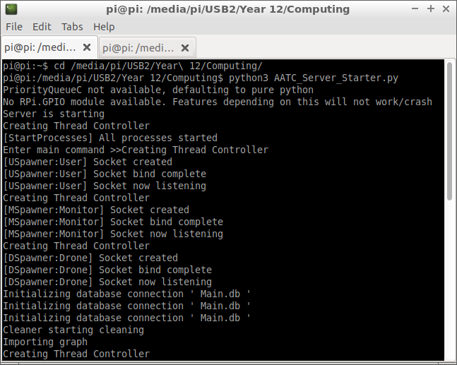
Server correctly started, all sub processes started.

2.
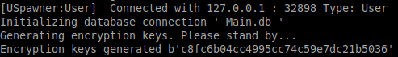
User correctly connected and displayed. This displays that a user connected to the server and that the encryption keys were setup.

3.
Successfully presented that the user attempted to use an unregistered command. This sent the command “asdf” to the server and the server detected that this command did not exist and displayed a warning.

4.
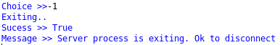
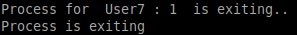
System successfully exited. This displayed that the connection to the user has closed.

5.
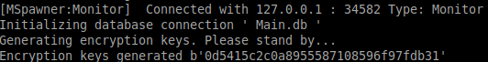
Sucessfully connected. This displays that a drone connected and that the encryption setup completed sucessfully.

6.
Correctly displayed that an incorrect command had been used. This displays that the monitor tried to use an unregistered command, in this case Asdf.

7.
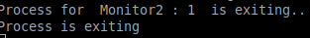
Correctly exited. This shows that the monitor correctly exited.

8.
Correctly logged in. This shows a drone connected to the server and that the encryption setup completed.

9.
Correctly displayed that an unregistered command had been used. The drone attempted to use the unregistered command and this was displayed.

10.
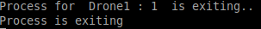
Correctly exited. The drone correctly closed the connection with the server.

11.
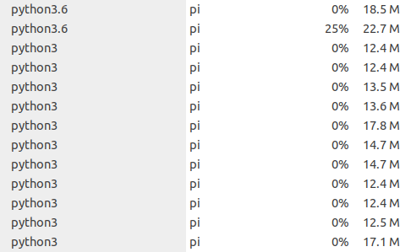
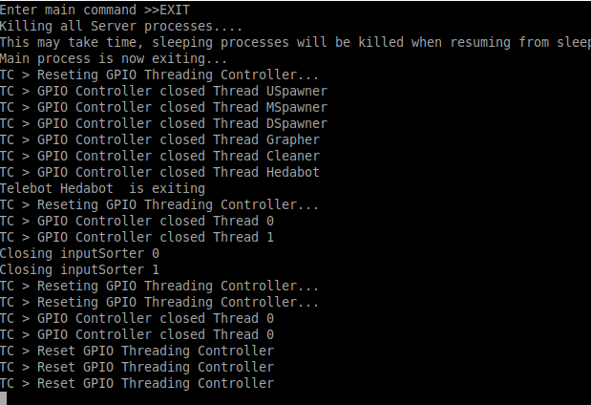
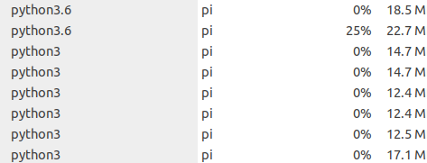
Most programs correctly exited. Most processes exited. The processes which still were present were from processes which were either sleeping or waiting for an incoming connection and will exit when they return and check the command queue. This function is used to tell all server processes to exit when possible.

12.
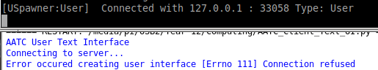
No longer can connect after the previous user connects. The previous user connect as displayed in the server log, then the user attempted to connect again, causing the connection to be refused as the user connection system had closed.

13.
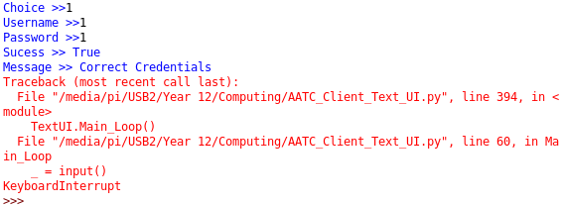
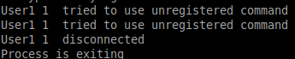
Correctly notified that an error occurred. The connection was killed by the user (simulating a network failure) and the socket raised errors on the server side. These errors were caught and the process correctly closed.

14.
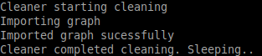
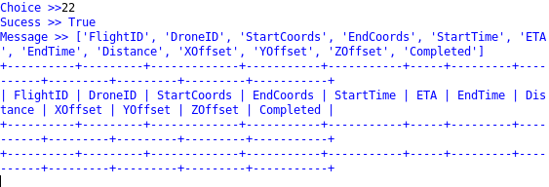
All old flights were cleaned (flights were there previously , same DB as rest of testing in most cases). Any old flights, flight waypoints, monitor permissions and other time limited components will be removed after a grace period.

15.
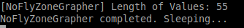
No fly zone grapher correctly functioned. The grapher will write the NoFlyZone details to the graph in a loop , checking for an exit command each time.

