Testing Document

COMP4981 – Assignment 03

Gabriel Seonghyoung Lee

Eunwon Moon

Contents

Introduction 2

Test Plan 2

Test Coverage 2

Test Strategy 2

Test Schedule 2

Test Cases 2

Index 7

# Introduction

This document explains the testing strategy for the Linux Chat Program project. It covers all the main elements (coverage, strategy, methods), as well as the list of test cases that the project will be tested against.

The focus of the testing will be the core functionalities of the project via manual testing. The testing will be performed by each individual members responsible for their own sections of the project. In addition, the application as a whole will be tested after the development stage is completed.

# Test Plan

This section covers the details of the testing that will be performed.

## Test Coverage

The testing will cover all aspects of the application: GUI, client, and the server. The intended coverage is the core functionalities and the predominately used areas such as: receive threads and font styles.

## Test Strategy

All the testing will be performed manually. Due to the straightforwardness of the project, unit testing and automated testing will only be “more trouble than its worth”.

## Test Schedule

All testing is to be performed at the end of the development stage. However, each sections of the code is to be tested before being committed to GitHub.

# Test Cases

|  |  |  |  |  |  |  |
| --- | --- | --- | --- | --- | --- | --- |
| Test ID | Test Description | Prerequisites | Test Data | Test Procedure | Expected Results | Pass/Fail |
| GUI | | | | | | |
| G1 | The application loads as intended. | * N/A | N/A | 1. Start the program. | The application loads onto the connection menu.  See Figure 1 | **Pass** |
| G2 | The application loads the client screen if all fields are set. | * Application started. | 127.0.0.1  7000  popo | 1. Input 127.0.0.1 to *Hostname/IP*. 2. Input 7000 to *Port*. 3. Input popo to *Nickname.* 4. Select *OK*. | The application directs the user to the client screen.  See Figure 1  See Figure 2  See Figure 3 | **Pass** |
| G3 | The application closes when the user selects *Cancel* at the connection screen. | * Application started. | N/A | 1. Select *Cancel*. | The application closes; exits normally. | **Pass** |
| G4 | The application prints input text to the message screen. (Enter/Return) | * Application started. * At client screen. | Hello world | 1. Input text into the input box. 2. Enter return button. | The application prints the text in the input box to the message screen.  See Figure 10 | **Pass** |
| G5 | The application prints input text to the message screen. (Send) | * Application started. * At client screen. | Hello world | 1. Input text into the input box. 2. Select *Send* button. | The application prints the text in the input box to the message screen.  See Figure 10 | **Pass** |
| G6 | The application brings up the file dialog when *Profile Pic* is selected. | * Application started. | N/A | 1. Select *Profile* -> *Profile Pic*. | The application brings up a file dialog for the user to select an image.  See Figure 5 | **Pass** |
| G7 | The application displays the profile pic in the client screen. | * Application screen. * Image selected. | Any *.jpg/.jpeg or *.png file. | 1. Select *Profile* -> *Profile Pic*. 2. Select an image file. 3. Double-click or select *Open*. | The selected image is displayed onto the client screen.  See Figure 6  See Figure 9 | **Pass** |
| G8 | The application brings up the color dialog when *Font Color* is selected. | * Application Started. | N/A | 1. Select *Profile* -> *Font Color*. | The application brings up a color dialog for the user to select a color.  See Figure 7 | **Pass** |
| G9 | The application displays text in the message box in the selected color. | * Application started. * Color selected. | Any color via the color dialog. | 1. Select *Profile* -> *Font Color*. 2. Select *OK*. 3. In the client screen, input text. 4. Enter return button. | The application prints the message in the previously selected color.  See Figure 10 | **Pass** |
| G10 | The application brings up the font dialog when *Font Style* is selected. | * Application Started. | N/A | 1. Select *Profile* -> *Font Style*. | The application brings up a color dialog for the user to select a style.  See Figure 8 | **Pass** |
| G11 | The application displays text in the message box in the selected style. | * Application started. * Style selected. | Any style via the font dialog. | 1. Select *Profile* -> *Font Style*. 2. Select *OK*. 3. In the client screen, input text. 4. Enter return button. | The application prints the message in the previously selected style.  See Figure 10 | **Pass** |
| G12 | The application properly builds formatted string. | * Application started. * Color selected. * Style Selected. | Any color and style selected. | 1. Input text to input field. 2. Enter return button. | The application properly formats the string to respond to the color and style that was previously selected.  See Figure 10 | **Pass** |
| G13 | The application inserts new list items for each new client. | * Application started. * Connected to server. * Client connects. | N/A | 1. Connect to server. 2. Wait for another user to connect. | The application list names of users in the server to the list box.  See Figure 4  See Figure 11 | **Pass** |
| G14 | The application updates the list items for client disconnects. | * Application started. * Connected to server. * Client disconnects. | N/A | 1. Connect to server. 2. Wait for another user to connect. 3. Wait for user to disconnect. | The application updates the list of names of user in the server.  See Figure 4  See Figure 11 | **Pass** |
| Client | | | | | | |
| C1 | The client connects to the server successfully. | * Application started. | 127.0.0.1  7000 | 1. Input 127.0.0.1 to *Hostname/IP*. 2. Input 7000 to *Port*. 3. Select *OK*. | The client connects the server successfully.  See Figure 4 | **Pass** |
| C2 | The client starts a receive thread to receive data from the server. | * Application started. * Client connected to server. | 127.0.0.1  7000 | 1. Input 127.0.0.1 to *Hostname/IP*. 2. Input 7000 to *Port*. 3. Select *OK*. | The client creates a thread to handle non-blocking receive from the server.  See Figure 2 | **Pass** |
| C3 | The client send and receive without locking up. | * Application started. * Client connected to server. | 127.0.0.1  7000 | 1. Input 127.0.0.1 to *Hostname/IP*. 2. Input 7000 to *Port*. 3. Select *OK*. 4. Input text to input field. | The client constantly perform non-blocking receive, while the user can send data to server. | **Pass** |
| C4 | The client appropriately updates the client list as needed. (Connect) | * Application started. * Client connected to server. | 127.0.0.1  7000 | 1. Input 127.0.0.1 to *Hostname/IP*. 2. Input 7000 to *Port*. 3. Select *OK*. 4. Wait for another client to connect. | The client updates the list of clients.  See Figure 11 | **Pass** |
| C5 | The client appropriately updates the client list as needed. (Disconnect) | * Application started. * Client connected to server. * Another client connected to server. | 127.0.0.1  7000 | 1. Input 127.0.0.1 to *Hostname/IP*. 2. Input 7000 to *Port*. 3. Select *OK*. 4. Wait for another client to disconnect. | The client updates the list of clients.  See Figure 11 | **Pass** |
| C6 | The client handles application termination gracefully. | * Application started. * Client connected to server. | N/A | 1. Close the program normally. | The client performs cleanup on all resources; closing sockets, alerting the server, etc. | **Pass** |
| Server | | | | | | |
| S1 | The server starts properly. | * N/A | N/A | 1. Start the server via command-line. | The server starts up normally without errors.  See Figure 1  See Figure 13 | **Pass** |
| S2 | The server starts on the default port if no port is specified. | * N/A | N/A | 1. Start the server via command-line without port specified. | The server starts up normally without errors on the default port.  See Figure 1  See Figure 13 | **Pass** |
| S3 | The server starts on the specified port if the port is specified. | * N/A | 51234 | 1. Start server via command-line with a port specified. | The server starts up normally without errors on the specified port. | **Pass** |
| S4 | The server receives data properly. | * Server started. | N/A | 1. Client(s) connect to the server. 2. Client send message. | The server properly receives the data without corruption or loss.  See Figure 12  See Figure 14 | **Pass** |
| S5 | The server echoes the received data to all other clients. | * Server started. | N/A | 1. Client(s) connect to the server. 2. Client send message. | The server properly receives the data and echoes the data to all connected clients except the sender.  See Figure 12  See Figure 14 | **Pass** |
| S6 | The server displays connection information on events. | * Server started. | N/A | 1. Client(s) connect to the server. 2. Client disconnect or send message. | The server displays reports regarding the connections.  See Figure 12  See Figure 14 | **Pass** |
| S7 | The server outputs connection information to a log file. | * Server started. | N/A | 1. Client(s) connect to the server. 2. Client disconnect or send message. | The server outputs all activity reports to a log file. | **Pass** |

# Index

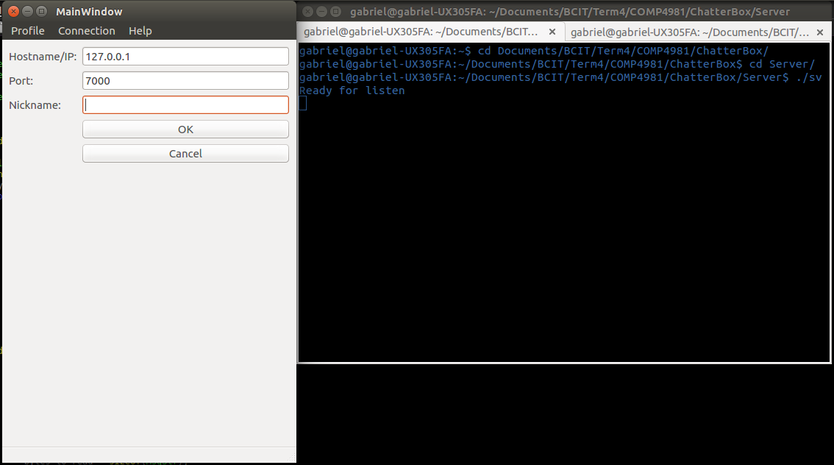

Figure

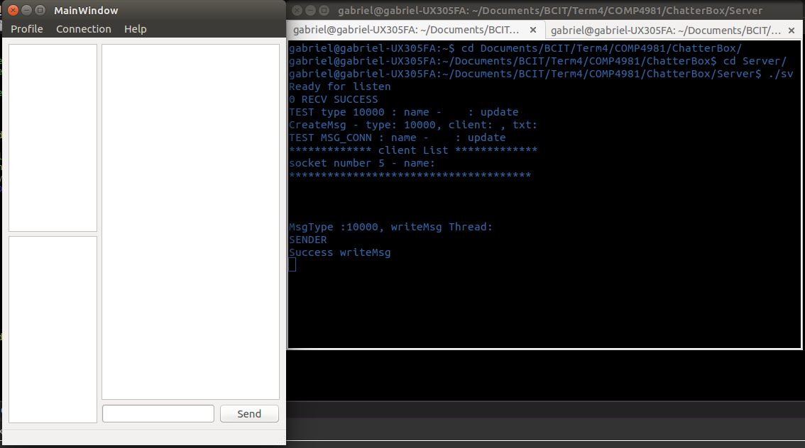

Figure

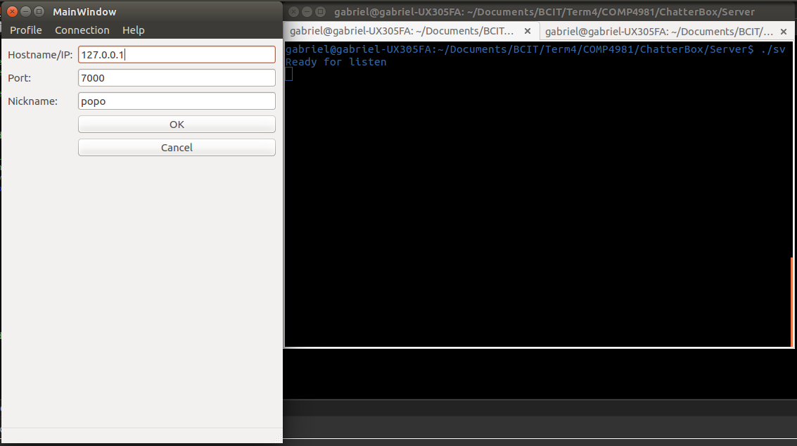

Figure

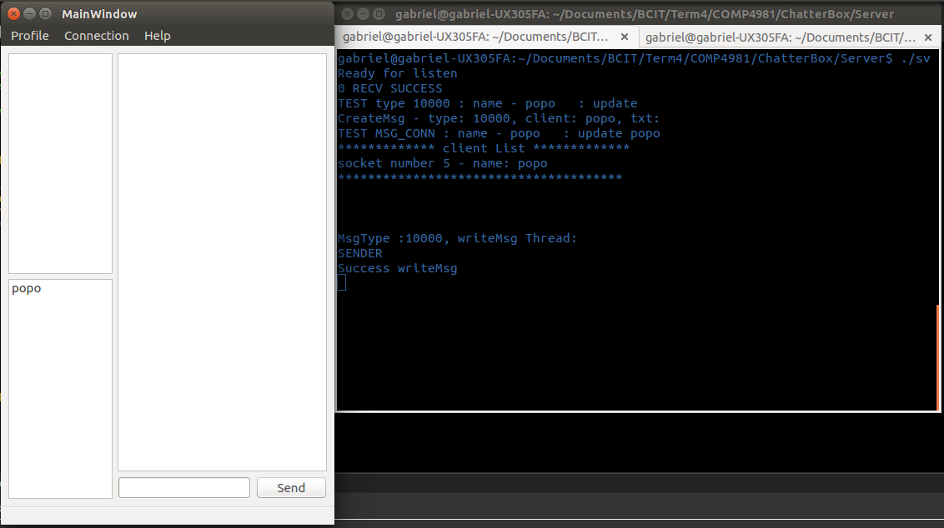

Figure

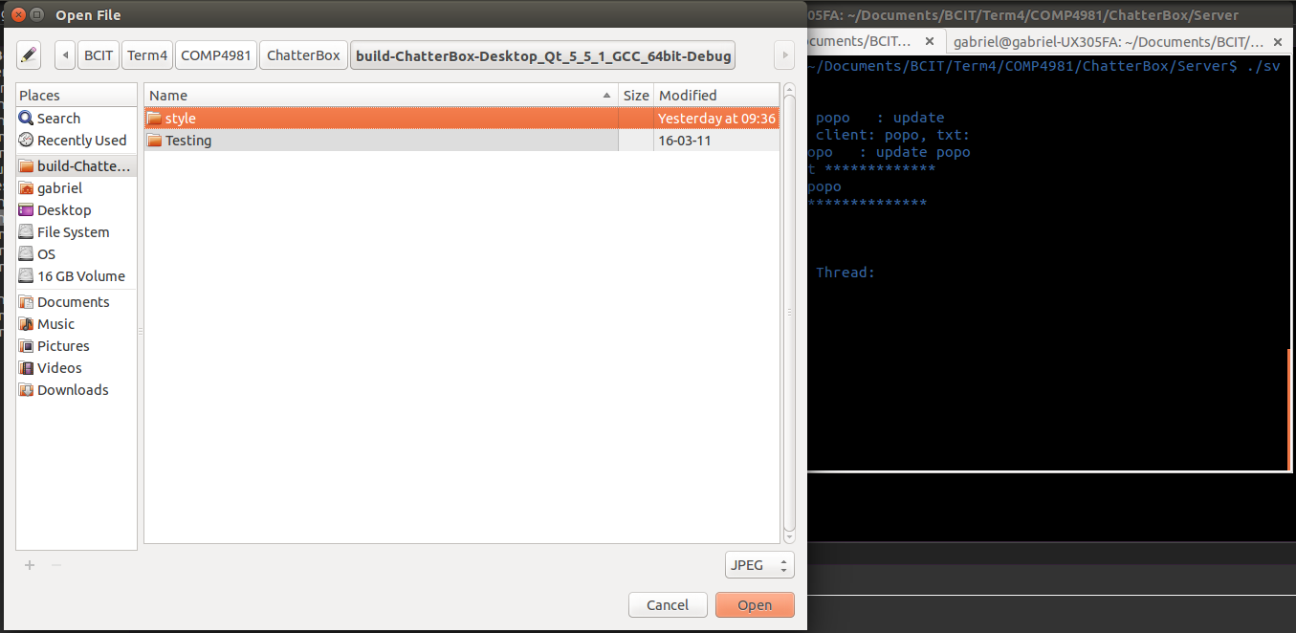

Figure

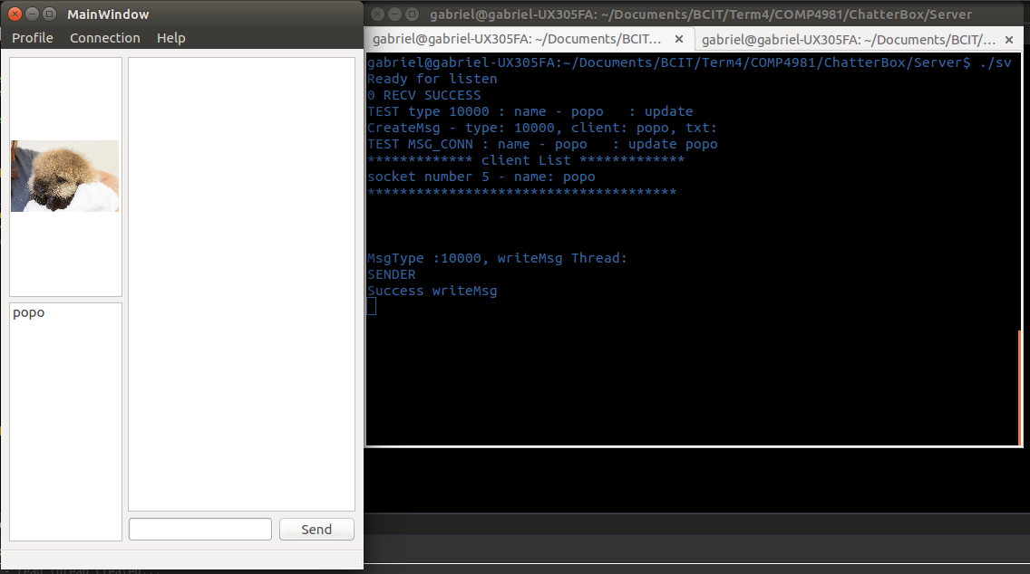

Figure

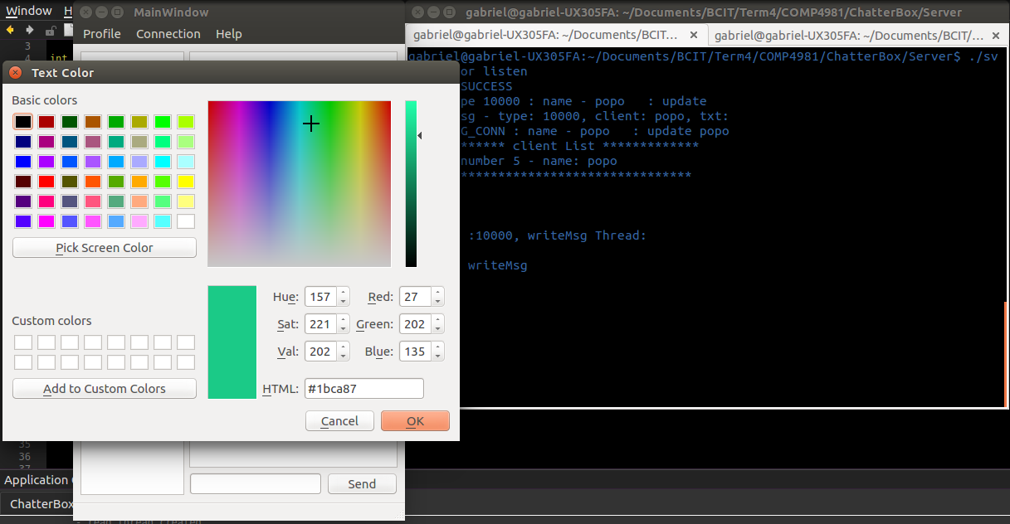

Figure

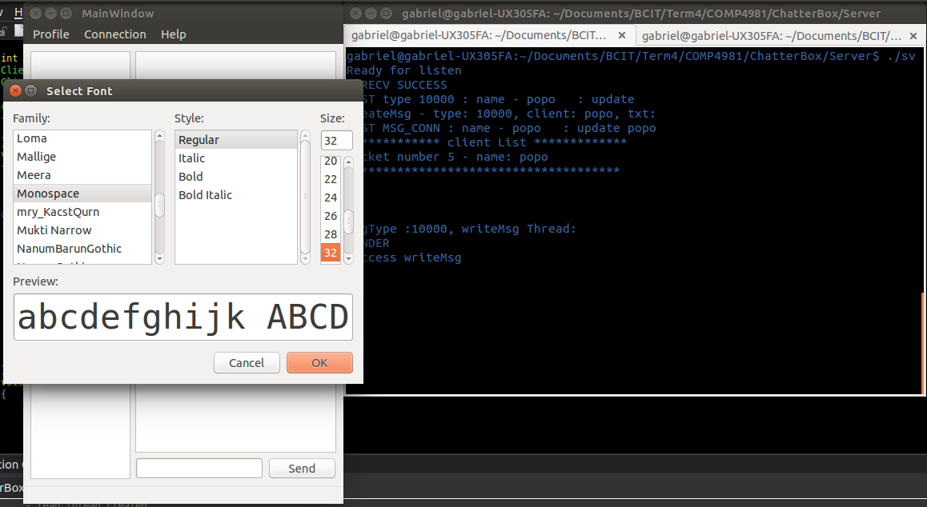

Figure

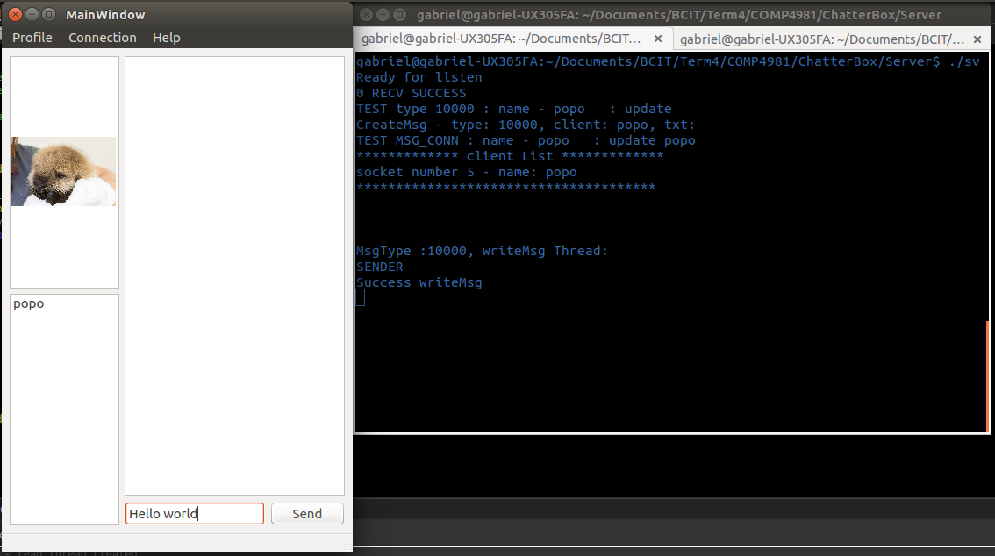

Figure

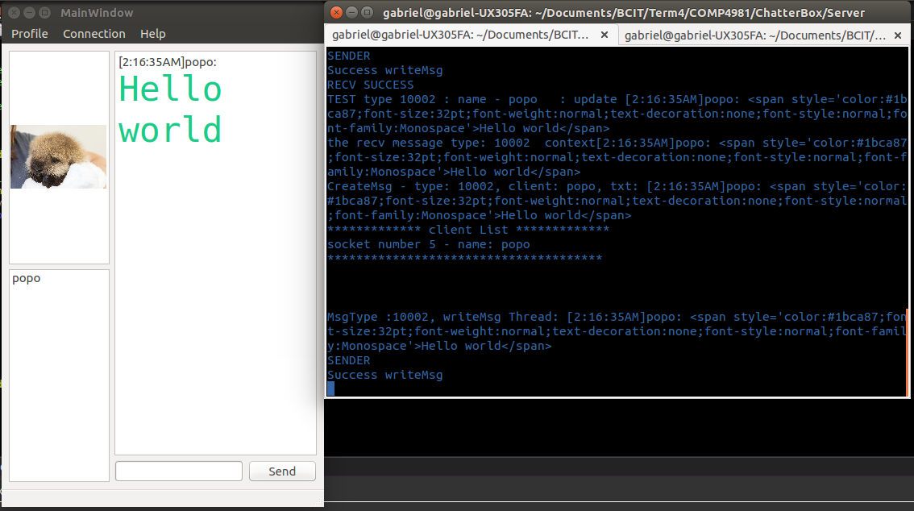

Figure

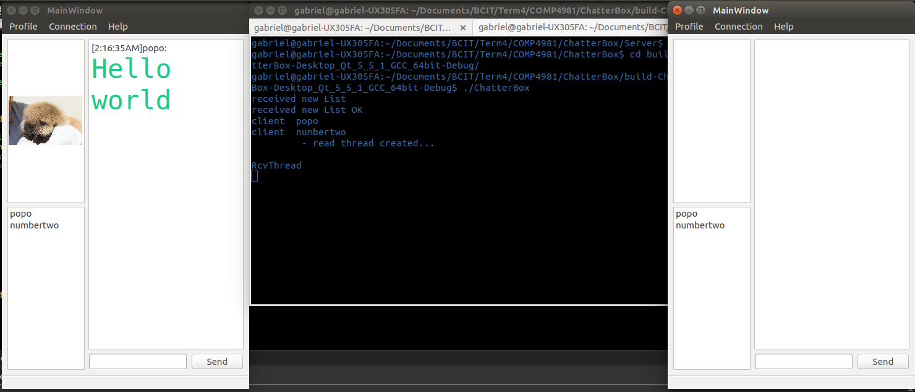

Figure

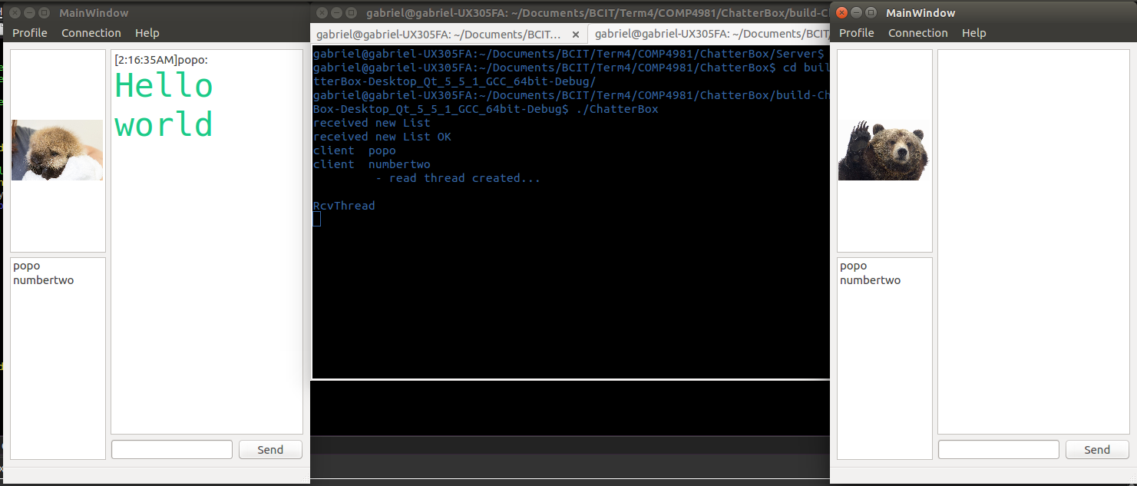

Figure

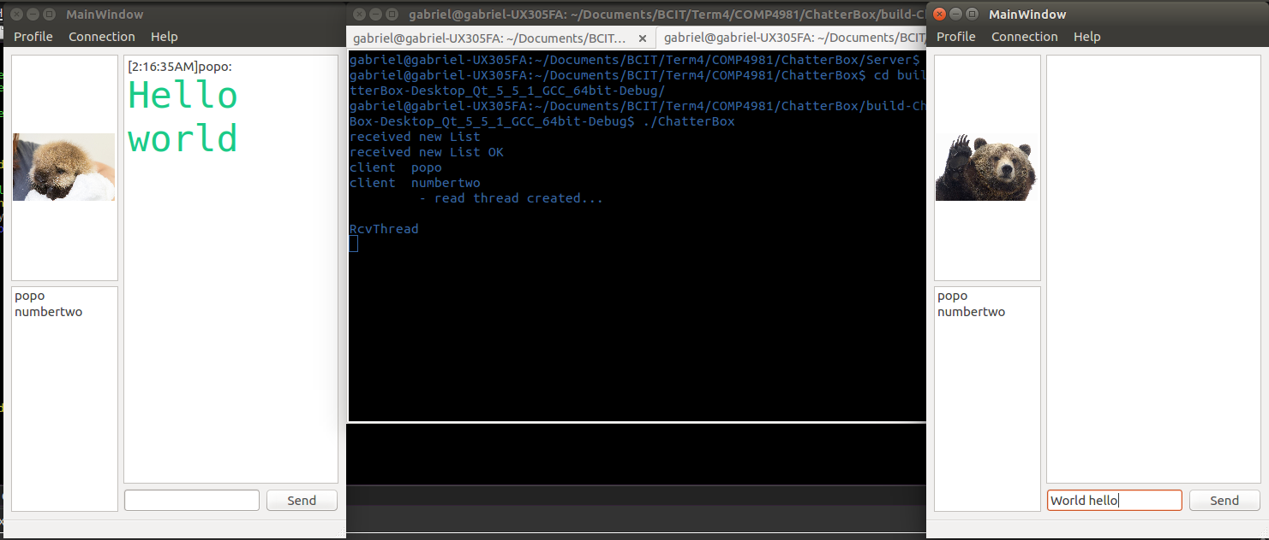

Figure

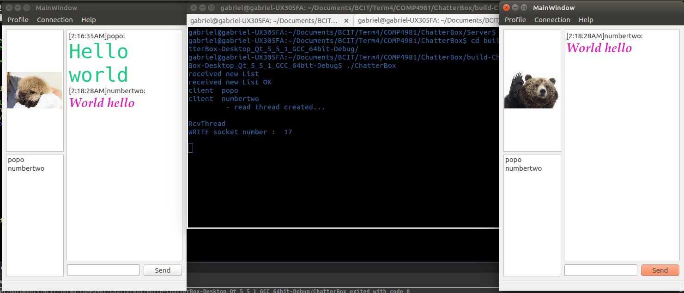

Figure