Gabriel Seonghyoung Lee

Eunwon Moon

User Guide

COMP4981 – Assignment 03

Contents

Introduction 2

How-To 2

Client 2

Running the client 2

Connect to server 2

Selecting profile picture 3

Change message text color 4

Change message font style 4

Sending a message 5

Connect to different server 5

Server 6

Building the server 6

Running the server 6

Destroy runnable file 6

Check log file 6

# Introduction

ChatterBox is a Linux multicast chat program that allows multiple clients to communicate with each other. It provides a GUI-driven application with features! Users can select a profile picture to be shown in the messaging screen, select text font styles, and select colors!

# How-To

## Client

### Running the client

There are 2 ways of running the client.

**Option 1:**

1. Navigate to the application folder via the file system.
2. Double-click *ChatterBox* to execute the program.

**Option 2:**

1. Open the terminal.
   * On most Ubuntu, the short cut is *Ctrl + Alt + t*.
2. Navigate to the application folder.
3. Run the *ChatterBox* executable.
   * If you are unable to run the executable, it might be because the application doesn’t have permission to do so.
     + To give the application permission, run the following command: *sudo chmod ChatterBox 777*.

A window will appear if you have successfully executed the program.

Connect to server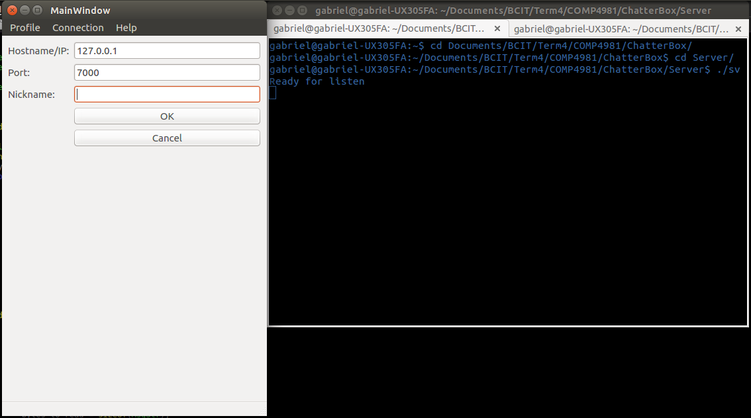

In order to properly use the application, you must first connect client to a server.

1. Input server hostname or IP address.
   * If you are running a server locally, you can simply input *127.0.0.1*.
2. Input server port number.
   * By default, the port is set to 7000 for the server if a port was not specified during start-up.
3. (Optional) Input nickname.
4. Click *OK*.

If the connection to the server has been successful, you will be directed to the client’s messaging screen.

Selecting profile picture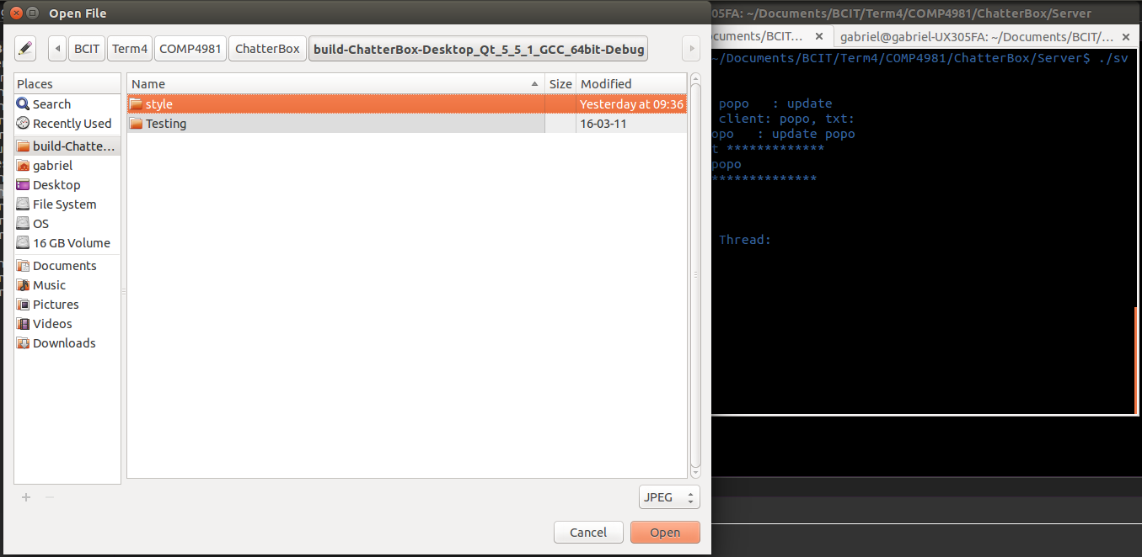

If you wish to display a profile picture in the client, it’s simple. Just follow the following steps!

1. Click *Profile -> Profile Pic*.
2. Select any *.jpg, *.jpeg, or *.png image, when the file dialog has opened.
3. Click *OK* after you have selected the desired image.
   * Double-clicking on the desired image works as well.

Your profile picture will be displayed on your client’s messaging screen.

Change message text color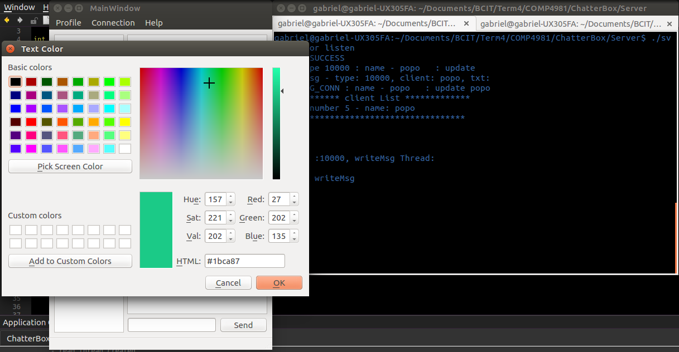

If you wish to change your message text color from the boring black & gray, simply pick any color you can imagine from the text color menu.

1. Click *Profile -> Font Color*.
2. Select any default colors on the right.
   * You can also use the color spectrum on the left to select the desired color.
   * If you wish to define the color via color codes, you can input the values on the lower left corner.
3. Click *OK* after you have selected the desired color.

Change message font style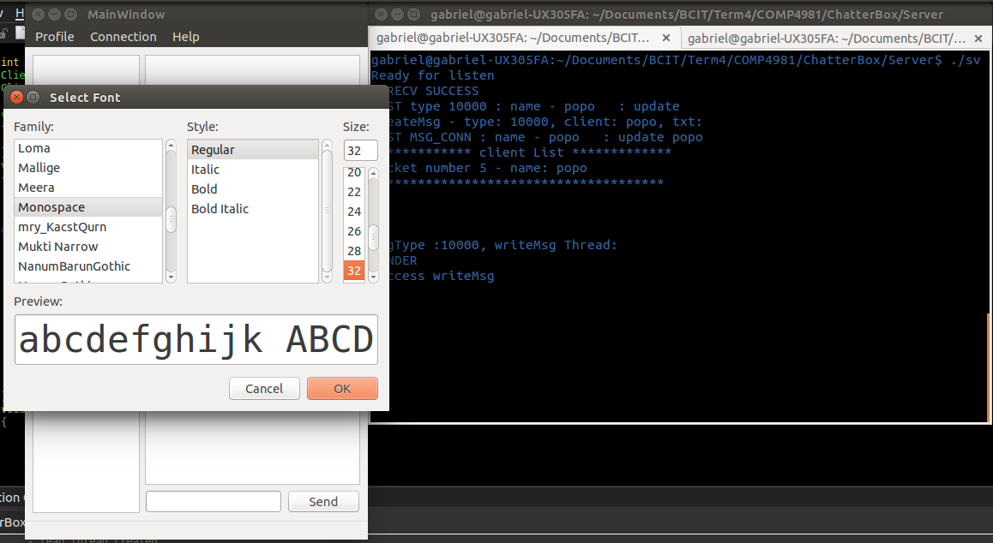

If you are tired of the basic default fonts, you can change to any fonts that are installed on your computer.

1. Click *Profile -> Font Style*.
2. Select the font family.
3. Select the style.
4. Select the size (in points).
5. Click *OK* after you have the desired font style.
   * The preview of your selection is displayed on the bottom of the font dialog.

Sending a message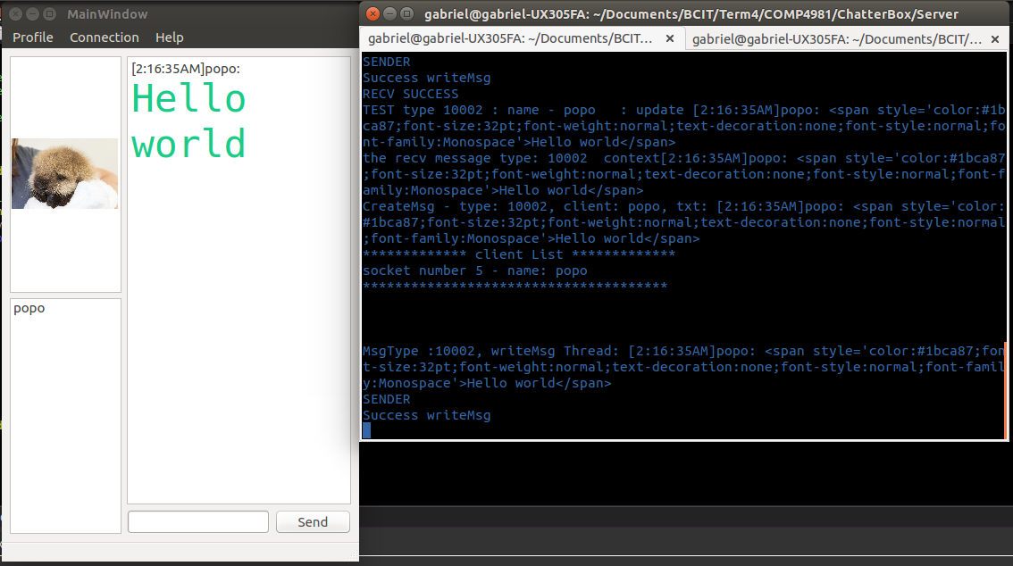

The primary purpose of the application is to send message between users. In order to do this, please complete *Connect to server* How-To first.

1. Click on the message input box to focus onto it.
2. Input any message you would like to send.
3. Press the return key to send the message.
   * Click on the *Send* button if you prefer.

And just like that, you are communicating with everyone on the server!

### Connect to different server

If you would like to leave the current server and join another server, it’s easy!

1. Click *Connection -> Connect*.
2. Repeat *Connect to server*.

Now you can speak to a new group of people!

## Server

The server is possible to run on Linux terminal.

### Building the server

If you want to build a server file:

1. Open a Linux *terminal*.
2. Navigate to the server folder where the files is exist.
3. Run *make* in the terminal.

### Running the server

To open server, run the runnable file in Server: Type *./server <port>* in your terminal. The *<port>* is optional; if left blank, the default port number (7000) will be used.

### Destroy runnable file

To delete a runnable file and object before rebuild new file: Type *make clean* in the terminal.

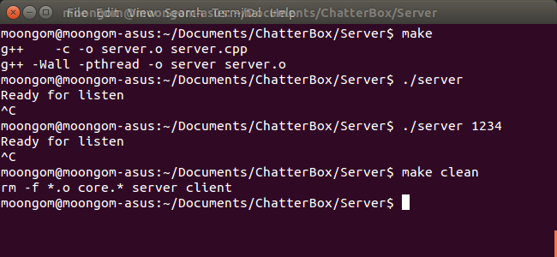

### Check log file

If you want to see the progress of chatting flow as a server, open a ‘log.txt’ file. It is located in the same directory as the server program.