JUMPY!

Under the Supervision of

Engr. Elsa S. Pascual

Computer Architecture and Organization (CSC 0222)

Submitted by:

Atienza, Laurence Charles C.
Buenavidez, Jozef Benedict C.
Carlos, Peter Simoun D.S
Clutario, Lea Rose S.
Datu, Lyxander Iskra L.
De Leon, Julian Manuelle S.
Eyana, Franco Tristan E.
Navarro, Emmanuel S.
Pearson, Charlles Albert L.
Reyes, Christine Lorriel C.
Sulit, Ruzzel Mae P.

I.MEMBERS AND TASKS

Members and Task/s

Name | Task/s
Atienza, Laurence Charles C. | - PowerPoint Presentation  - Logistics
Buenavidez, Jozef Benedict C. | - Frontend Developer  - UI WorkFlow  - Prototype Creation
Carlos, Peter Simoun D.S | - Group Leader  - Project Manager / Product Manager  - Full-Stack Developer  - Quality Assurance  - Technical Writer  - Document  - Demo
Clutario, Lea Rose S. | - UI WorkFlow  - Brochure  - Booth design  - Logistics Head
Datu, Lyxander Iskra L. | - Frontend Developer  - Prototype Creation
De Leon, Julian Manuelle S. | - Full-Stack Developer  - Document  - Prototype Creation
Eyana, Franco Tristan E. | - Frontend Developer  - Prototype Creation
Navarro, Emmanuel S. | - Dance  - Logistics
Pearson, Charlles Albert L. | - Brochure  - Booth design
Reyes, Christine Lorriel C. | - PowerPoint Presentation  - Logistics
Sulit, Ruzzel Mae P. | - Brochure  - Booth design

II.INTRODUCTION

This project is a retro single-screen platformer game called JUMPY! Learning Adventures, developed entirely in x86 NASM assembly language as part of the Computer Architecture and Organization course (CSC 0222). The game runs as a native 32-bit Windows (Win32) application and is designed for learners who wish to practice recognizing letters, numbers, and geometric shapes in an engaging arcade-style environment. The retro visual theme ” bright colors rendered on a dark background using Win32 GDI drawing calls ” gives the game a nostalgic 8-bit arcade appearance that is approachable for players of all ages.

The main goal of JUMPY! is straightforward: the player controls a character who must jump across a series of eleven elevated platforms and land on the collectible box that matches the current target displayed in the FIND: prompt at the top of the screen. Collecting the correct box awards ten points and immediately spawns a new set of boxes with the next target. Collecting a wrong box costs one life and triggers a brief 60-frame invincibility window, accompanied by an error sound. The challenge comes from reading the target quickly, choosing the right platform path, and avoiding wrong boxes while navigating the multi-level layout.

The game supports both a single-player mode and a competitive two-player mode. In two-player mode, Player 1 uses the W, A, and D keys while Player 2 uses the arrow keys, allowing both players to compete on the same screen simultaneously. Each player tracks their own score and lives independently, and the round ends only when both players exhaust all three lives. Each session score is automatically saved to a persistent file (scoreboard.dat) and ranked in a Top Scores leaderboard that holds up to ten entries.

Three difficulty levels are available: Easy, Medium, and Hard. Easy places 3 collectible boxes on the platforms per round, Medium places 5, and Hard places 6, increasing the number of wrong boxes the player must avoid. Three game modes keep the experience varied: Letters mode cycles through all 26 uppercase letters (A through Z), Numbers mode cycles through the ten digits (1 through 9 then 0), and Shapes mode presents eight geometric shapes from Circle through Nonagon. Together these settings scale the game from a relaxed recognition exercise to a fast-paced challenge for experienced players.

III.DEFINITION OF TERMS

- Collectible Box – A labeled box placed on a platform each round that the player collects by walking into it; each box displays a letter, digit, or shape name and is classified as either a Correct Item or a Wrong Item for the current target.
- Correct Item – The single collectible box in each round whose label exactly matches the current Target Character shown in the FIND: prompt; collecting it awards ten points, advances the sequence to the next target, and respawns the collecting player at their starting position.
- Difficulty Level – A setting chosen before each game session that determines how many collectible boxes are placed on the platforms per round ” Easy places 3 boxes, Medium places 5, and Hard places 6 ” with more boxes meaning more wrong items to avoid.
- GoLink – The 32-bit Windows linker used in the JUMPY! build pipeline to combine the assembled object file (game.obj) with the required system libraries (kernel32.dll, user32.dll, and gdi32.dll) and produce the final game.exe executable.
- Invincibility Frames – A 60-timer-tick grace period granted to a player immediately after they hit a Wrong Item, during which additional collisions are ignored and the player sprite blinks; this prevents a single misstep from rapidly draining multiple lives.
- JUMPY! – The full title of the game developed for this course project ” JUMPY! Learning Adventures ” a retro Win32 single-screen platformer written entirely in x86 NASM assembly in which players jump between platforms to collect correctly labeled boxes.
- Letters Mode – The game mode in which the target sequence consists of all 26 uppercase letters of the English alphabet (A through Z) presented in order, wrapping back to A once Z has been collected.
- Lives – The number of remaining attempts a player has before the game ends for them; each player starts with 3 lives, loses 1 upon touching a Wrong Item (subject to the Invincibility Frames cooldown), and the game ends for that player when the count reaches zero.
- MCI / winmm.dll – The Windows Multimedia Control Interface loaded at runtime from winmm.dll; JUMPY! uses mciSendStringA to open and loop the background music WAV file, and PlaySoundA for the success and error sound effects.
- NASM – The Netwide Assembler used to compile game.asm into the 32-bit Windows object file game.obj; the assembly command used in this project is: nasm -f win32 -o game.obj game.asm.
- Numbers Mode – The game mode in which the target sequence consists of the ten digit characters 1 through 9 followed by 0, presented in order and restarted from 1 after the full cycle is completed.
- Platform – One of the eleven horizontal rectangular surfaces in the game world on which a player can stand and jump; platforms are arranged at varying heights to create the multi-level layout, and collectible boxes are centered on top of each platform each round.
- Player Block – The 44-byte data structure in memory that stores all runtime state for a single player, including X and Y position, vertical velocity, on-ground flag, key states, invincibility timer, score, and lives count.
- Scoreboard – The in-game Top Scores screen accessible from the Main Menu by pressing [ 0 ], which lists up to ten all-time high-score entries ranked from highest to lowest; entries persist across sessions through the scoreboard.dat file.
- scoreboard.dat – The binary file saved alongside game.exe that stores the persistent leaderboard data; it begins with a 4-byte magic identifier (JSB1) followed by the entry count and score records, and is read on startup and updated automatically after each session.
- Sequence – The ordered list of target items for the currently active Game Mode (letters, digits, or shape identifiers); the game steps through the sequence one item per correct collection, wrapping back to the start after the final item is collected.
- Shapes Mode – The game mode in which the target sequence consists of eight geometric shape identifiers ” Circle, Triangle, Square, Pentagon, Hexagon, Heptagon, Octagon, and Nonagon ” displayed as a text label on the collectible box and drawn as a filled polygon in the upper-right corner of the screen.
- Target Character – The current item from the active Sequence that the player must locate and collect; it is displayed in the HUD at the top of the screen next to the FIND: label and determines which of the on-screen Collectible Boxes is the Correct Item.
- Game Mode – One of the three content categories selectable from the Main Menu: Letters (A through Z), Numbers (1 through 9 then 0), or Shapes (Circle through Nonagon); the active mode determines the full ordered sequence of target items the player must collect during a session.
- Two-Player Mode – The competitive multiplayer format in which Player 1 (WASD) and Player 2 (arrow keys) are active simultaneously on the same screen, each with independent lives and score; the round ends only when both players have zero lives remaining.
- Win32 GDI – The Windows Graphics Device Interface functions from gdi32.dll used by JUMPY! to render all game visuals including backgrounds, platforms, player rectangles, collectible boxes, polygon shapes, and text into an off-screen memory device context, which is blitted to the window each timer tick.
- Game Over – The screen displayed after all of a player's lives reach zero; in two-player mode the round does not end until both players have zero lives, at which point each player's score is automatically saved and the player may press SPACE to return to Difficulty Select or ESC to go back to the Main Menu.

IV.HOW TO PLAY

The game is straightforward and easy to follow. Below is a step-by-step walkthrough of the entire game experience from start to finish.

Starting the Game
- Launch the game by running game.exe from the build folder. On the very first launch, the game automatically displays the name entry screen before proceeding to the Main Menu.
2. Type your name using the letter keys (A through Z). Use BACKSPACE to delete characters and press ENTER to confirm. Your name will be used for score tracking and leaderboard display.

Main Menu
3. The Main Menu shows all available options. Press [ 1 ] for Letters mode, [ 2 ] for Numbers mode, or [ 3 ] for Shapes mode. Press [ 5 ] to toggle between 1 Player and 2 Players. Press [ 4 ] to change your name, [ 6 ] to set Player 2 name (2 Players only), or [ 0 ] for Top Scores.
4. If you switch to 2 Players mode for the first time, the game will prompt Player 2 to enter their name before returning to the Main Menu.

Difficulty Selection
5. After selecting a game mode, the Difficulty Select screen appears. Press [ 1 ] for Easy (3 boxes per round), [ 2 ] for Medium (5 boxes), or [ 3 ] for Hard (6 boxes). Press ESC to return to the Main Menu without starting.
Playing a Round
6. At the start of each round your character appears on screen. Player 1 spawns on the left and Player 2 on the right in two-player mode. The target to find is shown in the FIND: prompt at the top. Move Player 1 with A (left), D (right), and W or SPACE (jump). In 2 Players mode, Player 2 uses the Left, Right, and Up arrow keys.
7. Navigate the platforms and walk into the box whose label matches the FIND: target. A success sound plays, your score increases by 10 points, and your character respawns at the starting position with a fresh set of boxes. Walking into a wrong box plays an error sound, costs one life, and triggers a brief invincibility window.
8. Continue collecting the correct boxes in sequence. The target sequence restarts from the beginning once all items have been collected. The round ends when the player ”or in two-player mode, both players” exhaust all three lives. Press ESC at any time to return immediately to the Main Menu.

End of Game & Leaderboard
9. After all lives are spent, the Game Over screen displays your final score. Press SPACE to return to the Difficulty Select screen and try again, or press ESC to return to the Main Menu. From the Main Menu press [ 0 ] to view Top Scores, which lists up to ten all-time high scores ranked highest to lowest.

V. STORYBOARD / UI DESIGN
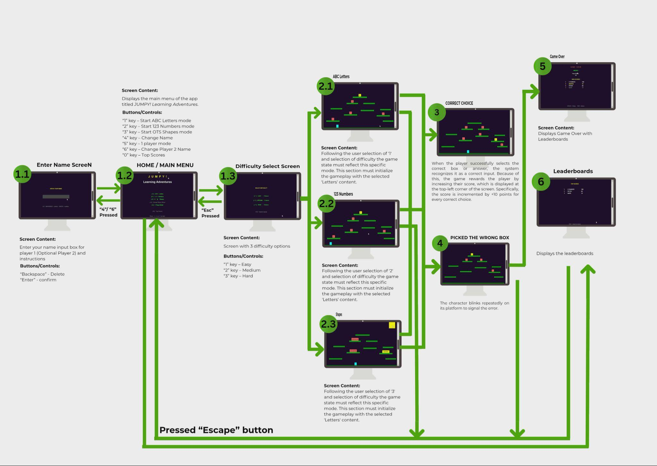
VI. HOW TO INSTALL & CONFIGURE

IMPORTANT: Complete the development environment setup in Section A before attempting to build or run the game from source. JUMPY! was developed entirely in Visual Studio Code using NASM x86 assembly, the GoLink linker, and GDB for debugging. Your PC must have this toolchain configured first; otherwise the assembly source cannot be assembled, linked, or debugged.

A. DEVELOPMENT ENVIRONMENT SETUP (Complete This First)

This section covers installing every tool required to build and debug the assembly source on Windows. No high-level wrappers or compiler drivers are used—you invoke the assembler and linker directly, as configured in the project's VS Code tasks.

A.1 NASM (Netwide Assembler)

NASM translates the .asm source into a Win32 COFF object file (.obj).

1. Download the latest stable Windows installer from: https://www.nasm.us/pub/nasm/releasebuilds/
2. Install the win64 installer (works on 64-bit Windows; assembles 32-bit code with -f win32).
3. Default install path: C:\Program Files\NASM
4. Add the NASM directory to your user PATH (System Properties → Environment Variables).
5. Verify by opening Command Prompt and running: nasm --version
Expected output example: NASM version 2.16.03 compiled on ...

A.2 GoLink (Linker)

GoLink is a lightweight Windows linker that links directly against system DLLs without import libraries (.lib files).

1. Download GoLink from: https://www.godevtool.com/
2. Extract GoLink.exe to a tools directory (e.g., C:\Tools\GoLink) and add that directory to your PATH.
3. Verify by running: GoLink /?

A.3 GDB (Debugger — Optional but Recommended)

GDB lets you step through assembly instruction-by-instruction and inspect registers, flags, and memory.

Option A — MSYS2 (recommended): pacman -S mingw-w64-i686-gdb
Option B — TDM-GCC: Download from https://jmeubank.github.io/tdm-gcc/ (bundles GDB).
After install, verify: gdb --version

A.4 Visual Studio Code Extension Stack

Install Visual Studio Code, then open the jumpstart-asm project folder. VS Code will prompt you to install recommended extensions from .vscode/extensions.json. Install all of the following:

• NASM Language Support (rights.nas-vscode) — syntax highlighting and snippets for NASM assembly
• x86 and x86-64 Assembly (13xforever.language-x86-64-assembly) — broader x86 syntax grammar
• ASM Code Lens (maziac.asm-code-lens) — go-to-definition and outline for labels/symbols
• C/C++ (ms-vscode.cpptools) — provides the cppdbg debug adapter for GDB integration
• Native Debug (webfreak.debug) — alternative GDB frontend with disassembly view
• Hex Editor (ms-vscode.hexeditor) — inspect .obj and .exe binaries in the editor

A.5 Project Structure

jumpstart-asm/
.vscode/ extensions.json, settings.json, tasks.json, launch.json
src/ game.asm (main game source)
build/ build.bat, game.exe output
res/ resources (future assets)

A.6 Build Automation in VS Code

After the toolchain is installed and the project is opened in VS Code:

• Ctrl+Shift+B — runs "Build All" (assemble then link)
• The Assemble task runs: nasm -f win32 -g -F cv8 -o build/game.obj src/game.asm
• The Link task runs GoLink with /entry _WinMain@16 /debug coff and links kernel32.dll, user32.dll, gdi32.dll
• A "Build & Run" task chains build and launch
• From the command line, you can also run: build\build.bat

A.7 Debugging (Optional)

The launch.json provides a "Debug Game (GDB)" configuration that auto-builds before each session, breaks at entry, and uses Intel syntax. Set breakpoints in game.asm by clicking the gutter. Use si/ni to step instructions, info registers to inspect CPU state, and the Disassembly View for raw machine code alongside source.

Once Section A is complete, proceed to Sections B and C below.

B. REQUIREMENTS (For Running the Game)

• Windows 10 or Windows 11 (64-bit; game.exe is a 32-bit Win32 application running under WOW64)
• The game files: game.exe, BG MUSIC.wav, SUCCESS.wav, and ERROR.wav (provided in the build folder, or produced after building from source)

C. INSTALLATION STEPS (Running the Pre-Built Game)

1. Download or build the game files. The build folder contains game.exe and the three WAV audio files (BG MUSIC.wav, SUCCESS.wav, ERROR.wav).
2. Create a folder on your computer (for example, C:\JUMPY) and place all four files inside it. All files must remain in the same folder for audio to work correctly.
3. Double-click game.exe to launch the game. The Main Menu will appear. No additional installation is required.

D. BUILDING FROM SOURCE (After Section A Setup Is Complete)

Only proceed here after NASM, GoLink, and VS Code are configured as described in Section A.

1. Open the jumpstart-asm project folder in Visual Studio Code.
2. Press Ctrl+Shift+B to build, or open Command Prompt at the project root and run:
nasm -f win32 -g -F cv8 -o build\game.obj src\game.asm
GoLink /entry _WinMain@16 /console /debug coff build\game.obj kernel32.dll user32.dll gdi32.dll winmm.dll
Alternatively, run: build\build.bat
3. Copy game.exe and the WAV files to your game folder (if not already there) and run game.exe.
4. If audio does not play, ensure the WAV files are in the same folder as game.exe.

E. TROUBLESHOOTING

• "nasm is not recognized" — NASM is not on PATH. Add the NASM install directory, restart VS Code, and try again.
• GoLink: "unresolved external" — Win32 stdcall decoration mismatch. Use _FunctionName@N where N is parameter bytes.
• GDB won't hit breakpoints — Assemble with -g -F cv8 flags so debug symbols are emitted.
• Window appears then crashes — Stack misalignment or wrong parameter count in a Win32 call. Use GDB stopAtEntry to step through WinMain.
• "Cannot find -lgdi32" — This is a GNU ld error, not GoLink. Pass DLL names directly (e.g., gdi32.dll).

To exit the game at any time, press ESC to return to the Main Menu, then close the window, or simply close the window directly.

VII. REFERENCES / CREDITS

Software & Tools
NASM Development Team. (2024). NASM — The Netwide Assembler Documentation. Retrieved from https://www.nasm.us/doc/
Jeremy Gordon. (2024). GoLink Win32 Linker Documentation. Retrieved from https://www.godevtool.com/

Microsoft Corporation. (2024). Windows API Reference: kernel32, user32, gdi32, winmm. Retrieved from https://learn.microsoft.com/en-us/windows/win32/api/
Thematic Reference
Retro 8/16-bit arcade platformer visual aesthetic. The color palette, platform layout, and character style are inspired by classic arcade platform games of the 1980s and 1990s. All visual elements in JUMPY! are original, produced entirely through Win32 GDI drawing calls in x86 assembly. Referenced for non-commercial, educational use only.

