Electrosense Sensor Hardware

|  |  |  |
| --- | --- | --- |
| **Author** | **Date** | **Revision** |
| Franco Minucci | 10/04/2020 | First draft |
| Domenico Giustiniano | 14/04/2020 | Revision 1 |
| Franco Minucci | 15/04/2020 | Revision 2 |

Table of Contents

Introduction 3

Raspberry Pi and RTL-SDR 4

Temperature range 5

Extension Board 6

Power Supply Requirements 8

Enclosure Recommendations 9

Public documents/links 10

# Introduction

This document describes the Electrosense sensor hardware composed by a set of three Antennas to cover different frequency bands, Raspberry Pi 3b, RTL-SDR Blog V3 and custom frequency extension board (In Figure 1). The purpose of the extension board is to extend the frequency range of the RTL-SDR, which is otherwise limited between 30 MHz and 1800 MHz.

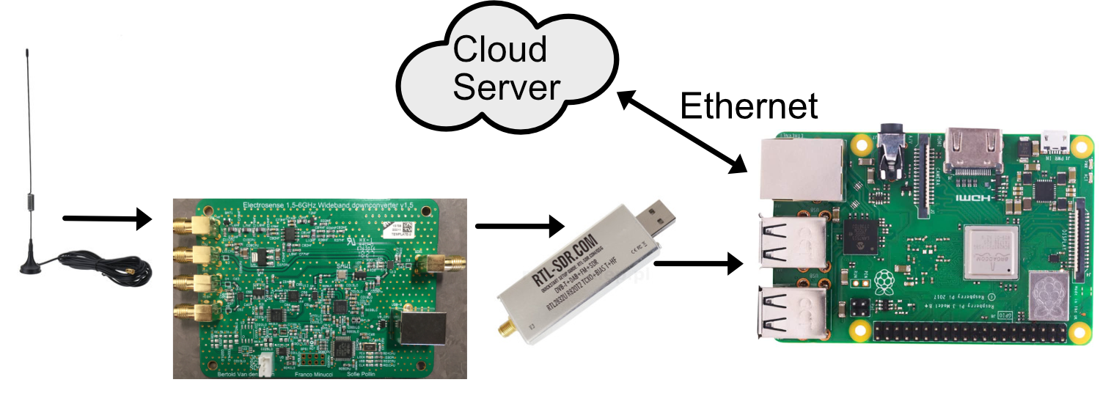

Figure 1: Components of the Electrosense sensor

All the signals captured by the different antennas are sampled by the RTL-SDR. Only one frequency band and antenna are selected at each time. The I/Q samples go to the Raspberry Pi which performs some basic computation (such as FFT, queue handling, compression) and transmits the resulting data to the private data centre owned by the Electrosense association. The servers in the data centre are responsible for data analysis and storage.

# Raspberry Pi and RTL-SDR

The Raspberry pi runs the controller software (property of IMDEA).

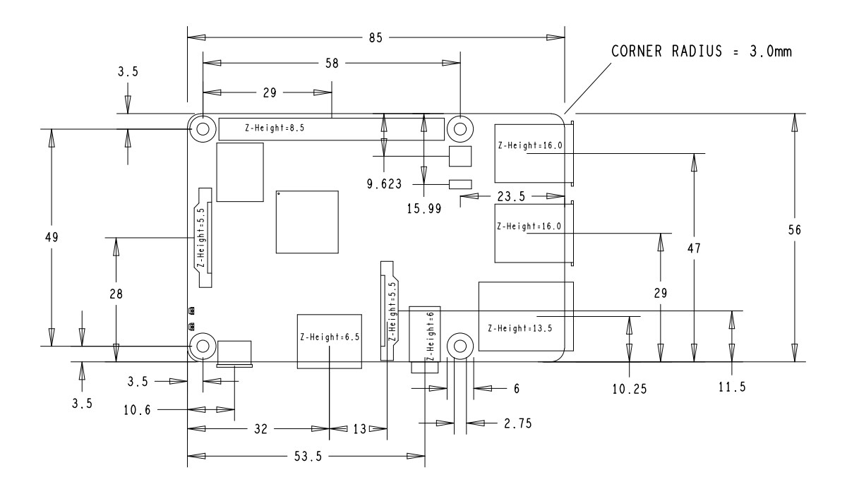

Figure 2: Raspberry Pi mechanical dimensions

The connection between RTL-SDR and Raspberry Pi is a direct connection via standard USB A (male-female) connectors. The protocol is USB 2.0.

The male connector is directly attached to the PCB of the RTL-SDR and strengthened in place by an aluminum sheet and 2 screws directly attached to the aluminum case (Figure 2).

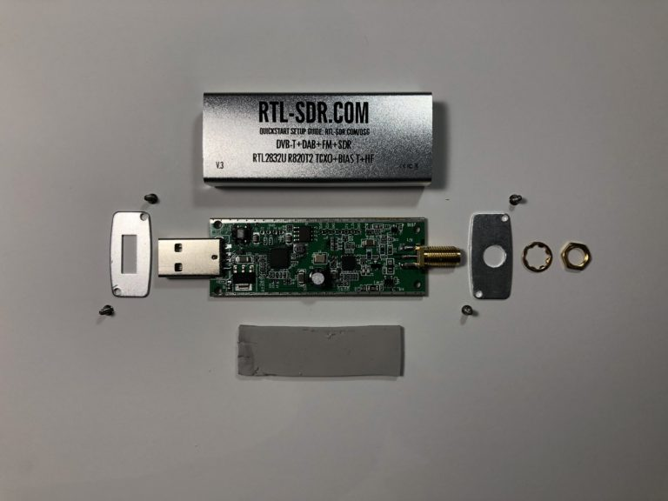

Figure 3: Components of the RTL-SDR

The case can be removed if needed but a heatsink might be needed on ICs 3 and 7 (Figure 3).

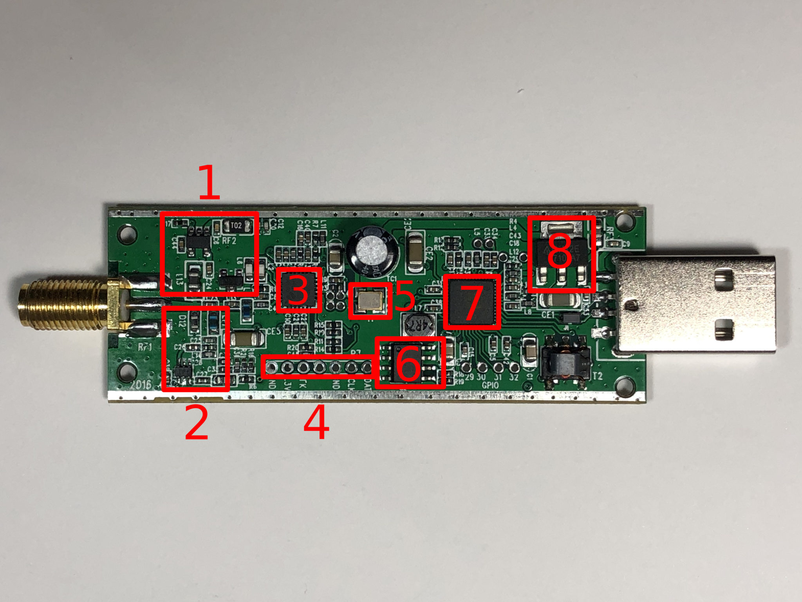

Figure 4: RTL-SDR PCB details

The highlighted components are:

1. Bias-T Section: Contains a voltage regulator and an RF-blocking inductor to bias the RF frontend. Software allows to enable the bias tee on RTL-SDR Blog V3 dongles.
2. Direct Sampling Section: This section can be used to configure the RF front end for direct sampling, bypassing the down conversion stage. This is not needed as the low frequencies are up-converted by the extension board.
3. Rafael Micro R820T2 Tuner: Converts the RF carrier frequency to the intermediate frequency accepted by the RTL2832U chipset.
4. I/O Pins
5. 28.800 MHz TCXO Crystal Oscillator
6. 24C02N Serial EEPROM
7. RTL2832U: Performs the ADC function and transfers the I/Q samples to the USB interface.
8. AP2114 Low-Noise 3.3V 1A LDO Regulator

Datasheet https://www.rtl-sdr.com/wp-content/uploads/2018/02/RTL-SDR-Blog-V3-Datasheet.pdf

The mechanical dimensions are not stated in the datasheet.

The RTL-SDR has a maximum RF bandwidth of 2.4 MHz.

## Temperature range

Raspberry Pi: the LAN9514 (Ethernet IC) is qualified from 0°C to 70°C. The SoC is qualified from -40°C to 85°C.

The RTL-SDR is expected to work between 0°C and 50°C.

# Extension Board

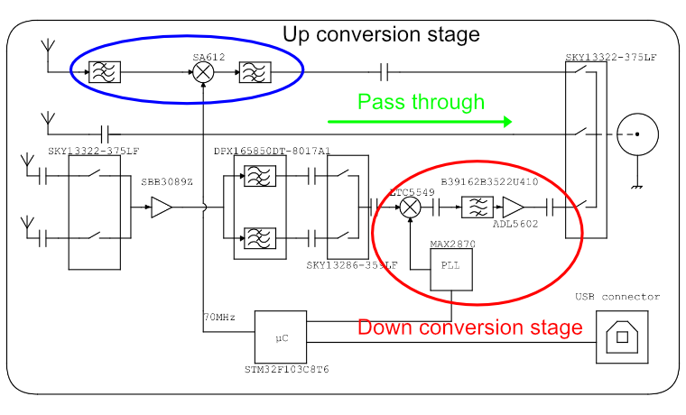

Figure 5: Simplified schematic of the extension board

The extension board consists of 3 functional paths:

1. **Down converter:** Brings the frequencies between 1800 MHz and 6000 MHz down to the range of the RTL-SDR (configurable).
2. **Pass through:** direct connection between antenna and receiver. This path includes only a bypass capacitor.
3. **Up converter:** Converts the frequency range between 0 MHz and 30 MHz in the range of the RTL-SDR (configurable).

The extension board is controlled by an STM32F103C8T6 microcontroller interfaced to the Raspberry Pi via USB. This interface appears as a virtual serial port.

The full hardware design is freely available at: https://github.com/electrosense/hardware

The repository includes both Altium Designer (v17) Files, a bill of materials BOM.xls, the gerber file CAMtastic1.Cam and the source code of the microcontroller firmware.

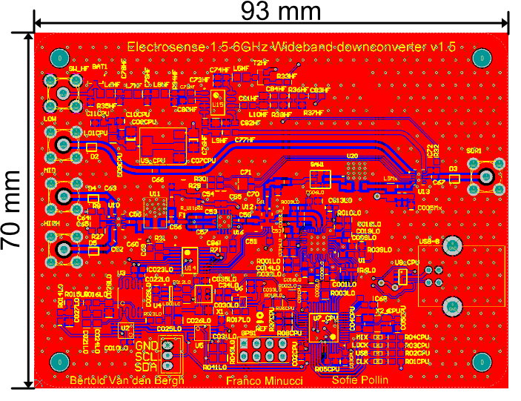

SDR1

Figure 6: Layout of the exteniosn board

Figure 6 shows the layout of the extension board. The 4 mounting holes are metalized but not connected to the ground plane.

The board is powered with 5V-500mA (max) via the USB-B connector.

The SMA marked as SDR1 should be connected to the RTL-SDR with a low loss SMA cable 50 ohms characteristic impedance. A rigid SMA cable is advised.

The other 4 SMA connectors are for the antennas:

* Low connector for the range 0-30 MHz
* Mid connector for the range 30 – 1800 MHz
* 2x High connector for the range 1800 – 6000 MHz

The 2 header connectors are for the I²C interface and for programming the microcontroller.

The microcontroller can be programmed with the ST-Link V2 programmer.

# Power Supply Requirements

The sensor requires a stable power supply of 5V (+/- 5%), 2.5A peak current.

Both RTL-SDR and the extension board are powered by the Raspberry Pi through USB. The Extension board has also a separate 5V connection, so it can be powered separately (requires a small hardware modification).

The sensor can be powered with 12Vdc with a dedicated DC/DC conversion board.

Table 1: Maximum current ratings for the Electrosense Sensor

|  |  |
| --- | --- |
| **Device** | **Maximum current consumption (on 5V)** |
| Raspberry Pi | 2.5A |
| RTL-SDR | 0.4A |
| Extension Board | 0.3A |
| **Total:** | 3.2A |

# Enclosure Recommendations

1. Ensure proper ventilation for the RTL-SDR in case of plastic enclosure
2. Ensure protection from water drips/splashing
3. If IP68 is needed, an aluminum heatsink is required on the CPU of the Raspberry Pi and ICs 3 and 7 of the RTL-SDR. The heatsinks must be connected to the aluminum case or exposed to air.
4. 2x glands/holes are required:
   1. 1x for Ethernet connection
   2. 1x for Power supply cable
5. One or more glands/holes are required for the antennas. Antennas can be connected with a coax cable to the on board connectors. Antenna impedance matching might be needed depending on the antenna.
6. If IP68 is needed, pre filled glands with waterproof gel must be used.
7. It is better to avoid active ventilation in order to reduce the dust intake in the enclosure.

# Public documents/links

1. RTL-SDR Blog V3 Datasheet : <https://www.rtl-sdr.com/wp-content/uploads/2018/02/RTL-SDR-Blog-V3-Datasheet.pdf>
2. Git Hub hardware repository: <https://github.com/electrosense/hardware>
3. Rajendran, Sreeraj, Roberto Calvo-Palomino, Markus Fuchs, Bertold Van den Bergh, Héctor Cordobés, Domenico Giustiniano, Sofie Pollin, and Vincent Lenders. "Electrosense: Open and big spectrum data." *IEEE Communications Magazine* 56, no. 1 (2017): 210-217.: <https://ieeexplore.ieee.org/abstract/document/8121869>
4. Van den Bergh, Bertold, Domenico Giustiniano, Héctor Cordobés, Markus Fuchs, Roberto Calvo-Palomino, Sofie Pollin, Sreeraj Rajendran, and Vincent Lenders. "Electrosense: Crowdsourcing spectrum monitoring." In *2017 IEEE International Symposium on Dynamic Spectrum Access Networks (DySPAN)*, pp. 1-2. IEEE, 2017. <https://ieeexplore.ieee.org/abstract/document/7920766>
5. Minucci, Franco and Van den Bergh, Bertold and Rajendran, Sreeraj and Giustiniano, Domenico and Cordobés de la Calle, Héctor and Fuchs, Markus and Calvo-Palomino, Roberto and Lenders, Vincent and Pollin, Sofie (2018) Demo: Electrosense - Spectrum Sensing with Increased Frequency Range. In: The 15th International Conference on Embedded Wireless Systems and Networks (EWSN 2018), 14-16 February 2018, Madrid, Spain.: <http://eprints.networks.imdea.org/1765/>
6. Electrosense website: [https:/www.electrosense.org](http://www.electrosense.org)