A Project Report

*On*

Pharmacy Store Management

*By*

Dahiwal Satyam Santoshkumar (307023)

Adharv Ajay Kumar (307018)

Akshay Raina (307024)

Gupta Sudhanshu Shekhar (307030)

*Under the guidance of*

Dr. Mrs. K. S. Thakare



**Department of Information Technology**

**Sinhgad College of Engineering**

**SAVITRIBAI PHULE PUNE UNIVERSITY**

**2019-2020**

|  |  |
| --- | --- |
| Sinhgad Technical Education Society,  Department of Information Technology  Sinhgad College of Engineering , Pune-41 |  |

Date:

**CERTIFICATE**

This is to certify that,

Dahiwal Satyam Santoshkumar (307023)

Adharv Ajay Kumar (307018)

Akshay Raina (307024)

Gupta Sudhanshu Shekhar (307030)

of class T.E IT; have successfully completed their project work on “**Pharmacy Store Management**’’ at SINHGAD COLLEGE OF ENGINEERING in the partial fulfillment of the Graduate Degree course in T.E at the Department of Information Technology, in the academic Year 2019-2020 Semester – I as prescribed by the Savitribai Phule Pune University.

**Dr. Mrs. K. S. Thakare**  **Prof.G. R. Pathak**

Guide Head of the Department

(Department of Information Technology)

**Acknowledgement**

I feel great pleasure in expressing my deepest sense of gratitude and sincere thanks to my guide **Prof. Dr. Mrs. K. S. Thakare** for their valuable guidance during the Project work, without which it would have been very difficult task. I have no words to express my sincere thanks for valuable guidance, extreme assistance and cooperation extended to all the **Staff Members** of my Department.

This acknowledgement would be incomplete without expressing my special thanks to **Prof.G. R. Pathak** Head of the Department (Information Technology) for their support during the work.

I would also like to extend my heartfelt gratitude to my **Principal, Dr. S. D. Lokhande** who provided a lot of valuable support, mostly being behind the veils of college bureaucracy.

Last but not least I would like to thanks all the Teaching, Non- Teaching staff members of my Department, my parent and my colleagues those who helped me directly or indirectly for completing of this Project successfully.

Name of Students

**Adharv Ajay Kumar**

**Dahiwal Satyam Santoshkumar**

**Akshay Raina**

**Gupta Sudhanshu Shekhar**

**Contents**

1. **TITLE OF THE PROJECT**
2. **ABSTRACT**
3. **INTRODUCTION**

* Problem definition

1. **SCOPE**
2. **SPECIFIC REQUIRMENTS**

* Hardware Interface
* Software Interface

1. **THEORY OF SOFTWERE USED**

* Java (JDK)
* MYSQL

1. **DATABASE FORMAT**
2. **ER DIAGRAM**
3. **OUTPUT SCREEN (GUI)**
4. **SAMPLE CODE**
5. **CONCLUSION**
6. **REFERENCES**

**Pharmacy Store Management**

**ABSTRACT**

Nowadays, Pharmacy Management System is one of the essential tools that are mostly used in medical stores; it is mostly used to manage pharmacy related activities such as medical inventory, record keeping sales management as well as managing the drug stock and information of the expired medicines. Many Pharmacists are still operating manually; they don’t have adequate software to manage their daily activities. It’s the need of the pharmacist to check the expiry of each medicine twice per week and it consumes lot of time to check whether the medicine is out of stock or not and buy the required medicines accordingly.

In this project we tried to develop a computerized Pharmacy Management system. Our main intention is to allow this application to be used in most retailing pharmacies where this application allows the user to use easily and most convenient way. This system is designed to overcome all the challenges related to the management of medicine that are used both locally and manually. Using this system, it will help us to record all transaction made at daily sales, customers, balance and stock. It will manage all the activities around the shop and increase productivity of the shop.

**INTRODUCTION**

The **Pharmacy Store Management System** is a system that stores data and enables functionality that organizes and maintains the medication use process within pharmacies.

Necessary actions for a basic, functioning pharmacy management system include a user interface, data entry and retention, and security limits to protect patient health information. Various pharmacy software operating systems are used throughout the many practice settings of pharmacy across the world.

The pharmacy management system serves many purposes, including the safe and effective dispensing of pharmaceutical drugs. During the dispensing process, the system will prompt the pharmacist to verify the medication they have filled is for the correct patient, contains the right quantity and dosage, and displays accurate information on the prescription label. Advanced pharmacy management systems offer clinical decision support and may be configured to alert the pharmacist to perform clinical interventions, such as an opportunity to offer verbal counseling if the patient’s prescription requires additional education.

* ***Problem definition:***

*The transactions related to Purchase of Medicines, Updating the price, stock of medicines are maintained manually at present along with Overall Report of the sales of medicines.*

*All these are to be automated and an application is required to relate all of them relatively and logically so that the current system can be replaced and accepted without major changes and problems.*

*The application should provide quick access to the records maintained and must reveal the important reviews about the business so that the growth can be easily compared and should provide with the various reports showing the related details so that the important decisions could be taken easily.*

**SCOPE**

The scope of this project is limited to the activities of a pharmaceutical store which includes will improving health outcomes, reduce hospital and long term care admissions, enhance access and care in the Estate and surrounding communities and ensuring best use of resources, the use of a computer based management system for improving the efficiency of a pharmacy is needed and it is an essential part of any modern continuously evolving society. The system will not be able to handle drug prescription, drug to drug interaction. The system will not be able to handle contradiction and poly pharmacy in a prescription; this implies that these services will be manually completed by the pharmacist.

The different areas where we can use this application are:

* Any small scale pharmacy store to keep the records of the medicine and price and shows an overall report of the transactions and the medicines which are unavailable or insufficient stock.
* It can also be used in hospitals to the keep the track of medicines and transactions and can also be used with large scale uses with minimum modification.

**SPECIFIC REQUIRMENTS**

**Specific Requirements:**

**Hardware Requirements:**

* Processor : Pentium IV 2GHz and Above
* RAM : 2GB RAM
* Monitor : 15” Color Monitor
* Keyboard
* Mouse

**Software Requirements**

* Operating System : Windows XP, 7 ,8 and 10.
* Developing Tool : Net Beans
* Language: Java Runtime Environment (Java).
* Database : MySQL

**THEORY OF SOFTWERE USED**

**Java:**

JDK:

The Java Development Kit (JDK) is an implementation of either one of the Java Platform, Standard Edition, Java Platform, Enterprise Edition, or Java Platform, Micro Edition platforms released by Oracle Corporation in the form of a binary product aimed at Java developers on Solaris, Linux, macOS or Windows. The JDK includes a private JVM and a few other resources to finish the development of a Java Application. Since the introduction of the Java platform, it has been by far the most widely used Software Development Kit (SDK).

JRE stands for Java Runtime Environment which is used to provide an environment at runtime. It is the cause of implementation of JVM (as discussed earlier). It contains a set of supporting libraries in combination with core classes and various other files that are used by JVM at runtime. JRE is a part of JDK (Java Development Toolkit) but can be downloaded separately.

JRE is a set of software tools for the development of Java applications.

You need JRE to execute your program, which includes two things:

* JVM
* Java Library:
* Static - Functions that are required at compile time.
* Dynamic - Functions that are required at runtime and not at compile time

JDBC:

JDBC API is a Java API that can access any kind of tabular data, especially data stored in a Relational Database. JDBC works with Java on a variety of platforms, such as Windows, Mac OS, and the various versions of UNIX.

**JDBC** stands for **J**ava **D**atabase **C**onnectivity, which is a standard Java API for database-independent connectivity between the Java programming language and a wide range of databases.

The JDBC library includes APIs for each of the tasks mentioned below that are commonly associated with database usage.

* Making a connection to a database.
* Creating SQL or MySQL statements.
* Executing SQL or MySQL queries in the database.
* Viewing & Modifying the resulting records.

Applications of JDBC:

Fundamentally, JDBC is a specification that provides a complete set of interfaces that allows for portable access to an underlying database. Java can be used to write different types of executable, such as −

* Java Applications
* Java Applets
* Java Servlets
* Java Server Pages (JSPs)
* Enterprise JavaBeans (EJBs).

All of these different executables are able to use a JDBC driver to access a database, and take advantage of the stored data.

JDBC provides the same capabilities as ODBC, allowing Java programs to contain database-independent code.

**MySQL:**

MySQL is written in C and C++. Its SQL parser is written in yacc, but it uses a home-brewed lexical analyzer. MySQL works on many system platforms, including AIX, BSDi, FreeBSD, HP-UX, eComStation, i5/OS, IRIX, Linux, macOS Microsoft Windows, Net BSD, Novel Net Ware, Open BSD, Open Solaris, OS/2Warp, QNX, Oracle Solaris, Symbian, SunOS, SCO Open Server, SCO Unix Ware, SanosandTru64. A port of MySQL to Open VMS also exists.

The MySQL server software itself and the client libraries use dual-licensing distribution. They are offered under GPL version2 or a proprietary license.

Support can be obtained from the official manual. Free support additionally is available in different IRC channels and forums. Oracle offers paid support via its MySQL Enterprise products. They differ in the scope of services and in price. Additionally, a number of third party organizations exist to provide support and services, including MariaDB and Percona.

MySQL has received positive reviews, and reviewers noticed it "performs extremely well in the average case" and that the "developer inter faces are there, and the documentation (not to mention feedback in the real world via Websites and the like) is very, very good". It has also been tested to be a "fast, stable and true multi-user, multi-threaded SQL database server".

**DATABASE FORMAT**

1. **Bill Table**

mysql> desc bill;

+--------+---------+------+-----+---------+----------------+

| Field | Type | Null | Key | Default | Extra |

+--------+---------+------+-----+---------+----------------+

| billid | int(11) | NO | PRI | | auto_increment |

| price | int(11) | YES | | | |

| date | date | YES | | | |

| time | time | YES | | | |

+--------+---------+------+-----+---------+----------------+

4 rows in set (0.01 sec)

1. **Cart Table**

mysql> desc cart;

+----------+---------+------+-----+---------+-------+

| Field | Type | Null | Key | Default | Extra |

+----------+---------+------+-----+---------+-------+

| id | int(11) | NO | MUL | | |

| quantity | int(11) | YES | | | |

| price | int(11) | YES | | | |

+----------+---------+------+-----+---------+-------+

3 rows in set (0.01 sec)

1. **Medicine Table**

mysql> desc medicine;

+----------+-------------+------+-----+---------+----------------+

| Field | Type | Null | Key | Default | Extra |

+----------+-------------+------+-----+---------+----------------+

| id | int(11) | NO | PRI | | auto_increment |

| name | varchar(45) | YES | | | |

| type | varchar(45) | YES | | | |

| expiry | date | YES | | | |

| price | int(11) | YES | | | |

| quantity | int(11) | YES | | | |

+----------+-------------+------+-----+---------+----------------+

6 rows in set (0.01 sec)

1. **Out of Stock Table**

mysql> desc out_of_stock;

+-------+---------+------+-----+---------+-------+

| Field | Type | Null | Key | Default | Extra |

+-------+---------+------+-----+---------+-------+

| id | int(11) | NO | MUL | | |

+-------+---------+------+-----+---------+-------+

1 row in set (0.01 sec)

1. **User Table**

mysql> desc user;

+----------+-------------+------+-----+---------+-------+

| Field | Type | Null | Key | Default | Extra |

+----------+-------------+------+-----+---------+-------+

| username | varchar(45) | NO | PRI | | |

| password | varchar(45) | YES | | | |

+----------+-------------+------+-----+---------+-------+

2 rows in set (0.01 sec)

**ER DIAGRAM**

Report

Bill

Adds to

Updates

Medicine

Generates

Admin

Add/Remove medicine

Cart

Add/Update

**SCHEMA DIAGRAM**

**Out_of_Stock**

ID

**Cart**

ID

Quantity

Price

**User**

Username

password

**Bill**

billID

Price

Date

Time

**Medicine**

ID

Name

Type

Expiry

Price

Quantity

**OUTPUT SCREEN(GUI)**

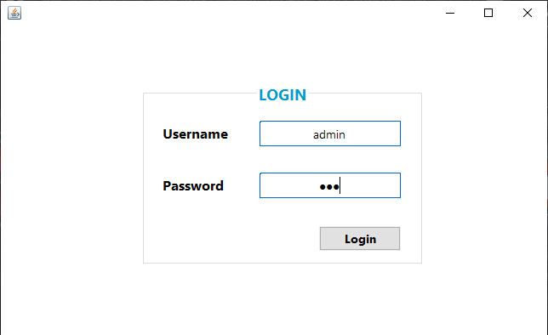

**Login Page**

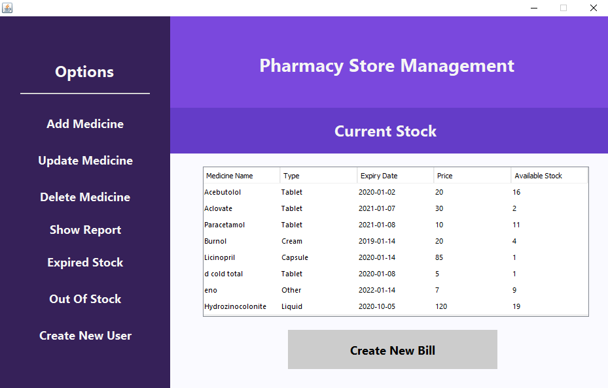

**Home Page**

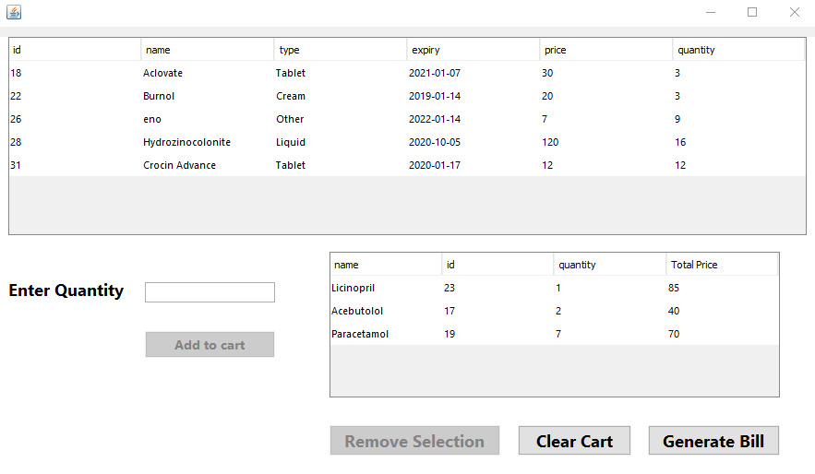

**Bill Creation**

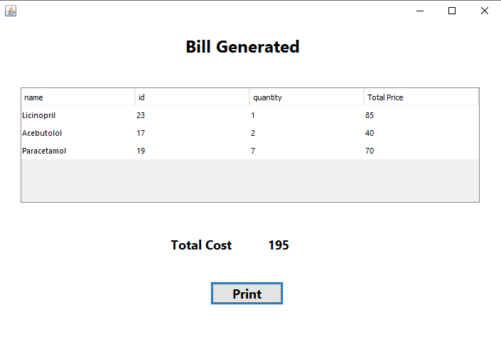

**Bill Generated**

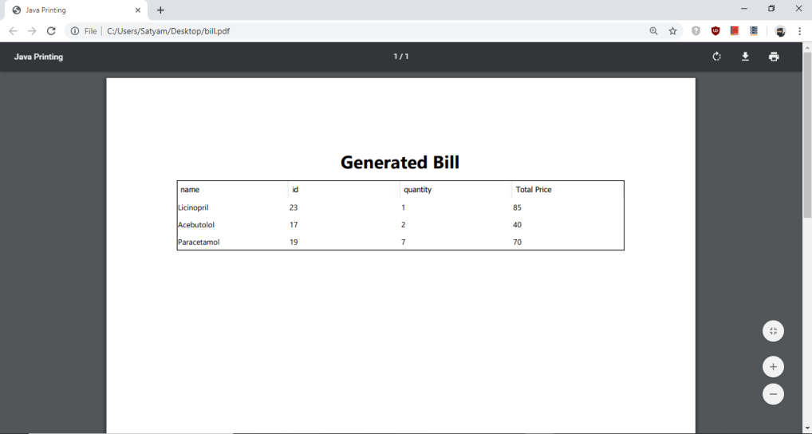

**Printed Bill PDF**

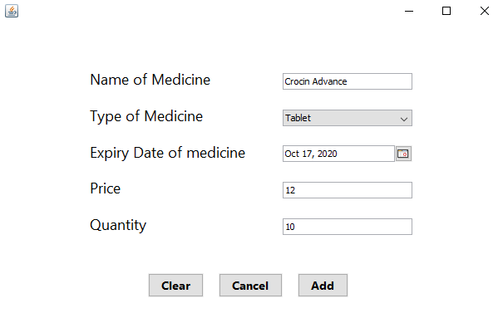

**Add Medicine**

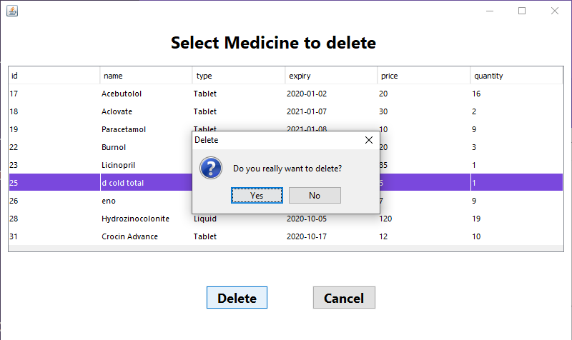

**Delete Medicine**

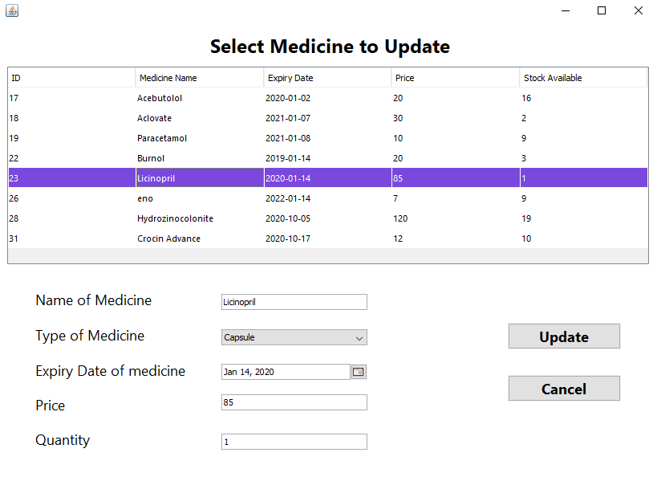

**Update Medicine**

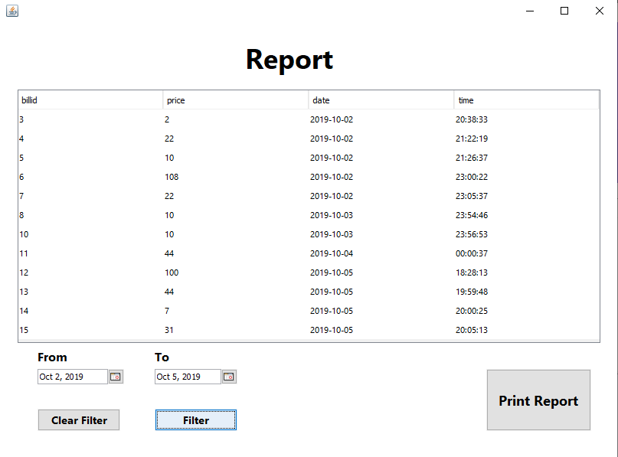

**Report of Transactions**

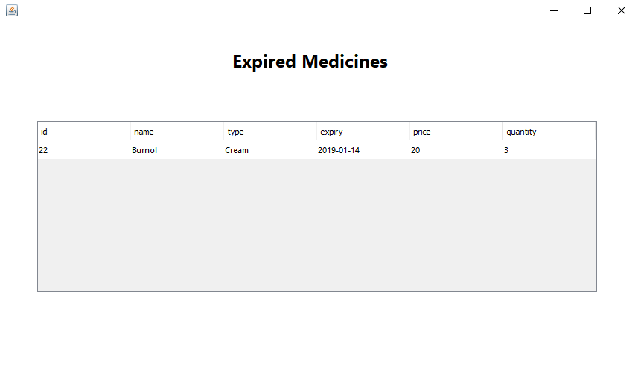

**Expired Medicines**

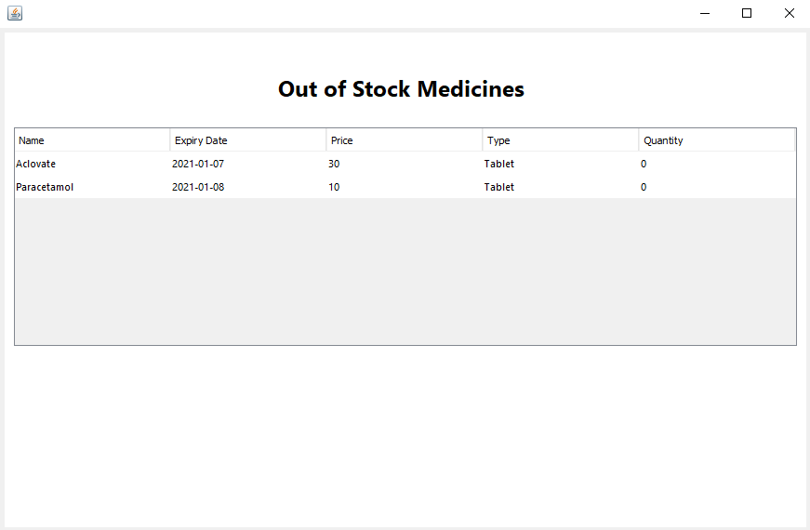

**Out of Stock Medicines**

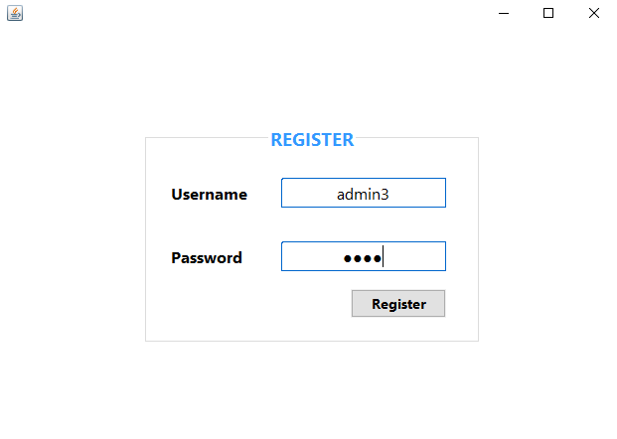

**Register New User**

**SAMPLE CODE**

1. **Trigger for Out of Stock:**

DELIMITER ;;

CREATE TRIGGER `outofstocktrigger`

BEFORE UPDATE ON `medicine`

FOR EACH ROW

begin

if NEW.quantity <= 0

then

insert into out_of_stock

set id = NEW.id;

elseif NEW.quantity > 0

then

delete from out_of_stock where out_of_stock.id = NEW.id;

end if;

end;

DELIMITER ;

1. **Add selected medicine with given quantity to cart:**

private void btn_addtocartActionPerformed(java.awt.event.ActionEvent evt) {

String quantity_validate = txt_quantity.getText();

int row = table_medicines.getSelectedRow();

String table_click = table_medicines.getModel().getValueAt(row, 0).toString(); // medicine id is taken into table_click variable

try {

String sql = "select * from medicine where id =" + table_click + ";";

pst = conn.prepareStatement(sql);

rs = pst.executeQuery();

if (rs.next()) {

price = rs.getString("price");

quantity = rs.getString("quantity");

}

} catch (Exception e) {

JOptionPane.showMessageDialog(null, e);

} finally {

try {

rs.close();

pst.close();

} catch (Exception e) {

JOptionPane.showMessageDialog(null, e);

}

}

if (quantity_validate.equals("")){

JOptionPane.showMessageDialog(null, "Enter quantity");

}

else if (Integer.parseInt(quantity_validate) > Integer.parseInt(quantity)) {

JOptionPane.showMessageDialog(null, "Not enough stock available!");

}

else {

try {

String sql = "insert into cart (id, price, quantity)values(?,?,?);";

pst = conn.prepareStatement(sql);

String currentSelectedID = medID;

pst.setString(1, medID);

pst.setString(2, price);

pst.setString(3, txt_quantity.getText());

pst.execute();

UpdateCart();

updateQuantityAfterAddingToCart(currentSelectedID);

btn_bill.setEnabled(true);

btn_clear.setEnabled(true);

txt_quantity.setText("");

noincart++;

} catch (Exception e) {

JOptionPane.showMessageDialog(null, e);

} finally { // gurantees this section will be executed, even if error is encountered

try {

rs.close();

pst.close();

} catch (Exception e) {

JOptionPane.showMessageDialog(null, e);

}

}

}

}

1. **Filtering Report using given dates on clicking ‘Filter’ button:**

private void btn_filterActionPerformed(java.awt.event.ActionEvent evt) {

java.util.Date from_date = date_from.getDate();

java.util.Date to_date = date_to.getDate();

java.util.Date date=new java.util.Date();

java.sql.Date sqlDate=new java.sql.Date(date.getTime());

if (from_date == null) {

JOptionPane.showMessageDialog(null, "Enter 'From' Date");

} else if (from_date.compareTo(sqlDate) >= 0) {

JOptionPane.showMessageDialog(null, "Enter past date in 'from' date chooser");

}

else if (to_date == null) {

JOptionPane.showMessageDialog(null, "Enter 'to' Date");

} else {

try {

SimpleDateFormat sdf = new SimpleDateFormat("yyyy-MM-dd");

String str_from_date = sdf.format(from_date);

String str_to_date = sdf.format(to_date);

String sql = "select * from bill where date >= ? and date <= ?;";

pst = conn.prepareStatement(sql);

pst.setString(1, str_from_date);

pst.setString(2, str_to_date);

rs = pst.executeQuery();

table_report.setModel(DbUtils.resultSetToTableModel(rs));

} catch (Exception e) {

JOptionPane.showMessageDialog(null, e);

} finally {

try {

rs.close();

pst.close();

} catch (Exception e) {

JOptionPane.showMessageDialog(null, e);

}

}

}

}

**CONCLUSION**

This **Pharmacy Store Management System** has been computed and tested successfully. It is user friendly and has various required options, which has been utilized by the user to perform the desired operations.

The software is developed using Java as front end and MySQL as backend in Windows environment. The goals that are achieved by the software are:

* Efficient management of records of medicines.
* Simplification of the operations.
* Less processing time and getting required information.
* User friendly.
* Portable and flexible for further enhancement.

**REFERENCES**

**Books:**

1. Database System Concepts 7th edition – Abraham Silberscahtz
2. Java The Complete Reference 9th edition – Herbert Schildt

**Links:**

1. https://en.wikipedia.org/wiki/Java_(programming_language)
2. <https://www.tutorialspoint.com/dbms/>
3. <https://netbeans.org/kb/docs/web/mysql>