Contents

DEPLOYMENT AND USAGE 1

CHANGES 2

NEW LOOK AND FEEL 4

FUTURE OF THE PROJECT 5

# DEPLOYMENT AND USAGE

# CHANGES

List of files in which changes were made

* DTL files
  + AgentFAQExplorer.dtl
  + AgentNavigationBar.dtl
  + CustomerTicketMessage.dtl
  + Header.dtl
  + Login.dtl
* JavaScript
  + Core.Agent.js
* CSS
  + Core.AgentTicketQueue.css
  + Core.Default.css
  + Core.Form.css
  + Core.Header.css
  + Core.OverviewSmall.css
  + Core.Table.css

DTL FILES

*AgentFAQExplorer.dtl*

Fixing of irregular layout caused by the new Vertical Navigation Bar, removed line: 25 Clear Fix

*AgentNavigationBar.dtl*

Many changes were done to facilitate hiding the sidebar, introducing the arrow for indicating the collapse and expand functionalities of List Items, and moving the other list items down.

*CustomerTicketMessage.dtl*

Introduced more form fields.

*Header.dtl*

Changed logout icon.

*Login.dtl*

Heavy changes made to the Agent login page.  
Login.dtl has some if not many inline CSS styles which obviously is not recommended in usual situation but in this case it works out pretty fairly as no other file/DOM is supposed to adopt this style.

The footer was not removed as removing it for some absurd reason disabled the login button (why this happened is still not clear)

The original header of the page is now the footer.

JAVASCRIPT

*Core.Agent.js*

Commented out Lines 98-102 to disable the timer of a List Item drop down.

CSS

*Core.Form.css*

Fixed layout and indentation for forms which was ruined because of the new Login page.

*Core.Header.css*

Modified colour attributes, Logout Button, Removed float, changed the Navigation bar to sidebar, Position Attributes, Position Attributes for Error message, changes to elements of sidebar to accommodate the changes made (Look and feel).

*Core.OverviewSmall.css*

Removed Padding, Fixed Layout.

*Core.Table.css*

Background and mouse hover highlight colour changed.

*Core.AgentTicketQueue.css, Core.Default.css*

Minor layout changes as a result of making the side Navigation Bar.

# NEW LOOK AND FEEL

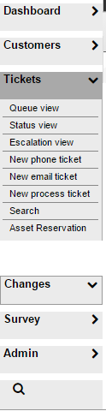

The new Navigation bar is a sidebar which has many dynamic entities added to it

Once a list Item is clicked it expands if it contains more elements.

It does not collapse until and unless it is manually done by the user

This is unlike the previous behaviour in which the list collapses after a few seconds.

There is a small arrow head indicating the current state of the list:

If the arrow head is pointing down is indicates that the list is expanded.

Arrow head pointing towards the right means it is currently collapsed.

On expansion of a list the other items move down to accommodate the sub list items.

The new Navigation Bar has dynamic size changing according to the text content. As can be seen from the previous and this image.

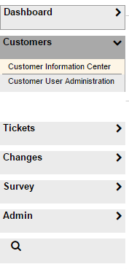

The currently selected page has the corresponding list Item a thin black border around it.

A slight pink color is added on a sub list item upon mouse hover

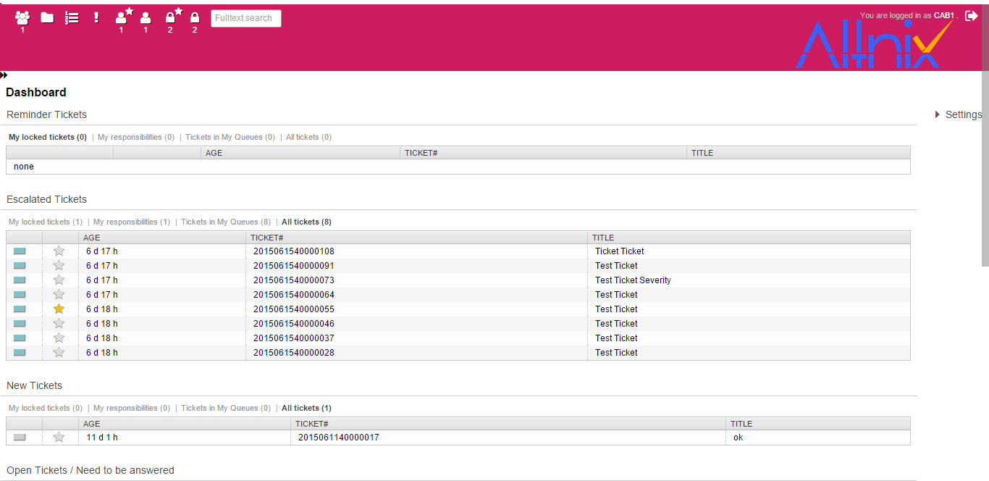

The whole Navigation Bar can be collapsed to the side increasing the workspace area.

This can be done by clicking on the double arrow on top of the Navigation Bar.



The new login page is completely revamped to give it a new feel and remove the excess unnecessary elements

Various other changes to match the new colour theme have been done. Ranging from the hover color on items in a list or in a table to changing the colour of the page header.

# FUTURE OF THE PROJECT

The immediate future scope of the project would be to switch the company logo for a mini-version so that the height of the header can be reduced.

In the longer run this project can be aimed to adapt the Material Design concept or something similar which reduces the number of functioning elements in the page to increase the visual experience and productivity from the user side.

Even though adapting the Material design in the project in its current state is not at all recommended. It requires a lot of panels to be removed which reduces the functionality of the application at a given screen presented to the user and also would increase the number of mouse clicks and mouse movements.

Hence adapting such concept certainly requires a lot pf planning and requirement analysis to be made.

Any further modifications as per the users’ requirement can be done by reading the changes section of this document and the guides mentioned at [OTRS GitHub docs](http://otrs.github.io/doc/index.html).