WEB-DEV_1.10 INTRODUCTION TO HTML

Line Breaks
The spacing between code in an HTML file doesn't affect the positioning of elements in the browser. If you are interested in modifying the spacing in the browser, you can use HTML's line break element: <br>.
The line break element is unique because it is only composed of a starting tag. You can use it anywhere within your HTML code and a line break will be shown in the browser.
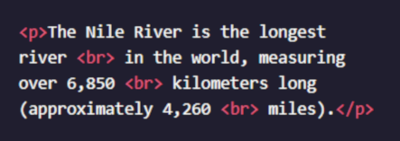

The code in the example above will result in an output that looks like the following:
The Nile River is the longest river
in the world, measuring over 6,850
kilometers long (approximately 4,260
miles).

Instructions
Add two line breaks (<br>) after the sentence that ends with Least Concern.

Questions
- Why do we need to use 2-space indentations?
- If both <br> and <br/> are valid syntaxes, which one should I use?
- Are line breaks the standard way of manipulating the position of HTML elements?

