WEB-DEV_1.11 INTRODUCTION TO HTML

Unordered Lists
In addition to organizing text in paragraph form, you can also display content in an easy-to-read list.
In HTML, you can use an unordered list tag (<ul>) to create a list of items in no particular order. An unordered list outlines individual list items with a bullet point.
The <ul> element should not hold raw text and won't automatically format raw text into an unordered list of items. Individual list items must be added to the unordered list using the <li> tag. The <li> or list item tag is used to describe an item in a list.
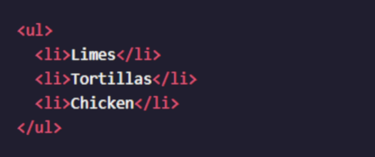

In the example above, the list was created using the <ul> tag and all individual list items were added using <li> tags.
The output will look like this:
- Limes
- Tortillas
- Chicken

Instructions
Under the heading that says Species, create an unordered list.
Do not add any list items to the list just yet.
Add the following list items to the unordered list:
- Arctos
- Collarus
- Horribilis
- Nelsoni (extinct)

Questions
- What happens if we put raw text directly in the <ul> element?
- Does the <li> tag always have to be nested within the <ul> tag?
- Is there a way to have the list items sit flush against the page like the rest of the text?

