WEB-DEV_1.12 INTRODUCTION TO HTML

Ordered Lists
Ordered lists (<ol>) are like unordered lists, except that each list item is numbered. They are useful when you need to list different steps in a process or rank items for first to last.
You can create the ordered list with the <ol> tag and then add individual list items to the list using <li> tags.
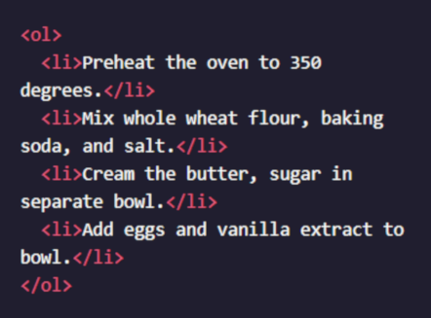

The output will look like this:
- Preheat the oven to 350 degrees.
- Mix whole wheat flour, baking soda, and salt.
- Cream the butter, sugar in separate bowl.
- Add eggs and vanilla extract to bowl.

Instructions
- Under the heading that says Countries with Large Brown Bear Populations, add an ordered list.
Do not add any list items to the list just yet.
- Add the following list items to the ordered list:
  - Russia
  - United States
  - Canada

Questions
- Can the <li> element contain content other than text?
- Can we only display either numbers or bullet-point lists?
- Is there a way to increase the space between the number and the text of each <li>?

