WEB-DEV_1.15 INTRODUCTION TO HTML

Videos
In addition to images, HTML also supports displaying videos. Like the <img> tag, the <video> tag requires a src attribute with a link to the video source. Unlike the <img> tag however, the <video>element requires an opening and a closing tag.
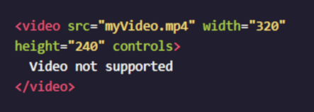

In this example, the video source (src) is myVideo.mp4 The source can be a video file that is hosted alongside your webpage, or a URL that points to a video file hosted on another webpage.
After the src attribute, the width and height attributes are used to set the size of the video displayed in the browser. The controls attribute instructs the browser to include basic video controls: pause, play and skip.
The text, "Video not supported", between the opening and closing video tags will only be displayed if the browser is unable to load the video.

Instructions
- Under the image, add the following video url and wrap it in <video></video> tags:
https://s3.amazonaws.com/codecademy-content/courses/freelance-1/unit-1/lesson-2/htmlcss1-vid_brown-bear.mp4
- Define the width of the video as "320" and the height as "240". Make sure to also include the controls attribute.
- In between the opening and closing <video> tags, add the phrase Video not supported, which will be displayed if the browser is unable to load your video.

Questions
- Why doesn’t the controls attribute need a value?
- Can we use an alt attribute with the video tag?
- Why are some tags self-closing but others are not?

