WEB-DEV_1.3 INTRODUCTION TO HTML

The Body
One of the key HTML elements we use to build a webpage is the body element. Only content inside the opening and closing body tags can be displayed to the screen. Here's what opening and closing body tags look like:
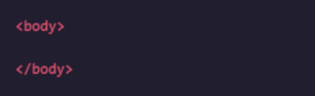

Once the file has a body, many different types of content – including text, images, and buttons – can be added to the body.
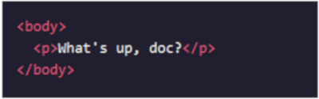

Instructions
- Open a blank file in notepad. Add a body to your web page using the <body>element.
- Add the following code between your opening and closing body tags:
<p>"Life is very short and what we have to do must be done in the now." - Audre Lorde</p>
- Save your file to your Google drive in “WebDev/Module-1”. Use the name “1-3_index.html”.

Questions
- Why doesn’t the site’s title appear on the page?
- What is a web browser?

