WEB-DEV_1.4 INTRODUCTION TO HTML

HTML Structure
Open the file “1-4_index.html”, which is found in the same folder as this instruction page (the one you are reading right now). Open the source code for 1-4_index.html. Briefly study the source code.
HTML is organized as a collection of family tree relationships. As you saw in the last exercise, we placed <p> tags within <body> tags. When an element is contained inside another element, it is considered the child of that element. The child element is said to be nested inside of the parent element.
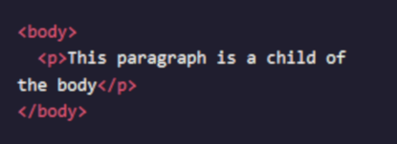

In the example above, the <p>element is nested inside the <body>element. The <p> element is considered a child of the <body>element, and the <body> element is considered the parent. You can also see that we've added two spaces of indentation (using the spacebar) for better readability.
Since there can be multiple levels of nesting, this analogy can be extended to grandchildren, great-grandchildren, and beyond. The relationship between elements and their ancestor and descendant elements is known as hierarchy.
Let's consider a more complicated example that uses some new tags:
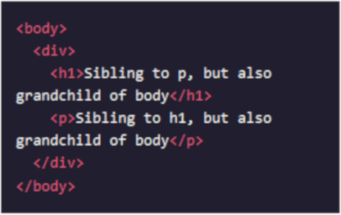

In this example, the <body> element is the parent of the <div> element. Both the <h1> and <p> elements are children of the <div> element. Because the <h1> and <p>elements are at the same level, they are considered siblings and are both grandchildren of the <body>element.
Understanding HTML hierarchy is important because child elements can inherit behavior and styling from their parent element. You'll learn more about webpage hierarchy in when you start digging into CSS.

Instructions
- Add the paragraph below as a child of the div element.
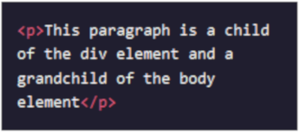

- Save your file to your Google drive in “WebDev/Module-1”. Use the name “1-3_index.html”.

Questions
- Is it correct to say that the <body> element is nested within the <html> element?
- What is the point of nesting the <p> element in a <div> element?
- What sorts of things can child elements inherit from their parents?

