WEB-DEV_1.6 INTRODUCTION TO HTML

Divs
One of the most popular elements in HTML is the <div> element. <div> is short for "division" or a container that divides the page into sections. These sections are very useful for grouping elements in your HTML together.
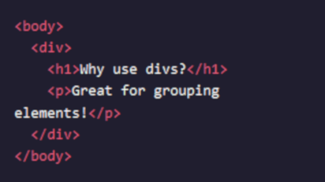

<div>s can contain any text or other HTML elements, such as links, images, or videos. Remember to always add two spaces of indentation when you nest elements inside of <div>s for better readability.

Instructions
- Below the <h1> heading that says The Brown Bear, add an opening <div> tag.
Place the closing </div>tag after the <h3> element that says Features.
Remember to use your space bar to add two spaces of indentation when you nest elements.
- Above the <h2> element that says Habitat, add an opening <div> tag.
Close the </div> tag after the <h3> element that says Countries with Small Brown Bear Populations.
- Above the <h2> element that says Media, add an opening <div> tag.
Place the closing </div>tag right above the closing </body> tag.

Questions
- Don’t <div> elements increase the complexity of our HTML structure?
- Why should we use divs if they don’t change things visually?
- Is two space indentation for nested elements standard practice?

