|  |
| --- |
| **Report file** |
| Smart surveillance monitoring system |
|  |
|  |
|  |
|  |
|  |
|  |
|  |
|  |

|  |
| --- |
| **Coordinator: - Dr RS Pavitra** |
|  |
| **Group member name: -**  Shivam kushwah (1904717)  Megha sharma (1904703)  Hardik bandil (1904694)  Jaya shukla (1904697) |

Content

* CERTIFICATE
* DECLARATION
* Introduction
* Acknowledgment
* PROPOSED SYSTEM
* component
* Description
* Using blynk app
* Coding
* Working
* Advantages & Uses
* Future scope and future work
* Conclusion
* References

CERTIFICATE

This is to certify that the project entitled Smart surveillance monitoring system submitted by shivam kushwah , hardik bandil, jaya sukhla and megha sharma in partial fulfillment of the requirements for the award of degree of Bachelor of vocation (Internet of things), to the Dayalbagh Educational Institute, Dayalbagh, Agra, is a record of their own work carried out under my supervision. The information included in this project has not been submitted for the award of any other degree.

Dr. R.S. Pavithr

Supervisor Dept. Of Physics and computer science

Faculty of Science

Dayalbagh Educational Institute

DECLARATION

I solemnly confirm that the report entitled Smart surveillance monitoring system includes the original work carried out by Shivam kushwah , Megha sharma , hardik bandi and jaya shukla and has not been submitted, either in part or full, to this or any other University/Institute for the award of any other degree.

Smart surveillance monitoring system

The smart surveillance monitoring system is the IOT based project which will reduce human work and increase comfort. With the help of this project we can control electrical appliances such as television, heater, air conditioner, washing machine, light bulb, fan, electronic security systems and other electronic and electrical devices from anywhere by single click through internet and also monitoring our home, office, room and etc. Sometimes we may forget to switch off our home appliances which will result in power wastage. By using this we can reduce such power wastage. To control these appliances we are using Node MCU, wireless communication technologies such as Wi-Fi and cloud computing technologies. The main goal of this project is to make devices more aware, interactive and efficient for a better and safer world.

It is made by the student of DEI College. It is work to make advance and smart home to use the some technics of IOT. We have used thingspeak. On that public platform we can create our channel based on our requirements. We can make our channel private or public based on application. As home is a private property we made it private. For applications like industries, factories we can make it public. It needs login id and password to enter the thingspeak account. We have to be careful to set a strong password for security purpose. In present world saving power is a major issue on which most of the countries are focusing. Smart surveillance system provides 100% efficiency as it saves time, helps to manage energy consumption which in turn saves money and provide optimum security to the user making the user’s home a safer and a smarter place to live in.

Acknowledgement

We would like to express our special thanks of gratitude to our teacher Mrs Khushboo dixit ma’am, Mrs Vandhna ma’am and Mr Amarjeet singh chauhan who gave us the golden opportunity to do this wonderful project on the topic Smart surveillance monitoring system and also helped out in doing a lot of research and we came to know about so many new things we are really thankful to them.

We would also special thanks of our college Dayalbhag educational institute in which we get a lot of facilities and we can research and get a chance to make a good project like our second semester project smart surveillance monitoring system. We are very lock who got admission in this college. And also we would hope we make our future bright with the help of all of them.

PROPOSED SYSTEM

In this project our main motive is make a life is easier and decries human effort. Via help of our project person make smart and him device is connected by their cellphone and they can control their house devises and also monitor all activities on their cellphone. The light on/off, fan on/off and also many devices controlled and have surveillance in our private place, sector.

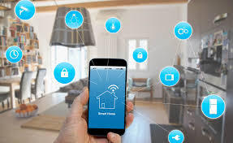

If we talk about its proposed system, it will be full connected via cellphone and we will handled this and use and enjoy its features whose designed by our group. Before choose this project we all are not all have no idea about if but we study on it and decide to developed this project and this is our second semester project and now we had complete it by help of our respected teachers and college.

Components

* **Relay**
* **PIR sensor**
* **MQ 135 gas sensor**
* **Node MCU**
* **HiLink Adapter**
* **Switches**
* **Wires**
* **GPS Module sim800/900**
* **Breadboard**

The component show in the above is the main component of this project. Component has the main important part of the project and we should have known to full knowledge of all component requirements before use them. So now discus about them and do experiment related to our project.

Relay

* Relays are the switches that open and close circuits electronically or electromechanically.
* Relay control one electrical circuit by opening and closing contacts in another circuits.
* They are used in wide variety of applications throughout industry, such as in telephone exchanges, digital computers and automation system.

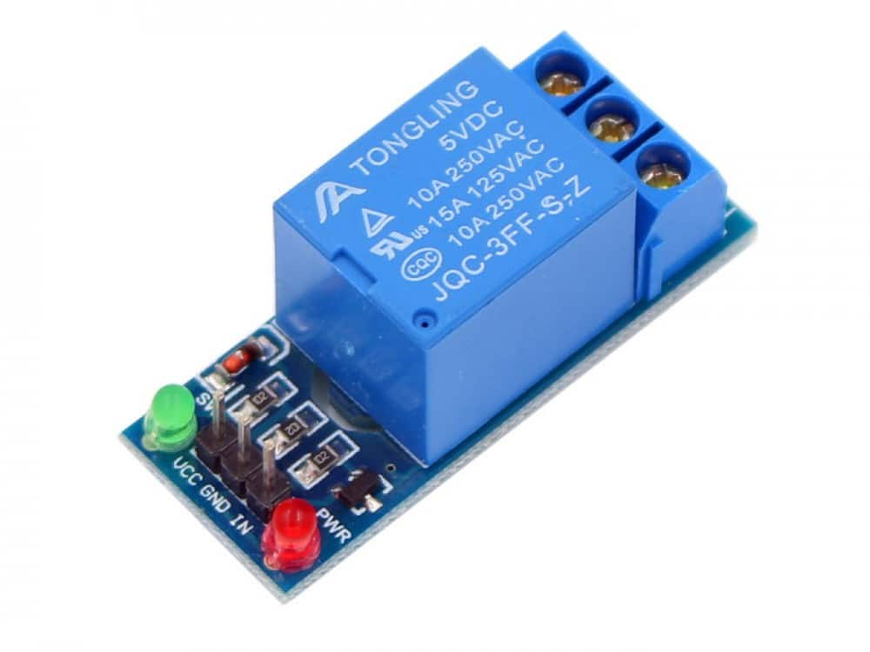

* It works on the principle of an electromagnetic attraction.
* When the circuit of the relay senses the fault current, it energies the electromagnetic field which produces the temporary magnetic field.
* This magnetic field moves the relay armature for opening or closing the connection.
* Relays are switching circuits that can close and break circuits mechanically. That means it can control an electrical circuit by closing and breaking connections in that circuit. To check the Connect relay output pin, VCC pin and GND pin to Adriano’s digital pin 13, VCC and GND pin.

Node MCU

Node MCU is an open source platform that is specifically designed for IOT projects. This tiny little board is based on ESP8266 Wi-Fi module which is specifically designed for working with or without micro controllers which uses Lau scripting language.

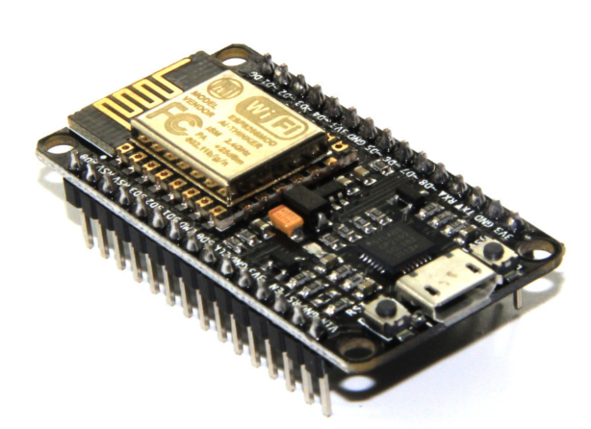

* NodeMCU is a low cost open source IOT platform.
* It initially included firmware which runs on the ESP8266 Wi-Fi SoC from Espressif Systems, and the hardware which was based on the ESP32 32 bit MCU was added.
* The NodeMCU is an open source firmware for which open source prototyping board designs are available.
* The name NodeMCU combines “node” and “MCU” (microcontroller unit)
* Both the firmware and prototyping board designs are open source.

PIR Sensor

PIR Sensor is Passive Infrared Sensor. PIR Sensor does not generate or radiate any energy for detection purposes. It detects the infrared radiation emitted or reflected from objects. Are small, inexpensive, low power and easy to use.

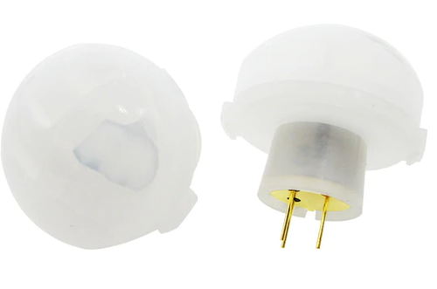

Most PIR sensors have a 3-pin connection at the side or bottom. One pin will be ground, another will be signal and the last pin will be power. Power is usually up to 5V. Sometimes bigger modules don’t have direct output and instead just operate a relay which case there is ground, power and the two switch associations. Interfacing PIR with microcontroller is very easy and simple. The PIR acts as a digital output so all you need to do is listening for the pin to flip high or low. The motion can be detected by checking for a high signal on a single I/O pin. Once the sensor warms up the output will remain low until there is motion, at which time the output will swing high for a couple of seconds, then return low. If motion continues the output will cycle in this manner until the sensors line of sight of still again. The PIR sensor needs a warm-up time with a specific end goal to capacity fittingly. This is because of the settling time included in studying nature’s domain. This could be anyplace from 10-60 seconds.

MQ 135 gas sensor

* The gas sensor consists of a steel exoskeleton under within a sensing element is housed. It ha four pins.
* When it comes to measuring or detecting a particular gas the MQ series Gas sensors are the most inexpensive and commonly used ones.

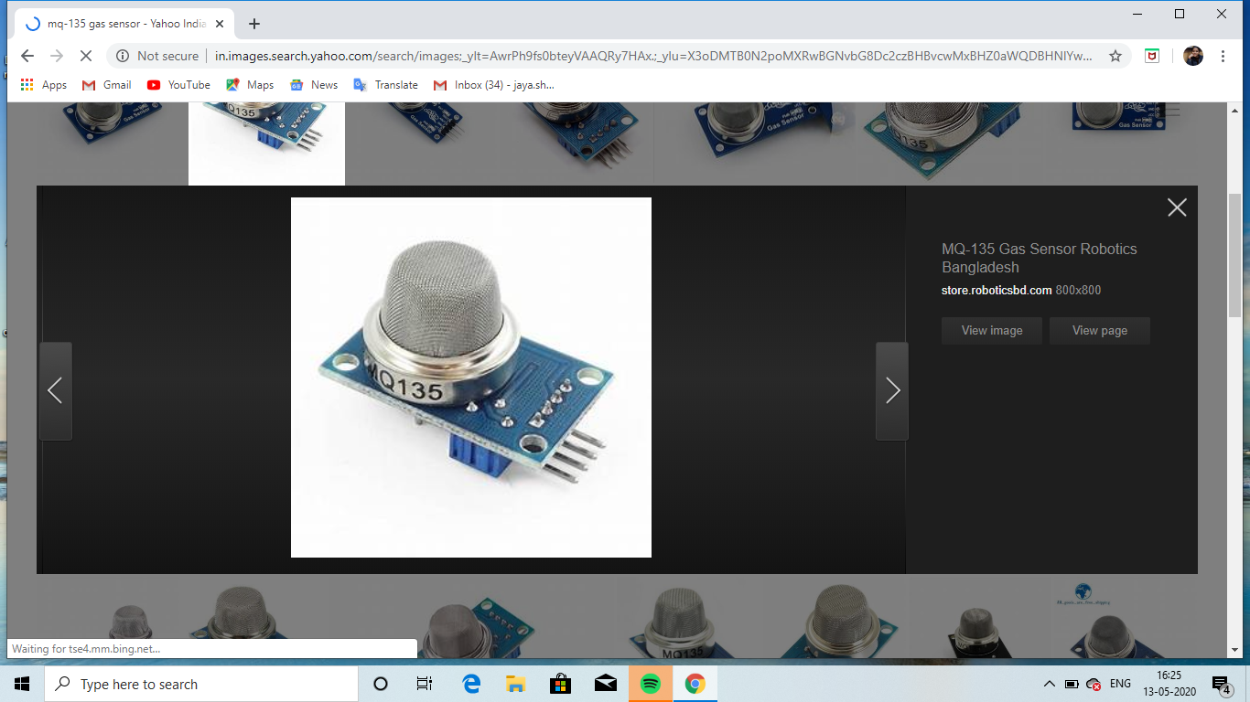

* MQ 135 is available as a module or as just the sensor alone. If you are trying to only detect the presence of a gas then you can buy it as a module since it comes with an op-amp comparator and a digital output pin. But if you planning to measure the ppm of a gas it is recommend buying the sensor alone without module.
* The MQ135 Gas sensors are used in air quality control equipment and are suitable for detecting or measuring of NH3, Nox, Alcohol, CO2, etc.

HiLink Adapter

Power Module HLK-PM01 230V to 5V /3W SMPS Module (Hi-Link) is PCB mounted plastic enclosed isolated switching step-down power supply module. It can supply 5V DC from 120V AC – 230V AC and has a power rating of 3 Watt. This makes it perfect for small projects that needs a 5V supply from Mains.

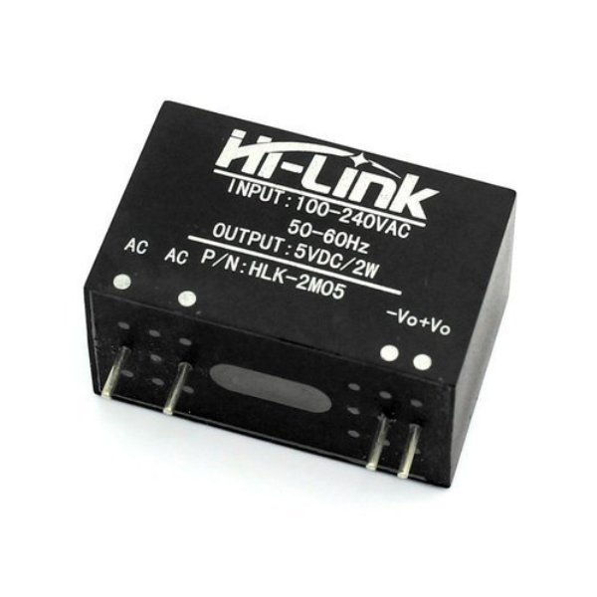

There are many advantages for these module, such as low temperature rise, low power, high efficiency, high reliability, high security isolation etc. It is widely used in smart home, automation and control, communication equipment, instrumentation and other industries.

Jumper Wires

Jumper wires are simply wires that have connector pins at each end, allowing them to be used to connect two points to each other without soldering. Jumper wires are typically used with [breadboards](https://blog.sparkfuneducation.com/what-is-a-breadboard) and other prototyping tools in order to make it easy to change a circuit as needed. Fairly simple. In fact, it doesn’t get much more basic than jumper wires.

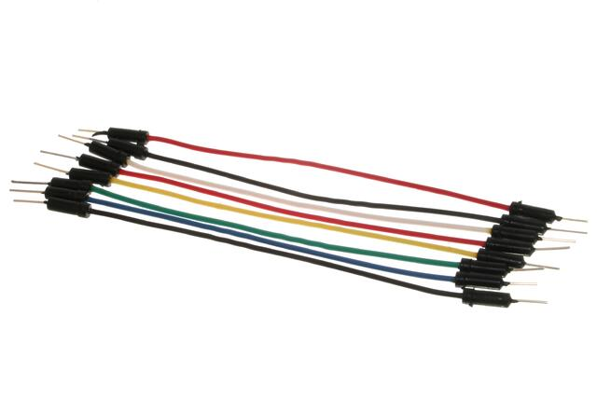

GPS Module sim800/900

SIM800L GSM/GPRS module is a miniature GSM modem, which can be integrated into a great number of IoT projects. You can use this module to accomplish almost anything a normal cell phone can; SMS text messages, Make or receive phone calls, connecting to internet through GPRS, TCP/IP, and more! To top it off, the module supports quad-band GSM/GPRS network, meaning it works pretty much anywhere in the world

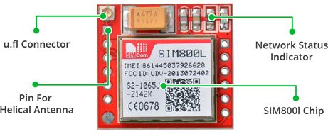

At the heart of the module is a SIM800L GSM cellular chip from SimCom. The operating voltage of the chip is from 3.4V to 4.4V, which makes it an ideal candidate for direct LiPo battery supply. This makes it a good choice for embedding into projects without a lot of space.

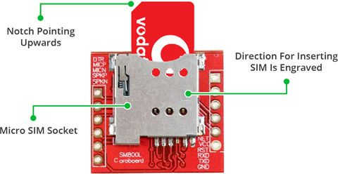

There’s a SIM socket on the back! Any activated, 2G micro SIM card would work perfectly. Correct direction for inserting SIM card is normally engraved on the surface of the SIM socket.

This module measures only 1 inch² but packs a surprising amount of features into its little frame. Some of them are listed below:

* Send and receive SMS messages
* Send and receive GPRS data.
* Scan and receive FM radio broadcasts
* Connect onto any global GSM network with any 2G SIM

Breadboard

A breadboard is used to make up **temporary circuits** for testing or to try out an idea. No soldering is required so it is easy to change connections and replace components. Parts are not damaged and can be re-used afterwards.

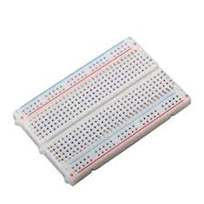

Using Blynk app

**Blynk** is a new platform that allows you to quickly build interfaces for controlling and monitoring your hardware projects from your iOS and Android device. After downloading the **Blynk app**, you can create a project dashboard and arrange buttons, sliders, graphs, and other widgets onto the screen.

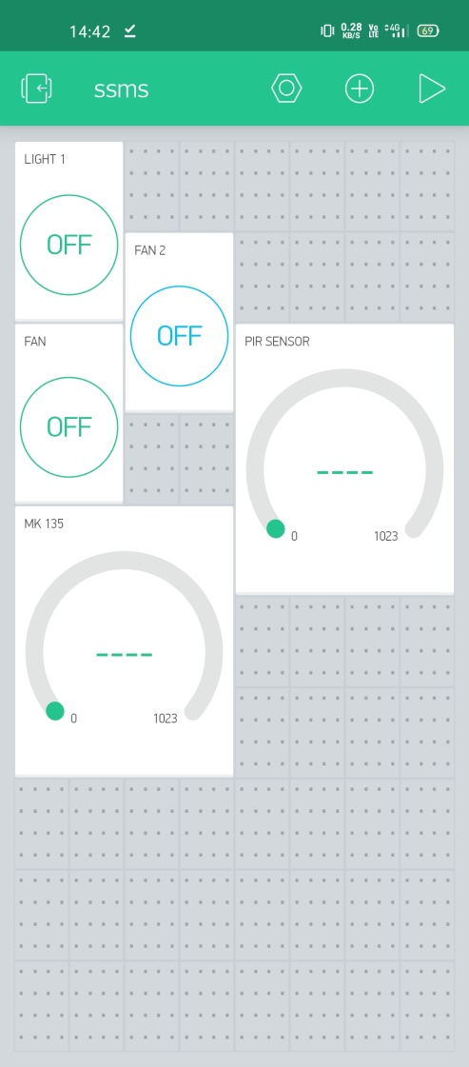

In this project the blynk app an have a main roll and very useful. We use it to control all devices and sensors and also work to on/off switches.

Create a Blynk Project

Click the “Create New Project” in the app to create a new Blynk app. Give it any name.

Blynk works with hundreds of hardware models and connection types. Select the Hardware type. After this, select connection type. In this project we have select Wi-Fi connectivity.

The Auth Token is very important – you’ll need to stick it into your ESP8266’s firmware. For now, copy it down or use the “E-mail” button to send it to yourself.

Add Widgets to The Project

Then you’ll be presented with a blank new project. To open the widget box, click in the project window to open.

We are selecting a button to control Led connected with NodeMCU.

* Click on Button.
* Give name to Button say led.
* Under OUTPUT tab- Click pin and select the pin to which led is connected to NodeMCU, here it is digital pin 2, hence select digital and under pin D2. And Click continue.

You have successfully created a GUI for Arduino.

Upload The Firmware

Now that your Blynk project is set-up, open Arduino and navigate to the ESP8266_Standalone example in the File > Examples > Blynk > Boards_WiFi> ESP8266_St menu.

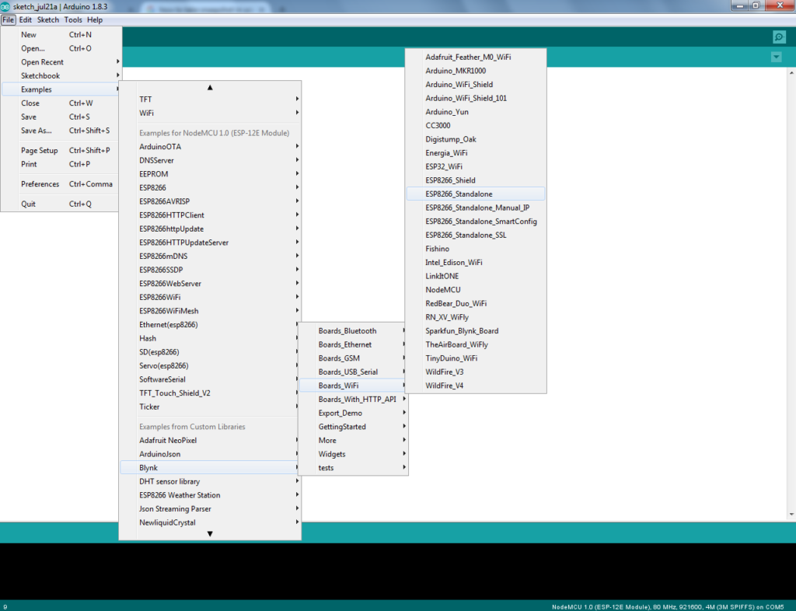

Programming Code:

Before uploading, make sure to paste your authorization token into the auth [] variable. Also make sure to load your Wi-Fi network settings into the Blynk.begin (auth, “ssid”, “pass”) function.

#include <ESP8266WiFi.h>

#define BLYNK_PRINT Serial

#include <BlynkSimpleEsp8266.h>

char auth[] = "Your Auth Key";

/* WiFi credentials */

char ssid[] = "Your Network";

char pass[] = "Your Password";

/* HC-SR501 Motion Detector */

#define pirPin 5 // Input for HC-S501

int pirValue; // Place to store read PIR Value

int pinValue; //Variable to read virtual pin

BLYNK_WRITE(V0)

{

pinValue = param.asInt();

}

void setup()

{

Serial.begin(115200);

delay(10);

pinMode(relay1, OUTPUT);

pinMode(relay2, OUTPUT);

pinMode(relay3, OUTPUT);

pinMode(relay4, OUTPUT);

digitalWrite(relay1,HIGH);

digitalWrite(relay2,HIGH);

digitalWrite(relay3,HIGH);

digitalWrite(relay4,HIGH);

connectWiFi();

server.begin();

Blynk.begin(auth, ssid, pass);

pinMode(pirPin, INPUT);

}

void loop()

{

if (pinValue == HIGH)

{

getPirValue();

}

Blynk.run();

}

void getPirValue(void) //Get PIR Data

{

pirValue = digitalRead(pirPin);

if (pirValue)

{

Serial.println("Motion detected");

Blynk.notify("Motion detected");

}

}

Execution

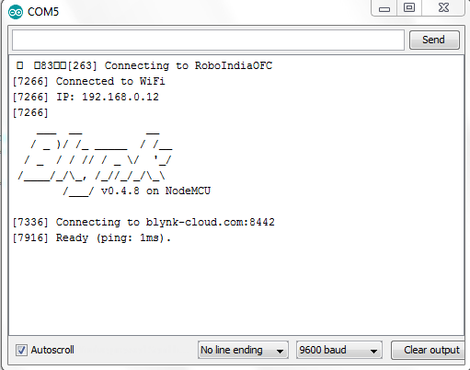

After the app has uploaded, open the serial monitor, setting the baud rate to 9600. Wait for the “Ready” message.

Then click the “Run” button in the top right corner of the Blynk app. Press the button and watch the LED

Then add more widgets to the project. They should immediately work on the ESP8266 without uploading any new firmware.

Now time of deployed the project in your private place and enjoy this amazing project made by the first year student megha, jaya, shivam and hardik. Now all test are clear and it is ready for show to all teachers and professors and time to get the credit of this.

Advantages & Uses

Advantages

* Display in many fields
* Make life easy
* Keep a safety option
* Can save electricity
* Make home smart
* Can see devices status on phone



Uses

* Making smart home
* Detect gas leakage
* Alert any device on
* Control devices by phone

Working

The home automation circuit is built around ESP8266, Blynk Android App, and a 4-channel relay board and PIR sensor and MQ135 gas sensor and GPS module 800/900. The hardware set up should be according to the circuit diagram. AC mains appliances (Bulbs) will be connected to relays which are controlled by the ESP8266. And also PIR sensor and other components are connected to the node MCU (ESP8266.

User has to install and configure the Blynk App as per the above instructions.

Whenever the user presses an icon in the app, then that information will be send to ESP8266 via Wi-Fi. The ESP8266 analyses the received commands and turns ON/OFF of the respective device via 4 – channel Relay board. And also get a notification button for gat the message of any activity in the personal room and office. In absence of you in your personal place if any activity happened the PIR sensor get high and give the notification by the GSM module. The second work of our project is if any electronic device is on in absence of person. The GSM module give us a notification via GSM module and some condition in case our home cylinder leaks the LGP gas that time our MQ135 gas sensor will activate and work for safe use.

Future scope of smart surveillance monitoring system

* As we are growing day by day our technology is along becomes so advanced.
* So, it is very essential for us it being more secured by unwanted technology.
* So, smart surveillance plays a crucial sole in this growing or contemporary ext.
* Through this, we can do several things by smart phones or smart technologies in the surveillance of smart system.

Future work

* As we are going to future work of this project, it wills deficiently such the high.
* Because in today’s era, security become the most essential part of everyone’s life.
* We shall grow this project and also design a web platform for this handling and will do more works on it.

CONCLUSION

* The smart surveillance monitoring system has been deployed.
* It is working well and very helpful to all.

REFERENCES

1. https://medium.com/kode-blood/4-step-home-automation-using-node-mcu-and-blynk-app-893ba362f976
2. https://medium.com/kode-blood/4-step-home-automation-using-node-mcu-and-blynk-app-893ba362f976
3. https://roboindia.com/tutorials/pir-motion-sensor-nodemcu-blynk/
4. https://create.arduino.cc/projecthub/Aritro/smoke-detection-using-mq-2-gas-sensor-79c54a
5. https://www.electronicshub.org/arduino-gsm-home-security-alarm-system/