**CSE3506 Essentials of Data Analytics**

Name : **Sparsh Raj**

Reg. No. : **19BPS1028**

Lab Exercise: 2- Solar Pond

**Objective:**

Consider 25 observations from the given dataframe titled ‘data’, store first 5 observations (6:00-08:00 ) in ‘data1’, next 10 observations(8:30-13:00) in ‘data2’ and the last 11 observations (13:00-18:00) in ‘data3’. Perform the following using R Programming.

**Methods:**

1. rbind (data1, dat2)
2. Store Temperature column : LCZ(TT=0), LCZ(TT=3), LCZ(TT=5), in variables V1, V2 and V3 respectively. Cbind all these three columns.
3. Plot Time Vs Pyranometer reading of ‘data’ for the month May
4. Plot Pyranometer reading Vs Two
5. Plot Pyranometer reading Vs Qact
6. Pyranometer reading Vs degree of temperature rise (ΔT1)
7. Determine the best linear fit equation between Pyranometer reading and Two/Qact/Efficiency/Effectiveness
8. Plot the best linear fit
9. Determine the Residual Sum of Squares (RSS)
10. Plot the residuals.

**Data upload:**

data=read.csv("SolarPond.csv",header=TRUE)

head(data)

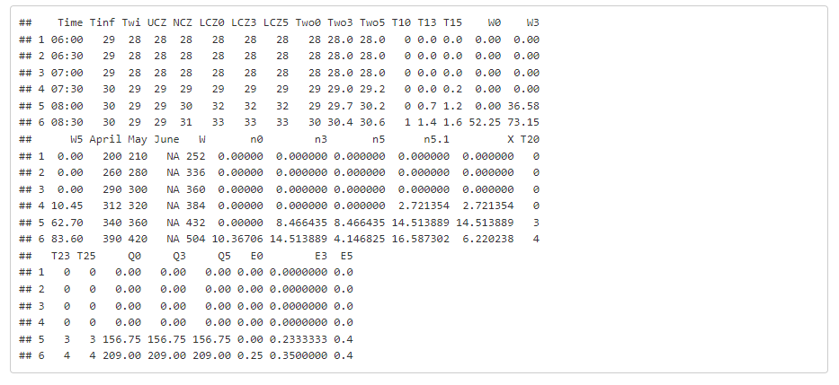

**Data Sampling:**

data1<-data[1:5,]

data2<-data[6:15,]

data3<-data[15:26,]

1. **rbind (data1, dat2)**

rbind (data1, data2)

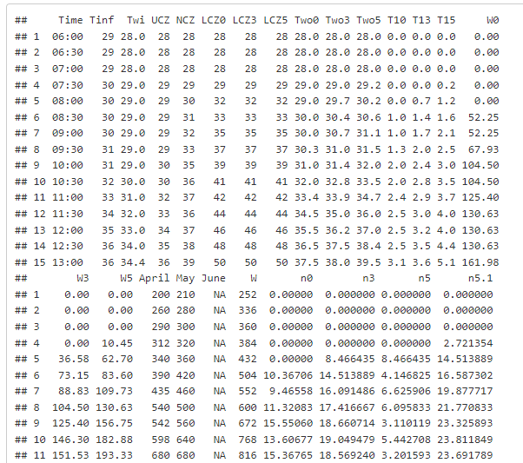

1. **Store Temperature column : LCZ(TT=0), LCZ(TT=3), LCZ(TT=5), in variables V1, V2 and V3 respectively. Cbind all these three columns.**

v1<-data$LCZ0

v2<-data$LCZ3

v3<-data$LCZ5

cbind(v1,v2,v3)

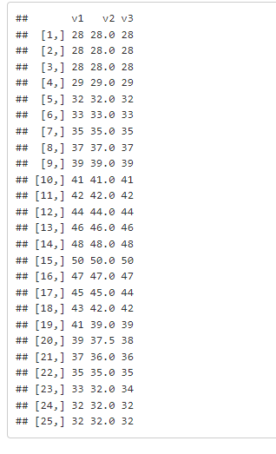

1. **Plot Time Vs Pyranometer reading of ‘data’ for the month May**

**library**("ggplot2")

ggplot(data,aes(x=Time,y=May))+geom_point()

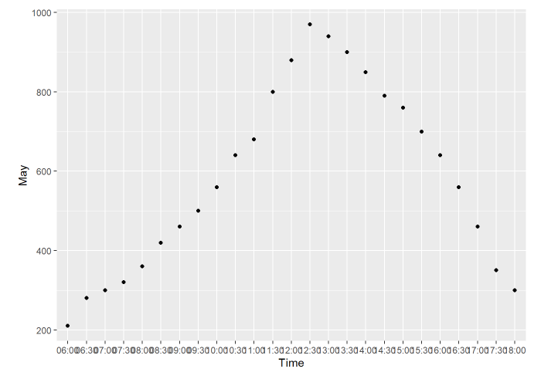

1. **Plot Pyranometer reading Vs Two**

**library**("ggplot2")

ggplot(data,aes(x=Two0,y=May))+geom_point()

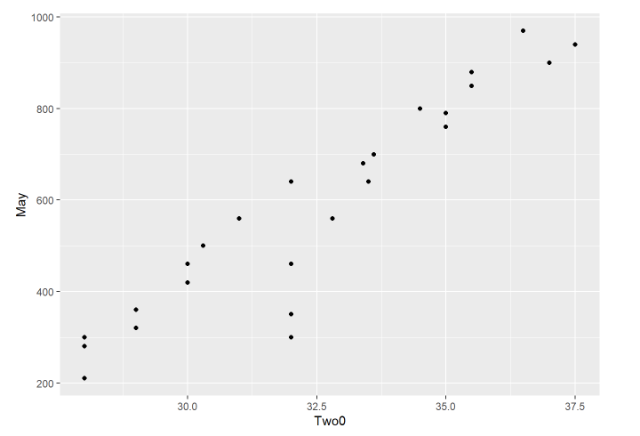

1. **Plot Pyranometer reading Vs Qact**

**library**("ggplot2")

ggplot(data,aes(x=W0,y=May))+geom_point()

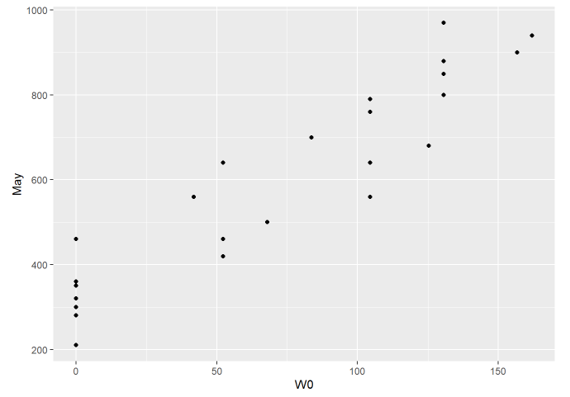

1. **Pyranometer reading Vs degree of temperature rise (ΔT1)**

**library**("ggplot2")

ggplot(data,aes(x=T10,y=May))+geom_point()

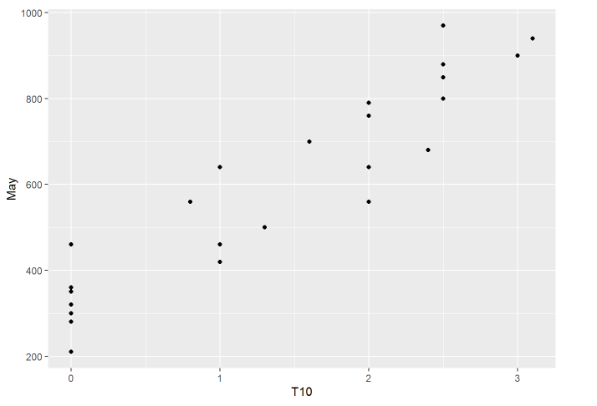

1. **Determine the best linear fit equation between Pyranometer reading and Two/Qact/Efficiency/Effectiveness**

blf<-lm(data3$May~data3$E0)

summary(blf)

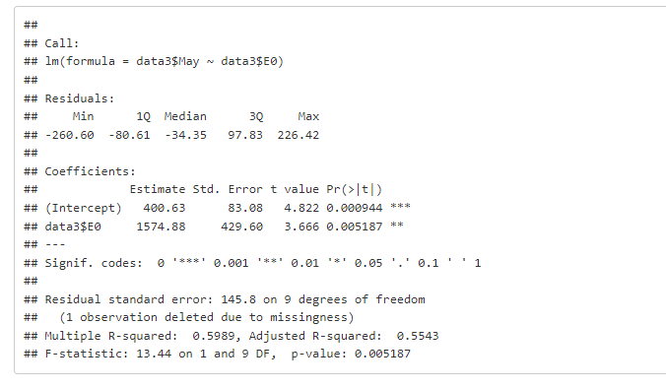

1. **Plot the best linear fit**

plot(data$E0,data$May,col = "red",main = "Pyranometer Vs Effectiveness(TT=0)",abline(lm(data$May~data$E0)),cex = 1.3,pch = 16,xlab = "Pyranometer (May)",ylab = "Effectiveness (TT=0)")

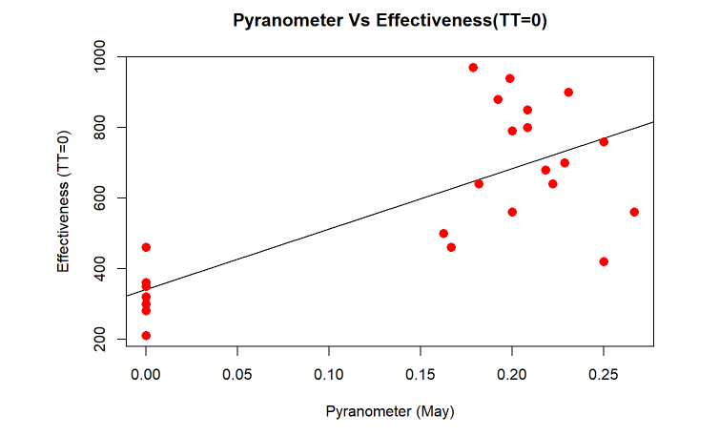

1. **Determine the Residual Sum of Squares (RSS)**

res<-sum(resid(blf)^2)

res

## [1] 191194

1. **Plot the residuals.**

res=resid(blf)

length(res)

## [1] 11

plot(data3$E0[1:11], res, ylab="Residuals", xlab="Effectiveness (TT=0)", main="Best Linear Fit Residuals",col="red")

abline(0, 0)

