**CSE3506 Essentials of Data Analytics**

Name : **Sparsh Raj**

Reg. No. : **19BPS1028**

Lab Exercise: 3 - Augmenting the Thermal Conductivity of PCM Using CuO Nanoparticle

**Objective:** Consider 16 observations (8 for solid state and 8 for liquid state) from the given dataframe. Perform the following using R Programming for analytical and experimental values.

**Methods:**

1. Determine the grand mean, and mean of thermal conductivity.
2. Sum of Squares between and Sum of Squares within
3. Degrees of Freedom (Between, Within and total)
4. Mean Squares (Between and Within)
5. F_Statistic and F Critical
6. Check, Is Null hypothesize accepted?
7. Plot Vol. Concentration VS Thermal Conductivity
8. Plot Vol Concentration Vs % increase in Thermal conductivity –(In bar chart)
9. Error (Measured Value-Analytical Value)
10. **Determine the grand mean, and mean of thermal conductivity.**

data=read.csv("lab3.csv",header=TRUE)

head(data)

## Conc Analytical.K Inc.in.A.k Exp.K Inc.in.E.k

## 1 0.00 0.1500000 0.0000 0.150 0.0000

## 2 0.01 0.1544326 2.9551 0.152 1.3333

## 3 0.02 0.1589534 5.9689 0.156 3.9474

## 4 0.03 0.1635650 9.0433 0.161 7.0513

## 5 0.04 0.1682702 12.1801 0.166 9.9379

## 6 0.05 0.1730720 15.3813 0.172 13.2530

names(data)

## [1] "Conc" "Analytical.K" "Inc.in.A.k" "Exp.K" "Inc.in.E.k"

gMean<- mean((data$Analytical.K+data$Exp.K+data$Inc.in.A.k+data$Inc.in.A.k))

print(paste("Grand Mean of analytical and experimental K:", gMean))

## [1] "Grand Mean of analytical and experimental K: 32.687881877"

anaMean<-mean(data$Analytical.K)

print(paste("Mean of analytical K:", anaMean))

## [1] "Mean of analytical K: 0.174256877"

expMean<-mean(data$Exp.K)

print(paste("Mean of experimental K:", expMean))

## [1] "Mean of experimental K: 0.171125"

anaIncMean<-mean(data$Inc.in.A.k)

print(paste("Mean of analytical %incease K:", anaIncMean))

## [1] "Mean of analytical %incease K: 16.17125"

expIncMean<-mean(data$Inc.in.E.k)

print(paste("Mean of experimental %incease K:", expIncMean))

## [1] "Mean of experimental %incease K: 12.049975"

1. **Sum of Squares between and Sum of Squares within**

**library**(plyr)

n<-nrow(ddply(data, .(Analytical.K), nrow))

ssc<- n*((anaMean-gMean)^2 + (expMean-gMean)^2 + (anaIncMean-gMean)^2 +(expIncMean-gMean)^2)

print(paste("Sum of Squares between: ", ssc))

## [1] "Sum of Squares between: 22505.5809381009"

sse1<- (data$Analytical.K-anaMean)^2

sse2<- (data$Inc.in.A.k-anaIncMean)^2

sse3<- (data$Exp.K-expMean)^2

sse4<- (data$Inc.in.E.k-expIncMean)^2

sse<- sum(sse1)+sum(sse2)+sum(sse3)+sum(sse4)

print(paste("Sum of Squares within: ", sse))

## [1] "Sum of Squares within: 3219.37259277604"

1. **Degrees of Freedom (Between, Within and total)**

dfB<-(ncol(data)-1)-1

dfW<-(n*(ncol(data)-1))-(ncol(data)-1)

dfT<-(n*(ncol(data)-1))-1

print(paste("Degrees of freedom between: ",dfB))

## [1] "Degrees of freedom between: 3"

print(paste("Degrees of freedom within: ",dfW))

## [1] "Degrees of freedom within: 28"

print(paste("Degrees of freedom total: ",dfT))

## [1] "Degrees of freedom total: 31"

1. **Mean Squares (Between and Within)**

msc<-ssc/dfB

print(paste("Mean square between: ",msc))

## [1] "Mean square between: 7501.86031270029"

mse<-sse/dfW

print(paste("Mean square within: ",mse))

## [1] "Mean square within: 114.977592599144"

1. **F_Statistic and F Critical**

fStat<-msc/mse

print(paste("F-statistic: ",fStat))

## [1] "F-statistic: 65.2462809762823"

fCrit<-qf(0.05, dfB, dfW, lower.tail=TRUE)

print(paste("F-Critical: ",fCrit))

## [1] "F-Critical: 0.11597074260607"

1. **Check, Is Null hypothesize accepted?**

print("Since, f-statistic is greater than f-critical, null hypotheseis is rejected. Therefore the given dataset belong to different samples.")

## [1] "Since, f-statistic is greater than f-critical, null hypotheseis is rejected. Therefore the given dataset belong to different samples."

1. **Plot Vol. Concentration VS Thermal Conductivity**

**library**("ggplot2")

ggplot(data,aes(x=Conc,y=Analytical.K))+geom_point()

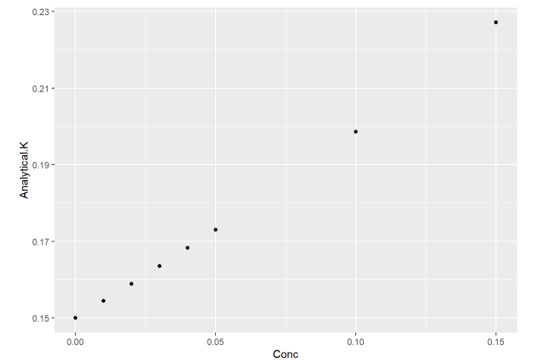

**library**("ggplot2")

ggplot(data,aes(x=Conc,y=Exp.K))+geom_point()

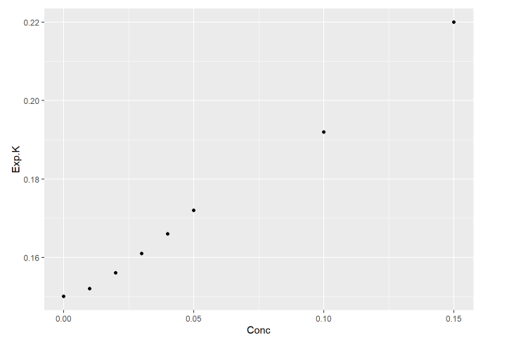

1. **Plot Vol Concentration Vs % increase in Thermal conductivity –(In bar chart)**

barplot(data$Conc,names.arg=data$Inc.in.A.k,xlab="Concentration",ylab="Analytical% increase K",col="blue",border="red")

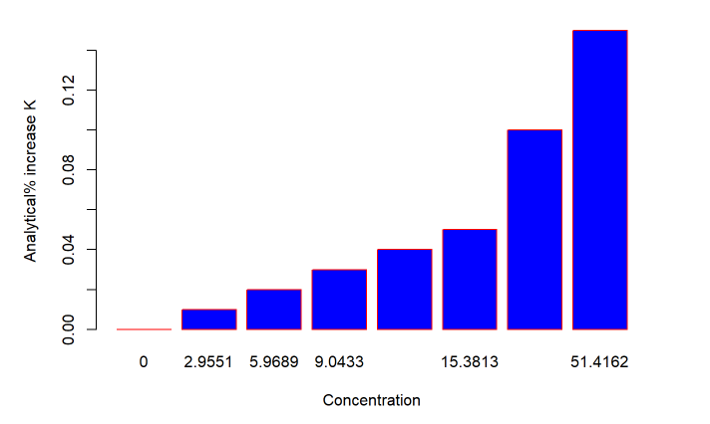

barplot(data$Conc,names.arg=data$Inc.in.E.k,xlab="Concentration",ylab="Exp % increase K",col="yellow",border="orange")

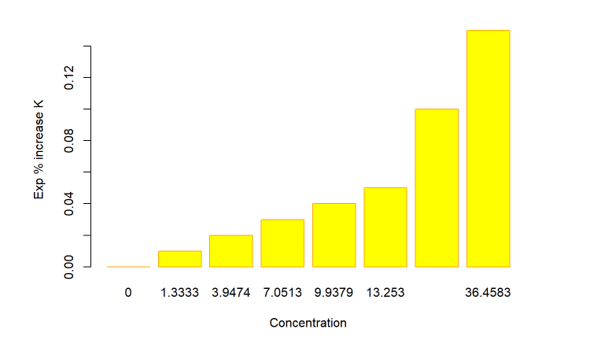

1. **Error (Measured Value-Analytical Value)**

err<- data$Exp.K - data$Analytical.K

print("Error: (Measured value - Analytical value): ")

## [1] "Error: (Measured value - Analytical value): "

err

## [1] 0.000000000 -0.002432580 -0.002953352 -0.002564975 -0.002270215

## [6] -0.001071952 -0.006637602 -0.007124340

incErr <- data$Inc.in.E.k - data$Inc.in.A.k

print("%increase Error: (Measured value - Analytical value): ")

## [1] "%increase Error: (Measured value - Analytical value): "

incErr

## [1] 0.0000 -1.6218 -2.0215 -1.9920 -2.2422 -2.1283 -8.0065 -14.9579