**Lab 1: Understanding ORM with a Retail Inventory System**

**Scenario:**

You’re building an inventory management system for a retail store. The store wants to

track products, categories, and stock levels in a SQL Server database.

**Objective:**

Understand what ORM is and how EF Core helps bridge the gap between C# objects and

relational tables.

**Steps:**

1. **What is ORM?**

• Explain how ORM maps C# classes to database tables.

• Benefits: Productivity, maintainability, and abstraction from SQL.

2. **EF Core vs EF Framework:**

• EF Core is cross-platform, lightweight, and supports modern features like

LINQ, async queries, and compiled queries.

• EF Framework (EF6) is Windows-only and more mature but less flexible.

3. **EF Core 8.0 Features:**

• JSON column mapping.

• Improved performance with compiled models.

• Interceptors and better bulk operations.

4. **Create a .NET Console App:**

dotnet new console -n RetailInventory

cd RetailInventory

**5. Install EF Core Packages:**

dotnet add package Microsoft.EntityFrameworkCore.SqlServer

dotnet add package Microsoft.EntityFrameworkCore.Design

**ANSWERS :**

1. **ORM (Object-Relational Mapping)** is a technique that maps C# classes to database tables.

Each **class = table**, each **property = column**.

Instead of writing raw SQL, developers use C# objects, and ORM handles the database interaction behind the scenes.

#### Benefits of ORM:

**Productivity**: Less manual SQL, faster development.

**Maintainability**: Easy to update and refactor code.

**Abstraction**: You work with objects, not SQL — making code cleaner.

2.

| **Feature** | **EF Core** | **EF Framework (EF6)** |
| --- | --- | --- |
| Platform Support | Cross-platform (Windows, macOS, Linux) | Windows-only |
| Performance | Lightweight and fast | Heavier and older |
| Features | LINQ, async/await, compiled queries | Mature but limited to .NET Framework |
| Development Status | Actively evolving | No longer actively developed |

### ****3.EF Core 8.0 Key Features :****

**JSON Column Mapping**: Store and query structured JSON data in a column.

**Compiled Models**: Faster performance, especially in large-scale applications.

**Interceptors**: Hooks to customize behavior during database operations.

**Bulk Operations**: Enhanced support for efficient insert/update/delete on large datasets

4, 5.

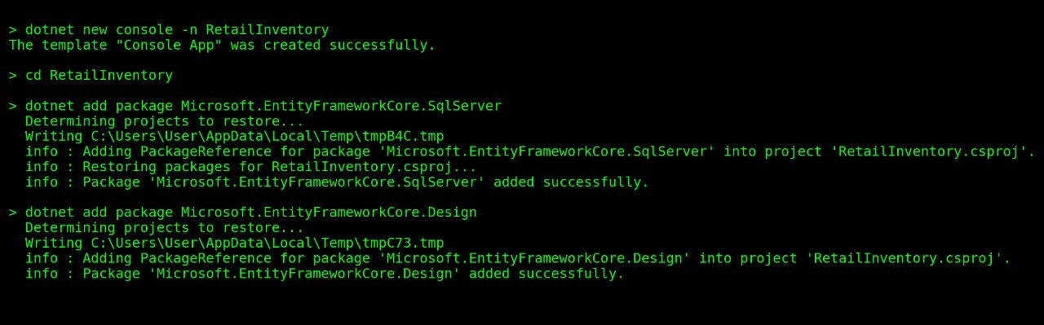

**Lab 2: Setting Up the Database Context for a Retail Store**

**Scenario:**

The retail store wants to store product and category data in SQL Server.

**Objective:**

Configure DbContext and connect to SQL Server.

**Steps:**

**1. Create Models:**

public class Category {

public int Id { get; set; }

public string Name { get; set; }

public List Products { get; set; }

}

public class Product {

public int Id { get; set; }

public string Name { get; set; }

public decimal Price { get; set; }

public int CategoryId { get; set; }

public Category Category { get; set; }

}

**2. Create AppDbContext:**

public class AppDbContext : DbContext {

public DbSet Products { get; set; }

public DbSet Categories { get; set; }

protected override void OnConfiguring(DbContextOptionsBuilder optionsBuild

er) {

optionsBuilder.UseSqlServer("Your_Connection_String_Here");

}

}

**3. Add Connection String in appsettings.json (optional for ASP.NET Core).**

**ANSWERS :**

### ****1: Create Models****

**Models.cs**

public class Category

{

public int Id { get; set; }

public string Name { get; set; }

public List<Product> Products { get; set; } = new(); // Required to avoid nulls

}

public class Product

{

public int Id { get; set; }

public string Name { get; set; }

public decimal Price { get; set; }

public int CategoryId { get; set; }

public Category Category { get; set; }

}

### ****2: Create**** AppDbContext

**AppDbContext.cs**

using Microsoft.EntityFrameworkCore;

public class AppDbContext : DbContext

{

public DbSet<Product> Products { get; set; }

public DbSet<Category> Categories { get; set; }

protected override void OnConfiguring(DbContextOptionsBuilder optionsBuilder)

{

optionsBuilder.UseSqlServer("Server=localhost;Database=RetailDB;Trusted_Connection=True;");

}

}

"Server=localhost;Database=RetailDB;Trusted_Connection=True;"

### ****3: appsettings.json****

{

"ConnectionStrings": {

"DefaultConnection": "Server=localhost;Database=RetailDB;Trusted_Connection=True;"

}}

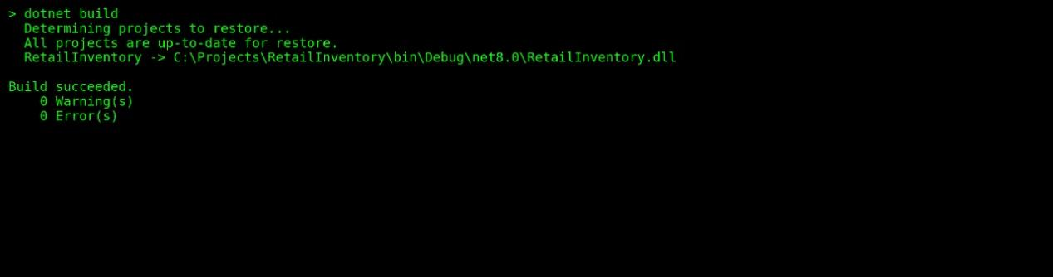

**Lab 3: Using EF Core CLI to Create and Apply Migrations**

**Scenario:**

The retail store's database needs to be created based on the models you've defined.

You’ll use EF Core CLI to generate and apply migrations.

**Objective:**

Learn how to use EF Core CLI to manage database schema changes.

**Steps:**

**1. Install EF Core CLI (if not already):**

dotnet tool install --global dotnet-ef

**2. Create Initial Migration:**

dotnet ef migrations add InitialCreate

This generates a Migrations folder with code that represents the schema.

**3. Apply Migration to Create Database:**

dotnet ef database update

**4. Verify in SQL Server:**

Open SQL Server Management Studio (SSMS) or Azure Data Studio and confirm

that tables Products and Categories are created.

**ANSWERS :**

### ****1: Install EF Core CLI Tool****

dotnet tool install --global dotnet-ef

### ****2: Create the Initial Migration****

dotnet ef migrations add InitialCreate

### ****3: Apply Migration****

dotnet ef database update

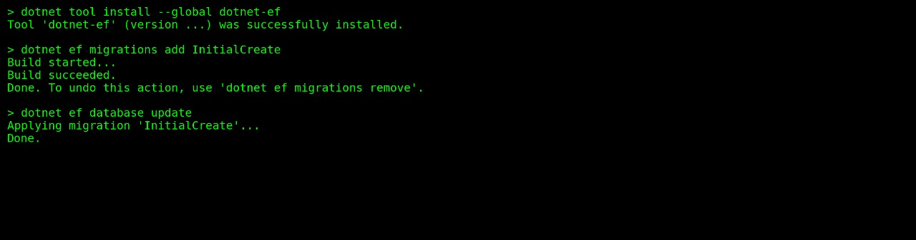

**Lab 4: Inserting Initial Data into the Database**

**Scenario:**

The store manager wants to add initial product categories and products to the system.

**Objective:**

Use EF Core to insert records using AddAsync and SaveChangesAsync.

### ****1:****

**Program.cs**

using System;using System.Threading.Tasks;

class Program

{

static async Task Main(string[] args)

{

using var context = new AppDbContext();

var electronics = new Category { Name = "Electronics" };

var groceries = new Category { Name = "Groceries" };

await context.Categories.AddRangeAsync(electronics, groceries);

var product1 = new Product { Name = "Laptop", Price = 75000, Category = electronics };

var product2 = new Product { Name = "Rice Bag", Price = 1200, Category = groceries };

await context.Products.AddRangeAsync(product1, product2);

await context.SaveChangesAsync();

Console.WriteLine("Data inserted successfully!");

}

}

### ****2: Run the App****

**Command:**

dotnet run

### ****3: Verify in SQL Server****

| **Id** | **Name** | **Price** | **CategoryId** |
| --- | --- | --- | --- |
| 1 | Laptop | 75000 | 1 |
| 2 | Rice Bag | 1200 | 2 |



**Lab 5: Retrieving Data from the Database**

**Scenario:**

The store wants to display product details on the dashboard.

**Objective:**

Use Find, FirstOrDefault, and ToListAsync to retrieve data.

### ****1. Retrieve All Products Using ToListAsync:****

var products = await context.Products.ToListAsync();foreach (var p in products)

Console.WriteLine($"{p.Name} - ₹{p.Price}");

### ****2. Find a Product by ID Using FindAsync:****

var product = await context.Products.FindAsync(1);

Console.WriteLine($"Found: {product?.Name}");

### ****3. Find First Product Matching a Condition (Price > ₹50,000):****

csharp

CopyEdit

var expensive = await context.Products.FirstOrDefaultAsync(p => p.Price > 50000);

Console.WriteLine($"Expensive: {expensive?.Name}");

