## **Objectives**

* Define SPA and its benefits
* Define React and identify its working
* Identify the differences between SPA and MPA
* Explain Pros & Cons of Single-Page Application
* Explain about React
* Define virtual DOM
* Explain Features of React

**Answers:**

1. Define SPA and its benefits

SPA (Single Page Application) is a type of web application that loads a single HTML page and dynamically updates the content as the user interacts with the app, without reloading the page.

Benefits of SPA:

- Fast and smooth user experience

- Reduces server load and page reloads

- Efficient client-side routing

- Better performance after the initial load

2. Define React and identify its working

React is a JavaScript library developed by Facebook for building user interfaces, especially single-page applications.

How React works:

- Uses components to build the UI

- Updates only the changed parts of the UI using the virtual DOM

- Handles state and data efficiently

- Uses JSX syntax, which allows writing HTML-like code inside JavaScript

3. Identify the differences between SPA and MPA

SPA (Single Page Application):

- Loads a single HTML page

- Updates content dynamically without full page reload

- Uses client-side routing

- Fast after initial load

- Example technologies: React, Angular, Vue

MPA (Multi Page Application):

- Loads a new HTML page for every interaction

- Full page reload on each navigation

- Uses server-side routing

- Slower navigation

- Example technologies: Traditional HTML, PHP, Java, ASP.NET

4. Explain Pros & Cons of Single-Page Application

Pros:

- Fast navigation and dynamic updates

- Better user experience

- Reduced server load after initial load

- Easy to create mobile-like applications

Cons:

- Slower initial loading time

- SEO can be difficult

- Requires more JavaScript and client-side logic

- Browser history management is more complex

5. Explain about React

React is an open-source JavaScript library used for building user interfaces. It is mainly used for building single-page applications by creating reusable UI components. React is efficient because it uses a virtual DOM to optimize rendering.

6. Define virtual DOM

The virtual DOM is a lightweight copy of the real DOM. It helps React improve performance.

How it works:

- When the UI changes, React updates the virtual DOM

- It compares the new virtual DOM with the previous one

- Only the changed parts are updated in the real DOM (this process is called "diffing")

1. Explain Features of React

- Uses JSX syntax for writing UI

- Virtual DOM for better performance

- One-way data flow (unidirectional)

- Strong ecosystem (with tools like Redux, React Router, etc.)

In this hands-on lab, you will learn how to:

* Set up a react environment
* Use create-react-app

## **Prerequisites**

The following is required to complete this hands-on lab:

* Node.js
* NPM
* Visual Studio Code

## **Notes**

Estimated time to complete this lab: **30 minutes.**

Create a new React Application with the name “myfirstreact”, Run the application to print “welcome to the first session of React” as heading of that page.

1. To create a new React app, Install Nodejs and Npm from the following link:

<https://nodejs.org/en/download/>

1. Install Create-react-app by running the following command in the command prompt:



1. To create a React Application with the name of “myfirstreact”, type the following command:



1. Once the App is created, navigate into the folder of myfirstreact by typing the following command:



1. Open the folder of myfirstreact in Visual Studio Code
2. Open the App.js file in Src Folder of myfirstreact
3. Remove the current content of “App.js”
4. Replace it with the following:

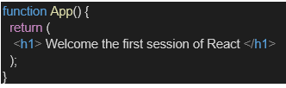

1. Run the following command to execute the React application:



1. Open a new browser window and type “localhost:3000” in the address bar

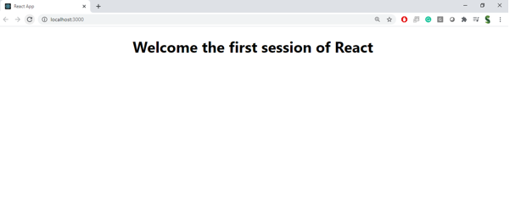

**Output :**

