## **Objectives**

* Explain React components
* Identify the differences between components and JavaScript functions
* Identify the types of components
* Explain class component
* Explain function component
* Define component constructor
* Define render() function

Answers :

**Explain React components**

**- React components are reusable, self-contained pieces of UI.**

**- They return HTML (JSX) to be rendered on the screen.**

**function Welcome() {**

**return <h1>Hello, World!</h1>;**

**}**

**Differences between components and JavaScript functions**

**- JS functions do computations; React components return UI (JSX).**

**- React components must start with a capital letter.**

**- React components can use hooks (in functional components) or lifecycle methods (in class components).**

**Types of components**

**1. **Function Component\*\***

**2. **Class Component\*\***

**Explain class component**

**import React, { Component } from 'react';**

**class Welcome extends Component {**

**render() {**

**return <h1>Hello from Class Component</h1>;**

**}**

**}**

**- Uses ES6 class.**

**- Has lifecycle methods.**

**- Requires `render()` to return JSX.**

**Explain function component**

**function Welcome() {**

**return <h1>Hello from Function Component</h1>;**

**}**

**```**

**- Simpler and preferred for most use cases.**

**- Can use React Hooks.**

**Define component constructor**

**class Welcome extends React.Component {**

**constructor(props) {**

**super(props);**

**this.state = { message: "Hello" };**

**}**

**}**

**- Initializes state and binds methods.**

**- Called before `render()`.**

**Define render() function**

**render() {**

**return <h1>Hello</h1>;**

**}**

**- Mandatory in class components.**

**- Returns the JSX to be rendered.**

In this hands-on lab, you will learn how to:

* Create a class component
* Create multiple components
* Render a component

## **Prerequisites**

The following is required to complete this hands-on lab:

* Node.js
* NPM
* Visual Studio Code

## **Notes**

Estimated time to complete this lab: **30 minutes.**

Create a react app for Student Management Portal named StudentApp and create a component named Home which will display the Message “Welcome to the Home page of Student Management Portal”. Create another component named About and display the Message “Welcome to the About page of the Student Management Portal”. Create a third component named Contact and display the Message “Welcome to the Contact page of the Student Management Portal”. Call all the three components.

1. Create a React project named “StudentApp” type the following command in terminal of Visual studio:



1. Create a new folder under Src folder with the name “Components”. Add a new file named “Home.js”
2. Type the following code in Home.js

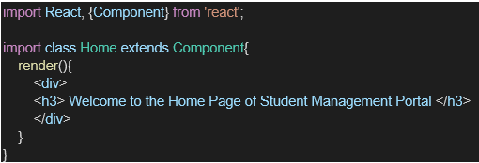

1. Under Src folder add another file named “About.js”
2. Repeat the same steps for Creating “About” and “Contact” component by adding a new file as ”About.js”, “Contact.js” under “Src” folder and edit the code as mentioned for “Home” Component.
3. Edit the App.js to invoke the Home, About and Contact component as follows:

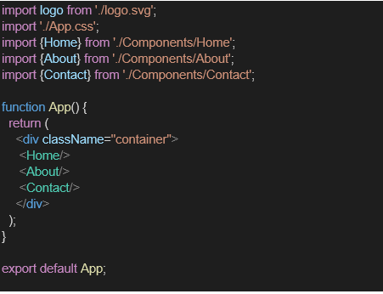

1. In command Prompt, navigate into StudentApp and execute the code by typing the following command:



1. Open browser and type “localhost:3000” in the address bar:

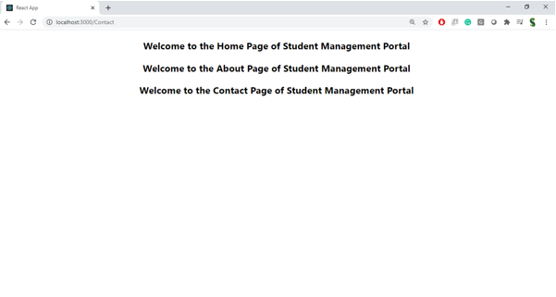

**Output :**

