**Objectives**

* Understanding the need for styling react component
* Working with CSS Module and inline styles

In this hands-on lab, you will learn how to:

* Style a react component
* Define styles using the CSS Module
* Apply styles to components using className and style properties

## **Prerequisites**

The following is required to complete this hands-on lab:

* Node.js
* NPM
* Visual Studio Code

## **Notes**

Estimated time to complete this lab: **30 minutes.**

My Academy team at Cognizant want to create a dashboard containing the details of ongoing and completed cohorts. A react application is created which displays the detail of the cohorts using react component. You are assigned the task of styling these react components.

Download and build the attached react application.



1. Unzip the react application in a folder
2. Open command prompt and switch to the react application folder
3. Restore the node packages using the following commands

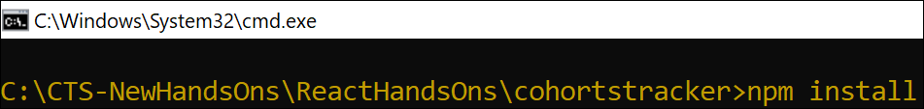

Figure 1: Restore packages

1. Open the application using VS Code
2. Create a new CSS Module in a file called “CohortDetails.module.css”
3. Define a css class with the name as “box” with following properties

*Width = 300px;*

*Display = inline block;*

*Overall 10px margin*

*Top and bottom padding as 10px*

*Left and right padding as 20px*

*1 px border in black color*

*A border radius of 10px*

1. Define a css style for html <dt> element using tag selector. Set the font weight to 500.
2. Open the cohort details component and import the CSS Module
3. Apply the box class to the container div
4. Define the style for <h3> element to use “green” color font when cohort status is “ongoing” and “blue” color in all other scenarios.
5. Final result should look similar to the below image

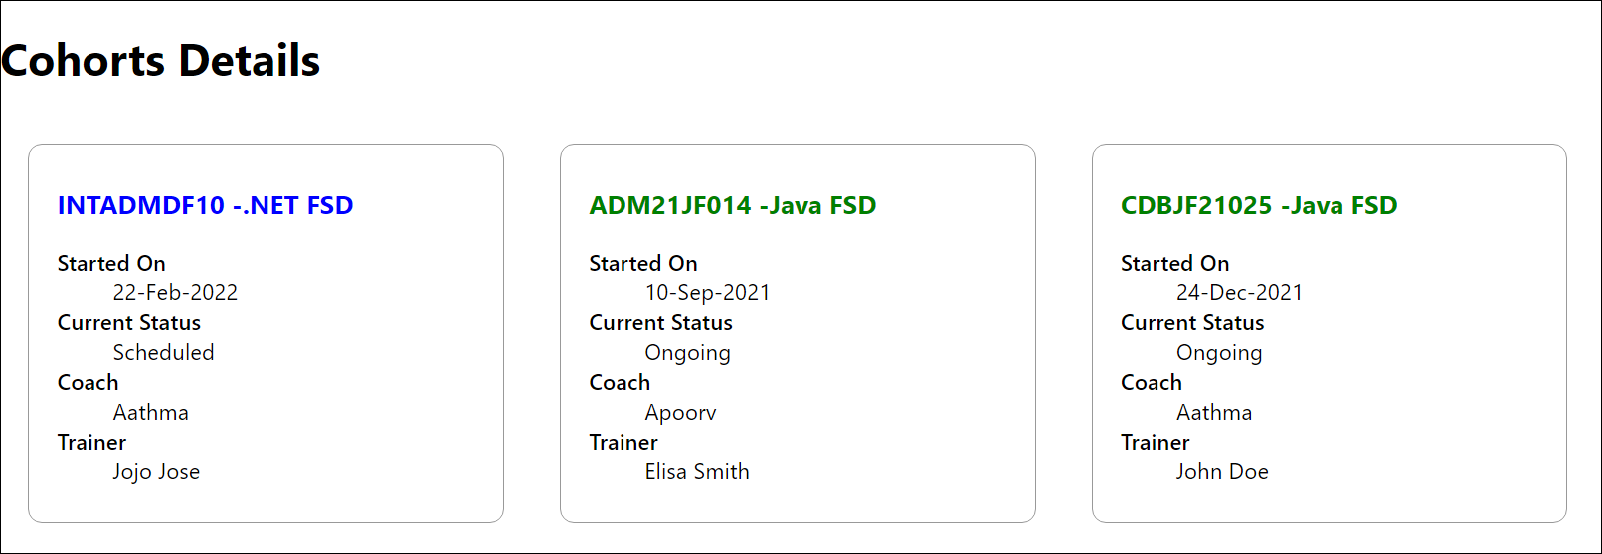

Figure 2: Final Result

Output :  
  
import React from 'react';

import styles from './CohortDetails.module.css';

const CohortDetails = ({ cohort }) => {

return (

<div className={styles.box}>

<h3 style={{ color: cohort.status === "ongoing" ? "green" : "blue" }}>

{cohort.title}

</h3>

<dl>

<dt>Instructor:</dt>

<dd>{cohort.instructor}</dd>

<dt>Status:</dt>

<dd>{cohort.status}</dd>

<dt>Duration:</dt>

<dd>{cohort.duration}</dd>

</dl>

</div>

);

};

export default CohortDetails;