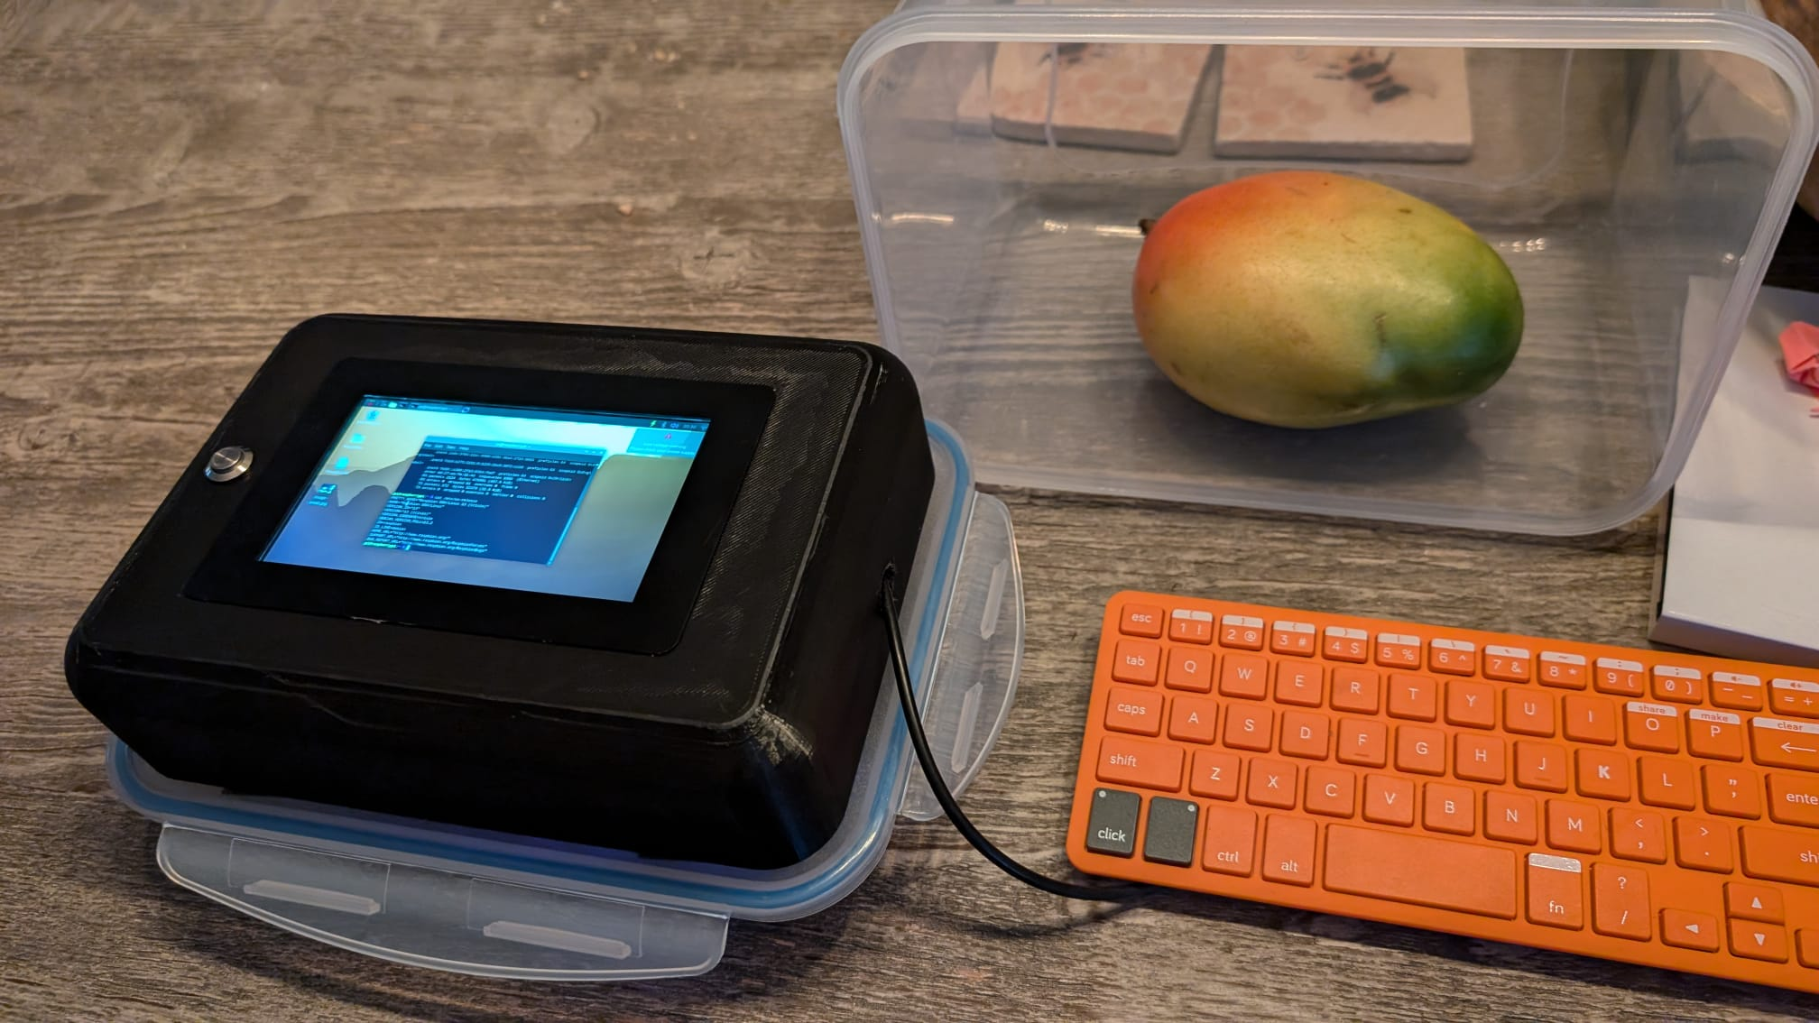
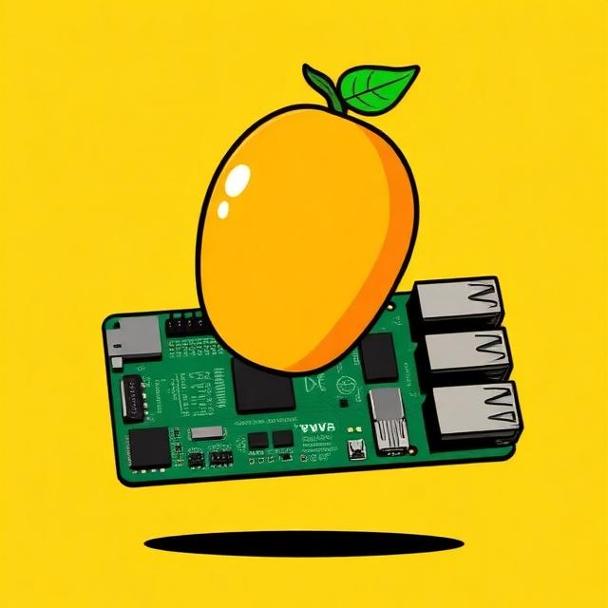

Our aim is to create a device that can protect elderly or vulnerable people from the risks of mouldy or stale food, which poses significant health risks, therefore we designed an easy to use prototype mould detector which can log a picture of the food item and then sample and determine the levels of ammonia gas in the air around the food and tell if it’s safe to eat.
The wider purpose of our project could help reduce food waste around the world by helping people make better decisions about food instead of just guessing and wasting it based on hard to read or conservative expiry dates, our mould detector gives a more accurate indication of food safety and prevents people throwing away food that is still safe to eat.
In the UK we waste about 10 million tonnes of food every year, and most of this comes from normal people’s homes. This costs families billions of pounds and adds unnecessary pollution. Lots of food that gets thrown away might still be safe, which means we’re wasting money and harming the environment. Our mould detector aims to help people avoid this by checking food properly instead of guessing.
During our research we found that food gives off ammonia gas when it starts to go bad. This means testing for ammonia is a simple way to tell if food is starting to rot. We chose the MQ-135 gas sensor because it can detect ammonia and similar gases linked with decomposition. We built our design so the detector can pull in air from around the food sample, helping the sensor get a more accurate reading.
Certain people are more at risk from eating spoiled food, such as the elderly, pregnant women, young children, visually impaired people, and anyone with a weaker immune system. Spoiled food can contain toxins or bacteria like Salmonella or E. coli, which cause vomiting, diarrhoea, and other serious illnesses. This makes it even more important to have a simple tool that can warn people when food might not be safe.
We wanted the detector to be affordable and easy for anyone to use. We built it as a lid that fits on top of common food containers, so people don’t need special equipment.
To make the measurements reliable, we designed the container to be mostly airtight. This prevents outside air from interfering with the readings.
We added a camera to take a close-up picture of the food being tested, so users can keep a record of what was checked. We also used NeoPixel LEDs to light the food for the camera and to show clear colour signals for safe or unsafe results, making it easy for the user to understand the level of risk.

