Vidatum Technical Test

Grants System

# Introduction

Every year, Vidatum University gives limited number of grants based on a specific criteria, thus, they need a new solution that lets the applicants to apply for those grants, and it will automatically reject or accept the applicant based on the provided information.  
  
The system should work as below:

1. The applicant should login to the system.
2. After logging in to the system, the applicant will be redirected to the application form.////
3. The applicant applies for the grant by submitting the application.
4. The system will process this application and return the assessment result to the applicant.\
5. If the applicant age is below 20 or above 30, the application will be rejected.
6. If the applicant cumulative average is 4, the application will be accepted if the applicant is in the age range.
7. If the applicant cumulative average is below 3 and the applicant age is 26 years or above, the application will be rejected.
8. If the applicant cumulative average is below 2, the application will be rejected.

# Task 1: Fixing the login process

One of our developers has already started working on the project, he started with the implementation of the login page and backend, and he wasn’t able to link the view with the backend, so the login form is not submitting to the backend to complete the login, the login process works as below:

1. The applicant enters his username and password.
2. The System validates the applicant’s credentials.
3. If the credentials validation succeeds, the applicant will be redirected to the application form.
4. If the credentials validations fail, the applicant will be redirected to the same page with a message notifying him “Invalid login”.

In addition to the above, it seems that one of the unit tests is failing, which means there’s something wrong with the logic behind it, the logic should be fixed to give the expected result, once it’s fixed, the unit test will pass.

# Task 2: Application

You’ll need to implement the whole application process, you’ll need to create a view for the application and the behind logic that process the application to either grant or reject the application as described in the introduction.

The application will form will look like below:

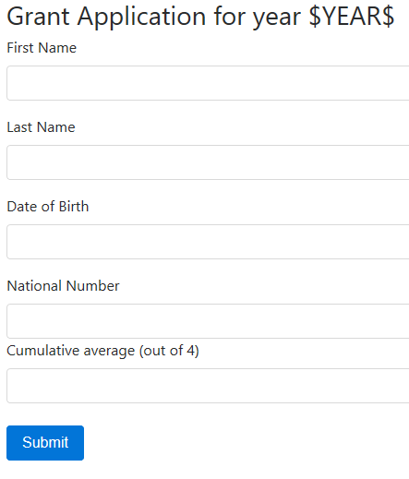

The result page will show the application details, the result and the reasons in case of rejection.

Notes:

* The form should be validated on frontend and backend.
* The national number must consist of 10 digits.
* The cumulative average must be in range between 1 and 4.