Technological Institute of the Philippines

938 Aurora Blvd. Cubao, Quezon City

College of Information Technology Education

IT 004– Web Systems and Technologies

Midterm Period

Developing Company Website

|  |  |
| --- | --- |
| Name: NAPAGAL, NYMUND  DAGDAGAN, KIT  ZERRUDO, JOHN LORENZ  GARCIA, JOEL MIGUEL  SALARDA, CHRISTIAN JAMES  CANONOY, PROI ADRIAN | Date: September 26, 2020 |
| Program / Section: BSIT / IT21S6 | Instructor: Ms. Roxanne A. Pagaduan |
| Assessment Task: Project Part 3: Designing Web Pages | |

**Instructions:**

* Provide screenshots to satisfy the requirements. (note: include screenshot of source code and sample run-time output in every source code and output changes)
* Include your **FULLNAME** in every screenshot.
* You are required to provide the screenshot of your source code for each files like (.html, .css, .js, .php) and a sample output running in the browser.
* Include a brief description in each screenshot.
* Use appropriate filename in saving your files.
* Save your work as **TeamName_ProjectPart3.DOC** (Ex. TeamWeb_ProjectPart3.DOC and .PDF)

**This activity supports the attainment of Course Intended Learning Outcomes (CILOs):**

* Use client-side programming like HTML, CSS, and JavaScript in creating web pages;
* Apply different tools available such as bootstrap and jQuery in designing a website; and
* Use server-side programming script like PHP in managing the database records.

**Requirements:**

1. Open and continue your project development with your business partners.
2. You can use the Collaboration Module for you to collaborate with your business partners.
3. As a team, use a server-side script like PHP in managing your website.

* Can manage the website contents or records.
* Perform functions for File Maintenance like (add, edit, delete, view, and search). **Note:** as part of your part3 requirements, make sure to apply add, edit, and delete functions.
  + *Minimum requirement:* at least one, as long as you perform and apply these methods in your project.

1. Working Log-in Page.
2. Provide screenshots of the following:

* Source codes in each file (like html, css, js, php, etc); and
* Screenshot of myphpadmin structures
* Sample output running on any web browser.

1. Provide the specific contributions of each member. (use the template provided)
2. Acknowledge all your references

**ANSWER:**

**Source Code**

**Login.php**

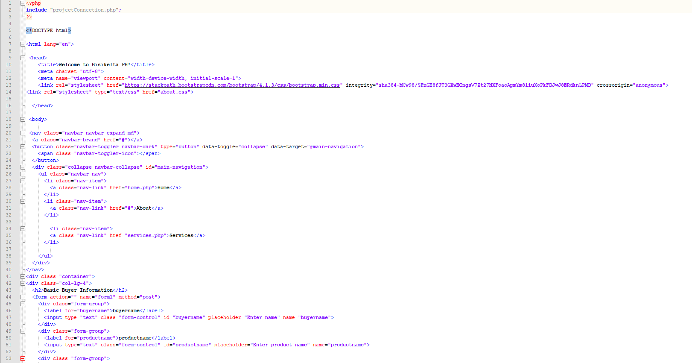

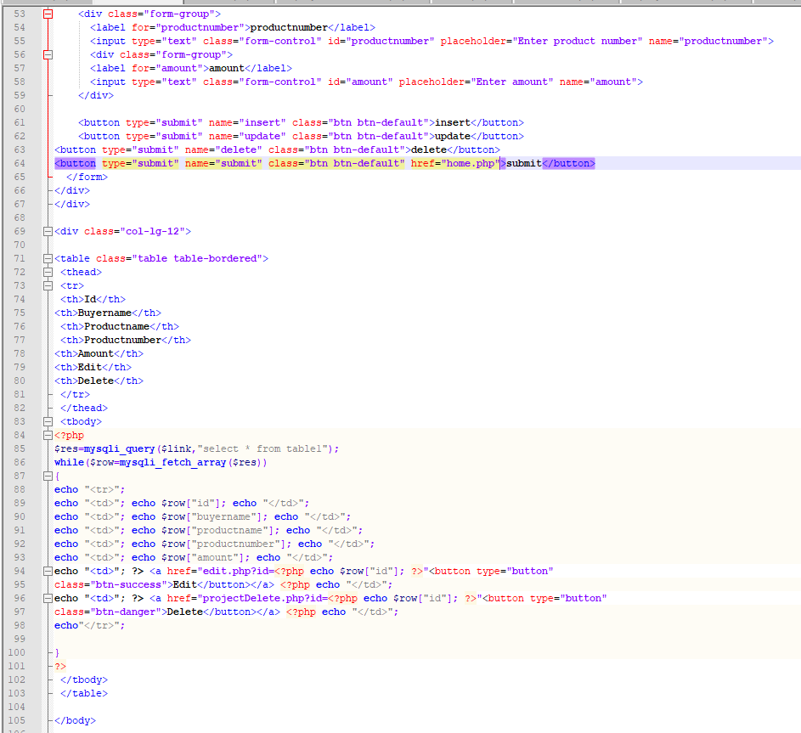.

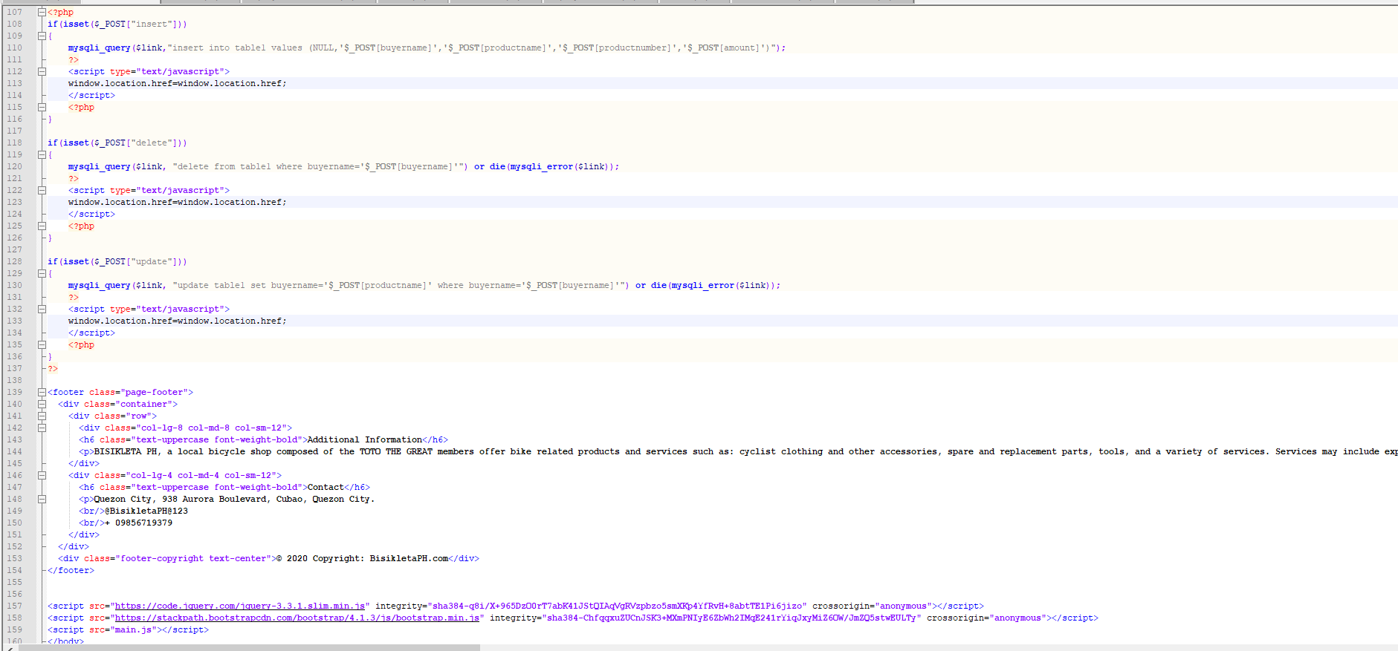

**Php connection**

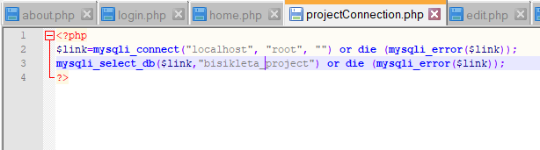

**Edit**

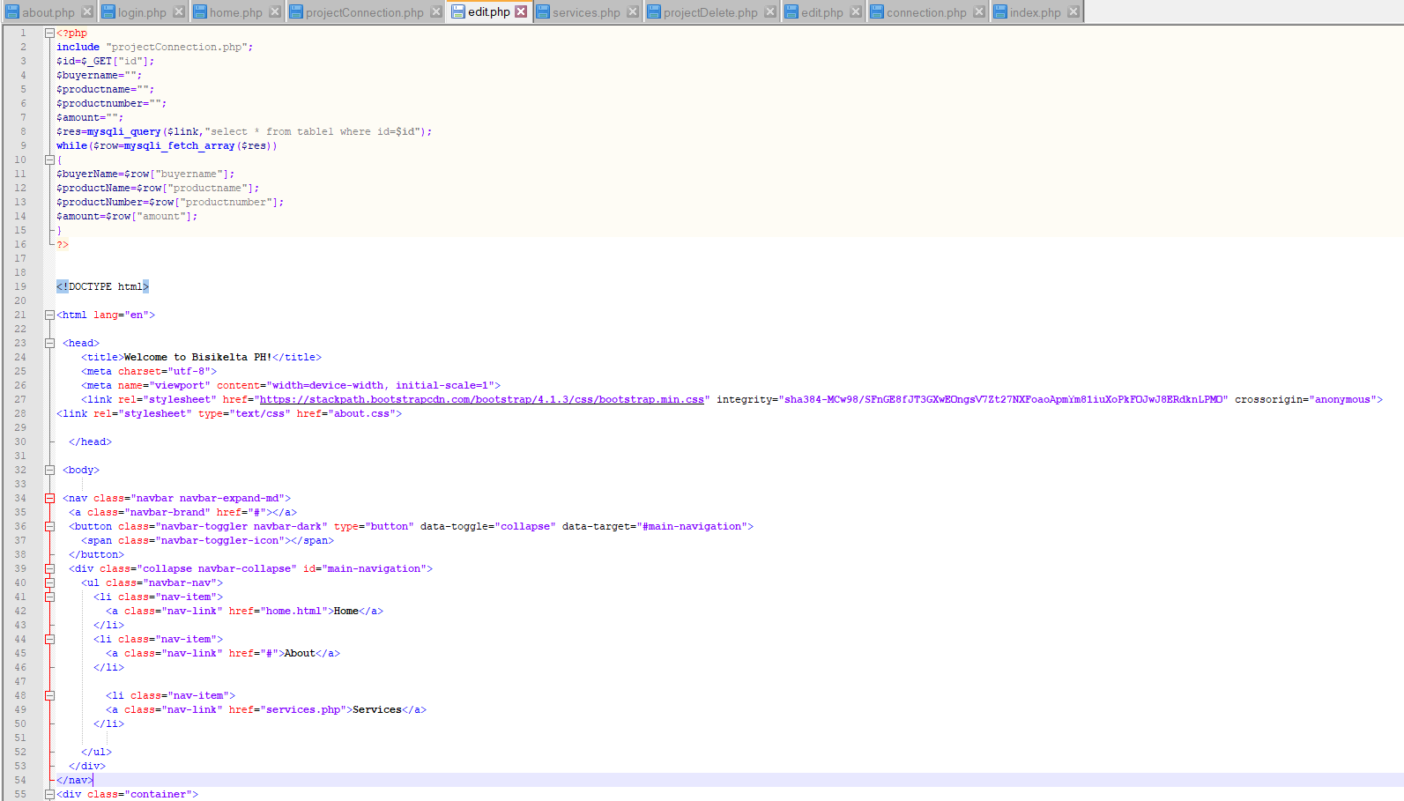

**Delete**

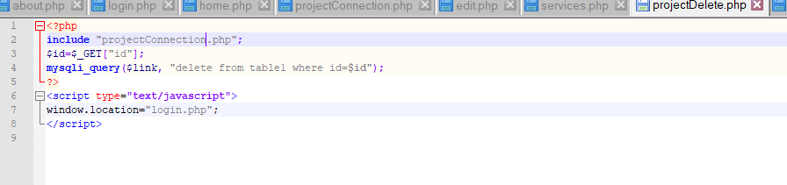

**Sample Output**

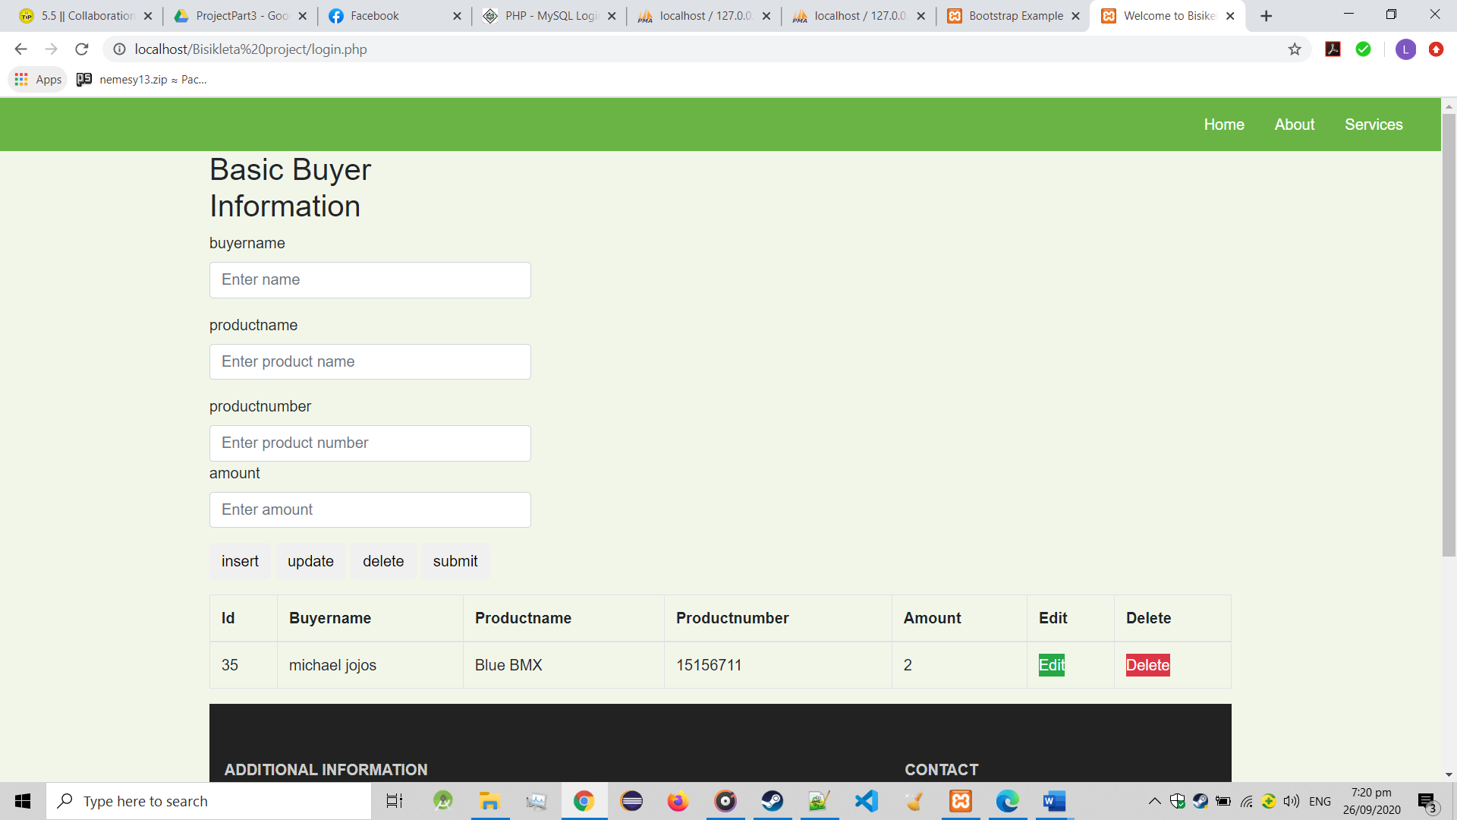

**myPHPAdmin Page**

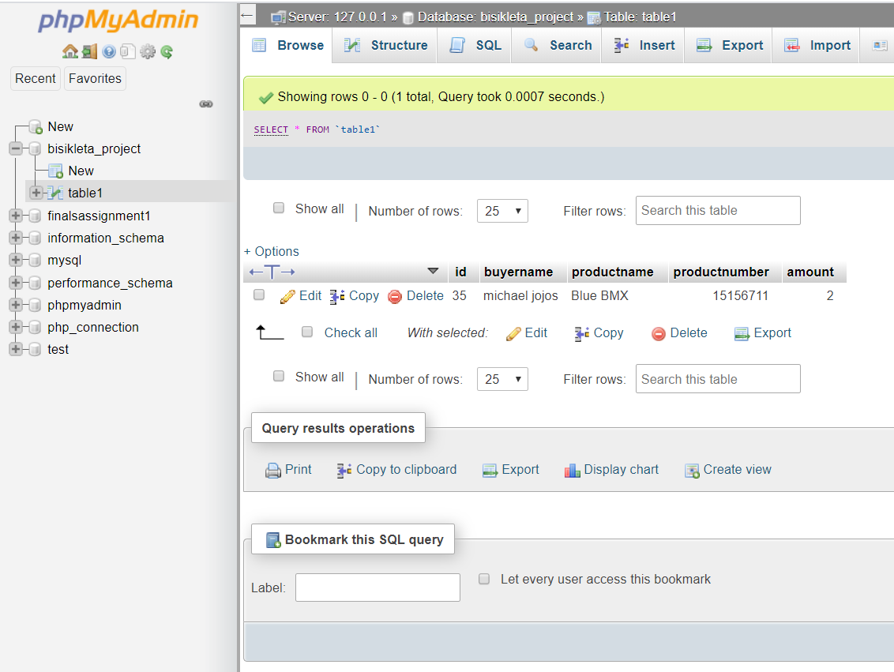

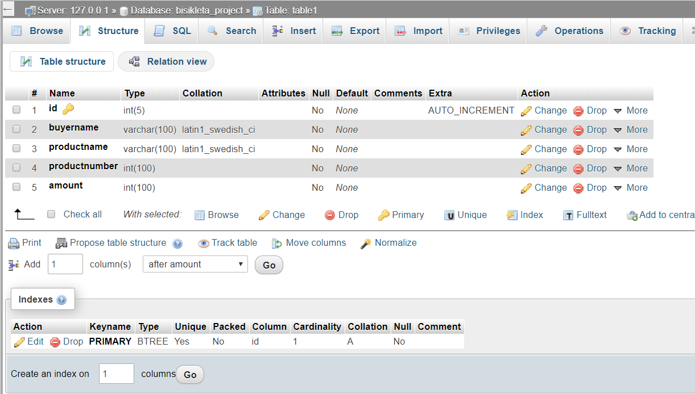

**Summary of Assigned Tasks**

|  |  |  |
| --- | --- | --- |
| **Name (SN, FN, MI.)** | **Picture** | **Detailed Contributions/Assigned Tasks:** |
| Leader's Name:  Napagal, Nymund  Nico |  | Products, Services HTML Coder and CSS Designer, Basic Buyer Information (apply add, edit, and delete) coder |
| Member 1:  Dagdagan, Irish Kit |  | Home, About HTML Coder and CSS Designer, Basic Buyer Information (apply add, edit, and delete) coder |
| Member 2:  Zerrudo, John Lorenz |  | Home, About HTML Coder and CSS Designer, Basic Buyer Information (apply add, edit, and delete) coder |
| Member 3:  Salarda, Christian James |  | Home, About HTML Coder and CSS Designer, Basic Buyer Information (apply add, edit, and delete) coder |
| Member 4:  Garcia, Joel Miguel |  | Products/Services HTML Coder and CSS Designer, Basic Buyer Information (apply add, edit, and delete) coder |
| Member 5:  Canonoy, Proi Adrian |  | Home, About HTML Coder and CSS Designer, Basic Buyer Information (apply add, edit, and delete) coder |

**References:**

file:///C:/Users/john_/Desktop/File%20Maintenance%20using%20PHP%20and%20MYSQL%20part1.pdf