Technological Institute of the Philippines

938 Aurora Blvd. Cubao, Quezon City

College of Information Technology Education

IT 004– Web Systems and Technologies

Midterm Period

Developing Company Website

|  |  |
| --- | --- |
| Name: NAPAGAL, NYMUND  DAGDAGAN, KIT  ZERRUDO, JOHN LORENZ  GARCIA, JOEL MIGUEL  SALARDA, CHRISTIAN JAMES  CANONOY, PROI ADRIAN | Date: September 2, 2020 |
| Program / Section: BSIT / IT21S6 | Instructor: Ms. Roxanne A. Pagaduan |
| Assessment Task: Project Part 4: Final Requirements | |

**Instructions:**

* Provide screenshots to satisfy the requirements. (note: include screenshot of source code and sample run-time output in every source code and output changes)
* Include your **FULLNAME** in every screenshot.
* You are required to provide the screenshot of your source code for each files like (.html, .css, .js, .php) and a sample output running in the browser.
* Include a brief description in each screenshot.
* Use appropriate filename in saving your files.
* Save your work as **TeamName_ProjectPart4.DOC** (Ex. TeamWeb_ProjectPart4.DOC and .PDF)

**This activity supports the attainment of Course Intended Learning Outcomes (CILOs):**

* Use client-side programming like HTML, CSS, and JavaScript in creating web pages;
* Apply different tools available such as bootstrap and jQuery in designing a website; and
* Use server-side programming script like PHP in managing the database records.

**Requirements:**

1. Open, continue, and finalize your project development with your business partners.
2. You can use the Collaboration Module for you to collaborate with your business partners.
3. As a team, use a server-side script like PHP in managing your website.

* Can manage the website contents or records.
* Perform functions for File Maintenance like (add, edit, delete, view, and search).
  + *Minimum requirement:* at least one, as long as you perform and apply this methods in your project.

1. Working Log-in Page
2. Provide screenshots of the following:

* Source codes in each file (like html, css, js, php, etc); and
* Screenshot of myphpadmin structures (table structures)
* Sample final output running on any web browser (note: provide sample screenshot of all web pages).

1. Submit all the files related to your project like documents, html, css, js, php, etc.
2. Provide the specific contributions of each member. (use the template provided)
3. Acknowledge all your references

**ANSWER:**

**Source Code**

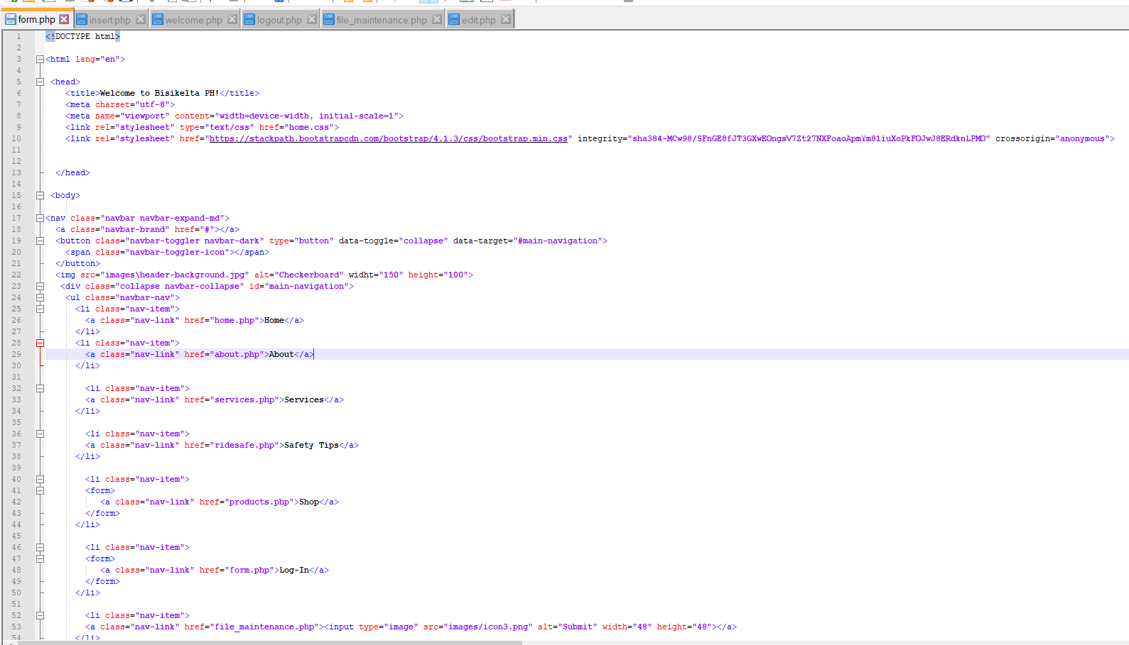 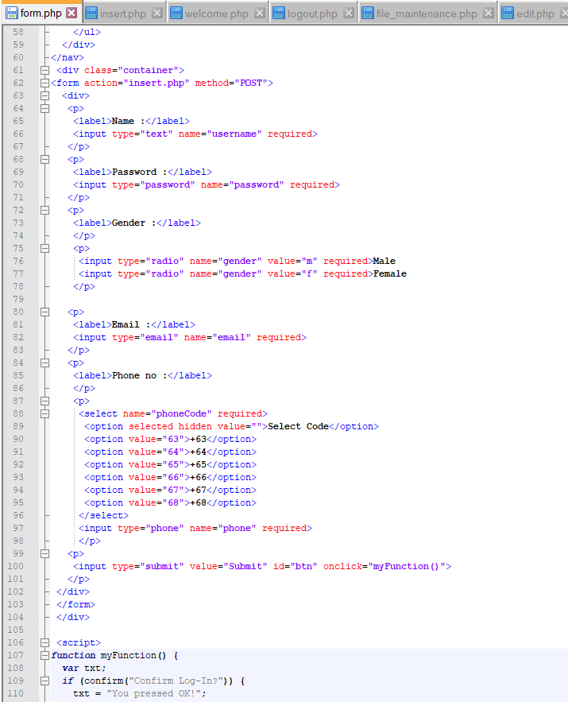

. 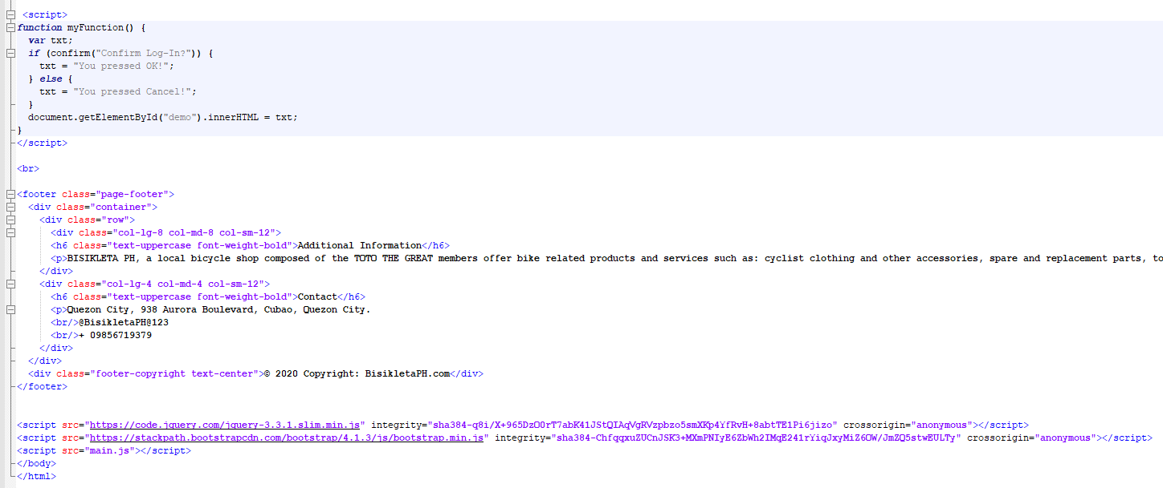

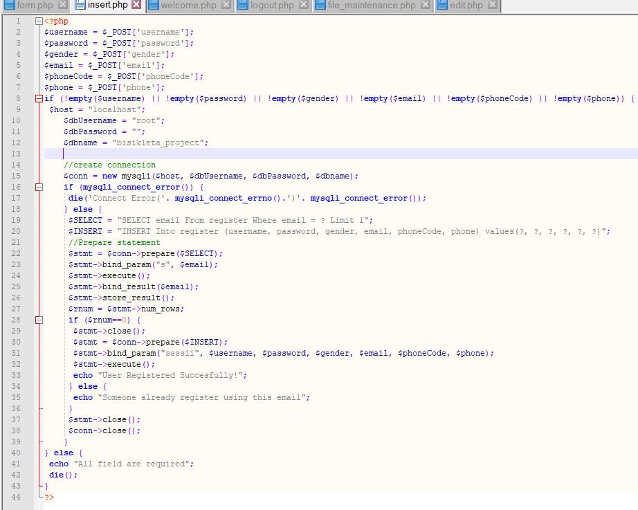

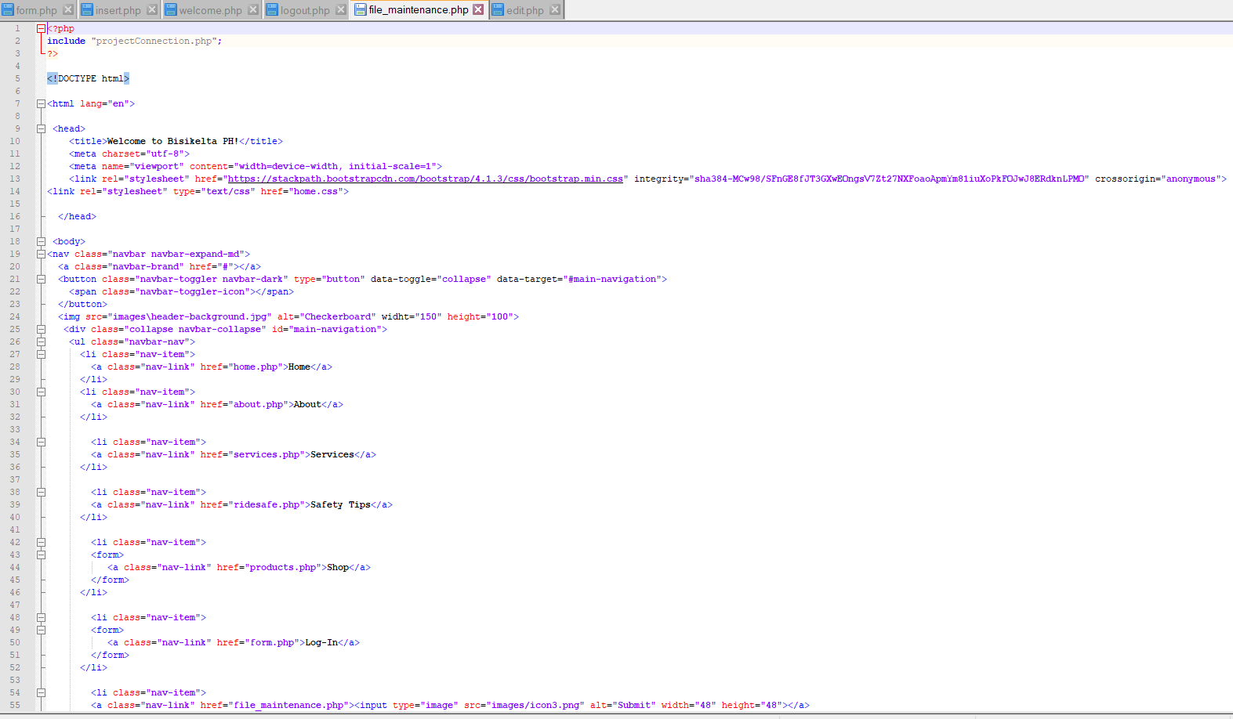

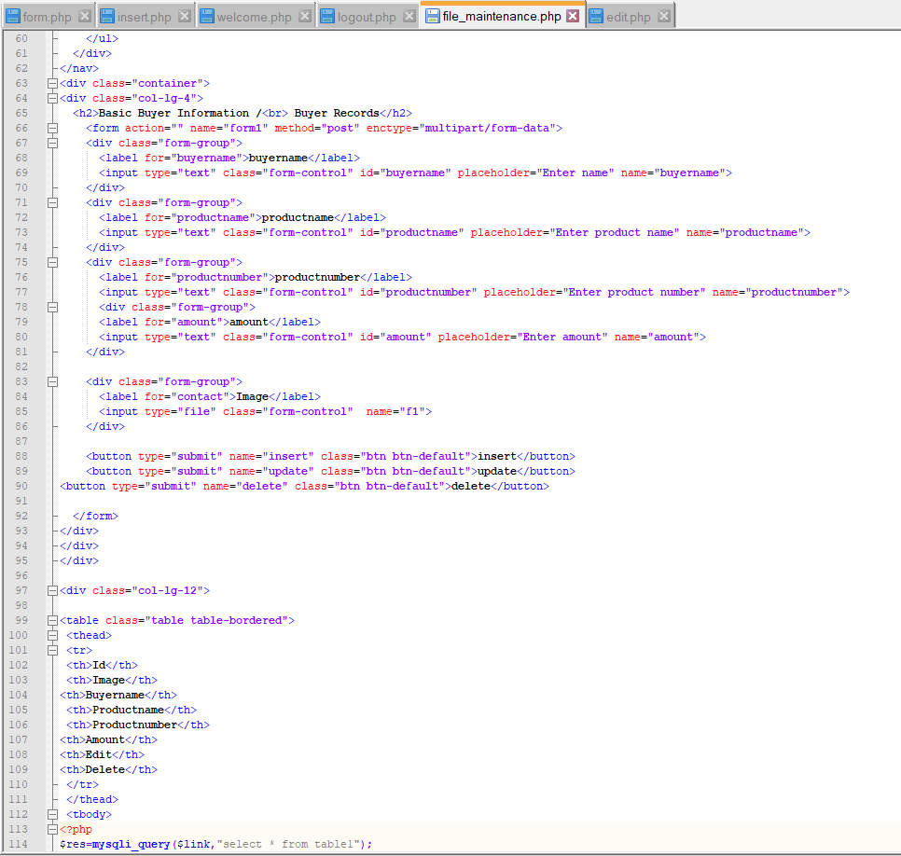

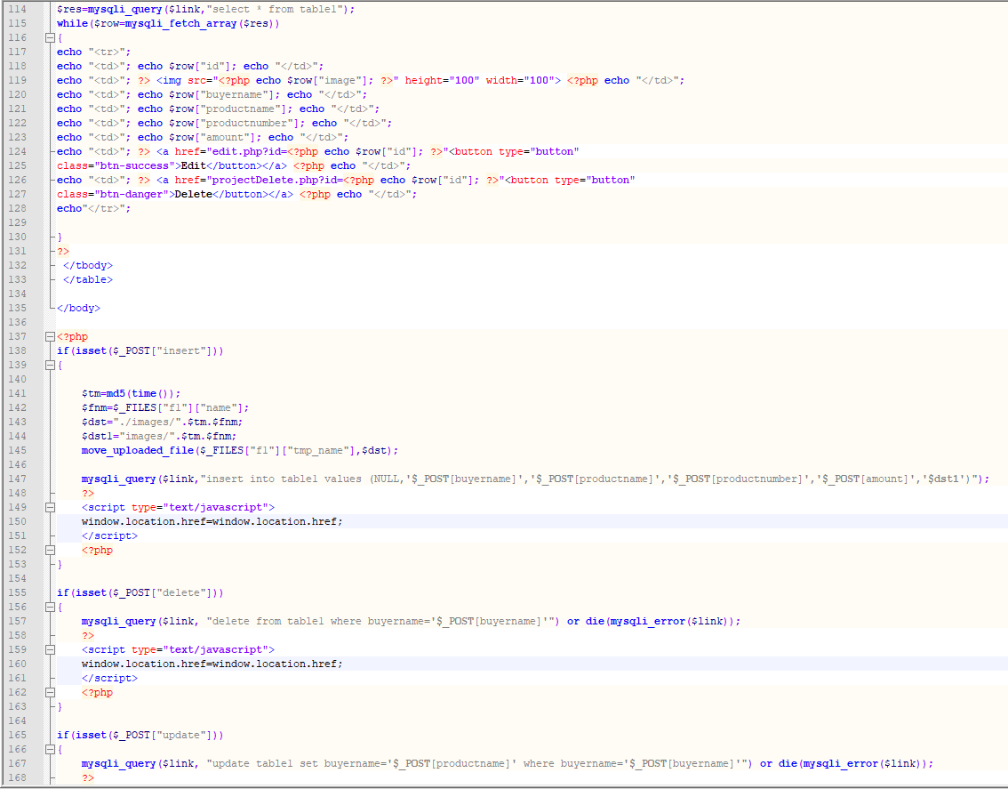

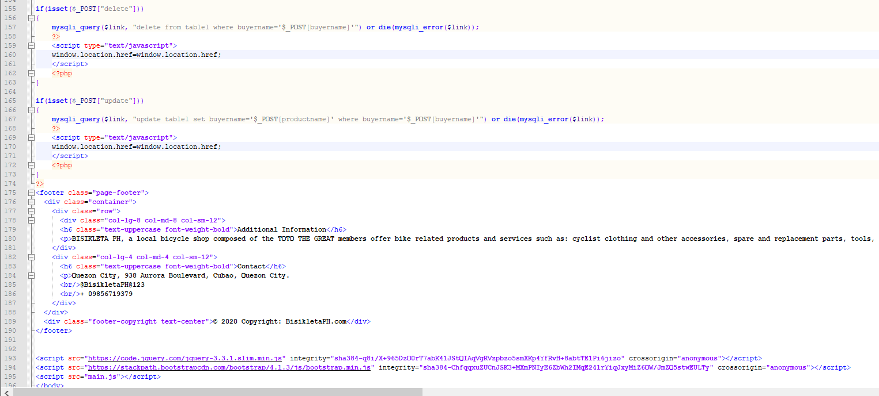

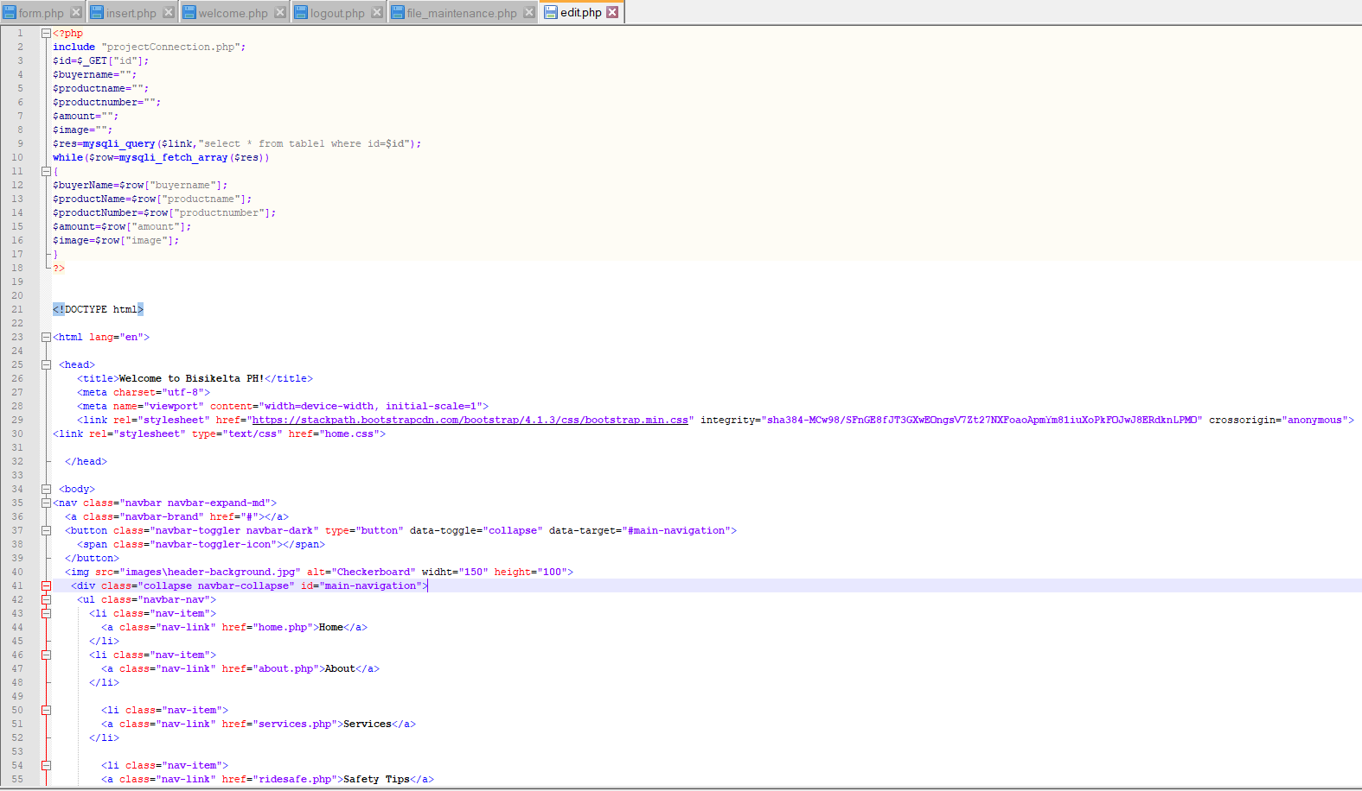

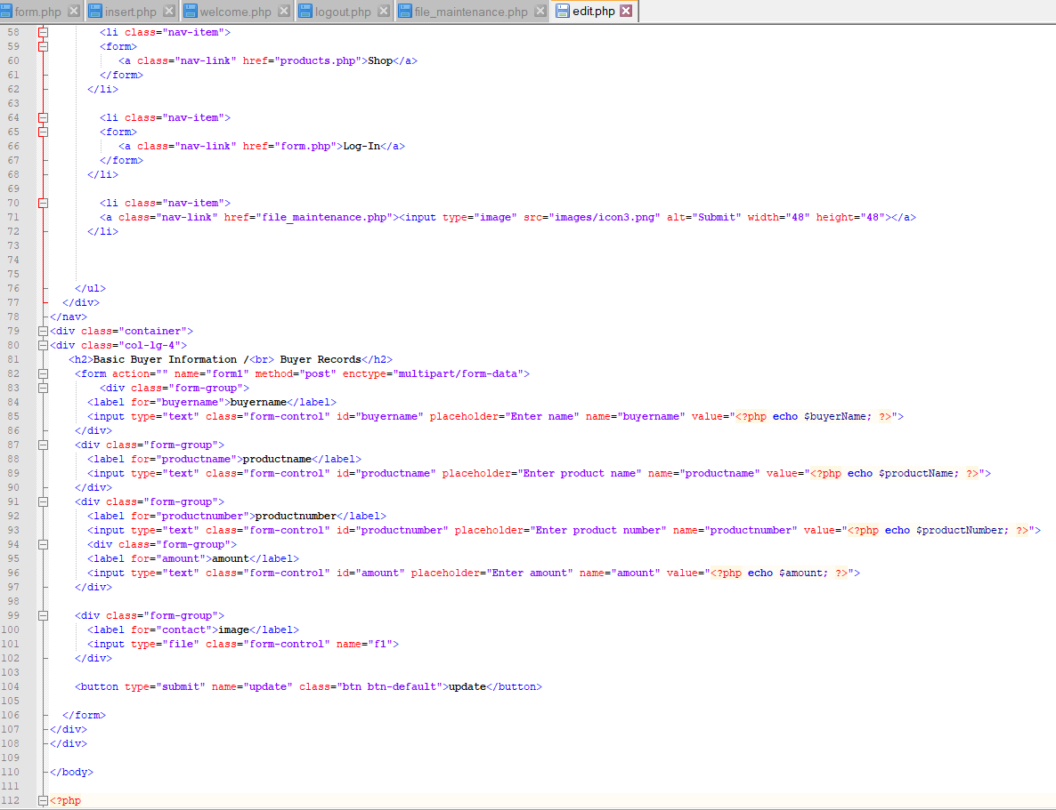

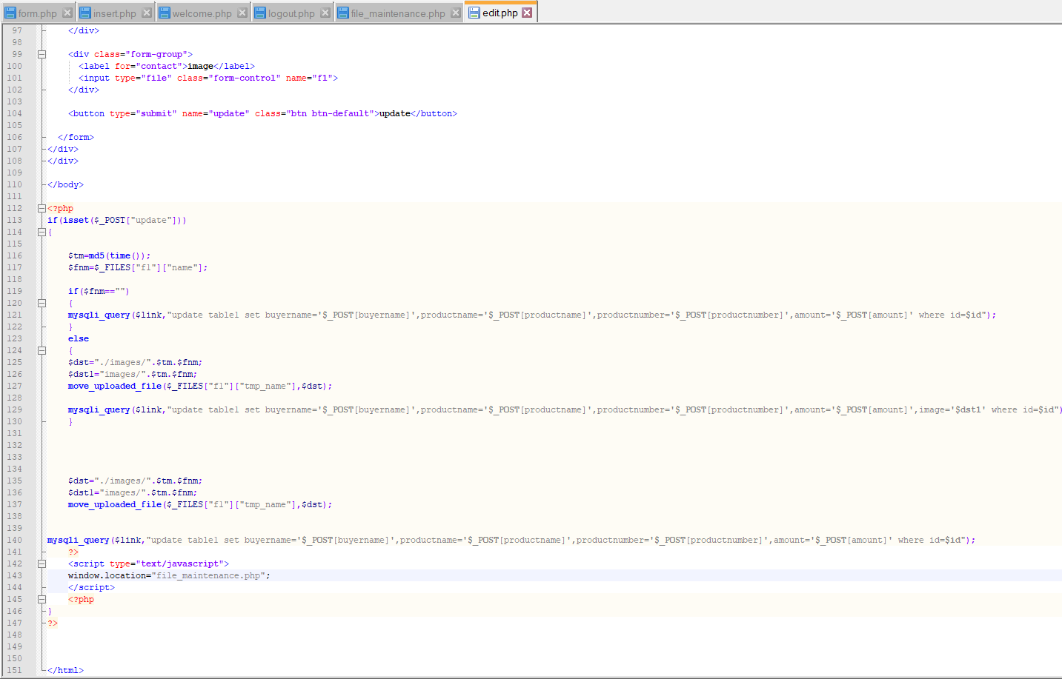

**Sample Output**

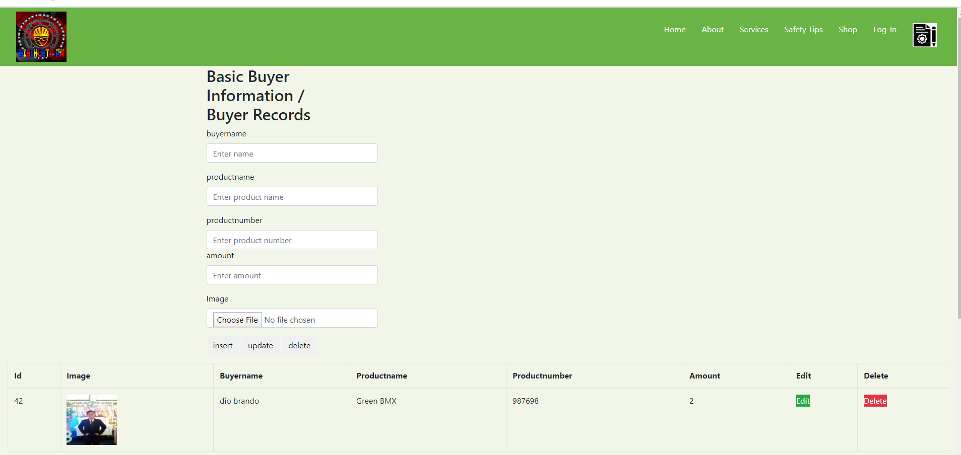 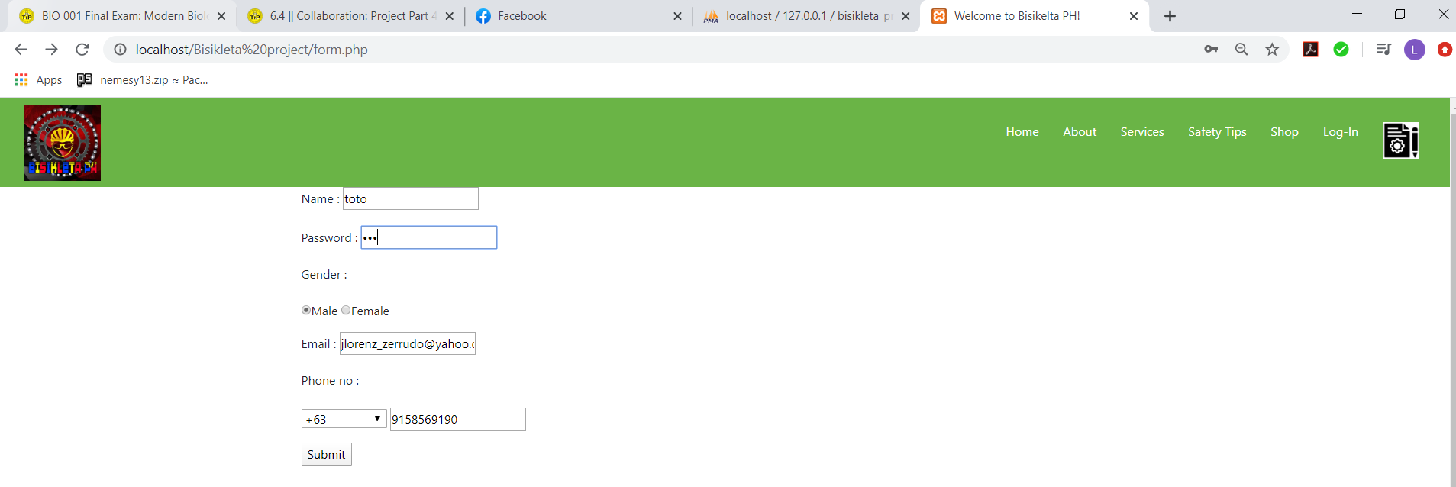

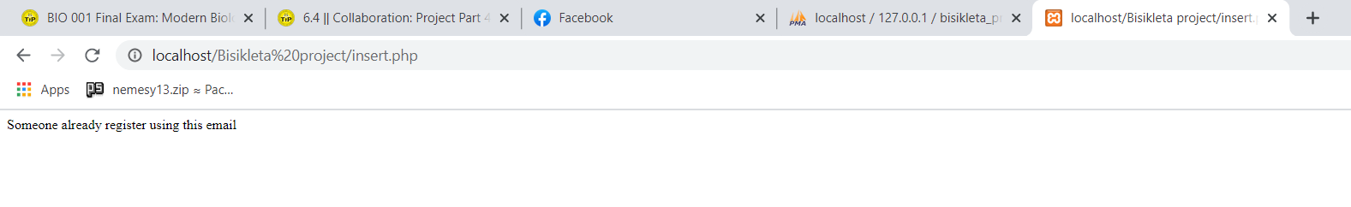

**myPHPAdmin Page**

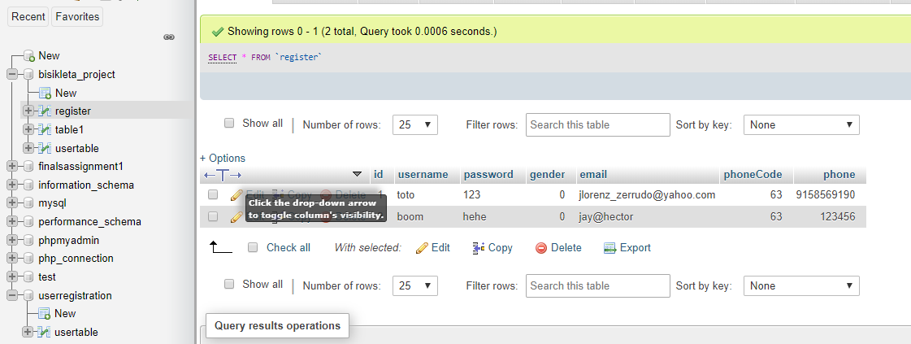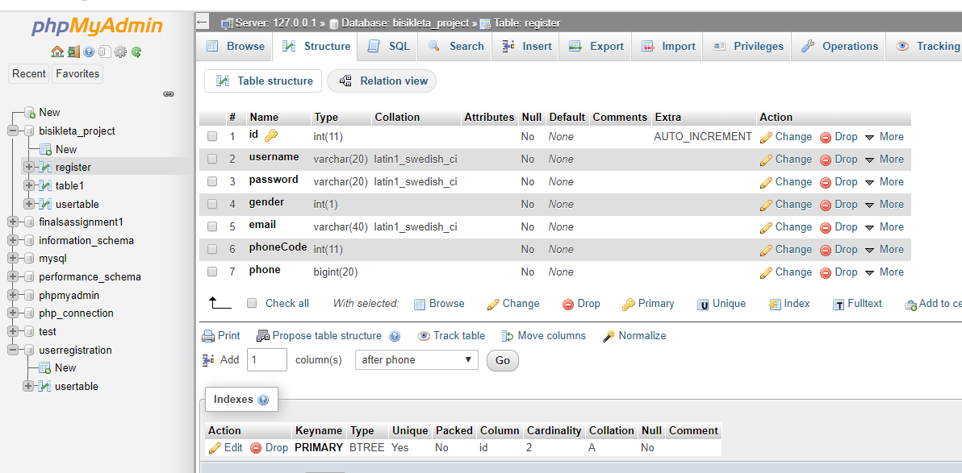

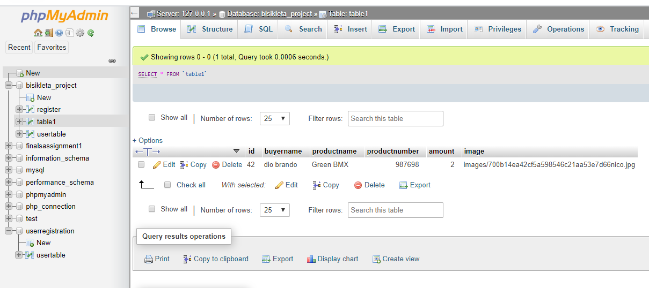 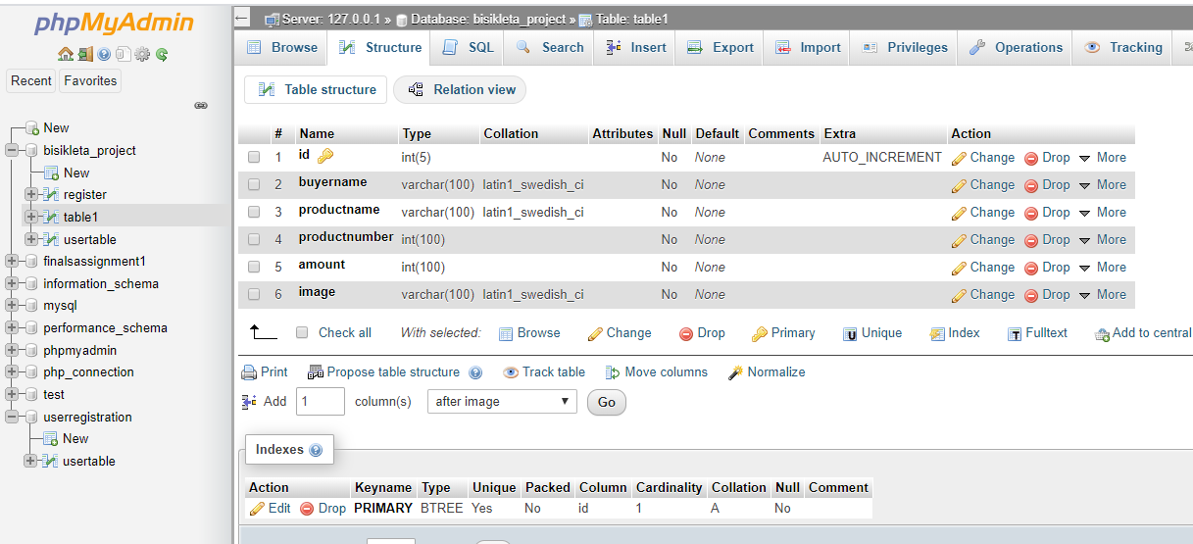

**Summary of Assigned Tasks**

|  |  |  |
| --- | --- | --- |
| **Name (SN, FN, MI.)** | **Picture** | **Detailed Contributions/Assigned Tasks:** |
| Leader's Name:  Napagal, Nymund  Nico |  | Products, Services HTML Coder and CSS Designer, Basic Buyer Information (apply add, edit, and delete) coder,  Product webpage coder (CSS and HTML) |
| Member 1:  Dagdagan, Irish Kit |  | Home, About HTML Coder and CSS Designer, Basic Buyer Information (apply add, edit, and delete) coder,  Product webpage coder (CSS and HTML) |
| Member 2:  Zerrudo, John Lorenz |  | Home, About HTML Coder and CSS Designer, Basic Buyer Information (apply add, edit, and delete) coder,  Product webpage coder (CSS and HTML)  File Maintenance coder (add image)  Login webpage coder |
| Member 3:  Salarda, Christian James |  | Home, About HTML Coder and CSS Designer, Basic Buyer Information (apply add, edit, and delete) coder,  Product webpage coder (CSS and HTML) |
| Member 4:  Garcia, Joel Miguel |  | Products/Services HTML Coder and CSS Designer, Basic Buyer Information (apply add, edit, and delete) coder,  Product webpage coder (CSS and HTML) |
| Member 5:  Canonoy, Proi Adrian |  | Home, About HTML Coder and CSS Designer, Basic Buyer Information (apply add, edit, and delete) coder,  Product webpage coder (CSS and HTML) |

**References:**

<https://www.codeandcourse.com/how-to-connect-html-register-form-to-mysql-database-with-php/>