Part II : Mini thesis based on Quarto + Gretl
Andreas Moen, Oskar Pettersson, Philip Jacobsen
Table of contents

Andreas Moen, Oskar Petterson, Philip Jacobsen

Topic of interest: The correlation between salary and higher education.
Research question: Does higher education lead to higer salary?
Our research question: Does higher education lead to higher salary? Is central to labor economics and has been explored a lot in academic literature over the years.
A big contribution to this field is Blaug (1972), who examines the correlation between education and earnings in his article The correlation between education and earnings:
What does it signify? Referance: https://link.springer.com/article/10.1007/BF01956881
Dataset: https://www.kaggle.com/datasets/nalisha/job-salary-prediction-dataset
The correlation between education and earnings: What does it signify? - Higher Education
link.springer.com

Step B: Analysis
1. Data Description & Summary Open your selected data set in Gretl and provide a brief summary using descriptive statistics and graphical representations of key variables. Relate the analysis to your RQ.
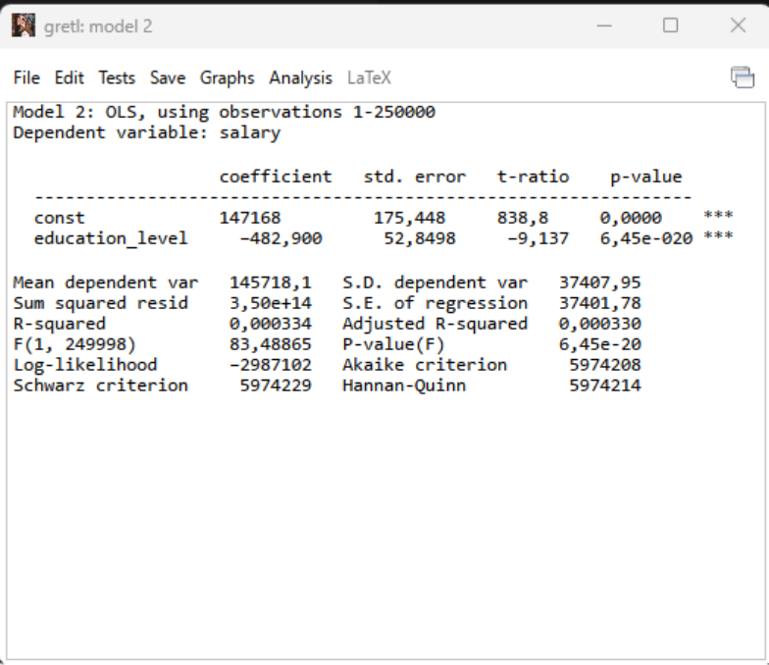
2. Simple Regression Model: Estimate a simple regression model where you define your dependent and indepen-dent variable based on your RQ.
a) Present the output from your analysis.
From the output we have 250 000 observations and the dependent variable is the salary. The key results from the regression model is given as.:
Variable | Coefficient | Std. Error | t-value | p-value
Constant | 147 168 | 175.45 | 838.8 | 0.000
Education Level | -482.9 | 52.85 | -9.14 | 6.45*10^-20
We also have a R squared value of 0.000334 and a F statistic p value of
$$6.45*{10}^{−}20$$

We can see there is a big significance between salary and education level.
b) Interpret the estimated coefficients.
The constant is estimated as 147168. This represents the yearly predicted salary to a person at the lowest educational level in the dataset. The coefficient for the education level is estimated to –482,9. This shows that for every additional step in the education the salary is expected to be 482.9 lower.
c) Evaluate the significance of the independent variable(s) at a 5% significance
level.
We can clearly see that
$$6.45*{10}^{−}20is<0.05$$
so the variable is statistically very significant. Even though its significant the R squared value is very low, which can be interpretated as the model not explaining the variation in the salary.
d) Make predictions using the model at different values of an independent variable.
We just plug in different variables for the education level. After we ran the simple regression model we got this equation:
$$salary=147168+(−482,90)×education_{l}evel$$
. By using this equation we can predict the salary based on the education levels.
Education_level | Predicted salary
1 | 146 685
2 | 146 202
3 | 145 719
4 | 145 236
5 | 144 753
This table shows that the predicted salary is getting lower by every education level. The results in the simple regression shows that there are negative correlation between salary and education level, to contradict our research question of whether higher education leads to higher salary. The model only includes education as an explanatory variable and does not control for other important factors such as work experience, skills and industry.
e) Calculate a 95% prediction interval for a specific observation in your context.
A 95% prediciton interval for a specific observation can be calculated as the predicted values plus or minus a critical value times the prediction standard error. Using the regression output the standard error of regression is 37401.78. So when education levels equals to 5 the predicted salery is.:
$$Salery=147168−482.9(5)$$
$$salery=147168−2414.5=144753.5$$
Then the approximate 95% prediciton interval:
$$1.96*37401.78=73307,49$$
so that gives us
So lower bound = 71 446.01
And upper bound = 218060.99 so the approximate 95% prediction interval is given as.:
(71446.01, 218060.99)
This means that the actual salary for an individual with education level 5 is expected to lie within thhis interval with 95% confidence.
3. Multiple Regression Model
Expand your model by including additional relevant variables.
a) Explain the choice of additional variables
We wanted to see how the industry, education level and experience have a correlation with salary. And it seems that there is a significant between education level, experience but not a big correlation with industry. Which make sense as you can have high and low salaries in all kinds of industry fields.
b) Present the output from your analysis.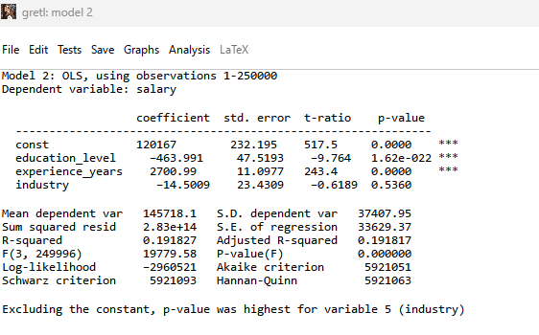
c) Interpret the estimated slope coefficients.
Based on the results from our new regression model, Education level: -463,991.
When we keep the experience years and the industry constant, the predicted salary drops by 464 units from every additional education level. This indicates a negative correlation between education and salary in this data set.
Experience years: 2700,99. When we keep the education level and the indusrty constant the expected yearly salary rises with 2701 units. This indicates an extremely positve effect on the yearly salary which makes sense.
Industry: -14-5. The P value is too high to really consider this and we can’t really use this data, because it is very random and we dont have enough proof.
d) Evaluate the significance of the independent variable(s) at a 5% significance Level.
Like mentioned previously the education level, and experience in years have a very strong statistically significant as p value < 0.05. However the industry have a p value of 0.536 > 0.05 so it’s not statistically significant.
At the 5% significance level, the variables education level and experience years are statistically significant, as their p values are far below 0.05 (close to 0.00). Which means both variables have a significant effect on salary. In contrast the variable industry has a p value of 0.536 which is greater than 0.05 indicating that its not statistically significant. Therefore, there is no evidence that industry affects salary in this model.
e) Compare the results to your simple regression analysis.
Compared to the simple regression model the multipåle regression model provides a much better fit to the data. The R Squared increases significantly from 0.000334 to 0.1918 indicating that the model explains a muchg larger share of the variation in salary. The coefficient for education level remains negative and statistically significant, but its magnitude decreases slightly when additional variables are included. This suggests that the simple model may suffer from omitted variable bias, particularly due to the exclusion of experience. Furthermore, experience years is highly significant and has a strong positive effect on salary, while the industry variable is not statistically significant. Overall, the multiple regression model is more reliable and provides a better explanation of salary differences.
4-1. Dummy Variable Analysis
Identify a situation where a dummy variable could be used in your data (e.g., an
event or using thresholds to generate groups). Create (if needed) and use this dummy
variable in a regression model. Use it to estimate a fixed effect, an interaction effect,
or a combination of both - whichever is more suitable for your project.
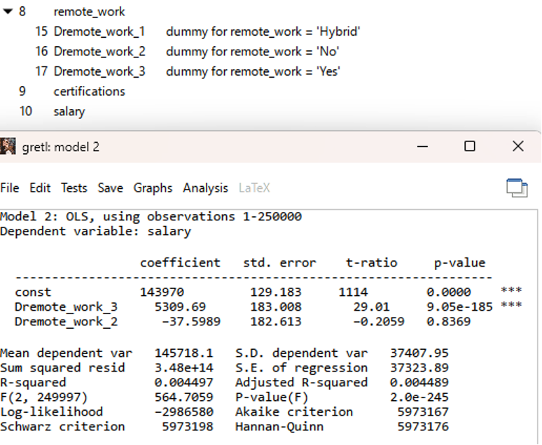
a) Present the output from your analysis.
Dummy variables are used to represent categorical variables in the regression model. In this case, remote work is divided into three categories.: Hybrid, NO and YES. Hybrid is only used as the reference category, while two dummy variables are included.: One for remote work = YES and one for remote work = NO
The constant term represents the average salary for individuals working in a hybrid arrangement. The coefficient for remote work = YES is 5309.69 and is statistically significant, indicating that fully remote workers earn on average about 5309 more than hybrid workers. The coefficient for remote work = NO is not statistically significant suggesting no meaningful difference in salary compared to hybrid workers.
b) Discuss the impact of this dummy variable on your dependent variable, considering any interaction effects.
The dummy variables for remote work capture differences in salary relative to the reference category, which is hybrid work. The Results show that individuals who work fully remotely earn on average about 5309 of X currency more than hybrid workers, and this effect is statistically significant. In contract, individuals who do not work remotely have a small and statistically insignificant difference in salary compared to hybrid workers indicating no meaningful effect.
These results suggest that remote work may be associated with higher paying jobs, while there is no clear difference between hybrid and fully on-site work. The model does not include any interaction terms, meaning that the effect of remote work is assumed to be constant across all indivduals. The impact of remote work may vary dpeneing on factors such as experience or education, but this is not captured in the current specification.
5. Model Selection and Analysis
a) Use the different models to predict the dependent variable in for a given state
of the independent variables
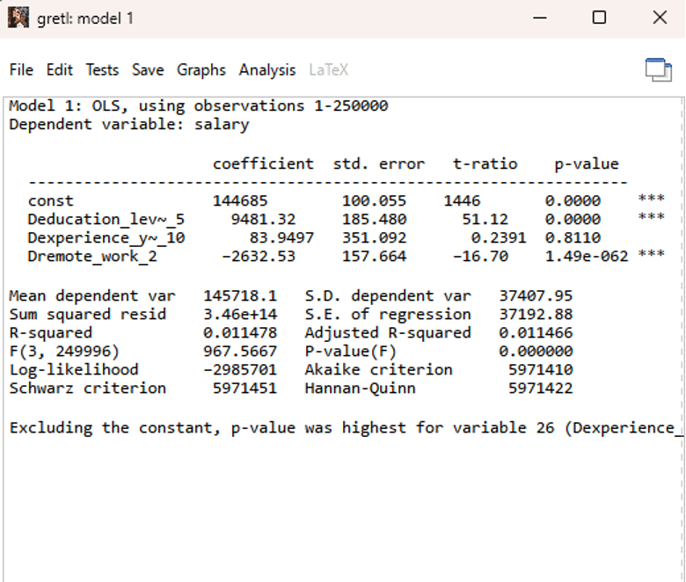
Model number 1 has master degree, 10 years of work experience and works on site.
We can see that the master degree has the biggest impact on his/her salary. With a significance value of 0.000. Compared to the others, we can see that 10 years of experience is not significant with a p value of 0.8110 and working on site has a negative effect on the salary with a very high signifance p value of 0.00…1.49
This person will have a salary of
$$144685+9481+83,95−2633=151617$$
This means the expected salary is approximately 151 618 in X currency. The master degree has a strong positive and statistically significant effect on salary, increasing it by about 9481, compared to the reference group. The effect of having 10 years of experience is small and not statistically significant, indicating no meaningful impact. Working on site is associated with a decrease in salary of about 2633 compared to the reference category and is statistically significant.
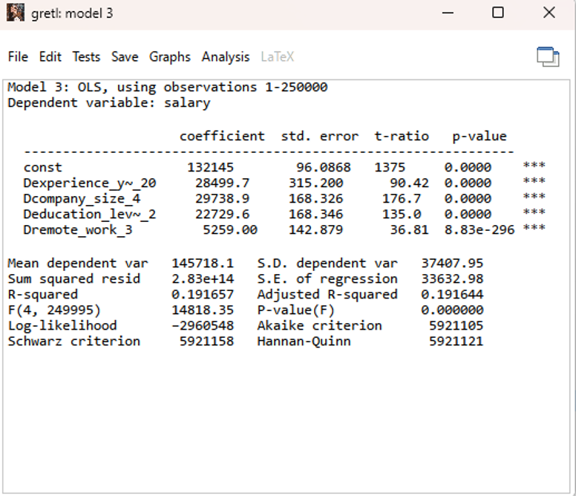
For model number 2 we have 20 years of experience, a PHD degree and he/her is working in an enterprise and working from home.
THis corresponds to an expected salary of approximately 218 372. All included variables have a positive and statistically significant effects on salary. In particular working from home increases the salary by about 5259 compared to the reference category holding others factors constant. The R squared value tells us that 19.17% of the variation in salary is explained by the model. More of the model can be explained if we add what country and what type of field the person is working in.
b) Based on these analyses and additional considerations (e.g., model fit, theore-
tical soundness), discuss which model you would prefer for predicting outcomes
within your context and why.
We prefer model 2 because it has the highest R² which is 19,2%, compared to the other models that is far lower than this. A higher R² explains a bigger portion of the variation in the salary making it more accurate and gives us the most accurate information. The model does not explain all variation, but it gives us a reliable estimate and most accurate comparing to the other models we have used.

