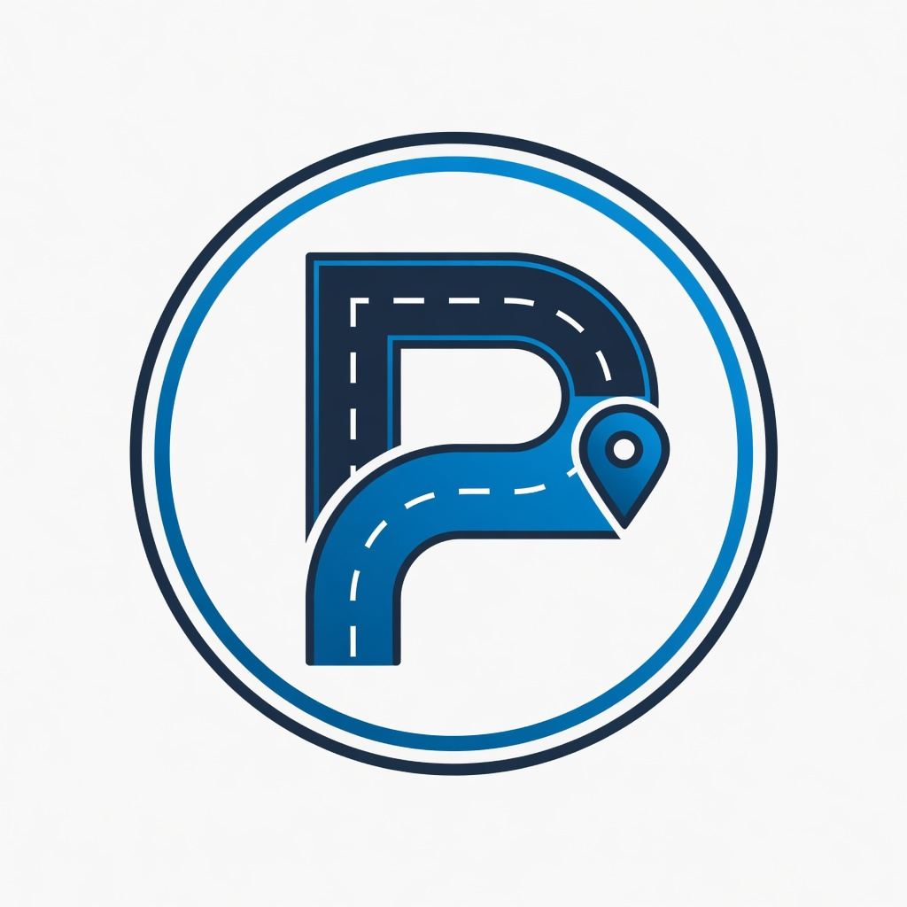 | PAZE  Crowdsourced Road Intelligence Platform  "Drive. Report. Get Paid."

Platform Overview
PAZE is a crowdsourced road intelligence platform that pays drivers for reporting road hazards, weather conditions, accidents, police activity, traffic, and more. Users earn real money by submitting geo-tagged photos and 15-second video reports. The platform also features an optional Live Drive Mode that acts as a continuous dashcam for users seeking major insurance discounts.

The Problem
Motor vehicle crashes cost the United States approximately $340 billion annually. Pothole damage alone costs American drivers an estimated $3 billion to $26 billion per year in vehicle repairs. Traditional methods of identifying and fixing road hazards are slow and often lack visual evidence.

Data Monetization Strategy
PAZE generates revenue by licensing high-quality visual and geospatial road data:
- Auto insurance companies — improved risk modeling and reduced claims
- Government entities (DOT, DOE, EPA, FAA) — infrastructure planning, environmental studies, transportation safety
- Premium government licensing rates with community revenue-share back to contributing drivers

Technical Architecture

Mobile Application (Flutter + Mapbox + ElevenLabs)
- Mapbox SDK for real-time hazard maps and navigation overlays
- 15-second geo-tagged video reports with on-device compression
- Live Drive Mode — continuous dashcam with GPS breadcrumb trails
- ElevenLabs voice integration for hands-free reporting
- Stripe/Plaid payout wallet with instant cash-out

Backend API & Data Pipeline
- REST + WebSocket API with JWT authentication
- S3 media storage with FFmpeg transcoding pipeline
- PostGIS geospatial indexing for hazard clustering and heatmaps
- ML pipeline for automatic hazard classification
- Revenue-share engine and tiered data licensing API

Web Dashboard & Admin Panel
- Interactive Mapbox GL maps for enterprise clients
- Report browser with metadata export and analytics suite
- Content moderation queue and payout administration
- SOC 2-aligned compliance controls for government contracts

Mission Statement
To make roads safer by turning every driver into a rewarded contributor of real-time road intelligence.

Proposal for Tesla Partnership
Subject: Exclusive Pilot Partnership Proposal – PAZE + Tesla Vehicles

Dear Elon Musk and Tesla Team,

PAZE offers Tesla a unique opportunity to rapidly expand real-world visual road data collection through a dedicated partnership.
We propose an exclusive pilot where Tesla vehicles can optionally stream anonymized road hazard and condition data directly into the PAZE network. In return, Tesla gains access to crowdsourced visual data from millions of non-Tesla drivers, significantly supplementing Tesla's own fleet data.
This partnership would accelerate improvements to Full Self-Driving by providing richer, more diverse visual training data for edge cases, construction zones, weather events, and temporary hazards that even advanced sensor suites may miss.
We believe this collaboration would meaningfully advance vehicle safety for both Tesla owners and all road users.
I would welcome the opportunity to present a detailed pilot plan.

Best regards,
Charles Clottin
Founder, PAZE

© 2026 PAZE · paze.app · Confidential

