GOVERNMENT EFFECTIVENESS EVIDENCE CAMPAIGN — business plan (v1, draft)
Date: 2026-06-28. Status: vision/plan. A separate, later workstream from the core platform (design now, build when the platform gives it somewhere to plug in and there is moderation + legal capacity). Companion to SEARCH_STRATEGY.md §9.5 (the institutional-outcome graph this feeds).

1. The idea, and why it is worth doing
A public, structured channel inviting civil servants and the public to submit concrete examples of where government works and where it fails — waste, friction, structural and cultural problems, and reforms that worked. Submissions are collected as structured form data, never published without permission, mined for striking verifiable findings, and turned into news stories that draw in more submissions.
Why it matters: official corpora (legislation, inquiries, NAO) tell you law and post-hoc findings, but not how implementation actually fails on the ground, or how institutional incentives play out. Front-line, real-world evidence is data you cannot get any other way. It becomes (a) a unique corpus feeding the platform's principle and institutional-outcome streams, (b) a public evidence resource that is itself a credibility/PR asset, and (c) the fuel for a growth flywheel.

2. The growth engine — the flywheel
This is the core mechanic; everything else serves it.
Each turn compounds: better findings → better stories → more reach → more submissions → better findings. The story output is also what makes the data worth collecting — without the publishing loop it is just a database.
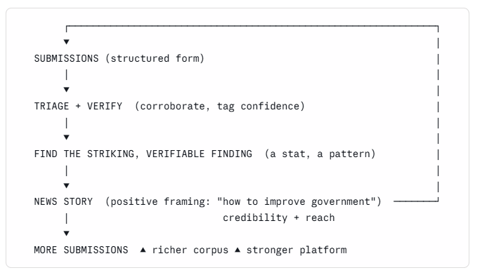

3. Positioning — positive, non-partisan, balanced (the make-or-break)
The framing decides whether this becomes a load-bearing dataset or a dismissible grievance dump.
- Frame as constructive inquiry: "finding ways to make government work better." Not "exposing how the Civil Service manipulates." The same evidence gathered constructively is far harder to dismiss, and it is taken seriously by the very people who can act on it — including the reformers inside government who are your best sources. The adversarial frame alienates them and attracts one-sided submissions that destroy the dataset's credibility.
- Collect what works, not only what fails (see §4). A failure-only campaign reads as a grudge list. Successes give balance, credibility, and the positive news stories the flywheel needs. This is the single most important addition to the category list.
- Strictly non-partisan. Problems and fixes, not parties. Protects both the campaign and Scrutinise's neutrality.
- Consider a distinct sub-brand (positive, plain-English) so the campaign's tone and any controversy stay separable from the core Scrutinise platform.

4. Categories (your divisions, refined + extended)
Category | What it captures | Note
Financial waste | money spent badly — overspend, procurement failures, duplicated spend, sunk costs | your list
Operational waste | effort/resource consumed for no output — process drag, duplicated work, slow systems | your list
Productivity barriers | good work actively prevented — rules, approvals, tooling that stop people doing their job | distinct from operational waste: waste = effort burned; barrier = output blocked. Different fix (cut vs remove).
Structural issues | org design, accountability gaps, split/unclear responsibility, machinery-of-government | your list
Cultural issues | risk aversion, blame culture, defensive decisions, no follow-through | your list
Perverse incentives / gaming | targets distorting behaviour, box-ticking, metrics over outcomes | added — specific and high-value
Policy / implementation failure | a law or policy not achieving its aim on the ground | added — the most on-mission; feeds the evidence base directly
Citizen / business-facing friction | the outward failure — "computer says no", forms, delays people experience | added — the public's direct experience, distinct from internal waste
★ What works | a reform, process, or team that succeeded — and why | added — the credibility anchor and the positive-story fuel (§3)

5. The form — the capture schema (the load-bearing technical decision)
Free text is unsearchable; structure is the product. Each submission captures fixed fields so the corpus is aggregable and feeds the platform (§7):
- Category (§4, single + optional secondary)
- Which body / area (department, agency, NHS trust, council, programme — controlled list + free)
- What happened (short structured description)
- Quantification (£ / hours / people / time period — optional but prompted; the stat fuels §2)
- Outcome / impact (what the failure or success produced)
- Evidence (link to FOI, document, news, report; or "first-hand, unverified")
- Time period and recurring? (one-off vs systemic)
- Consent level (§6) and contact (optional, for follow-up)
- Submitter type (insider / affected public / observer) — never published; used for weighting
A short, well-designed form with good defaults beats a long one; quantification and evidence are the two fields that turn a complaint into a usable data point, so prompt for them gently.

6. Consent — nothing public without permission (tiered)
Default to the most private; publication is an explicit opt-in, per submission:
- Private — internal analysis only, never shown.
- Anonymised aggregate — counted in stats/patterns, never quoted.
- Anonymised public — may be quoted/published with identifying detail removed.
- Attributed public — may be published with attribution (explicit, rare).
Default = 1–2. Publication (3–4) requires the submitter's active choice. State the consent model plainly on the form; it is also what makes insiders willing to contribute.

7. How it feeds the platform
Structured submissions become a corpus that plugs into:
- the institutional-outcome / failure-pattern graph (SEARCH_STRATEGY.md §9.5) — body → failure-mode → outcome, making historical failure a predictive risk signal for new policy;
- the principle-retrieval streams (§3.1) — transferable patterns of how implementation fails;
- the public evidence resource — aggregated, anonymised stats as a credibility/PR asset.
This is also why the schema matters: the graph and streams can only use structured fields.

8. Verification & moderation
Crowd-sourced claims are unverified and unusable raw. Minimum pipeline:
- Triage queue — sort, deduplicate, categorise.
- Corroboration — match to FOI, documents, news, official reports; tag confidence (uncorroborated / partially / corroborated).
- Publication gate — only corroborated + consented items inform a story; the bar for anything named is higher than for aggregate stats.
This is ongoing work, not a one-off — weigh the moderation load against your time before launching at scale.

9. Legal & ethical (get advice before launch)
Real risk surface; flagging, not advising — take proper legal counsel:
- Defamation — specific allegations about named bodies or individuals carry liability; corroboration + careful publication policy + the consent gate mitigate but do not remove it.
- Data protection — submissions may contain personal data (the submitter's and third parties'); needs a lawful basis, retention policy, and a way to honour deletion.
- Whistleblower exposure — insiders submitting about their own employer must be protected (anonymity by default, no retaliation surface); this is both an ethical duty and a trust factor.

10. Phasing & resourcing
- Design now — schema, categories, consent, the triage pipeline; legal review. Cheap.
- Pilot narrow — one or two categories, a bounded ask, manual triage; prove the flywheel and the verification work at small scale before scaling.
- Build into the platform — once the core platform gives the corpus somewhere to plug in (§7) and there is moderation + legal capacity.
- Scale via the flywheel (§2) — each verified finding seeds a story that draws the next wave.
Sequence after the core platform. The honest constraint is recurring moderation, verification, and legal effort — which competes with your time and the build. Design it now as vision; switch it on when there is capacity to run it well.

11. Risks & mitigations (summary)
Risk | Mitigation
Becomes a grievance dump | constructive framing §3; collect "what works"; structured schema §5
Alienates the insiders you need | positive non-partisan framing; whistleblower protection §9
Unverifiable / false claims | triage + corroboration + confidence tags §8; publication gate
Legal liability | consent gate §6; legal review §9; higher bar for anything named
Moderation overwhelms you | pilot narrow §10; scale only with capacity
Free-text data is unsearchable | structured capture schema §5 (designed before any channel opens)

