Table of Contents

Scrutinise — where the search platform stands
20 August 2026
This document is written to be read without knowing how any of it works. It answers three questions: what does the whole thing look like, what can a person actually do with it today, and for everything that isn’t working yet — what exactly are we waiting for?
The detailed engineering version is SEARCH_STRATEGY_v5.md. This is not a summary of it. It is the same picture drawn for someone deciding what to do next.

1. The whole thing on one page
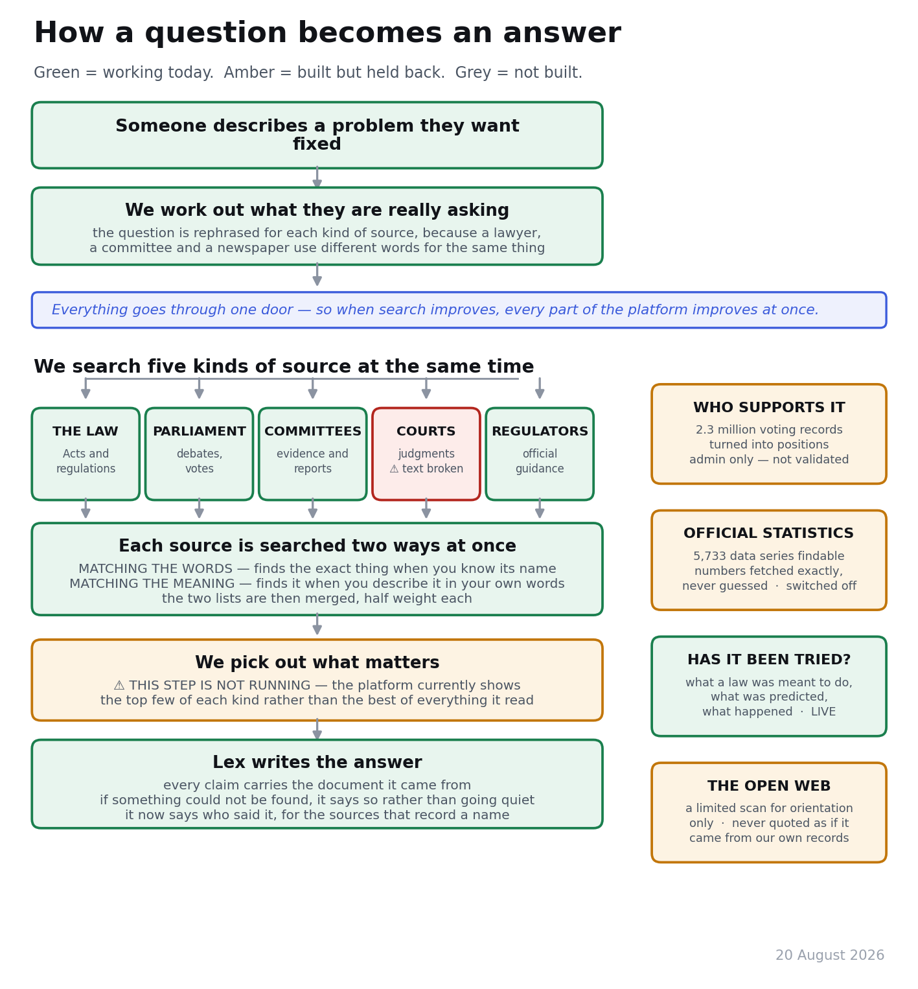
How a question becomes an answer
The one idea worth taking from that page. Everything — the chat, the research passes, the side panels, the admin tools — goes through a single door. That is why a fix to search improves every part of the platform at once, and why a fault in search shows up everywhere at once. It is also why the court-judgment problem below matters more than it first sounds.

2. What is live, what is next, what each thing is waiting for
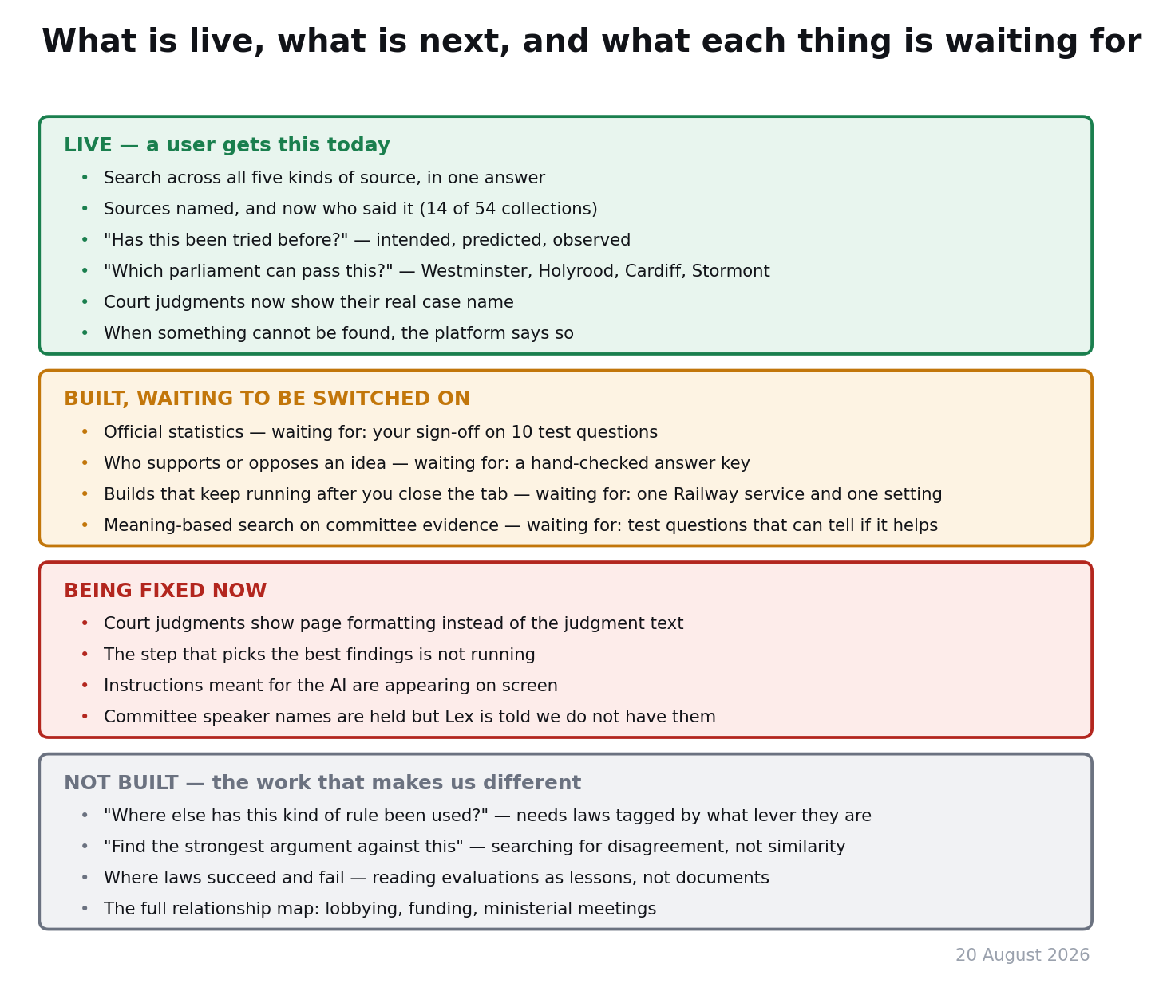
Status at 20 August 2026

3. What a person can do today that they could not a week ago
Ask a question and get an answer drawn from everything we hold. Until last week the main conversation could only see Acts and regulations. Asked what MPs argued about assisted dying, it searched the law, found the letters “assist investi” inside a surveillance regulation, and offered that. It now reads debates, committee evidence, judgments and regulator guidance as well.
See who said something. A committee transcript used to arrive as an anonymous quote. For the 14 of 54 collections that record a name, the platform now says whose evidence it is — and, crucially, distinguishes a witness said this from the committee concluded this. Those are very different claims and confusing them would be seriously misleading.
Ask whether something has been tried before. For any measure, the platform assembles three things side by side: what it was meant to do, what was predicted of it, and what actually happened. Where nobody has ever assessed whether it worked, it says so plainly rather than quietly presenting the prediction as the result. That refusal is deliberate and it is one of the few things on the platform that a commercial competitor would find genuinely hard to copy, because it requires admitting an absence.
Ask which parliament could pass it. Westminster, Holyrood, Cardiff or Stormont. It shows who has legislated in the area and names the statutes that settle the question — it does not pretend to answer a constitutional question with a count.
Be told when something cannot be found. “I looked for what committees have said about this and I can’t reach committee evidence yet” is a good answer. “I don’t have information on that” is a bad one, because a user cannot tell it apart from the subject not existing. The platform is built to give the first kind.

4. Built but not switched on — and precisely what each is waiting for

Official statistics — waiting for you
5,733 official data series (Office for National Statistics, the OBR, HMRC, the World Bank and others) can now be found by describing what you want. The platform finds which measurement exists; the actual numbers are then fetched exactly, never approximately matched — a rough answer is fine for a debate transcript and unacceptable for a statistic.
Waiting for: your sign-off on ten test questions (numbers 51–60 in the review document). Without them we cannot tell whether the feature helps or gets in the way.
Also worth knowing: roughly two in five of those series come from publishers who restrict how their data may be used. The platform now filters those out before anything is ranked, according to a setting that declares what kind of organisation we are. That setting is a declaration, not something the system works out — so it has to change on the day Scrutinise starts doing anything commercial.

Who supports or opposes an idea — waiting for an answer key
Two and a half million recorded votes, sixty thousand motion signatures, witness appearances and declared interests have been turned into 2.3 million position estimates. No AI was used anywhere in it and it cost nothing to build, because it is all arithmetic over records we already held.
It puts the right people at the top without being told who they are: asked for the strongest recorded positions in the whole system, it returns the known serial rebels. It correctly treats one MP’s two votes on the same bill differently because he had lost his party’s whip for the first and been readmitted by the second — nobody told it about the suspension.
Waiting for: a hand-checked answer key — around ten well-known controversies with about ten people each whose public position is documented and citable. Until then it lives on an admin page so it can be argued with before anyone else sees it.
And one real weakness, found by looking at it: everyone who voted the same way gets an identical score, so the list can’t yet rank people by strength of commitment — it falls back to alphabetical order. Being fixed.

Builds that survive closing the tab — waiting for five minutes of your time
At the moment, building a proposal requires the browser tab to stay open, because the page itself is driving the work. The replacement is built and tested: the work moves to a server, so a person can start a build, close the laptop, and come back to a finished proposal.
Waiting for: one service created on Railway (roughly five minutes in a dashboard, following a written recipe) and one setting changed in Vercel. No further code.

Meaning-based search on committee evidence — waiting for test questions
See section 6.

5. Being fixed right now
Court judgments show page formatting instead of the judgment. Every judgment we hold was stored with its stylesheet rather than its text — the platform’s evidence for R (Miller) v The Prime Minister literally begins with font instructions. Two hundred out of two hundred sampled, so assume all of them. A person searching case law has never once seen a judgment. Being scoped now; the size of the job depends on whether the original text is still in our storage or has to be downloaded again.
The step that picks out what matters is not running. The research passes read hundreds of documents and then keep the top few of each kind, rather than the best of everything read. The platform declares this honestly on screen, which is why we found it — but the output is unjudged.
Instructions meant for the AI are appearing on screen. Text like “Say so plainly. Do NOT substitute what was predicted for what was observed” is guidance written for the model, currently rendered to the reader.
Lex is being told we hold no committee speaker names. That was true two days ago and is now false for 97% of committee evidence. Left alone, Lex will apologise for missing information it is actually holding.

6. The one real weakness: we are not using meaning-based search well
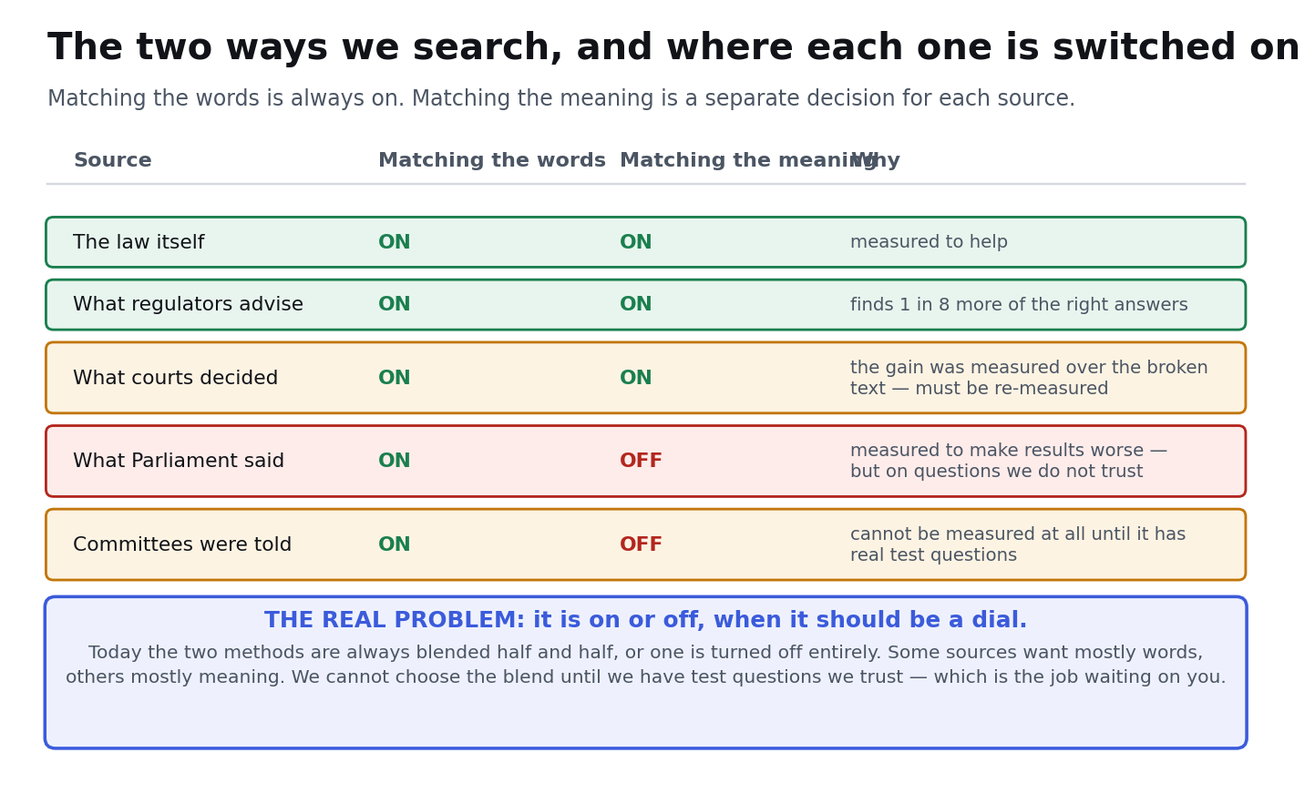
Where each search method is switched on
What the two methods are. Matching the words finds a document because it contains the words you typed — reliable when you know what a thing is called, useless when you don’t. Matching the meaning finds a document because it is about the same thing in different words — it is how someone describing “people dumping sewage in rivers” reaches a document that says “unauthorised discharges by water undertakers.”
Where we’ve got to. Meaning-based search is switched on for three of five sources and off for two, and each of those decisions is on shakier ground than it looks:
- Guidance and the law: genuinely helping. On guidance, roughly one in eight more of the right answers now appear.
- Court judgments: the gain we measured is void, because it was measured over the stylesheet text described above. It must be measured again after the text is fixed.
- Debates: measured as making results worse — but on a small set of questions we wrote ourselves, which is not evidence we should act on permanently.
- Committee evidence: cannot be measured at all. It scores full marks on the only questions it has, which means those questions are too easy to distinguish anything.
The underlying design problem, in one sentence. It is a switch when it should be a dial. Today the two methods are blended half and half wherever meaning-based search is on, and switched off entirely where it isn’t. But debates and legislation are not alike: debates are long, rhetorical and usually contain the exact words people search for, so word-matching is already close to its best and a noisy second opinion actively drags good results down the list. Judgments and regulator guidance are the opposite — people describe those in their own words. The right setting is almost certainly different for each source and is unlikely to be “all” or “nothing” for any of them.

How we solve it — in order
- You validate the test questions. Sixty of them, one line each. Nothing below can be done honestly until this exists, because every number we currently hold about search quality was scored either on questions the machine wrote for itself or on text that turned out to be broken.
- Fix the judgment text, then re-measure case law. In that order.
- Replace the switch with a dial. Once there is a trusted test set, try several blends per source and keep whichever wins on that source. This is cheap to do and impossible to do responsibly first.
- Re-examine debates rather than accepting the verdict. The likeliest explanation is that debates are so large and so conversational that meaning-matching returns many things that sound related and aren’t. If that’s right, the fix is a small share of meaning-matching rather than none.
- Widen the search service. A separate, purely mechanical limit: the service that does the meaning-matching handles four requests at once, and we search five sources at once. That bottleneck — not the software — is what makes slow answers slow. Raising it is the single change most likely to improve how fast the platform feels.
- Look again at the query itself. We rephrase the question for each source before searching. Worth confirming that the meaning-based half is actually using the rephrased version rather than the raw one — if it isn’t, that is a large improvement for very little work.

7. Not built — the work nothing else can replicate
These are listed last but they are the reason the platform is worth building. Everything above makes Scrutinise a good search tool. These would make it the only one of its kind.
“Where else has this kind of rule been used?” Not the same subject — the same mechanism. A levy with a rebate, a duty to consult, a sunset clause, a licensing regime with a fitness test. Someone proposing a reform in one area could see how the same lever performed in five unrelated ones. This requires tagging laws by what kind of lever they are, which nobody has done, and it deliberately wants results that are unrelated by subject — the opposite of what both our search methods reward, so it needs its own technique.
“Find the strongest argument against this.” The research passes already notice when every finding supports the user’s view and flag it. They cannot yet go and find the opposition, because searching is built to find things that are similar to your question, not things that disagree with it.
Where laws succeed and fail. The National Audit Office and the Public Accounts Committee have spent decades writing up why things didn’t work. Read as lessons rather than as documents, that is a body of knowledge about the design of legislation that is not indexed anywhere.
The full relationship map. Lobbying registers, all-party group funders, ministerial meetings, donations — who is connected to whom, on the record, drillable to source.

8. What needs a decision from you
# | Decision | Recommendation
1 | Validate the 60 test questions | Do it — 30–45 minutes, and it unblocks every quality claim we can make
2 | Create the Railway service and change one setting, so builds survive a closed tab | Do it — five minutes, and it removes the platform’s most obvious usability limit
3 | Whether to re-download 74,896 judgments, if the original text turns out not to be in storage | Wait for the scoping report; the answer changes the size of the job by an order of magnitude
4 | Confirm the actual Neon storage allowance so the alert threshold reflects reality | Get the number from the billing page; the current threshold is a figure from an old note and is wrong
5 | When Scrutinise takes any commercial revenue, change the data-use setting | Put a reminder on it now; it is a licence obligation, not a preference

9. Two rules this fortnight earned
Nothing counts until it is measured on the running system. Four separate premises were reversed in two days, each by running the thing rather than reasoning about it: two “non-existent” AI models turned out to work; increasing the search capacity made it slower; the voting data already held a field we assumed we’d have to work out; and two planned data sources turned out not to exist at all.
A service can answer with something other than what you asked for. When we requested a retired AI model, the provider silently answered with a different one and reported success. Every check we had — is it listed, did it work — passed. The only check that catches it is whether the answer identifies itself as the thing requested. That is now a rule, and it is the sort of thing that would otherwise be discovered in a year, by accident, in an expensive way.

