Table of Contents

Scrutinise — how the search platform works, and what is left to do
8 September 2026
This document is written for someone who wants to understand what happens under the bonnet without having to decode engineering shorthand. Technical terms are used where they are the right word, and every one of them is in the glossary at the end.
It has four parts: how it works, what we fixed recently, what is next, and what needs you.

1. How it works
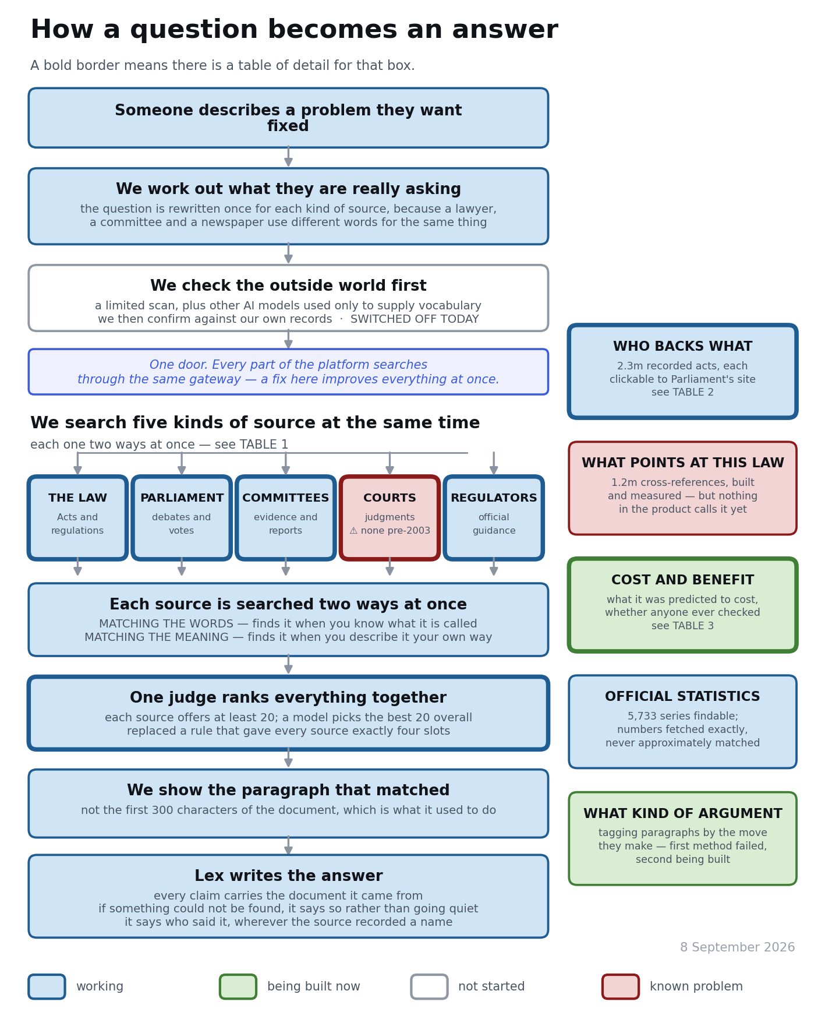
Figure 1 — the path a question takes. A bold border means there is a table of detail for that box.

1.1 The written version
Somebody describes a problem in their own words. The first thing the platform does is rewrite that question once for each kind of source it is about to search, because a lawyer, a select committee and a newspaper use different words for the same thing. A question about “landlords chucking people out with no reason” has to become something that will match the phrase “assured shorthold tenancy” in an Act, and something quite different to match a committee transcript.
Everything then goes through a single gateway. That matters more than it sounds: the chat, the research passes, the side panels and the admin tools all search through the same door, so an improvement to search improves every part of the product at once — and a fault appears everywhere at once too.
Five kinds of source are searched at the same time, and each is searched two ways simultaneously — see Table 1. Matching the words finds a document because it contains what you typed; it is unbeatable when you know what a thing is called and useless when you do not. Matching the meaning finds a document because it is about the same thing in different words; it is how “people dumping sewage in rivers” reaches a document that says “unauthorised discharges by water undertakers”.
The five result lists then have to become one. Until August this was done by rationing — five sources, twenty slots, four slots each — which meant that a correct answer sitting fifth in its own source’s list could never be shown, no matter how good it was. That has been replaced: every source now offers at least twenty candidates and a model reads them all and picks the best twenty overall. One source can take every slot if that is where the answers are.
Finally, the paragraph that actually matched is what gets displayed. Until late August the platform showed the first 300 characters of the document instead — so for a 4,000-word speech you got the opening pleasantries while the matching passage sat unseen further down.
Around that core sit five capabilities that answer questions retrieval alone cannot: who backs what, what points at a given law, what something was predicted to cost, which official statistics exist, and what kind of argument a passage makes.

1.2 Table 1 — the five sources, and how each is searched
Source | What is in it | Matching the words | Matching the meaning | State
The law | every UK Act and statutory instrument, devolved equivalents, retained EU law | on | on | working
Parliament | Commons and Lords debates back to the nineteenth century, plus Holyrood, the Senedd and Stormont | on | on | working — meaning-based search was switched off here until it was re-tested and found to help
Committees | select committee reports, and the written and oral evidence given to them | on | on | working, but see below
Courts | judgments and tribunal decisions | on | on | ⚠ we hold nothing before 2003
Regulators | HMRC manuals, the FCA Handbook, Ofcom, Ofgem, the ICO, planning policy, building regulations | on | on | working
⚠ Two things about this table are worth knowing. Committee evidence is our largest evidence collection and it appeared for months to be performing terribly — 2 questions right out of 10. When somebody finally looked at the ten questions one at a time, eight of them could not be answered fairly as they were written: ten of the nineteen “correct answers” were ministerial letters while the questions asked what a committee had said. The search was working; the marking was wrong.
And the courts gap is not a coverage boundary anyone chose. The National Archives service simply starts in 2003, and the alternative source’s terms forbid us from taking a copy. The consequence is worse than an absence: ask about Caparo and you get an unrelated employment tribunal case with a similar name, confidently.

1.3 Table 2 — who backs what
What it holds | 2.3 million recorded acts by named people — how they voted, which motions they tabled, which inquiries they gave evidence to, what interests they declared
What a user sees | a person, the act, the date, and a link straight to Parliament’s own record
What it estimates | a stance, from −1 to +1, with a confidence figure
State | live and clickable since 4 September
⚠ The boundary | our record of Commons divisions begins 9 March 2016. Nothing earlier exists here. The platform now says this on screen — it never used to
⚠ The gap | we hold who tabled each early day motion and none of the 2.06 million people who signed them. That is why a motion shows one name where a division shows 254
⚠ Not validated | the stance estimates have never been scored against a checked answer key. The recorded acts underneath them are facts and need no such caveat

1.4 Table 3 — cost and benefit
This is the newest capability and it answers two opposite questions.
Row | What it says | Where it comes from
Predicted | what the department said the measure would cost and gain | the impact assessment published with it
Checked | whether anyone assessed it afterwards, and what they found | a post-implementation review
Measured | which official statistics bear on it | the statistics catalogue
Not known | ⚠ what nobody has established | stated plainly, with the reason
Comparable | measures of a similar kind, and what those cost | by subject, and it says so
⚠ The fourth row is the point. Ask “what has the Public Sector Equality Duty cost to date” and the honest answer is that no impact assessment for the duty is held, no review of it exists, no official series measures its cost, and therefore nobody has established what it has cost. That is a finding with a citation, and it is not available anywhere else. An empty answer would be indistinguishable from not having looked.

2. The three graphs
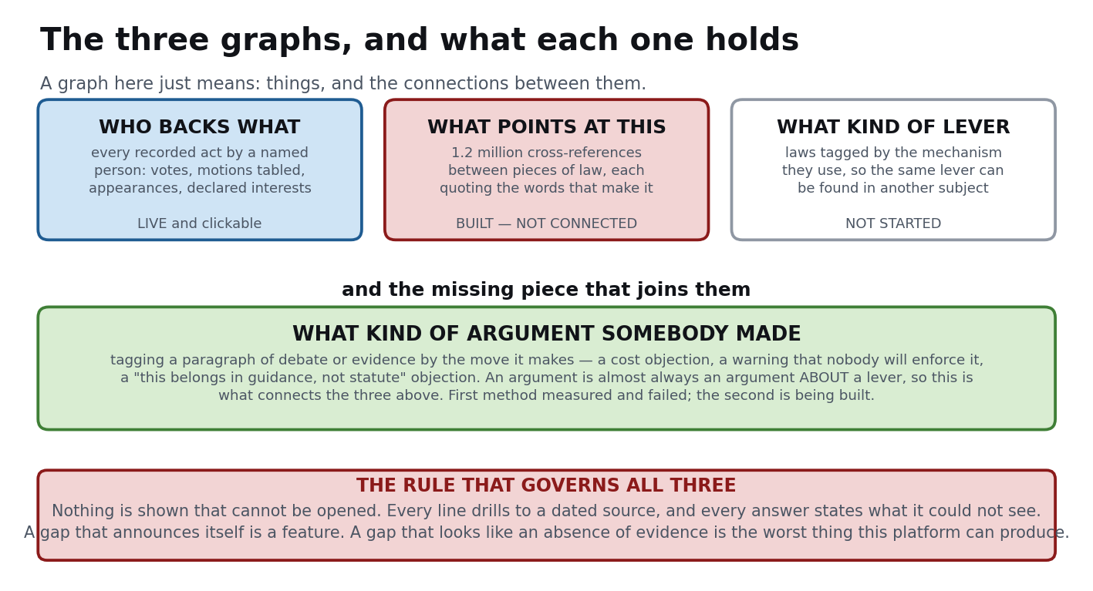
Figure 2 — the three graphs and the piece that joins them.
“Graph” here just means things and the connections between them — no more than that.
Who backs what is live. What points at this law is built, measured, hand-checked against the official source twenty times out of twenty — and nothing in the product calls it, so every answer it has ever given was given to a script. What kind of lever has not been started.
The piece that joins them is what kind of argument somebody made. An argument is almost always an argument about a lever: “sunset clauses create a cliff edge for business” is an objection attached to a mechanism, made in a debate about something else entirely. Tag both and a housing reformer can be shown the objection that sank an identical mechanism in fisheries — a connection nobody else can make, because every existing system indexes by subject.

2.1 On witnesses to committees and inquiries
You asked where the people brought in to give evidence sit. The answer is that they are split across three things, and only one of them needs the unreliable AI extraction:
- That somebody appeared is a fact in the graph. It carries no direction — appearing is attention, not a position.
- What they wrote is in the search corpus with their name and organisation attached, on 97.7% of written evidence. So “the Local Government Association told this committee, in these words…” is answerable today.
- Which side they took is the AI-extracted layer, and that is the part measured at 44% wrong and deliberately demoted. It is not shown to anyone.
⚠ And one real gap: for oral evidence we store one row per whole transcript, so none of the 15,806 oral rows carries a speaker. “Who appeared” is answerable; “what this witness said” is not. Fixing that is the largest single unlock in this area.

3. What we fixed recently
A short list, because the detail is in the sprint reports.
- The merge stopped rationing. Correct answers displayed went from 14 to 30 out of 64.
- The search service could lock itself up. It handled four requests at a time in total, and work abandoned by a user was still executed. The real cause turned out to be an index missing 6.5% of its rows, making one lookup take 133 seconds. Rebuilding it took 45 seconds and cost less than a penny.
- Meaning-based search over judgments was matching formatting code. Every judgment had been stored with its stylesheet; the text was recovered and re-indexed for $31.90 against a $31.88 estimate.
- Court cases had no titles and committee evidence had no speakers. Both were recovered from data we already held — the writer had them in hand and dropped them.
- 48,883 documents could not be returned by any query at all, including all the Competition and Markets Authority cases. Seven of the nine collections are now reachable.
- The positions surface had never displayed anything to anybody. It was deployed and empty; the screen and the document were using different matchers. One resolver now, and 83 of 83 ideas agree.
- “Has this been tried before” had two legs that had never returned a single row. 952 measures were being told “nobody has published an assessment of whether it worked” while we held 1,197 review sections about them.
- The daily coverage report could not show anything as incomplete, because its target figure had been copied from the figure achieved and then labelled as verified.
⚠ The pattern in that list is worth naming, because it is the most useful thing this project has learned. Almost none of these were failures to build something. They were correct things being computed and then dropped, mislabelled, or never connected — and in every case a check existed that could not fail: it asked whether an index existed rather than whether it was complete, whether a title was present rather than whether it matched.

4. What is next

4.1 The three things that gate everything else
One — the measuring instrument. We score the platform against 64 questions. Roughly a third of the failures are now known to be marking errors rather than search errors, and until they are re-keyed every number we quote is wrong in a direction we cannot measure. This is mostly waiting on you (§5).
Two — the unit. Twelve of the 32 remaining failures are the same thing: the answer is a paragraph inside a long document and we score the document. The same finding turned up independently in the cost work — searched at document level the right impact assessment comes back for eight questions of nine; searched at section level, none. Fixing this lifts debates, committee evidence and inquiry evidence together.
Three — reach. Four collections still cannot be returned by any query, and four more are never routed to.

4.2 Then, in order
- Connect the cross-reference graph to Lex. A million cross-references, built and verified, and nothing calls them. “If you change this, here is what points at it” is the most useful thing we hold that nobody can see.
- Ingest the 2.06 million early day motion signatures. No AI spend. Turns a motion from one name into about thirty-five.
- Rebuild the argument tagging around phrase patterns. The first method — find paragraphs similar to hand-picked examples — scored zero on held-out tests, while plain phrase patterns scored 90%. The reason is instructive: similarity finds paraphrases of your example, not other people making the same move in different words.
- Close the corpus holes already costed. House of Lords judgments (a top court we hold none of, clean licence, under $2). The 41,913 identified-but-unfetched instruments. Northern Ireland primary legislation, which is the single largest cause of unresolved cross-references.
- Extract the cost figures into columns. We hold them as prose inside documents, so they cannot be compared or ranked.
- Then the mechanism graph — laws tagged by what lever they are.

4.3 Two cautions carried forward
⚠ The impact assessment template is being abandoned. The standard proforma appears in 97% of 2017 assessments and 51.9% of 2026 ones — so extraction will be weakest on exactly the recent years a forward-looking question needs most.
⚠ Everything is measured against 64 questions written and validated by one person. That is a real instrument and it is also one point of view. At some point soon the highest-value next step is not another sprint — it is five real users, and the beta feedback mechanism for that is built and waiting.

5. What needs you
Each item names the file to work on.
# | What | File | Why it matters
1 | Verdict on 11 re-keyed debates questions | docs/GOLD_V2_DEBATES_REKEY.md | debates currently scores 0 of 11 and we cannot tell how much of that is marking
2 | Verdict on 10 re-keyed committee questions | docs/GOLD_COMMITTEES_REKEY.md | 8 of 10 could not be scored fairly as posed
3 | Verdict on 8 costing questions | docs/COSTING_QUESTIONS_V1.md | two of them are deliberate traps where the right answer is “nobody has measured this”
4 | Verdict on 50 position rows | docs/POSITION_VALIDATION_CANDIDATES.md | until this is done there is no accuracy figure at all for who-backs-what
5 | Decide D-1: re-key 9 impact assessment questions | docs/SEARCH_S18_REPORT.md | 9 of 18 keys are cover sheets or empty tables; this gates every number in the cost area
6 | Decide decision 2: how cost figures are extracted | docs/INGEST_IMPACT_NUMBERS_REPORT.md | the summary sheet is not a table, so “find the label and take the next number” returns the price year as the cost
7 | Companies House API key | — | unlocks roughly eight times the current donation signal from data already held
8 | Two one-line changes to relay to Lex | docs/SURFACE_4_REPORT.md §4 | one files positions on rebuild; one renders the donation review panel
⚠ Items 1 to 5 are all the same job in different clothes: telling us what a right answer looks like. That judgement cannot be delegated, and it has already caught four wrong case-law keys, 138 unsound position rows, and nine unanswerable cost keys.

6. Glossary
Answer key — the specific document we have decided is the correct answer to a test question. If the key is wrong, good search looks like bad search.
Chunk — a paragraph-sized piece of a document. Meaning-based search works on chunks; until recently the platform found the right chunk and then displayed the wrong one.
Collection — one body of documents from one source, e.g. all Commons debates, or all impact assessments. We hold 74 of them.
Coverage statement — a sentence generated fresh on every answer saying what the search could not see. Never written by hand, because a hand-written caveat goes out of date silently.
Dense retrieval / meaning-based search — finding documents by similarity of meaning rather than by shared words. Works by turning text into a list of numbers and finding lists that are close together.
EANDCB — “equivalent annual net direct cost to business”. The single headline figure in a UK impact assessment. ⚠ A negative figure means a benefit to business, not a cost.
Early day motion — a formal motion tabled in the Commons that members sign to signal support. Signing one is voluntary and unwhipped, which makes it strong evidence of a person’s view.
Free vote — a vote where members are not instructed how to vote by their party. Not recorded anywhere, so we infer it from voting patterns — an inference, and labelled as one.
Gateway — the single point through which every part of the platform searches.
Gold set / gold questions — the validated test questions the platform is scored against.
Impact assessment — the document published alongside a measure setting out what it is expected to cost and achieve. A prediction, not an outcome.
Index — the prepared structure that makes searching fast. Data can be correct in the database and absent from the index, in which case no user ever sees it.
Keyword search / BM25 — finding documents by the words they contain, ranked by how distinctive those words are.
Merge — combining the results from all five sources into one list.
Post-implementation review — the document published some years later saying whether a measure worked. ⚠ Only 73 exist for the 1,169 assessments we hold.
Rebellion — voting against the majority of one’s own party. A strong signal, because the member paid a price for it.
Recall@20 — of the test questions with a known correct answer, the share where that answer appears in the top twenty results.
Reranker — a model that reads a set of candidate results and puts them in a better order.
Routing — deciding which of the five sources to search for a given question.
Statutory instrument — secondary legislation made under an Act. Most references to any Act sit in the instruments made under it, which is why they matter to the cross-reference graph.

