Scrutinise — Search & Graph Strategy
Version 5.1 · 19 August 2026
Table of Contents

Scrutinise — Search and Graph Strategy
Version 5.1 · 19 August 2026
Status: living document. Authoritative reference for the search stack and the position graph; cite by section number in CC briefs. Supersedes v4 (13 August 2026).
What this revision records. Two sprints landed on 19 August: SEARCH S8, which finished the first-pass retrieval stack, and GRAPH 3A, which built the position graph’s factual layer. Both are described in the sections below and in the delivery record at §0.1. Three streams are running against this document as at the date above: CC-Ingest (recovering names), CC-Search (the statistics catalogue), and a Lex display fix.

0. Status at a glance
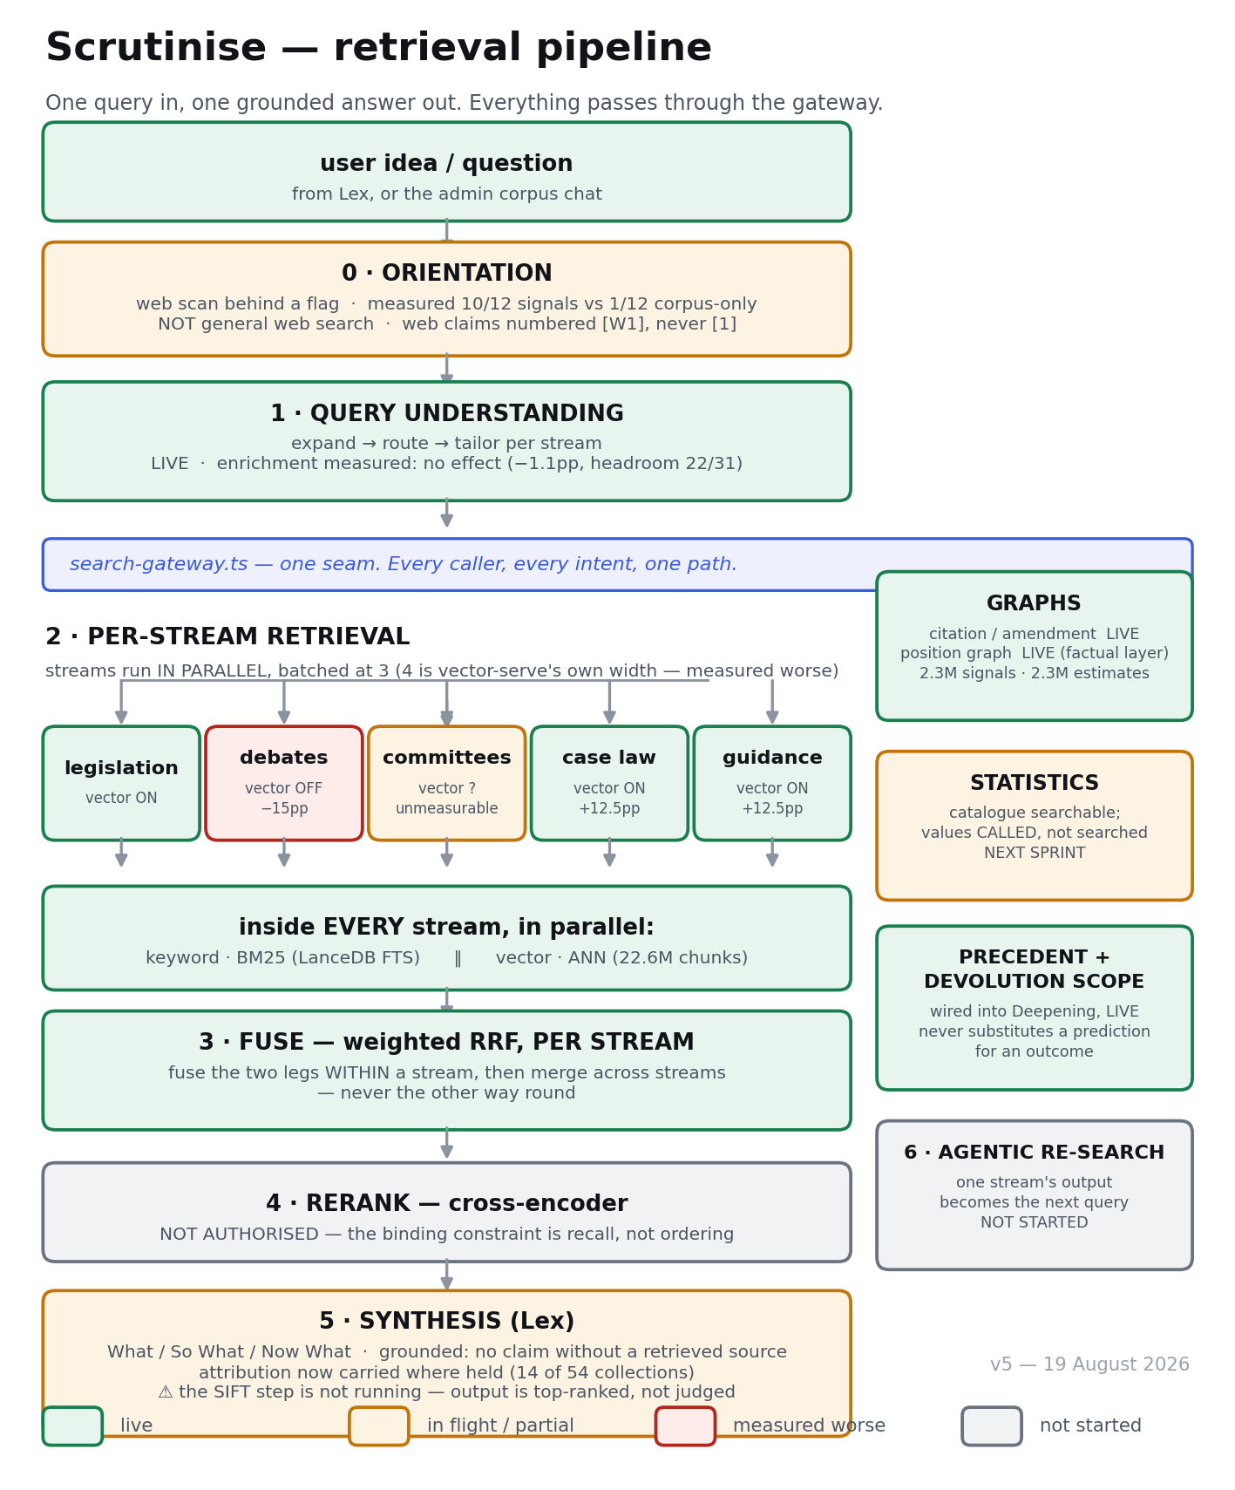
The retrieval pipeline as at 19 August 2026

0.1 What was delivered on 19 August
Sprint | What it did | Status
SEARCH S8 | Wired PRECEDENT and DEVOLUTION_SCOPE into the Deepening; added attribution through the gateway; re-homed the framing experiment on the real gateway; extended the router to the newest typed streams; concurrency experiment; config hygiene; drafted 50 gold questions | 8 commits, pushed, live
GRAPH 3A | The position graph’s factual layer: 2,317,523 signals and 2,304,748 estimates, built from votes, EDM signatures, witness appearances and declared interests. No model used, £0 spent | 9 commits, pushed, admin surface live

0.2 Four premises the sprints reversed
Each was reversed by running the thing, not by reading about it. This is the single most consistent pattern in the project’s history and the strongest argument for the audit-then-build discipline.
- A provider can answer with a model you did not ask for. Both “non-existent” fallback models returned HTTP 200. grok-3-fast-beta returns 200 and echoes back grok-4.3 — xAI silently substitutes. So the model our configuration named was never the model any user got on that path, and the spend ledger priced it wrongly. The guard that works is neither “is it listed” nor “does it return 200” — it is whether the response echoes the identity requested. New standing rule.
- More concurrency is slower. Raising the stream cap from 3 to 4 made five-stream questions worse on every statistic (p95 13,071 → 19,885 ms), because 4 is exactly vector-serve’s own width (queueHighWaterMark: 4). Prediction refuted; cap stays at 3.
- We already store party-at-time-of-vote. GRAPH 3A expected to infer it; it is present on 2,527,966 of 2,528,032 vote rows (99.997%). Verified rather than trusted from a code comment. It shows up working: one member’s two assisted-dying votes classify differently because he had lost the Labour whip for the first and been readmitted by the second — nothing was told about the suspension.
- Two planned signal types have no source data at all. Amendment sponsorship and committee membership are not in the database; we hold bill PDFs, not who sponsored what. Both are printed by name on every run rather than silently skipped.

0.3 What a user can now do that they could not on 18 August
- Run a Deepening pass and see precedent assembled as a group — what a measure was intended to do, what was predicted of it, and what was observed — with an explicit statement where nobody has ever assessed whether it worked. Verified live on the Constitutional Reform and Governance Act
- See who said it on retrieved evidence, for the 14 of 54 collections that hold attribution structurally.
- (Admin only) Ask who has a recorded position on a specific division or motion, and drill every line to its dated source.

0.4 Defects observed in live output on 19 August
Named here because a defect recorded in a strategy document survives a session clear.
Symptom a user would see | Cause | Owner
The Deepening returns the top few of each document type rather than the best of what it read (630 reviewed, 28 kept, evenly split 6/6/6/6) | The sift — the step that judges candidates rather than ranking them — did not run | Lex
Instructions written for the model appear in user-facing output (“Say so plainly. Do NOT substitute…”) | Prompt text rendered into the evidence block | Lex
Mechanically-assembled precedent and model-written summaries both carry the badge “Precedent” | One label over two reliability classes | Lex
The “known unknowns” list repeats one sentence eight times with a different Act name | No collapsing of identical gap statements | Lex
The position-graph admin page says “showing the top 40” but the list is alphabetical | Every actor with the same two votes ties at the same confidence, so the tie-break is name order — the score does not yet discriminate | Graph

1. Governing principles
Carried forward from v4, with four additions earned since. Plain-language glosses inline.
- Measure against the gold set, always. No search change ships on a hunch. The gold set itself must be trusted before its numbers are — answer keys need a human validation pass, and any baseline measured across an index change is void and must be retaken.
- Separate cheap-reversible decisions from expensive-sticky ones (§2). Pilot sticky ones on a subset first.
- The corpus is ground truth. The LLM frames the search and writes the answer, but never asserts a fact the corpus did not return.
- Web is for orientation; the corpus is for the law you cite. Web claims are numbered [W1], provably non-colliding with corpus [1], so a web claim can never wear the corpus’s authority.
- Index by function and outcome, not only by subject and citation.
- Every component is config-driven, flag-gated, default OFF, flipped only once the gold set rewards it.
- Alternatives considered are recorded.
- Every brief is written to disk before it is trusted to survive a session clear.
- One shared resource, one owner at a time, recorded when it changes hands.
- Verify engagement positively. A flag flipped is not a flag in effect; prove it with a counter that moved.
- A push is not a deploy. Deploy state is observed off the running product, never inferred.
- Fix a failure class in the shared helper, not in each caller.
New in v5:
- A saturated metric is not a null result. A metric that comes back identical in every configuration (S7’s on-kind count: 180 of 180, four times) is measuring a property that cannot vary, not proving the change did nothing. Report the saturation as the finding.
- A floor effect is not a null result either. When 27 of 31 test queries score zero in both arms, only 4 could have shown a difference; “+0.0pp” from that sample licenses no conclusion. Every A/B report must state its headroom — how many cases could have differed.
- Record the prediction before the measurement. S7’s brief predicted committees would gain most from semantic search; the measurement showed the prediction could not be tested (committees is at a ceiling on its only questions). A written prediction is what makes a surprising result a finding rather than a shrug.
- An inference must not travel as a measurement. A 17.5 GiB database limit taken from a handoff note shaped a sprint’s design; the real ceiling is 16 TiB. When a number matters, fetch it from the system, and record where it came from.

2. The core distinction — keyword vs vector
(Unchanged in principle from v4.) Keyword FTS (BM25 — ranked word-matching) is cheap and reversible: tune, measure, move on. Vector search (meaning-based matching over embeddings) is a quality continuum dominated by two sticky choices — embedding model and chunking — both executed via pilot → measure → commit (gemini-embedding-001 at 768 dimensions won the bake-off). Vector is also operationally a second system: paid hours-long embed jobs, index builds on the heavy-job runner, and a probe-count parameter that trades latency against candidate size on every query.
What v5 adds: vector is also per-stream in value, not uniform. The same dense leg that adds +12.5pp of recall on caselaw and guidance subtracts 15pp on debates. “Turn vector on” is not one decision; it is one decision per stream, gated per stream (LEX_VECTOR_STREAMS), each with its own measurement.

3. The stream model

3.1 The full stream set
(Structure unchanged from v4; statuses updated.) Nineteen streams across two kinds: specific-retrieval streams want the exact item; principle-retrieval streams want transferable patterns and are architecturally different and genuinely unbuilt. The load-bearing rows today:
Stream | Purpose | Status
Legislation | the precise law to amend, add to or revoke | live · keyword + vector
Debates (Hansard) | contested views on causes | live · keyword; vector measured 15pp worse — leave off
Committees | evidence and hypotheses on causes and effects | live · keyword; vector unmeasurable until gold questions exist
Case law | how courts interpret the law | live · keyword; vector +12.5pp — recommended on
Guidance | how a regulator expects compliance | live · keyword; vector +12.5pp — recommended on; +2.5s p50 latency cost, watched
Explanatory notes / memoranda | what a measure was for | live · typed and indexed
Impact assessments (incl. 1,014 post-implementation review sections) | what was predicted — and what actually happened | live · typed and indexed; router not yet extended to select it deliberately
Consultations | what was proposed, who objected, what changed | live · typed and indexed; same router caveat
Division votes | who voted which way | ingested; 2.53M rows; a graph input, never text-searched
Members’ interests | declared interests | ingested; a graph input
Statistics catalogue | does a relevant numeric series exist | unblocked, scoped, not built; values are called, never searched
Principle streams (NAO/PAC evaluations, inquiries as lesson-sources) | where laws succeed and fail | unbuilt; a different build

3.2 Reassembly is a dependency chain, not a merge
(Unchanged.) One stream’s output becomes another’s query; the synthesis layer assembles the briefing. A stream earns its place only when the gold set shows it improves the result.

3.3 The mechanism matrix — what searches what
(Updated.) Legend: ● live · ◐ partial or flag-gated · ○ designed, not built · — not applicable.
Stream | Keyword | Vector | Graph | Routed | Where it runs
Legislation | ● | ● on | ● citation/amendment | ● | LanceDB FTS + ANN on R2
Debates | ● | ◐ built, measured worse, off | ○ argument | ● | same services, tier filter
Committees | ● | ◐ built, unmeasurable | ○ witness | ● | same
Case law | ● | ◐ built, recommended on | ◐ cites | ● | same
Guidance | ● | ◐ built, recommended on | ○ | ● | same
Explanatory notes / IA / consultations | ● | ● | — | ◐ surface via neighbours; router prompt predates them | same
Division votes | — | — | ● 2.48M voted edges | — | relational; graph input
Members’ interests | — | — | ○ interests | — | relational; graph input
Statistics catalogue | ○ | — | — | ○ | statistics DB; headings only
Position graph (§9.2) | — | ◐ prototype-scoring uses the existing vector index | ○ soft edges | — side-rail | relational + existing embeddings
Web orientation | — | — | — | ◐ flag-gated LEX_WEB_ORIENTATION | outside the corpus
The change from v4: the Vector column is no longer a uniform ●. The capability is live everywhere; the decision to use it is per stream, evidence-gated, and two streams currently fail the gate (debates on evidence, committees on absence of evidence).

3.4 Parallel vs series
(Unchanged from v4, one addition.) Streams run in parallel; stages run in series; fuse within a stream before merging across, never the other way round. Addition: stream concurrency is now batched at 3 (LEX_STREAM_CONCURRENCY) because five parallel streams saturated a four-wide service, and the limiter’s effect is observed (maxInFlight logged), not assumed. The pre-batching scare — 2× latency under two users — does not reproduce post-batching: measured 0.75×–1.37× of serial p95. Raising the cap to 4 is a one-variable experiment worth running; p95 at 9 seconds on the chat route is acceptable-ish, not good.

4. Target architecture
(Unchanged.) Orientation and query understanding in series; per-stream retrieval in parallel with two legs per stream; per-stream fusion then a merge across streams; rerank not authorised; grounded synthesis; graphs and statistics as side-rails. The router both selects streams and rewrites the query per stream; a scoped caller that skips selection must still receive the rewrite. The router’s structured-response truncation fails open (query proceeds unrouted); the guard lives in the shared LLM helper and the failure is loud.

5. Layer roadmap
# | Layer | Status
1 | Keyword FTS + citation resolver + legislation boost | ● live
2 | Lex adapter | ● live
3 | Query expansion | ● live
3.5 | Query router | ● live
3.6 | Legacy call-site repoints | ◐ stopped pending the recall/ingest work (§5.1)
4 | FTS index hygiene | ● resolved
4.5 | Act-level metadata (corpus_acts) | ● live
5 | Vector / semantic (hybrid + RRF) | ● live full-corpus; per-stream enablement is the live decision (LEX_VECTOR_STREAMS)
5.4 | Lex chat sees the whole corpus — two channels, gap notes, unmet-demand log | ● shipped, SEARCH S5
5.5 | PRECEDENT + DEVOLUTION_SCOPE retrieval jobs | ◐ built and tested; nothing calls them — wiring is S8
5.6 | Attribution (who said it) through the gateway contract | ○ named gap; S8
6 | Reranker | ⛔ not authorised — binding constraint is recall (§5.1)
7 | Tier 1 graphs (citation/amendment) | ● live
7.5 | Position graph — probabilistic (§9.2) | ○ redesigned; factual layer buildable now from held data
8 | Statistics catalogue | ○ unblocked, scoped
9 | Principle streams + mechanism lens | ○ post-pilot
10 | Web orientation | ◐ flag-gated, measured 10/12 signals vs 1/12 corpus-only; not general web search

5.1 The reranker was declined; the binding constraint was recall
(Unchanged in substance.) The reranker measurement showed 11 of 15 scored pairs turned on retrieval, not ordering; and 17,261 instruments known to the legacy table were absent from the corpus (since diagnosed further by INGEST V36: the number is wrong in both directions, and the route is re-fetch, not migrate). Recall work is an ingest problem before it is a search problem; the legacy-table deletion stays blocked.

5.2 The binding constraint now: the measuring instrument (new)
Nothing about retrieval quality can be improved reliably until the test set is real. The current position:
- Three of five collections (committees, caselaw, guidance) are scored on questions CC drafted for itself — the implementer writing its own exam.
- Committees sits at 100% on those questions: a ceiling. It cannot show a gain from any change, which means the largest evidence collection we hold is currently unevaluable.
- One live metric saturated (identical in every arm) and one experiment floored (27 of 31 queries zero in both arms). Both were reported as “this cannot answer the question”, which is the correct output — but it means the question is still open.
- The framing experiment must be re-run through runSearch() (the real gateway, with routing, fusion and expansion) rather than bare BM25; the harness location, not the design, was the fault.
The fix is cheap and mostly human: roughly ten questions per collection whose correct answers are known documents, drafted by CC, validated by Charlie as things a real user would ask. This is the bridge from the build phase to the measurement phase and it gates everything in §11.

6. Layer detail
(6a–6c unchanged from v4.)

6d. Statistics — headings are searchable, values are callable
(Unchanged.) The catalogue (dataset title, measure, geography, span) is searchable; the numeric values are called by exact tool once the series is known. Prerequisite (stable series key) met. Known residuals: sourceSeriesId null on a large minority of rows; licence terms are per dataset and cannot express per-vintage restrictions.

7. Synthesis structure — What / So What / Now What
(Unchanged, strengthened.) The never-claim rule is now written into SEARCH_CONTRACT.md §6 and enforced in code: if Lex wants something search cannot supply, it says what it looked for and could not reach — never a vague deflection, never general knowledge dressed as corpus. A failed search (“the corpus was not consulted”) is distinguished from an empty one. Every unmet request is logged (LexUnmetRequest) with the streams the router chose — separating our routing bug from a corpus gap — and without the question text, because a Stage-1 idea is private.

8. (reserved — see §9)

9. Graph strategy — a plural taxonomy, one lens, and a rebuilt §9.2
“Graph” was never one thing. Our edge is unchanged: existing legal search serves lawyers looking up what the law is; Scrutinise serves reformers trying to change it — so we index function, outcome, and people-and-involvement, not only subject and citation.

9.1 Explicit / structural graphs (factual, cheap, high precision)
(Unchanged.) Citation/amendment graph ● built (powers rescission traversal and the SURFACE 1 repeal labelling). Metadata graph queued. Regulator-oversight graph designed.

9.2 The position graph — probabilistic, factual-first (rewritten)
What died, and why. The first design read positions out of written submissions with an LLM and stored them as assertions. Hand-reading fifty against source found 22 wrong or partly wrong (44%). The diagnosis matters more than the number: the direction was wrong on only 2 of 50. The model is nearly always right about which side a document takes — it simply claims a position far too often, because saying “this document doesn’t take one” feels to a model like failing. Over-eagerness, not misreading. Meanwhile the corpus already held 2.5 million perfectly reliable positions — every division vote is a position, needing no extraction, no confidence score and no caveat — and we had surfaced none of them.
The reframing. The graph holds graded, evidence-backed estimates, not certainties. Every edge is:
(actor, target, stance_score ∈ [−1, +1], confidence ∈ [0, 1],
evidence_ids[], observed_at, source_type, decay_policy)
where actor is a person or organisation, target is an idea, bill, instrument or (later) a mechanism, stance_score is direction and strength, confidence reflects the reliability of the source type, evidence_ids point at the corpus sections behind the estimate so every claim is drillable to source, and observed_at plus a decay policy make old signals fade rather than persist as false certainty. Hard facts (a recorded vote) are simply edges with confidence 1.0. The 44%-wrong extractions are not discarded: they become one low-confidence signal among many, weighted for what they are actually good at (direction) and discounted for what they are bad at (whether a position exists at all).
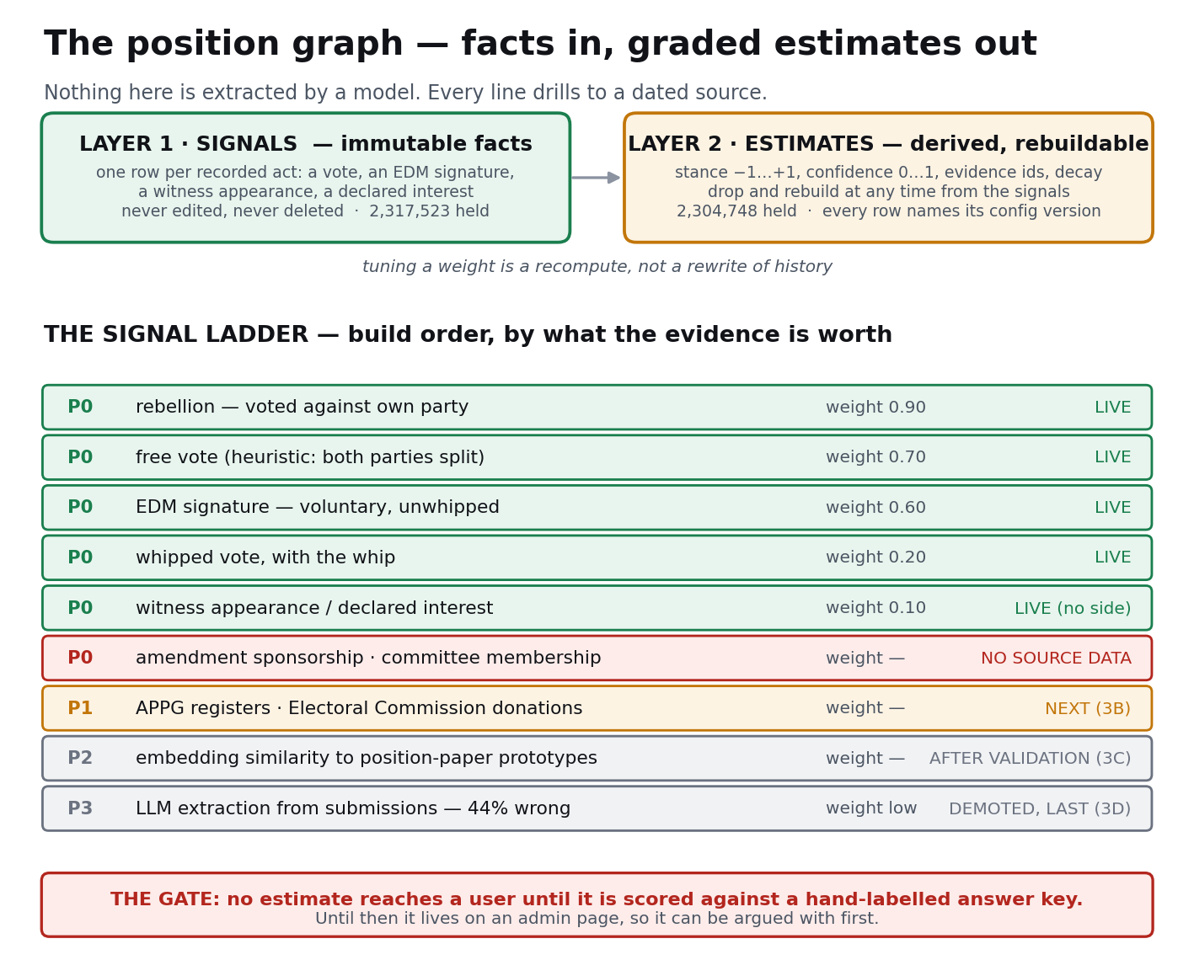
How the position graph is built
The signal ladder, in build order — priced by what already exists:
Tier | Signal | Source | Confidence class | Status
P0 — factual, held today | Division votes, weighted: free votes and rebellions ≫ whipped votes (a whipped vote mostly measures the whip; a rebellion measures the member) | 2.53M vote rows; 2.48M voted edges already built (GRAPH 2D-2) | fact (1.0); informativeness varies, encoded in weight | buildable now — no new data
P0 | EDM signatures — voluntary signalling, unwhipped | 59,996 sponsorships, held | fact | buildable now
P0 | Amendment behaviour — who tables/co-sponsors strengthening vs wrecking amendments | bills-api, held; needs cheap classification of amendment-vs-parent | fact of the act; classification adds a confidence term | buildable now, classification piloted first
P0 | Committee membership and witness appearances | held | fact (affinity prior, weak) | buildable now
P0 | Declared interests | 1,505 interests + 5,496 org register numbers, held | fact (a prior on alignment, not a position) | buildable now
P1 — public registers, small ingest | APPG membership and funders (All-Party Parliamentary Groups — voluntary affinity groups; membership, especially of funded groups, is a clean soft prior) | published registers; scrape | fact of membership; soft as stance | small CC-Ingest job
P1 | Electoral Commission donations; Companies House joins (MP ← donor → sector paths) | bulk public data | fact of the path; soft as stance | small CC-Ingest job
P2 — embedding prototypes | Stance scoring by similarity to small sets of prototype texts (known lobby briefs, charity position papers) — reusing the live vector index, no new embed job | existing embeddings + curated prototypes | continuous, calibrated by measurement | cheap pilot after gold set exists
P2 | Written/oral questions as revealed attention (volume, framing, persistence) | LDA corpora, held | weak, attention not stance | later
P3 — LLM extraction | The existing 16,196 extracted positions, plus Charlie’s bottom-up claims architecture (measured: finds 74% more claims, 85% real, recovers only 57% of known-correct, costs 3.73× — a supplement, not a switch) | committee submissions | low confidence; direction reliable, existence unreliable | demoted to one signal; never shown as fact
P3 | Free-text speech stance (plenary language is theatrical; committee “backstage” language less so — weight accordingly) | Hansard + committee oral evidence | low | later
Derived structure, once edges exist: community detection over co-signing/co-voting on free votes; label propagation from a few seeded hard positions; bridge-actor identification (cross-party APPG members, high-betweenness actors — the natural outreach targets); and, once the mechanism lens (§9.3) exists, mechanism-transfer edges — “actors who supported analogous levers in other domains” — which is the genuinely original move and depends on §9.3, not on this section.
The first consumer is unchanged and is the reason the soft model works: the political-risk pass in the Lex deepening — “who will resist, on what grounds, with the evidence attached.” It runs in the background with a minutes-long latency budget, so multi-hop traversal and large candidate sets are affordable; and its output language is naturally probabilistic (“high-confidence opposition from X, grounded in these three votes and this submission”), which is honest where a hard graph would have to invent certainty. Ranked-likely-supporters/opponents with drillable evidence is the product; the graph formalism is just how it is stored.
Discipline, restated for this graph specifically:
- Factual edges ship first; every inferred edge carries provenance and confidence; no edge type is promoted into a user-visible surface until measured against a hand-labelled set of known controversial bills.
- Party membership and whipped votes are weak priors only, easily overridden by P0 free-vote and P1 register signals.
- Never merge two identities on similarity (standing rule): an unresolved name is visibly thin and harmless; a wrongly merged one is a person who does not exist holding contradictory views.
- The never-claim rule applies: the synthesis layer reports scores and their grounds; it does not round a 0.6 up to “supports”.

9.3 The mechanism / principle lens
(Unchanged.) Not a graph among graphs but a cross-cutting lens: tag provisions by what kind of lever they are, connect matches across unrelated subjects. Deliberately wants topically distant results, which both BM25 and embeddings work against — its own technique, scoped after the streams it cuts across are solid. It is also the prerequisite for mechanism-transfer edges in §9.2.

9.4 Other inferred / content graphs
(Unchanged.) Intent/problem→lever; institutional-failure patterns; argument graph over Hansard; case-law doctrine graph; lineage-of-attempts graph.

9.5 Behavioural (needs traffic) — unchanged.

9.6 Discipline — unchanged: explicit before inferred; provenance and confidence on every
inferred edge; each layer gates on the gold set; content graphs land after retrieval is solid.

10. The seam, the type taxonomy, and the callers
(Updated.) search-gateway.ts remains the only place that touches search; SEARCH_CONTRACT.md is the standing reference other streams build against, updated in the same commit as any capability change. The taxonomy is thirteen display types. Two response shapes now exist by design: LegacySearchResult (legislation — actId/actTitle/sectionNumber) and EvidenceResult (everything else), and the separation is structural: EvidenceResult has no field through which a committee transcript could render as a section of an Act. A Bill travels in the evidence channel, because a proposal is not operative law.
Callers, all through the one gateway: BACKGROUND_BRIEFING, LEGAL_LANDSCAPE, CAUSE_SEEDING, POLICY_ALTERNATIVES, AD_HOC_RESEARCH, GENERAL_CORPUS_CHAT, PRECEDENT, CAUSAL_EVIDENCE, DEVOLUTION_SCOPE, plus the three deliberately legislation-only surfaces (IDEA_CHAT_GROUNDING retired in favour of the routed chat path; LEGISLATION_PANEL; LEGISLATION_SEARCH). ⚠ Descriptive intents select no streams — PRECEDENT, CAUSAL_EVIDENCE, DEVOLUTION_SCOPE, GENERAL_CORPUS_CHAT are logged and keyed off, but adding a new intent string changes no retrieval; retrieval changes are a conversation with CC-Search.
The two special requirements of the deepening consumer stand: CAUSAL_EVIDENCE values contradicting documents as much as supporting ones; and deepening’s background budget (minutes) licenses techniques the interactive path cannot afford — which is exactly where the §9.2 graph side-rail plugs in.

11. Evaluation, A/B, and feedback signals
(Carried forward, with §5.2 now the governing statement.) Offline gold-set scoring remains the instrument; the answer keys have never had a human validation pass and this remains the single highest-leverage non-build task. A metric that cannot fail is not a metric — watch every metric failing before trusting it passing; state the headroom of every A/B; candidate-set fidelity is not recall. The Lex feedback capture (user critique, consent-gated, personal content stripped) is the first source of observed real questions, and the LexUnmetRequest log is the first direct evidence of what the corpus should hold next.

12. Where each workstream stands
Workstream | State on 19 August 2026
Retrieval — first pass | Complete. Five streams routed, two channels, gap notes, unmet-demand log, batching at 3, precedent and devolution jobs wired, attribution carried where held.
Semantic search per stream | Legislation, case law and guidance ON (each +12.5pp measured on caselaw and guidance). Debates OFF (15pp worse). Committees unmeasurable until it has real questions.
The measuring instrument | The binding constraint. 50 draft gold questions exist; none validated. Case-law keys cannot be verified because every judgment title is blank.
Attribution | Live in the gateway. 14 of 54 collections carry it. Committees carries none — 0 of 800 rows sampled. Ingest work in flight.
Statistics catalogue | Briefed (SEARCH S9), in flight.
Position graph — factual layer | Live on an admin surface. 2.3M signals, 2.3M estimates, £0. Not user-visible and must not be until validated.
Position graph — registers, prototypes, extraction | Designed (3B / 3C / 3D), not built.
Mechanism lens and cross-domain analogues | Designed, unbuilt. The strongest differentiator and the largest body of work.
Recall / absent instruments | Route agreed (re-fetch, not migrate). Not started.
Deepening display defects | Four named at §0.4. Lex brief in flight.

13. What is ahead
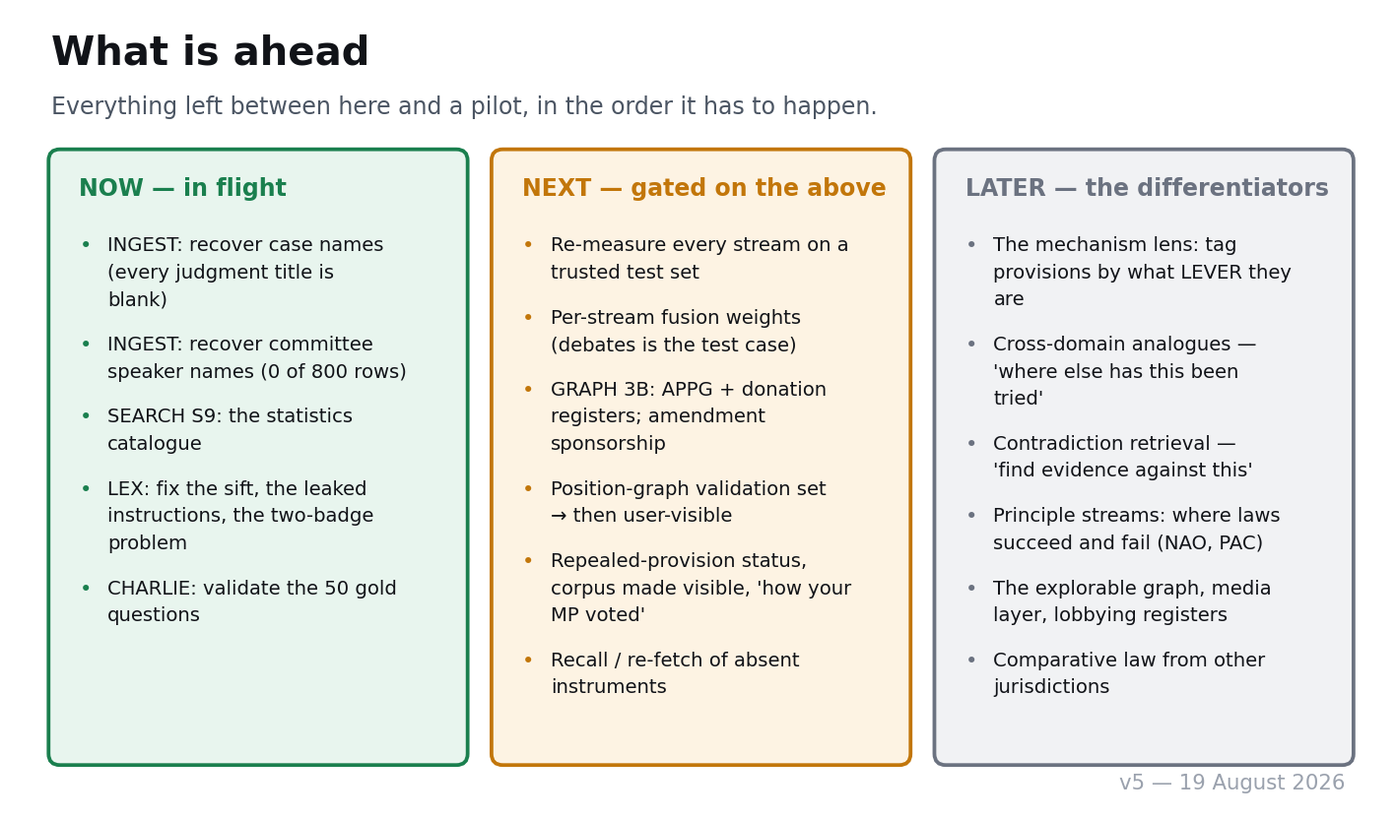
The road from here to a pilot

13.1 Now — in flight as at 19 August
- INGEST — the missing names. Every court judgment we hold has a blank title (the stored id is the citation), and committee evidence carries no speaker. Both are the same failure: we stored the document and discarded what it was. The judgment fix also unblocks ten gold questions whose answer keys cannot currently be verified.
- SEARCH S9 — the statistics catalogue. Headings become searchable so the platform can find which official series exist; values are then fetched by exact call. Numbers are never approximately matched. The sprint also enforces the licence register structurally — a series whose licence excludes commercial use must be filtered at retrieval, not flagged for a caller to respect.
- LEX — the display fixes at §0.4: the sift, the leaked instruction text, the badge collision and the repeated gap statements.
- CHARLIE — validate the 50 gold questions. Everything in 13.2 is gated on this.

13.2 Next — gated on the measuring instrument
- Re-measure every stream on the validated set. The per-stream vector decisions, the framing result and the committees question are all currently answered by an instrument we do not trust.
- Per-stream fusion weights. Debates is the test case: rather than vector on/off, blend the two retrieval methods in a ratio chosen per stream. Cheap tuning, and exactly the kind that must not be attempted before the instrument is trusted.
- GRAPH 3B — the public registers (APPG membership and funders, Electoral Commission donations, Companies House joins), plus amendment sponsorship once its source data exists.
- The position-graph validation set — roughly ten well-known contested matters with about ten documented actors each, hand-labelled by Charlie. This is the gate on any of the graph reaching a user.
- Surfacing work already possible from held data — repealed-provision status, the corpus made visible, “how your MP voted”, explicit search.
- Recall — the absent instruments. An ingest problem before it is a search problem; the legacy-table deletion stays blocked until it is closed.

13.3 Later — the differentiators nothing else replicates
- The mechanism lens. Tag provisions by what kind of lever they are, not what subject they concern. Prerequisite for both of the next two items.
- Cross-domain mechanism analogues — “where else has a levy-and-rebate been used”. Wants results that are topically distant, which is the opposite of what both retrieval methods reward, so it needs its own technique.
- Contradiction retrieval — “find the strongest evidence against this”. The Deepening already flags one-sidedness; it cannot yet cure it.
- Principle streams — where laws succeed and fail, read out of NAO and PAC evaluations as lesson-sources rather than as documents.
- Mechanism-transfer edges in the position graph — actors who backed analogous levers in other domains. Depends on item 11.
- The explorable graph, the media layer, the lobbying and ministerial-meeting registers, comparative law from other jurisdictions.

13.4 The one-sentence statement of the plan
The capability is built. Now make the measuring instrument real, label everything honestly, grow the graph factual-first as graded estimates with provenance, and only then spend effort on the differentiators — so that what the platform shows a user is always something it can prove.

14. Standing rules earned by measurement
Each of these cost a sprint or a defect to learn. They are listed together because a rule that lives only in the sprint report that produced it will be rediscovered expensively.
- A check that cannot fail is not a check. Watch every new check fail before trusting it to pass.
- An inference must not travel as a measurement. A 17.5 GB database ceiling taken from a handoff note shaped a whole sprint’s design; the real ceiling is 16 TB.
- Reachability is not completeness. The corpus reported 99% reachable while holding a quarter of the Acts that exist.
- Read the artefact, not the counter.
- A saturated metric is not a null result, and a floor effect is not one either. State the headroom of every A/B test — how many cases could have differed.
- Record the prediction before the measurement.
- Verify engagement positively. A flag flipped is not a flag in effect. A push is not a deploy.
- One sample of a cache header is not a measurement. GRAPH 3A published a deploy claim from a single ETag reading and withdrew it four minutes later when the page revalidated on its own.
- A response only verifies a model if it echoes the model id requested. Providers substitute silently behind a 200.
- Never merge two identities on similarity. An unresolved name is visibly thin and harmless; a wrongly merged one is a person who does not exist holding contradictory views.
- Fix a failure class in the shared helper, not in each caller.
- Commit scripts are named per stream and per sprint. Two sessions in one tree sharing commit-all.sh raced, and one deleted the other’s script mid-use.
- Every brief is written to disk before it is trusted to survive a session clear.

