

**C语言课程设计**

**农田无人机喷洒农药模拟系统**

**课程设计终期报告**

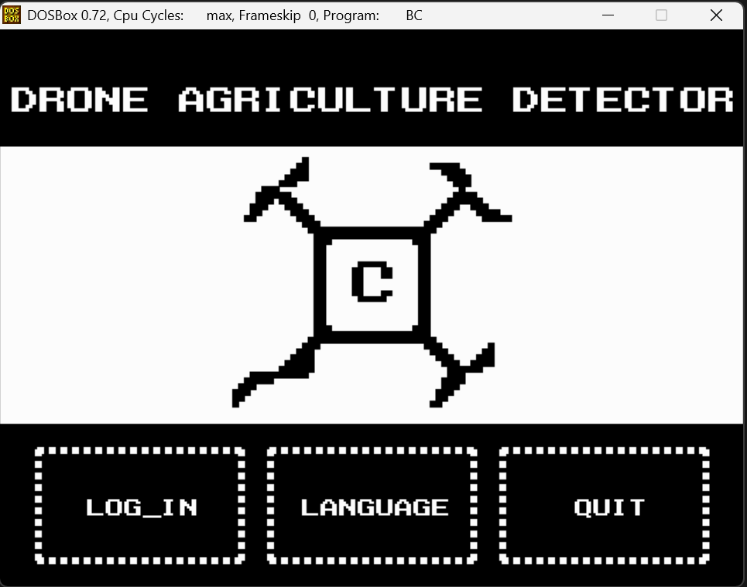

**专业班级：自动化2406班**

**小组成员：迟泰炎U202414215 吴立锟U202414232**

**指导老师：周纯杰，何顶新，左峥嵘，高常鑫，汪国有，彭刚，周凯波，陈忠**

**目录**

1. **前言**
2. **选题介绍**
3. **编写背景**
4. **编写目的**
5. **参考资料**
6. **任务概述**
7. **需求分析**
8. **可行性分析**
9. **编写规范**
10. **运行环境与配置**
11. **硬件接口**
12. **软件接口**
13. **控制**
14. **主要功能**

**1.在homepage点击界面按钮所需资源**

1. **程序设计**

**1.程序设置流程图**

1. **源码和有关文件**
2. **include <.h>**
3. **.c**
4. **.dat**
5. **课设感想**
6. **分工详情**

**一.前言：**

**1.选题介绍：农田无人机喷洒农药模拟系统**

主要功能说明：利用无人机进行农作物生长监测，针对不同病害进行农药配制，对农药喷洒路径进行规划，模拟无人机喷洒过程等功能。

**2.编写背景：**

在当下科技的逐步发展，人们已经不满足于先前的机械化农业，即使用各种机械化设备配合人力进行工作，这样并没有真正的解放劳动力，再加上农村的人员外流，以及当下人们的愿景逐渐趋于可以采取一种完全解放劳动力的种植方式，这推动了自动化行业的发展，将自动化技术和智能技术应用于种植当中，可以智能监测农田的生长情况，并且针对不同的病害进行处理，同时它可以克服地形和气候对人的影响，大大提高劳作的灵活程度，从而提高产量。但并非所有农民都明白如何去对无人机进行喷洒规划，也不明白怎样的飞行是效率最高，工作时间最短，得到的产率最大

基于这些问题，编者编写了这个农田无人机喷洒农药模拟系统，旨在帮助更多的农民用户在图形化的界面了解自己农田可能出现的问题，了解如何对虫害进行更快处理，从而提高产量。我们欢迎所有希望采用全自动技术进行劳作的劳动者们，希望通过此项技术可以模拟出真实环境下无人机喷洒的实际演示，来让劳动者们得到更高效的生产方式，便宜自身。

**3.编写目的：**

通过“无人机喷洒农药模拟系统”，我们可以通过图形化的页面让用户自由绘制自己的农田，或者将农田分块进行处理，来达到更加灵活的规划，在此同时我们支持不同的无人机型号，也具备各种灵活的规划，针对这一项目，我们编写了这项报告，希望 从项目概述，功能分析，代码实现以及一些核心算法解释这些方面来进行解答，旨在让用户通过阅读本篇报告来了解整个项目的原理和尽快熟练使用整个程序。

**4.参考资料：**

1.周纯杰，何顶新等. 程序设计教程—用C/C++语言编程. 北京: 机械工业出版社, 2016

2. 王士元. C高级实用程序设计. 北京: 清华大学出版社. 1996

**二.任务概述：**

1.需求分析：

用户可以进入一个农田数据管理的界面，产生像素风格界面的沉浸感。

用户可以在简易图形的引导与安排下，在拟合现实的情况下（时间流动等），自行安排对农田状态和无人机飞控的部署规划（如在哪块地种什么，在模拟时获得怎样的预期效果）。

用户在使用本系统时可以获得挑战性、多样性（如农田虫害的挑战，合理规划无人机性能和飞行轨迹）。

用户使用本系统时要实现对农田不同时段的模拟，如天气变化，虫害发生，飞行规划，时间推移等。

用户可以在管理农田中得到责任感、成就感、满足感，同时系统实现退出展示动画（退出致谢）。

2.可行性分析：

通过新的画图函数实现像素风格；

通过新的绘制图片，实现简单易懂的图像绘制；

通过数据记录在.dat文件中进行数据读取与写入；

通过主界面集成不同界面，实现界面跳转；

通过手动规划和自动规划两方面进行飞控模拟；

3.编写规范：

1.注释：对于代码，我们尽可能多的加入了注释，有利于使用者了解代码工作原理（不计入工作量）；

2.函数命名根据其具体功能及页面进行命名；

**三.运行环境与配置：**

**1.硬件接口：**

**处理器：Intel Pentium 166 MX 或以上。**

**硬盘：空间 500MB 以上。**

**屏幕适配器：VGA 接口。**

**系统运行内存：要求 32MB 以上。**

**2.软件接口：**

**开发软件工具：Borland C++ 3.1 For DOS**

**文字编辑工具：Visual Studio Code、Visual Studio 2022 Preview**

**数据库：记事本**

**操作系统：DOS WINDOWS 9X/ME/2000/XP/WINDOWS 7**

**3.控制**

**该系统通过鼠标与键盘实现对界面的与功能的控制。**

**1. 在欢迎页面通过点击语言模式实现切换中英文系统。通过点击退出实现退出模拟系统。点击登录进入登陆页面。**

**2. 在登录注册界面通过鼠标实现输入框、进入按键、点击注册、退出按键的控制。**

**3. 在主界面内为鼠标模式，单击退出以实现退出系统，单击返回键退回到登陆页面，单击对应按钮进入对应子界面。**

**4. 用鼠标实现对其余功能，其余按键的点击。**

**四.主要功能：**

**1. 实现注册/登录/切换语言。**

**2. 第一次进入主界面显示六个模块：退出，无人机，农田，农药，检测，日志。**

**3. 进入农田界面，点击农田，点击信封获取当前登陆账号农田信息或创造新农田，保存。回到上一级，点击画笔设置农田位置，点击水设置水源位置，点击橡皮进行擦除，保存。回到上一级，点击植物显示三种作物水稻、玉米、甘蔗，点击对应类别，单击田地对应格子进行种植。单击铲子进行删除作物。回到上一级，单击房子，在地图上点击空白土地进行设置。完成任务，退回到homepage。**

**4. 进入无人机界面，单击录入无人机输入名称，输入质量，机翼数，天气和使用时间，单击确认完成录入。单击查看无人机，可以查询到该账号下全部已经录入的无人机。**

**5. 进入农药界面，单击管理农药，点击以往该账号已经录入的农药信息；回到上一级，单击名称录入新农药名称，喷洒周期和对应虫害种类。**

**6. 进入监测界面，选择模式（自动/手动）。右上角可自主输入对应时间天数，或者单击向上或向下三角形调整天数。自动模式下，选择无人机数量（一个/多个），选择set，输入对应房子内无人机种类，输入两种农药调配配方；双击start，开始按时间顺序进行自主喷洒农药，自动模式最大模拟天数60天。单击chart，可见田地内各种数据。手动模式下，单击route手动规划路径（不必设置返航路径），完成后单击start开始自主喷洒农药模拟。**

**7. 进入日志界面，选择要查看的用户名，选择要查看的类别，单击文件名，对于农田界面，可以展示农田具体设置和房子、作物信息；对于无人机，可以显示无人机名称和对应天气；对于农药，可以显示农药名。**

**8. 单击退出，显示退出致谢动画。**

**五.程序设计：**

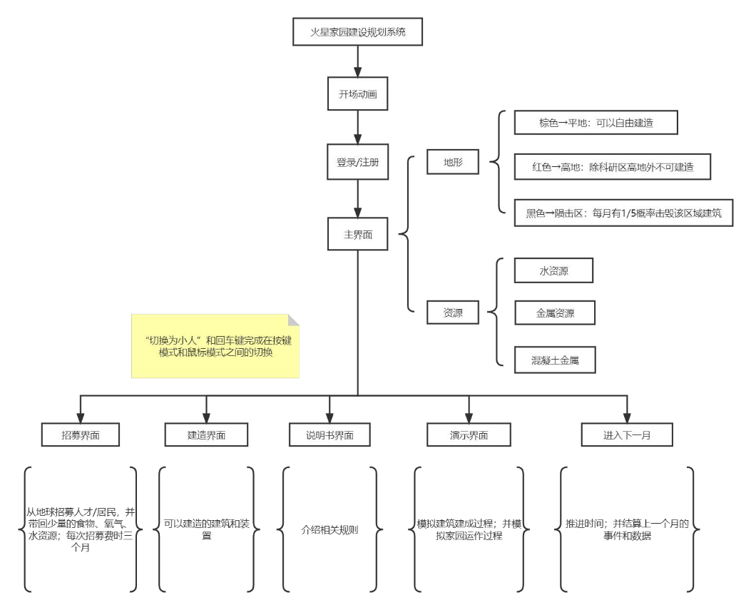

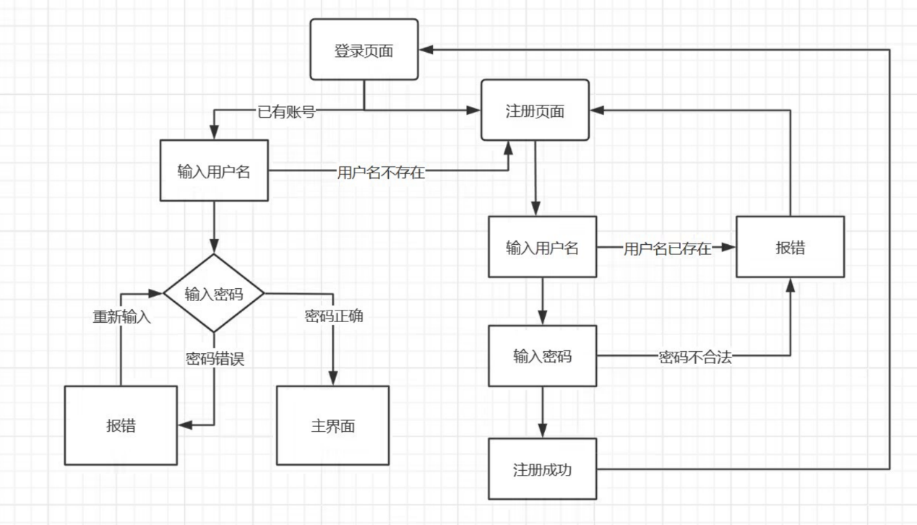

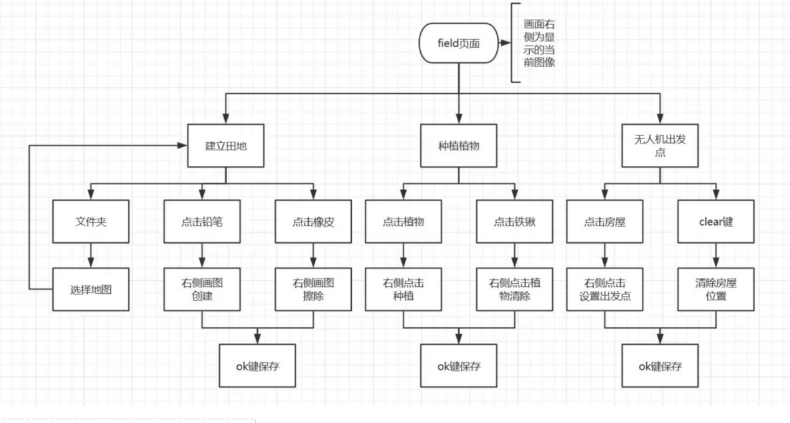

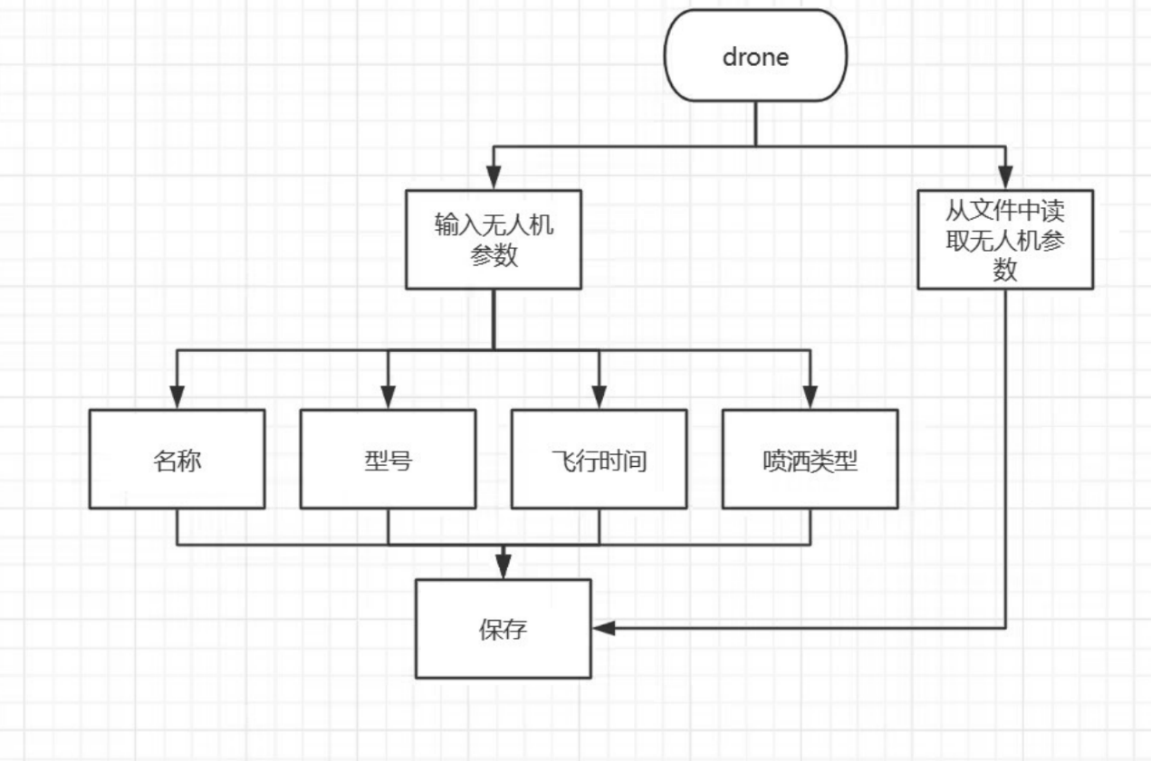

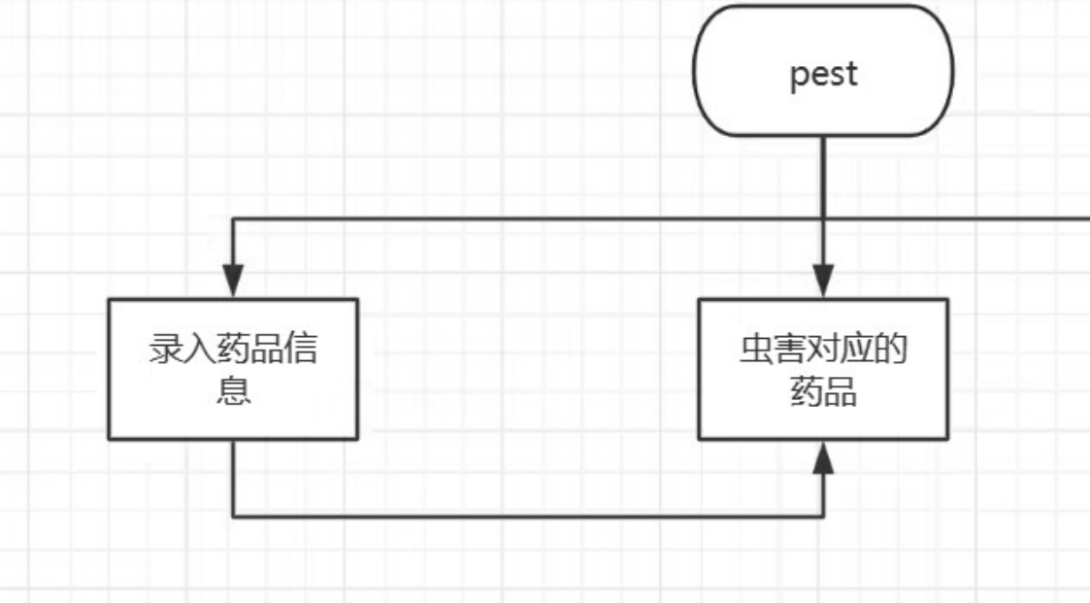

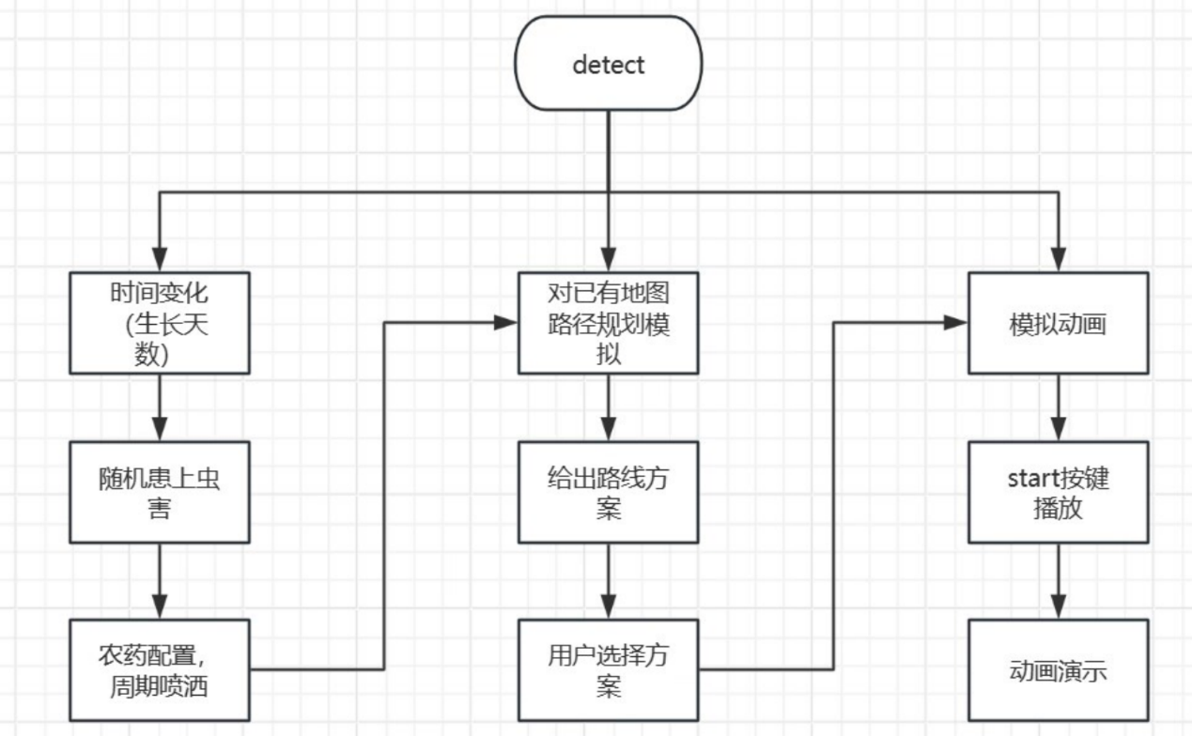

**欢迎：**



**登录：**

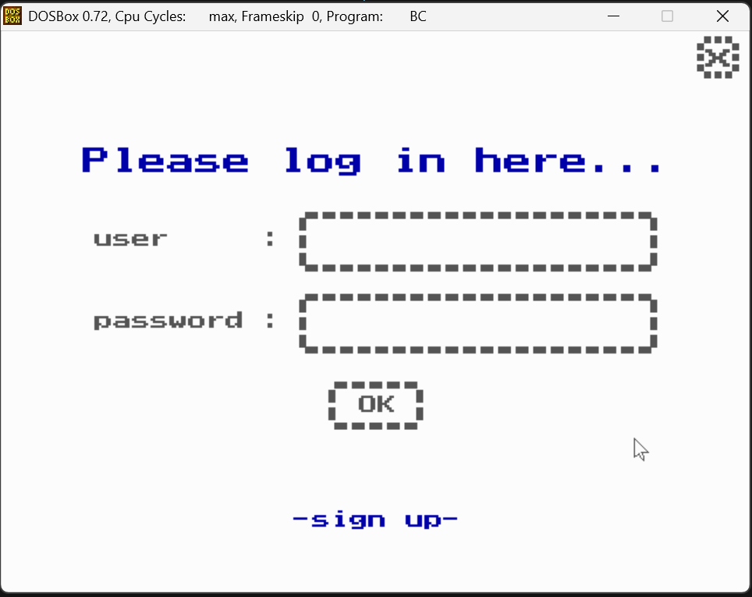

**注册：**

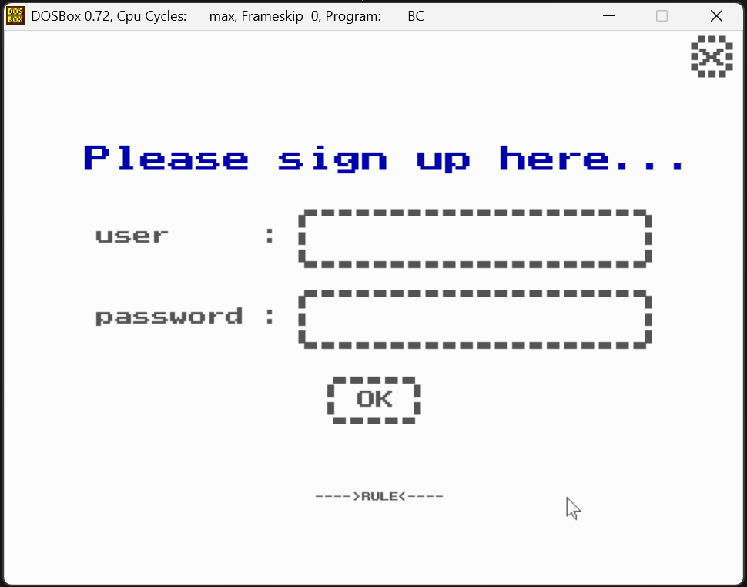

**注册规则：**

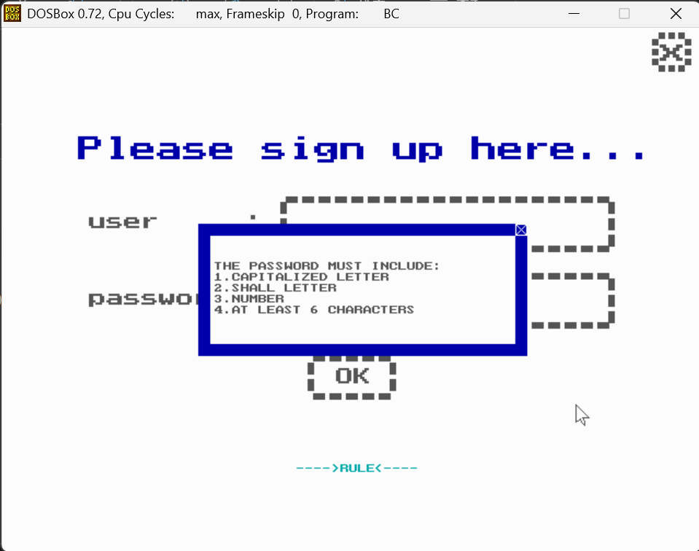

**主页：**

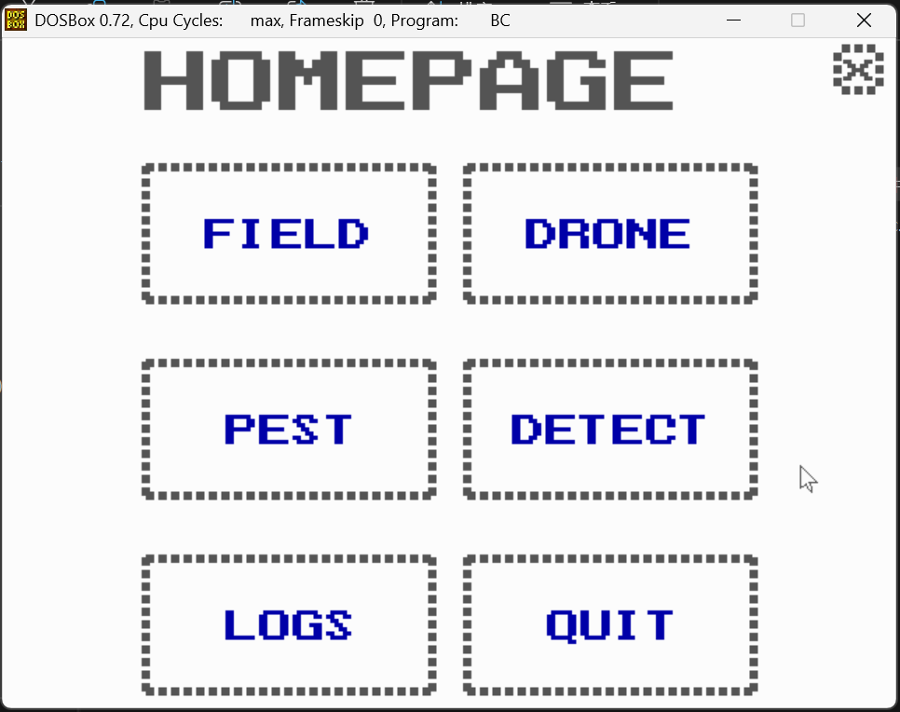

**农田主页面：**

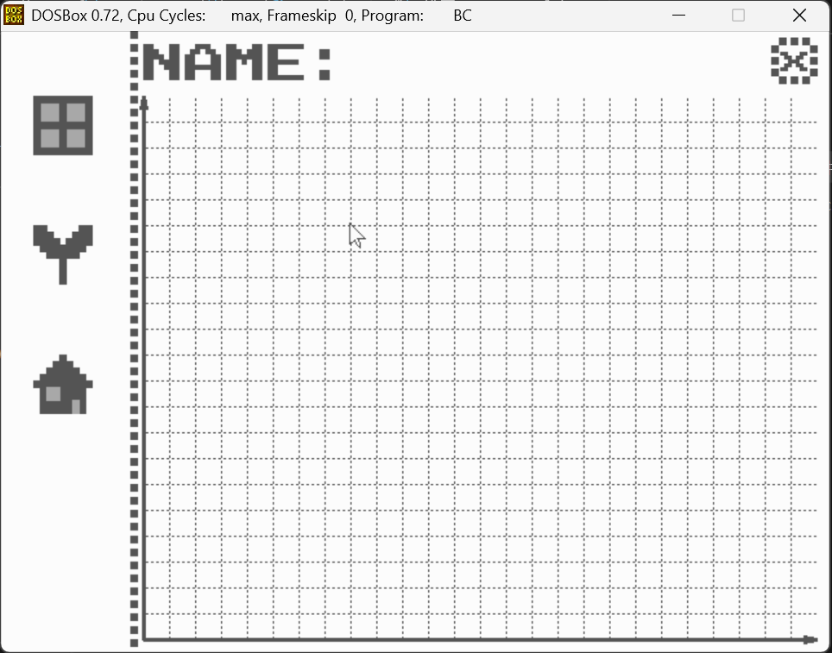

**打开农田/新农田：**

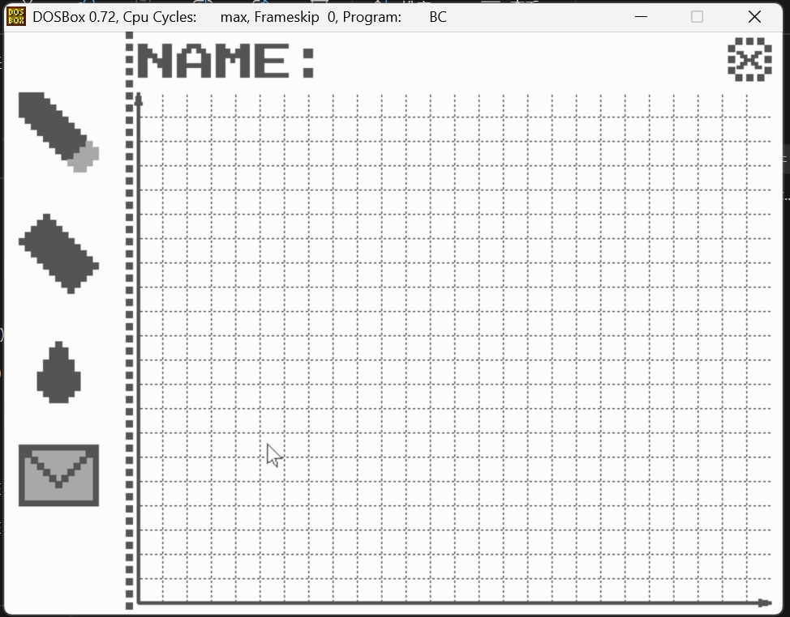

**选择文件：**

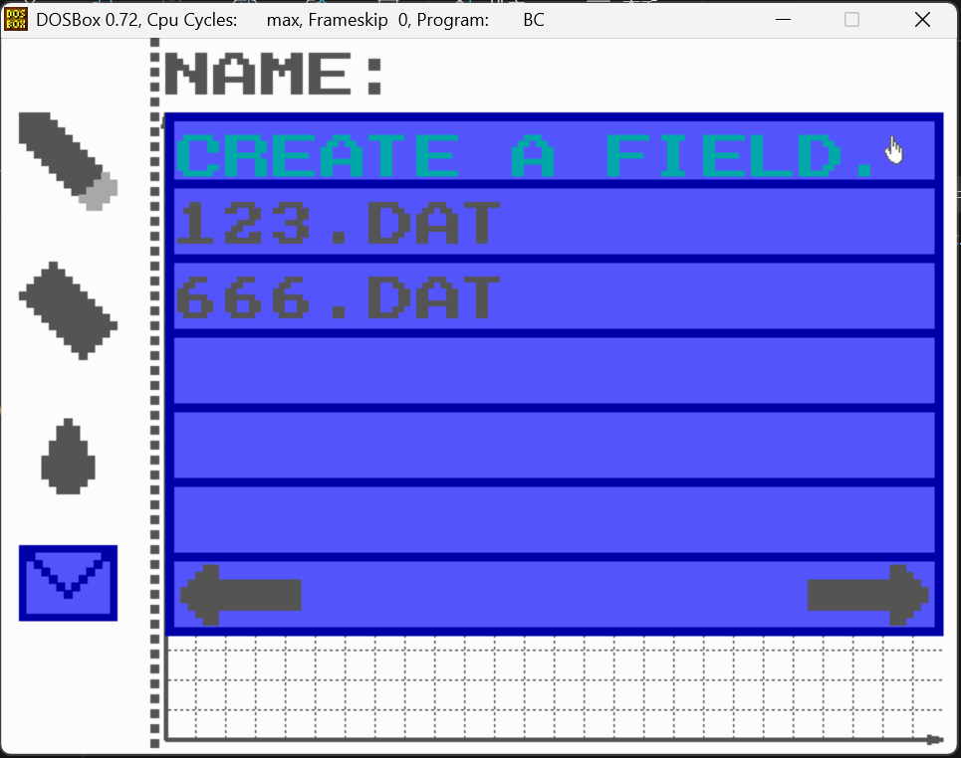

**画农田：**

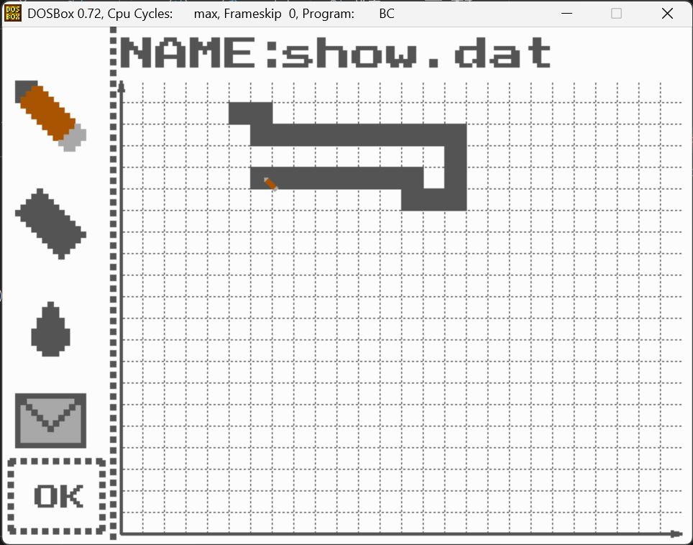

**画水源：**

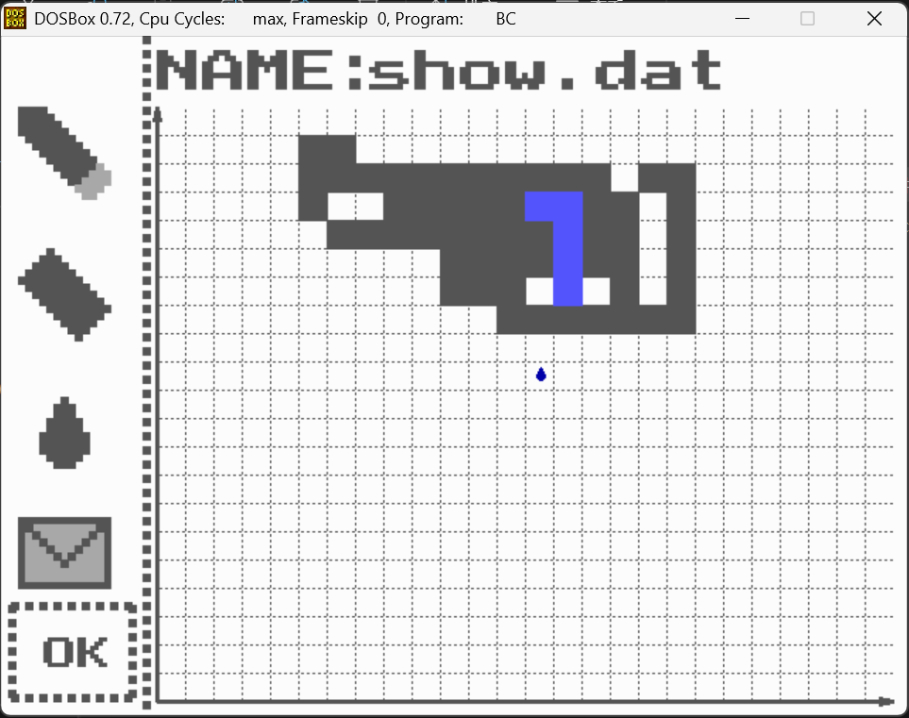

**擦除：**

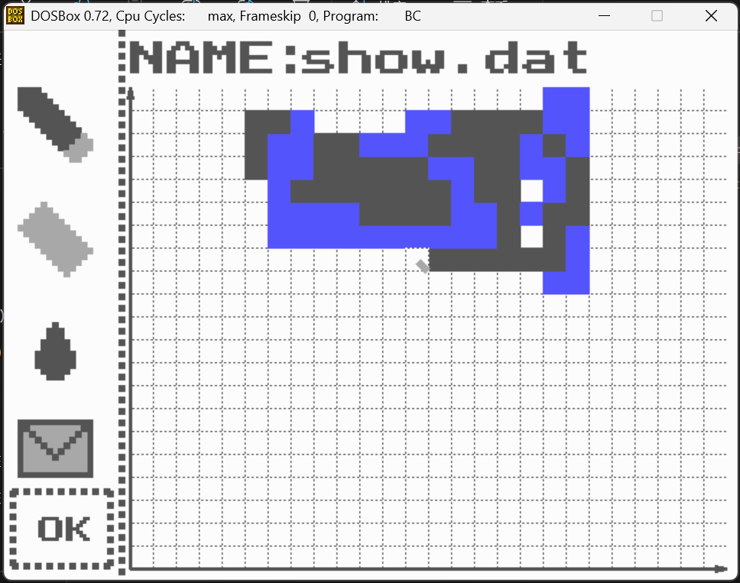

**种植物/铲除植物：**

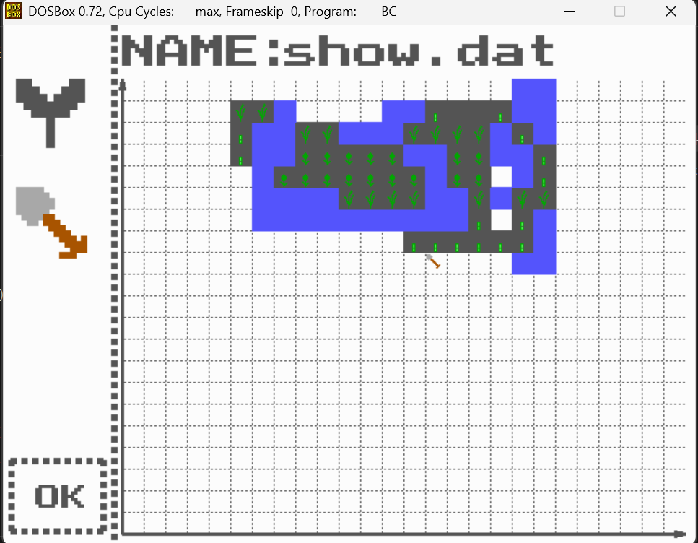

**设置无人机起飞点位置：**

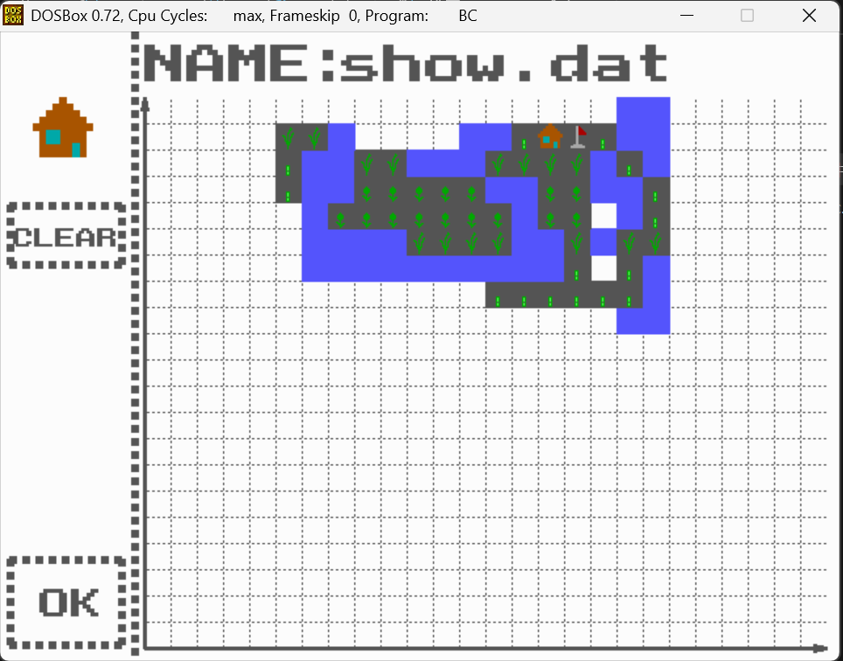

**无人机界面：**

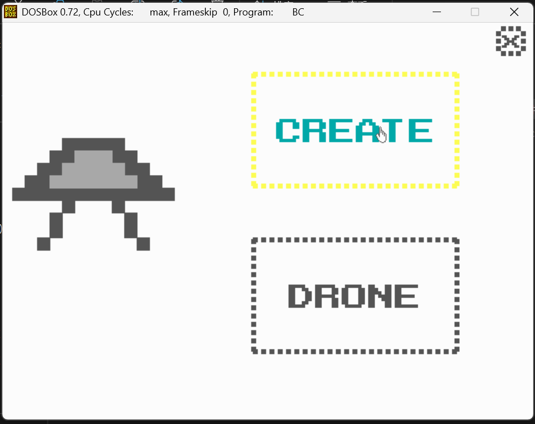

**录入无人机：**

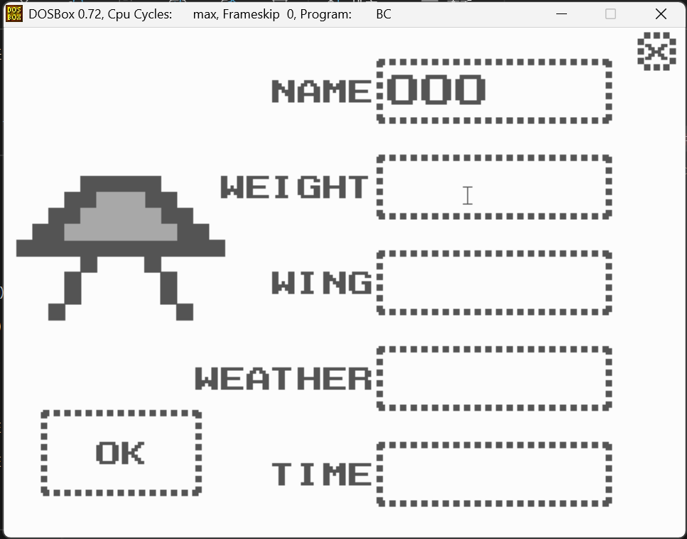

**查看已有无人机信息：**

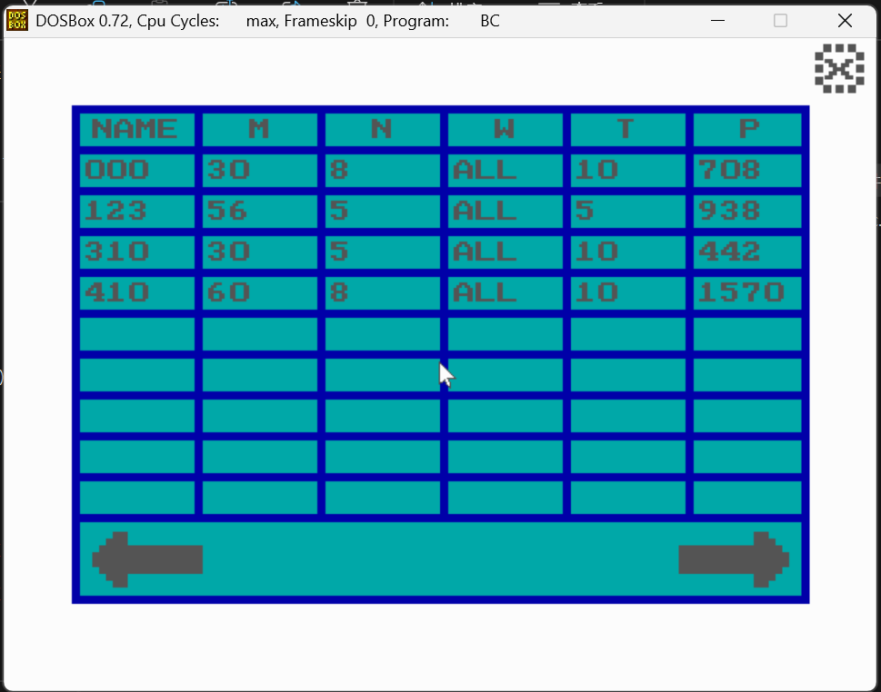

**管理已有农药：**

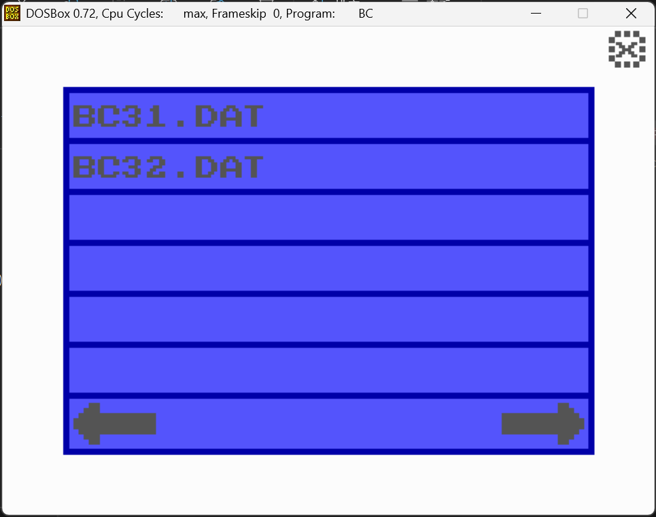

**配置新农药：**

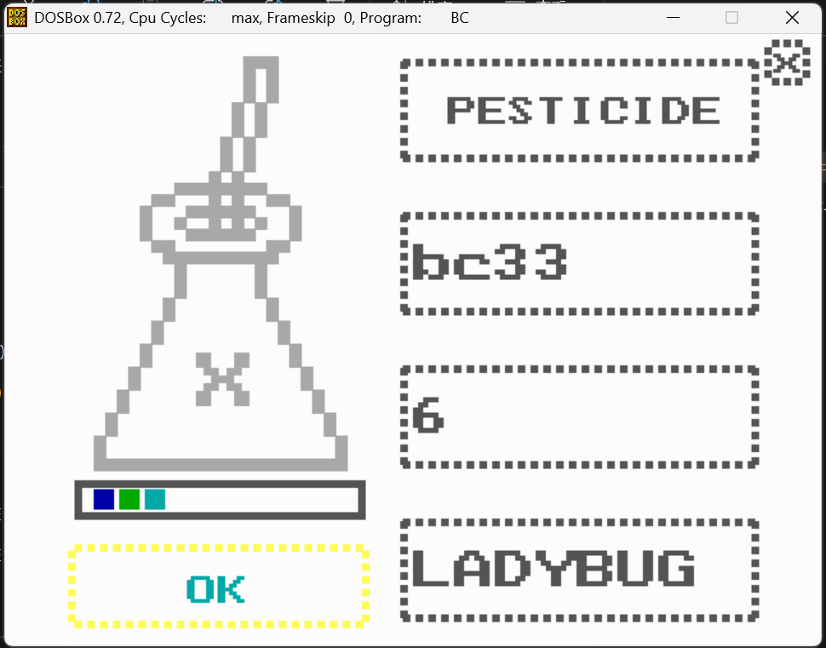

**监测：**

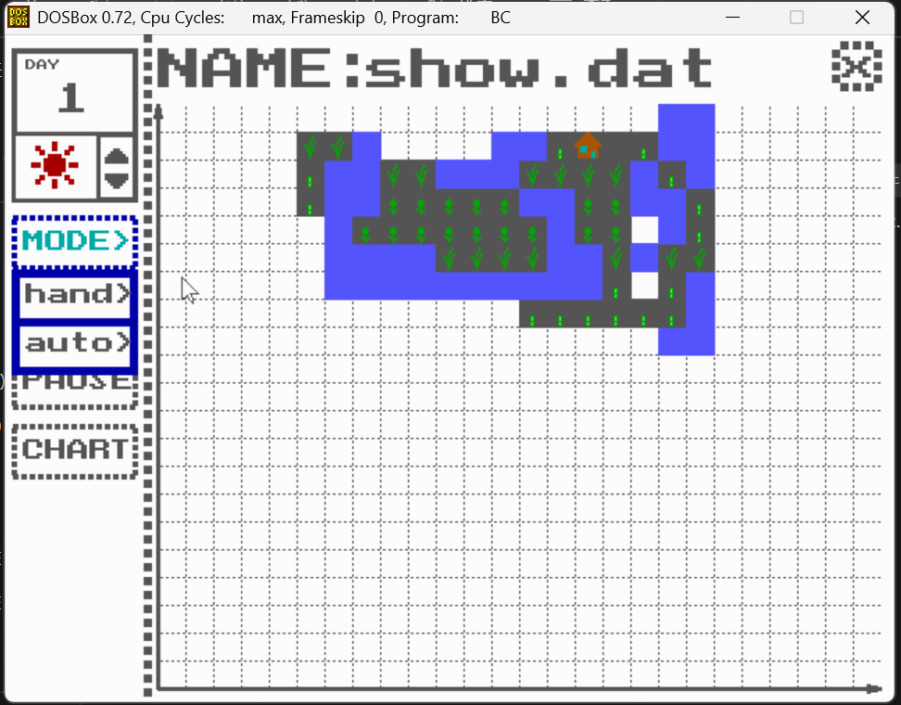

**手动规划线路：**

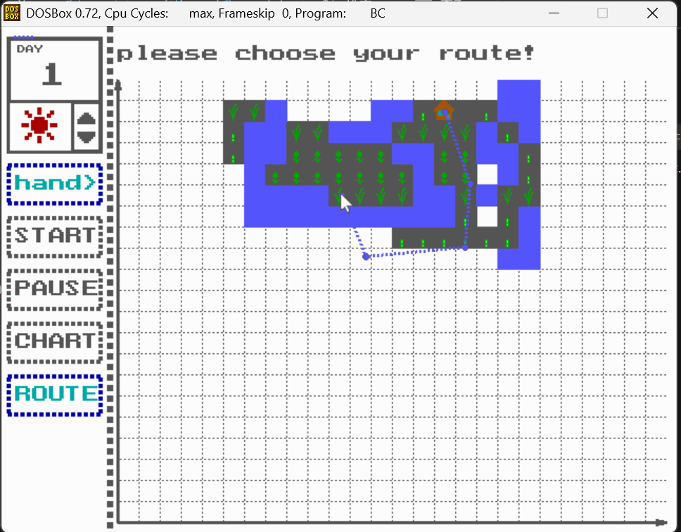

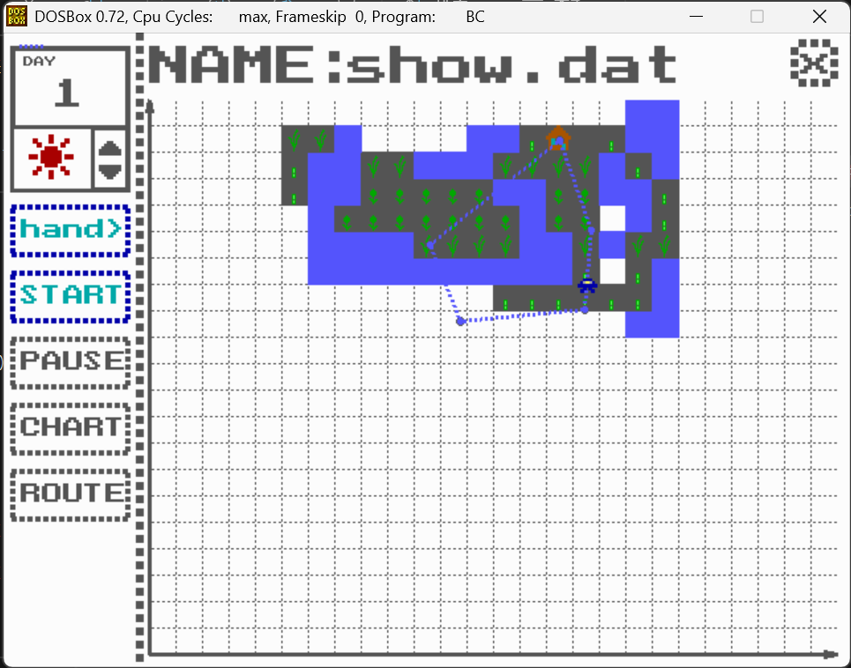

**自动模式：**

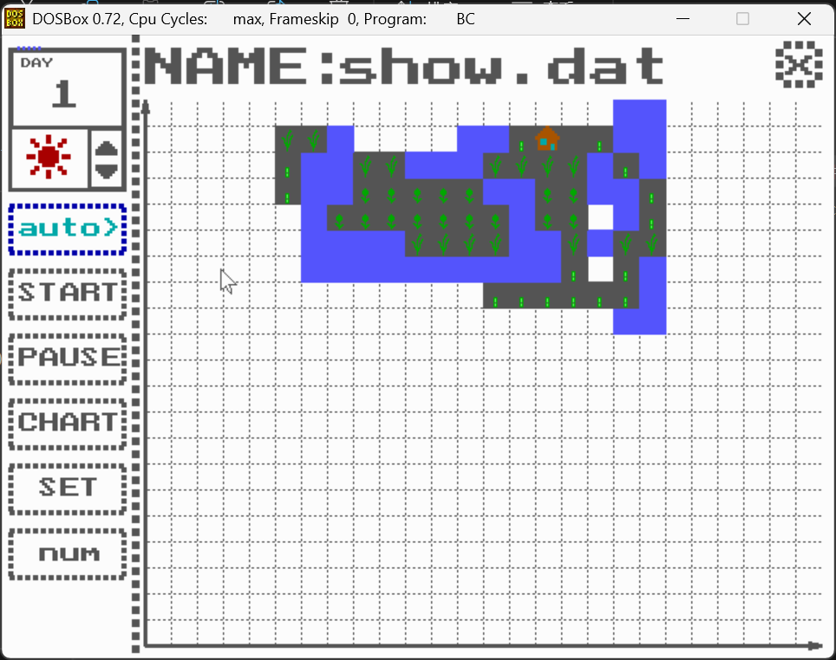

**配置无人机：**

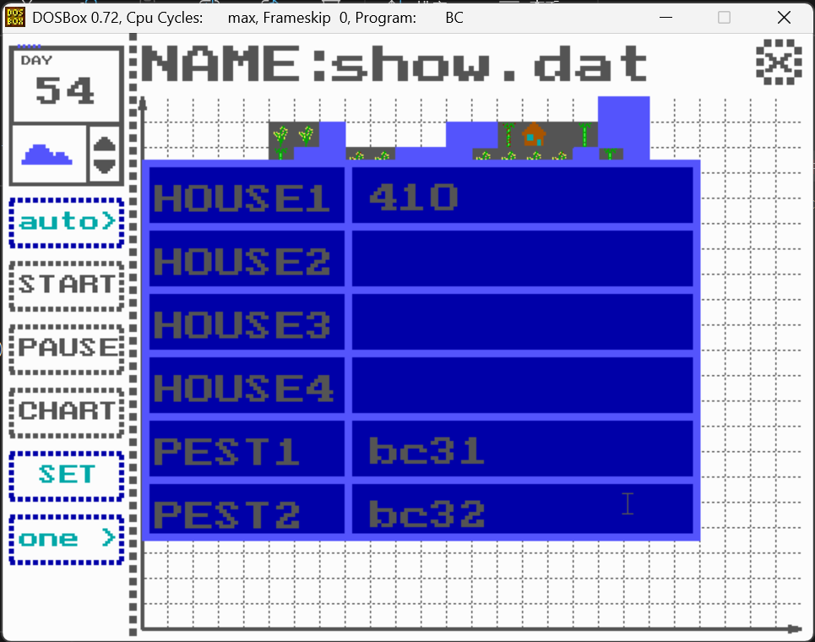

**开始自主飞行：**

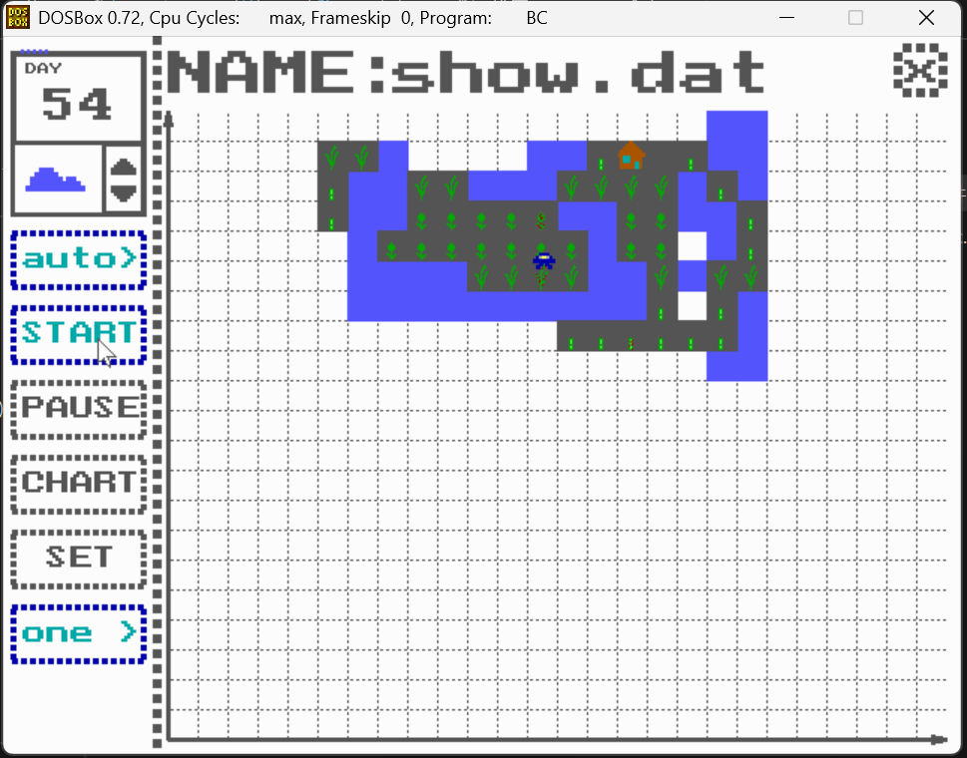

**时间调节：**

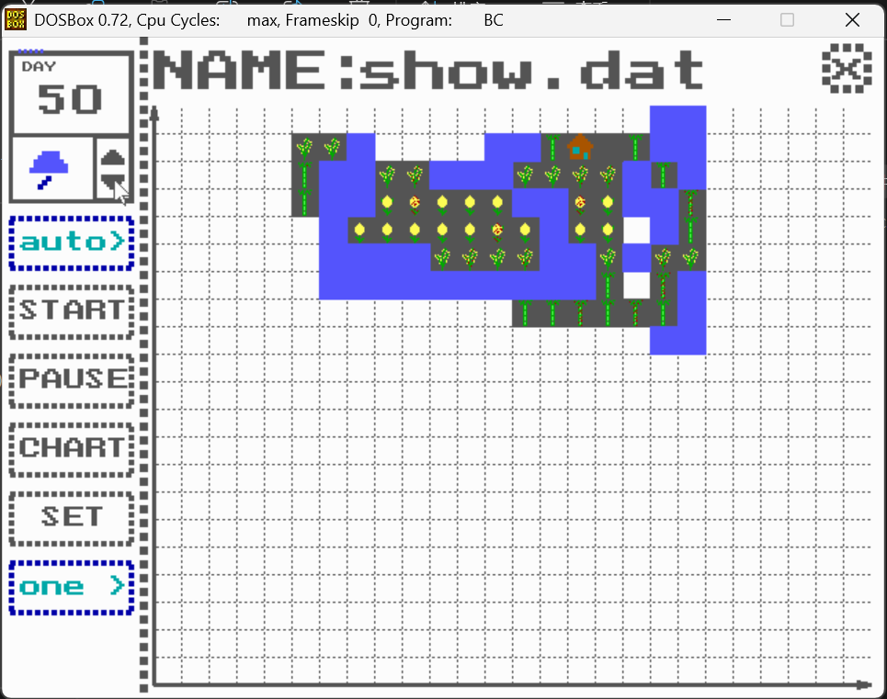

**数据分析：**

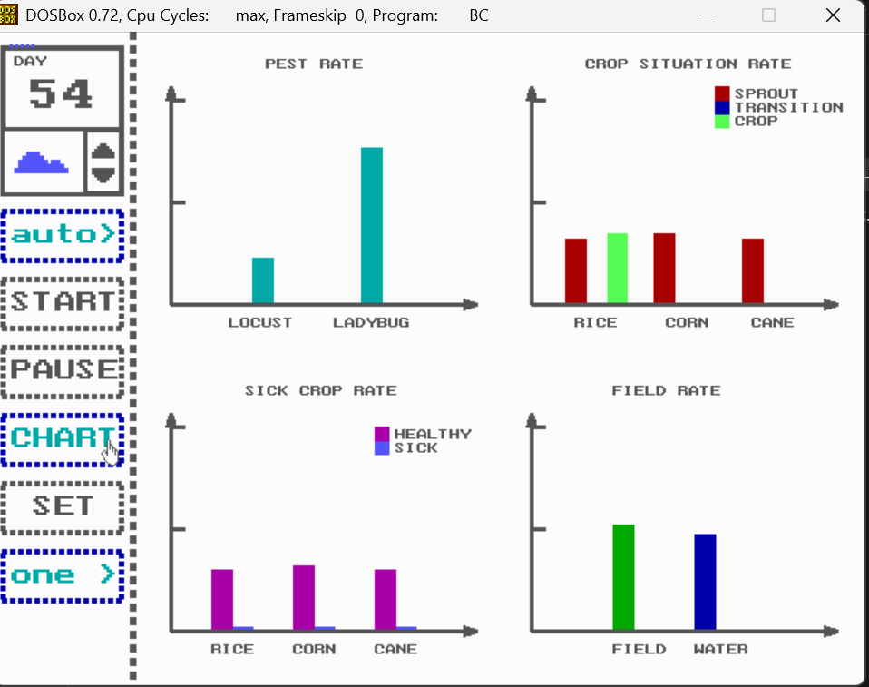

**日志：**

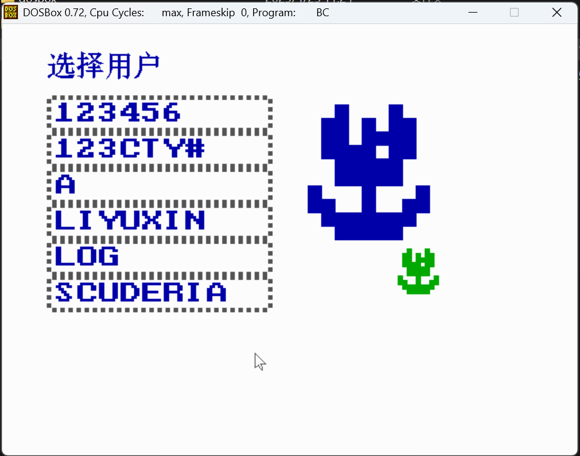

**选择类别：**

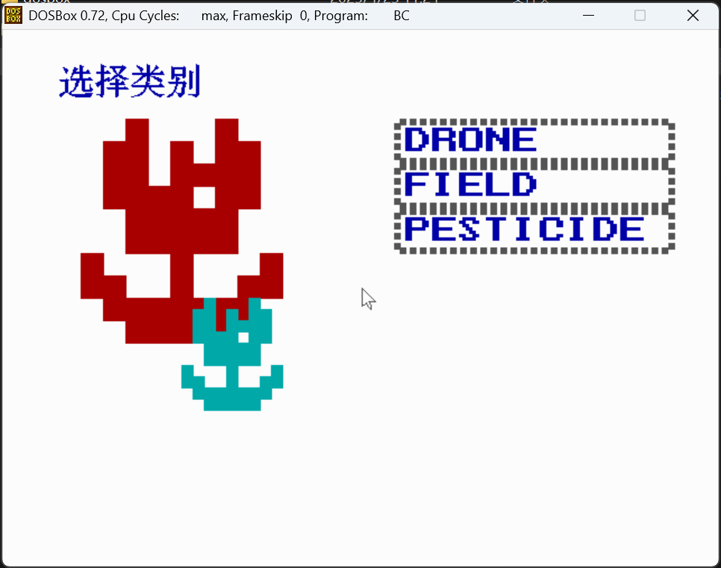

**选择文件：**

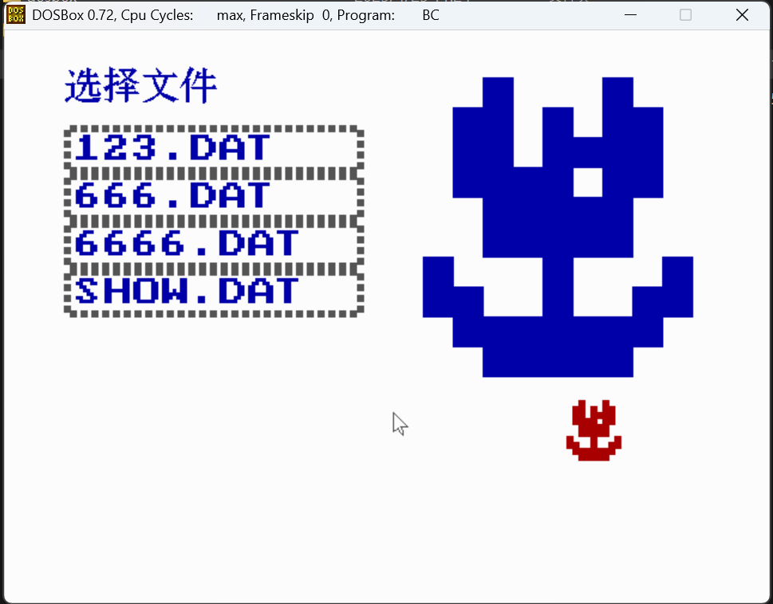

**展示田地文件内容：**

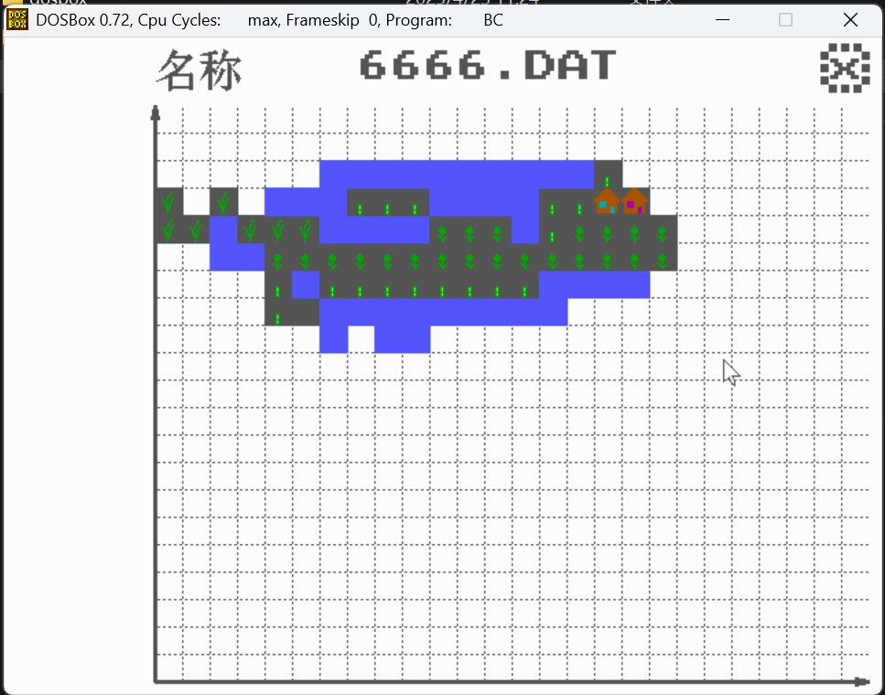

**展示无人机信息：**

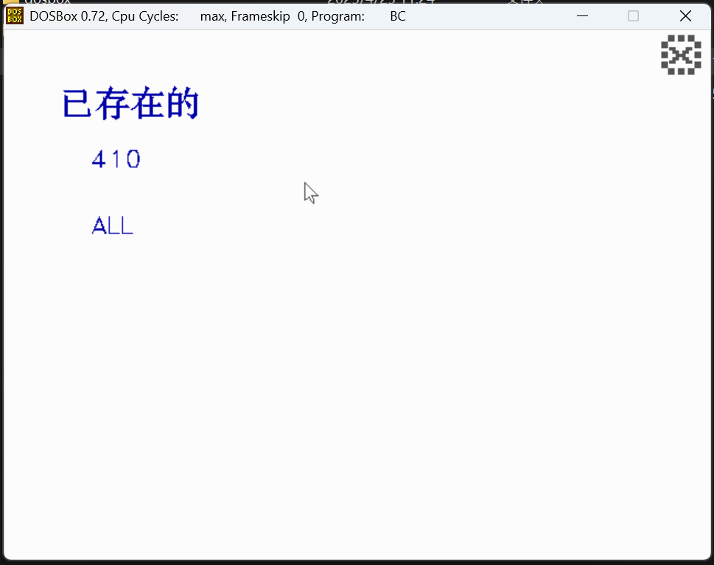

**六.源码及有关文件(按首字母排序)：**

**1.include<.h>**

**/****************************************************************************************/**

**/*****detect.h****/**

**#ifndef _DETECT_H_**

**#define _DETECT_H_**

**#include "detectf.h"**

**#include "public.h"**

**void put_calender(void);**

**void put_calender_number(char *date);**

**void put_calender_weather(char weather[10]);**

**void automode_button(int flag);**

**void set_button(int flag);**

**void pause_button(int flag);**

**void mode_button(int flag);**

**void chart_button(int flag);**

**void route_button(int flag);**

**void start_button(int flag);**

**void detect_screen(int record[21][26] , char *nowfield ,int language);**

**int detect_page(char *username,char *nowfield,int language);**

**void auto_simulate(int record[21][26], char *date_char ,char *username , char *nowfield , int automode ,struct droneinfo dronerecord[5],struct pesticideinfo pestrecord[3]);**

**void show_chart(int record[21][26],char* now_field);**

**#endif**

**/******detectf.h******/**

**#ifndef _DETECTFUNC_H_**

**#define _DETECTFUNC_H_**

**#include "public.h"**

**#include "detect.h"**

**void change_weather(char *weather);**

**void recover_field(int record[21][26],char *username , char *nowfield );**

**void grow(int record[21][26] , int date );**

**void grow_oneday(int record[21][26] ,int date);**

**void find_house(int record[21][26] , int houserecord[5][2] );**

**int find_house_number(int record[21][26] );**

**void find_house_xy(int record[21][26] , Point houserecord[5]);**

**Point find_closest_house(int record[21][26]);**

**void setinfo(char *username,struct droneinfo dronerecord[5],struct pesticideinfo pestrecord[3],int setting[2]);**

**#endif**

**/*********draw.h*********/**

**#ifndef _DRAW_H_**

**#define _DRAW_H_**

**void put_pencil(int x,int y,int COLOR1,int COLOR2,int COLOR3,int pix);**

**void put_rubber(int x,int y,int COLOR,int pix);**

**void put_sprout(int x,int y,int COLOR,int pix);**

**void put_field(int x,int y,int LIGHTCOLOR,int DARKCOLOR,int pix);**

**void put_house(int x,int y,int DARKCOLOR,int LIGHTCOLOR,int pix);**

**void put_file(int x,int y,int DARKCOLOR,int LIGHTCOLOR,int pix);**

**void put_arrow(int x,int y,int COLOR,int pix,int flag);**

**void put_shovel(int x,int y,int pix,int COLOR1,int COLOR2);**

**void put_drone2(int x,int y,int DARKCOLOR,int LIGHTCOLOR,int pix);**

**void put_crop1(int x,int y,int type,int situation);**

**void put_crop2(int x,int y,int type,int situation);**

**void put_crop3(int x,int y,int type,int situation);**

**void put_drone1(float x,float y,int pix);**

**void put_tree1(int x,int y,int pix);**

**void put_Erlenmeyer_flask(int x,int y,int style,int pix);**

**void put_water(int x,int y,int COLOR,int pix);**

**void put_cloud(int x,int y,int pix);**

**void put_sun(int x,int y,int pix,int COLOR);**

**void put_rain(int x,int y,int pix);**

**void put_snow(int x,int y,int pix);**

**void put_up_arrow(int x,int y,int pix);**

**void put_down_arrow(int x,int y,int pix);**

**#endif**

**/**********drone.h************/**

**#ifndef _DRONE_H_**

**#define _DRONE_H_**

**void drone_screen(int language);**

**int drone_page(char *username,char *drone_name_now,DRONEINFO *drone,int language);**

**void open_file2(int language);**

**#endif**

**/*************dronf.h************/**

**#ifndef _DRONEFUNC_H_**

**#define _DRONEFUNC_H_**

**void dronefunc_screen(int language);**

**int drone_list_page(char *username,DRONEINFO *nowdrone,int language);**

**#endif**

**/*********fief.h*********/**

**#ifndef _FIELDFUNC_H_**

**#define _FIELDFUNC_H_**

**void draw_field_screen(int record[21][26] ,char *now_field,int language);**

**int draw_field_page(char *name,char *now_field,int language);**

**void put_ok_button(int flag);**

**void open_file(int language);**

**#endif**

**/***********field.h*********/**

**#ifndef _FIELD_H_**

**#define _FIELD_H_**

**#include "fief.h"**

**#include "public.h"**

**void field_screen( int record[21][26] ,char *now_field,int language);**

**int field_page(INFO* temp,char* now_field,int language);**

**#endif**

**/**************flyfunc.h*************/**

**#ifndef _FLYFUNC_H_**

**#define _FLYFUNC_H_**

**void save_bk_drone(int nx, int ny);**

**void clear_drone(int nx, int ny) ;**

**void draw_drone(int nx, int ny);**

**int x_record_to_screen(int x);**

**int y_record_to_screen(int y);**

**void new_field( int record[21][26] ,char *nowfield);**

**void update_field(int record[21][26], int drone_x , int drone_y );**

**void move_drone1(int record[21][26], int x1,int y1,int x2,int y2 );**

**void simulate( int record[21][26] ,char *nowfield);**

**void simulate_handmode(int record[21][26] , int route[100][2] );**

**void fly_detect(int record[21][26] , Point start );**

**void fly_spray(int record[21][26], int n );**

**double dis_a_to_b(Point a ,Point b );**

**double relative_position(Point A ,Point B ,Point C);**

**double projection(Point A, Point B, Point C) ;**

**void fly_one_round(int record[21][26] , Point A);**

**#endif**

**/*************home.h************/**

**#ifndef _HOME_H_**

**#define _HOME_H_**

**#define MAX_ITEMS 20**

**#define BTN_WIDTH 250**

**#define BTN_HEIGHT 40**

**#define MAX_FILES 20 // 定义文件数量上限**

**// 状态枚举**

**enum { SELECT_USER, SELECT_CATEGORY, SELECT_FILE, SHOW_CONTENT };**

**int home_page(INFO *temp, int language);**

**void home_button_recovery(int num, int language);**

**void home_button_light(int flag, int language);**

**void home_screen(int language);**

**#endif**

**/************house.h**************/**

**#ifndef _HOUSE_H_**

**#define _HOUSE_H_**

**void house_screen(int record[21][26] ,char *nowfield,int language);**

**void clear_button(int flag);**

**int house_page(char *username,char *nowfield,int language);**

**void paint_field( int record[21][26] ,char *nowfield,int language);**

**void put_ok_button(int flag);**

**#endif**

**/***************hz.h(借用)****************/**

**#ifndef _HZ_H_**

**#define _HZ_H_**

**void puthz(int x, int y, char *s, int flag, int part, int color);**

**#endif**

**/**************langua.h****************/**

**#ifndef _LANGUAGE_H_**

**#define _LANGUAGE_H_**

**int language_page(int *language);**

**#endif**

**/***************logfuc.h****************/**

**#ifndef _LOGFUNC_H_**

**#define _LOGFUNC_H_**

**int check(INFO *user,int language);**

**void temp_input(char *temp,int x,int y,int maxi,int w,int h,int COLOR1,int size);**

**int userinfo_input(INFO *user,int *state1,int *state2,int language);**

**void password_warning(char *s);**

**void title_warning(char *s,int PAGE,int language);**

**int password_check(const char *password);**

**int user_exist_check(const char *username);**

**void creat_user_directory(INFO *user);**

**void creat_userinfo_file(INFO *user);**

**#endif**

**/*************login.h*************/**

**#ifndef _LOGIN_H_**

**#define _LOGIN_H_**

**#include "public.h"**

**void login_bkpaint(int language);//鐢荤櫥褰曢〉闈㈣儗鏅?**

**void signup_button_recover(int language);**

**void signup_button_light(int language);**

**void put_flower(int x,int y,int pix,int COLOR);**

**void ok_button_light(void);**

**void ok_button_recover(void);**

**int login_page(INFO *temp,int language);**

**#endif**

**/***********logs.h**********/**

**#ifndef _LOGS_H_**

**#define _LOGS_H_**

**#define MAX_ITEMS 20**

**#define BTN_WIDTH 250**

**#define BTN_HEIGHT 40**

**#define MAX_FILES 20 // 定义文件数量上限**

**// 界面绘制与处理函数**

**int logs_page(int language);**

**int draw_user_list(const char users[][13], int count, int language, int drawuserlist);**

**int draw_category_list(int language, int drawcategorylist, int homeflag);**

**int draw_file_list(const char files[][13], int count, int language, int drawfilelist);**

**void show_file_content(const char* path, int language, int scuderia);**

**void trans(int num, char* str);**

**int go_to_home(int* state);**

**void draw_home_button(int state);**

**void put_flower(int x, int y, int pix, int COLOR);**

**void paint_field_in_log(int record[21][26], char* nowfield, int language, int paintfieldinlog, char* users);**

**/* 用户数据结构 */**

**struct UserData**

**{**

**char logsname[9];**

**char drone_files[MAX_FILES][13];**

**char field_files[MAX_FILES][13];**

**char pesticide_files[MAX_FILES][13];**

**int drone_count;**

**int field_count;**

**int pesticide_count;**

**};**

**#endif**

**/**************main.h***************/**

**#ifndef _MAIN_H**

**#define _MAIN_H**

**#include "detectf.h"**

**#include "login.h"**

**#include "welcome.h"**

**#include "signup.h"**

**#include "home.h"**

**#include "field.h"**

**#include "fief.h"**

**#include "plant.h"**

**#include "drone.h"**

**#include "house.h"**

**#include "dronf.h"**

**#include "flyfunc.h"**

**#include "detect.h"**

**#include "pest.h"**

**#include "langua.h"**

**#include "logs.h"**

**#include "quit.h"**

**#define WELCOME 0**

**#define LOGIN 1**

**#define SIGHUP 2**

**#define HOME 3**

**#define FIELD 4**

**#define DRONE 5**

**#define PESTICIDE 6**

**#define DETECTOR 7**

**#define QUIT 8**

**#define LOGS 9**

**#define DRAW_FIELD 10**

**#define PLANT 11**

**#define HOUSE 12**

**#define DRONE_LIST 13**

**#endif**

**/***************mouse.h(借用)*************/**

**#ifndef _MOUSE_H_**

**#define _MOUSE_H_**

**int mouse_press(int x1, int y1, int x2, int y2);//如果在框中点击，则返回1；在框中未点击，则返回2；不在框中则返回0**

**void mouse(int,int);//设计鼠标**

**void mouseinit(void);//初始化**

**//void mou_pos(int*,int*,int*);//更改鼠标位置**

**void mread(int *,int *,int*);//改坐标不画**

**void save_bk_mou(int x,int y);//存鼠标背景**

**void clrmous(int x,int y);//清除鼠标**

**void drawmous(int x,int y);//画鼠标**

**void newmouse(int *nx,int *ny,int *nbuttons); //更新鼠标**

**extern int MouseX;**

**extern int MouseY;**

**extern int MouseS;**

**extern int press;**

**extern union REGS regs;**

**#endif**

**/************pest.h**************/**

**#ifndef _PESTICIDE_H_**

**#define _PESTICIDE_H_**

**void pesticide_screen(int language);**

**int pesticide_page(char *username,char *now_pesticide,int language);**

**#endif**

**/************plant.h*************/**

**#ifndef _PLANT_H_**

**#define _PLANT_H_**

**void paint_field( int record[21][26] ,char *nowfield,int language);**

**void plant_screen( int record[21][26] ,char *nowfield,int language);**

**int plant_page(char *username,char *nowfield,int language);**

**void put_ok_button(int flag);**

**#endif**

**/*************public.h**************/**

**#ifndef _PUBLIC_H_**

**#define _PUBLIC_H_**

**#define NUM0 0x5230**

**#define NUM1 0x4f31**

**#define NUM2 0x5032**

**#define NUM3 0x5133**

**#define NUM4 0x4134**

**#define NUM5 0x4c35**

**#define NUM6 0x4d36**

**#define NUM7 0x4737**

**#define NUM8 0x4838**

**#define NUM9 0x4939**

**#define F2 0x3c00**

**#define F3 0x3d00**

**#define F4 0x3e00**

**#define F5 0x3f00**

**#define F6 0x4000**

**#define F7 0x4100**

**#define F8 0x4200**

**#define F9 0x4300**

**#define F10 0x4400**

**#define F1 0x3b00**

**#define ENTER 0x1c0d**

**#define BACK 0x0e08**

**#define ESC 0x011b**

**#define UP 0x4800**

**#define DOWN 0x5000**

**#define RIGHT 0x4d00**

**#define LEFT 0x4b00**

**#define ONE 0x0231**

**#define TWO 0x0332**

**#define THREE 0x0433**

**#define FOUR 0x0534**

**#define FIVE 0x0635**

**#define SIX 0x0736**

**#define SEVEN 0x0837**

**#define EIGHT 0x0938**

**#define NINE 0x0a39**

**#define ZERO 0x0b30**

**#define WELCOME 0**

**#define LOGIN 1**

**#define SIGNUP 2**

**#define HOME 3**

**#define FIELD 4**

**#define DRONE 5**

**#define PESTICIDE 6**

**#define DETECTOR 7**

**#define QUIT 8**

**#define README 9**

**#define DRAW_FIELD 10**

**#define PLANT 11**

**#define HOUSE 12**

**#define DRONE_LIST 13**

**#define WEIGHT_MAX 60**

**#define WEIGHT_MIN 30**

**#define WING_MAX 8**

**#define WING_MIN 4**

**#define TIME_MAX 10**

**#define TIME_MIN 5**

**#define PAINT 0**

**#define RECOVER 1**

**#define LIGHT 2**

**#define DELETE 3**

**#define LEFTARROW 1**

**#define RIGHTARROW 2**

**#define SPROUT 1**

**#define TRANSITION 2**

**#define CROP 3**

**#define SICK 1**

**#define HEALTHY 2**

**#define CROP1_STATE1 12**

**#define CROP1_STATE2 24**

**#define CROP2_STATE1 14**

**#define CROP2_STATE2 28**

**#define CROP3_STATE1 10**

**#define CROP3_STATE2 20**

**#define CALENDER_MAX 60**

**#define MAX 0x3f3f3f3f**

**#define BUG 4**

**#define CHINESE 1**

**#define ENGLISH 2**

**#define MAX_ITEMS 20**

**#define BTN_WIDTH 250**

**#define BTN_HEIGHT 40**

**#define MAX_FILES 20**

**#define GOHOME 300**

**void printline(int x,int y,int len,int n,int flag,int COLOR,int wid,int gap);**

**void printbox(int x1,int y1,int x2,int y2,int COLOR,int len,int wid,int gap);**

**void back_button(int flag);**

**void string_limitation(char *string , int len);**

**void warning(char *msg,int nx,int ny,int size);**

**void drop_down_menu(int x,int y,int wide,int h,int n,int size,char **msgs,int lightcolor,int darkcolor,char *record);**

**typedef struct userinfo**

**{**

**char name[18];**

**char password[18];**

**}INFO;**

**typedef struct droneinfo**

**{**

**char name[10];**

**char weight[10];**

**char wing[10];**

**char weather[10];**

**char time[10];**

**char power[10];**

**} DRONEINFO;**

**typedef struct pesticideinfo**

**{**

**char name[10];**

**char period[10];**

**char pest_style[20];**

**} PESTICIDEINFO;**

**typedef struct house**

**{**

**int i ;**

**int j ;**

**int record ;**

**int drone_index ;**

**} House ;**

**typedef struct point**

**{**

**int x;**

**int y;**

**} Point ;**

**#include <stdio.h>**

**#include <stdlib.h>**

**#include <string.h>**

**#include <graphics.h>**

**#include <math.h>**

**#include <bios.h>**

**#include <conio.h>**

**#include <dos.h>**

**#include <time.h>**

**#include <io.h>**

**#include <dir.h>**

**#include "hz.h"**

**#include "mouse.h"**

**#include "draw.h"**

**#include "plant.h"**

**#include "logs.h"**

**#endif**

**/*************quit.h***************/**

**#ifndef _QUIT_H_**

**#define _QUIT_H_**

**void quit_page(void);**

**#endif**

**/**************signup.h**************/**

**#ifndef _SIGNUP_H_**

**#define _SIGNUP_H_**

**void signup_bkpaint(int language);**

**int signup_page(int language);**

**void ok_button_light(void);**

**void ok_button_recover(void);**

**void show_rule_english();**

**void show_rule_chinese();**

**#endif**

**/******************welcome.h********************/**

**#ifndef _WELCOME_H_**

**#define _WELCOME_H_**

**void welcome_screen(int language);**

**void put_title(int language);**

**void drone(void);**

**void drone_wing(int* drone_flag,int x,int y);**

**int welcome_page(int *language);**

**void welcome_buttons_recovery(int num,int language);**

**void welcome_buttons_light(int flag,int language);**

**#endif**

**/*****************************************************************************************/**

**.c(按首字母排序)**

**/*****************************************************************************************/**

**/***************detect.c************/**

**#include "public.h"**

**#include "detect.h"**

**#include "flyfunc.h"**

**#include "detectf.h"**

**void detect_screen(int record[21][26] , char *nowfield ,int language)**

**{**

**setbkcolor(WHITE);**

**cleardevice();**

**clrmous(MouseX,MouseY);**

**paint_field(record ,nowfield,language);**

**put_calender();**

**mode_button(PAINT);**

**start_button(PAINT);**

**pause_button(PAINT);**

**chart_button(PAINT);**

**}**

**void put_calender(void)**

**{**

**setfillstyle(SOLID_FILL,DARKGRAY);**

**bar(5,10,95,13);//(5,10) (95,120)**

**bar(5,10,8,120);**

**bar(5,117,95,120);**

**bar(92,10,95,120);**

**bar(5,70,95,73);//73-117 44 22 73-95 95-117 x:68-92**

**bar(65,70,68,120);**

**setcolor(DARKGRAY);**

**settextstyle(DEFAULT_FONT,HORIZ_DIR,1);**

**outtextxy(15,18,"DAY");**

**put_up_arrow(72,90,2);**

**put_down_arrow(72,100,2);**

**}**

**void put_calender_number(char *date)//(15,20,90,60)**

**{**

**setfillstyle(SOLID_FILL,WHITE);**

**bar(11,25,90,69);**

**setcolor(DARKGRAY);**

**settextstyle(DEFAULT_FONT,HORIZ_DIR,3);**

**if(strlen(date)==3) outtextxy(15,35,date);**

**if(strlen(date)==1) outtextxy(39,35,date);**

**if(strlen(date)==2) outtextxy(27,35,date);**

**}**

**void put_calender_weather(char weather[10])**

**{**

**setfillstyle(SOLID_FILL,WHITE);**

**bar(8,73,65,117);**

**if(strcmp(weather,"CLOUD") == 0 ) {**

**put_cloud(15,100,3);**

**}**

**else if(strcmp(weather,"SUN")==0 ) {**

**put_sun(28,86,3,RED);**

**}**

**else if(strcmp(weather,"RAIN")==0 ) {**

**put_rain(20,95,3);**

**}**

**else if(strcmp(weather,"SNOW")==0 ) {**

**put_snow(20,95,3);**

**}**

**}**

**void mode_button(int flag)**

**{**

**if(flag == PAINT)**

**{**

**clrmous(MouseX,MouseY);**

**printbox(5,130,95,169,DARKGRAY,1,3,3);**

**setcolor(DARKGRAY);**

**settextstyle(DEFAULT_FONT,HORIZ_DIR,2);**

**outtextxy(13,141,"MODE>");**

**}**

**else if(flag == LIGHT)**

**{**

**clrmous(MouseX,MouseY);**

**printbox(5,130,95,169,BLUE,1,3,3);//39**

**setcolor(CYAN);**

**settextstyle(DEFAULT_FONT,HORIZ_DIR,2);**

**outtextxy(13,141,"MODE>");**

**}**

**else if(flag == RECOVER)**

**{**

**mode_button(PAINT);**

**}**

**}**

**void start_button(int flag)**

**{**

**if(flag == PAINT)**

**{**

**clrmous(MouseX,MouseY);**

**printbox(5,180,95,219,DARKGRAY,1,3,3);**

**setcolor(DARKGRAY);**

**settextstyle(DEFAULT_FONT,HORIZ_DIR,2);**

**outtextxy(13,191,"START");**

**}**

**else if(flag == LIGHT)**

**{**

**clrmous(MouseX,MouseY);**

**printbox(5,180,95,219,BLUE,1,3,3);**

**setcolor(CYAN);**

**settextstyle(DEFAULT_FONT,HORIZ_DIR,2);**

**outtextxy(13,191,"START");**

**}**

**else if(flag == RECOVER)**

**{**

**start_button(PAINT);**

**}**

**}**

**void pause_button(int flag)**

**{**

**if(flag == PAINT)**

**{**

**clrmous(MouseX,MouseY);**

**printbox(5,230,95,269,DARKGRAY,1,3,3);**

**setcolor(DARKGRAY);**

**settextstyle(DEFAULT_FONT,HORIZ_DIR,2);**

**outtextxy(13,241,"PAUSE");**

**}**

**else if(flag == LIGHT)**

**{**

**clrmous(MouseX,MouseY);**

**printbox(5,230,95,269,BLUE,1,3,3);**

**setcolor(CYAN);**

**settextstyle(DEFAULT_FONT,HORIZ_DIR,2);**

**outtextxy(13,241,"PAUSE");**

**}**

**else if(flag == RECOVER)**

**{**

**pause_button(PAINT);**

**}**

**}**

**void chart_button(int flag)**

**{**

**if(flag == PAINT)**

**{**

**clrmous(MouseX,MouseY);**

**printbox(5,280,95,319,DARKGRAY,1,3,3);**

**setcolor(DARKGRAY);**

**settextstyle(DEFAULT_FONT,HORIZ_DIR,2);**

**outtextxy(13,291,"CHART");**

**}**

**else if(flag == LIGHT)**

**{**

**clrmous(MouseX,MouseY);**

**printbox(5,280,95,319,BLUE,1,3,3);**

**setcolor(CYAN);**

**settextstyle(DEFAULT_FONT,HORIZ_DIR,2);**

**outtextxy(13,291,"CHART");**

**}**

**else if(flag == RECOVER)**

**{**

**chart_button(PAINT);**

**}**

**}**

**void route_button(int flag)**

**{**

**if(flag == PAINT)**

**{**

**clrmous(MouseX,MouseY);**

**printbox(5,330,95,369,DARKGRAY,1,3,3);**

**setcolor(DARKGRAY);**

**settextstyle(DEFAULT_FONT,HORIZ_DIR,2);**

**outtextxy(13,341,"ROUTE");**

**}**

**else if(flag == LIGHT)**

**{**

**clrmous(MouseX,MouseY);**

**printbox(5,330,95,369,BLUE,1,3,3);**

**setcolor(CYAN);**

**settextstyle(DEFAULT_FONT,HORIZ_DIR,2);**

**outtextxy(13,341,"ROUTE");**

**}**

**else if(flag == DELETE)**

**{**

**setfillstyle(SOLID_FILL,WHITE);**

**bar(5,330,95,369);**

**}**

**else if(flag == RECOVER)**

**{**

**route_button(PAINT);**

**}**

**}**

**void set_button(int flag)**

**{**

**if(flag == PAINT)**

**{**

**clrmous(MouseX,MouseY);**

**printbox(5,330,95,369,DARKGRAY,1,3,3);**

**setcolor(DARKGRAY);**

**settextstyle(DEFAULT_FONT,HORIZ_DIR,2);**

**outtextxy(13,341," SET");**

**}**

**else if(flag == LIGHT)**

**{**

**clrmous(MouseX,MouseY);**

**printbox(5,330,95,369,BLUE,1,3,3);**

**setcolor(CYAN);**

**settextstyle(DEFAULT_FONT,HORIZ_DIR,2);**

**outtextxy(13,341," SET");**

**}**

**else if(flag == DELETE)**

**{**

**setfillstyle(SOLID_FILL,WHITE);**

**bar(5,330,95,369);**

**}**

**else if(flag == RECOVER)**

**{**

**set_button(PAINT);**

**}**

**}**

**void automode_button(int flag)**

**{**

**if(flag == PAINT)**

**{**

**clrmous(MouseX,MouseY);**

**printbox(5,380,95,419,DARKGRAY,1,3,3);**

**setcolor(DARKGRAY);**

**settextstyle(DEFAULT_FONT,HORIZ_DIR,2);**

**outtextxy(13,391," num ");**

**}**

**else if(flag == LIGHT)**

**{**

**clrmous(MouseX,MouseY);**

**printbox(5,380,95,419,BLUE,1,3,3);**

**setcolor(CYAN);**

**settextstyle(DEFAULT_FONT,HORIZ_DIR,2);**

**outtextxy(13,391," num ");**

**}**

**else if(flag == DELETE)**

**{**

**setfillstyle(SOLID_FILL,WHITE);**

**bar(5,380,95,419);**

**}**

**else if(flag == RECOVER)**

**{**

**automode_button(PAINT);**

**}**

**}**

**int detect_page(char *username ,char *nowfield,int language)**

**{**

**int record[21][26];**

**int i,j,k,pre_x=-1,pre_y=-1,x,y,temp_date;**

**int flag = 0,flag2 = 0 , mode = 0, handmode_flag = 0 , automode_flag = 0 , routebutton_flag = 0 , setbutton_flag = 0 , line_flag = 0 , field_flag=0;**

**int random_weather ,automode = 0 ;**

**int num[10],setting[2];**

**char path[100]="C:\\DATA\\";**

**char presentmode[10],presentmode_auto[10];**

**char *tempmsgs[2] = {"hand>","auto>"};**

**char *tempmsgs_auto[2] = {"one >","many>"};**

**FILE *fp;**

**int route[100][2];**

**char date[10] = "1" , compare[10] ;**

**char weather[10] = "CLOUD" ;**

**struct droneinfo drone_record[5];**

**struct pesticideinfo pest_record[3];**

**memset(record , 0 , sizeof(record));**

**memset(route,-1, sizeof(route));**

**memset(compare , 0 , sizeof(compare));**

**memset(presentmode,0,sizeof(presentmode));**

**memset(presentmode_auto,0,sizeof(presentmode_auto));**

**memset(num,0,sizeof(num));**

**memset(drone_record,0,sizeof(drone_record));**

**memset(pest_record,0,sizeof(pest_record));**

**memset(setting,0,sizeof(setting));**

**strcat(path,username);**

**strcat(path,"\\FIELD\\");**

**strcat(path,nowfield);**

**if ( (fp = fopen(path,"rb")) != NULL )**

**{**

**for(i=0; i<21 ;i++ )**

**{**

**fread( record[i],sizeof(int), 26 ,fp);**

**}**

**}**

**else**

**{**

**// perror("error in opening fieldfile!");**

**}**

**fclose(fp);**

**detect_screen(record , nowfield,language);**

**mouseinit();**

**if( strlen(date) != 0 ) {**

**put_calender_number(date);**

**change_weather(weather);**

**put_calender_weather(weather);**

**}**

**while(1)**

**{**

**newmouse(&MouseX,&MouseY,&press);**

**if( mouse_press(5,130,95,169)==2 )//mode未点击5,130,95,169**

**{**

**if( flag != 1 && num[1]!=10)**

**{**

**MouseS = 1 ;**

**flag = 1 ;**

**num[1] = 1;**

**clrmous(MouseX,MouseY);**

**mode_button(LIGHT);**

**}**

**}**

**else if( mouse_press(5,130,95,169)==1 )//mode点击**

**{**

**MouseS = 0;**

**clrmous(MouseX,MouseY);**

**drop_down_menu(5,169,90,35,2,2, tempmsgs ,WHITE,BLUE,presentmode);**

**if(strlen(presentmode) != 0)**

**{**

**setfillstyle(SOLID_FILL,WHITE);**

**bar(5,130,95,169);**

**printbox(5,130,95,169,BLUE,1,3,3);**

**setcolor(CYAN);**

**settextstyle(DEFAULT_FONT,HORIZ_DIR,2);**

**outtextxy(13,141,presentmode);**

**num[1]=10;**

**}**

**if(presentmode[0]=='a') {**

**if(line_flag != 0 )**

**{**

**paint_field_right(record , nowfield , language);**

**line_flag = 0 ;**

**}**

**}**

**start_button(PAINT);**

**pause_button(PAINT);**

**chart_button(PAINT);**

**if(presentmode[0]=='a' && setbutton_flag == 0 ) {**

**set_button(PAINT);**

**automode_button(PAINT);**

**}**

**else if(presentmode[0]=='h' && routebutton_flag == 0 ) route_button(PAINT);**

**delay(50);//防止下拉菜单选择后连点**

**}**

**else if( mouse_press(5,180,95,219)==2 )//start未点击**

**{**

**if( flag != 3 )**

**{**

**MouseS = 1 ;**

**flag = 3 ;**

**num[3] = 1;**

**clrmous(MouseX,MouseY);**

**start_button(LIGHT);**

**}**

**}**

**else if( mouse_press(5,180,95,219)==1 )//start点击5,180,95,219**

**{**

**MouseS = 0;**

**clrmous(MouseX,MouseY);**

**if( handmode_flag == 1 && presentmode[0] == 'h')**

**{**

**simulate_handmode(record,route);**

**}**

**if(presentmode[0] == 'a')**

**{**

**if((setting[0]==0 || setting[1]==0 ) && automode == 0 ) {**

**warning("please choose set & mode!",240,255,1);**

**continue ;**

**}**

**else if(setting[0]==0 || setting[1]==0 ) {**

**warning("please choose set!",240,255,1);**

**continue ;**

**}**

**else if( automode == 0) {**

**warning("please choose mode!",240,255,1);**

**continue ;**

**}**

**auto_simulate( record , date ,username , nowfield ,automode,drone_record,pest_record);**

**}**

**}**

**else if( mouse_press(5,230,95,269)==2 )//pause未点击**

**{**

**if( flag != 4 )**

**{**

**MouseS = 1 ;**

**flag = 4 ;**

**num[4] = 1;**

**clrmous(MouseX,MouseY);**

**pause_button(LIGHT);**

**}**

**}**

**else if( mouse_press(5,230,95,269)==1 )//pause点击**

**{**

**MouseS = 0;**

**clrmous(MouseX,MouseY);**

**}**

**else if( mouse_press(5,280,95,319)==2 )//chart未点击**

**{**

**if( flag != 5 )**

**{**

**MouseS = 1 ;**

**flag = 5 ;**

**num[5] = 1;**

**clrmous(MouseX,MouseY);**

**chart_button(LIGHT);**

**}**

**}**

**else if( mouse_press(5,280,95,319)==1 )//chart点击**

**{**

**MouseS = 0;**

**clrmous(MouseX,MouseY);**

**delay(200);**

**show_chart(record,nowfield);**

**delay(100);**

**paint_field_right(record,nowfield,language);**

**}**

**else if( mouse_press(595,5,630,40)==2 )//退出键未点击**

**{**

**if( flag!=2 )**

**{**

**MouseS = 1 ;**

**flag = 2 ;**

**num[2] = 1;**

**clrmous(MouseX,MouseY);**

**back_button(LIGHT);**

**}**

**}**

**else if( mouse_press(595,5,630,40)==1 )//退出点击**

**{**

**MouseS = 0 ;**

**clrmous(MouseX,MouseY);**

**delay(100);**

**return HOME;**

**}**

**else if( mouse_press(15,20,90,60)==1 ) //日历数字点击**

**{**

**strcpy(compare , date );**

**setfillstyle(SOLID_FILL,WHITE);**

**bar(11,25,90,69);**

**temp_input(date , 18,35, 3 , 22 ,20,WHITE,3);//4 33 25**

**put_calender_number(date);**

**if(strcmp(compare , date )!= 0 ) {**

**change_weather(weather);**

**put_calender_weather(weather);**

**recover_field(record,username,nowfield);**

**grow(record , atoi(date));//每次日期改变时,都刷新右侧地图**

**field_flag = 1 ;**

**}**

**}**

**else if( mouse_press(68,73,92,95)==1 )// 上箭头**

**{**

**strcpy(compare , date );**

**setfillstyle(SOLID_FILL,WHITE);**

**bar(11,25,90,69);**

**temp_date = atoi(date);**

**if(temp_date >= CALENDER_MAX ) continue ;**

**temp_date++ ;**

**itoa(temp_date , date , 10 );**

**put_calender_number(date);**

**change_weather(weather);**

**put_calender_weather(weather);**

**if(temp_date == 2 )**

**{**

**if(strcmp(compare , date )!= 0 ) {**

**grow(record , atoi(date));//每次日期改变时,都刷新右侧地图**

**field_flag = 1 ;**

**}**

**}**

**else {**

**if(strcmp(compare , date )!= 0 ) {**

**grow_oneday(record , temp_date);**

**field_flag = 1 ;**

**}**

**}**

**delay(200);**

**}**

**else if( mouse_press(68,95,92,117)==1 )// 下箭头**

**{**

**strcpy(compare , date );**

**setfillstyle(SOLID_FILL,WHITE);**

**bar(11,25,90,69);**

**temp_date = atoi(date);**

**if(temp_date==1) continue ;**

**temp_date-- ;**

**itoa(temp_date , date , 10 );**

**put_calender_number(date);**

**change_weather(weather);**

**put_calender_weather(weather);**

**if(strcmp(compare , date )!= 0 ) {**

**grow(record , atoi(date));//每次日期改变时,都刷新右侧地图**

**field_flag = 1 ;**

**}**

**delay(200);**

**}**

**else if( mouse_press(5,330,95,369)==2 && presentmode[0]=='h') //route未点击**

**{**

**if( flag != 6 )**

**{**

**MouseS = 1 ;**

**flag = 6 ;**

**num[6] = 1;**

**clrmous(MouseX,MouseY);**

**route_button(LIGHT);**

**}**

**}**

**else if( mouse_press(5,330,95,369)==1 && presentmode[0]=='h')//route点击**

**{**

**MouseS = 0;**

**clrmous(MouseX,MouseY);**

**if(handmode_flag == 1 ) //存在hand档的地图 清空地图**

**{**

**paint_field_right(record , nowfield,language);**

**memset(route,-1,sizeof(route));**

**handmode_flag = 0 ;**

**}**

**mode = 1 ;**

**delay(200);**

**}**

**else if( mouse_press(5,330,95,369)==2 && presentmode[0]=='a') //set未点击**

**{**

**if( flag != 6 )**

**{**

**MouseS = 1 ;**

**flag = 6 ;**

**num[6] = 1;**

**clrmous(MouseX,MouseY);**

**set_button(LIGHT);**

**}**

**}**

**else if( mouse_press(5,330,95,369)==1 && presentmode[0]=='a')//set点击**

**{**

**MouseS = 0;**

**clrmous(MouseX,MouseY);**

**delay(200);**

**setinfo(username , drone_record ,pest_record , setting);**

**paint_field_right(record,nowfield,language);**

**}**

**else if( mouse_press(5,380,95,419)==2 && presentmode[0]=='a') //automode未点击**

**{**

**if( flag != 7 && num[7]!=10)**

**{**

**MouseS = 1 ;**

**flag = 7 ;**

**num[7] = 1;**

**clrmous(MouseX,MouseY);**

**automode_button(LIGHT);**

**}**

**}**

**else if( mouse_press(5,380,95,419)==1 && presentmode[0]=='a')//automode点击**

**{**

**MouseS = 0;**

**clrmous(MouseX,MouseY);**

**setfillstyle(SOLID_FILL,WHITE);**

**bar(5,380,95,419);**

**setcolor(CYAN);**

**settextstyle(DEFAULT_FONT,HORIZ_DIR,2);**

**if(automode == 0 || automode == 2) {**

**// automode_button(DELETE);**

**strcpy(presentmode_auto,"one >");**

**automode = 1 ;**

**num[7] = 10;**

**}**

**else if(automode == 1 )**

**{**

**// automode_button(DELETE);**

**strcpy(presentmode_auto,"many>");**

**automode = 2 ;**

**num[7] = 10;**

**}**

**outtextxy(13,391,presentmode_auto);**

**printbox(5,380,95,419,BLUE,1,3,3);**

**delay(200);**

**}**

**else**

**{**

**if(flag!=0)**

**{**

**MouseS = 0 ;**

**flag = 0 ;**

**}**

**}**

**if( presentmode[0]!='h' && routebutton_flag == 1)**

**{**

**route_button(DELETE) ;**

**routebutton_flag = 0 ;**

**}**

**if( presentmode[0]=='a' && setbutton_flag == 0)**

**{**

**set_button(PAINT);**

**automode_button(PAINT);**

**setbutton_flag = 1;**

**}**

**if( presentmode[0]!='a' && setbutton_flag == 1)**

**{**

**set_button(DELETE) ;**

**automode_button(DELETE);**

**setbutton_flag = 0 ;**

**}**

**if( presentmode[0]=='h' && routebutton_flag == 0)**

**{**

**route_button(PAINT);**

**routebutton_flag = 1;**

**}**

**if( flag!=1 && num[1]==1)**

**{**

**clrmous(MouseX,MouseY);**

**mode_button(RECOVER);**

**num[1]=0;**

**}**

**else if( flag!=2 && num[2]==1 )**

**{**

**clrmous(MouseX,MouseY);**

**back_button(RECOVER);**

**num[2]=0;**

**}**

**else if( flag!=3 && num[3]==1 )**

**{**

**clrmous(MouseX,MouseY);**

**start_button(RECOVER);**

**num[3]=0;**

**}**

**else if( flag!=4 && num[4]==1 )**

**{**

**clrmous(MouseX,MouseY);**

**pause_button(RECOVER);**

**num[4]=0;**

**}**

**else if( flag!=5 && num[5]==1 )**

**{**

**clrmous(MouseX,MouseY);**

**chart_button(RECOVER);**

**num[5]=0;**

**}**

**else if( flag!=6 && num[6]==1 )**

**{**

**clrmous(MouseX,MouseY);**

**if( presentmode[0] == 'h') {**

**route_button(RECOVER);**

**}**

**else if(presentmode[0] == 'a') {**

**set_button(RECOVER);**

**}**

**num[6] = 0;**

**}**

**else if( flag!=7 && num[7]==1 && presentmode[0] == 'a' )**

**{**

**clrmous(MouseX,MouseY);**

**automode_button(RECOVER);**

**num[7] = 0;**

**}**

**if(mode == 1) //选择hand后选点**

**{**

**clrmous(MouseX,MouseY);**

**setfillstyle(SOLID_FILL,WHITE);**

**bar(110,0,640,50);**

**setcolor(DARKGRAY);**

**settextstyle(DEFAULT_FONT,HORIZ_DIR,2);**

**outtextxy(110,18,"please choose your route!");**

**k=0;**

**while(1)**

**{**

**newmouse(&MouseX,&MouseY,&press);**

**if( mouse_press(110,50,630,470)==1 )//处于画图区域并且点击**

**{**

**if(k==0) {**

**i = (470-MouseY)/20;**

**j = (MouseX - 110)/20;**

**if(record[i][j] < 3 || record[i][j] > 6 ) {**

**setfillstyle(SOLID_FILL,WHITE);**

**bar(110,0,640,50);**

**setcolor(DARKGRAY);**

**settextstyle(DEFAULT_FONT,HORIZ_DIR,2);**

**outtextxy(110,18,"please start from a house!");**

**delay(1500);**

**setfillstyle(SOLID_FILL,WHITE);**

**bar(110,0,640,50);**

**setcolor(DARKGRAY);**

**settextstyle(DEFAULT_FONT,HORIZ_DIR,2);**

**outtextxy(110,18,"please choose your route!");**

**continue ;**

**}**

**}**

**route[k][0] = MouseX;**

**route[k][1] = MouseY;**

**clrmous(MouseX,MouseY);**

**delay(200);**

**setfillstyle(SOLID_FILL,LIGHTBLUE);**

**fillellipse(MouseX, MouseY, 3, 3);**

**if(k!=0) {**

**setlinestyle(DOTTED_LINE, 0, THICK_WIDTH);**

**setcolor(LIGHTBLUE);**

**line(10,10,30,10);**

**settextstyle(DEFAULT_FONT,HORIZ_DIR,2);**

**line(route[k-1][0],route[k-1][1],route[k][0],route[k][1]);**

**}**

**k++;**

**if(line_flag != 1 ) line_flag = 1 ;**

**}**

**if( mouse_press(5,330,95,369)==1 ) //route点击**

**{**

**route[k][0] = route[0][0];**

**route[k][1] = route[0][1];**

**setlinestyle(DOTTED_LINE, 0, THICK_WIDTH);**

**setcolor(LIGHTBLUE);**

**line(route[k-1][0],route[k-1][1],route[k][0],route[k][1]);**

**clrmous(MouseX , MouseY);**

**setfillstyle(SOLID_FILL,WHITE);**

**bar(110,0,640,50);**

**back_button(PAINT);**

**setcolor(DARKGRAY);**

**settextstyle(DEFAULT_FONT,HORIZ_DIR,4);**

**outtextxy(110,10,"NAME:");**

**outtextxy(260,10,nowfield);**

**mode = 0 ;**

**k = 0;**

**break;**

**}**

**}**

**handmode_flag = 1;**

**delay(200);**

**}**

**}**

**}**

**void auto_simulate(int record[21][26], char *date_char ,char *username , char *nowfield , int automode ,struct droneinfo dronerecord[5],struct pesticideinfo pestrecord[3])**

**{**

**int date ,i,j,k, add = 1 , flag = 0 , startlight = 0 , pauselight = 0 ,random_weather;**

**long long int timecount ;**

**int num[10] , record_fly[21][26];**

**char date_temp[10];**

**char weather[10];**

**int housenumber , fly_housenumber , houserecord[5][2];**

**struct droneinfo drone[4];**

**Point houserecord_xy[5];**

**House house[5];**

**char save[30][20];**

**char save2[30][20];**

**static running_time = 0;**

**char path[40] = "c:\\DATA\\LOG\\";**

**char now_path[40];**

**char ceshi[100];**

**int all_date = 0;**

**FILE*fp;**

**memset(save,0,sizeof(save));**

**memset(save2,0,sizeof(save2));**

**memset(houserecord,0,sizeof(houserecord));**

**memset(date_temp,0,sizeof(date_temp));**

**memset(num,0,sizeof(num));**

**memset(house,0,sizeof(house));**

**date = atoi( date_char );//从date天开始**

**if(date != 1) {**

**grow(record , date );**

**}**

**// srand((unsigned)time(NULL));**

**mouseinit();**

**// housenumber = find_house_number( record );**

**// find_house( record , houserecord );**

**// find_house_xy(record , houserecord_xy);**

**k = 0 ;**

**for(i=0;i<21;i++)//y**

**{**

**for(j=0;j<26;j++)//x**

**{**

**if(record[i][j]>=3 && record[i][j] <= 6 )**

**{**

**house[k].record = record[i][j] ;**

**house[k].i = i ;**

**house[k].j = j ;**

**house[k].drone_index = k ;**

**k++ ;**

**}**

**}**

**}**

**// for(i=0;i<k;i++)**

**// {**

**// itoa(house[i].record,ceshi,10);**

**// settextstyle(DEFAULT_FONT,HORIZ_DIR,1);**

**// outtextxy(200,50+i*20,ceshi);**

**// itoa(house[i].i,ceshi,10);**

**// outtextxy(250,50+i*20,ceshi);**

**// itoa(house[i].j,ceshi,10);**

**// outtextxy(300,50+i*20,ceshi);**

**// itoa(house[i].drone_index,ceshi,10);**

**// outtextxy(350,50+i*20,ceshi);**

**// }**

**while(1)**

**{**

**newmouse(&MouseX,&MouseY,&press);**

**if(timecount%600000 == 0)**

**{**

**itoa(date , date_temp , 10);**

**put_calender_number(date_temp);**

**random_weather = rand() % 100 ;**

**memset(weather,0,sizeof(weather));**

**if(random_weather <= 20 ) {**

**strcpy(weather,"SUN");**

**}**

**else if(random_weather >20 && random_weather <= 40 ) {**

**strcpy(weather,"RAIN");**

**}**

**else if(random_weather > 40 && random_weather <=50 ) {**

**strcpy(weather,"SNOW");**

**}**

**else {**

**strcpy(weather,"CLOUD");**

**}**

**put_calender_weather(weather);**

**grow_oneday(record,date);**

**if(date % 3 == 0) //侦测天数**

**{**

**// setcolor(DARKGRAY);**

**// settextstyle(DEFAULT_FONT,HORIZ_DIR,1);**

**// outtextxy(20,440,"DETECTING");**

**// fly_detect( record , find_closest_house(record) );**

**// setfillstyle(SOLID_FILL,WHITE);**

**// bar(20,440,95,480);**

**// setcolor(DARKGRAY);**

**// settextstyle(DEFAULT_FONT,HORIZ_DIR,1);**

**// outtextxy(20,440,"SPRAYING");**

**if(automode == 1 ) {**

**fly_one_round(record,find_closest_house(record));**

**}**

**else if(automode == 2 ) {**

**fly_housenumber = k ;**

**for(i=0;i<k;i++)**

**{**

**if( strlen(dronerecord[house[i].drone_index].name)==0 || strcmp(dronerecord[house[i].drone_index].weather , weather )==0 ) //不能飞或者该房子没有无人机**

**{**

**record[house[i].i][house[i].j] = 1 ;**

**fly_housenumber-- ;**

**}**

**}**

**// itoa(fly_housenumber,ceshi,10);**

**// outtextxy(200,100,ceshi);**

**// fly_spray(record , fly_housenumber);**

**// bar(200,100,225,125);**

**for(i=0;i<k;i++){**

**record[house[i].i][house[i].j] = house[i].record ;**

**}**

**running_time++;**

**strcpy(now_path,path);**

**strcat(now_path,"at");**

**strcat(now_path,".txt");**

**itoa(all_date,ceshi,10);**

**if((fp = fopen(now_path,"a+"))!=NULL);**

**{**

**itoa(fly_housenumber,ceshi,10);**

**fprintf(fp,"today drone:%s\n",ceshi);**

**fprintf(fp,"today weather:%s\n",weather);**

**}**

**fclose(fp);**

**}**

**setfillstyle(SOLID_FILL,WHITE);**

**bar(20,440,95,480);**

**}**

**timecount = 0;**

**date++ ;**

**all_date++;**

**}**

**if(mouse_press(100,100,200,200)==1)**

**{**

**cleardevice();**

**if((fp=fopen(now_path,"r+"))!=NULL)**

**{**

**for(i=0;i<10;i++)**

**{**

**fscanf(fp,"today drone:%s\n",save[i]);**

**scanf(fp,"today weather:%s\n",save2[i]);**

**setcolor(DARKGRAY);**

**settextstyle(DEFAULT_FONT,HORIZ_DIR,1);**

**outtextxy(50,10+i*20,save[i]);**

**outtextxy(100,10+i*20,save2[i]);**

**}**

**}**

**while(1)**

**{**

**}**

**}**

**if( mouse_press(5,180,95,219)==2 )//start未点击**

**{**

**if(startlight == 0)**

**{**

**if( flag != 1 )**

**{**

**MouseS = 1 ;**

**flag = 1 ;**

**num[1] = 1;**

**clrmous(MouseX,MouseY);**

**start_button(LIGHT);**

**}**

**}**

**}**

**else if( mouse_press(5,180,95,219)==1 )//start点击5,180,95,219**

**{**

**MouseS = 0;**

**clrmous(MouseX,MouseY);**

**startlight = 1;**

**if(pauselight == 1)**

**{**

**pauselight = 0 ;**

**pause_button(RECOVER);**

**}**

**delay(50);**

**}**

**else if( mouse_press(5,230,95,269)==2 )//pause未点击**

**{**

**if(pauselight == 0)**

**{**

**if( flag != 2 )**

**{**

**MouseS = 1 ;**

**flag = 2 ;**

**num[2] = 1;**

**clrmous(MouseX,MouseY);**

**pause_button(LIGHT);**

**}**

**}**

**}**

**else if( mouse_press(5,230,95,269)==1 )//pause点击**

**{**

**MouseS = 0;**

**clrmous(MouseX,MouseY);**

**pauselight = 1 ;**

**if(startlight == 1) {**

**startlight = 0 ;**

**start_button(RECOVER);**

**}**

**delay(50);**

**}**

**else if( mouse_press(5,130,95,169)==1 )//mode点击**

**{**

**MouseS = 0;**

**clrmous(MouseX,MouseY);**

**itoa(date,date_char,10);**

**delay(200);**

**return ;**

**}**

**else if( mouse_press(15,20,90,60)==1 ) //日历数字点击**

**{**

**setfillstyle(SOLID_FILL,WHITE);**

**bar(11,25,90,69);**

**temp_input(date_temp , 18,35, 3 , 22 ,20,WHITE,3);//4 33 25**

**put_calender_number(date_temp);**

**if( date+1 == atoi( date_temp ) ) {**

**date = date+1 ;**

**random_weather = rand() % 100 ;**

**memset(weather,0,sizeof(weather));**

**if(random_weather <= 20 ) {**

**strcpy(weather,"SUN");**

**}**

**else if(random_weather >20 && random_weather <= 40 ) {**

**strcpy(weather,"RAIN");**

**}**

**else if(random_weather > 40 && random_weather <=50 ) {**

**strcpy(weather,"SNOW");**

**}**

**else {**

**strcpy(weather,"CLOUD");**

**}**

**put_calender_weather(weather);**

**grow_oneday(record,date);**

**}**

**else {**

**recover_field(record,username,nowfield);**

**date = atoi(date_temp);**

**random_weather = rand() % 100 ;**

**memset(weather,0,sizeof(weather));**

**if(random_weather <= 20 ) {**

**strcpy(weather,"SUN");**

**}**

**else if(random_weather >20 && random_weather <= 40 ) {**

**strcpy(weather,"RAIN");**

**}**

**else if(random_weather > 40 && random_weather <=50 ) {**

**strcpy(weather,"SNOW");**

**}**

**else {**

**strcpy(weather,"CLOUD");**

**}**

**put_calender_weather(weather);**

**grow(record , date );**

**}**

**}**

**else if( mouse_press(595,5,630,40)==2 )//退出键未点击**

**{**

**if( pauselight == 1 )**

**{**

**if(flag!=3)**

**{**

**MouseS = 1 ;**

**flag = 3 ;**

**num[3] = 1;**

**clrmous(MouseX,MouseY);**

**back_button(LIGHT);**

**}**

**}**

**}**

**else if( mouse_press(595,5,630,40)==1 )//退出点击**

**{**

**MouseS = 0 ;**

**clrmous(MouseX,MouseY);**

**itoa(date,date_char,10);**

**delay(200);**

**return ;**

**}**

**else**

**{**

**if(flag!=0)**

**{**

**MouseS = 0;**

**flag = 0;**

**}**

**}**

**if( flag!=1 && num[1]==1 )**

**{**

**num[1]=0;**

**if(startlight!=1) {**

**clrmous(MouseX,MouseY);**

**start_button(RECOVER);**

**}**

**}**

**else if( flag!=2 && num[2]==1 )**

**{**

**num[2]=0;**

**if(pauselight != 1) {**

**clrmous(MouseX,MouseY);**

**pause_button(RECOVER);**

**}**

**}**

**else if( flag!=3 && num[3]==1 )**

**{**

**clrmous(MouseX,MouseY);**

**back_button(RECOVER);**

**num[3]=0;**

**}**

**if(startlight) timecount++ ;**

**if(date > CALENDER_MAX) {**

**itoa(date,date_char,10);**

**return ;**

**}**

**}**

**return ;**

**}**

**void show_chart(int record[21][26],char* now_field)**

**{**

**int i,j;**

**int flag = 0;**

**double height[20];**

**char *strheight[20];**

**double sum[5];**

**double crop1_sprout = 0,crop1_transition = 0,crop1_crop = 0;**

**double crop2_sprout = 0,crop2_transition = 0,crop2_crop = 0;**

**double crop3_sprout = 0,crop3_transition = 0,crop3_crop = 0;**

**double crop1_sick = 0, crop1_healthy = 0;**

**double crop2_sick = 0, crop2_healthy = 0;**

**double crop3_sick = 0, crop3_healthy = 0;**

**double locust = 0,ladybug = 10;**

**double field = 0,water = 0;**

**for(i=0;i<21;i++)**

**{**

**for(j=0;j<26;j++)**

**{**

**if(record[i][j]>=10&&record[i][j]<=19) crop1_sprout++;**

**else if(record[i][j]>=20&&record[i][j]<=29) crop1_transition++;**

**else if(record[i][j]>=30&&record[i][j]<=39) crop1_crop++;**

**else if(record[i][j]>=40&&record[i][j]<=49) crop2_sprout++;**

**else if(record[i][j]>=50&&record[i][j]<=59) crop2_transition++;**

**else if(record[i][j]>=60&&record[i][j]<=69) crop2_crop++;**

**else if(record[i][j]>=70&&record[i][j]<=79) crop3_sprout++;**

**else if(record[i][j]>=80&&record[i][j]<=89) crop3_transition++;**

**else if(record[i][j]>=90&&record[i][j]<=99) crop3_crop++;**

**if((record[i][j]>=10&&record[i][j]<=39)&&record[i][j]%10!=0) crop1_sick++;**

**else if((record[i][j]>=10&&record[i][j]<=39)&&record[i][j]%10==0) crop1_healthy++;**

**else if((record[i][j]>=40&&record[i][j]<=69)&&record[i][j]%10!=0) crop2_sick++;**

**else if((record[i][j]>=40&&record[i][j]<=69)&&record[i][j]%10==0) crop2_healthy++;**

**else if((record[i][j]>=70&&record[i][j]<=99)&&record[i][j]%10!=0) crop3_sick++;**

**else if((record[i][j]>=70&&record[i][j]<=99)&&record[i][j]%10==0) crop3_healthy++;**

**if((record[i][j]>=10&&record[i][j]<=99)&&((record[i][j]%10)>=1&&(record[i][j]%10)<=BUG)) locust++;**

**else if((record[i][j]>=10&&record[i][j]<=99)&&((record[i][j]%10)>BUG&&(record[i][j]%10)<=9)) ladybug++;**

**if(record[i][j]!=2&&record[i][j]!=0) field++;**

**else if(record[i][j]==2) water++;**

**}**

**}**

**memset(height,0,sizeof(height));**

**memset(sum,0,sizeof(sum));**

**memset(strheight,0,sizeof(strheight));**

**sum[0] = (crop1_sprout + crop1_transition + crop1_crop + crop2_sprout + crop2_transition + crop2_crop + crop3_sprout + crop3_transition + crop3_crop);**

**sum[1] = (locust+ladybug);**

**sum[2] = (field+water);**

**if(sum[0]!=0)**

**{**

**height[0] = (crop1_sprout/sum[0])*100;**

**height[1] = (crop1_transition/sum[0])*100;**

**height[2] = (crop1_crop/sum[0])*100;**

**height[3] = (crop2_sprout/sum[0])*100;**

**height[4] = (crop2_transition/sum[0])*100;**

**height[5] = (crop2_crop/sum[0])*100;**

**height[6] = (crop3_sprout/sum[0])*100;**

**height[7] = (crop3_transition/sum[0])*100;**

**height[8] = (crop3_crop/sum[0])*100;**

**height[9] = (crop1_healthy/sum[0]*100);**

**height[10] = (crop1_sick/sum[0]*100);**

**height[11] = (crop2_healthy/sum[0]*100);**

**height[12] = (crop2_sick/sum[0]*100);**

**height[13] = (crop3_healthy/sum[0]*100);**

**height[14] = (crop3_sick/sum[0]*100);**

**}**

**if(sum[1]!=0)**

**{**

**height[15] = (locust/sum[1])*100;**

**height[16] = (ladybug/sum[1])*100;**

**}**

**if(sum[2]!=0)**

**{**

**height[17] = (field/sum[2])*100;**

**height[18] = (water/sum[2])*100;**

**}**

**setfillstyle(SOLID_FILL,WHITE);**

**bar(105,0,640,480);**

**setcolor(DARKGRAY);**

**settextstyle(DEFAULT_FONT,HORIZ_DIR,1);**

**outtextxy(427,210,"RICE");**

**outtextxy(494,210,"CORN");**

**outtextxy(557,210,"CANE");**

**outtextxy(545,42,"SPROUT");**

**outtextxy(545,52,"TRANSITION");**

**outtextxy(545,62,"CROP");**

**outtextxy(173,210,"LOCUST");**

**outtextxy(250,210,"LADYBUG");**

**outtextxy(295,292,"HEALTHY");**

**outtextxy(295,302,"SICK");**

**outtextxy(160,450,"RICE");**

**outtextxy(220,450,"CORN");**

**outtextxy(280,450,"CANE");**

**outtextxy(455,450,"FIELD");**

**outtextxy(515,450,"WATER");**

**setfillstyle(SOLID_FILL,RED);**

**bar(530,40,540,50);**

**bar(420,200-(int)(height[0]*1.5),435,200);**

**bar(485,200-(int)(height[3]*1.5),500,200);**

**bar(550,200-(int)(height[6]*1.5),565,200);**

**setfillstyle(SOLID_FILL,BLUE);**

**bar(530,51,540,60);**

**bar(436,200-(int)(height[1]*1.5),450,200);**

**bar(501,200-(int)(height[4]*1.5),515,200);**

**bar(566,200-(int)(height[7]*1.5),580,200);**

**setfillstyle(SOLID_FILL,LIGHTGREEN);**

**bar(530,61,540,70);**

**bar(451,200-(int)(height[3]*1.5),465,200);**

**bar(516,200-(int)(height[5]*1.5),530,200);**

**bar(581,200-(int)(height[8]*1.5),595,200);**

**setfillstyle(SOLID_FILL,CYAN);**

**bar(190,200-(int)(height[15]*1.5),205,200);**

**bar(270,200-(int)(height[16]*1.5),285,200);**

**setfillstyle(SOLID_FILL,MAGENTA);**

**bar(280,290,290,300);**

**bar(160,440-(int)(height[9]*1.5),175,440);**

**bar(220,440-(int)(height[11]*1.5),235,440);**

**bar(280,440-(int)(height[13]*1.5),295,440);**

**setfillstyle(SOLID_FILL,LIGHTBLUE);**

**bar(280,301,290,310);**

**bar(176,440-(int)(height[10]*1.5),190,440);**

**bar(236,440-(int)(height[12]*1.5),250,440);**

**bar(296,440-(int)(height[14]*1.5),310,440);**

**setfillstyle(SOLID_FILL,GREEN);**

**bar(455,440-(int)(height[17]*1.5),470,440);**

**setfillstyle(SOLID_FILL,BLUE);**

**bar(515,440-(int)(height[18]*1.5),530,440);**

**setcolor(DARKGRAY);**

**setlinestyle(SOLID_LINE,0,THICK_WIDTH);**

**line(130,50,140,50);**

**line(130,125,140,125);**

**line(395,50,405,50);**

**line(395,125,405,125);**

**line(130,290,140,290);**

**line(130,365,140,365);**

**line(395,290,405,290);**

**line(395,365,405,365);**

**line(130,200,355,200);**

**line(130,200,130,40);**

**line(395,200,620,200);**

**line(395,200,395,40);**

**line(130,440,355,440);**

**line(130,440,130,280);**

**line(395,440,620,440);**

**line(395,440,395,280);**

**line(355,200,345,197);**

**line(355,200,345,203);**

**line(133,50,130,40);**

**line(127,50,130,40);**

**line(610,203,620,200);**

**line(610,197,620,200);**

**line(392,50,395,40);**

**line(398,50,395,40);**

**line(345,437,355,440);**

**line(345,443,355,440);**

**line(133,290,130,280);**

**line(127,290,130,280);**

**line(610,443,620,440);**

**line(610,437,620,440);**

**line(398,290,395,280);**

**line(392,290,395,280);**

**settextstyle(DEFAULT_FONT,HORIZ_DIR,1);**

**outtextxy(200,20,"PEST RATE");**

**outtextxy(435,20,"CROP SITUATION RATE");**

**outtextxy(185,260,"SICK CROP RATE");**

**outtextxy(455,260,"FIELD RATE");**

**mouseinit();**

**while(1)**

**{**

**newmouse(&MouseX,&MouseY,&press);**

**if(mouse_press(5,280,95,319)==2)**

**{**

**if(flag!=1)**

**{**

**MouseS = 1;**

**flag = 1;**

**}**

**}**

**else if(mouse_press(5,280,95,319)==1)**

**{**

**return;**

**}**

**else**

**{**

**if(flag!=0)**

**{**

**MouseS = 0;**

**flag = 0;**

**}**

**}**

**}**

**}**

**/***************detectf.c****************/**

**#include "public.h"**

**#include "detectf.h"**

**void change_weather(char *weather)**

**{**

**int random_weather ;**

**// srand((unsigned)time(NULL));**

**random_weather = rand() % 100 ;**

**// time_t t;**

**// time(&t);**

**// weather = (int)t ;**

**if(random_weather <= 20 ) {**

**strcpy(weather,"SUN");**

**}**

**else if(random_weather >20 && random_weather <= 40 ) {**

**strcpy(weather,"RAIN");**

**}**

**else if(random_weather > 40 && random_weather <=50 ) {**

**strcpy(weather,"SNOW");**

**}**

**else {**

**strcpy(weather,"CLOUD");**

**}**

**return ;**

**}**

**void recover_field(int record[21][26],char *username , char *nowfield )**

**{**

**int i,j ;**

**char path[100]="C:\\DATA\\";**

**FILE *fp;**

**strcat(path,username);**

**strcat(path,"\\FIELD\\");**

**strcat(path,nowfield);**

**if ( (fp = fopen(path,"rb")) != NULL )**

**{**

**for(i=0; i<21 ;i++ )**

**{**

**fread( record[i],sizeof(int), 26 ,fp);**

**}**

**}**

**else**

**{**

**// perror("error in opening fieldfile!");**

**}**

**fclose(fp);**

**}**

**void grow(int record[21][26] , int date ) //reord从最初始状态，直接计算date状态时现象**

**{**

**int i,j,k,x,y,random_grow, random_health , state , health ,crop;**

**// srand((unsigned)time(NULL));**

**for(i=0;i<21;i++)//y**

**{**

**for(j=0;j<26;j++)//x**

**{**

**x = 110 + j*20 ;**

**y = 470-i*20-20 ;**

**if ( record[i][j]==1 )**

**{**

**setfillstyle(SOLID_FILL,DARKGRAY);**

**bar(x , y , x+20 , y+20 );**

**}**

**else if( record[i][j]==2)**

**{**

**setfillstyle(SOLID_FILL,LIGHTBLUE);**

**bar(x , y,x+20, y+20);**

**}**

**if((record[i][j]>=10 && record[i][j]<=39)) //crop1 / 12 24**

**{**

**crop = 1 ;**

**state = SPROUT ;**

**health = HEALTHY ;**

**random_grow = rand() % 100 ;//0-99**

**if(date >= CROP1_STATE1 ) {**

**if(random_grow <= 90) {**

**state = TRANSITION ;**

**}**

**}**

**if(date >= CROP1_STATE2 ) {**

**random_grow = rand() % 100 ;**

**if(state == TRANSITION && random_grow <= 90) {**

**state = CROP ;**

**}**

**}**

**random_health = rand() % 100 ;**

**if(random_health <= 20) health = SICK ;**

**else health = HEALTHY ;**

**if(date == 1) health = HEALTHY ;**

**put_crop1(x,y,state , health);**

**}**

**else if(record[i][j]>=40 && record[i][j]<=69) //crop2 / 10 20**

**{**

**crop = 2 ;**

**state = SPROUT ;**

**health = HEALTHY ;**

**random_grow = rand() % 100 ;//0-99**

**if(date >= CROP2_STATE1 ) {**

**if(random_grow <= 90) {**

**state = TRANSITION ;**

**}**

**}**

**if(date >= CROP2_STATE2 ) {**

**random_grow = rand() % 100 ;**

**if(state == TRANSITION && random_grow <= 90) {**

**state = CROP ;**

**}**

**}**

**random_health = rand() % 100 ;**

**if(random_health <= 20) health = SICK ;**

**else health = HEALTHY ;**

**if(date == 1) health = HEALTHY ;**

**put_crop2(x,y,state , health);**

**}**

**else if(record[i][j]>=70 && record[i][j]<=99) //crop3 / 14 28**

**{**

**crop = 3 ;**

**state = SPROUT ;**

**health = HEALTHY ;**

**random_grow = rand() % 100 ;//0-99**

**if(date >= CROP3_STATE1 ) {**

**if(random_grow <= 90) {**

**state = TRANSITION ;**

**}**

**}**

**if(date >= CROP3_STATE2 ) {**

**random_grow = rand() % 100 ;**

**if(state == TRANSITION && random_grow <= 90) {**

**state = CROP ;**

**}**

**}**

**random_health = rand() % 100 ;**

**if(random_health <= 20) health = SICK ;**

**else health = HEALTHY ;**

**if(date == 1) health = HEALTHY ;**

**put_crop3(x,y,state , health);**

**}**

**else if( record[i][j]==3 )**

**{**

**put_house(x,y,BROWN,CYAN,2);**

**}**

**else if( record[i][j]==4 )**

**{**

**put_house(x,y,BROWN,MAGENTA,2);**

**}**

**else if( record[i][j]==5 )**

**{**

**put_house(x,y,BROWN,YELLOW,2);**

**}**

**else if( record[i][j]==6 )**

**{**

**put_house(x,y,BROWN,BLUE,2);**

**}**

**}**

**}**

**}**

**void grow_oneday(int record[21][26] ,int date)**

**{**

**int random_sick ,random_state ,health , state ,one_place , ten_place ,date_one,date_ten,crop = -1;**

**int i , j ,x,y;**

**char temp_out[20];**

**// srand((unsigned)time(NULL));**

**setwritemode(COPY_PUT);**

**if(date == 1 ) return ;**

**for(i=0;i<21;i++)//y**

**{**

**for(j=0;j<26;j++) //x**

**{**

**if(record[i][j] < 10 ) continue ;**

**x = 110 + j*20 ;**

**y = 450 - i*20 ;**

**one_place = record[i][j] % 10 ;**

**ten_place = record[i][j] / 10 ;**

**date_one = date % 10 ;**

**date_ten = date / 10 ;**

**health = HEALTHY ;**

**state = SPROUT ;**

**random_sick = rand() % 100 ;**

**if(record[i][j] >= 10 )**

**{**

**if(one_place == 0 )**

**{**

**if(random_sick <= 5 ) {**

**record[i][j] += 3;**

**health = SICK ;**

**}**

**}**

**else if(one_place != 0 ) {**

**health = SICK ;**

**}**

**}**

**crop = -1 ;**

**if( record[i][j]>=10 && record[i][j]<=39 ){**

**crop = 1 ;**

**if(record[i][j]>=10 && record[i][j]<=19 ) {**

**state = SPROUT ;**

**}**

**else if(record[i][j]>=20 && record[i][j]<=29 ) {**

**state = TRANSITION ;**

**}**

**else if(record[i][j]>=30 && record[i][j]<=39 ) {**

**state = CROP ;**

**}**

**}**

**else if( record[i][j]>=40 && record[i][j]<=69 ){**

**crop = 2 ;**

**if(record[i][j]>=40 && record[i][j]<=49 ) {**

**state = SPROUT ;**

**}**

**else if(record[i][j]>=50 && record[i][j]<=59 ) {**

**state = TRANSITION ;**

**}**

**else if(record[i][j]>=60 && record[i][j]<=69 ) {**

**state = CROP ;**

**}**

**}**

**else if( record[i][j]>=70 && record[i][j]<=99 ){**

**crop = 3 ;**

**if(record[i][j]>=70 && record[i][j]<=79 ) {**

**state = SPROUT ;**

**}**

**else if(record[i][j]>=80 && record[i][j]<=89 ) {**

**state = TRANSITION ;**

**}**

**else if(record[i][j]>=90 && record[i][j]<=99 ) {**

**state = CROP ;**

**}**

**}**

**random_state = rand() % 100 ;**

**if(date >= CROP1_STATE1-3 && date <= CROP1_STATE1+3 && ten_place == 1 ) {**

**crop = 1 ;**

**state = SPROUT ;**

**if(random_state <= 90 && record[i][j] <= 20 ) {**

**state = TRANSITION ;**

**record[i][j]+=10 ;**

**}**

**}**

**else if(date >= CROP1_STATE2-3 && date <= CROP1_STATE2+3 && ten_place==2 ) {**

**crop = 1 ;**

**state = TRANSITION ;**

**if(random_state <= 90 && record[i][j] <= 30 ) {**

**state = CROP ;**

**record[i][j]+=10 ;**

**}**

**}**

**else if(date >= CROP2_STATE1-3 && date <= CROP2_STATE1+3 && ten_place==4 ) {**

**crop = 2 ;**

**state = SPROUT ;**

**if(random_state <= 90 && record[i][j] <= 40 ) {**

**state = TRANSITION ;**

**record[i][j]+=10 ;**

**}**

**}**

**else if(date >= CROP2_STATE2-3 && date <= CROP2_STATE2+3 && ten_place==5 ) {**

**crop = 2 ;**

**state = TRANSITION ;**

**if(random_state <= 90 && record[i][j] <= 60 ) {**

**state = CROP ;**

**record[i][j]+=10 ;**

**}**

**}**

**else if(date >= CROP3_STATE1-3 && date <= CROP3_STATE1+3 && ten_place==7 ) {**

**crop = 3 ;**

**state = SPROUT ;**

**if(random_state <= 90 && record[i][j] <= 80 ) {**

**state = TRANSITION ;**

**record[i][j]+=10 ;**

**}**

**}**

**else if(date >= CROP3_STATE2-3 && date <= CROP3_STATE2+3 && ten_place==8 ) {**

**crop = 3 ;**

**state = TRANSITION ;**

**if(random_state <= 90 && record[i][j] <= 90 ) {**

**state = CROP ;**

**record[i][j]+=10 ;**

**}**

**}**

**// setlinestyle(SOLID_LINE,0,NORM_WIDTH);**

**// setcolor(RED);**

**// line(x,y+20,x+20,y+20);**

**setfillstyle(SOLID_FILL,DARKGRAY);**

**bar(x,y,x+20,y+20);**

**if(crop == 1 )**

**{**

**put_crop1(x,y,state,health);**

**}**

**else if(crop == 2)**

**{**

**put_crop2(x,y,state,health);**

**}**

**else if(crop == 3 )**

**{**

**put_crop3(x,y,state,health);**

**}**

**}**

**}**

**}**

**void find_house(int record[21][26] , int houserecord[5][2])**

**{**

**int i,j,k ;**

**k = 0 ;**

**for(i=0;i<21;i++)//y**

**{**

**for(j=0;j<26;j++)//x**

**{**

**if( record[i][j]==3 )**

**{**

**houserecord[k][0] = i ;**

**houserecord[k][1] = j ;**

**k++ ;**

**}**

**else if( record[i][j]==4 )**

**{**

**houserecord[k][0] = i ;**

**houserecord[k][1] = j ;**

**k++ ;**

**}**

**else if( record[i][j]==5 )**

**{**

**houserecord[k][0] = i ;**

**houserecord[k][1] = j ;**

**k++ ;**

**}**

**else if( record[i][j]==6 )**

**{**

**houserecord[k][0] = i ;**

**houserecord[k][1] = j ;**

**k++ ;**

**}**

**if( k >= 4 ) return ;**

**}**

**}**

**}**

**void find_house_xy(int record[21][26] , Point houserecord[5])**

**{**

**int i,j,k ,x,y;**

**k = 0 ;**

**for(i=0;i<21;i++)//y**

**{**

**for(j=0;j<26;j++)//x**

**{**

**if( record[i][j]==3 )**

**{**

**x = 110 + j*20 ;**

**y = 450 - i*20 ;**

**houserecord[k].x = x ;**

**houserecord[k].y = y ;**

**k++ ;**

**}**

**else if( record[i][j]==4 )**

**{**

**x = 110 + j*20 ;**

**y = 450 - i*20 ;**

**houserecord[k].x = x ;**

**houserecord[k].y = y ;**

**k++ ;**

**}**

**else if( record[i][j]==5 )**

**{**

**x = 110 + j*20 ;**

**y = 450 - i*20 ;**

**houserecord[k].x = x ;**

**houserecord[k].y = y ;**

**k++ ;**

**}**

**else if( record[i][j]==6 )**

**{**

**x = 110 + j*20 ;**

**y = 450 - i*20 ;**

**houserecord[k].x = x ;**

**houserecord[k].y = y ;**

**k++ ;**

**}**

**if( k >= 4 ) return ;**

**}**

**}**

**}**

**int find_house_number(int record[21][26] )**

**{**

**int i,j,k ;**

**k = 0 ;**

**for(i=0;i<21;i++)//y**

**{**

**for(j=0;j<26;j++)//x**

**{**

**if( record[i][j]==3 )**

**{**

**k++ ;**

**}**

**else if( record[i][j]==4 )**

**{**

**k++ ;**

**}**

**else if( record[i][j]==5 )**

**{**

**k++ ;**

**}**

**else if( record[i][j]==6 )**

**{**

**k++ ;**

**}**

**if( k >= 4 ) return k;**

**}**

**}**

**return k ;**

**}**

**Point find_closest_house(int record[21][26])**

**{**

**Point house ;**

**int i,j,crop_i = -1, crop_j = -1;**

**float dis = MAX ,temp_dis;**

**for(i=0;i<21;i++)//y**

**{**

**for(j=0;j<26;j++)//x**

**{**

**if(record[i][j]>=10 && crop_i == -1) //左下角第一个植株**

**{**

**crop_i = i ;**

**crop_j = j ;**

**j=0;**

**}**

**else if( record[i][j]>=3 && record[i][j]<=6 )**

**{**

**temp_dis = sqrt(fabs((i-crop_i)*(i-crop_i)+(j-crop_j)*(j-crop_j))) ;**

**if( temp_dis < dis ) {**

**dis = temp_dis ;**

**house.x = 110 + j*20 ;**

**house.y = 450-i*20 ;**

**}**

**}**

**}**

**}**

**return house ;**

**}**

**void setinfo(char *username,struct droneinfo dronerecord[5],struct pesticideinfo pestrecord[3],int setting[2])**

**{**

**int i;**

**int flag = 0 , avaliable = 1 ;**

**char string[80] = "c:\\DATA";**

**char stringnow[80];**

**FILE* fp;**

**clrmous(MouseX,MouseY);**

**setfillstyle(SOLID_FILL,BLUE);**

**bar(100+10,100,540+10,400);**

**setfillstyle(SOLID_FILL,LIGHTBLUE);**

**bar(100+10,100,540+10,105);**

**bar(100+10,100,105+10,400);//115 120**

**bar(100+10,395,540+10,400);**

**bar(535+10,100,540+10,400);**

**bar(260+10,100,265+10,400);//275 280**

**for(i=0;i<5;i++)**

**{**

**bar(100+10,100+50*(i+1),540+10,105+50*(i+1));**

**}**

**settextstyle(DEFAULT_FONT,HORIZ_DIR,3);**

**outtextxy(110+10,120,"HOUSE1");**

**outtextxy(110+10,170,"HOUSE2");**

**outtextxy(110+10,220,"HOUSE3");**

**outtextxy(110+10,270,"HOUSE4");**

**outtextxy(110+10,320,"PEST1");**

**outtextxy(110+10,370,"PEST2");**

**strcat(string,"\\");**

**strcat(string,username);**

**strcat(string,"\\");**

**i = 0 ;**

**for(i=0;i<=3;i++)**

**{**

**if(sizeof(dronerecord[i])!=0) {**

**outtextxy(290,120+i*50,dronerecord[i].name);**

**setting[0] = 1 ;**

**}**

**}**

**for(i=0;i<=1;i++)**

**{**

**if(sizeof(pestrecord[i])!=0) {**

**outtextxy(290,120+(i+4)*50,pestrecord[i].name);**

**setting[1] = 1 ;**

**}**

**}**

**while(1)**

**{**

**newmouse(&MouseX,&MouseY,&press);**

**if(mouse_press(270+10,105,535+10,150)==2)**

**{**

**if(flag!=1)**

**{**

**MouseS = 2;**

**flag = 1;**

**}**

**}**

**else if(mouse_press(270+10,105,535+10,150)==1)**

**{**

**temp_input(dronerecord[0].name,280+10,119,5,25,20,BLUE,3);**

**strcpy(stringnow,string);**

**strcat(stringnow,"DRONE\\");**

**strcat(stringnow,dronerecord[0].name);**

**strcat(stringnow,".dat");**

**if((fp=fopen(stringnow,"rb"))!=NULL)**

**{**

**avaliable = 1;**

**for(i=0;i<4;i++)**

**{**

**if(sizeof(dronerecord[i])!=0) {**

**if(i == 0 ) continue ;**

**if(strcmp(dronerecord[i].name , dronerecord[0].name)==0) {**

**avaliable = 0 ;**

**}**

**}**

**}**

**if(avaliable == 1 ) {**

**fread(&dronerecord[0],sizeof(DRONEINFO),1,fp);**

**}**

**else {**

**warning("REPEAT!",280,255,1);**

**delay(100);**

**setfillstyle(SOLID_FILL,BLUE);**

**bar(280+10,110,525+10,140);**

**memset(dronerecord[0].name,0,sizeof(dronerecord[0].name));**

**}**

**}**

**else**

**{**

**warning("NOT EXIST!",280,255,1);**

**delay(100);**

**setfillstyle(SOLID_FILL,BLUE);**

**bar(280+10,110,525+10,140);**

**memset(dronerecord[0].name,0,sizeof(dronerecord[0].name));**

**}**

**}**

**else if(mouse_press(270+10,155,535+10,200)==2)**

**{**

**if(flag!=2)**

**{**

**MouseS = 2;**

**flag = 2;**

**}**

**}**

**else if(mouse_press(270+10,155,535+10,200)==1)**

**{**

**temp_input(dronerecord[1].name,280+10,169,5,25,20,BLUE,3);**

**strcpy(stringnow,string);**

**strcat(stringnow,"DRONE\\");**

**strcat(stringnow,dronerecord[1].name);**

**strcat(stringnow,".dat");**

**if((fp=fopen(stringnow,"rb"))!=NULL)**

**{**

**avaliable = 1;**

**for(i=0;i<4;i++)**

**{**

**if(sizeof(dronerecord[i])!=0) {**

**if(i == 1 ) continue ;**

**if(strcmp(dronerecord[i].name , dronerecord[1].name)==0) {**

**avaliable = 0 ;**

**}**

**}**

**}**

**if(avaliable == 1 ) {**

**fread(&dronerecord[1],sizeof(DRONEINFO),1,fp);**

**}**

**else {**

**warning("REPEAT!",280,255,1);**

**delay(100);**

**setfillstyle(SOLID_FILL,BLUE);**

**bar(290,165,535,190);**

**memset(dronerecord[1].name,0,sizeof(dronerecord[1].name));**

**}**

**}**

**else**

**{**

**warning("NOT EXIST!",280,255,1);**

**delay(100);**

**setfillstyle(SOLID_FILL,BLUE);**

**bar(290,165,535,190);**

**memset(dronerecord[1].name,0,sizeof(dronerecord[1].name));**

**}**

**}**

**else if(mouse_press(270+10,205,535+10,250)==2)**

**{**

**if(flag!=3)**

**{**

**MouseS = 2;**

**flag = 3;**

**}**

**}**

**else if(mouse_press(270+10,205,535+10,250)==1)**

**{**

**temp_input(dronerecord[2].name,280+10,219,5,25,20,BLUE,3);**

**strcpy(stringnow,string);**

**strcat(stringnow,"DRONE\\");**

**strcat(stringnow,dronerecord[2].name);**

**strcat(stringnow,".dat");**

**if((fp=fopen(stringnow,"rb"))!=NULL)**

**{**

**avaliable = 1;**

**for(i=0;i<4;i++)**

**{**

**if(sizeof(dronerecord[i])!=0) {**

**if(i == 2 ) continue ;**

**if(strcmp(dronerecord[i].name , dronerecord[2].name)==0) {**

**avaliable = 0 ;**

**}**

**}**

**}**

**if(avaliable == 1 ) {**

**fread(&dronerecord[2],sizeof(DRONEINFO),1,fp);**

**}**

**else {**

**warning("REPEAT!",280,255,1);**

**delay(100);**

**setfillstyle(SOLID_FILL,BLUE);**

**bar(290,215,535,240);**

**memset(dronerecord[2].name,0,sizeof(dronerecord[2].name));**

**}**

**}**

**else**

**{**

**warning("NOT EXIST!",280,255,1);**

**delay(100);**

**setfillstyle(SOLID_FILL,BLUE);**

**bar(290,215,535,240);**

**memset(dronerecord[2].name,0,sizeof(dronerecord[2].name));**

**}**

**}**

**else if(mouse_press(270+10,255,535+10,300)==2)**

**{**

**if(flag!=4)**

**{**

**MouseS = 2;**

**flag = 4;**

**}**

**}**

**else if(mouse_press(270+10,255,535+10,300)==1)**

**{**

**temp_input(dronerecord[3].name,280+10,269,5,25,20,BLUE,3);**

**strcpy(stringnow,string);**

**strcat(stringnow,"DRONE\\");**

**strcat(stringnow,dronerecord[3].name);**

**strcat(stringnow,".dat");**

**if((fp=fopen(stringnow,"rb"))!=NULL)**

**{**

**avaliable = 1;**

**for(i=0;i<4;i++)**

**{**

**if(sizeof(dronerecord[i])!=0) {**

**if(i == 3 ) continue ;**

**if(strcmp(dronerecord[i].name , dronerecord[3].name)==0) {**

**avaliable = 0 ;**

**}**

**}**

**}**

**if(avaliable == 1 ) {**

**fread(&dronerecord[3],sizeof(DRONEINFO),1,fp);**

**}**

**else {**

**warning("REPEAT!",280,255,1);**

**delay(100);**

**setfillstyle(SOLID_FILL,BLUE);**

**bar(290,265,535,290);**

**memset(dronerecord[3].name,0,sizeof(dronerecord[3].name));**

**}**

**}**

**else**

**{**

**warning("NOT EXIST!",280,255,1);**

**delay(100);**

**setfillstyle(SOLID_FILL,BLUE);**

**bar(290,265,535,290);**

**memset(dronerecord[3].name,0,sizeof(dronerecord[3].name));**

**}**

**}**

**else if(mouse_press(270+10,305,535+10,350)==2)**

**{**

**if(flag!=5)**

**{**

**MouseS = 2;**

**flag = 5;**

**}**

**}**

**else if(mouse_press(270+10,305,535+10,350)==1)**

**{**

**temp_input(pestrecord[0].name,280+10,319,5,25,20,BLUE,3);**

**strcpy(stringnow,string);**

**strcat(stringnow,"PESTICID\\");**

**strcat(stringnow,pestrecord[0].name);**

**strcat(stringnow,".dat");**

**if((fp=fopen(stringnow,"rb"))!=NULL)**

**{**

**avaliable = 1;**

**for(i=0;i<2;i++)**

**{**

**if(sizeof(pestrecord[i])!=0) {**

**if(i == 0 ) continue ;**

**if(strcmp(pestrecord[i].name , pestrecord[0].name)==0) {**

**avaliable = 0 ;**

**}**

**}**

**}**

**if(avaliable == 1 ) {**

**fread(&pestrecord[0],sizeof(PESTICIDEINFO),1,fp);**

**if(strcmp(pestrecord[1].pest_style,pestrecord[0].pest_style)==0)**

**{**

**warning("STYLE REPEAT!",250,255,1);**

**setfillstyle(SOLID_FILL,BLUE);**

**bar(290,315,535,340);**

**memset(pestrecord[0].name,0,sizeof(pestrecord[0].name));**

**}**

**}**

**else**

**{**

**warning("REPEAT!",280,255,1);**

**delay(100);**

**setfillstyle(SOLID_FILL,BLUE);**

**bar(290,315,535,340);**

**memset(pestrecord[0].name,0,sizeof(pestrecord[0].name));**

**}**

**}**

**else**

**{**

**warning("NOT EXIST!",280,255,1);**

**delay(100);**

**setfillstyle(SOLID_FILL,BLUE);**

**bar(290,315,535,340);**

**memset(pestrecord[0].name,0,sizeof(pestrecord[0].name));**

**}**

**}**

**else if(mouse_press(270+10,355,535+10,400)==2)**

**{**

**if(flag!=5)**

**{**

**MouseS = 2;**

**flag = 5;**

**}**

**}**

**else if(mouse_press(270+10,355,535+10,400)==1)**

**{**

**temp_input(pestrecord[1].name,280+10,369,5,25,20,BLUE,3);**

**strcpy(stringnow,string);**

**strcat(stringnow,"PESTICID\\");**

**strcat(stringnow,pestrecord[1].name);**

**strcat(stringnow,".dat");**

**if((fp=fopen(stringnow,"rb"))!=NULL)**

**{**

**avaliable = 1;**

**for(i=0;i<2;i++)**

**{**

**if(sizeof(pestrecord[i])!=0)**

**{**

**if(i == 1 ) continue ;**

**if(strcmp(pestrecord[i].name , pestrecord[1].name)==0) {**

**avaliable = 0 ;**

**}**

**}**

**}**

**if(avaliable == 1 )**

**{**

**fread(&pestrecord[1],sizeof(PESTICIDEINFO),1,fp);**

**if(strcmp(pestrecord[1].pest_style,pestrecord[0].pest_style)==0)**

**{**

**warning("STYLE REPEAT!",250,255,1);**

**setfillstyle(SOLID_FILL,BLUE);**

**bar(290,365,535,390);**

**memset(pestrecord[1].name,0,sizeof(pestrecord[1].name));**

**}**

**}**

**else**

**{**

**warning("REPEAT!",280,255,1);**

**delay(100);**

**setfillstyle(SOLID_FILL,BLUE);**

**bar(290,365,535,390);**

**memset(pestrecord[1].name,0,sizeof(pestrecord[1].name));**

**}**

**}**

**else**

**{**

**warning("NOT EXIST!",280,255,1);**

**delay(100);**

**setfillstyle(SOLID_FILL,BLUE);**

**bar(290,365,535,390);**

**memset(pestrecord[1].name,0,sizeof(pestrecord[1].name));**

**}**

**}**

**else if(mouse_press(5,330,95,369)== 1) //set return**

**{**

**setting[0] = 0 ;**

**setting[1] = 0 ;**

**for(i=0;i<=3;i++)**

**{**

**if(sizeof(dronerecord[i])!=0)**

**{**

**setting[0] = 1 ;**

**}**

**}**

**for(i=0;i<=1;i++)**

**{**

**if(sizeof(pestrecord[i])!=0)**

**{**

**setting[1] = 1 ;**

**}**

**}**

**delay(100);**

**return ;**

**}**

**else**

**{**

**if(flag!=0)**

**{**

**flag = 0;**

**MouseS = 0;**

**}**

**}**

**}**

**}**

**/***************draw.c***************/**

**#include "public.h"**

**#include "draw.h"**

**void put_pencil(int x,int y,int COLOR1,int COLOR2,int COLOR3,int pix)**

**{**

**printline(x,y,1,4,0,COLOR1,pix,0);**

**printline(x,y+pix,1,3,0,COLOR1,pix,0);**

**printline(x,y+2*pix,1,2,0,COLOR1,pix,0);**

**printline(x,y+3*pix,1,1,0,COLOR1,pix,0);**

**printline(x+3*pix,y+pix,1,2,0,COLOR2,pix,0);**

**printline(x+2*pix,y+2*pix,1,4,0,COLOR2,pix,0);**

**printline(x+pix,y+3*pix,1,6,0,COLOR2,pix,0);**

**printline(x+pix,y+4*pix,1,7,0,COLOR2,pix,0);**

**printline(x+2*pix,y+5*pix,1,7,0,COLOR2,pix,0);**

**printline(x+3*pix,y+6*pix,1,7,0,COLOR2,pix,0);**

**printline(x+4*pix,y+7*pix,1,7,0,COLOR2,pix,0);**

**printline(x+5*pix,y+8*pix,1,6,0,COLOR2,pix,0);**

**printline(x+6*pix,y+9*pix,1,4,0,COLOR2,pix,0);**

**printline(x+7*pix,y+10*pix,1,2,0,COLOR2,pix,0);**

**printline(x+11*pix,y+8*pix,1,1,0,COLOR3,pix,0);**

**printline(x+10*pix,y+9*pix,1,3,0,COLOR3,pix,0);**

**printline(x+9*pix,y+10*pix,1,4,0,COLOR3,pix,0);**

**printline(x+8*pix,y+11*pix,1,4,0,COLOR3,pix,0);**

**printline(x+9*pix,y+12*pix,1,2,0,COLOR3,pix,0);**

**}**

**void put_rubber(int x,int y,int COLOR,int pix)**

**{**

**printline(x+4*pix,y,1,1,0,COLOR,pix,0);**

**printline(x+3*pix,y+pix,1,3,0,COLOR,pix,0);**

**printline(x+2*pix,y+2*pix,1,5,0,COLOR,pix,0);**

**printline(x+pix,y+3*pix,1,7,0,COLOR,pix,0);**

**printline(x,y+4*pix,1,9,0,COLOR,pix,0);**

**printline(x+pix,y+5*pix,1,9,0,COLOR,pix,0);**

**printline(x+2*pix,y+6*pix,1,9,0,COLOR,pix,0);**

**printline(x+3*pix,y+7*pix,1,9,0,COLOR,pix,0);**

**printline(x+4*pix,y+8*pix,1,9,0,COLOR,pix,0);**

**printline(x+5*pix,y+9*pix,1,7,0,COLOR,pix,0);**

**printline(x+6*pix,y+10*pix,1,5,0,COLOR,pix,0);**

**printline(x+7*pix,y+11*pix,1,3,0,COLOR,pix,0);**

**printline(x+8*pix,y+12*pix,1,1,0,COLOR,pix,0);**

**}**

**void put_file(int x,int y,int DARKCOLOR,int LIGHTCOLOR,int pix)**

**{**

**int i;**

**setfillstyle(SOLID_FILL,DARKCOLOR);**

**bar(x,y,x+13*pix,y+10*pix);**

**setfillstyle(SOLID_FILL,LIGHTCOLOR);**

**bar(x+pix,y+pix,x+12*pix,y+9*pix);**

**setfillstyle(SOLID_FILL,DARKCOLOR);**

**for(i=0;i<=6;i++)**

**bar(x+i*pix,y+i*pix,x+(i+1)*pix,y+(i+1)*pix);**

**for(i=0;i<=6;i++)**

**bar(x+(12-i)*pix,y+i*pix,x+(13-i)*pix,y+(i+1)*pix);**

**}**

**void put_sprout(int x,int y,int COLOR,int pix)**

**{**

**printline(x,y,1,2,0,COLOR,pix,0);**

**printline(x+7*pix,y,1,2,0,COLOR,pix,0);**

**printline(x,y+pix,1,3,0,COLOR,pix,0);**

**printline(x+6*pix,y+pix,1,3,0,COLOR,pix,0);**

**printline(x,y+2*pix,1,4,0,COLOR,pix,0);**

**printline(x+5*pix,y+2*pix,1,4,0,COLOR,pix,0);**

**printline(x+pix,y+3*pix,1,7,0,COLOR,pix,0);**

**printline(x+2*pix,y+4*pix,1,5,0,COLOR,pix,0);**

**printline(x+4*pix,y+5*pix,1,4,1,COLOR,pix,0);**

**}**

**void put_field(int x,int y,int LIGHTCOLOR,int DARKCOLOR,int pix)**

**{**

**setfillstyle(SOLID_FILL,LIGHTCOLOR);**

**bar(x,y,x+9*pix,y+9*pix);**

**printline(x,y,1,9,0,DARKCOLOR,pix,0);**

**printline(x,y+4*pix,1,9,0,DARKCOLOR,pix,0);**

**printline(x,y+8*pix,1,9,0,DARKCOLOR,pix,0);**

**printline(x,y,1,9,1,DARKCOLOR,pix,0);**

**printline(x+4*pix,y,1,9,1,DARKCOLOR,pix,0);**

**printline(x+8*pix,y,1,9,1,DARKCOLOR,pix,0);**

**}**

**void put_house(int x,int y,int DARKCOLOR,int LIGHTCOLOR,int pix)**

**{**

**printline(x+4*pix,y,1,1,0,DARKCOLOR,pix,0);**

**printline(x+3*pix,y+pix,1,3,0,DARKCOLOR,pix,0);**

**printline(x+2*pix,y+2*pix,1,5,0,DARKCOLOR,pix,0);**

**printline(x+pix,y+3*pix,1,7,0,DARKCOLOR,pix,0);**

**printline(x,y+4*pix,1,9,0,DARKCOLOR,pix,0);**

**setfillstyle(SOLID_FILL,DARKCOLOR);**

**bar(x+pix,y+5*pix,x+8*pix,y+9*pix);**

**setfillstyle(SOLID_FILL,LIGHTCOLOR);**

**bar(x+2*pix,y+5*pix,x+4*pix,y+7*pix);**

**printline(x+6*pix,y+7*pix,1,2,1,LIGHTCOLOR,pix,0);**

**}**

**void put_arrow(int x,int y,int COLOR,int pix,int flag)**

**{**

**if(flag == LEFTARROW)**

**{**

**printline(x+3*pix,y,1,2,0,COLOR,pix,0);**

**printline(x+2*pix,y+pix,1,3,0,COLOR,pix,0);**

**printline(x+pix,y+2*pix,1,15,0,COLOR,pix,0);**

**printline(x,y+3*pix,1,16,0,COLOR,pix,0);**

**printline(x,y+4*pix,1,16,0,COLOR,pix,0);**

**printline(x+pix,y+5*pix,1,15,0,COLOR,pix,0);**

**printline(x+2*pix,y+6*pix,1,3,0,COLOR,pix,0);**

**printline(x+3*pix,y+7*pix,1,2,0,COLOR,pix,0);**

**}**

**else if(flag == RIGHTARROW)**

**{**

**printline(x+11*pix,y,1,2,0,COLOR,pix,0);**

**printline(x+11*pix,y+pix,1,3,0,COLOR,pix,0);**

**printline(x,y+2*pix,1,15,0,COLOR,pix,0);**

**printline(x,y+3*pix,1,16,0,COLOR,pix,0);**

**printline(x,y+4*pix,1,16,0,COLOR,pix,0);**

**printline(x,y+5*pix,1,15,0,COLOR,pix,0);**

**printline(x+11*pix,y+6*pix,1,3,0,COLOR,pix,0);**

**printline(x+11*pix,y+7*pix,1,2,0,COLOR,pix,0);**

**}**

**}**

**void put_shovel(int x,int y,int pix,int COLOR1,int COLOR2)**

**{**

**printline(x,y,1,5,0,COLOR1,pix,0);**

**printline(x,y+pix,1,6,0,COLOR1,pix,0);**

**printline(x,y+2*pix,1,7,0,COLOR1,pix,0);**

**printline(x,y+3*pix,1,7,0,COLOR1,pix,0);**

**printline(x,y+4*pix,1,6,0,COLOR1,pix,0);**

**printline(x+pix,y+5*pix,1,4,0,COLOR1,pix,0);**

**printline(x+2*pix,y+6*pix,1,2,0,COLOR1,pix,0);**

**printline(x+5*pix,y+5*pix,1,2,0,COLOR2,pix,0);**

**printline(x+5*pix,y+6*pix,1,3,0,COLOR2,pix,0);**

**printline(x+6*pix,y+7*pix,1,3,0,COLOR2,pix,0);**

**printline(x+7*pix,y+8*pix,1,3,0,COLOR2,pix,0);**

**printline(x+8*pix,y+9*pix,1,3,0,COLOR2,pix,0);**

**printline(x+9*pix,y+10*pix,1,3,0,COLOR2,pix,0);**

**printline(x+10*pix,y+11*pix,1,2,0,COLOR2,pix,0);**

**printline(x+8*pix,y+12*pix,1,3,0,COLOR2,pix,0);**

**printline(x+12*pix,y+9*pix,1,3,1,COLOR2,pix,0);**

**}**

**void put_drone2(int x,int y,int DARKCOLOR,int LIGHTCOLOR,int pix)**

**{**

**printline(x+4*pix,y,1,5,0,DARKCOLOR,pix,0);**

**printline(x+3*pix,y+pix,1,7,0,DARKCOLOR,pix,0);**

**printline(x+2*pix,y+2*pix,1,9,0,DARKCOLOR,pix,0);**

**printline(x+pix,y+3*pix,1,11,0,DARKCOLOR,pix,0);**

**printline(x,y+4*pix,1,13,0,DARKCOLOR,pix,0);**

**printline(x+4*pix,y+5*pix,1,1,0,DARKCOLOR,pix,0);**

**printline(x+8*pix,y+5*pix,1,1,0,DARKCOLOR,pix,0);**

**printline(x+3*pix,y+6*pix,1,2,1,DARKCOLOR,pix,0);**

**printline(x+9*pix,y+6*pix,1,2,1,DARKCOLOR,pix,0);**

**printline(x+2*pix,y+8*pix,1,1,0,DARKCOLOR,pix,0);**

**printline(x+10*pix,y+8*pix,1,1,0,DARKCOLOR,pix,0);**

**printline(x+5*pix,y+pix,1,3,0,LIGHTCOLOR,pix,0);**

**printline(x+4*pix,y+2*pix,1,5,0,LIGHTCOLOR,pix,0);**

**printline(x+3*pix,y+3*pix,1,7,0,LIGHTCOLOR,pix,0);**

**}**

**void put_crop1(int x,int y,int type,int situation)//rice**

**{**

**setlinestyle(SOLID_LINE,0,NORM_WIDTH);**

**if(type == SPROUT)**

**{**

**if(situation == HEALTHY)**

**{**

**putpixel(x+11,y+3,GREEN);**

**setcolor(GREEN);**

**line(x+11,y+4,x+12,y+4);**

**line(x+10,y+5,x+11,y+5);**

**line(x+10,y+5,x+10,y+7);**

**line(x+9,y+7,x+10,y+7);**

**line(x+9,y+7,x+9,y+12);**

**line(x+5,y+9,x+6,y+9);**

**line(x+6,y+10,x+7,y+10);**

**line(x+7,y+10,x+7,y+12);**

**line(x+7,y+13,x+9,y+13);**

**line(x+8,y+14,x+11,y+14);**

**line(x+8,y+15,x+10,y+15);**

**line(x+9,y+16,x+10,y+16);**

**line(x+9,y+17,x+9,y+19);**

**line(x+11,y+10,x+11,y+14);**

**line(x+12,y+8,x+12,y+10);**

**line(x+13,y+7,x+13,y+8);**

**}**

**else if(situation == SICK)**

**{**

**putpixel(x+11,y+3,GREEN);**

**setcolor(GREEN);**

**line(x+11,y+4,x+12,y+4);**

**line(x+10,y+5,x+11,y+5);**

**line(x+10,y+5,x+10,y+7);**

**line(x+9,y+7,x+10,y+7);**

**line(x+9,y+7,x+9,y+12);**

**line(x+5,y+9,x+6,y+9);**

**line(x+6,y+10,x+7,y+10);**

**line(x+7,y+10,x+7,y+12);**

**line(x+7,y+13,x+9,y+13);**

**line(x+8,y+14,x+11,y+14);**

**line(x+8,y+15,x+10,y+15);**

**line(x+9,y+16,x+10,y+16);**

**line(x+9,y+17,x+9,y+19);**

**line(x+11,y+10,x+11,y+14);**

**line(x+12,y+8,x+12,y+10);**

**line(x+13,y+7,x+13,y+8);**

**putpixel(x+12,y+4,RED);**

**putpixel(x+10,y+5,RED);**

**putpixel(x+6,y+9,RED);**

**putpixel(x+7,y+11,RED);**

**putpixel(x+12,y+10,RED);**

**putpixel(x+11,y+12,RED);**

**putpixel(x+8,y+13,RED);**

**putpixel(x+8,y+14,RED);**

**putpixel(x+10,y+16,RED);**

**}**

**}**

**else if(type == TRANSITION)**

**{**

**if(situation == HEALTHY)**

**{**

**putpixel(x+11,y+3,GREEN);**

**putpixel(x+10,y+4,YELLOW);**

**putpixel(x+12,y+5,YELLOW);**

**putpixel(x+14,y+8,YELLOW);**

**putpixel(x+9,y+7,YELLOW);**

**putpixel(x+6,y+11,YELLOW);**

**setcolor(GREEN);**

**line(x+11,y+4,x+12,y+4);**

**line(x+10,y+5,x+11,y+5);**

**line(x+10,y+5,x+10,y+7);**

**line(x+9,y+7,x+10,y+7);**

**line(x+9,y+7,x+9,y+12);**

**line(x+5,y+9,x+6,y+9);**

**line(x+6,y+10,x+7,y+10);**

**line(x+7,y+10,x+7,y+12);**

**line(x+7,y+13,x+9,y+13);**

**line(x+8,y+14,x+11,y+14);**

**line(x+8,y+15,x+10,y+15);**

**line(x+9,y+16,x+10,y+16);**

**line(x+9,y+17,x+9,y+19);**

**line(x+11,y+10,x+11,y+14);**

**line(x+12,y+8,x+12,y+10);**

**line(x+13,y+7,x+13,y+8);**

**}**

**else if(situation == SICK)**

**{**

**putpixel(x+11,y+3,GREEN);**

**putpixel(x+10,y+4,YELLOW);**

**putpixel(x+12,y+5,YELLOW);**

**putpixel(x+14,y+8,YELLOW);**

**putpixel(x+9,y+7,YELLOW);**

**putpixel(x+6,y+11,YELLOW);**

**setcolor(GREEN);**

**line(x+11,y+4,x+12,y+4);**

**line(x+10,y+5,x+11,y+5);**

**line(x+10,y+5,x+10,y+7);**

**line(x+9,y+7,x+10,y+7);**

**line(x+9,y+7,x+9,y+12);**

**line(x+5,y+9,x+6,y+9);**

**line(x+6,y+10,x+7,y+10);**

**line(x+7,y+10,x+7,y+12);**

**line(x+7,y+13,x+9,y+13);**

**line(x+8,y+14,x+11,y+14);**

**line(x+8,y+15,x+10,y+15);**

**line(x+9,y+16,x+10,y+16);**

**line(x+9,y+17,x+9,y+19);**

**line(x+11,y+10,x+11,y+14);**

**line(x+12,y+8,x+12,y+10);**

**line(x+13,y+7,x+13,y+8);**

**putpixel(x+12,y+4,RED);**

**putpixel(x+10,y+5,RED);**

**putpixel(x+6,y+9,RED);**

**putpixel(x+7,y+11,RED);**

**putpixel(x+12,y+10,RED);**

**putpixel(x+11,y+12,RED);**

**putpixel(x+8,y+13,RED);**

**putpixel(x+8,y+14,RED);**

**putpixel(x+10,y+16,RED);**

**}**

**}**

**else if(type == CROP)**

**{**

**if(situation == HEALTHY)**

**{**

**putpixel(x+11,y+3,GREEN);**

**putpixel(x+10,y+4,YELLOW);**

**putpixel(x+12,y+5,YELLOW);**

**putpixel(x+14,y+8,YELLOW);**

**putpixel(x+9,y+7,YELLOW);**

**putpixel(x+6,y+11,YELLOW);**

**putpixel(x+9,y+5,YELLOW);**

**putpixel(x+13,y+6,YELLOW);**

**putpixel(x+14,y+6,YELLOW);**

**putpixel(x+11,y+7,YELLOW);**

**putpixel(x+4,y+8,YELLOW);**

**putpixel(x+6,y+8,YELLOW);**

**putpixel(x+14,y+8,YELLOW);**

**putpixel(x+4,y+9,YELLOW);**

**putpixel(x+7,y+9,YELLOW);**

**putpixel(x+8,y+9,YELLOW);**

**putpixel(x+11,y+9,YELLOW);**

**putpixel(x+5,y+10,YELLOW);**

**putpixel(x+10,y+10,YELLOW);**

**putpixel(x+13,y+10,YELLOW);**

**putpixel(x+8,y+11,YELLOW);**

**putpixel(x+8,y+12,YELLOW);**

**putpixel(x+12,y+12,YELLOW);**

**putpixel(x+12,y+13,YELLOW);**

**putpixel(x+7,y+14,YELLOW);**

**setcolor(GREEN);**

**line(x+11,y+4,x+12,y+4);**

**line(x+10,y+5,x+11,y+5);**

**line(x+10,y+5,x+10,y+7);**

**line(x+9,y+7,x+10,y+7);**

**line(x+9,y+7,x+9,y+12);**

**line(x+5,y+9,x+6,y+9);**

**line(x+6,y+10,x+7,y+10);**

**line(x+7,y+10,x+7,y+12);**

**line(x+7,y+13,x+9,y+13);**

**line(x+8,y+14,x+11,y+14);**

**line(x+8,y+15,x+10,y+15);**

**line(x+9,y+16,x+10,y+16);**

**line(x+9,y+17,x+9,y+19);**

**line(x+11,y+10,x+11,y+14);**

**line(x+12,y+8,x+12,y+10);**

**line(x+13,y+7,x+13,y+8);**

**}**

**else if(situation == SICK)**

**{**

**putpixel(x+11,y+3,GREEN);**

**putpixel(x+10,y+4,YELLOW);**

**putpixel(x+12,y+5,YELLOW);**

**putpixel(x+14,y+8,YELLOW);**

**putpixel(x+9,y+7,YELLOW);**

**putpixel(x+6,y+11,YELLOW);**

**putpixel(x+9,y+5,YELLOW);**

**putpixel(x+13,y+6,YELLOW);**

**putpixel(x+14,y+6,YELLOW);**

**putpixel(x+11,y+7,YELLOW);**

**putpixel(x+4,y+8,YELLOW);**

**putpixel(x+6,y+8,YELLOW);**

**putpixel(x+14,y+8,YELLOW);**

**putpixel(x+4,y+9,YELLOW);**

**putpixel(x+7,y+9,YELLOW);**

**putpixel(x+8,y+9,YELLOW);**

**putpixel(x+11,y+9,YELLOW);**

**putpixel(x+5,y+10,YELLOW);**

**putpixel(x+10,y+10,YELLOW);**

**putpixel(x+13,y+10,YELLOW);**

**putpixel(x+8,y+11,YELLOW);**

**putpixel(x+8,y+12,YELLOW);**

**putpixel(x+12,y+12,YELLOW);**

**putpixel(x+12,y+13,YELLOW);**

**putpixel(x+7,y+14,YELLOW);**

**setcolor(GREEN);**

**line(x+11,y+4,x+12,y+4);**

**line(x+10,y+5,x+11,y+5);**

**line(x+10,y+5,x+10,y+7);**

**line(x+9,y+7,x+10,y+7);**

**line(x+9,y+7,x+9,y+12);**

**line(x+5,y+9,x+6,y+9);**

**line(x+6,y+10,x+7,y+10);**

**line(x+7,y+10,x+7,y+12);**

**line(x+7,y+13,x+9,y+13);**

**line(x+8,y+14,x+11,y+14);**

**line(x+8,y+15,x+10,y+15);**

**line(x+9,y+16,x+10,y+16);**

**line(x+9,y+17,x+9,y+19);**

**line(x+11,y+10,x+11,y+14);**

**line(x+12,y+8,x+12,y+10);**

**line(x+13,y+7,x+13,y+8);**

**putpixel(x+12,y+4,RED);**

**putpixel(x+10,y+5,RED);**

**putpixel(x+6,y+9,RED);**

**putpixel(x+7,y+11,RED);**

**putpixel(x+12,y+10,RED);**

**putpixel(x+11,y+12,RED);**

**putpixel(x+8,y+13,RED);**

**putpixel(x+8,y+14,RED);**

**putpixel(x+10,y+16,RED);**

**}**

**}**

**}**

**void put_crop2(int x,int y,int type,int situation)//corn**

**{**

**setlinestyle(SOLID_LINE,0,NORM_WIDTH);**

**if(type == SPROUT)**

**{**

**if(situation == HEALTHY)**

**{**

**putpixel(x+9,y+8,GREEN);**

**setcolor(GREEN);**

**line(x+8,y+9,x+10,y+9);**

**line(x+7,y+10,x+11,y+10);**

**line(x+7,y+11,x+11,y+11);**

**line(x+7,y+12,x+11,y+12);**

**line(x+8,y+13,x+10,y+13);**

**line(x+9,y+13,x+9,y+19);**

**line(x+6,y+15,x+7,y+15);**

**line(x+7,y+16,x+8,y+16);**

**line(x+8,y+17,x+9,y+17);**

**line(x+11,y+16,x+12,y+16);**

**line(x+10,y+17,x+11,y+17);**

**line(x+9,y+18,x+10,y+18);**

**}**

**else if(situation == SICK)**

**{**

**putpixel(x+9,y+8,GREEN);**

**setcolor(GREEN);**

**line(x+8,y+9,x+10,y+9);**

**line(x+7,y+10,x+11,y+10);**

**line(x+7,y+11,x+11,y+11);**

**line(x+7,y+12,x+11,y+12);**

**line(x+8,y+13,x+10,y+13);**

**line(x+9,y+13,x+9,y+19);**

**line(x+6,y+15,x+7,y+15);**

**line(x+7,y+16,x+8,y+16);**

**line(x+8,y+17,x+9,y+17);**

**line(x+11,y+16,x+12,y+16);**

**line(x+10,y+17,x+11,y+17);**

**line(x+9,y+18,x+10,y+18);**

**putpixel(x+9,y+9,RED);**

**putpixel(x+8,y+10,RED);**

**putpixel(x+9,y+11,RED);**

**putpixel(x+10,y+11,RED);**

**putpixel(x+9,y+12,RED);**

**putpixel(x+9,y+15,RED);**

**putpixel(x+7,y+16,RED);**

**putpixel(x+11,y+16,RED);**

**putpixel(x+8,y+17,RED);**

**putpixel(x+9,y+18,RED);**

**}**

**}**

**else if(type == TRANSITION)**

**{**

**if(situation == HEALTHY)**

**{**

**putpixel(x+9,y+5,YELLOW);**

**setcolor(GREEN);**

**line(x+9,y+13,x+9,y+19);**

**line(x+6,y+15,x+7,y+15);**

**line(x+7,y+16,x+8,y+16);**

**line(x+8,y+17,x+9,y+17);**

**line(x+11,y+16,x+12,y+16);**

**line(x+10,y+17,x+11,y+17);**

**line(x+9,y+18,x+10,y+18);**

**setcolor(YELLOW);**

**line(x+8,y+6,x+10,y+6);**

**line(x+7,y+7,x+11,y+7);**

**line(x+6,y+8,x+12,y+8);**

**line(x+6,y+9,x+12,y+9);**

**line(x+6,y+10,x+12,y+10);**

**line(x+6,y+11,x+12,y+11);**

**line(x+7,y+12,x+11,y+12);**

**line(x+8,y+13,x+10,y+13);**

**setcolor(GREEN);**

**line(x+5,y+7,x+5,y+9);**

**line(x+6,y+9,x+6,y+11);**

**line(x+7,y+10,x+7,y+12);**

**line(x+8,y+11,x+8,y+13);**

**line(x+8,y+13,x+10,y+13);**

**line(x+13,y+7,x+13,y+9);**

**line(x+12,y+9,x+12,y+11);**

**line(x+11,y+10,x+11,y+12);**

**line(x+10,y+11,x+10,y+13);**

**}**

**else if(situation == SICK)**

**{**

**putpixel(x+9,y+5,YELLOW);**

**setcolor(GREEN);**

**line(x+9,y+13,x+9,y+19);**

**line(x+6,y+15,x+7,y+15);**

**line(x+7,y+16,x+8,y+16);**

**line(x+8,y+17,x+9,y+17);**

**line(x+11,y+16,x+12,y+16);**

**line(x+10,y+17,x+11,y+17);**

**line(x+9,y+18,x+10,y+18);**

**setcolor(YELLOW);**

**line(x+8,y+6,x+10,y+6);**

**line(x+7,y+7,x+11,y+7);**

**line(x+6,y+8,x+12,y+8);**

**line(x+6,y+9,x+12,y+9);**

**line(x+6,y+10,x+12,y+10);**

**line(x+6,y+11,x+12,y+11);**

**line(x+7,y+12,x+11,y+12);**

**line(x+8,y+13,x+10,y+13);**

**setcolor(GREEN);**

**line(x+5,y+7,x+5,y+9);**

**line(x+6,y+9,x+6,y+11);**

**line(x+7,y+10,x+7,y+12);**

**line(x+8,y+11,x+8,y+13);**

**line(x+8,y+13,x+10,y+13);**

**line(x+13,y+7,x+13,y+9);**

**line(x+12,y+9,x+12,y+11);**

**line(x+11,y+10,x+11,y+12);**

**line(x+10,y+11,x+10,y+13);**

**putpixel(x+9,y+9,RED);**

**putpixel(x+8,y+10,RED);**

**putpixel(x+9,y+11,RED);**

**putpixel(x+10,y+11,RED);**

**putpixel(x+9,y+12,RED);**

**putpixel(x+9,y+15,RED);**

**putpixel(x+7,y+16,RED);**

**putpixel(x+11,y+16,RED);**

**putpixel(x+8,y+17,RED);**

**putpixel(x+9,y+18,RED);**

**putpixel(x+5,y+7,RED);**

**putpixel(x+6,y+10,RED);**

**putpixel(x+6,y+11,RED);**

**putpixel(x+11,y+12,RED);**

**putpixel(x+13,y+9,RED);**

**}**

**}**

**else if(type == CROP)**

**{**

**if(situation == HEALTHY)**

**{**

**putpixel(x+9,y+5,YELLOW);**

**setcolor(GREEN);**

**line(x+9,y+13,x+9,y+19);**

**line(x+6,y+15,x+7,y+15);**

**line(x+7,y+16,x+8,y+16);**

**line(x+8,y+17,x+9,y+17);**

**line(x+11,y+16,x+12,y+16);**

**line(x+10,y+17,x+11,y+17);**

**line(x+9,y+18,x+10,y+18);**

**setcolor(YELLOW);**

**line(x+8,y+6,x+10,y+6);**

**line(x+7,y+7,x+11,y+7);**

**line(x+6,y+8,x+12,y+8);**

**line(x+6,y+9,x+12,y+9);**

**line(x+6,y+10,x+12,y+10);**

**line(x+6,y+11,x+12,y+11);**

**line(x+7,y+12,x+11,y+12);**

**line(x+8,y+13,x+10,y+13);**

**}**

**else if(situation == SICK)**

**{**

**putpixel(x+9,y+5,YELLOW);**

**setcolor(GREEN);**

**line(x+9,y+13,x+9,y+19);**

**line(x+6,y+15,x+7,y+15);**

**line(x+7,y+16,x+8,y+16);**

**line(x+8,y+17,x+9,y+17);**

**line(x+11,y+16,x+12,y+16);**

**line(x+10,y+17,x+11,y+17);**

**line(x+9,y+18,x+10,y+18);**

**setcolor(YELLOW);**

**line(x+8,y+6,x+10,y+6);**

**line(x+7,y+7,x+11,y+7);**

**line(x+6,y+8,x+12,y+8);**

**line(x+6,y+9,x+12,y+9);**

**line(x+6,y+10,x+12,y+10);**

**line(x+6,y+11,x+12,y+11);**

**line(x+7,y+12,x+11,y+12);**

**line(x+8,y+13,x+10,y+13);**

**putpixel(x+9,y+9,RED);**

**putpixel(x+8,y+10,RED);**

**putpixel(x+9,y+11,RED);**

**putpixel(x+10,y+11,RED);**

**putpixel(x+9,y+12,RED);**

**putpixel(x+9,y+15,RED);**

**putpixel(x+7,y+16,RED);**

**putpixel(x+11,y+16,RED);**

**putpixel(x+8,y+17,RED);**

**putpixel(x+9,y+18,RED);**

**putpixel(x+9,y+5,RED);**

**putpixel(x+10,y+6,RED);**

**putpixel(x+11,y+7,RED);**

**putpixel(x+8,y+7,RED);**

**putpixel(x+11,y+9,RED);**

**putpixel(x+12,y+9,RED);**

**putpixel(x+12,y+10,RED);**

**putpixel(x+7,y+11,RED);**

**}**

**}**

**}**

**void put_crop3(int x,int y,int type,int situation)//cane**

**{**

**setlinestyle(SOLID_LINE,0,NORM_WIDTH);**

**if(type == SPROUT)**

**{**

**if(situation == HEALTHY)**

**{**

**setcolor(GREEN);**

**line(x+8,y+12,x+10,y+12);**

**line(x+8,y+12,x+8,y+19);**

**line(x+10,y+12,x+10,y+19);**

**line(x+8,y+19,x+10,y+19);**

**line(x+8,y+16,x+8,y+16);**

**setcolor(LIGHTGREEN);**

**line(x+9,y+13,x+9,y+15);**

**line(x+9,y+17,x+9,y+18);**

**}**

**else if(situation == SICK)**

**{**

**setcolor(GREEN);**

**line(x+8,y+12,x+10,y+12);**

**line(x+8,y+12,x+8,y+19);**

**line(x+10,y+12,x+10,y+19);**

**line(x+8,y+19,x+10,y+19);**

**line(x+8,y+16,x+8,y+16);**

**setcolor(LIGHTGREEN);**

**line(x+9,y+13,x+9,y+15);**

**line(x+9,y+17,x+9,y+18);**

**putpixel(x+10,y+13,RED);**

**putpixel(x+10,y+15,RED);**

**putpixel(x+10,y+16,RED);**

**putpixel(x+8,y+17,RED);**

**putpixel(x+10,y+19,RED);**

**putpixel(x+9,y+14,RED);**

**}**

**}**

**else if(type == TRANSITION)**

**{**

**if(situation == HEALTHY)**

**{**

**setcolor(GREEN);**

**line(x+8,y+12,x+10,y+12);**

**line(x+8,y+12,x+8,y+19);**

**line(x+10,y+12,x+10,y+19);**

**line(x+8,y+19,x+10,y+19);**

**line(x+8,y+16,x+8,y+16);**

**line(x+8,y+8,x+8,y+12);**

**line(x+10,y+8,x+10,y+12);**

**line(x+8,y+8,x+10,y+8);**

**setcolor(LIGHTGREEN);**

**line(x+9,y+13,x+9,y+15);**

**line(x+9,y+17,x+9,y+18);**

**line(x+9,y+9,x+9,y+11);**

**}**

**else if(situation == SICK)**

**{**

**setcolor(GREEN);**

**line(x+8,y+12,x+10,y+12);**

**line(x+8,y+12,x+8,y+19);**

**line(x+10,y+12,x+10,y+19);**

**line(x+8,y+19,x+10,y+19);**

**line(x+8,y+16,x+8,y+16);**

**line(x+8,y+8,x+8,y+12);**

**line(x+10,y+8,x+10,y+12);**

**line(x+8,y+8,x+10,y+8);**

**setcolor(LIGHTGREEN);**

**line(x+9,y+13,x+9,y+15);**

**line(x+9,y+17,x+9,y+18);**

**line(x+9,y+9,x+9,y+11);**

**putpixel(x+10,y+13,RED);**

**putpixel(x+10,y+15,RED);**

**putpixel(x+10,y+16,RED);**

**putpixel(x+8,y+17,RED);**

**putpixel(x+10,y+19,RED);**

**putpixel(x+9,y+14,RED);**

**putpixel(x+10,y+8,RED);**

**putpixel(x+10,y+10,RED);**

**putpixel(x+9,y+9,RED);**

**putpixel(x+8,y+10,RED);**

**}**

**}**

**else if(type == CROP)**

**{**

**if(situation == HEALTHY)**

**{**

**setcolor(GREEN);**

**line(x+8,y+12,x+10,y+12);**

**line(x+8,y+12,x+8,y+19);**

**line(x+10,y+12,x+10,y+19);**

**line(x+8,y+19,x+10,y+19);**

**line(x+8,y+16,x+8,y+16);**

**line(x+8,y+8,x+8,y+12);**

**line(x+10,y+8,x+10,y+12);**

**line(x+8,y+8,x+10,y+8);**

**line(x+8,y+1,x+8,y+7);**

**line(x+10,y+2,x+10,y+7);**

**line(x+8,y+4,x+10,y+4);**

**line(x+5,y+1,x+5,y+2);**

**line(x+6,y+3,x+6,y+4);**

**line(x+7,y+2,x+7,y+3);**

**line(x+11,y+1,x+11,y+2);**

**line(x+12,y+2,x+12,y+3);**

**line(x+13,y+3,x+13,y+4);**

**line(x+13,y+1,x+14,y+1);**

**setcolor(LIGHTGREEN);**

**line(x+9,y+13,x+9,y+15);**

**line(x+9,y+17,x+9,y+18);**

**line(x+9,y+9,x+9,y+11);**

**line(x+9,y+5,x+9,y+7);**

**}**

**else if(situation == SICK)**

**{**

**setcolor(GREEN);**

**line(x+8,y+12,x+10,y+12);**

**line(x+8,y+12,x+8,y+19);**

**line(x+10,y+12,x+10,y+19);**

**line(x+8,y+19,x+10,y+19);**

**line(x+8,y+16,x+8,y+16);**

**line(x+8,y+8,x+8,y+12);**

**line(x+10,y+8,x+10,y+12);**

**line(x+8,y+8,x+10,y+8);**

**line(x+8,y+1,x+8,y+7);**

**line(x+10,y+2,x+10,y+7);**

**line(x+8,y+4,x+10,y+4);**

**line(x+5,y+1,x+5,y+2);**

**line(x+6,y+3,x+6,y+4);**

**line(x+7,y+2,x+7,y+3);**

**line(x+11,y+1,x+11,y+2);**

**line(x+12,y+2,x+12,y+3);**

**line(x+13,y+3,x+13,y+4);**

**line(x+13,y+1,x+14,y+1);**

**setcolor(LIGHTGREEN);**

**line(x+9,y+13,x+9,y+15);**

**line(x+9,y+17,x+9,y+18);**

**line(x+9,y+9,x+9,y+11);**

**line(x+9,y+5,x+9,y+7);**

**putpixel(x+10,y+13,RED);**

**putpixel(x+10,y+15,RED);**

**putpixel(x+10,y+16,RED);**

**putpixel(x+8,y+17,RED);**

**putpixel(x+10,y+19,RED);**

**putpixel(x+9,y+14,RED);**

**putpixel(x+10,y+8,RED);**

**putpixel(x+10,y+10,RED);**

**putpixel(x+9,y+9,RED);**

**putpixel(x+8,y+10,RED);**

**putpixel(x+5,y+2,RED);**

**putpixel(x+14,y+1,RED);**

**putpixel(x+8,y+3,RED);**

**putpixel(x+11,y+3,RED);**

**putpixel(x+9,y+5,RED);**

**putpixel(x+8,y+6,RED);**

**}**

**}**

**}**

**void put_drone1(float x,float y,int pix)**

**{**

**printline(x-1*pix,y-1*pix,1,3,0,BLUE,pix,0);**

**printline(x-2*pix,y,1,5,0,BLUE,pix,0);**

**printline(x-1*pix,y,1,3,0,LIGHTGRAY,pix,0);**

**printline(x,y,1,1,0,YELLOW,pix,0);**

**printline(x-3*pix,y+1*pix,1,7,0,BLUE,pix,0);**

**printline(x-1*pix,y+2*pix,1,1,0,BLUE,pix,0);**

**printline(x+1*pix,y+2*pix,1,1,0,BLUE,pix,0);**

**printline(x-2*pix,y+3*pix,1,1,0,BLUE,pix,0);**

**printline(x+2*pix,y+3*pix,1,1,0,BLUE,pix,0);**

**}**

**void put_tree1(int x,int y,int pix)**

**{**

**printline(x,y,1,7,1,GREEN,pix,0);**

**printline(x+pix,y+pix,1,6,1,GREEN,pix,0);**

**printline(x-pix,y+pix,1,6,1,GREEN,pix,0);**

**printline(x+2*pix,y+2*pix,1,5,1,GREEN,pix,0);**

**printline(x-2*pix,y+2*pix,1,5,1,GREEN,pix,0);**

**printline(x+3*pix,y+3*pix,1,3,1,GREEN,pix,0);**

**printline(x-3*pix,y+3*pix,1,3,1,GREEN,pix,0);**

**printline(x,y+7*pix,1,2,1,BROWN,pix,0);**

**}**

**void put_Erlenmeyer_flask(int x,int y,int style,int pix)**

**{**

**int i;**

**if(style == 0)**

**{**

**for(i=0;i<7;i++)**

**{**

**printline(x+3*pix+i*pix,y+3*pix+2*i*pix,1,2,1,LIGHTGRAY,pix,0);**

**printline(x+5*pix+i*pix,y+3*pix+2*i*pix,1,2,1,LIGHTGRAY,pix,0);**

**}**

**printline(x+3*pix,y+3*pix,1,3,0,LIGHTGRAY,pix,0);**

**}**

**else if(style == 1)**

**{**

**for(i=0;i<4;i++)**

**{**

**printline(x+6*pix+i*pix,y+5*pix+3*i*pix,1,3,1,LIGHTGRAY,pix,0);**

**printline(x+8*pix+i*pix,y+5*pix+3*i*pix,1,3,1,LIGHTGRAY,pix,0);**

**}**

**printline(x+6*pix,y+4*pix,1,3,0,LIGHTGRAY,pix,0);**

**}**

**else if(style == 2)**

**{**

**printline(x+9*pix,y+5*pix,1,3,0,LIGHTGRAY,pix,0);**

**printline(x+9*pix,y+5*pix,1,12,1,LIGHTGRAY,pix,0);**

**printline(x+11*pix,y+5*pix,1,12,1,LIGHTGRAY,pix,0);**

**}**

**else if(style == 3)**

**{**

**for(i=0;i<4;i++)**

**{**

**printline(x+13*pix-i*pix,y+5*pix+3*i*pix,1,3,1,LIGHTGRAY,pix,0);**

**printline(x+15*pix-i*pix,y+5*pix+3*i*pix,1,3,1,LIGHTGRAY,pix,0);**

**}**

**printline(x+13*pix,y+4*pix,1,3,0,LIGHTGRAY,pix,0);**

**}**

**else if(style == 4)**

**{**

**for(i=0;i<7;i++)**

**{**

**printline(x+16*pix-i*pix,y+3*pix+2*i*pix,1,2,1,LIGHTGRAY,pix,0);**

**printline(x+18*pix-i*pix,y+3*pix+2*i*pix,1,2,1,LIGHTGRAY,pix,0);**

**}**

**printline(x+16*pix,y+3*pix,1,3,0,LIGHTGRAY,pix,0);**

**}**

**else if(style == 5)**

**{**

**for(i=0;i<3;i++)**

**{**

**printline(x+13*pix-i*pix,y+3*pix+3*i*pix,1,3,1,LIGHTGRAY,pix,0);**

**printline(x+15*pix-i*pix,y+3*pix+3*i*pix,1,3,1,LIGHTGRAY,pix,0);**

**}**

**printline(x+13*pix-3*pix,y+3*pix+3*3*pix,1,5,1,LIGHTGRAY,pix,0);**

**printline(x+15*pix-3*pix,y+3*pix+3*3*pix,1,5,1,LIGHTGRAY,pix,0);**

**printline(x+13*pix,y+2*pix,1,3,0,LIGHTGRAY,pix,0);**

**}**

**else if(style == 6)**

**{**

**printline(x+9*pix,y+pix,1,3,0,LIGHTGRAY,pix,0);**

**printline(x+9*pix,y+pix,1,16,1,LIGHTGRAY,pix,0);**

**printline(x+11*pix,y+pix,1,16,1,LIGHTGRAY,pix,0);**

**}**

**else if(style == 7)**

**{**

**for(i=0;i<3;i++)**

**{**

**printline(x+6*pix+i*pix,y+3*pix+3*i*pix,1,3,1,LIGHTGRAY,pix,0);**

**printline(x+8*pix+i*pix,y+3*pix+3*i*pix,1,3,1,LIGHTGRAY,pix,0);**

**}**

**printline(x+6*pix+3*pix,y+3*pix+3*3*pix,1,5,1,LIGHTGRAY,pix,0);**

**printline(x+8*pix+3*pix,y+3*pix+3*3*pix,1,5,1,LIGHTGRAY,pix,0);**

**printline(x+6*pix,y+2*pix,1,3,0,LIGHTGRAY,pix,0);**

**}**

**printline(x+7*pix,y+13*pix,1,8,0,LIGHTGRAY,pix,0);**

**printline(x+5*pix,y+14*pix,1,2,0,LIGHTGRAY,pix,0);**

**printline(x+15*pix,y+14*pix,1,2,0,LIGHTGRAY,pix,0);**

**printline(x+4*pix,y+15*pix,1,3,1,LIGHTGRAY,pix,0);**

**printline(x+17*pix,y+15*pix,1,3,1,LIGHTGRAY,pix,0);**

**printline(x+5*pix,y+18*pix,1,2,0,LIGHTGRAY,pix,0);**

**printline(x+15*pix,y+18*pix,1,2,0,LIGHTGRAY,pix,0);**

**printline(x+6*pix,y+19*pix,1,10,0,LIGHTGRAY,pix,0);**

**printline(x+7*pix,y+20*pix,1,3,1,LIGHTGRAY,pix,0);**

**printline(x+14*pix,y+20*pix,1,3,1,LIGHTGRAY,pix,0);**

**printline(x+8*pix,y+17*pix,1,6,0,LIGHTGRAY,pix,0);**

**printline(x+8*pix,y+15*pix,1,6,0,LIGHTGRAY,pix,0);**

**printline(x+7*pix,y+16*pix,1,1,0,LIGHTGRAY,pix,0);**

**printline(x+14*pix,y+16*pix,1,1,0,LIGHTGRAY,pix,0);**

**for(i=0;i<7;i++)**

**{**

**printline(x+6*pix-i*pix,y+23*pix+2*i*pix,1,2,1,LIGHTGRAY,pix,0);**

**printline(x+15*pix+i*pix,y+23*pix+2*i*pix,1,2,1,LIGHTGRAY,pix,0);**

**}**

**printline(x,y+37*pix,1,22,0,LIGHTGRAY,pix,0);**

**}**

**void put_cloud(int x,int y,int pix)**

**{**

**printline(x,y,1,13,0,LIGHTBLUE,pix,0);**

**printline(x+1*pix,y-1*pix,1,11,0,LIGHTBLUE,pix,0);**

**printline(x+1*pix,y-2*pix,1,7,0,LIGHTBLUE,pix,0);**

**printline(x+9*pix,y-2*pix,1,2,0,LIGHTBLUE,pix,0);**

**printline(x+2*pix,y-3*pix,1,5,0,LIGHTBLUE,pix,0);**

**printline(x+3*pix,y-4*pix,1,3,0,LIGHTBLUE,pix,0);**

**}**

**void put_sun(int x,int y,int pix,int COLOR)**

**{**

**printline(x+1*pix,y,1,3,0,COLOR,pix,0);**

**printline(x,y+1*pix,1,5,0,COLOR,pix,0);**

**printline(x,y+2*pix,1,5,0,COLOR,pix,0);**

**printline(x,y+3*pix,1,5,0,COLOR,pix,0);**

**printline(x+1*pix,y+4*pix,1,3,0,COLOR,pix,0);**

**printline(x+2*pix,y-3*pix,1,2,1,COLOR,pix,0);**

**printline(x+2*pix,y+6*pix,1,2,1,COLOR,pix,0);**

**printline(x-3*pix,y+2*pix,1,2,0,COLOR,pix,0);**

**printline(x+6*pix,y+2*pix,1,2,0,COLOR,pix,0);**

**printline(x-2*pix,y-2*pix,1,1,0,COLOR,pix,0);**

**printline(x-1*pix,y-1*pix,1,1,0,COLOR,pix,0);**

**printline(x+5*pix,y+5*pix,1,1,0,COLOR,pix,0);**

**printline(x+6*pix,y+6*pix,1,1,0,COLOR,pix,0);**

**printline(x+5*pix,y-1*pix,1,1,0,COLOR,pix,0);**

**printline(x+6*pix,y-2*pix,1,1,0,COLOR,pix,0);**

**printline(x-1*pix,y+5*pix,1,1,0,COLOR,pix,0);**

**printline(x-2*pix,y+6*pix,1,1,0,COLOR,pix,0);**

**}**

**void put_rain(int x,int y,int pix)**

**{**

**printline(x,y,1,9,0,LIGHTBLUE,pix,0);**

**printline(x+1*pix,y-1*pix,1,8,0,LIGHTBLUE,pix,0);**

**printline(x+1*pix,y-2*pix,1,7,0,LIGHTBLUE,pix,0);**

**printline(x+2*pix,y-3*pix,1,5,0,LIGHTBLUE,pix,0);**

**printline(x+3*pix,y-4*pix,1,4,0,LIGHTBLUE,pix,0);**

**printline(x+4*pix,y+2*pix,1,1,0,BLUE,pix,0);**

**printline(x+3*pix,y+3*pix,1,1,0,BLUE,pix,0);**

**printline(x+2*pix,y+4*pix,1,1,0,BLUE,pix,0);**

**}**

**void put_snow(int x,int y,int pix)**

**{**

**int pixel=1;**

**printline(x,y,1,9,0,LIGHTBLUE,pix,0);**

**printline(x+1*pix,y-1*pix,1,8,0,LIGHTBLUE,pix,0);**

**printline(x+1*pix,y-2*pix,1,7,0,LIGHTBLUE,pix,0);**

**printline(x+2*pix,y-3*pix,1,5,0,LIGHTBLUE,pix,0);**

**printline(x+3*pix,y-4*pix,1,4,0,LIGHTBLUE,pix,0);**

**printline(x+5*pix-2*pixel,y+2*pix+2*pixel,1,1,0,BLUE,pixel,0);**

**printline(x+5*pix+2*pixel,y+2*pix+2*pixel,1,1,0,BLUE,pixel,0);**

**printline(x+5*pix-3*pixel,y+2*pix+3*pixel,1,4,0,BLUE,pixel,0);**

**printline(x+5*pix+3*pixel,y+2*pix+3*pixel,1,1,0,BLUE,pixel,0);**

**printline(x+5*pix-4*pixel,y+2*pix+4*pixel,1,3,0,BLUE,pixel,0);**

**printline(x+5*pix+1*pixel,y+2*pix+4*pixel,1,4,0,BLUE,pixel,0);**

**printline(x+5*pix-2*pixel,y+2*pix+5*pixel,1,1,0,BLUE,pixel,0);**

**printline(x+5*pix,y+2*pix+5*pixel,1,3,0,BLUE,pixel,0);**

**printline(x+5*pix-4*pixel,y+2*pix+6*pixel,1,4,0,BLUE,pixel,0);**

**printline(x+5*pix+2*pixel,y+2*pix+6*pixel,1,3,0,BLUE,pixel,0);**

**printline(x+5*pix-1*pixel,y+2*pix+7*pixel,1,1,0,BLUE,pixel,0);**

**printline(x+5*pix+2*pixel,y+2*pix+7*pixel,1,1,0,BLUE,pixel,0);**

**}**

**void put_up_arrow(int x,int y,int pix)**

**{**

**printline(x,y,1,8,0,DARKGRAY,pix,0);**

**printline(x,y-1*pix,1,8,0,DARKGRAY,pix,0);**

**printline(x+pix*1,y-2*pix,1,6,0,DARKGRAY,pix,0);**

**printline(x+pix*2,y-3*pix,1,4,0,DARKGRAY,pix,0);**

**printline(x+pix*3,y-4*pix,1,2,0,DARKGRAY,pix,0);**

**}**

**void put_down_arrow(int x,int y,int pix)**

**{**

**printline(x,y,1,8,0,DARKGRAY,pix,0);**

**printline(x,y+1*pix,1,8,0,DARKGRAY,pix,0);**

**printline(x+pix*1,y+2*pix,1,6,0,DARKGRAY,pix,0);**

**printline(x+pix*2,y+3*pix,1,4,0,DARKGRAY,pix,0);**

**printline(x+pix*3,y+4*pix,1,2,0,DARKGRAY,pix,0);**

**}**

**void put_water(int x,int y,int COLOR,int pix)**

**{**

**printline(x+6*pix,y+5*pix,1,1,0,COLOR,pix,0);**

**printline(x+5*pix,y+6*pix,1,3,0,COLOR,pix,0);**

**printline(x+5*pix,y+7*pix,1,3,0,COLOR,pix,0);**

**printline(x+4*pix,y+8*pix,1,5,0,COLOR,pix,0);**

**printline(x+4*pix,y+9*pix,1,5,0,COLOR,pix,0);**

**printline(x+3*pix,y+10*pix,1,7,0,COLOR,pix,0);**

**printline(x+3*pix,y+11*pix,1,7,0,COLOR,pix,0);**

**printline(x+3*pix,y+12*pix,1,7,0,COLOR,pix,0);**

**printline(x+4*pix,y+13*pix,1,5,0,COLOR,pix,0);**

**printline(x+5*pix,y+14*pix,1,3,0,COLOR,pix,0);**

**}**

**/*****************drone.c*****************/**

**#include "public.h"**

**#include "drone.h"**

**#include "main.h"**

**void drone_screen(int language)**

**{**

**back_button(PAINT);**

**put_drone2(12,140,DARKGRAY,LIGHTGRAY,15);**

**printbox(300,60,550,200,DARKGRAY,1,5,5);**

**printbox(300,260,550,400,DARKGRAY,1,5,5);**

**setfillstyle(SOLID_FILL, WHITE);**

**bar(0, 0, 40, 40);**

**if(language == ENGLISH ){**

**setcolor(DARKGRAY);**

**settextstyle(DEFAULT_FONT,HORIZ_DIR,4);**

**outtextxy(330,117,"CREATE");**

**outtextxy(345,317,"DRONE");**

**}**

**else if(language == CHINESE)**

**{**

**puthz(345,115,"录入无人机",32,32,DARKGRAY);**

**puthz(345,315,"管理无人机",32,32,DARKGRAY);**

**}**

**}**

**void open_file2(int language)**

**{**

**int i;**

**clrmous(MouseX,MouseY);**

**setfillstyle(SOLID_FILL,CYAN);**

**bar(50,50,590,415);**

**setfillstyle(SOLID_FILL,BLUE);**

**for(i=0;i<10;i++)**

**{**

**bar(50,50+i*30,590,50+i*30+5);**

**}**

**bar(50,350,590,355);**

**bar(50,410,590,415);**

**bar(50,50,55,415);**

**bar(585,50,590,415);**

**bar(140,50,145,350);**

**bar(230,50,235,350);**

**bar(320,50,325,350);**

**bar(410,50,415,350);**

**bar(500,50,505,350);**

**put_arrow(65,363,DARKGRAY,5,LEFTARROW); //(65,363,150,403)**

**put_arrow(495,363,DARKGRAY,5,RIGHTARROW); //(495,363,580,403)**

**if(language == ENGLISH )**

**{**

**setcolor(DARKGRAY);**

**settextstyle(DEFAULT_FONT,HORIZ_DIR,2);**

**outtextxy(65,60,"NAME");**

**outtextxy(180,60,"M");**

**outtextxy(270,60,"N");**

**outtextxy(360,60,"W");**

**outtextxy(450,60,"T");**

**outtextxy(540,60,"P");**

**}**

**else if(language == CHINESE )**

**{**

**puthz(80,60,"名称",16,16,DARKGRAY);**

**puthz(170,60,"质量",16,16,DARKGRAY);**

**puthz(260,60,"机翼",16,16,DARKGRAY);**

**puthz(350,60,"天气",16,16,DARKGRAY);**

**puthz(440,60,"时间",16,16,DARKGRAY);**

**puthz(530,60,"功率",16,16,DARKGRAY);**

**}**

**back_button(PAINT);**

**}**

**int drone_page(char *username,char *drone_name_now,DRONEINFO *drone,int language)**

**{**

**struct ffblk ffblk;**

**int done;**

**int page = 0;**

**int pagemax;**

**int file_number=0;**

**int file_time = 0;**

**int flag;**

**int num[4];**

**int file_flag;**

**int filenum[10];**

**int mode = 0;**

**int i=0,j=0;**

**char string[80] = "c:\\DATA\\";**

**char stringnow[80];**

**char stringall[80];**

**// char drone_list[40][20];**

**struct droneinfo drone_list[20];**

**char drone_name[20];**

**FILE *fp;**

**strcat(string,username);**

**strcat(string,"\\DRONE");**

**strcpy(stringall,string);**

**strcat(stringall,"\\*.*");**

**memset(drone_list,0,sizeof(drone_list));**

**done = findfirst(stringall,&ffblk,0);**

**while(!done)**

**{**

**// strcpy(drone_list[i],ffblk.ff_name);**

**strcpy(stringnow,string);**

**strcat(stringnow,"\\");**

**strcat(stringnow,ffblk.ff_name);**

**if((fp=fopen(stringnow,"rb"))!=NULL)**

**{**

**if((fread(&drone_list[i],sizeof(DRONEINFO),1,fp))!=1)**

**{**

**// perror("ERROR IN READING");**

**}**

**}**

**else**

**{**

**// perror("ERROR IN CREATING!");**

**}**

**fclose(fp);**

**done = findnext(&ffblk);**

**i++;**

**file_number++;**

**}**

**memset(drone_name,0,sizeof(drone_name));**

**clrmous(MouseX,MouseY);**

**cleardevice();**

**put_crop1(10,10,CROP,HEALTHY);**

**drone_screen(language);**

**mouseinit();**

**while(1)**

**{**

**newmouse(&MouseX,&MouseY,&press);**

**if(mouse_press(300,60,550,200)==2)**

**{**

**if(flag!=1)**

**{**

**MouseS = 1;**

**flag = 1;**

**num[1] = 1;**

**clrmous(MouseX,MouseY);**

**printbox(300,60,550,200,YELLOW,1,5,5);**

**if(language == ENGLISH ){**

**setcolor(CYAN);**

**settextstyle(DEFAULT_FONT,HORIZ_DIR,4);**

**outtextxy(330,117,"CREATE");**

**}**

**else if(language == CHINESE)**

**{**

**puthz(345,115,"录入无人机",32,32,CYAN);**

**}**

**}**

**}**

**else if(mouse_press(300,60,550,200)==1)**

**{**

**clrmous(MouseX,MouseY);**

**setfillstyle(SOLID_FILL,WHITE);**

**bar(300,60,550,200);**

**printbox(300,60,550,200,YELLOW,1,5,5);**

**temp_input(drone_name,330,117,5,33,25,WHITE,4);**

**if(strlen(drone_name)!=0)**

**{**

**// free(drone_list);**

**clrmous(MouseX,MouseY);**

**cleardevice();**

**MouseS = 0;**

**strcpy(drone_name_now,drone_name);**

**return DRONE_LIST;**

**}**

**}**

**else if(mouse_press(300,260,550,400)==2)**

**{**

**if(flag!=2)**

**{**

**MouseS = 1;**

**flag = 2;**

**num[2] = 1;**

**clrmous(MouseX,MouseY);**

**printbox(300,260,550,400,YELLOW,1,5,5);**

**if(language == ENGLISH ){**

**setcolor(CYAN);**

**settextstyle(DEFAULT_FONT,HORIZ_DIR,4);**

**outtextxy(330,117,"CREATE");**

**outtextxy(345,317,"DRONE");**

**}**

**else if(language == CHINESE)**

**{**

**puthz(345,315,"管理无人机",32,32,CYAN);**

**}**

**}**

**}**

**else if(mouse_press(300,260,550,400)==1)**

**{**

**mode = 1;**

**}**

**else if(mouse_press(595,5,630,40)==2)**

**{**

**if(flag!=3)**

**{**

**MouseS = 1;**

**flag = 3;**

**num[3] = 1;**

**back_button(LIGHT);**

**}**

**}**

**else if(mouse_press(595,5,630,40)==1)**

**{**

**delay(100);**

**return HOME;**

**}**

**else**

**{**

**if(flag!=0)**

**{**

**MouseS = 0;**

**flag = 0;**

**}**

**}**

**if(flag!=1&&num[1]==1)**

**{**

**clrmous(MouseX,MouseY);**

**printbox(300,60,550,200,DARKGRAY,1,5,5);**

**if(language == ENGLISH ){**

**setcolor(DARKGRAY);**

**settextstyle(DEFAULT_FONT,HORIZ_DIR,4);**

**outtextxy(330,117,"CREATE");**

**}**

**else if(language == CHINESE)**

**{**

**puthz(345,115,"录入无人机",32,32,DARKGRAY);**

**}**

**num[1]=0;**

**}**

**else if(flag!=2&&num[2]==1)**

**{**

**clrmous(MouseX,MouseY);**

**printbox(300,260,550,400,DARKGRAY,1,5,5);**

**if(language == ENGLISH ){**

**setcolor(DARKGRAY);**

**settextstyle(DEFAULT_FONT,HORIZ_DIR,4);**

**outtextxy(345,317,"DRONE");**

**}**

**else if(language == CHINESE)**

**{**

**puthz(345,315,"管理无人机",32,32,DARKGRAY);**

**}**

**num[2]=0;**

**}**

**else if(flag!=3&&num[3]==1)**

**{**

**back_button(RECOVER);**

**num[3]=0;**

**}**

**if(mode == 1)**

**{**

**clrmous(MouseX,MouseY);**

**mouseinit();**

**while(1)**

**{**

**newmouse(&MouseX,&MouseY,&press);**

**if(file_time == 0)**

**{**

**clrmous(MouseX,MouseY);**

**cleardevice();**

**open_file2(language);**

**setcolor(DARKGRAY);**

**settextstyle(DEFAULT_FONT,HORIZ_DIR,2);**

**pagemax = file_number/9;**

**if(file_number%9==0)**

**{**

**pagemax -=1;**

**}**

**if((file_number-9*page)>=0)**

**{**

**clrmous(MouseX,MouseY);**

**for(i=0;i<9;i++)**

**{**

**outtextxy(60,90+i*30,drone_list[i+page*9].name);**

**outtextxy(150,90+i*30,drone_list[i+page*9].weight);**

**outtextxy(240,90+i*30,drone_list[i+page*9].wing);**

**outtextxy(330,90+i*30,drone_list[i+page*9].weather);**

**outtextxy(420,90+i*30,drone_list[i+page*9].time);**

**outtextxy(510,90+i*30,drone_list[i+page*9].power);**

**}**

**}**

**file_time = 1;**

**}**

**if(mouse_press(65,363,150,403)==2)**

**{**

**if(file_flag!=1)**

**{**

**MouseS = 1;**

**file_flag = 1;**

**filenum[1] = 1;**

**clrmous(MouseX,MouseY);**

**put_arrow(65,363,YELLOW,5,LEFTARROW); //(65,363,150,403)**

**}**

**}**

**else if(mouse_press(65,363,150,403)==1)**

**{**

**delay(50);**

**if(page>=1)**

**{**

**page--;**

**file_time = 0;**

**}**

**}**

**else if(mouse_press(495,363,580,403)==2)**

**{**

**if(file_flag!=2)**

**{**

**MouseS = 1;**

**file_flag = 2;**

**filenum[2] = 1;**

**clrmous(MouseX,MouseY);**

**put_arrow(495,363,YELLOW,5,RIGHTARROW); //(495,363,580,403)**

**}**

**}**

**else if(mouse_press(495,363,580,403)==1)**

**{**

**delay(50);**

**if(page<pagemax)**

**{**

**page++;**

**file_time = 0;**

**}**

**}**

**else if(mouse_press(595,5,630,40)==2)**

**{**

**if(file_flag!=3)**

**{**

**MouseS = 1;**

**file_flag = 3;**

**filenum[3] = 1;**

**clrmous(MouseX,MouseY);**

**back_button(LIGHT);**

**}**

**}**

**else if(mouse_press(595,5,630,40)==1)**

**{**

**return DRONE;**

**}**

**else**

**{**

**if(file_flag!=0)**

**{**

**MouseS = 0;**

**file_flag = 0;**

**}**

**}**

**if(file_flag!=1&&filenum[1]==1)**

**{**

**clrmous(MouseX,MouseY);**

**put_arrow(65,363,DARKGRAY,5,LEFTARROW);**

**filenum[1] = 0;**

**}**

**else if(file_flag!=2&&filenum[2]==1)**

**{**

**clrmous(MouseX,MouseY);**

**put_arrow(495,363,DARKGRAY,5,RIGHTARROW);**

**filenum[2] = 0;**

**}**

**else if(file_flag!=3&&filenum[3]==1)**

**{**

**clrmous(MouseX,MouseY);**

**back_button(RECOVER);**

**filenum[3] = 0;**

**}**

**}**

**}**

**}**

**}**

**/******************dronefunc.c*******************/**

**#include "public.h"**

**#include "dronf.h"**

**void dronefunc_screen(int language)**

**{**

**back_button(PAINT);**

**put_drone2(12,140,DARKGRAY,LIGHTGRAY,15);**

**printbox(350,30,570,90,DARKGRAY,1,5,5);**

**printbox(350,120,570,180,DARKGRAY,1,5,5);**

**printbox(350,210,570,270,DARKGRAY,1,5,5);**

**printbox(350,300,570,360,DARKGRAY,1,5,5);**

**printbox(350,390,570,450,DARKGRAY,1,5,5);**

**if(language == ENGLISH ){**

**setcolor(DARKGRAY);**

**settextstyle(DEFAULT_FONT,HORIZ_DIR,3);**

**outtextxy(180,50," NAME");**

**outtextxy(180,140," WEIGHT");**

**outtextxy(180,230," WING");**

**outtextxy(180,320,"WEATHER ");**

**outtextxy(180,410," TIME");**

**outtextxy(87,390,"OK");**

**}**

**else if(language == CHINESE)**

**{**

**puthz(210,50,"名称",32,32,DARKGRAY);**

**puthz(210,140,"质量",32,32,DARKGRAY);**

**puthz(210,230,"机翼",32,32,DARKGRAY);**

**puthz(210,320,"天气",32,32,DARKGRAY);**

**puthz(210,410,"时间",32,32,DARKGRAY);**

**puthz(83,387,"确认",32,32,DARKGRAY);**

**}**

**printbox(35,360,185,440,DARKGRAY,1,5,5);**

**}**

**int drone_list_page(char *username,DRONEINFO *nowdrone,int language)**

**{**

**int i;**

**int flag;**

**int num[3];**

**int test[3];**

**char dronename[20];**

**char *weather_msgs[3]={"ALL","RAIN","SNOW"};**

**FILE *fp;**

**int power;**

**double factor;**

**char string[80] = "c:\\DATA\\";**

**strcat(string,username);**

**strcat(string,"\\DRONE\\");**

**strcat(string,nowdrone->name);**

**strcat(string,".dat");**

**setcolor(DARKGRAY);**

**settextstyle(DEFAULT_FONT,HORIZ_DIR,4);**

**outtextxy(360,45,nowdrone->name);**

**strcpy(dronename,nowdrone->name);**

**memset(test,0,sizeof(test));**

**memset(nowdrone->weight,0,sizeof(nowdrone->weight));**

**memset(nowdrone->time,0,sizeof(nowdrone->time));**

**memset(nowdrone->weather,0,sizeof(nowdrone->weather));**

**memset(nowdrone->wing,0,sizeof(nowdrone->wing));**

**if((fp=fopen(string,"rb"))!=NULL)**

**{**

**if((fread(nowdrone,sizeof(DRONEINFO),1,fp))!=1)**

**{**

**// perror("ERROR IN READING");**

**}**

**}**

**else**

**{**

**// perror("ERROR IN CREATING!");**

**}**

**fclose(fp);**

**dronefunc_screen(language);**

**setcolor(DARKGRAY);**

**settextstyle(DEFAULT_FONT,HORIZ_DIR,4);**

**outtextxy(360,135,nowdrone->weight);**

**outtextxy(360,225,nowdrone->wing);**

**outtextxy(360,315,nowdrone->weather);**

**outtextxy(360,405,nowdrone->time);**

**mouseinit();**

**while(1)**

**{**

**newmouse(&MouseX,&MouseY,&press);**

**if(mouse_press(350,120,570,180)==2) //weight**

**{**

**if(flag!=1)**

**{**

**MouseS = 2;**

**flag = 1;**

**}**

**}**

**else if(mouse_press(350,120,570,180)==1)**

**{**

**temp_input(nowdrone->weight,360,135,6,33,30,WHITE,4);**

**test[0] = 1;**

**for(i=0;i<strlen(nowdrone->weight);i++)**

**{**

**if(nowdrone->weight[i]>='0'&&nowdrone->weight[i]<='9') continue;**

**else**

**{**

**clrmous(MouseX,MouseY);**

**warning("PLEASE INPUT THE NUMBER!",230,255,1);**

**memset(nowdrone->weight,0,sizeof(nowdrone->weight));**

**setfillstyle(SOLID_FILL,WHITE);**

**bar(360,130,560,170);**

**if (language == ENGLISH)**

**{**

**setcolor(DARKGRAY);**

**settextstyle(DEFAULT_FONT, HORIZ_DIR, 3);**

**outtextxy(180, 140, " WEIGHT");**

**}**

**else if (language == CHINESE)**

**{**

**puthz(210, 140, "质量", 32, 32, DARKGRAY);**

**}**

**test[0] = 0;**

**break;**

**}**

**}**

**if(test[0]!=0 && (atoi(nowdrone->weight)>WEIGHT_MAX || atoi(nowdrone->weight)<WEIGHT_MIN)&&strlen(nowdrone->weight)!=0)**

**{**

**clrmous(MouseX,MouseY);**

**warning("INPUT 30-60!",250,255,1);**

**memset(nowdrone->weight,0,sizeof(nowdrone->weight));**

**setfillstyle(SOLID_FILL,WHITE);**

**bar(360,130,560,170);**

**if (language == ENGLISH)**

**{**

**setcolor(DARKGRAY);**

**settextstyle(DEFAULT_FONT, HORIZ_DIR, 3);**

**outtextxy(180, 140, " WEIGHT");**

**}**

**else if (language == CHINESE)**

**{**

**puthz(210, 140, "质量", 32, 32, DARKGRAY);**

**}**

**}**

**}**

**else if(mouse_press(350,210,570,270)==2) //wing**

**{**

**if(flag!=2)**

**{**

**MouseS = 2;**

**flag = 2;**

**}**

**}**

**else if(mouse_press(350,210,570,270)==1)**

**{**

**temp_input(nowdrone->wing,360,225,6,33,30,WHITE,4);**

**test[1] = 1;**

**for(i=0;i<strlen(nowdrone->wing);i++)**

**{**

**if(nowdrone->wing[i]>='0'&&nowdrone->wing[i]<='9') continue;**

**else**

**{**

**clrmous(MouseX,MouseY);**

**warning("PLEASE INPUT THE NUMBER!",230,255,1);**

**memset(nowdrone->wing,0,sizeof(nowdrone->wing));**

**setfillstyle(SOLID_FILL,WHITE);**

**bar(360,220,560,260);**

**if (language == ENGLISH)**

**{**

**setcolor(DARKGRAY);**

**settextstyle(DEFAULT_FONT, HORIZ_DIR, 3);**

**outtextxy(180, 230, " WING");**

**}**

**else if (language == CHINESE)**

**{**

**puthz(210, 230, "机翼", 32, 32, DARKGRAY);**

**}**

**test[1] = 0;**

**break;**

**}**

**}**

**if(test[1]!=0 && (atoi(nowdrone->wing)>WING_MAX || atoi(nowdrone->wing)<WING_MIN)&&strlen(nowdrone->wing)!=0)**

**{**

**clrmous(MouseX,MouseY);**

**warning("INPUT 4-8!",255,255,1);**

**memset(nowdrone->wing,0,sizeof(nowdrone->wing));**

**setfillstyle(SOLID_FILL,WHITE);**

**bar(360,220,560,260);**

**if (language == ENGLISH)**

**{**

**setcolor(DARKGRAY);**

**settextstyle(DEFAULT_FONT, HORIZ_DIR, 3);**

**outtextxy(180, 230, " WING");**

**}**

**else if (language == CHINESE)**

**{**

**puthz(210, 230, "机翼", 32, 32, DARKGRAY);**

**}**

**}**

**}**

**else if(mouse_press(350,300,570,360)==2) //scale**

**{**

**if(flag!=3)**

**{**

**MouseS = 1;**

**flag = 3;**

**}**

**}**

**else if(mouse_press(350,300,570,360)==1)**

**{**

**drop_down_menu(350,360,220,50,3,4,weather_msgs,LIGHTGRAY,DARKGRAY,nowdrone->weather);**

**delay(100);**

**setfillstyle(SOLID_FILL,WHITE);**

**bar(360,310,560,350);**

**clrmous(MouseX,MouseY);**

**setcolor(DARKGRAY);**

**settextstyle(DEFAULT_FONT,HORIZ_DIR,4);**

**outtextxy(360,315,nowdrone->weather);**

**}**

**else if(mouse_press(350,390,570,450)==2) //time**

**{**

**if(flag!=4)**

**{**

**MouseS = 2;**

**flag = 4;**

**}**

**}**

**else if(mouse_press(350,390,570,450)==1)**

**{**

**temp_input(nowdrone->time,360,405,6,33,30,WHITE,4);**

**test[2] = 1;**

**for(i=0;i<strlen(nowdrone->time);i++)**

**{**

**if(nowdrone->time[i]>='0'&&nowdrone->time[i]<='9') continue;**

**else**

**{**

**clrmous(MouseX,MouseY);**

**warning("PLEASE INPUT THE NUMBER!",230,255,1);**

**memset(nowdrone->time,0,sizeof(nowdrone->time));**

**setfillstyle(SOLID_FILL,WHITE);**

**bar(360,400,560,440);**

**if (language == ENGLISH)**

**{**

**setcolor(DARKGRAY);**

**settextstyle(DEFAULT_FONT, HORIZ_DIR, 3);**

**outtextxy(180, 410, " TIME");**

**}**

**else if (language == CHINESE)**

**{**

**puthz(210, 410, "时间", 32, 32, DARKGRAY);**

**}**

**test[2] = 0;**

**break;**

**}**

**}**

**if(test[2]!=0 && (atoi(nowdrone->time)>TIME_MAX || atoi(nowdrone->time)<TIME_MIN)&&strlen(nowdrone->time)!=0)**

**{**

**clrmous(MouseX,MouseY);**

**warning("INPUT 5-10!",255,255,1);**

**memset(nowdrone->time,0,sizeof(nowdrone->time));**

**setfillstyle(SOLID_FILL,WHITE);**

**bar(360,400,560,440);**

**if (language == ENGLISH)**

**{**

**setcolor(DARKGRAY);**

**settextstyle(DEFAULT_FONT, HORIZ_DIR, 3);**

**outtextxy(180, 410, " TIME");**

**}**

**else if (language == CHINESE)**

**{**

**puthz(210, 410, "时间", 32, 32, DARKGRAY);**

**}**

**}**

**}**

**else if(mouse_press(595,5,630,40)==2)**

**{**

**if(flag!=5)**

**{**

**MouseS = 1;**

**flag = 5;**

**num[1] = 1;**

**back_button(LIGHT);**

**}**

**}**

**else if(mouse_press(595,5,630,40)==1)**

**{**

**clrmous(MouseX,MouseY);**

**cleardevice();**

**MouseS = 0;**

**delay(100);**

**return HOME;**

**}**

**else if(mouse_press(35,360,185,440)==2)**

**{**

**if(flag!=6)**

**{**

**MouseS = 1;**

**flag = 6;**

**num[2] = 1;**

**clrmous(MouseX,MouseY);**

**printbox(35,360,185,440,YELLOW,1,5,5);**

**if(language == ENGLISH ){**

**setcolor(CYAN);**

**settextstyle(DEFAULT_FONT,HORIZ_DIR,3);**

**outtextxy(87,390,"OK");**

**}**

**else if(language == CHINESE)**

**{**

**puthz(87,390,"确认",32,32,CYAN);**

**}**

**}**

**}**

**else if(mouse_press(35,360,185,440)==1)**

**{**

**if(strlen(nowdrone->name)!=0&&strlen(nowdrone->weight)!=0&&strlen(nowdrone->wing)!=0&&strlen(nowdrone->weather)!=0&&strlen(nowdrone->time)!=0)**

**{**

**clrmous(MouseX,MouseY);**

**cleardevice();**

**MouseS = 0;**

**strcpy(nowdrone->name,dronename);**

**factor = 4*atoi(nowdrone->weight)-atoi(nowdrone->time);**

**power = (atoi(nowdrone->wing)*100*(factor*log(factor)-factor)+atoi(nowdrone->time)*atoi(nowdrone->time))/(400+2*atoi(nowdrone->weight));**

**itoa(power,nowdrone->power,10);**

**if((fp=fopen(string,"wb"))!=NULL) //.dat .txt**

**{**

**if((fwrite(nowdrone,sizeof(DRONEINFO),1,fp))!=1)**

**{**

**// perror("ERROR IN WRITING");**

**// delay(3000);**

**// exit(1);**

**}**

**}**

**else**

**{**

**// perror("ERROR IN OPENING FILE!");**

**}**

**fclose(fp);**

**return DRONE;**

**}**

**else**

**{**

**clrmous(MouseX,MouseY);**

**warning("PLEASE FILL ALL BLANK!",230,255,1);**

**}**

**}**

**else**

**{**

**if(flag!=0)**

**{**

**MouseS = 0;**

**flag = 0;**

**}**

**}**

**if(flag!=5&&num[1]==1)**

**{**

**clrmous(MouseX,MouseY);**

**back_button(RECOVER);**

**num[1] = 0;**

**}**

**else if(flag!=6&&num[2]==1)**

**{**

**clrmous(MouseX,MouseY);**

**printbox(35,360,185,440,DARKGRAY,1,5,5);**

**if(language == ENGLISH )**

**{**

**setcolor(DARKGRAY);**

**settextstyle(DEFAULT_FONT,HORIZ_DIR,3);**

**outtextxy(87,390,"OK");**

**}**

**else if(language == CHINESE)**

**{**

**puthz(87,390,"确认",32,32,DARKGRAY);**

**}**

**num[2] = 0;**

**}**

**}**

**}**

**/****************field.c*****************/**

**#include "public.h"**

**#include "field.h"**

**#include "main.h"**

**void field_screen( int record[21][26] ,char *now_field,int language)**

**{**

**paint_field(record , now_field , language );**

**back_button(PAINT);**

**put_field(25,50,LIGHTGRAY,DARKGRAY,5);**

**put_sprout(25,150,DARKGRAY,5);**

**put_house(25,250,DARKGRAY,LIGHTGRAY,5);**

**}**

**int field_page(INFO* temp,char* now_field,int language)**

**{**

**int i;**

**int record[21][26];**

**int flag = 0;**

**int num[5];**

**char string[80] = "c:\\DATA\\";**

**FILE* fp;**

**memset(record,0,sizeof(record));**

**setfillstyle(SOLID_FILL,WHITE);**

**bar(0,0,100,480);**

**if(strlen(now_field)!=0)**

**{**

**strcat(string,temp->name);**

**strcat(string,"\\");**

**strcat(string,"FIELD\\");**

**strcat(string,now_field);**

**strcat(string,".dat");**

**if ( (fp = fopen(string,"rb")) != NULL )**

**{**

**for(i=0; i<21 ;i++ )**

**{**

**fread( record[i],sizeof(int), 26 ,fp);**

**}**

**}**

**else**

**{**

**// perror("error in opening fieldfile!");**

**}**

**fclose(fp);**

**}**

**field_screen(record,now_field,language);**

**mouseinit();**

**while(1)**

**{**

**newmouse(&MouseX,&MouseY,&press);**

**if(mouse_press(25,50,70,95)==2) //绘制农田未点击**

**{**

**if(flag!=1)**

**{**

**clrmous(MouseX,MouseY);**

**put_field(25,50,GREEN,BROWN,5);**

**MouseS = 1;**

**flag = 1;**

**num[1]=1;**

**}**

**}**

**else if(mouse_press(25,150,70,195)==2)//放置农作物位置未点击**

**{**

**if(flag!=2)**

**{**

**clrmous(MouseX,MouseY);**

**put_sprout(25,150,GREEN,5);**

**MouseS = 1;**

**flag = 2;**

**num[2]=1;**

**}**

**}**

**else if(mouse_press(25,250,70,295)==2)//放置无人机位置未点击**

**{**

**if(flag!=3)**

**{**

**clrmous(MouseX,MouseY);**

**put_house(25,250,BROWN,CYAN,5);**

**MouseS = 1;**

**flag = 3;**

**num[3]=1;**

**}**

**}**

**else if(mouse_press(595,5,630,40)==2)//退出键未点击**

**{**

**if(flag!=4)**

**{**

**back_button(LIGHT);**

**MouseS = 1;**

**flag = 4;**

**num[4]=1;**

**}**

**}**

**else**

**{**

**MouseS = 0;**

**flag = 0;**

**}**

**if(mouse_press(25,50,70,95)==1) //绘制农田点击**

**{**

**clrmous(MouseX,MouseY);**

**cleardevice();**

**return DRAW_FIELD;**

**}**

**else if(mouse_press(25,150,70,195)==1)**

**{**

**clrmous(MouseX,MouseY);**

**cleardevice();**

**return PLANT;**

**}**

**else if(mouse_press(25,250,70,295)==1)**

**{**

**clrmous(MouseX,MouseY);**

**cleardevice();**

**return HOUSE;**

**}**

**else if(mouse_press(595,5,630,40)==1)**

**{**

**cleardevice();**

**delay(100);**

**return HOME;**

**}**

**if(flag!=1&&num[1]==1)**

**{**

**clrmous(MouseX,MouseY);**

**put_field(25,50,LIGHTGRAY,DARKGRAY,5);**

**num[1]=0;**

**}**

**else if(flag!=2&&num[2]==1)**

**{**

**clrmous(MouseX,MouseY);**

**put_sprout(25,150,LIGHTGRAY,5);**

**num[2]=0;**

**}**

**else if(flag!=3&&num[3]==1)**

**{**

**clrmous(MouseX,MouseY);**

**put_house(25,250,DARKGRAY,LIGHTGRAY,5);**

**num[3]=0;**

**}**

**else if(flag!=4&&num[4]==1)**

**{**

**back_button(RECOVER);**

**num[4]=0;**

**}**

**}**

**}**

**/******************fieldfunc.c********************/**

**#include "public.h"**

**#include "fief.h"**

**#include "main.h"**

**void draw_field_screen(int record[21][26] ,char *now_field,int language)**

**{**

**back_button(PAINT);**

**paint_field(record , now_field , language );**

**put_pencil(12,50,DARKGRAY,DARKGRAY,LIGHTGRAY,5);**

**put_rubber(12,150,DARKGRAY,5);**

**put_file(12,340,DARKGRAY,LIGHTGRAY,5); //260**

**put_water(12,230,DARKGRAY,5);**

**}**

**void open_file(int language)**

**{**

**clrmous(MouseX,MouseY);**

**setfillstyle(SOLID_FILL,LIGHTBLUE);**

**bar(110,50,630,400);**

**printline(110,50,1,104,0,BLUE,5,0);**

**printline(110,395,1,104,0,BLUE,5,0);**

**printline(110,50,1,70,1,BLUE,5,0);**

**printline(625,50,1,70,1,BLUE,5,0);**

**printline(110,95,1,104,0,BLUE,5,0);**

**printline(110,145,1,104,0,BLUE,5,0);**

**printline(110,195,1,104,0,BLUE,5,0);**

**printline(110,245,1,104,0,BLUE,5,0);**

**printline(110,295,1,104,0,BLUE,5,0);**

**printline(110,345,1,104,0,BLUE,5,0);**

**printline(110,395,1,104,0,BLUE,5,0);**

**if(language == ENGLISH ){**

**settextstyle(DEFAULT_FONT,HORIZ_DIR,4);**

**setcolor(DARKGRAY);**

**outtextxy(118,65,"CREATE A FIELD.");**

**}**

**else if(language == CHINESE)**

**{**

**puthz(118,63,"创造一个新农田",32,32,DARKGRAY);**

**}**

**put_arrow(120,353,DARKGRAY,5,1);**

**put_arrow(540,353,DARKGRAY,5,2);**

**}**

**int draw_field_page(char *name,char *now_field,int language)**

**{**

**struct ffblk ffblk;**

**int done;**

**char fieldfilename[60][20];**

**int record[21][26];**

**int mode = 0;**

**int filetime = 1,file_number=0;**

**int num[5];**

**int filenum[5];**

**int flag = 0;**

**int pencil_flag = 0,rubber_flag = 0,file_flag = 0,water_flag=0;**

**int (*precord)[26] = record;**

**int i=0;**

**int page=0,pagemax=0;**

**FILE *fp;**

**char string[80] = "c:\\DATA\\";**

**char stringall[80],stringnow[80];**

**char filename[80];**

**char null[80] = {'\0'};**

**strcat(string,name);**

**strcat(string,"\\FIELD");**

**memset(record , 0 , sizeof(record));**

**if(access(string,0)==-1) //协助创建农田文件夹**

**{**

**if(mkdir(string)!=0)**

**{**

**// perror("ERROR IN BUILDING THE FIELD PACKAGE!");**

**// delay(2000);**

**// exit(1);**

**}**

**}**

**clrmous(MouseX,MouseY);**

**cleardevice();**

**if(strlen(now_field)!=0)**

**{**

**strcpy(stringnow,string);**

**strcat(stringnow,"\\");**

**strcat(stringnow,now_field);**

**if ( (fp = fopen(stringnow,"rb")) != NULL )**

**{**

**for(i=0; i<21 ;i++ )**

**{**

**fread( record[i],sizeof(int), 26 ,fp);**

**}**

**}**

**else**

**{**

**// perror("error in opening fieldfile!");**

**}**

**fclose(fp);**

**}**

**paint_field(record ,now_field,language);**

**draw_field_screen(record , now_field , language);**

**mouseinit();**

**while(1)**

**{**

**newmouse(&MouseX,&MouseY,&press);**

**if(mouse_press(12,50,77,115)==2) //铅笔不点击**

**{**

**if(flag!=1)**

**{**

**MouseS = 1;**

**flag = 1;**

**num[1] = 1;**

**clrmous(MouseX,MouseY);**

**put_pencil(12,50,DARKGRAY,BROWN,LIGHTGRAY,5);**

**}**

**}**

**else if(mouse_press(12,50,77,115)==1) //铅笔点击**

**{**

**mode = 1;**

**MouseS = 0;**

**clrmous(MouseX,MouseY);**

**}**

**else if(mouse_press(12,150,77,215)==2) //橡皮不点击**

**{**

**if(flag!=2)**

**{**

**MouseS = 1;**

**flag = 2;**

**num[2] =1;**

**clrmous(MouseX,MouseY);**

**put_rubber(12,150,LIGHTGRAY,5);**

**}**

**}**

**else if(mouse_press(12,150,77,215)==1) //橡皮点击**

**{**

**mode = 2;**

**MouseS = 0;**

**clrmous(MouseX,MouseY);**

**}**

**else if(mouse_press(22,250,62,305)==2)**

**{**

**if(flag!=5)**

**{**

**MouseS = 1;**

**flag = 5;**

**num[5]=1;**

**clrmous(MouseX,MouseY);**

**put_water(12,230,BLUE,5);**

**}**

**}**

**else if(mouse_press(22,250,62,305)==1)**

**{**

**mode = 4;**

**MouseS = 0;**

**clrmous(MouseX,MouseY);**

**}**

**else if(mouse_press(12,340,77,390)==2) //文件夹未点击**

**{**

**if(flag!=3)**

**{**

**MouseS = 1;**

**flag = 3;**

**num[3]=1;**

**clrmous(MouseX,MouseY);**

**put_file(12,340,BLUE,LIGHTBLUE,5);**

**}**

**}**

**else if(mouse_press(12,340,77,390)==1) //文件夹点击**

**{**

**mode =3;**

**MouseS = 0;**

**clrmous(MouseX,MouseY);**

**}**

**else if(mouse_press(595,5,630,40)==2) //退出未点击**

**{**

**if(flag!=4)**

**{**

**MouseS = 1;**

**flag = 4;**

**num[4] =1;**

**clrmous(MouseX,MouseY);**

**back_button(LIGHT);**

**}**

**}**

**else if(mouse_press(595,5,630,40)==1) //退出点击**

**{**

**clrmous(MouseX,MouseY);**

**return FIELD;**

**}**

**else**

**{**

**if(flag!=0)**

**{**

**MouseS = 0;**

**flag = 0;**

**}**

**}**

**if(flag!=1&&num[1]==1)**

**{**

**clrmous(MouseX,MouseY);**

**put_pencil(12,50,DARKGRAY,DARKGRAY,LIGHTGRAY,5);**

**num[1] = 0;**

**}**

**else if(flag!=2&&num[2]==1)**

**{**

**clrmous(MouseX,MouseY);**

**put_rubber(12,150,DARKGRAY,5);**

**num[2] = 0;**

**}**

**else if(flag!=3&&num[3]==1)**

**{**

**clrmous(MouseX,MouseY);**

**put_file(12,340,DARKGRAY,LIGHTGRAY,5);**

**num[3] = 0;**

**}**

**else if(flag!=4&&num[4]==1)**

**{**

**clrmous(MouseX,MouseY);**

**back_button(RECOVER);**

**num[4] = 0;**

**}**

**else if(flag!=5&&num[5]==1)**

**{**

**clrmous(MouseX,MouseY);**

**put_water(12,230,DARKGRAY,5);**

**num[5] = 0;**

**}**

**if(mode ==1) //mode1代表画图模式**

**{**

**put_pencil(12,50,DARKGRAY,BROWN,LIGHTGRAY,5);**

**put_ok_button(PAINT);**

**setfillstyle(SOLID_FILL,WHITE);**

**bar(595,5,630,40);**

**while(1)**

**{**

**newmouse(&MouseX,&MouseY,&press);**

**if(mouse_press(110,50,630,470)==2) //处于画图区域，但未点击**

**{**

**if(pencil_flag!=1)**

**{**

**MouseS = mode+3;**

**pencil_flag = 1;**

**}**

**}**

**else if(mouse_press(110,50,630,470)==1) //处于画图区域并且点击**

**{**

**clrmous(MouseX,MouseY);**

**setfillstyle(SOLID_FILL,DARKGRAY);**

**bar(110+20*((MouseX - 110)/20),470-20*((470-MouseY)/20+1),110+20*((MouseX - 110)/20)+20,470-20*((470-MouseY)/20+1)+20);**

**record[(470-MouseY)/20][(MouseX - 110)/20] = 1;**

**}**

**else if(mouse_press(5,400,95,470)==2) //处于ok区域未点击**

**{**

**if(pencil_flag!=2)**

**{**

**MouseS = 1;**

**pencil_flag = 2;**

**put_ok_button(LIGHT);**

**}**

**}**

**else if(mouse_press(5,400,95,470)==1) //处于ok区域并且点击**

**{**

**MouseS = 0;**

**mode = 0;**

**strcpy(stringnow,string);**

**strcat(stringnow,"\\");**

**strcat(stringnow,now_field);**

**if((fp = fopen(stringnow,"wb"))!=NULL)**

**{**

**for(i=0;i<21;i++)**

**{**

**fwrite(precord[i],sizeof(int),26,fp);**

**}**

**}**

**else**

**{**

**// perror("ERROR IN RECORDING!");**

**}**

**fclose(fp);**

**clrmous(MouseX,MouseY);**

**setfillstyle(SOLID_FILL,WHITE);**

**bar(0,0,95,480);**

**break;**

**}**

**else**

**{**

**if(pencil_flag!=0)**

**{**

**MouseS = 0;**

**pencil_flag = 0;**

**put_ok_button(RECOVER);**

**}**

**}**

**}**

**return DRAW_FIELD;**

**}**

**if(mode ==2) //mode2代表擦除模式**

**{**

**put_rubber(12,150,LIGHTGRAY,5);**

**put_ok_button(PAINT);**

**setfillstyle(SOLID_FILL,WHITE);**

**bar(595,5,630,40);**

**while(1)**

**{**

**newmouse(&MouseX,&MouseY,&press);**

**if(mouse_press(110,50,630,470)==2) //处于画图区域，但未点击**

**{**

**if(rubber_flag!=1)**

**{**

**MouseS = mode+3;**

**rubber_flag = 1;**

**}**

**}**

**else if(mouse_press(110,50,630,470)==1) //处于画图区域并且点击**

**{**

**clrmous(MouseX,MouseY);**

**setfillstyle(SOLID_FILL,WHITE);**

**bar(110+20*((MouseX - 110)/20),470-20*((470-MouseY)/20+1),110+20*((MouseX - 110)/20)+20,470-20*((470-MouseY)/20+1)+20);**

**setcolor(DARKGRAY);**

**setlinestyle(DOTTED_LINE,0,NORM_WIDTH);**

**line(110+20*((MouseX - 110)/20),470-20*((470-MouseY)/20+1),110+20*((MouseX - 110)/20),470-20*((470-MouseY)/20+1)+20);**

**line(110+20*((MouseX - 110)/20),470-20*((470-MouseY)/20+1),110+20*((MouseX - 110)/20)+20,470-20*((470-MouseY)/20+1));**

**line(110+20*((MouseX - 110)/20),470-20*((470-MouseY)/20+1)+20,110+20*((MouseX - 110)/20)+20,470-20*((470-MouseY)/20+1)+20);**

**line(110+20*((MouseX - 110)/20)+20,470-20*((470-MouseY)/20+1)+20,110+20*((MouseX - 110)/20)+20,470-20*((470-MouseY)/20+1));**

**record[(470-MouseY)/20][(MouseX - 110)/20] = 0;**

**}**

**else if(mouse_press(5,400,95,470)==2) //处于ok区域未点击**

**{**

**if(rubber_flag!=2)**

**{**

**MouseS = 1;**

**rubber_flag = 2;**

**put_ok_button(LIGHT);**

**}**

**}**

**else if(mouse_press(5,400,95,470)==1) //处于ok区域并且点击**

**{**

**MouseS = 0;**

**mode = 0;**

**strcpy(stringnow,string);**

**strcat(stringnow,"\\");**

**strcat(stringnow,now_field);**

**if((fp = fopen(stringnow,"wb"))!=NULL)**

**{**

**for(i=0;i<21;i++)**

**{**

**fwrite(precord[i],sizeof(int),26,fp);**

**}**

**}**

**else**

**{**

**// perror("ERROR IN RECORDING!");**

**}**

**fclose(fp);**

**clrmous(MouseX,MouseY);**

**setfillstyle(SOLID_FILL,WHITE);**

**bar(0,0,95,480);**

**break;**

**}**

**else**

**{**

**if(rubber_flag!=0)**

**{**

**MouseS = 0;**

**rubber_flag = 0;**

**put_ok_button(RECOVER);**

**}**

**}**

**}**

**return DRAW_FIELD;**

**}**

**if(mode == 3)**

**{**

**open_file(language);**

**put_arrow(120,353,DARKGRAY,5,1);**

**put_arrow(540,353,DARKGRAY,5,2);**

**put_file(12,340,BLUE,LIGHTBLUE,5);**

**setfillstyle(SOLID_FILL,WHITE);**

**bar(595,5,630,40);**

**strcpy(stringall,string);**

**strcat(stringall,"\\*.*");**

**memset(fieldfilename,0,sizeof(fieldfilename));**

**while(1)**

**{**

**newmouse(&MouseX,&MouseY,&press);**

**if(filetime == 1)**

**{**

**file_number = 0;**

**i=0;**

**done = findfirst(stringall,&ffblk,0);**

**while(!done)**

**{**

**strcpy(fieldfilename[i],ffblk.ff_name);**

**string_limitation(fieldfilename[i],15);**

**done = findnext(&ffblk);**

**i++;**

**file_number++;**

**}**

**open_file(language);**

**setcolor(DARKGRAY);**

**settextstyle(DEFAULT_FONT,HORIZ_DIR,4);**

**pagemax = file_number/5;**

**if(file_number%5==0)**

**{**

**pagemax -=1;**

**}**

**if((file_number-5*page)>=0)**

**{**

**for(i=0;i<5;i++)**

**{**

**clrmous(MouseX,MouseY);**

**outtextxy(118,60+50*(i+1),fieldfilename[i+page*5]);**

**}**

**}**

**filetime = 0;**

**}**

**if(mouse_press(115,55,625,95)==2) //创建农田未点击**

**{**

**if(file_flag!=1)**

**{**

**MouseS = 1;**

**file_flag = 1;**

**filenum[1] = 1;**

**clrmous(MouseX,MouseY);**

**if(language == ENGLISH ){**

**settextstyle(DEFAULT_FONT,HORIZ_DIR,4);**

**setcolor(CYAN);**

**outtextxy(118,65,"CREATE A FIELD.");**

**}**

**else if(language == CHINESE)**

**{**

**puthz(118,63,"创造一个新农田",32,32,CYAN);**

**}**

**}**

**}**

**else if(mouse_press(115,55,625,95)==1) //创建农田点击**

**{**

**clrmous(MouseX,MouseY);**

**setfillstyle(SOLID_FILL,LIGHTBLUE);**

**bar(116,55,625,95);**

**temp_input(null,118,63,15,33,25,LIGHTBLUE,4);**

**setfillstyle(SOLID_FILL,LIGHTBLUE);**

**bar(116,55,625,95);**

**strcpy(now_field,null);**

**if(strlen(now_field)!=0)**

**{**

**strcpy(stringnow,string);**

**strcat(stringnow,"\\");**

**strcat(now_field,".dat");**

**strcat(stringnow,now_field);**

**// if((fp = fopen(stringnow,"wb"))!= NULL)**

**// {**

**// for(i=0;i<21;i++)**

**// {**

**// fwrite(precord[i],sizeof(int),26,fp);**

**// }**

**// }**

**// else**

**// {**

**// perror("ERROR IN CREATING!");**

**// delay(3000);**

**// exit(1);**

**// }**

**fopen(stringnow,"wb+");**

**fclose(fp);**

**filetime = 1;**

**return DRAW_FIELD;**

**}**

**}**

**else if(mouse_press(120,353,200,393)==2)**

**{**

**if(file_flag!=2)**

**{**

**MouseS = 1;**

**file_flag = 2;**

**filenum[2] = 1;**

**clrmous(MouseX,MouseY);**

**put_arrow(120,353,CYAN,5,1);**

**}**

**}**

**else if(mouse_press(120,353,200,393)==1)**

**{**

**delay(50);**

**if(page>=1)**

**{**

**page--;**

**filetime = 1;**

**}**

**}**

**else if(mouse_press(540,353,620,393)==2)**

**{**

**if(file_flag!=3)**

**{**

**MouseS = 1;**

**file_flag = 3;**

**filenum[3] = 1;**

**clrmous(MouseX,MouseY);**

**put_arrow(540,353,CYAN,5,2);**

**}**

**}**

**else if(mouse_press(540,353,620,393)==1)**

**{**

**delay(50);**

**if(page<pagemax)**

**{**

**page++;**

**filetime = 1;**

**}**

**}**

**else if(mouse_press(115,100,625,145)==2)**

**{**

**if(file_flag!=4)**

**{**

**MouseS = 1;**

**file_flag = 4;**

**filenum[4] = 1;**

**clrmous(MouseX,MouseY);**

**setcolor(CYAN);**

**settextstyle(DEFAULT_FONT,HORIZ_DIR,4);**

**outtextxy(118,60+50*(0+1),fieldfilename[0+page*5]);**

**}**

**}**

**else if(mouse_press(115,100,625,145)==1)**

**{**

**strcpy(now_field,fieldfilename[0+page*5]);**

**clrmous(MouseX,MouseY);**

**cleardevice();**

**mode = 0;**

**return DRAW_FIELD;**

**}**

**else if(mouse_press(115,150,625,195)==2)**

**{**

**if(file_flag!=5)**

**{**

**MouseS = 1;**

**file_flag = 5;**

**filenum[5] = 1;**

**clrmous(MouseX,MouseY);**

**setcolor(CYAN);**

**settextstyle(DEFAULT_FONT,HORIZ_DIR,4);**

**outtextxy(118,60+50*(1+1),fieldfilename[1+page*5]);**

**}**

**}**

**else if(mouse_press(115,150,625,195)==1)**

**{**

**strcpy(now_field,fieldfilename[1+page*5]);**

**clrmous(MouseX,MouseY);**

**cleardevice();**

**mode = 0;**

**return DRAW_FIELD;**

**}**

**else if(mouse_press(115,200,625,245)==2)**

**{**

**if(file_flag!=6)**

**{**

**MouseS = 1;**

**file_flag = 6;**

**filenum[6] = 1;**

**clrmous(MouseX,MouseY);**

**setcolor(CYAN);**

**settextstyle(DEFAULT_FONT,HORIZ_DIR,4);**

**outtextxy(118,60+50*(2+1),fieldfilename[2+page*5]);**

**}**

**}**

**else if(mouse_press(115,200,625,245)==1)**

**{**

**strcpy(now_field,fieldfilename[2+page*5]);**

**clrmous(MouseX,MouseY);**

**cleardevice();**

**mode = 0;**

**return DRAW_FIELD;**

**}**

**else if(mouse_press(115,250,625,295)==2)**

**{**

**if(file_flag!=7)**

**{**

**MouseS = 1;**

**file_flag = 7;**

**filenum[7] = 1;**

**clrmous(MouseX,MouseY);**

**setcolor(CYAN);**

**settextstyle(DEFAULT_FONT,HORIZ_DIR,4);**

**outtextxy(118,60+50*(3+1),fieldfilename[3+page*5]);**

**}**

**}**

**else if(mouse_press(115,250,625,295)==1)**

**{**

**strcpy(now_field,fieldfilename[3+page*5]);**

**clrmous(MouseX,MouseY);**

**cleardevice();**

**mode = 0;**

**return DRAW_FIELD;**

**}**

**else if(mouse_press(115,300,625,345)==2)**

**{**

**if(file_flag!=8)**

**{**

**MouseS = 1;**

**file_flag = 8;**

**filenum[8] = 1;**

**clrmous(MouseX,MouseY);**

**setcolor(CYAN);**

**settextstyle(DEFAULT_FONT,HORIZ_DIR,4);**

**outtextxy(118,60+50*(4+1),fieldfilename[4+page*5]);**

**}**

**}**

**else if(mouse_press(115,300,625,345)==1)**

**{**

**strcpy(now_field,fieldfilename[4+page*5]);**

**clrmous(MouseX,MouseY);**

**cleardevice();**

**mode = 0;**

**return DRAW_FIELD;**

**}**

**else if(mouse_press(12,340,77,390)==2) //文件夹未点击**

**{**

**if(file_flag!=9)**

**{**

**MouseS = 1;**

**file_flag = 9;**

**filenum[9]=1;**

**clrmous(MouseX,MouseY);**

**put_file(12,340,DARKGRAY,LIGHTGRAY,5);**

**}**

**}**

**else if(mouse_press(12,340,77,390)==1) //文件夹点击**

**{**

**clrmous(MouseX,MouseY);**

**cleardevice();**

**mode = 0;**

**return DRAW_FIELD;**

**}**

**else**

**{**

**if(file_flag!=0)**

**{**

**MouseS = 0;**

**file_flag = 0;**

**}**

**}**

**if(file_flag!=1&&filenum[1]==1)**

**{**

**clrmous(MouseX,MouseY);**

**setcolor(DARKGRAY);**

**if(language == ENGLISH ) {**

**settextstyle(DEFAULT_FONT,HORIZ_DIR,4);**

**setcolor(DARKGRAY);**

**outtextxy(118,65,"CREATE A FIELD.");**

**}**

**else if(language == CHINESE)**

**{**

**puthz(118,63,"创造一个新农田",32,32,DARKGRAY);**

**}**

**filenum[1]=0;**

**}**

**else if(file_flag!=2&&filenum[2]==1)**

**{**

**clrmous(MouseX,MouseY);**

**put_arrow(120,353,DARKGRAY,5,1);**

**filenum[2]=0;**

**}**

**else if(file_flag!=3&&filenum[3]==1)**

**{**

**clrmous(MouseX,MouseY);**

**put_arrow(540,353,DARKGRAY,5,2);**

**filenum[3]=0;**

**}**

**else if(file_flag!=4&&filenum[4]==1)**

**{**

**clrmous(MouseX,MouseY);**

**setcolor(DARKGRAY);**

**settextstyle(DEFAULT_FONT,HORIZ_DIR,4);**

**outtextxy(118,60+50*(0+1),fieldfilename[0+page*5]);**

**filenum[4]=0;**

**}**

**else if(file_flag!=5&&filenum[5]==1)**

**{**

**clrmous(MouseX,MouseY);**

**setcolor(DARKGRAY);**

**settextstyle(DEFAULT_FONT,HORIZ_DIR,4);**

**outtextxy(118,60+50*(1+1),fieldfilename[1+page*5]);**

**filenum[5]=0;**

**}**

**else if(file_flag!=6&&filenum[6]==1)**

**{**

**clrmous(MouseX,MouseY);**

**setcolor(DARKGRAY);**

**settextstyle(DEFAULT_FONT,HORIZ_DIR,4);**

**outtextxy(118,60+50*(2+1),fieldfilename[2+page*5]);**

**filenum[6]=0;**

**}**

**else if(file_flag!=7&&filenum[7]==1)**

**{**

**clrmous(MouseX,MouseY);**

**setcolor(DARKGRAY);**

**settextstyle(DEFAULT_FONT,HORIZ_DIR,4);**

**outtextxy(118,60+50*(3+1),fieldfilename[3+page*5]);**

**filenum[7]=0;**

**}**

**else if(file_flag!=8&&filenum[8]==1)**

**{**

**clrmous(MouseX,MouseY);**

**setcolor(DARKGRAY);**

**settextstyle(DEFAULT_FONT,HORIZ_DIR,4);**

**outtextxy(118,60+50*(4+1),fieldfilename[4+page*5]);**

**filenum[8]=0;**

**}**

**else if(file_flag!=9&&filenum[9]==1)**

**{**

**clrmous(MouseX,MouseY);**

**put_file(12,340,BLUE,LIGHTBLUE,5);**

**filenum[9]=0;**

**}**

**}**

**}**

**if(mode ==4) //mode4代表水源模式**

**{**

**put_water(12,230,DARKGRAY,5);**

**put_ok_button(PAINT);**

**setfillstyle(SOLID_FILL,WHITE);**

**bar(595,5,630,40);**

**while(1)**

**{**

**newmouse(&MouseX,&MouseY,&press);**

**if(mouse_press(110,50,630,470)==2) //处于画图区域，但未点击**

**{**

**if(water_flag!=1)**

**{**

**MouseS = mode+5;**

**water_flag = 1;**

**}**

**}**

**else if(mouse_press(110,50,630,470)==1) //处于画图区域并且点击**

**{**

**clrmous(MouseX,MouseY);**

**setfillstyle(SOLID_FILL,LIGHTBLUE);**

**bar(110+20*((MouseX - 110)/20),470-20*((470-MouseY)/20+1),110+20*((MouseX - 110)/20)+20,470-20*((470-MouseY)/20+1)+20);**

**record[(470-MouseY)/20][(MouseX - 110)/20] = 2;**

**}**

**else if(mouse_press(5,400,95,470)==2) //处于ok区域未点击**

**{**

**if(water_flag!=2)**

**{**

**MouseS = 1;**

**water_flag = 2;**

**put_ok_button(LIGHT);**

**}**

**}**

**else if(mouse_press(5,400,95,470)==1) //处于ok区域并且点击**

**{**

**MouseS = 0;**

**mode = 0;**

**strcpy(stringnow,string);**

**strcat(stringnow,"\\");**

**strcat(stringnow,now_field);**

**if((fp = fopen(stringnow,"wb"))!=NULL)**

**{**

**for(i=0;i<21;i++)**

**{**

**fwrite(precord[i],sizeof(int),26,fp);**

**}**

**}**

**else**

**{**

**// perror("ERROR IN RECORDING!");**

**}**

**fclose(fp);**

**clrmous(MouseX,MouseY);**

**setfillstyle(SOLID_FILL,WHITE);**

**bar(0,0,95,480);**

**break;**

**}**

**else**

**{**

**if(pencil_flag!=0)**

**{**

**MouseS = 0;**

**pencil_flag = 0;**

**put_ok_button(RECOVER);**

**}**

**}**

**}**

**return DRAW_FIELD;**

**}**

**}**

**}**

**void put_ok_button(int flag)**

**{**

**if(flag == PAINT)**

**{**

**clrmous(MouseX,MouseY);**

**printbox(5,400,95,470,DARKGRAY,1,5,5);**

**setcolor(DARKGRAY);**

**settextstyle(DEFAULT_FONT,HORIZ_DIR,3);**

**outtextxy(30,425,"OK");**

**}**

**else if(flag == LIGHT)**

**{**

**clrmous(MouseX,MouseY);**

**printbox(5,400,95,470,YELLOW,1,5,5);**

**setcolor(CYAN);**

**settextstyle(DEFAULT_FONT,HORIZ_DIR,3);**

**outtextxy(30,425,"OK");**

**}**

**else if(flag == RECOVER)**

**{**

**put_ok_button(PAINT);**

**}**

**}**

**/******************flyfunc.c********************/**

**#include "public.h"**

**#include "flyfunc.h"**

**void *drone_buffer;**

**int drone_flag = 0;**

**void move_drone1(int record[21][26], int x1,int y1,int x2,int y2 )**

**{**

**int i,step;**

**double step_x,step_y,x,y ;**

**step = max( abs(x2-x1),abs(y2-y1));**

**if(step<1) step = 1;**

**step /= 4.5;//速度修改**

**step_x = (x2-x1) / (float)step;**

**step_y = (y2-y1) / (float)step;**

**x = x1;**

**y = y1;**

**for( i=0 ;i<=step ;i++)**

**{**

**save_bk_drone((int)x,(int)y);**

**draw_drone(x,y);**

**delay(50);**

**clear_drone((int)x,(int)y);**

**x += step_x;**

**y += step_y;**

**}**

**save_bk_drone((int)x,(int)y);**

**draw_drone(x,y);**

**clear_drone((int)x,(int)y);**

**}**

**void save_bk_drone(int nx, int ny)**

**{**

**int size;**

**size = imagesize(nx-10, ny-10, nx + 20, ny + 20);**

**drone_buffer = malloc(size);**

**if (drone_buffer != NULL)**

**getimage(nx-10, ny-10, nx + 20, ny + 20 , drone_buffer);**

**// else**

**//printf("Error");**

**}**

**void clear_drone(int nx, int ny)**

**{**

**if (drone_flag == 1)**

**{**

**setwritemode(XOR_PUT);**

**put_drone1(nx, ny,2);**

**putimage(nx-10, ny-10, drone_buffer, COPY_PUT);**

**free(drone_buffer);**

**drone_flag = 0;**

**setwritemode(COPY_PUT);**

**}**

**}**

**void draw_drone(int nx, int ny)**

**{**

**if (drone_flag == 0)**

**{**

**setwritemode(COPY_PUT);**

**put_drone1(nx, ny,2);**

**drone_flag = 1;**

**}**

**}**

**int x_record_to_screen(int x)**

**{**

**return 110+ x*20 + 5 ; //110+ x*20格子左上角x**

**}**

**int y_record_to_screen(int y)**

**{**

**return 470-y*20-20 + 5; //470-y*20-20格子左上角y**

**}**

**void simulate( int record[21][26] ,char *nowfield )**

**{**

**int house_x,house_y,house_screen_x,house_screen_y;**

**int i,j,k;**

**}**

**void simulate_handmode(int record[21][26] , int route[100][2] )**

**{**

**int i=0;**

**while(route[i+1][0]!=-1)**

**{**

**// setfillstyle(SOLID_FILL,LIGHTBLUE);**

**// bar(10+i*10,10+i*10,10+(i+1)*10,10+(i+1)*10);**

**move_drone1(record,route[i][0],route[i][1],route[i+1][0],route[i+1][1]);**

**i++;**

**}**

**// setfillstyle(SOLID_FILL,RED);**

**// bar(400,400,405,405);**

**}**

**void fly_detect(int record[21][26] , Point start )**

**{**

**int i,j,k ;**

**Point route[200];**

**memset(route,-1,sizeof(route));**

**clrmous(MouseX,MouseY);**

**k = 0 ;**

**// i = (470-MouseY)/20;**

**// j = (MouseX - 110)/20;**

**// x = 110 + j*20 ;**

**// y = 470-i*20-20 ;**

**for(i=0;i<21;i++)//y**

**{**

**for(j=0;j<26;j++)//x**

**{**

**if(record[i][j] >= 10 )**

**{**

**k++ ;**

**route[k].x = 110 + j*20 +10 ;//x**

**route[k].y = 470-i*20-10 ;//y**

**}**

**}**

**}**

**route[0].x = start.x +10 ;**

**route[0].y = start.y + 10 ;**

**k++;**

**route[k].x = start.x +10 ;**

**route[k].y = start.y + 10 ;**

**k = 0 ;**

**while(route[k+1].x!=-1)**

**{**

**move_drone1(record,route[k].x,route[k].y,route[k+1].x,route[k+1].y);**

**k++;**

**}**

**}**

**void fly_spray(int record[21][26], int n )**

**{**

**int i,j,k ,t,x,y,count,flying,size,nx,ny,next_target = 0,now_x,now_y,closest_x,closest_y;**

**double dis = 99999.99 , temp , max_double = 99999.99 ;**

**double distance ,dx,dy,delta_x , delta_y ;**

**double threshold = 5.00 ;**

**int flag[21][26]; //此处内存可以通过+100节省，但是记住要还原record的值**

**Point route[5][50];**

**int num[5] , fly[5] , drone_flag_n[5] , drone_if_draw[5] ;**

**double step[5] , step_x[5] , step_y[5], x_n[5] , y_n[5];**

**void *drone_buffer0 ,*drone_buffer1 , *drone_buffer2, *drone_buffer3 ;**

**char temp_out[20];**

**memset(route,0,sizeof(route));**

**memset(flag,0,sizeof(flag));**

**memset(num,0,sizeof(num));**

**memset(fly,0,sizeof(fly));**

**memset(drone_flag_n,0,sizeof(drone_flag_n));**

**memset(step_x,0,sizeof(step_x));**

**memset(step_y,0,sizeof(step_y));**

**memset(x_n,0,sizeof(x_n));**

**memset(y_n,0,sizeof(y_n));**

**memset(drone_if_draw,0,sizeof(drone_if_draw));**

**k = 0 ;**

**count = 0 ;**

**setcolor(DARKGRAY);**

**settextstyle(DEFAULT_FONT,HORIZ_DIR,1);**

**//存储起点**

**for(i=0;i<21;i++)//y**

**{**

**for(j=0;j<26;j++)//x**

**{**

**x = 110 + j*20 ;**

**y = 450 - i*20 ;**

**if( record[i][j]>=3 && record[i][j] <= 6 && flag[i][j]!=1 ) //房子 && (!flag[i][j])**

**{**

**flag[i][j] = 1 ;**

**route[k][0].x = x ;**

**route[k][0].y = y ;**

**num[k]++ ;//num储存的就是该飞机route上实际点的个数**

**k++ ;//k:0 1 2 3**

**}**

**if((record[i][j] % 10 ) != 0 && record[i][j] >= 10) {**

**count ++ ;//多少株植物得病了**

**}**

**}**

**}**

**if(count==0) return ;**

**//计算病虫**

**while(count > 0)**

**{**

**for(k=0 ; k <= n-1 ; k++)**

**{**

**dis = max_double ;**

**closest_x = -1 ;**

**closest_y = -1 ;**

**now_x = route[k][num[k]-1].x ;**

**now_y = route[k][num[k]-1].y ;**

**for(i=0;i<21;i++)//y**

**{**

**for(j=0;j<26;j++)//x**

**{**

**if(flag[i][j]) continue ;**

**if(record[i][j]<10 || record[i][j]>99 || record[i][j]%10 == 0) continue ;**

**x = 110 + j*20 ;**

**y = 450 - i*20 ;**

**temp = sqrt(fabs( (x-now_x)*(x-now_x) + (y-now_y)*(y-now_y) )) ;**

**if(temp < dis) {**

**dis = temp ;**

**closest_x = x ;**

**closest_y = y ;**

**}**

**}**

**}**

**if(dis < max_double)**

**{**

**num[k]++; // 更新路线**

**route[k][num[k]-1].x = closest_x;**

**route[k][num[k]-1].y = closest_y;**

**flag[(450-closest_y)/20 ][(closest_x-110)/20] = 1 ;**

**count-- ;**

**}**

**if(count==0) break ;**

**}**

**}**

**//存储结尾**

**for(k = 0 ; k <= n-1 ; k++)**

**{**

**num[k]++ ;**

**route[k][num[k]-1].x = route[k][0].x;**

**route[k][num[k]-1].y = route[k][0].y;**

**}**

**flying = 0 ;**

**for( k = 0 ; k < n ; k++)**

**{**

**if( num[k] != 2 )**

**flying = 1 ;**

**}**

**if( flying == 0 )**

**return ;**

**for( k = 0 ; k < n ; k++)//step初始化 0-1**

**{**

**if(num[k]==2) continue ;**

**fly[k] = 1 ;**

**step[k] = max(abs(route[k][1].x - route[k][0].x), abs(route[k][1].y - route[k][0].y));**

**if (step[k] < 1) step[k] = 1;**

**step[k] /= 6; // 速度修改**

**step_x[k] = (route[k][1].x - route[k][0].x) / step[k];**

**step_y[k] = (route[k][1].y - route[k][0].y) / step[k];**

**x_n[k] = route[k][0].x;**

**y_n[k] = route[k][0].y;**

**}**

**flying = 1 ;**

**while(flying)**

**{**

**flying = 0 ;**

**for( k = 0 ; k < n ; k++)**

**{**

**if(num[k]==2) continue ;**

**if (fly[k] < num[k] ) //fly[k]为当前飞机已经飞过的点，fly[k]+1为下一个要飞到的点**

**{**

**flying = 1 ;**

**}**

**}**

**if(flying == 0 ) break ;**

**memset(drone_if_draw,0,sizeof(drone_if_draw));**

**for( k = 0 ; k < n ; k++)**

**{**

**if( num[k]==2 || fly[k] >= num[k] ) {**

**drone_if_draw[k] = 0 ;**

**continue ;**

**}**

**nx = (int)x_n[k] ;**

**ny = (int)y_n[k] ;**

**size = imagesize(nx-10, ny-10, nx + 10, ny + 10);//save_bk_drone((int)x,(int)y);**

**drone_if_draw[k] = 1 ;**

**if(k==0) {**

**drone_buffer0 = malloc(size);**

**if (drone_buffer0 != NULL)**

**getimage(nx-10, ny-10, nx + 10, ny + 10 , drone_buffer0);**

**// else**

**//printf("Error");**

**}**

**else if(k==1) {**

**drone_buffer1 = malloc(size);**

**if (drone_buffer1 != NULL)**

**getimage(nx-10, ny-10, nx + 10, ny + 10 , drone_buffer1);**

**// else**

**//printf("Error");**

**}**

**else if(k==2) {**

**drone_buffer2 = malloc(size);**

**if (drone_buffer2 != NULL)**

**getimage(nx-10, ny-10, nx + 10, ny + 10 , drone_buffer2);**

**// else**

**//printf("Error");**

**}**

**else if(k==3) {**

**drone_buffer3 = malloc(size);**

**if (drone_buffer3 != NULL)**

**getimage(nx-10, ny-10, nx + 10, ny + 10 , drone_buffer3);**

**// else**

**//printf("Error");**

**}**

**}**

**for( k = 0 ; k < n ; k++)**

**{**

**if( drone_flag_n[k] == 0 && drone_if_draw[k] == 1 ) //draw_drone**

**{**

**setwritemode(COPY_PUT);**

**put_drone1((int)x_n[k], (int)y_n[k], 2);**

**drone_flag_n[k] = 1 ;**

**}**

**}**

**delay(150);**

**for( k = 0 ; k < n ; k++)**

**{**

**if(num[k]==2 || fly[k] >= num[k] ) continue ;**

**nx = (int)x_n[k] ;**

**ny = (int)y_n[k] ;**

**if(drone_flag_n[k] == 1 ) {**

**setwritemode(XOR_PUT);**

**put_drone1(nx, ny , 2);**

**if(k==0) {**

**putimage(nx-10, ny-10, drone_buffer0, COPY_PUT);**

**free( drone_buffer0 );**

**}**

**else if(k==1) {**

**putimage(nx-10, ny-10, drone_buffer1, COPY_PUT);**

**free( drone_buffer1 );**

**}**

**else if(k==2) {**

**putimage(nx-10, ny-10, drone_buffer2, COPY_PUT);**

**free( drone_buffer2 );**

**}**

**else if(k==3) {**

**putimage(nx-10, ny-10, drone_buffer3, COPY_PUT);**

**free( drone_buffer3 );**

**}**

**drone_flag_n[k] = 0;**

**setwritemode(COPY_PUT);**

**}**

**}**

**flying = 1 ;**

**for( k = 0 ; k < n ; k++) //从fly[k]飞到fly[k]+1的点的过程**

**{**

**if(num[k]==2 ) continue ;**

**x_n[k] += step_x[k] ;**

**y_n[k] += step_y[k] ;**

**if(fly[k] >= num[k] ) {**

**step_x[k] = 0;**

**step_y[k] = 0;**

**continue ;**

**}**

**next_target = fly[k] +1 ;//route[k][next_target-1]为target这个点实际储存的点的位置**

**if((abs(x_n[k]-route[k][next_target-1].x)<=threshold) && (abs(y_n[k]-route[k][next_target-1].y )<=threshold ))//飞机已经飞到下一个点，更新step**

**{**

**fly[k] ++ ;**

**if( fly[k] < num[k] )**

**{**

**next_target = fly[k] +1 ;**

**step[k] = max(abs(route[k][next_target-1].x - (int)x_n[k]), abs(route[k][next_target-1].y - (int)y_n[k]));**

**if (step[k] < 1) step[k] = 1;**

**step[k] /= 6; // 速度修改**

**step_x[k] = (route[k][next_target-1].x - (int)x_n[k]) / step[k];**

**step_y[k] = (route[k][next_target-1].y - (int)y_n[k]) / step[k];**

**}**

**else {**

**step_x[k] = 0;**

**step_y[k] = 0;**

**}**

**}**

**}**

**}**

**for(i=0;i<21;i++)//y**

**{**

**for(j=0;j<26;j++)//x**

**{**

**x = 110 + j*20 ;**

**y = 450 - i*20 ;**

**if((record[i][j] % 10 ) != 0 && record[i][j] >= 10) {**

**record[i][j]-- ;//喷洒了一次**

**}**

**}**

**}**

**return ;**

**}**

**double dis_a_to_b(Point a ,Point b )**

**{**

**return sqrt(fabs( (a.x - b.x)*(a.x - b.x) + (a.y - b.y )*(a.y - b.y ) ));**

**}**

**double relative_position(Point A ,Point B ,Point C)// 判断点C相对于直线AB的位置，返回正值表示一侧，负值表示另一侧，0表示在线上**

**{**

**return (B.x - A.x) * (C.y - A.y) - (B.y - A.y) * (C.x - A.x);**

**}**

**double projection(Point A, Point B, Point C)**

**{**

**double ABx,ABy,ACx,ACy,dotProduct,lenAB ;**

**ABx = B.x - A.x;**

**ABy = B.y - A.y;**

**ACx = C.x - A.x;**

**ACy = C.y - A.y;**

**dotProduct = ABx * ACx + ABy * ACy;// 计算向量点乘，得到投影长度**

**lenAB = sqrt(fabs(ABx * ABx + ABy * ABy));// AB向量长度**

**return dotProduct / lenAB;// 投影的长度**

**}**

**void fly_one_round(int record[21][26] , Point A)**

**{**

**Point points[100] ,B , route[100] ,T;**

**int x,y,i,j , k=0 , t=0 , positive = 0 , negative = 0 ,B_index;**

**int flag[100];**

**double dist , dis_max = 0 , proj[100] , temp;**

**double pos[100] ;**

**int now_index = -1;**

**char temp_out[20];**

**memset(points,0,sizeof(points));**

**memset(route,0,sizeof(route));**

**memset(flag,0,sizeof(flag));**

**k = 0 ;**

**for(i=0;i<21;i++)//y**

**{**

**for(j=0;j<26;j++)//x**

**{**

**x = 110 + j*20 ;**

**y = 450 - i*20 ;**

**if( record[i][j] >= 10 && ( record[i][j]%10 != 0 ) ) //sick**

**{**

**k++ ;**

**points[k].x = x;**

**points[k].y = y ;**

**}**

**}**

**}**

**for(i=1 ; i <= k ; i++)**

**{**

**dist = dis_a_to_b(A,points[i]);**

**if(dist > dis_max ) {**

**dis_max = dist ;**

**B = points[i];**

**B_index = i ;**

**}**

**}**

**positive = negative = 0 ;**

**for(i=1 ;i <= k ;i++)**

**{**

**if(i == B_index ) {**

**pos[B_index] = 0 ;**

**}**

**else {**

**pos[i] = relative_position(A,B,points[i]);**

**}**

**proj[i] = projection(A,B,points[i]);**

**if(pos[i] >= 0 ) {**

**pos[i] = 1 ;**

**positive ++ ;**

**}**

**else {**

**pos[i] = -1 ;**

**negative ++ ;**

**}**

**}**

**temp = 99999.99 ;**

**t = 0 ;**

**route[t].x = A.x ;**

**route[t].y = A.y ;**

**flag[0] = 1 ;**

**now_index = 0;**

**while( positive )**

**{**

**temp = 99999.99 ;**

**for(i=1;i<=k;i++)**

**{**

**if(pos[i] < 0 ) continue ;**

**if(flag[i]) continue ;**

**if(proj[i] < temp) {**

**temp = proj[i] ;**

**T.x = points[i].x;**

**T.y = points[i].y;**

**now_index = i;**

**}**

**}**

**flag[now_index] = 1;**

**t++ ;**

**route[t].x = T.x ;**

**route[t].y = T.y ;**

**positive -- ;**

**}**

**temp = 0 ;**

**while( negative )**

**{**

**temp = 0 ;**

**for(i=1;i<=k;i++)**

**{**

**if(pos[i] > 0 ) continue ;**

**if(flag[i]) continue ;**

**if(proj[i] > temp) {**

**temp = proj[i] ;**

**T.x = points[i].x;**

**T.y = points[i].y;**

**now_index = i;**

**}**

**}**

**flag[now_index] = 1;**

**t++ ;**

**route[t].x = T.x ;**

**route[t].y = T.y ;**

**negative -- ;**

**}**

**t++ ;**

**route[t].x = A.x ;**

**route[t].y = A.y ;**

**for(i=0;i<t;i++)**

**{**

**move_drone1(record ,route[i].x+10,route[i].y+10,route[i+1].x+10,route[i+1].y+10) ;**

**}**

**}**

**/****************home.c*****************/**

**#include "main.h"**

**#include "logs.h"**

**#include "public.h"**

**#include <dos.h>**

**#include <conio.h>**

**#include "home.h"**

**void home_screen(int language)**

**{**

**printbox(100,90,310,190,DARKGRAY,1,5,4);**

**printbox(330,90,540,190,DARKGRAY,1,5,4);**

**printbox(100,230,310,330,DARKGRAY,1,5,4);**

**printbox(330,230,540,330,DARKGRAY,1,5,4);**

**printbox(100,370,310,470,DARKGRAY,1,5,4);**

**printbox(330,370,540,470,DARKGRAY,1,5,4);**

**if(language == ENGLISH)**

**{**

**setcolor(BLUE);**

**settextstyle(DEFAULT_FONT , HORIZ_DIR,3);**

**outtextxy(145,130, "FIELD");**

**outtextxy(375,130, "DRONE");**

**outtextxy(160,270, "PEST");**

**outtextxy(365,270, "DETECT");**

**outtextxy(160,410, "LOGS");**

**outtextxy(390,410, "QUIT");**

**setcolor(DARKGRAY);**

**settextstyle(DEFAULT_FONT,HORIZ_DIR,6);**

**outtextxy(102,10,"HOMEPAGE");**

**}**

**else if(language == CHINESE)**

**{**

**puthz(170,120,"农田",32,32,BLUE);**

**puthz(390,120,"无人机",32,32,BLUE);**

**puthz(170,260,"农药",32,32,BLUE);**

**puthz(400,260,"监测",32,32,BLUE);**

**puthz(170,400,"日志",32,32,BLUE);**

**puthz(400,400,"退出",32,32,BLUE);**

**puthz(275,20,"主页",48,48,BLUE);**

**}**

**printbox(595,5,630,40,DARKGRAY,1,5,4);**

**setcolor(DARKGRAY);**

**settextstyle(DEFAULT_FONT , HORIZ_DIR,3);**

**outtextxy(602,10, "x");**

**}**

**int home_page(INFO *temp,int language)**

**{**

**int flag = 0;**

**int num[8] = {0,0,0,0,0,0,0,0};**

**cleardevice();**

**setbkcolor(WHITE);**

**clrmous(MouseX,MouseY);**

**home_screen(language);**

**mouseinit();**

**while(1)**

**{**

**newmouse(&MouseX,&MouseY,&press);**

**if(mouse_press(100,90,310,190)==2)**

**{**

**if(flag!=1)**

**{**

**MouseS = 1;**

**flag = 1;**

**num[1] = 1;**

**home_button_light(flag,language);**

**}**

**}**

**else if(mouse_press(330,90,540,190)==2)**

**{**

**if(flag!=2)**

**{**

**MouseS = 1;**

**flag = 2;**

**num[2] = 2;**

**home_button_light(flag,language);**

**}**

**}**

**else if(mouse_press(100,230,310,330)==2)**

**{**

**if(flag!=3)**

**{**

**MouseS = 1;**

**flag = 3;**

**num[3] = 3;**

**home_button_light(flag,language);**

**}**

**}**

**else if(mouse_press(330,230,540,330)==2)**

**{**

**if(flag!=4)**

**{**

**MouseS = 1;**

**flag = 4;**

**num[4] = 4;**

**home_button_light(flag,language);**

**}**

**}**

**else if(mouse_press(100,370,310,470)==2)**

**{**

**if(flag!=5)**

**{**

**MouseS = 1;**

**flag = 5;**

**num[5] = 5;**

**home_button_light(flag,language);**

**}**

**}**

**else if(mouse_press(330,370,540,470)==2)**

**{**

**if(flag!=6)**

**{**

**MouseS = 1;**

**flag = 6;**

**num[6] = 6;**

**home_button_light(flag,language);**

**}**

**}**

**else if(mouse_press(595,5,630,40)==2)**

**{**

**if(flag!=7)**

**{**

**MouseS = 1;**

**flag = 7;**

**num[7] = 7;**

**back_button(LIGHT);**

**}**

**}**

**else**

**{**

**MouseS = 0;**

**flag = 0;**

**}**

**if(mouse_press(100,90,310,190)==1)**

**{**

**clrmous(MouseX,MouseY);**

**cleardevice();**

**return FIELD;**

**}**

**else if(mouse_press(330,90,540,190)==1)**

**{**

**clrmous(MouseX,MouseY);**

**cleardevice();**

**return DRONE;**

**}**

**else if(mouse_press(100,230,310,330)==1)**

**{**

**clrmous(MouseX,MouseY);**

**cleardevice();**

**return PESTICIDE;**

**}**

**else if(mouse_press(330,230,540,330)==1)**

**{**

**clrmous(MouseX,MouseY);**

**cleardevice();**

**return DETECTOR;**

**}**

**else if(mouse_press(100,370,310,470)==1)**

**{**

**clrmous(MouseX,MouseY);**

**return LOGS;**

**}**

**else if(mouse_press(330,370,540,470)==1)**

**{**

**clrmous(MouseX,MouseY);**

**cleardevice();**

**return QUIT;**

**}**

**else if(mouse_press(595,5,630,40)==1)**

**{**

**clrmous(MouseX,MouseY);**

**cleardevice();**

**return LOGIN;**

**}**

**if(flag!=1&&num[1]==1)**

**{**

**home_button_recovery(num[1],language);**

**num[1]=0;**

**}**

**else if(flag!=2&&num[2]==2)**

**{**

**home_button_recovery(num[2],language);**

**num[2]=0;**

**}**

**else if(flag!=3&&num[3]==3)**

**{**

**home_button_recovery(num[3],language);**

**num[3]=0;**

**}**

**else if(flag!=4&&num[4]==4)**

**{**

**home_button_recovery(num[4],language);**

**num[4]=0;**

**}**

**else if(flag!=5&&num[5]==5)**

**{**

**home_button_recovery(num[5],language);**

**num[5]=0;**

**}**

**else if(flag!=6&&num[6]==6)**

**{**

**home_button_recovery(num[6],language);**

**num[6]=0;**

**}**

**else if (flag != 7 && num[7] == 7)**

**{**

**back_button(RECOVER);**

**num[7] = 0;**

**}**

**}**

**}**

**void home_button_light(int flag,int language)**

**{**

**clrmous(MouseX,MouseY);**

**if(language == ENGLISH)**

**{**

**if(flag==1)**

**{**

**printbox(100,90,310,190,YELLOW,1,5,4);**

**setcolor(CYAN);**

**settextstyle( DEFAULT_FONT , HORIZ_DIR , 3);**

**outtextxy(145,130, "FIELD");**

**}**

**else if(flag==2)**

**{**

**printbox(330,90,540,190,YELLOW,1,5,4);**

**setcolor(CYAN);**

**settextstyle( DEFAULT_FONT , HORIZ_DIR , 3);**

**outtextxy(375,130, "DRONE");**

**}**

**else if(flag==3)**

**{**

**printbox(100,230,310,330,YELLOW,1,5,4);**

**setcolor(CYAN);**

**settextstyle( DEFAULT_FONT , HORIZ_DIR , 3);**

**outtextxy(160,270, "PEST");**

**}**

**else if(flag==4)**

**{**

**printbox(330,230,540,330,YELLOW,1,5,4);**

**setcolor(CYAN);**

**settextstyle( DEFAULT_FONT , HORIZ_DIR , 3);**

**outtextxy(365,270, "DETECT");**

**}**

**else if(flag==5)**

**{**

**printbox(100,370,310,470,YELLOW,1,5,4);**

**setcolor(CYAN);**

**settextstyle( DEFAULT_FONT , HORIZ_DIR , 3);**

**outtextxy(160,410, "LOGS");**

**outtextxy(160,410, "LOGS");**

**}**

**else if(flag==6)**

**{**

**printbox(330,370,540,470,YELLOW,1,5,4);**

**setcolor(CYAN);**

**settextstyle( DEFAULT_FONT , HORIZ_DIR , 3);**

**outtextxy(390,410, "QUIT");**

**}**

**}**

**else if(language == CHINESE)**

**{**

**if(flag==1)**

**{**

**printbox(100,90,310,190,YELLOW,1,5,4);**

**puthz(170,120,"农田",32,32,CYAN);**

**}**

**else if(flag==2)**

**{**

**printbox(330,90,540,190,YELLOW,1,5,4);**

**puthz(390,120,"无人机",32,32,CYAN);**

**}**

**else if(flag==3)**

**{**

**printbox(100,230,310,330,YELLOW,1,5,4);**

**puthz(170,260,"农药",32,32,CYAN);**

**}**

**else if(flag==4)**

**{**

**printbox(330,230,540,330,YELLOW,1,5,4);**

**puthz(400,260,"监测",32,32,CYAN);**

**}**

**else if(flag==5)**

**{**

**printbox(100,370,310,470,YELLOW,1,5,4);**

**puthz(170,400,"日志",32,32,CYAN);**

**}**

**else if(flag==6)**

**{**

**printbox(330,370,540,470,YELLOW,1,5,4);**

**puthz(400,400,"退出",32,32,CYAN);**

**}**

**}**

**}**

**void home_button_recovery(int num,int language)**

**{**

**clrmous(MouseX,MouseY);**

**printbox(100,90,310,190,DARKGRAY,1,5,4);**

**printbox(330,90,540,190,DARKGRAY,1,5,4);**

**printbox(100,230,310,330,DARKGRAY,1,5,4);**

**printbox(330,230,540,330,DARKGRAY,1,5,4);**

**printbox(100,370,310,470,DARKGRAY,1,5,4);**

**printbox(330,370,540,470,DARKGRAY,1,5,4);**

**if(language == ENGLISH)**

**{**

**if(num == 1)**

**{**

**printbox(100,90,310,190,DARKGRAY,1,5,4);**

**setcolor(BLUE);**

**settextstyle(DEFAULT_FONT , HORIZ_DIR,3);**

**outtextxy(145,130, "FIELD");**

**}**

**else if(num == 2)**

**{**

**printbox(330,90,540,190,DARKGRAY,1,5,4);**

**setcolor(BLUE);**

**settextstyle(DEFAULT_FONT , HORIZ_DIR,3);**

**outtextxy(375,130, "DRONE");**

**}**

**else if(num == 3)**

**{**

**printbox(100,230,310,330,DARKGRAY,1,5,4);**

**setcolor(BLUE);**

**settextstyle(DEFAULT_FONT , HORIZ_DIR,3);**

**outtextxy(160,270, "PEST");**

**}**

**else if(num == 4)**

**{**

**printbox(330,230,540,330,DARKGRAY,1,5,4);**

**setcolor(BLUE);**

**settextstyle(DEFAULT_FONT , HORIZ_DIR,3);**

**outtextxy(365,270, "DETECT");**

**}**

**else if(num == 5)**

**{**

**printbox(100,370,310,470,DARKGRAY,1,5,4);**

**setcolor(BLUE);**

**settextstyle(DEFAULT_FONT , HORIZ_DIR,3);**

**outtextxy(160,410, "LOGS");**

**}**

**else if(num == 6)**

**{**

**printbox(330,370,540,470,DARKGRAY,1,5,4);**

**setcolor(BLUE);**

**settextstyle(DEFAULT_FONT , HORIZ_DIR,3);**

**outtextxy(390,410, "QUIT");**

**}**

**}**

**else if(language == CHINESE)**

**{**

**if(num == 1)**

**{**

**printbox(100,90,310,190,DARKGRAY,1,5,4);**

**puthz(170,120,"农田",32,32,BLUE);**

**}**

**else if(num == 2)**

**{**

**printbox(330,90,540,190,DARKGRAY,1,5,4);**

**puthz(390,120,"无人机",32,32,BLUE);**

**}**

**else if(num == 3)**

**{**

**printbox(100,230,310,330,DARKGRAY,1,5,4);**

**puthz(170,260,"农药",32,32,BLUE);**

**}**

**else if(num == 4)**

**{**

**printbox(330,230,540,330,DARKGRAY,1,5,4);**

**puthz(400,260,"监测",32,32,BLUE);**

**}**

**else if(num == 5)**

**{**

**printbox(100,370,310,470,DARKGRAY,1,5,4);**

**puthz(170,400,"日志",32,32,BLUE);**

**}**

**else if(num == 6)**

**{**

**printbox(330,370,540,470,DARKGRAY,1,5,4);**

**puthz(400,400,"退出",32,32,BLUE);**

**}**

**}**

**}**

**/****************house.c******************/**

**#include "public.h"**

**#include "house.h"**

**void house_screen(int record[21][26] ,char *nowfield,int language)**

**{**

**setbkcolor(WHITE);**

**cleardevice();**

**clrmous(MouseX,MouseY);**

**paint_field(record ,nowfield,language);**

**put_house(25,50,DARKGRAY,LIGHTGRAY,5);**

**}**

**void clear_button(int flag)**

**{**

**if(flag == PAINT)**

**{**

**clrmous(MouseX,MouseY);**

**printbox(5,130,95,180,DARKGRAY,1,5,5);**

**setcolor(DARKGRAY);**

**settextstyle(DEFAULT_FONT,HORIZ_DIR,2);**

**outtextxy(10,150,"CLEAR");**

**}**

**else if(flag == LIGHT)**

**{**

**clrmous(MouseX,MouseY);**

**printbox(5,130,95,180,YELLOW,1,5,5);**

**setcolor(CYAN);**

**settextstyle(DEFAULT_FONT,HORIZ_DIR,2);**

**outtextxy(10,150,"CLEAR");**

**}**

**else if(flag == RECOVER)**

**{**

**clear_button(PAINT);**

**}**

**else if(flag == DELETE)**

**{**

**setfillstyle(SOLID_FILL,WHITE);**

**bar(5,130,95,180);**

**}**

**}**

**int house_page(char *username,char *nowfield,int language)**

**{**

**int record[21][26];**

**int housenumber = 0;**

**int flag = 0;**

**int mode = 0;**

**int num[5];**

**int house_flag=0 ,house = 0;**

**int x,y;**

**char path[50]="C:\\DATA\\";**

**int i,j,k,t;**

**int i_recent[10],j_recent[10];**

**FILE *fp;**

**memset(i_recent,0,sizeof(i_recent));**

**memset(j_recent,0,sizeof(j_recent));**

**memset(record , 0 , sizeof(record));**

**strcat(path,username);**

**strcat(path,"\\FIELD\\");**

**strcat(path,nowfield);**

**if ( (fp = fopen(path,"rb")) != NULL )**

**{**

**for(i=0; i<21 ;i++ )**

**{**

**fread( record[i],sizeof(int), 26 ,fp);**

**}**

**}**

**else**

**{**

**// perror("error in opening fieldfile!");**

**}**

**fclose(fp);**

**house_screen( record ,nowfield,language);**

**for(i=0;i<21;i++)**

**{**

**for(j=0;j<26;j++)**

**{**

**if(record[i][j]==3)//3 -> 1**

**{**

**housenumber++;**

**i_recent[housenumber] = i;**

**j_recent[housenumber] = j;**

**}**

**else if(record[i][j]==4)**

**{**

**housenumber++;**

**i_recent[housenumber] = i;**

**j_recent[housenumber] = j;**

**}**

**else if(record[i][j]==5)**

**{**

**housenumber++;**

**i_recent[housenumber] = i;**

**j_recent[housenumber] = j;**

**}**

**else if(record[i][j]==6)**

**{**

**housenumber++;**

**i_recent[housenumber] = i;**

**j_recent[housenumber] = j;**

**}**

**}**

**}**

**mouseinit();**

**i=0;j=0;**

**while(1)**

**{**

**newmouse(&MouseX,&MouseY,&press);**

**if( mouse_press(25,50,70,95)==2 )//房子未点击**

**{**

**if( flag!=1 )**

**{**

**MouseS = 1;**

**flag = 1;**

**num[1] = 1 ;**

**clrmous(MouseX,MouseY);**

**put_house(25,50,BROWN,CYAN,5);**

**}**

**}**

**else if( mouse_press(25,50,70,95)==1 ) //房子点击**

**{**

**mode = 1 ;**

**MouseS = 0;**

**clrmous(MouseX,MouseY);**

**}**

**else if( mouse_press(595,5,630,40)==2 )//退出键未点击**

**{**

**if( flag!=2 )**

**{**

**MouseS = 1 ;**

**flag = 2 ;**

**num[2] = 1;**

**clrmous(MouseX,MouseY);**

**back_button(LIGHT);**

**}**

**}**

**else if( mouse_press(595,5,630,40)==1 )//退出点击**

**{**

**clrmous(MouseX,MouseY);**

**return FIELD;**

**}**

**else**

**{**

**MouseS = 0 ;**

**flag = 0 ;**

**}**

**if( flag!=1 && num[1]==1)**

**{**

**clrmous(MouseX,MouseY);**

**put_house(25,50,DARKGRAY,LIGHTGRAY,5);**

**num[1]=0;**

**}**

**else if( flag!=2 && num[2]==1 )**

**{**

**clrmous(MouseX,MouseY);**

**back_button(RECOVER);**

**num[2]=0;**

**}**

**if( mode==1 )**

**{**

**put_house(25,50,BROWN,CYAN,5);**

**clear_button(PAINT);**

**put_ok_button(PAINT);**

**setfillstyle(SOLID_FILL,WHITE);**

**bar(595,5,630,40);**

**while(1)**

**{**

**newmouse(&MouseX,&MouseY,&press);**

**if( mouse_press(110,50,630,470)==2 ) //处于画图区域，但未点击**

**{**

**if(house_flag != 1 )**

**{**

**MouseS = 8;**

**house_flag = 1;**

**}**

**}**

**else if( mouse_press(110,50,630,470)==1 )//处于画图区域并且点击**

**{**

**if(housenumber >= 4) continue;**

**clrmous(MouseX,MouseY);**

**i = (470-MouseY)/20;**

**j = (MouseX - 110)/20;**

**delay(100);**

**if( record[i][j] == 1 )**

**{**

**housenumber ++;**

**x = 110+j*20 ;**

**y = 470-i*20-20 ;**

**put_house(x,y,BROWN,CYAN,2);**

**record[i][j] = 2 + housenumber;//1 -> record=3**

**i_recent[housenumber] = i ;**

**j_recent[housenumber] = j ;**

**}**

**}**

**else if(mouse_press(5,400,95,470)==2)//处于ok区域未点击**

**{**

**if( house_flag != 2)**

**{**

**MouseS = 1;**

**house_flag = 2;**

**clrmous(MouseX,MouseY);**

**put_ok_button(LIGHT);**

**}**

**}**

**else if( mouse_press(5,400,95,470)==1 )//处于ok区域并且点击**

**{**

**MouseS = 0;**

**mode = 0;**

**if ( (fp = fopen(path,"wb")) != NULL )**

**{**

**for(i=0;i<21;i++)**

**{**

**fwrite(record[i],sizeof(int),26,fp);**

**}**

**}**

**else**

**{**

**// perror("error in changing record data!");**

**}**

**fclose(fp);**

**clrmous(MouseX,MouseY);**

**setfillstyle(SOLID_FILL,WHITE);**

**bar(0,0,95,480);**

**put_house(25,50,DARKGRAY,LIGHTGRAY,5);**

**back_button(PAINT);**

**clear_button(DELETE);**

**break;**

**}**

**else if( mouse_press(5,130,95,180)==2 )//清空键未点击**

**{**

**if( house_flag != 3 )**

**{**

**MouseS = 1 ;**

**house_flag = 3 ;**

**num[3] = 1;**

**clrmous(MouseX,MouseY);**

**clear_button(LIGHT);**

**}**

**}**

**else if( mouse_press(5,130,95,180)==1 )//清空键点击**

**{**

**if( housenumber != 0 )**

**{**

**k = 1;**

**while( k <= housenumber )**

**{**

**clrmous(MouseX,MouseY);**

**x = 110+j_recent[k]*20 ;**

**y = 470-i_recent[k]*20-20 ;//左上角**

**setfillstyle(SOLID_FILL,DARKGRAY);**

**bar(x,y,x+20,y+20);**

**i = i_recent[k] ;**

**j = j_recent[k] ;**

**record[i][j] = 1;**

**i_recent[k] = 0 ;**

**j_recent[k] = 0 ;**

**k++ ;**

**}**

**housenumber = 0;**

**}**

**}**

**else**

**{**

**if(house_flag != 0)**

**{**

**MouseS = 0;**

**house_flag = 0;**

**put_ok_button(RECOVER);**

**clear_button(RECOVER);**

**}**

**}**

**}**

**}**

**}**

**}**

**/*****************hz.c(借用)*******************/**

**#include <graphics.h>**

**#include<conio.h>**

**#include<stdio.h>**

**#include<stdlib.h>**

**#include<string.h>**

**#include"hz.h"**

**/\*\*\*\*\*\*\*\*\*\*\*\*\*\*\*\*\*\*\*\*\*\*\*\*\*\*\*\*\*\*\*\***

**function name:puthz**

**description:指定位置显示文字**

**input:int x,int y,char *s,int flag,int part,int color**

**(x,y表示输出位置坐标，s指示字符串首地址，flag表示字体大小，part为两个字之间的距离，color为颜色（枚举）)**

**return:void**

**\*\*\*\*\*\*\*\*\*\*\*\*\*\*\*\*\*\*\*\*\*\*\*\*\*\*\*\*\*\*\*\*/**

**void puthz(int x, int y,char *s,int flag,int part,int color)**

**{**

**FILE *hzk_p=NULL; //定义汉字库文件指针**

**unsigned char quma,weima; //定义汉字的区码和位码**

**unsigned long offset; //定义汉字在字库中的偏移量**

**unsigned char mask[] = {0x80,0x40,0x20,0x10,0x08,0x04,0x02,0x01}; //功能数组，用于显示汉字点阵中的亮点**

**int i,j,pos;**

**switch(flag) //不同的flag对应不同的汉字库，实现了汉字的大小可根据需要改变**

**{**

**case 16 :**

**{**

**char mat[32]; //16*16的汉字需要32个字节的数组来存储**

**int y0=y;**

**int x0=x;**

**hzk_p = fopen("HZK\\HZ16","rb"); //使用相对路径**

**if(hzk_p==NULL)**

**{**

**settextjustify(LEFT_TEXT,TOP_TEXT); //左部对齐，顶部对齐**

**settextstyle(GOTHIC_FONT,HORIZ_DIR,1); //黑体笔划输出，水平输出，24*24点阵**

**outtextxy(10,10,"Can't open hzk16 file!Press any key to quit...");**

**getch();**

**exit(1);**

**}**

**while(*s!=NULL)**

**{**

**while (x<640-flag && (*s!=NULL))**

**{**

**y=y0;**

**quma=s[0]-0xa0; //求出区码**

**weima=s[1]-0xa0; //求出位码**

**offset=(94*(quma-1)+(weima-1))*32L; //求出要显示的汉字在字库文件中的偏移**

**fseek(hzk_p,offset,SEEK_SET); //重定位文件指针**

**fread (mat,32,1,hzk_p); //读出该汉字的具体点阵数据,1为要读入的项数**

**for(i=0;i<16;i++)**

**{**

**pos=2*i; //16*16矩阵中有每一行有两外字节**

**for(j=0;j<16;j++) //一行一行地扫描，将位上为了1的点显示出来**

**{**

**if((mask[j%8]&mat[pos+j/8])!=NULL) //j%8只能在0—8之间循环，j/8在0，1之间循环**

**{**

**putpixel(x+j,y,color);**

**}**

**}**

**y++;**

**}**

**/*====================================================**

**以上是一个汉字显示完**

**====================================================*/**

**x+=part; //给x 一个偏移量part**

**s+=2; //汉字里存放的是内码，2个字节，所以要加2**

**}**

**x=x0;y0+=flag+10; //一行汉字显示完后,重新从左侧开始输出汉字，给y一个偏移量**

**}**

**break;**

**}**

**case 24 :**

**{**

**char mat[72]; //24*24矩阵要72个字节来存储**

**int y0=y;**

**int x0=x;**

**hzk_p = fopen("HZK\\Hzk24k","rb");**

**if (hzk_p==NULL)**

**{**

**settextjustify(LEFT_TEXT,TOP_TEXT); //左部对齐，顶部对齐**

**settextstyle(GOTHIC_FONT,HORIZ_DIR,3); //黑体笔划输出，水平输出，24*24点阵**

**outtextxy(10,10,"Can't open hzk24 file!Press any key to quit...");**

**getch();**

**exit(1);**

**}**

**while(*s!=NULL)**

**{**

**while(x<640-flag && (*s!=NULL))**

**{**

**y=y0;**

**quma=s[0]-0xa0; //求出区码**

**weima=s[1]-0xa0; //求出位码**

**offset=(94*(quma-1)+(weima-1))*72L;**

**fseek(hzk_p,offset,SEEK_SET);**

**fread (mat,72,1,hzk_p);**

**for (i=0;i<24;i++)**

**{**

**pos=3*i; //矩阵中每一行有三个字节**

**for (j=0;j<24;j++) // 每一行有24位**

**{**

**if ((mask[j%8]&mat[pos+j/8])!=NULL)**

**putpixel(x+j,y,color);**

**}**

**y++;**

**}**

**x+=part;**

**s+=2;**

**}**

**x=x0;y0+=flag+10;**

**}**

**break;**

**}**

**case 32 :**

**{**

**char mat[128]; //32*32的汉字需要128个字节的数组来存储**

**int y0=y;**

**int x0=x;**

**hzk_p = fopen("HZK\\HZK32S","rb");**

**if(hzk_p==NULL)**

**{**

**settextjustify(LEFT_TEXT,TOP_TEXT); //左部对齐，顶部对齐**

**settextstyle(GOTHIC_FONT,HORIZ_DIR,3); //黑体笔划输出，水平输出，24*24点阵**

**outtextxy(10,10,"Can't open hzk32 file!Press any key to quit...");**

**getch();**

**exit(1);**

**}**

**while(*s!=NULL)**

**{**

**while (x<640-flag && (*s!=NULL))**

**{**

**y=y0;**

**quma=s[0]-0xa0; //求出区码**

**weima=s[1]-0xa0; //求出位码**

**offset=(94*(quma-1)+(weima-1))*128L;**

**fseek(hzk_p,offset,SEEK_SET);**

**fread (mat,128,1,hzk_p);**

**for(i=0;i<32;i++)**

**{**

**pos=4*i; //32*32矩阵中有每一行有两外字节**

**for(j=0;j<32;j++)**

**{**

**if((mask[j%8]&mat[pos+j/8])!=NULL)**

**{**

**putpixel(x+j,y,color);**

**}**

**}**

**y++;**

**}**

**//以上是一个汉字显示完**

**x+=part; //给x 一个偏移量part**

**s+=2; //汉字里存放的是内码，2个字节，所以要加2**

**}**

**x=x0;y0+=flag+10; //一行汉字显示完后，给y一个偏移量**

**}**

**break;**

**}**

**case 48:**

**{**

**char mat[288]; //48*48的汉字需要288个字节的数组来存储**

**int y0=y;**

**int x0=x;**

**hzk_p = fopen("HZK\\Hzk48k","rb");**

**if(hzk_p==NULL)**

**{**

**settextjustify(LEFT_TEXT,TOP_TEXT); //左部对齐，顶部对齐**

**settextstyle(GOTHIC_FONT,HORIZ_DIR,3); //黑体笔划输出，水平输出，24*24点阵**

**outtextxy(10,10,"Can't open hzk48 file!Press any key to quit...");**

**getch();**

**exit(1);**

**}**

**while(*s!=NULL)**

**{**

**while (x<640-flag && (*s!=NULL))**

**{**

**y=y0;**

**quma=s[0]-0xa0; //求出区码**

**weima=s[1]-0xa0; //求出位码**

**offset=(94*(quma-1)+(weima-1))*288L; //求出要显示的汉字在字库文件中的偏移**

**fseek(hzk_p,offset,SEEK_SET); //重定位文件指针**

**fread (mat,288,1,hzk_p); //读出该汉字的具体点阵数据,1为要读入的项数**

**for(i=0;i<48;i++)**

**{**

**pos=6*i;**

**for(j=0;j<48;j++) //一行一行地扫描，将位上为了1的点显示出来**

**{**

**if((mask[j%8]&mat[pos+j/8])!=NULL) //j%8只能在0—8之间循环，j/8在0，1之间循环**

**{**

**putpixel(x+j,y,color);**

**}**

**}**

**y++;**

**}**

**//以上是一个汉字显示完**

**x+=part; //给x 一个偏移量part**

**s+=2; //汉字里存放的是内码，2个字节，所以要加2**

**}**

**x=x0;y0+=flag+10; //一行汉字显示完后，给y一个偏移量**

**}**

**break;**

**}**

**default:**

**break;**

**}**

**fclose(hzk_p);**

**}**

**/**************language.c*************/**

**#include "langua.h"**

**#include "public.h"**

**#include "main.h"**

**int language_page(int *language)**

**{**

**int flag;**

**int num[3];**

**printbox(10,300,95,350,DARKGRAY,1,5,5);**

**printbox(10,380,95,430,DARKGRAY,1,5,5);**

**if((*language) == CHINESE)**

**{**

**puthz(33,315,"中文",16,16,DARKGRAY);**

**puthz(33,395,"英文",16,16,DARKGRAY);**

**}**

**else if((*language)==ENGLISH)**

**{**

**setcolor(DARKGRAY);**

**settextstyle(DEFAULT_FONT,HORIZ_DIR,1);**

**outtextxy(25,320,"CHINESE");**

**outtextxy(25,400,"ENGLISH");**

**}**

**mouseinit();**

**while(1)**

**{**

**newmouse(&MouseX,&MouseY,&press);**

**if(mouse_press(10,300,95,350)==2)**

**{**

**if (flag != 1)**

**{**

**flag =1;**

**MouseS = 1;**

**num[1] = 1;**

**clrmous(MouseX,MouseY);**

**printbox(10,300,95,350,BLUE,1,5,5);**

**if((*language) == CHINESE)**

**{**

**puthz(33,315,"中文",16,16,YELLOW);**

**}**

**else if((*language)==ENGLISH)**

**{**

**setcolor(YELLOW);**

**settextstyle(DEFAULT_FONT,HORIZ_DIR,1);**

**outtextxy(25,320,"CHINESE");**

**}**

**}**

**}**

**else if(mouse_press(10,300,95,350)==1)**

**{**

**(*language) =CHINESE;**

**clrmous(MouseX,MouseY);**

**cleardevice();**

**delay(100);**

**return HOME;**

**}**

**else if(mouse_press(10,380,95,430)==2)**

**{**

**if(flag!=2)**

**{**

**flag =2;**

**MouseS = 1;**

**num[2] = 1;**

**printbox(10,380,95,430,BLUE,1,5,5);**

**clrmous(MouseX,MouseY);**

**if((*language) == CHINESE)**

**{**

**puthz(33,395,"英文",16,16,CYAN);**

**}**

**else if((*language)==ENGLISH)**

**{**

**setcolor(CYAN);**

**settextstyle(DEFAULT_FONT,HORIZ_DIR,1);**

**outtextxy(25,400,"ENGLISH");**

**}**

**}**

**}**

**else if(mouse_press(10,380,95,430)==1)**

**{**

**(*language) = ENGLISH;**

**clrmous(MouseX,MouseY);**

**cleardevice();**

**delay(100);**

**return HOME;**

**}**

**else**

**{**

**if(flag!=0)**

**{**

**MouseS = 0;**

**flag = 0;**

**}**

**}**

**if(flag!=1&&num[1]==1)**

**{**

**clrmous(MouseX,MouseY);**

**num[1] = 0;**

**clrmous(MouseX,MouseY);**

**printbox(10,300,95,350,DARKGRAY,1,5,5);**

**if((*language) == CHINESE)**

**{**

**puthz(33,315,"中文",16,16,DARKGRAY);**

**}**

**else if((*language)==ENGLISH)**

**{**

**setcolor(DARKGRAY);**

**settextstyle(DEFAULT_FONT,HORIZ_DIR,1);**

**outtextxy(25,320,"CHINESE");**

**}**

**}**

**else if(flag!=2&&num[2]==1)**

**{**

**clrmous(MouseX,MouseY);**

**num[2] = 0;**

**clrmous(MouseX,MouseY);**

**printbox(10,300,95,350,DARKGRAY,1,5,5);**

**if((*language) == CHINESE)**

**{**

**puthz(33,395,"英文",16,16,DARKGRAY);**

**}**

**else if((*language)==ENGLISH)**

**{**

**setcolor(DARKGRAY);**

**settextstyle(DEFAULT_FONT,HORIZ_DIR,1);**

**outtextxy(25,400,"ENGLISH");**

**}**

**}**

**}**

**}**

**/*************logfunc.c***************/**

**#include "public.h"**

**#include "logfunc.h"**

**int check(INFO *user,int language)**

**{**

**char path[30]="C:\\DATA\\";**

**INFO read;**

**FILE *fp;**

**strcat(path,user->name);**

**if(access(path,0) == -1) // 妫€鏌ユ枃浠跺す鏄惁瀛樺湪**

**{**

**if(language == ENGLISH)**

**{**

**title_warning("User not registered!",LOGIN,language);**

**}**

**else if(language == CHINESE)**

**{**

**title_warning("用户未注册",LOGIN,language);**

**}**

**return 0;**

**}**

**strcat(path,"\\info");**

**fp= fopen(path,"rb");**

**if(fp==NULL ) {**

**//printf("cannot open infofile.dat");**

**delay(3000);**

**exit(1);**

**}**

**if( fread(&read,sizeof(INFO),1,fp) ==1 )**

**{**

**fclose(fp);**

**if(strcmp(read.password,user->password) == 0)//瀵嗙爜鍖归厤**

**{**

**if(language == ENGLISH)**

**{**

**title_warning("Login successfully!",0,language);**

**}**

**else if(language == CHINESE)**

**{**

**title_warning("登录成功",0,language);**

**}**

**return 1;**

**}**

**else {**

**if(language == ENGLISH)**

**{**

**title_warning("Password incorrect!",LOGIN,language);**

**}**

**else if(language == CHINESE)**

**{**

**title_warning("密码错误",LOGIN,language);**

**}**

**return 0;**

**}**

**}**

**else {**

**//printf("error reading userinfo file");**

**delay(3000);**

**exit(1);**

**}**

**fclose(fp);**

**return 0;**

**}**

**void temp_input(char *temp,int x,int y,int maxi,int w,int h,int COLOR1,int size)**

**{**

**char t;**

**int i=0,key,j;**

**int scan_code,ascii;**

**int cursor = 0 ;**

**clrmous(MouseX,MouseY);**

**setfillstyle(SOLID_FILL, COLOR1);**

**setcolor(DARKGRAY);**

**setlinestyle(SOLID_LINE, 0, NORM_WIDTH);**

**settextstyle(DEFAULT_FONT , HORIZ_DIR,size);**

**settextjustify(LEFT_TEXT, TOP_TEXT);**

**i = strlen(temp);**

**cursor = i;**

**outtextxy(x,y,temp);**

**line(x+cursor*w,y,x+cursor*w,y+h);**

**while(bioskey(1))//娓呯┖閿洏缂撳啿鍖轰腑鐨勬墍鏈夋寜閿簨浠?**

**{**

**key = bioskey(0);**

**}**

**while(1)**

**{**

**key=bioskey(0);**

**ascii = key & 0x00FF;**

**scan_code = key>>8;**

**if(scan_code==0x4B)//宸︾澶撮敭**

**if(scan_code==0x4B && ascii != '4')//宸︾澶撮敭**

**{**

**if( cursor>0 ) {**

**cursor--;**

**bar(x,y-5,x+maxi*w,y+h+5);**

**outtextxy(x,y,temp);**

**line(x+cursor*w,y,x+cursor*w,y+h);**

**}**

**continue;**

**}**

**if(scan_code==0x4D)//鍙崇澶撮敭**

**if(scan_code==0x4D && ascii != '6')//鍙崇澶撮敭**

**{**

**if( cursor <i ) {**

**cursor++;**

**bar(x,y-5,x+maxi*w,y+h+5);**

**outtextxy(x,y,temp);**

**line(x+cursor*w,y,x+cursor*w,y+h);**

**}**

**continue;**

**}**

**if(i < maxi)**

**{**

**if(ascii==' ' || ascii=='\n' || ascii=='\r' || ascii==27)//澶勭悊绌烘牸銆佹崲琛屻€佸洖杞﹀拰ESC閿?**

**{**

**setfillstyle(SOLID_FILL, COLOR1);**

**bar(x+cursor*w-1,y-5,x+cursor*w+1,y+h+5);//娓呯┖鍏夋爣**

**break;**

**}**

**else**

**{**

**if(ascii !='\b')**

**{**

**if( i<maxi )**

**{**

**for(j=i;j>=cursor;j--) {**

**temp[j+1]=temp[j];**

**}**

**temp[cursor]=ascii;**

**cursor++;**

**i++;**

**}**

**}**

**else if(ascii=='\b')**

**{**

**if( cursor>0 ) //浠庡厜鏍囦綅缃紑濮嬪垹闄ゅ瓧绗?**

**{**

**for(j=cursor;j<i;j++) {**

**temp[j-1]=temp[j];**

**}**

**temp[i-1]='\0';**

**cursor--;**

**i--;**

**}**

**}**

**bar(x,y-5,x+maxi*w,y+h+5);**

**outtextxy(x,y,temp);**

**line(x+cursor*w,y,x+cursor*w,y+h);**

**}**

**}**

**else if(i>=maxi)**

**{**

**if(ascii==' ' || ascii=='\n' || ascii=='\r' || ascii==27)//閫€鍑洪敭**

**{**

**setfillstyle(SOLID_FILL, COLOR1);**

**bar(x+cursor*w-1,y-5,x+cursor*w+1,y+h+5);**

**break;**

**}**

**else**

**{**

**if(ascii=='\b' )**

**{**

**if( cursor>0 ) //浠庡厜鏍囦綅缃紑濮嬪垹闄ゅ瓧绗?**

**{**

**for(j=cursor;j<i;j++) {**

**temp[j-1]=temp[j];**

**}**

**temp[i-1]='\0';**

**cursor--;**

**i--;**

**}**

**bar(x,y-5,x+maxi*w,y+h+5);**

**outtextxy(x,y,temp);**

**line(x+cursor*w,y,x+cursor*w,y+h);**

**}**

**}**

**}**

**}**

**}**

**int userinfo_input(INFO *user,int *state1,int *state2,int language)**

**{**

**//state1濮撳悕杈撳叆鐘舵€? state2瀵嗙爜杈撳叆鐘舵€?**

**int k;**

**if( *state1==1 && *state2==1 )**

**{**

**creat_userinfo_file(user);**

**clrmous(MouseX,MouseY);**

**setfillstyle(SOLID_FILL, WHITE);**

**bar(50,70,585,130);//鏍囬娓呯┖**

**if(language == ENGLISH)**

**{**

**setcolor(BLUE);**

**settextstyle(DEFAULT_FONT , HORIZ_DIR,3);**

**outtextxy(70, 100, "Signed up successfully!");**

**}**

**else if(language == CHINESE)**

**{**

**puthz(80,75,"注册成功！",48,48,BLUE);**

**}**

**delay(2000);**

**return 1;**

**}**

**else**

**{**

**if(*state1 != 1)**

**{**

**if( user_exist_check(user->name)==0 )//鐢ㄦ埛鍚嶆湭娉ㄥ唽杩?**

**{**

**\*state1 = 1;**

**creat_user_directory(user);**

**}**

**else //鐢ㄦ埛鍚嶆敞鍐岃繃**

**{**

**clrmous(MouseX,MouseY);**

**setfillstyle(SOLID_FILL, WHITE);**

**bar(50,70,585,130);//鏍囬娓呯┖**

**if(language == ENGLISH)**

**{**

**setcolor(BLUE);**

**settextstyle(DEFAULT_FONT , HORIZ_DIR,3);**

**outtextxy(70, 100, "Name is repeated!");**

**}**

**else if(language == CHINESE)**

**{**

**puthz(80,75,"用户名重复",48,48,BLUE);**

**}**

**delay(2000);**

**if(user!=NULL) memset(user,0,sizeof(INFO));**

**cleardevice();**

**signup_bkpaint(language);**

**return 0;**

**}**

**}**

**else if( *state2!=1 )**

**{**

**k = password_check(user->password);**

**if( k==1 ) {**

**password_warning("too short!");**

**if(user->password != NULL) {**

**user->password[0] = '\0';//娓呯┖宸插偍瀛樼殑瀵嗙爜鍊?**

**}**

**return 0;**

**}**

**else if(k==2 || k==3) {**

**password_warning("illegal!");**

**if(user->password != NULL) {**

**user->password[0] = '\0';**

**}**

**return 0;**

**}**

**else if( k==0 ) {**

**\*state2 = 1 ;**

**}**

**}**

**}**

**return 0;**

**}**

**void password_warning(char *s)**

**{**

**clrmous(MouseX,MouseY);**

**setfillstyle(SOLID_FILL, WHITE);**

**bar(261,231,554,269);//瀵嗙爜杈撳叆妗嗘竻绌?**

**setcolor(DARKGRAY);**

**settextstyle(DEFAULT_FONT , HORIZ_DIR,2);**

**outtextxy(275, 240, s);**

**delay(2000);**

**setfillstyle(SOLID_FILL, WHITE);**

**bar(261,231,554,269);// 鍐嶆娓呯┖瀵嗙爜杈撳叆妗?**

**}**

**void title_warning(char *s,int PAGE,int language)**

**{**

**clrmous(MouseX,MouseY);**

**setfillstyle(SOLID_FILL, WHITE);**

**bar(50,70,585,130);//鏍囬娓呯┖**

**if(language == ENGLISH)**

**{**

**setcolor(BLUE);**

**settextstyle(DEFAULT_FONT , HORIZ_DIR,3);**

**outtextxy(70, 100, s);**

**}**

**else if(language == CHINESE)**

**{**

**puthz(80,75,s,48,48,BLUE);**

**}**

**delay(2000);**

**if(PAGE == SIGNUP)**

**{**

**setfillstyle(SOLID_FILL, WHITE);**

**bar(50,70,585,130);//鏍囬娓呯┖**

**if(language == ENGLISH)**

**{**

**setcolor(BLUE);**

**settextstyle(DEFAULT_FONT , HORIZ_DIR,3);**

**outtextxy(70, 100, "Please sign up here...");**

**}**

**else if(language == CHINESE)**

**{**

**puthz(80,75,"请在此处注册",48,48,BLUE);**

**}**

**}**

**else if(PAGE == LOGIN)**

**{**

**setfillstyle(SOLID_FILL, WHITE);**

**bar(50,70,585,130);//鏍囬娓呯┖**

**if(language == ENGLISH)**

**{**

**setcolor(BLUE);**

**settextstyle(DEFAULT_FONT , HORIZ_DIR,3);**

**outtextxy(70, 100, "Please log in here...");**

**}**

**else if(language == CHINESE)**

**{**

**puthz(80,75,"请在此处登录",48,48,BLUE);**

**}**

**}**

**}**

**int password_check(const char *password)**

**{**

**int upper_count = 0 ;**

**int lower_count = 0 ;**

**int digit_count = 0 ;**

**const char *p;**

**if(strlen(password) <=6 ) {**

**return 1;// 妫€鏌ュ瘑鐮侀暱搴︽槸鍚﹀ぇ浜庡叚浣?**

**}**

**for( p=password ; *p ; p++ )**

**{**

**if(*p>='A' && *p<='Z') {**

**upper_count=1;**

**}**

**else if(*p>='a' && *p<='z') {**

**lower_count=1;**

**}**

**else if(*p>='0' && *p<='9') {**

**digit_count=1;**

**}**

**else {**

**return 2;// 濡傛灉瀛楃鏃笉鏄ぇ鍐欏瓧姣嶄篃涓嶆槸灏忓啓瀛楁瘝涔熶笉鏄暟瀛楋紝杩斿洖2**

**}**

**}**

**if((!upper_count) || (!lower_count) || (!digit_count) ) {**

**return 3;**

**}**

**return 0;//鍚堟硶**

**}**

**int user_exist_check(const char *username)**

**{**

**char path[50];**

**sprintf(path,"C:\\DATA\\%s",username);**

**if( access(path,0)!=-1 ){**

**return 1;//璇ョ敤鎴峰悕鐨勬枃浠跺す瀛樺湪**

**}**

**else {**

**return 0;////璇ョ敤鎴峰悕鐨勬枃浠跺す涓嶅瓨鍦?**

**}**

**}**

**void creat_user_directory(INFO *user)**

**{**

**char path[30];**

**strcpy(path,"C:\\DATA\\");**

**strcat(path,user->name);**

**if(access(path,0)==-1)**

**{**

**if(mkdir(path)!=0)**

**{**

**// perror("error creat_user_directory !");**

**// exit(1);**

**}**

**}**

**}**

**void creat_userinfo_file(INFO *user)**

**{**

**char path[30];**

**char filename[30];**

**FILE *fp;**

**sprintf(path,"C:\\DATA\\%s",user->name);**

**if( access(path,0)==-1 ){**

**// perror("error dir didin't exist !");**

**return ;**

**}**

**sprintf(filename,"%s\\info",path);**

**fp=fopen(filename,"wb");**

**if(fp==NULL ) {**

**// perror("error file can't open !");**

**return ;**

**}**

**if(fwrite( user,sizeof(INFO),1,fp) != 1 ) {**

**// perror("error writing to file!");**

**fclose(fp);**

**return ;**

**}**

**fclose(fp);**

**}**

**/*************login.c*************/**

**#include "login.h"**

**#include "public.h"**

**#include "logfunc.h"**

**#include "main.h"**

**void login_bkpaint(int language)//画登录页面背景**

**{**

**setbkcolor(WHITE);**

**cleardevice();**

**clrmous(MouseX,MouseY);**

**if(language == ENGLISH)**

**{**

**setcolor(BLUE);**

**settextstyle(DEFAULT_FONT , HORIZ_DIR,3);**

**outtextxy(70, 100, "Please log in here...");**

**settextstyle(DEFAULT_FONT , HORIZ_DIR,2);**

**outtextxy(250, 410, "-sign up-");**

**}**

**else if(language == CHINESE)**

**{**

**puthz(80,75,"请在此处登录",48,48,BLUE);**

**puthz(320,410,"注册",16,16,BLUE);**

**}**

**if(language == ENGLISH)**

**{**

**setcolor(DARKGRAY);**

**settextstyle(DEFAULT_FONT , HORIZ_DIR,2);**

**outtextxy(80, 170, "user :");**

**outtextxy(80, 240, "password :");**

**}**

**else if(language == CHINESE)**

**{**

**puthz(120,165,"用户名",32,32,DARKGRAY);**

**puthz(135,235,"密码",32,32,DARKGRAY);**

**}**

**printbox(255,155,560,205,DARKGRAY,2,5,5);**

**printbox(255,225,560,275,DARKGRAY,2,5,5);**

**printbox(320-40,300,320+40,300+40,DARKGRAY,2,5,5);**

**setcolor(DARKGRAY);**

**settextstyle(DEFAULT_FONT , HORIZ_DIR,2);**

**outtextxy(306, 312, "OK");**

**back_button(PAINT);**

**}**

**void ok_button_light(void)**

**{**

**clrmous(MouseX,MouseY);**

**printbox(320-40,300,320+40,300+40,BLUE,2,5,5);**

**setcolor(BLUE);**

**settextstyle(DEFAULT_FONT , HORIZ_DIR,2);**

**outtextxy(306, 312, "OK");**

**}**

**void ok_button_recover(void)**

**{**

**clrmous(MouseX,MouseY);**

**printbox(320-40,300,320+40,300+40,DARKGRAY,2,5,5);**

**setcolor(DARKGRAY);**

**settextstyle(DEFAULT_FONT , HORIZ_DIR,2);**

**outtextxy(306, 312, "OK");**

**}**

**void signup_button_recover(int language)**

**{**

**clrmous(MouseX, MouseY);**

**if(language == ENGLISH)**

**{**

**setcolor(BLUE);**

**settextstyle(DEFAULT_FONT , HORIZ_DIR,2);**

**outtextxy(250, 410, "-sign up-");**

**}**

**else if(language == CHINESE)**

**{**

**puthz(320,410,"注册",16,16,BLUE);**

**}**

**}**

**void signup_button_light(int language)**

**{**

**clrmous(MouseX,MouseY);**

**if(language == ENGLISH)**

**{**

**setcolor(CYAN);**

**settextstyle(DEFAULT_FONT , HORIZ_DIR,2);**

**outtextxy(250, 410, "-sign up-");**

**}**

**else if(language == CHINESE)**

**{**

**puthz(320,410,"注册",16,16,CYAN);**

**}**

**}**

**int login_page(INFO *temp,int language)**

**{**

**int place=0;//鼠标在的位置**

**INFO *user = (INFO *)malloc(sizeof(INFO));**

**// char *path = "C:\\DATA";**

**// if(access(path,0) == -1)**

**// {**

**// ;**

**// }**

**if(user != NULL)**

**{**

**memset(user,0,sizeof(INFO));**

**}**

**login_bkpaint(language);**

**delay(60);**

**mouseinit();**

**if(temp != NULL)**

**{**

**memset(temp,0,sizeof(INFO));**

**}**

**while(1)**

**{**

**newmouse(&MouseX, &MouseY, &press);**

**if( mouse_press(265,405,375,425)==2 )//注册按钮未按**

**{**

**if(place == 0)**

**{**

**MouseS = 1;**

**place = 1;//signup按钮(265,405,375,425)**

**signup_button_light(language);**

**}**

**}**

**else if( mouse_press(265,405,375,425)==1 )//跳转注册页面(2)**

**{**

**setbkcolor(WHITE);**

**cleardevice();**

**newmouse(&MouseX, &MouseY, &press);**

**clrmous(MouseX,MouseY);**

**return SIGHUP;**

**}**

**else if( mouse_press(595,5,630,40)==2 )//退出按钮未按**

**{**

**MouseS = 1;**

**if( place==0 )**

**{**

**place=2;//back按钮(595,5,630,40)**

**back_button(LIGHT);**

**}**

**}**

**else if( mouse_press(595,5,630,40)==1 )//退出按钮按下,跳转welcome页面**

**{**

**if( user!=NULL ) {**

**free(user);**

**}**

**cleardevice();**

**return WELCOME;**

**}**

**else if( mouse_press(280,300,360,340)==2 )//ok未按**

**{**

**if(place == 0)**

**{**

**MouseS = 1;**

**place = 3;//ok按钮(280,300,360,340)**

**ok_button_light();**

**}**

**}**

**else if( mouse_press(280,300,360,340)==1 )//ok按下**

**{**

**if( user->name[0]=='\0' || user->password[0]=='\0') continue;**

**if ( check(user,language)==1 )**

**{**

**\*temp=*user;**

**free(user);**

**delay(100);**

**return HOME;**

**}**

**}**

**else if( mouse_press(255,155,560,205)==2 )//用户名输入框未按**

**{**

**if(place==0)**

**{**

**MouseS = 2;**

**place = 4;//用户名输入框(255,155,560,205)**

**}**

**}**

**else if( mouse_press(255,155,560,205)==1 )//用户名输入框按下**

**{**

**temp_input(user->name,266,170,17,16,20,WHITE,2);**

**}**

**else if( mouse_press(255,225,560,275)==2 )//密码输入框未按**

**{**

**if(place==0)**

**{**

**MouseS = 2;**

**place = 5;//密码输入框(255,225,560,275)**

**}**

**}**

**else if( mouse_press(255,225,560,275)==1 )//密码输入框按下**

**{**

**temp_input(user->password,266,240,17,16,20,WHITE,2);**

**}**

**else {**

**if(place!=0)**

**{**

**MouseS=0;**

**place=0;**

**signup_button_recover(language);**

**ok_button_recover();**

**back_button(RECOVER);**

**}**

**}**

**}**

**}**

**/****************logs.c*****************/**

**#include "logs.h"**

**#include "public.h"**

**#include "home.h"**

**#include "main.h"**

**#include "draw.h"**

**#include <dos.h>**

**#include <conio.h>**

**#include <dir.h>**

**#include <fcntl.h>**

**int logs_page(int language)**

**{**

**FILE* filelog = NULL;**

**FILE* fplogs = NULL;**

**static int state = SELECT_USER; // 褰撳墠鐣岄潰鐘舵€?**

**static char currentUser[13] = { 0 }; // 褰撳墠閫変腑鐢ㄦ埛**

**static char currentCategory[13] = { 0 }; // 褰撳墠閫変腑绫诲埆**

**static char currentFile[13] = { 0 }; // 褰撳墠閫変腑鏂囦欢**

**int drawuserlist = 0; // 鏄?鍚︾粯鍒剁敤鎴峰垪琛?**

**int drawcategorylist = 0; // 鏄?鍚︾粯鍒剁被鍒?鍒楄〃**

**int drawfilelist = 0; // 鏄?鍚︾粯鍒舵枃浠跺垪琛?**

**int drawcontent = 0; // 鏄?鍚︾粯鍒舵枃浠跺唴瀹?**

**int new_state = 0;**

**int showHomeButton = 0;**

**struct ffblk ffblk;**

**char path[128];**

**int done;**

**int returnflag = 0;**

**int selected;**

**int userCount = 0;**

**int fileCount = 0;**

**char users[MAX_ITEMS][13] = { 0 };**

**char files[MAX_ITEMS][13] = { 0 };**

**int record[21][26] = { 0 }; // 鍐滅敯璁板綍鏁扮粍**

**char* nowfield; // 褰撳墠鍐滅敯鍚嶇О**

**int logsflag = 0; // 鐢ㄤ簬璁板綍绫诲埆閫夋嫨**

**//int paintfieldinlog = 0; // 鐢ㄤ簬缁樺埗鍐滅敯鐣岄潰**

**const char* categories[] = { "DRONE", "FIELD", "PESTICIDE" };**

**delay(50);**

**//memset(record, 0, sizeof(record)); // 鍐滅敯璁板綍鏁扮粍鍒╨?€**

**clrmous(MouseX, MouseY);**

**cleardevice(); // 纭?淇濇竻灞忕敓鏁?**

**setbkcolor(WHITE); // 鏄惧紡璁剧疆鑳屾櫙鑹?**

**mouseinit();**

**// 涓诲惊鐜?**

**while (1)**

**{**

**newmouse(&MouseX, &MouseY, &press);**

**if (showHomeButton) {**

**go_to_home(&state);**

**if (state == SELECT_USER) {**

**// 閲嶇疆鎵€鏈夐潤鎬佸彉閲忓拰鐣岄潰鐘舵€?**

**currentUser[0] = '\0';**

**currentCategory[0] = '\0';**

**currentFile[0] = '\0';**

**drawuserlist = 0;**

**drawcategorylist = 0;**

**drawfilelist = 0;**

**drawcontent = 0;**

**showHomeButton = 0; // 闅愯棌杩斿洖涓婚〉鎸夐挳**

**return HOME;**

**}**

**}**

**switch (state)**

**{**

**case SELECT_USER:**

**{**

**// 鎵?鎻忕洰褰曡幏鍙栫敤鎴峰垪琛?**

**done = findfirst("C:\\DATA\\*.*", &ffblk, FA_DIREC);**

**userCount = 0; // 閲嶇疆鐢ㄦ埛璁℃暟**

**delay(50);**

**while (!done && userCount < MAX_ITEMS)**

**{**

**if ((ffblk.ff_attrib & FA_DIREC) && strcmp(ffblk.ff_name, ".") && strcmp(ffblk.ff_name, ".."))**

**{**

**strcpy(users[userCount++], ffblk.ff_name);**

**}**

**done = findnext(&ffblk);**

**}**

**// 缁樺埗鐢ㄦ埛鍒楄〃骞惰幏鍙栭€夋嫨**

**selected = draw_user_list(users, userCount, language, drawuserlist);**

**if (drawuserlist == 0)**

**{**

**drawuserlist = 1;**

**}**

**if (selected != -1)**

**{**

**strncpy(currentUser, users[selected], sizeof(currentUser) - 1);**

**currentUser[sizeof(currentUser) - 1] = '\0'; // 纭?淇濈粓姝㈢??**

**delay(50);**

**state = SELECT_CATEGORY;**

**}**

**break;**

**}**

**case SELECT_CATEGORY:**

**{**

**// 缁樺埗鍥哄畾涓変釜绫诲埆**

**selected = draw_category_list(language, drawcategorylist, state);**

**logsflag = selected;**

**if (drawcategorylist == 0)**

**{**

**drawcategorylist = 1;**

**}**

**if (selected != -1)**

**{**

**strcpy(currentCategory, categories[selected]);**

**delay(50);**

**state = SELECT_FILE;**

**}**

**break;**

**}**

**case SELECT_FILE:**

**{**

**// 鏋勫缓璺?寰勶細C:\DATA\鐢ㄦ埛\绫诲埆\*.dat**

**sprintf(path, "C:\\DATA\\%s\\%s\\*.dat", currentUser, currentCategory);**

**done = findfirst(path, &ffblk, 0);**

**if (drawfilelist == 0)**

**{**

**while (!done && fileCount < MAX_ITEMS)**

**{**

**strcpy(files[fileCount++], ffblk.ff_name);**

**done = findnext(&ffblk);**

**}**

**}**

**// 缁樺埗鏂囦欢鍒楄〃**

**selected = draw_file_list(files, fileCount, language, drawfilelist);**

**if (drawfilelist == 0)**

**{**

**drawfilelist = 1;**

**}**

**if (selected != -1)**

**{**

**strcpy(currentFile, files[selected]);**

**delay(50);**

**state = SHOW_CONTENT;**

**}**

**break;**

**}**

**case SHOW_CONTENT:**

**{**

**// 鏋勫缓瀹屾暣鏂囦欢璺?寰?**

**sprintf(path, "C:\\DATA\\%s\\%s\\%s", currentUser, currentCategory, currentFile);**

**nowfield = currentFile; // 褰撳墠鍐滅敯鍚嶇О**

**if (drawcontent == 0)**

**{**

**if (logsflag == 1) // 濡傛灉鏄?鍐滅敯**

**{**

**paint_field_in_log(record, nowfield, language, drawcontent, currentUser); // 缁樺埗鍐滅敯鐣岄潰**

**}**

**else**

**{**

**show_file_content(path, language, drawcontent);**

**}**

**drawcontent = 1;**

**}**

**//if(logsflag == 1) // 濡傛灉鏄?鍐滅敯**

**//{**

**// paint_field(record, nowfield, language); // 缁樺埗鍐滅敯鐣岄潰**

**//}**

**//else**

**//{**

**// show_file_content(path, language, drawcontent);**

**//}**

**//paint_field(record, nowfield, language); // 缁樺埗鍐滅敯鐣岄潰**

**//show_file_content(path, language, drawcontent);**

**if(drawcontent == 0)**

**{**

**drawcontent = 1;**

**}**

**showHomeButton = 1;**

**delay(50);**

**break;**

**}**

**}**

**}**

**}**

**int draw_user_list(const char users[][13], int count, int language, int drawuserlist)**

**{**

**int i, y;**

**if (drawuserlist == 0)**

**{**

**cleardevice();**

**clrmous(MouseX, MouseY);**

**settextstyle(DEFAULT_FONT, HORIZ_DIR, 3);**

**put_flower(400, 240, 15, BLUE);**

**put_flower(460, 300, 5, GREEN);**

**if (language == ENGLISH)**

**{**

**setcolor(BLUE);**

**outtextxy(50, 30, "Select User:");**

**}**

**else if (language == CHINESE)**

**{**

**puthz(50, 30, "选择用户", 32, 32, BLUE);**

**}**

**// 缁樺埗鐢ㄦ埛鍒楄〃**

**for (i = 0; i < count; i++)**

**{**

**y = 80 + i * 40;**

**printbox(50, y, 50 + BTN_WIDTH, y + BTN_HEIGHT, DARKGRAY, 1, 4, 5);**

**outtextxy(60, y + 8, users[i]);**

**}**

**drawuserlist++;**

**}**

**// 妫€娴嬬偣鍑?**

**for (i = 0; i < count; i++)**

**{**

**y = 80 + i * 40;**

**if (MouseX > 50 && MouseX < 50 + BTN_WIDTH && MouseY > y && MouseY < y + BTN_HEIGHT && mouse_press(50, y, 50 + BTN_WIDTH, y + BTN_HEIGHT) == 2)**

**{**

**setcolor(CYAN);**

**printbox(50, y, 50 + BTN_WIDTH, y + BTN_HEIGHT, YELLOW, 1, 4, 5);**

**outtextxy(60, y + 8, users[i]);**

**}**

**if (mouse_press(50, y, 50 + BTN_WIDTH, y + BTN_HEIGHT) == 0)**

**{**

**setcolor(BLUE);**

**printbox(50, y, 50 + BTN_WIDTH, y + BTN_HEIGHT, DARKGRAY, 1, 4, 5);**

**outtextxy(60, y + 8, users[i]);**

**}**

**if (MouseX > 50 && MouseX < 50 + BTN_WIDTH && MouseY > y && MouseY < y + BTN_HEIGHT && mouse_press(50, y, 50 + BTN_WIDTH, y + BTN_HEIGHT) == 1)**

**{**

**return i;**

**}**

**}**

**return -1;**

**}**

**int draw_category_list(int language, int drawcategorylist, int homeflag)**

**{**

**const char* categories[] = { "DRONE", "FIELD", "PESTICIDE" };**

**int i, y;**

**if (drawcategorylist == 0)**

**{**

**cleardevice();**

**clrmous(MouseX, MouseY);**

**setfillstyle(SOLID_FILL, WHITE);**

**bar(50, 70, 330, 480);**

**put_flower(150, 280, 20, RED);**

**put_flower(200, 340, 10, CYAN);**

**if (language == ENGLISH)**

**{**

**settextstyle(DEFAULT_FONT, HORIZ_DIR, 3);**

**setcolor(BLUE);**

**outtextxy(50, 30, "Select Category:");**

**}**

**else if (language == CHINESE)**

**{**

**puthz(50, 30, "选择类别", 32, 32, BLUE);**

**}**

**for (i = 0; i < 3; i++)**

**{**

**y = 80 + i * 40;**

**printbox(350, y, 350 + BTN_WIDTH, y + BTN_HEIGHT, DARKGRAY, 1, 5, 4);**

**outtextxy(360, y + 8, categories[i]);**

**}**

**drawcategorylist++;**

**}**

**// 妫€娴嬬偣鍑?**

**for (i = 0; i < 3; i++)**

**{**

**y = 80 + i * 40;**

**if (MouseX > 350 && MouseX < 350 + BTN_WIDTH && MouseY > y && MouseY < y + BTN_HEIGHT && mouse_press(350, y, 350 + BTN_WIDTH, y + BTN_HEIGHT) == 2)**

**{**

**setcolor(CYAN);**

**printbox(350, y, 350 + BTN_WIDTH, y + BTN_HEIGHT, YELLOW, 1, 4, 5);**

**settextstyle(DEFAULT_FONT, HORIZ_DIR, 3);**

**outtextxy(360, y + 8, categories[i]);**

**}**

**if (mouse_press(350, y, 350 + BTN_WIDTH, y + BTN_HEIGHT) == 0)**

**{**

**setcolor(BLUE);**

**printbox(350, y, 350 + BTN_WIDTH, y + BTN_HEIGHT, DARKGRAY, 1, 4, 5);**

**outtextxy(360, y + 8, categories[i]);**

**}**

**if (MouseX > 350 && MouseX < 350 + BTN_WIDTH && MouseY > y && MouseY < y + BTN_HEIGHT && mouse_press(350, y, 350 + BTN_WIDTH, y + BTN_HEIGHT) == 1)**

**{**

**return i;**

**}**

**}**

**return -1;**

**}**

**int draw_file_list(const char files[][13], int count, int language, int drawfilelist)**

**{**

**int i, y = 0;**

**static int tag=0;**

**if (drawfilelist == 0)**

**{**

**clrmous(MouseX, MouseY);**

**settextstyle(DEFAULT_FONT, HORIZ_DIR, 3);**

**cleardevice();**

**put_flower(450, 290, 25, BLUE);**

**put_flower(490, 360, 5, RED);**

**// 缁樺埗鏍囬??**

**if (language == ENGLISH)**

**{**

**setcolor(BLUE);**

**outtextxy(50, 30, "Select File:");**

**}**

**else if (language == CHINESE)**

**{**

**puthz(50, 30, "选择文件", 32, 32, BLUE);**

**}**

**// 缁樺埗鏂囦欢鍒楄〃**

**for (i = 0; i < count; i++)**

**{**

**y = 80 + i * 40;**

**printbox(50, y, 50 + BTN_WIDTH, y + BTN_HEIGHT, DARKGRAY, 1, 5, 4);**

**outtextxy(60, y + 8, files[i]);**

**}**

**drawfilelist++;**

**}**

**// 妫€娴嬬偣鍑?**

**for (i = 0; i < count; i++)**

**{**

**y = 80 + i * 40;**

**if (MouseX > 50 && MouseX < 50 + BTN_WIDTH && MouseY > y && MouseY < y + BTN_HEIGHT && mouse_press(50, y, 50 + BTN_WIDTH, y + BTN_HEIGHT) == 2)**

**{**

**setcolor(CYAN);**

**printbox(50, y, 50 + BTN_WIDTH, y + BTN_HEIGHT, YELLOW, 1, 4, 5);**

**outtextxy(60, y + 8, files[i]);**

**}**

**if (MouseX > 50 && MouseX < 50 + BTN_WIDTH && MouseY > y && MouseY < y + BTN_HEIGHT && mouse_press(50, y, 50 + BTN_WIDTH, y + BTN_HEIGHT) == 1)**

**{**

**return i;**

**}**

**if (mouse_press(50, y, 50 + BTN_WIDTH, y + BTN_HEIGHT) == 0)**

**{**

**setcolor(BLUE);**

**printbox(50, y, 50 + BTN_WIDTH, y + BTN_HEIGHT, DARKGRAY, 1, 4, 5);**

**outtextxy(60, y + 8, files[i]);**

**}**

**}**

**return -1;**

**}**

**void show_file_content(const char* path, int language, int drawcontent)**

**{**

**FILE* fp = fopen(path, "rb");**

**char buffer[16];**

**int y = 70;**

**if (drawcontent == 0)**

**{**

**clrmous(MouseX, MouseY);**

**cleardevice();**

**//settextstyle(SANS_SERIF_FONT, HORIZ_DIR, 3);**

**settextstyle(DEFAULT_FONT, HORIZ_DIR, 3);**

**printbox(595, 5, 630, 40, DARKGRAY, 1, 5, 4);**

**setcolor(DARKGRAY);**

**settextstyle(DEFAULT_FONT, HORIZ_DIR, 3);**

**outtextxy(602, 10, "x");**

**if (language == ENGLISH)**

**{**

**setcolor(BLUE);**

**outtextxy(50, 50, "Existing:");**

**}**

**else if(language== CHINESE)**

**{**

**puthz(50, 50, "已存在的", 32, 32, BLUE);**

**}**

**if (!fp)**

**{**

**if (language == ENGLISH)**

**{**

**setcolor(BLUE);**

**outtextxy(50, 80, "Empty file!");**

**outtextxy(50, 110, "Not Found!");**

**}**

**else if (language == CHINESE)**

**{**

**puthz(50, 80, "打开文件为空", 32, 32, BLUE);**

**puthz(50, 110, "未找到", 32, 32, BLUE);**

**}**

**//return;**

**drawcontent++;**

**}**

**settextstyle(SANS_SERIF_FONT, HORIZ_DIR, 3);**

**// 璇诲彇,鏄剧ず鍐呭??**

**while (fgets(buffer, sizeof(buffer), fp))**

**{**

**setcolor(BLUE);**

**outtextxy(80, y + 30, buffer);**

**y += 30;**

**if (y > 300)**

**break; // 瓒呭嚭灞忓箷灏卞仠姝?**

**}**

**}**

**drawcontent++;**

**fclose(fp);**

**}**

**void trans(int num, char* str)**

**{**

**int temp = num;**

**int digits = 0; //浣嶆暟**

**int index = 0;**

**while (temp != 0)**

**{**

**temp /= 10;**

**digits++;**

**}**

**index = digits - 1;**

**temp = num;**

**do**

**{**

**str[index--] = temp % 10 + '0';**

**temp /= 10;**

**} while (temp != 0);**

**//鏈€鍚庡姞0**

**str[digits] = '\0';**

**//缁?0涔熻緭鍑哄瓧绗︿覆**

**if (num == 0)**

**{**

**str[0] = '0';**

**str[1] = '\0';**

**}**

**}**

**int go_to_home(int* state)**

**{**

**static int button_state = 0; // 0: 姝ｅ父, 1: 鎮?鍋?, 2: 鎸変笅**

**int new_button_state = button_state;**

**// 妫€娴嬮紶鏍囨槸鍚﹀湪鎸夐挳涓?**

**if (MouseX >= 595 && MouseX <= 630 && MouseY >= 5 && MouseY <= 40) {**

**if (press == 1)**

**{ // 榧犳爣鎸変笅**

**new_button_state = 2;**

**\*state = SELECT_USER;**

**}**

**else**

**{ // 榧犳爣鎮?鍋?**

**new_button_state = 1;**

**}**

**}**

**else {**

**new_button_state = 0;**

**}**

**// 濡傛灉鎸夐挳鐘舵€佸彂鐢熷彉鍖栵紝鍒欓噸缁樻寜閽?**

**if (new_button_state != button_state) {**

**button_state = new_button_state;**

**draw_home_button(button_state);**

**}**

**return button_state;**

**}**

**void draw_home_button(int state)**

**{**

**//cleardevice();**

**switch (state)**

**{**

**case 0: // 姝ｅ父鐘舵€?**

**printbox(595, 5, 630, 40, DARKGRAY, 1, 5, 4);**

**setcolor(DARKGRAY);**

**settextstyle(DEFAULT_FONT, HORIZ_DIR, 3);**

**outtextxy(602, 10, "x");**

**break;**

**case 1: // 鎮?鍋滅姸鎬?**

**printbox(595, 5, 630, 40, BLUE, 1, 5, 4);**

**setcolor(BLUE);**

**settextstyle(DEFAULT_FONT, HORIZ_DIR, 3);**

**outtextxy(602, 10, "x");**

**break;**

**case 2: // 鎸変笅鐘舵€?**

**printbox(595, 5, 630, 40, DARKGRAY, 1, 5, 4);**

**setcolor(DARKGRAY);**

**settextstyle(DEFAULT_FONT, HORIZ_DIR, 3);**

**outtextxy(602, 10, "x");**

**break;**

**}**

**}**

**// 缁樺埗涓€鏈靛儚绱犻?庢牸鐨勮姳鏈碉紙涓?蹇? + 鑺辩摚 + 鑼庯級**

**void put_flower(int x, int y, int pix, int COLOR)**

**{**

**// 涓诲共**

**printline(x, y - pix * 9, 1, 9, 1, COLOR, pix, 0);**

**// 妯?鍚戣姳鐡ｏ紙涓?闂翠袱灞傦級**

**printline(x - 2 * pix, y - pix * 6, 1, 5, 0, COLOR, pix, 0);**

**printline(x - 2 * pix, y - pix * 5, 1, 5, 0, COLOR, pix, 0);**

**// 宸︿笂涓庡彸涓婅姳鐡?**

**printline(x - 2 * pix, y - pix * 10, 1, 4, 1, COLOR, pix, 0);**

**printline(x - 3 * pix, y - pix * 9, 1, 3, 1, COLOR, pix, 0);**

**printline(x + 2 * pix, y - pix * 10, 1, 4, 1, COLOR, pix, 0);**

**printline(x + 3 * pix, y - pix * 9, 1, 3, 1, COLOR, pix, 0);**

**// 涓?闂村姞娣?**

**printline(x, y - pix * 8, 1, 3, 0, COLOR, pix, 0);**

**// 宸﹀彸涓嬫柟鑺辩摚**

**printline(x - 4 * pix, y - pix * 4, 1, 2, 1, COLOR, pix, 0);**

**printline(x - 3 * pix, y - pix * 3, 1, 2, 1, COLOR, pix, 0);**

**printline(x + 4 * pix, y - pix * 4, 1, 2, 1, COLOR, pix, 0);**

**printline(x + 3 * pix, y - pix * 3, 1, 2, 1, COLOR, pix, 0);**

**// 涓嬪眰妯?鍚戣姳鐡?**

**printline(x - 2 * pix, y - pix * 2, 1, 5, 0, COLOR, pix, 0);**

**printline(x - 2 * pix, y - pix * 1, 1, 5, 0, COLOR, pix, 0);**

**// 宸︿笅鍨傜洿绾胯ˉ鑺辫姱**

**printline(x - pix, y - pix * 7, 1, 3, 1, COLOR, pix, 0);**

**}**

**void paint_field_in_log(int record[21][26], char* nowfield, int language, int paintfieldinlog, char* users)**

**{**

**int i, j, x, y;**

**char path[100];**

**FILE* fp;**

**char string[80] = "c:\\DATA\\";**

**char* username = users;**

**memset(record, 0, sizeof(record));**

**if (username == NULL)**

**{**

**cleardevice();**

**setbkcolor(BLACK);**

**printf("无法获取用户名。\n");**

**delay(1000);**

**return;**

**}**

**clrmous(MouseX, MouseY);**

**if (strlen(nowfield) != 0)**

**{**

**strcat(string, username);**

**strcat(string, "\\");**

**strcat(string, "FIELD\\");**

**strcat(string, nowfield);**

**//strcat(string, ".dat");**

**if ((fp = fopen(string, "rb")) != NULL)**

**{**

**for (i = 0; i < 21; i++)**

**{**

**fread(record[i], sizeof(int), 26, fp);**

**}**

**}**

**else**

**{**

**cleardevice();**

**setbkcolor(BLACK);**

**printf("无法打开文件: %s\n", path);**

**delay(1000);**

**}**

**fclose(fp);**

**}**

**delay(50);**

**setbkcolor(WHITE); // 璀滃磾鍢樺皻寮艰憥鏄撳技**

**cleardevice(); // 璩犺寘璀滃Д**

**back_button(PAINT); // 绱欏礄鍗︽寚姊撴偿**

**setcolor(DARKGRAY); // 璀滃磾鍐插技钁庡湩瀛愬技**

**if (language == ENGLISH)**

**{**

**settextstyle(DEFAULT_FONT, HORIZ_DIR, 4); // 璀滃磾鐚熶簯鍔斿?€**

**outtextxy(110, 10, "NAME:"); // 瑁滅珒鐚熶簯 NAME:**

**}**

**else if (language == CHINESE)**

**{**

**puthz(110, 8, "名称", 32, 32, DARKGRAY); // 瑁滅珒鏌诲繓 鍏嗗悇**

**}**

**outtextxy(260, 10, nowfield); // 瑁滅珒杓濆康婊村讥鍏嗗悇**

**setlinestyle(SOLID_LINE, 0, THICK_WIDTH); // 璀滃磾銥嶄緩钁庣碁銥?**

**setcolor(DARKGRAY); // 璀滃磾鍐插技钁庡湩瀛愬技**

**line(110, 50, 110, 470); // 绱欏礄鎻涘卜銥?**

**line(110, 470, 630, 470); // 绱欏礄閭﹀碃銥?**

**line(110, 50, 108, 60); // 绱欏礄鐪夊彅渚樻仯璨у彅**

**line(110, 50, 112, 60);**

**line(630, 470, 620, 468); // 绱欏礄鐪夊彅渚樺様鍜屽彅**

**line(630, 470, 620, 472);**

**setlinestyle(DOTTED_LINE, 0, NORM_WIDTH); // 璀滃磾銥嶄緩钁庡€°瀺**

**setcolor(DARKGRAY); // 璀滃磾鍐插技钁庡湩瀛愬技**

**for (i = 0; i < 26; i++) // 绱欏礄鎻涘卜鍊°瀺**

**{**

**line(110 + i * 20, 50, 110 + i * 20, 470);**

**}**

**for (i = 0; i < 21; i++) // 绱欏礄閭﹀碃鍊°瀺**

**{**

**line(110, 470 - i * 20, 630, 470 - i * 20);**

**}**

**// 绱欏礄婊村讥鍧?鍚?**

**for (i = 0; i < 21; i++)//y**

**{**

**for (j = 0; j < 26; j++)//x**

**{**

**x = 110 + j * 20;**

**y = 470 - i * 20 - 20;**

**if (record[i][j] != 2 && record[i][j] != 0)**

**{**

**setfillstyle(SOLID_FILL, DARKGRAY);**

**bar(110 + j * 20, 470 - (i + 1) * 20, 110 + (j + 1) * 20, 470 - i * 20);**

**}**

**if (record[i][j] == 2)**

**{**

**setfillstyle(SOLID_FILL, LIGHTBLUE);**

**bar(110 + j * 20, 470 - (i + 1) * 20, 110 + (j + 1) * 20, 470 - i * 20);**

**}**

**if (record[i][j] == 3)**

**{**

**put_house(x, y, BROWN, CYAN, 2);**

**}**

**else if (record[i][j] == 4)**

**{**

**put_house(x, y, BROWN, MAGENTA, 2);**

**}**

**else if (record[i][j] == 5)**

**{**

**put_house(x, y, BROWN, YELLOW, 2);**

**}**

**else if (record[i][j] == 6)**

**{**

**put_house(x, y, BROWN, BLUE, 2);**

**}**

**else if (record[i][j] >= 10 && record[i][j] <= 39) {**

**put_crop1(x, y, SPROUT, HEALTHY);**

**}**

**else if (record[i][j] >= 40 && record[i][j] <= 69) {**

**put_crop2(x, y, SPROUT, HEALTHY);**

**}**

**else if (record[i][j] >= 70 && record[i][j] <= 99) {**

**put_crop3(x, y, SPROUT, HEALTHY);**

**}**

**}**

**}**

**paintfieldinlog++;**

**}**

**/**************main.c***************/**

**#include "main.h"**

**#include "public.h"**

**void main()**

**{**

**int language = CHINESE;**

**int gdriver = VGA;**

**int gmode = VGAHI;**

**int page = WELCOME;**

**INFO *temp;**

**DRONEINFO *drone;**

**char pesticide[20] = {'\0'};**

**char now_field[80] = {'\0'};**

**initgraph(&gdriver,&gmode,"c:\\borlandc\\bgi");**

**srand(time(0));**

**while(1)**

**{**

**switch(page)**

**{**

**case WELCOME :**

**page = welcome_page(&language); //0**

**break;**

**case LOGIN :**

**page = login_page(temp,language);//1**

**break;**

**case SIGNUP :**

**page = signup_page(language);//2**

**break;**

**case HOME :**

**page = home_page(temp,language);**

**break;**

**case FIELD :**

**page = field_page(temp,now_field,language);**

**break;**

**case DRONE :**

**page = drone_page(temp->name,drone->name,drone,language);**

**break;**

**case PESTICIDE :**

**page = pesticide_page(temp->name,pesticide,language);**

**break;**

**case DETECTOR :**

**page = detect_page(temp->name,now_field,language);**

**break;**

**case DRAW_FIELD:**

**page = draw_field_page(temp->name,now_field,language);**

**break;**

**case PLANT :**

**page = plant_page(temp->name,now_field,language);**

**break;**

**case HOUSE :**

**page = house_page(temp->name,now_field,language);**

**break;**

**case DRONE_LIST:**

**page = drone_list_page(temp->name,drone,language);**

**break;**

**case LOGS:**

**page = logs_page(language);**

**break;**

**case QUIT:**

**quit_page();**

**closegraph();**

**exit(1);**

**break;**

**default :**

**exit(1);**

**}**

**}**

**getch();**

**closegraph();**

**}**

**/*************mouse.c(借用)*************/**

**#include <conio.h>**

**#include <graphics.h>**

**#include <dos.h>**

**#include <stdio.h>**

**#include <stdlib.h>**

**#include "mouse.h"**

**/\*\*\*\*\*\*\*\*\*\*\*\*\*\*\*\*\*\*\*\*\*\*\*\*\*\***

**MOUSE.c**

**UPDATER: dengshuumin**

**FUNCTION: mouse action**

**ABSTRACT:**

**A.mread**

**B.newmouse**

**VERSION: 3.0**

**\*\*\*\*\*\*\*\*\*\*\*\*\*\*\*\*\*\*\*\*\*\*\*\*\*\*\*/**

**int MouseX;**

**int MouseY;**

**int MouseS;**

**int press;**

**void *buffer;**

**union REGS regs;**

**int flag = 0;**

**void mouseinit() //鍒濆鍖?**

**{**

**int retcode;**

**int xmin, xmax, ymin, ymax, x_max = 625, y_max = 480;**

**int size;**

**xmin = 2;**

**xmax = x_max - 1;**

**ymin = 8;**

**ymax = y_max - 2;**

**regs.x.ax = 0;**

**int86(51, &regs, &regs);**

**retcode = regs.x.ax;**

**if (retcode == 0)**

**{**

**;**

**//printf("Mouse or Mouse Driver Obsent,Please Install!");**

**//delay(5000);**

**}**

**else**

**{**

**regs.x.ax = 7;**

**regs.x.cx = xmin;**

**regs.x.dx = xmax;**

**int86(51, &regs, &regs);**

**regs.x.ax = 8;**

**regs.x.cx = ymin;**

**regs.x.dx = ymax;**

**int86(51, &regs, &regs);**

**}**

**MouseS = 0;**

**MouseX = 320, MouseY = 240;**

**save_bk_mou(320, 240);**

**mouse(MouseX, MouseY);**

**flag = 1;**

**}**

**/\*\*\*\*\*\*\*\*\*\*\*\*\*\*\*\*\*\*\*\*\*\*\*\*\*\*\*\*\***

**FUNCTION: mouse**

**DESCRIPTION: 鐢讳笉鍚屽舰鎬佺殑榧犳爣**

**INPUT: x,y**

**RETURN: 鏃?**

**\*\*\*\*\*\*\*\*\*\*\*\*\*\*\*\*\*\*\*\*\*\*\*\*\*\*\*\*\*\*/**

**void mouse(int x, int y)**

**{**

**switch (MouseS)**

**{**

**case 1: //鎵嬪娍榧犳爣**

**{**

**setcolor(WHITE);**

**setlinestyle(0, 0, 1);**

**line(x - 1, y + 9, x - 1, y + 8);**

**line(x, y + 7, x, y + 11);**

**line(x + 1, y + 6, x + 1, y + 13);**

**line(x + 2, y + 8, x + 2, y + 14);**

**line(x + 3, y - 1, x + 3, y + 15);**

**arc(x + 4, y - 1, 0, 180, 1);**

**line(x + 4, y - 2, x + 4, y + 15);**

**line(x + 5, y - 1, x + 5, y + 16);**

**arc(x + 6, y + 3, 0, 180, 1);**

**line(x + 6, y + 2, x + 6, y + 16);**

**line(x + 7, y + 3, x + 7, y + 17);**

**arc(x + 8, y + 5, 0, 180, 1);**

**line(x + 8, y + 4, x + 8, y + 17);**

**line(x + 9, y + 5, x + 9, y + 16);**

**arc(x + 10, y + 7, 0, 180, 1);**

**line(x + 10, y + 6, x + 10, y + 16);**

**line(x + 11, y + 7, x + 11, y + 13);**

**setcolor(DARKGRAY);**

**line(x - 1, y + 9, x - 1, y + 8);**

**line(x - 1, y + 8, x + 1, y + 6);**

**line(x + 1, y + 6, x + 3, y + 10);**

**line(x + 3, y + 10, x + 3, y - 1);**

**arc(x + 4, y - 1, 0, 180, 1);**

**line(x + 5, y - 1, x + 5, y + 5);**

**arc(x + 6, y + 3, 0, 180, 1);**

**line(x + 7, y + 3, x + 7, y + 7);**

**arc(x + 8, y + 5, 0, 180, 1);**

**line(x + 9, y + 5, x + 9, y + 9);**

**arc(x + 10, y + 7, 0, 180, 1);**

**line(x + 11, y + 7, x + 11, y + 13);**

**arc(x + 7, y + 13, -90, 0, 4);**

**line(x + 7, y + 17, x + 3, y + 15);**

**line(x + 3, y + 15, x + 1, y + 13);**

**line(x + 1, y + 13, x - 1, y + 9);**

**}**

**break;**

**case 2: //鍏夋爣**

**{**

**setcolor(DARKGRAY);**

**setlinestyle(0, 0, 1);**

**line(x + 1, y - 1, x + 9, y - 1);**

**line(x + 1, y + 15, x + 9, y + 15);**

**line(x + 5, y - 1, x + 5, y + 15);**

**}**

**break;**

**case 3: //鍗佸瓧**

**{**

**setcolor(WHITE);**

**setlinestyle(0, 0, 1);**

**line(x - 1, y + 7, x + 11, y + 7);**

**line(x + 5, y - 1, x + 5, y + 15);**

**}**

**break;**

**case 4://閾呯瑪**

**{**

**setcolor(LIGHTGRAY);**

**setlinestyle(0,0,1);**

**line(x-1,y-2,x+2,y-2);**

**line(x-1,y-1,x+1,y-1);**

**line(x-1,y,x,y);**

**putpixel(x-1,y+1,LIGHTGRAY);**

**setcolor(BROWN);**

**setlinestyle(0,0,1);**

**line(x+2,y-1,x+3,y-1);**

**line(x+1,y,x+4,y);**

**line(x,y+1,x+5,y+1);**

**line(x,y+2,x+6,y+2);**

**line(x+1,y+3,x+7,y+3);**

**line(x+2,y+4,x+8,y+4);**

**line(x+3,y+5,x+9,y+5);**

**line(x+4,y+6,x+9,y+6);**

**line(x+5,y+7,x+8,y+7);**

**line(x+6,y+8,x+7,y+8);**

**putpixel(x+10,y+6,LIGHTGRAY);**

**setcolor(LIGHTGRAY);**

**setlinestyle(0,0,1);**

**line(x+9,y+7,x+11,y+7);**

**line(x+8,y+8,x+11,y+8);**

**line(x+7,y+9,x+10,y+9);**

**line(x+8,y+10,x+9,y+10);**

**}**

**break;**

**case 5: //姗＄毊**

**{**

**putpixel(x+3,y-2,LIGHTGRAY);**

**setlinestyle(0,0,1);**

**setcolor(LIGHTGRAY);**

**line(x+2,y-1,x+4,y-1);**

**line(x+1,y,x+5,y);**

**line(x,y+1,x+6,y+1);**

**line(x-1,y+2,x+7,y+2);**

**line(x,y+3,x+8,y+3);**

**line(x+1,y+4,x+9,y+4);**

**line(x+2,y+5,x+10,y+5);**

**line(x+3,y+6,x+11,y+6);**

**line(x+4,y+7,x+10,y+7);**

**line(x+5,y+8,x+9,y+8);**

**line(x+6,y+9,x+8,y+9);**

**putpixel(x+7,y+10,LIGHTGRAY);**

**}**

**break;**

**case 6 : //鏍戣嫍**

**{**

**setcolor(GREEN);**

**setlinestyle(SOLID_LINE,0,NORM_WIDTH);**

**line(x-1,y-2,x,y-2);**

**line(x-1,y-1,x+1,y-1);**

**line(x-1,y,x+2,y);**

**line(x,y+1,x+6,y+1);**

**line(x+1,y+2,x+5,y+2);**

**line(x+3,y+2,x+3,y+6);**

**line(x+6,y-2,x+7,y-2);**

**line(x+5,y-1,x+7,y-1);**

**line(x+4,y,x+7,y);**

**}**

**break;**

**case 7 : //閾插瓙**

**{**

**setcolor(LIGHTGRAY);**

**setlinestyle(SOLID_LINE,0,NORM_WIDTH);**

**line(x-1,y-2,x+2,y-2);**

**line(x-1,y-1,x+3,y-1);**

**line(x-1,y,x+4,y);**

**line(x-1,y+1,x+3,y+1);**

**line(x,y+2,x+2,y+2);**

**putpixel(x+1,y+3,LIGHTGRAY);**

**setcolor(BROWN);**

**line(x+3,y+2,x+4,y+2);**

**line(x+3,y+3,x+5,y+3);//x-1 y-2**

**line(x+4,y+4,x+6,y+4);**

**line(x+5,y+5,x+7,y+5);**

**line(x+6,y+6,x+8,y+6);**

**line(x+7,y+7,x+9,y+7);**

**line(x+8,y+8,x+11,y+8);**

**line(x+9,y+9,x+10,y+9);**

**line(x+8,y+10,x+9,y+10);**

**putpixel(x+11,y+7,BROWN);**

**}**

**break;**

**case 8 : //鏃楀瓙**

**{**

**setcolor(LIGHTGRAY);**

**setlinestyle(SOLID_LINE,0,NORM_WIDTH);**

**line(x+4,y,x+4,y+13);**

**line(x+5,y,x+5,y+13);**

**line(x+2,y+14,x+8,y+14);**

**line(x,y+15,x+10,y+15);**

**line(x,y+16,x+10,y+16);**

**setcolor(RED);**

**line(x+6,y,x+6,y+6);**

**line(x+7,y+1,x+7,y+6);**

**line(x+8,y+2,x+8,y+6);**

**line(x+9,y+3,x+9,y+6);**

**line(x+10,y+4,x+10,y+6);**

**line(x+11,y+5,x+11,y+6);**

**}**

**break;**

**case 9: //姘?**

**{**

**setcolor(BLUE);**

**setlinestyle(SOLID_LINE,0,NORM_WIDTH);**

**putpixel(x+3,y+0,BLUE);**

**line(x+2,y+1,x+4,y+1);**

**line(x+2,y+2,x+4,y+2);**

**line(x+1,y+3,x+5,y+3);**

**line(x+1,y+4,x+5,y+4);**

**line(x,y+5,x+6,y+5);**

**line(x,y+6,x+6,y+6);**

**line(x,y+7,x+6,y+7);**

**line(x+1,y+8,x+5,y+8);**

**line(x+2,y+9,x+4,y+9);**

**}**

**break;**

**default: //榛樿榧犳爣**

**{**

**setlinestyle(0, 0, 1);**

**setcolor(WHITE);**

**line(x, y, x, y + 13);**

**line(x + 1, y + 1, x + 1, y + 12);**

**line(x + 2, y + 2, x + 2, y + 11);**

**line(x + 3, y + 3, x + 3, y + 10);**

**line(x + 4, y + 4, x + 4, y + 12);**

**line(x + 5, y + 5, x + 5, y + 9);**

**line(x + 5, y + 11, x + 5, y + 14);**

**line(x + 6, y + 6, x + 6, y + 9);**

**line(x + 6, y + 13, x + 6, y + 15);**

**line(x + 7, y + 7, x + 7, y + 9);**

**line(x + 8, y + 8, x + 8, y + 9);**

**line(x + 9, y + 9, x + 9, y + 9);**

**setcolor(DARKGRAY);**

**line(x - 1, y - 1, x - 1, y + 14);**

**line(x - 1, y + 14, x + 3, y + 11);**

**line(x + 3, y + 11, x + 3, y + 12);**

**line(x + 3, y + 12, x + 4, y + 13);**

**line(x + 4, y + 13, x + 4, y + 14);**

**line(x + 4, y + 14, x + 7, y + 17);**

**line(x + 7, y + 17, x + 7, y + 13);**

**line(x + 7, y + 13, x + 6, y + 12);**

**line(x + 6, y + 12, x + 6, y + 11);**

**line(x + 6, y + 11, x + 5, y + 10);**

**line(x + 5, y + 10, x + 11, y + 10);**

**line(x + 11, y + 10, x - 1, y - 2);**

**}**

**break;**

**}**

**}**

**/*void mou_pos(int *nx,int *ny,int*nbuttons)//鏇存敼榧犳爣浣嶇疆**

**{**

**int x0=*nx,y0=*ny;**

**mread(nx,ny,nbuttons);**

**clrmous(x0,y0);**

**save_bk_mou(*nx,*ny);**

**drawmous(*nx,*ny);**

**}**

**void mread(int *nx,int *ny,int*nbuttons)//鏀瑰潗鏍囦笉鐢?**

**{**

**int x0=*nx,y0=*ny,buttons0=*nbuttons;**

**int xnew,ynew,buttonsnew;**

**do{**

**regs.x.ax=3;**

**int86(51,&regs,&regs);**

**buttonsnew=regs.x.bx;**

**delay(10);**

**regs.x.ax=3;**

**int86(51,&regs,&regs);**

**if(regs.x.bx==buttonsnew)**

**\*nbuttons=regs.x.bx;**

**else**

**\*nbuttons=buttons0;**

**xnew=regs.x.cx;**

**ynew=regs.x.dx;**

**}while(xnew==x0&&ynew==y0&&*nbuttons==0);**

**\*nx=xnew;**

**\*ny=ynew;**

**}**

**\*/**

**/\*\*\*\*\*\*\*\*\*\*\*\*\*\*\*\*\*\*\*\*\*\*\*\*\*\*\*\*\*\*\*\*\*\*\*\*\*\*\***

**FUNCTION: mread**

**DESCRIPTION: 鑾峰彇鏂扮殑瀵勫瓨鍣ㄤ俊鎭?**

**INPUT: nx,ny,nbuttons**

**RETURN: 鏃?**

**\*\*\*\*\*\*\*\*\*\*\*\*\*\*\*\*\*\*\*\*\*\*\*\*\*\*\*\*\*\*\*\*\*\*\*\*\*\*\*\*/**

**void mread(int *nx, int *ny, int *nbuttons)**

**{**

**regs.x.ax = 3;**

**int86(51, &regs, &regs);**

**\*nx = regs.x.cx;**

**\*ny = regs.x.dx;**

**\*nbuttons = regs.x.bx;**

**}**

**/\*\*\*\*\*\*\*\*\*\*\*\*\*\*\*\*\*\*\*\*\*\*\*\*\*\*\*\*\*\*\*\*\*\*\*\*\*\*\*\*\*\*\***

**FUNCTION: newmouse**

**DESCRIPTION: 榧犳爣鐘舵€佸彂鐢熷彉鍖栧垯鏇存柊榧犳爣**

**INPUT: nx,ny,nbuttons**

**RETURN: 鏃?**

**\*\*\*\*\*\*\*\*\*\*\*\*\*\*\*\*\*\*\*\*\*\*\*\*\*\*\*\*\*\*\*\*\*\*\*\*\*\*\*\*\*\*\*\*/**

**void newmouse(int *nx, int *ny, int *nbuttons)**

**{**

**int xn, yn, buttonsn;**

**int x0 = *nx, y0 = *ny, buttons0 = *nbuttons;**

**mread(&xn, &yn, &buttonsn);**

**\*nx = xn;**

**\*ny = yn;**

**\*nbuttons = buttonsn;**

**if (buttons0 == *nbuttons)**

**\*nbuttons = 0; //浣垮緱鑳借繛缁寜閿?**

**if (xn == x0 && yn == y0 && buttonsn == buttons0)**

**return; //榧犳爣鐘舵€佷笉鍙樺垯鐩存帴杩斿洖S**

**clrmous(x0, y0); //璇存槑榧犳爣鐘舵€佸彂鐢熶簡鏀瑰彉**

**save_bk_mou(*nx, *ny);**

**drawmous(*nx, *ny);**

**}**

**void save_bk_mou(int nx, int ny) //瀛橀紶鏍囪儗鏅?**

**{**

**int size;**

**size = imagesize(nx - 1, ny - 2, nx + 11, ny + 17);**

**buffer = malloc(size);**

**if (buffer != NULL)**

**getimage(nx - 1, ny - 2, nx + 11, ny + 17, buffer);**

**// else**

**//printf("Error");**

**}**

**void clrmous(int nx, int ny) //娓呴櫎榧犳爣**

**{**

**if (flag == 1)**

**{**

**setwritemode(XOR_PUT);**

**mouse(nx, ny);**

**putimage(nx - 1, ny - 2, buffer, COPY_PUT);**

**free(buffer);**

**flag = 0;**

**setwritemode(COPY_PUT);**

**}**

**}**

**void drawmous(int nx, int ny)**

**{**

**if (flag == 0)**

**{**

**setwritemode(COPY_PUT);**

**mouse(nx, ny);**

**flag = 1;**

**}**

**}**

**//濡傛灉鍦ㄦ涓偣鍑伙紝鍒欒繑鍥?1锛涘湪妗嗕腑鏈偣鍑伙紝鍒欒繑鍥?2锛涗笉鍦ㄦ涓垯杩斿洖0**

**int mouse_press(int x1, int y1, int x2, int y2)**

**{**

**//鍦ㄦ涓偣鍑伙紝鍒欒繑鍥?1**

**if (MouseX > x1 && MouseX < x2 && MouseY > y1 && MouseY < y2 && press == 1)**

**{**

**return 1;**

**}**

**//鍦ㄦ涓湭鐐瑰嚮锛屽垯杩斿洖2**

**else if (MouseX > x1 && MouseX < x2 && MouseY > y1 && MouseY < y2 && press == 0)**

**{**

**return 2;**

**}**

**//鍦ㄦ涓偣鍑诲彸閿紝鍒欒繑鍥?3**

**else if (MouseX > x1 && MouseX < x2 && MouseY > y1 && MouseY < y2 && press == 2)**

**{**

**return 3;**

**}**

**else**

**{**

**return 0;**

**}**

**}**

**/****************pesticide.c*****************/**

**#include "pest.h"**

**#include "main.h"**

**#include "public.h"**

**void pesticide_screen(int language)**

**{**

**setbkcolor(WHITE);**

**printbox(310,20,590,100,DARKGRAY,1,5,5);**

**printbox(310,140,590,220,DARKGRAY,1,5,5);**

**printbox(310,260,590,340,DARKGRAY,1,5,5);**

**printbox(310,380,590,460,DARKGRAY,1,5,5);**

**printbox(50,400,285,465,DARKGRAY,1,5,5);**

**put_Erlenmeyer_flask(70,0,0,9);**

**if(language == ENGLISH ){**

**setcolor(DARKGRAY);**

**settextstyle(DEFAULT_FONT,HORIZ_DIR,3);**

**outtextxy(347,50,"PESTICIDE");**

**outtextxy(405,170,"NAME");**

**outtextxy(382,290,"PERIOD");**

**outtextxy(332,410,"PEST STYLE");**

**outtextxy(143,425,"OK");**

**}**

**else if(language == CHINESE)**

**{**

**puthz(350,50,"管理农药",32,32,DARKGRAY);**

**puthz(350,170,"药品名称",32,32,DARKGRAY);**

**puthz(350,290,"喷洒周期",32,32,DARKGRAY);**

**puthz(350,410,"虫害种类",32,32,DARKGRAY);**

**puthz(143,425,"确认",32,32,DARKGRAY);**

**}**

**setfillstyle(SOLID_FILL,DARKGRAY);**

**bar(55,350,282,355);**

**bar(55,350,60,380);**

**bar(277,350,282,380);**

**bar(55,375,282,380);**

**setcolor(LIGHTGRAY);**

**settextstyle(DEFAULT_FONT,HORIZ_DIR,6);**

**outtextxy(150,250,"X");**

**back_button(PAINT);**

**}**

**void open_file3()**

**{**

**int i;**

**setfillstyle(SOLID_FILL,LIGHTBLUE);**

**bar(60,60,580,420);**

**setfillstyle(SOLID_FILL,BLUE);**

**bar(60,60,580,65);**

**bar(60,60,65,420);**

**bar(575,60,580,420);**

**bar(60,415,580,420);**

**for(i=0;i<6;i++)**

**{**

**bar(60,60+(i+1)*50,580,65+(i+1)*50);**

**}**

**put_arrow(70,370,DARKGRAY,5,LEFTARROW); //(70,370,155,410)**

**put_arrow(490,370,DARKGRAY,5,RIGHTARROW); //(490,370,575,410)**

**back_button(PAINT);**

**}**

**int pesticide_page(char *username,char *now_pesticide,int language)**

**{**

**int flag = 0;**

**int mode = 0;**

**long long int time=1;**

**int style = 0;**

**int num[8];**

**char string[80] = "C:\\DATA\\";**

**char stringnow[80];**

**int ifbegin = 0;**

**int percent = 0,draw_percent = 0;**

**struct pesticideinfo pesticide;**

**FILE *fp;**

**char *peststyle[2]={"LOCUST","LADYBUG"};**

**int file_time = 0,file_number;**

**int pagemax = 0,page = 0;**

**int i = 0;**

**int file_flag = 0;**

**int filenum[12] = {1,1,1,1,1,1,1,1,1,1,1,1};**

**int done;**

**struct ffblk ffblk;**

**char stringall[80];**

**char pesticide_list[20][20];**

**char ceshi[100];**

**memset(pesticide.name,0,sizeof(pesticide.name));**

**memset(pesticide.period,0,sizeof(pesticide.period));**

**memset(pesticide.pest_style,0,sizeof(pesticide.pest_style));**

**memset(pesticide_list,0,sizeof(pesticide_list));**

**strcat(string,username);**

**strcat(string,"\\PESTICIDE");**

**strcpy(stringall,string);**

**strcat(stringall,"\\*.*");**

**if(access(string,0)==-1) //协助创建农药文件夹**

**{**

**if(mkdir(string)!=0)**

**{**

**// perror("ERROR IN BUILDING THE FIELD PACKAGE!");**

**delay(2000);**

**exit(1);**

**}**

**}**

**if(strlen(now_pesticide)>4)**

**{**

**strcpy(stringnow,string);**

**strcat(stringnow,"\\");**

**strcat(stringnow,now_pesticide);**

**if((fp=fopen(stringnow,"rb+"))!=NULL)**

**{**

**if((fread(&pesticide,sizeof(pesticide),1,fp))==1)**

**{**

**// perror("ERROR IN READING");**

**}**

**}**

**else**

**{**

**// perror("ERROR IN CREATING!");**

**}**

**fclose(fp);**

**}**

**clrmous(MouseX,MouseY);**

**cleardevice();**

**pesticide_screen(language);**

**setcolor(DARKGRAY);**

**setfillstyle(SOLID_FILL,WHITE);**

**bar(320,270,580,330);**

**bar(320,390,580,450);**

**bar(320,150,580,210);**

**if(strlen(pesticide.name)!=0)**

**{**

**settextstyle(DEFAULT_FONT,HORIZ_DIR,4);**

**outtextxy(320,165,pesticide.name);**

**}**

**else**

**{**

**if(language == ENGLISH ){**

**setcolor(DARKGRAY);**

**settextstyle(DEFAULT_FONT,HORIZ_DIR,3);**

**outtextxy(405,170,"NAME");**

**}**

**else if(language == CHINESE)**

**{**

**puthz(350,170,"药品名称",32,32,DARKGRAY);**

**}**

**}**

**if(strlen(pesticide.period)!=0)**

**{**

**settextstyle(DEFAULT_FONT,HORIZ_DIR,4);**

**outtextxy(320,285,pesticide.period);**

**}**

**else**

**{**

**if(language == ENGLISH ){**

**setcolor(DARKGRAY);**

**settextstyle(DEFAULT_FONT,HORIZ_DIR,3);**

**outtextxy(382,290,"PERIOD");**

**}**

**else if(language == CHINESE)**

**{**

**puthz(350,290,"喷洒周期",32,32,DARKGRAY);**

**}**

**}**

**if(strlen(pesticide.pest_style)!=0)**

**{**

**settextstyle(DEFAULT_FONT,HORIZ_DIR,4);**

**outtextxy(320,405,pesticide.pest_style);**

**}**

**else**

**{**

**if(language == ENGLISH ){**

**setcolor(DARKGRAY);**

**settextstyle(DEFAULT_FONT,HORIZ_DIR,3);**

**outtextxy(332,410,"PEST STYLE");**

**}**

**else if(language == CHINESE)**

**{**

**puthz(350,410,"虫害种类",32,32,DARKGRAY);**

**}**

**}**

**mouseinit();**

**while(1)**

**{**

**newmouse(&MouseX,&MouseY,&press);**

**if(mouse_press(310,20,590,100)==2)**

**{**

**if(flag!=1)**

**{**

**clrmous(MouseX,MouseY);**

**MouseS = 1;**

**flag = 1;**

**num[1] = 1;**

**if(language == ENGLISH ){**

**setcolor(YELLOW);**

**settextstyle(DEFAULT_FONT,HORIZ_DIR,3);**

**outtextxy(347,50,"PESTICIDE");**

**}**

**else if(language == CHINESE)**

**{**

**puthz(350,50,"管理农药",32,32,DARKGRAY);**

**}**

**}**

**}**

**else if(mouse_press(310,20,590,100)==1)**

**{**

**mode = 1;**

**delay(100);**

**}**

**else if(mouse_press(310,140,590,220)==2)**

**{**

**if(flag!=2)**

**{**

**if(strlen(pesticide.name)==0)**

**{**

**clrmous(MouseX,MouseY);**

**MouseS = 1;**

**flag = 2;**

**num[2] = 1;**

**if(language == ENGLISH ){**

**setcolor(YELLOW);**

**settextstyle(DEFAULT_FONT,HORIZ_DIR,3);**

**outtextxy(405,170,"NAME");**

**}**

**else if(language == CHINESE)**

**{**

**puthz(350,170,"药品名称",32,32,YELLOW);**

**}**

**}**

**else**

**{**

**clrmous(MouseX,MouseY);**

**MouseS = 2;**

**flag = 2;**

**num[2] = 1;**

**}**

**}**

**}**

**else if(mouse_press(310,140,590,220)==1)**

**{**

**clrmous(MouseX,MouseY);**

**setfillstyle(SOLID_FILL,WHITE);**

**bar(325,155,575,205);**

**temp_input(pesticide.name,320,165,8,33,30,WHITE,4);**

**strcpy(stringnow,string);**

**strcat(stringnow,"\\");**

**strcat(stringnow,pesticide.name);**

**strcat(stringnow,".dat");**

**memset(pesticide.period,0,sizeof(pesticide.period));**

**memset(pesticide.pest_style,0,sizeof(pesticide.pest_style));**

**if((fp=fopen(stringnow,"rb+"))!=NULL)**

**{**

**if((fread(&pesticide,sizeof(pesticide),1,fp))!=1)**

**{**

**// perror("ERROR IN READING");**

**}**

**}**

**else**

**{**

**// perror("ERROR IN CREATING!");**

**}**

**fclose(fp);**

**setcolor(DARKGRAY);**

**setfillstyle(SOLID_FILL,WHITE);**

**bar(320,270,580,330);**

**bar(320,390,580,450);**

**if(strlen(pesticide.period)!=0)**

**{**

**settextstyle(DEFAULT_FONT,HORIZ_DIR,4);**

**outtextxy(320,285,pesticide.period);**

**}**

**else**

**{**

**if(language == ENGLISH ){**

**setcolor(DARKGRAY);**

**settextstyle(DEFAULT_FONT,HORIZ_DIR,3);**

**outtextxy(382,290,"PERIOD");**

**}**

**else if(language == CHINESE)**

**{**

**puthz(350,290,"喷洒周期",32,32,DARKGRAY);**

**}**

**}**

**if(strlen(pesticide.pest_style)!=0)**

**{**

**settextstyle(DEFAULT_FONT,HORIZ_DIR,4);**

**outtextxy(320,405,pesticide.pest_style);**

**}**

**else**

**{**

**if(language == ENGLISH ){**

**setcolor(DARKGRAY);**

**settextstyle(DEFAULT_FONT,HORIZ_DIR,3);**

**outtextxy(332,410,"PEST STYLE");**

**}**

**else if(language == CHINESE)**

**{**

**puthz(350,410,"虫害种类",32,32,DARKGRAY);**

**}**

**}**

**}**

**else if(mouse_press(310,260,590,340)==2)**

**{**

**if(flag!=3)**

**{**

**if(strlen(pesticide.period)==0)**

**{**

**clrmous(MouseX,MouseY);**

**MouseS = 1;**

**flag = 3;**

**num[3] = 1;**

**if(language == ENGLISH ){**

**setcolor(YELLOW);**

**settextstyle(DEFAULT_FONT,HORIZ_DIR,3);**

**outtextxy(382,290,"PERIOD");**

**}**

**else if(language == CHINESE)**

**{**

**puthz(350,290,"喷洒周期",32,32,YELLOW);**

**}**

**}**

**else**

**{**

**clrmous(MouseX,MouseY);**

**MouseS = 2;**

**flag = 3;**

**num[3] = 1;**

**}**

**}**

**}**

**else if(mouse_press(310,260,590,340)==1)**

**{**

**clrmous(MouseX,MouseY);**

**setfillstyle(SOLID_FILL,WHITE);**

**bar(325,275,575,325);**

**temp_input(pesticide.period,320,285,8,33,30,WHITE,4);**

**for(i=0;i<strlen(pesticide.period);i++)**

**{**

**if(pesticide.period[i]>='0'&&pesticide.period[i]<='9') continue;**

**else**

**{**

**warning("PLEASE INPUT THE NUMBER!",230,255,1);**

**memset(pesticide.period,0,sizeof(pesticide.period));**

**setfillstyle(SOLID_FILL,WHITE);**

**bar(320,275,575,325);**

**if(language == ENGLISH ){**

**setcolor(DARKGRAY);**

**settextstyle(DEFAULT_FONT,HORIZ_DIR,3);**

**outtextxy(382,290,"PERIOD");**

**}**

**else if(language == CHINESE)**

**{**

**puthz(350,290,"喷洒周期",32,32,DARKGRAY);**

**}**

**break;**

**}**

**}**

**}**

**else if(mouse_press(310,380,590,460)==2)**

**{**

**if(flag!=4)**

**{**

**if(strlen(pesticide.pest_style)==0)**

**{**

**clrmous(MouseX,MouseY);**

**MouseS = 1;**

**flag = 4;**

**num[4] = 1;**

**if(language == ENGLISH ){**

**setcolor(YELLOW);**

**settextstyle(DEFAULT_FONT,HORIZ_DIR,3);**

**outtextxy(332,410,"PEST STYLE");**

**}**

**else if(language == CHINESE)**

**{**

**puthz(350,410,"虫害种类",32,32,YELLOW);**

**}**

**}**

**else**

**{**

**clrmous(MouseX,MouseY);**

**MouseS = 2;**

**flag = 4;**

**num[4] = 1;**

**}**

**}**

**}**

**else if(mouse_press(310,380,590,460)==1)**

**{**

**clrmous(MouseX,MouseY);**

**setfillstyle(SOLID_FILL,WHITE);**

**bar(325,395,575,445);**

**drop_down_menu(310,380,280,50,2,3,peststyle,LIGHTGRAY,DARKGRAY,pesticide.pest_style);**

**clrmous(MouseX,MouseY);**

**setcolor(DARKGRAY);**

**settextstyle(DEFAULT_FONT,HORIZ_DIR,4);**

**outtextxy(320,405,pesticide.pest_style);**

**delay(200);**

**}**

**else if(mouse_press(50,400,285,465)==2)**

**{**

**if(flag!=5)**

**{**

**clrmous(MouseX,MouseY);**

**MouseS = 1;**

**flag = 5;**

**num[5] = 1;**

**printbox(50,400,285,465,YELLOW,1,5,5);**

**if(language == ENGLISH ){**

**setcolor(CYAN);**

**settextstyle(DEFAULT_FONT,HORIZ_DIR,3);**

**outtextxy(143,425,"OK");**

**}**

**else if(language == CHINESE)**

**{**

**puthz(143,425,"确认",32,32,CYAN);**

**}**

**}**

**}**

**else if(mouse_press(50,400,285,465)==1)**

**{**

**if(strlen(pesticide.name)!=0 && strlen(pesticide.period)!=0 && strlen(pesticide.pest_style)!=0)**

**{**

**percent =0;**

**draw_percent = 0;**

**setfillstyle(SOLID_FILL,WHITE);**

**bar(70,357,265,372);**

**ifbegin = 1;**

**}**

**else**

**{**

**clrmous(MouseX,MouseY);**

**warning("PLEASE FILL ALL BLANK!",230,255,1);**

**}**

**}**

**else if(mouse_press(595,5,630,40)==2)**

**{**

**if(flag!=6)**

**{**

**clrmous(MouseX,MouseY);**

**MouseS = 1;**

**flag =6;**

**num[6] = 1;**

**back_button(LIGHT);**

**}**

**}**

**else if(mouse_press(595,5,630,40)==1)**

**{**

**MouseS = 0;**

**return HOME;**

**}**

**else**

**{**

**flag = 0;**

**MouseS = 0;**

**}**

**if(flag!=1&&num[1]==1)**

**{**

**num[1] = 0;**

**if(language == ENGLISH ){**

**setcolor(DARKGRAY);**

**settextstyle(DEFAULT_FONT,HORIZ_DIR,3);**

**outtextxy(347,50,"PESTICIDE");**

**}**

**else if(language == CHINESE)**

**{**

**puthz(350,50,"管理农药",32,32,DARKGRAY);**

**}**

**}**

**else if(flag!=2&&num[2]==1)**

**{**

**num[2] = 0;**

**if(strlen(pesticide.name)==0)**

**{**

**if(language == ENGLISH ){**

**setcolor(DARKGRAY);**

**settextstyle(DEFAULT_FONT,HORIZ_DIR,3);**

**outtextxy(405,170,"NAME");**

**}**

**else if(language == CHINESE)**

**{**

**puthz(350,170,"药品名称",32,32,DARKGRAY);**

**}**

**}**

**}**

**else if(flag!=3&&num[3]==1)**

**{**

**num[3] = 0;**

**if(strlen(pesticide.period)==0)**

**{**

**if(language == ENGLISH ){**

**setcolor(DARKGRAY);**

**settextstyle(DEFAULT_FONT,HORIZ_DIR,3);**

**outtextxy(382,290,"PERIOD");**

**}**

**else if(language == CHINESE)**

**{**

**puthz(350,290,"喷洒周期",32,32,DARKGRAY);**

**}**

**}**

**}**

**else if(flag!=4&&num[4]==1)**

**{**

**num[4] = 0;**

**if(strlen(pesticide.pest_style)==0)**

**{**

**if(language == ENGLISH ){**

**setcolor(DARKGRAY);**

**settextstyle(DEFAULT_FONT,HORIZ_DIR,3);**

**outtextxy(332,410,"PEST STYLE");**

**}**

**else if(language == CHINESE)**

**{**

**puthz(350,410,"虫害种类",32,32,DARKGRAY);**

**}**

**}**

**}**

**else if(flag!=5&&num[5]==1)**

**{**

**num[5] = 0;**

**clrmous(MouseX,MouseY);**

**printbox(50,400,285,465,DARKGRAY,1,5,5);**

**if(language == ENGLISH ){**

**setcolor(DARKGRAY);**

**settextstyle(DEFAULT_FONT,HORIZ_DIR,3);**

**outtextxy(143,425,"OK");**

**}**

**else if(language == CHINESE)**

**{**

**puthz(143,425,"确认",32,32,DARKGRAY);**

**}**

**}**

**else if(flag!=6&&num[6]==1)**

**{**

**num[6] = 0;**

**back_button(RECOVER);**

**}**

**while(ifbegin)**

**{**

**time++;**

**if(time%100000==0)**

**{**

**clrmous(MouseX,MouseY);**

**setfillstyle(SOLID_FILL,WHITE);**

**bar(70,0,70+19*9,17*9);**

**put_Erlenmeyer_flask(70,0,style,9);**

**style++;**

**time = 1;**

**if(style>7)**

**{**

**style = 0;**

**}**

**percent++;**

**if(percent%10==0)**

**{**

**setfillstyle(SOLID_FILL,draw_percent+1);**

**bar(70+(draw_percent)*20,357,85+(draw_percent)*20,372);**

**draw_percent++;**

**if(draw_percent==10)**

**{**

**strcpy(stringnow,string);**

**strcat(stringnow,"\\");**

**strcat(stringnow,pesticide.name);**

**strcat(stringnow,".dat");**

**if((fp=fopen(stringnow,"wb"))!=NULL) //.dat .txt**

**{**

**if((fwrite(&pesticide,sizeof(pesticide),1,fp))!=1)**

**{**

**// perror("ERROR IN WRITING");**

**// delay(3000);**

**// exit(1);**

**}**

**}**

**else**

**{**

**// perror("ERROR IN OPENING FILE!");**

**}**

**fclose(fp);**

**ifbegin = 0;**

**}**

**}**

**}**

**}**

**if(mode == 1)**

**{**

**clrmous(MouseX,MouseY);**

**mouseinit();**

**memset(pesticide_list,0,sizeof(pesticide_list));**

**while(1)**

**{**

**newmouse(&MouseX,&MouseY,&press);**

**if(file_time == 0)**

**{**

**file_number = 0;**

**file_time = 1;**

**clrmous(MouseX,MouseY);**

**cleardevice();**

**i = 0;**

**done = findfirst(stringall,&ffblk,0);**

**while(!done)**

**{**

**strcpy(pesticide_list[i],ffblk.ff_name);**

**done = findnext(&ffblk);**

**i++;**

**file_number++;**

**}**

**open_file3();**

**setcolor(DARKGRAY);**

**settextstyle(DEFAULT_FONT,HORIZ_DIR,3);**

**outtextxy(20,20,ceshi);**

**pagemax = file_number/6;**

**if(file_number%6==0)**

**{**

**pagemax -=1;**

**}**

**if((file_number-6*page)>=0)**

**{**

**clrmous(MouseX,MouseY);**

**for(i=0;i<6;i++)**

**{**

**outtextxy(70,78+i*50,pesticide_list[i+6*page]);**

**}**

**}**

**}**

**if(mouse_press(70,370,155,410)==2) //左键**

**{**

**if(file_flag!=1)**

**{**

**MouseS = 1;**

**file_flag = 1;**

**filenum[1] = 1;**

**clrmous(MouseX,MouseY);**

**put_arrow(70,370,CYAN,5,LEFTARROW);**

**}**

**}**

**else if(mouse_press(70,370,155,410)==1)**

**{**

**delay(50);**

**if(page>=1)**

**{**

**page--;**

**file_time = 0;**

**}**

**}**

**else if(mouse_press(490,370,575,410)==2) //右键**

**{**

**if(file_flag!=2)**

**{**

**MouseS = 1;**

**file_flag = 2;**

**filenum[2] = 1;**

**clrmous(MouseX,MouseY);**

**put_arrow(490,370,CYAN,5,RIGHTARROW);**

**}**

**}**

**else if(mouse_press(490,370,575,410)==1)**

**{**

**delay(50);**

**if(page<pagemax)**

**{**

**page++;**

**file_time = 0;**

**}**

**}**

**else if(mouse_press(595,5,630,40)==2) //退出键**

**{**

**if(file_flag!=3)**

**{**

**MouseS = 1;**

**file_flag = 3;**

**filenum[3] = 1;**

**clrmous(MouseX,MouseY);**

**back_button(LIGHT);**

**}**

**}**

**else if(mouse_press(595,5,630,40)==1)**

**{**

**return PESTICIDE;**

**}**

**else if(mouse_press(60,60,580,110)==2)**

**{**

**if(file_flag!=4)**

**{**

**MouseS = 1;**

**file_flag = 4;**

**filenum[4] = 1;**

**setcolor(CYAN);**

**settextstyle(DEFAULT_FONT,HORIZ_DIR,3);**

**outtextxy(70,78+0*50,pesticide_list[0+6*page]);**

**}**

**}**

**else if(mouse_press(60,60,580,110)==1)**

**{**

**strcpy(now_pesticide,pesticide_list[0+6*page]);**

**return PESTICIDE;**

**}**

**else if(mouse_press(60,110,580,160)==2)**

**{**

**if(file_flag!=5)**

**{**

**MouseS = 1;**

**file_flag = 5;**

**filenum[5] = 1;**

**setcolor(CYAN);**

**settextstyle(DEFAULT_FONT,HORIZ_DIR,3);**

**outtextxy(70,78+1*50,pesticide_list[1+6*page]);**

**}**

**}**

**else if(mouse_press(60,110,580,160)==1)**

**{**

**strcpy(now_pesticide,pesticide_list[1+6*page]);**

**return PESTICIDE;**

**}**

**else if(mouse_press(60,160,580,210)==2)**

**{**

**if(file_flag!=6)**

**{**

**MouseS = 1;**

**file_flag = 6;**

**filenum[6] = 1;**

**setcolor(CYAN);**

**settextstyle(DEFAULT_FONT,HORIZ_DIR,3);**

**outtextxy(70,78+2*50,pesticide_list[2+6*page]);**

**}**

**}**

**else if(mouse_press(60,160,580,210)==1)**

**{**

**strcpy(now_pesticide,pesticide_list[2+6*page]);**

**return PESTICIDE;**

**}**

**else if(mouse_press(60,210,580,260)==2)**

**{**

**if(file_flag!=7)**

**{**

**MouseS = 1;**

**file_flag = 7;**

**filenum[7] = 1;**

**setcolor(CYAN);**

**settextstyle(DEFAULT_FONT,HORIZ_DIR,3);**

**outtextxy(70,78+3*50,pesticide_list[3+6*page]);**

**}**

**}**

**else if(mouse_press(60,210,580,260)==1)**

**{**

**strcpy(now_pesticide,pesticide_list[3+6*page]);**

**return PESTICIDE;**

**}**

**else if(mouse_press(60,260,580,310)==2)**

**{**

**if(file_flag!=8)**

**{**

**MouseS = 1;**

**file_flag = 8;**

**filenum[8] = 1;**

**setcolor(CYAN);**

**settextstyle(DEFAULT_FONT,HORIZ_DIR,3);**

**outtextxy(70,78+4*50,pesticide_list[4+6*page]);**

**}**

**}**

**else if(mouse_press(60,260,580,310)==1)**

**{**

**strcpy(now_pesticide,pesticide_list[4+6*page]);**

**return PESTICIDE;**

**}**

**else if(mouse_press(60,310,580,360)==2)**

**{**

**if(file_flag!=9)**

**{**

**MouseS = 1;**

**file_flag = 9;**

**filenum[9] = 1;**

**setcolor(CYAN);**

**settextstyle(DEFAULT_FONT,HORIZ_DIR,3);**

**outtextxy(70,78+5*50,pesticide_list[5+6*page]);**

**}**

**}**

**else if(mouse_press(60,310,580,360)==1)**

**{**

**strcpy(now_pesticide,pesticide_list[5+6*page]);**

**return PESTICIDE;**

**}**

**else**

**{**

**if(file_flag!=0)**

**{**

**MouseS = 0;**

**file_flag = 0;**

**}**

**}**

**if(file_flag!=1&&filenum[1]==1)**

**{**

**clrmous(MouseX,MouseY);**

**put_arrow(70,370,DARKGRAY,5,LEFTARROW);**

**filenum[1] = 0;**

**}**

**else if(file_flag!=2&&filenum[2]==1)**

**{**

**clrmous(MouseX,MouseY);**

**put_arrow(490,370,DARKGRAY,5,RIGHTARROW);**

**filenum[2] = 0;**

**}**

**else if(file_flag!=3&&filenum[3]==1)**

**{**

**clrmous(MouseX,MouseY);**

**back_button(RECOVER);**

**filenum[3] = 0;**

**}**

**else if(file_flag!=4&&filenum[4]==1)**

**{**

**clrmous(MouseX,MouseY);**

**setcolor(DARKGRAY);**

**settextstyle(DEFAULT_FONT,HORIZ_DIR,3);**

**outtextxy(70,78+0*50,pesticide_list[0+6*page]);**

**filenum[4] = 0;**

**}**

**else if(file_flag!=5&&filenum[5]==1)**

**{**

**clrmous(MouseX,MouseY);**

**setcolor(DARKGRAY);**

**settextstyle(DEFAULT_FONT,HORIZ_DIR,3);**

**outtextxy(70,78+1*50,pesticide_list[1+6*page]);**

**filenum[5] = 0;**

**}**

**else if(file_flag!=6&&filenum[6]==1)**

**{**

**clrmous(MouseX,MouseY);**

**setcolor(DARKGRAY);**

**settextstyle(DEFAULT_FONT,HORIZ_DIR,3);**

**outtextxy(70,78+2*50,pesticide_list[2+6*page]);**

**filenum[6] = 0;**

**}**

**else if(file_flag!=7&&filenum[7]==1)**

**{**

**clrmous(MouseX,MouseY);**

**setcolor(DARKGRAY);**

**settextstyle(DEFAULT_FONT,HORIZ_DIR,3);**

**outtextxy(70,78+3*50,pesticide_list[3+6*page]);**

**filenum[7] = 0;**

**}**

**else if(file_flag!=8&&filenum[8]==1)**

**{**

**clrmous(MouseX,MouseY);**

**setcolor(DARKGRAY);**

**settextstyle(DEFAULT_FONT,HORIZ_DIR,3);**

**outtextxy(70,78+4*50,pesticide_list[4+6*page]);**

**filenum[8] = 0;**

**}**

**else if(file_flag!=9&&filenum[9]==1)**

**{**

**clrmous(MouseX,MouseY);**

**setcolor(DARKGRAY);**

**settextstyle(DEFAULT_FONT,HORIZ_DIR,3);**

**outtextxy(70,78+5*50,pesticide_list[5+6*page]);**

**filenum[9] = 0;**

**}**

**}**

**}**

**}**

**}**

**/****************plant.c*****************/**

**#include "public.h"**

**#include "plant.h"**

**void paint_field( int record[21][26] ,char *nowfield,int language)**

**{**

**int i,j,x,y;**

**setbkcolor(WHITE);**

**cleardevice();**

**clrmous(MouseX,MouseY);**

**back_button(PAINT);**

**setcolor(DARKGRAY);**

**printline(100,0,1,50,1,DARKGRAY,5,5);**

**if(language == ENGLISH)**

**{**

**settextstyle(DEFAULT_FONT,HORIZ_DIR,4);**

**outtextxy(110,10,"NAME:");**

**}**

**else if(language == CHINESE)**

**{**

**puthz(110,8,"名称",32,32,DARKGRAY);**

**}**

**outtextxy(260,10,nowfield);**

**// outtextxy(260,10,nowfield_outstring);**

**setlinestyle(SOLID_LINE,0,THICK_WIDTH);**

**setcolor(DARKGRAY);**

**line(110,50,110,470);**

**line(110,470,630,470);**

**line(110,50,108,60);**

**line(110,50,112,60);**

**line(630,470,620,468);**

**line(630,470,620,472);**

**setlinestyle(DOTTED_LINE,0,NORM_WIDTH);**

**setcolor(DARKGRAY);**

**for(i=0;i<26;i++)**

**{**

**line(110+i*20,50,110+i*20,470);**

**}**

**for(i=0;i<21;i++)**

**{**

**line(110,470-i*20,630,470-i*20);**

**}**

**for(i=0;i<21;i++)//y**

**{**

**for(j=0;j<26;j++)//x**

**{**

**x = 110 + j*20 ;**

**y = 470-i*20-20 ;**

**if ( record[i][j]!=2&&record[i][j]!=0 )**

**{**

**setfillstyle(SOLID_FILL,DARKGRAY);**

**bar(110+j*20 , 470-(i+1)*20 ,110+(j+1)*20, 470-i*20);**

**}**

**if( record[i][j]==2)**

**{**

**setfillstyle(SOLID_FILL,LIGHTBLUE);**

**bar(110+j*20 , 470-(i+1)*20 ,110+(j+1)*20, 470-i*20);**

**}**

**if( record[i][j]==3 )**

**{**

**put_house(x,y,BROWN,CYAN,2);**

**}**

**else if( record[i][j]==4 )**

**{**

**put_house(x,y,BROWN,MAGENTA,2);**

**}**

**else if( record[i][j]==5 )**

**{**

**put_house(x,y,BROWN,YELLOW,2);**

**}**

**else if( record[i][j]==6 )**

**{**

**put_house(x,y,BROWN,BLUE,2);**

**}**

**else if( record[i][j]>=10 && record[i][j]<=39 ){**

**put_crop1(x,y,SPROUT,HEALTHY);**

**}**

**else if( record[i][j]>=40 && record[i][j]<=69 ){**

**put_crop2(x,y,SPROUT,HEALTHY);**

**}**

**else if( record[i][j]>=70 && record[i][j]<=99 ){**

**put_crop3(x,y,SPROUT,HEALTHY);**

**}**

**}**

**}**

**}**

**void paint_field_right( int record[21][26] ,char *nowfield,int language)**

**{**

**int i,j,x,y;**

**clrmous(MouseX,MouseY);**

**setfillstyle(SOLID_FILL,WHITE);**

**bar(110,0,640,480);**

**back_button(PAINT);**

**setcolor(DARKGRAY);**

**printline(100,0,1,50,1,DARKGRAY,5,5);**

**if(language == ENGLISH)**

**{**

**settextstyle(DEFAULT_FONT,HORIZ_DIR,4);**

**outtextxy(110,10,"NAME:");**

**}**

**else if(language == CHINESE)**

**{**

**puthz(110,8,"名称",32,32,DARKGRAY);**

**}**

**outtextxy(260,10,nowfield);**

**setlinestyle(SOLID_LINE,0,THICK_WIDTH);**

**setcolor(DARKGRAY);**

**line(110,50,110,470);**

**line(110,470,630,470);**

**line(110,50,108,60);**

**line(110,50,112,60);**

**line(630,470,620,468);**

**line(630,470,620,472);**

**setlinestyle(DOTTED_LINE,0,NORM_WIDTH);**

**setcolor(DARKGRAY);**

**for(i=0;i<26;i++)**

**{**

**line(110+i*20,50,110+i*20,470);**

**}**

**for(i=0;i<21;i++)**

**{**

**line(110,470-i*20,630,470-i*20);**

**}**

**for(i=0;i<21;i++)//y**

**{**

**for(j=0;j<26;j++)//x**

**{**

**x = 110 + j*20 ;**

**y = 470-i*20-20 ;**

**if ( record[i][j]!=2&&record[i][j]!=0 )**

**{**

**setfillstyle(SOLID_FILL,DARKGRAY);**

**bar(110+j*20 , 470-(i+1)*20 ,110+(j+1)*20, 470-i*20);**

**}**

**if( record[i][j]==3 )**

**{**

**put_house(x,y,BROWN,CYAN,2);**

**}**

**else if( record[i][j]==4 )**

**{**

**put_house(x,y,BROWN,MAGENTA,2);**

**}**

**else if( record[i][j]==5 )**

**{**

**put_house(x,y,BROWN,YELLOW,2);**

**}**

**else if( record[i][j]==6 )**

**{**

**put_house(x,y,BROWN,BLUE,2);**

**}**

**if( record[i][j]==2)**

**{**

**setfillstyle(SOLID_FILL,LIGHTBLUE);**

**bar(110+j*20 , 470-(i+1)*20 ,110+(j+1)*20, 470-i*20);**

**}**

**else if( record[i][j]>=10 && record[i][j]<=39 ){**

**put_crop1(x,y,SPROUT,HEALTHY);**

**}**

**else if( record[i][j]>=40 && record[i][j]<=69 ){**

**put_crop2(x,y,SPROUT,HEALTHY);**

**}**

**else if( record[i][j]>=70 && record[i][j]<=99 ){**

**put_crop3(x,y,SPROUT,HEALTHY);**

**}**

**}**

**}**

**}**

**//0-3 幼苗 4-6 过渡 7-9 成苗**

**void plant_screen( int record[21][26] ,char *nowfield,int language)**

**{**

**setbkcolor(WHITE);**

**cleardevice();**

**clrmous(MouseX,MouseY);**

**paint_field(record ,nowfield,language);**

**put_sprout(12,50,DARKGRAY,7);**

**put_shovel(12,150,5,DARKGRAY,DARKGRAY);**

**}**

**int plant_page(char *username,char *nowfield,int language)**

**{**

**int record[21][26];**

**int flag = 0;**

**int mode = 0;**

**int num[5];**

**int sprout_flag=0 ,shovel_flag=0 ,crop=0 ;**

**int x,y;**

**char path[100]="C:\\DATA\\";**

**char *tempmsgs[3] = {"rice","corn","cane"};**

**int i,j;**

**char *plant ;**

**FILE *fp;**

**memset(record , 0 , sizeof(record));**

**strcat(path,username);**

**strcat(path,"\\FIELD\\");**

**strcat(path,nowfield);**

**if ( (fp = fopen(path,"rb")) != NULL )**

**{**

**for(i=0; i<21 ;i++ )**

**{**

**fread( record[i],sizeof(int), 26 ,fp);**

**}**

**}**

**// else**

**// {**

**// // perror("error in opening fieldfile!");**

**// }**

**fclose(fp);**

**plant_screen( record ,nowfield,language);**

**mouseinit();**

**while(1)**

**{**

**newmouse(&MouseX,&MouseY,&press);**

**if( mouse_press(12,50,80,110)==2 )//种树未点击**

**{**

**if(flag != 1)**

**{**

**MouseS = 1;**

**flag = 1;**

**num[1] = 1;**

**clrmous(MouseX,MouseY);**

**put_sprout(12,50,GREEN,7);**

**}**

**}**

**else if( mouse_press(12,50,80,110)==1 )//种树点击**

**{**

**MouseS = 0;**

**clrmous(MouseX,MouseY);**

**drop_down_menu(8,120,80,35,3,2,tempmsgs,WHITE,GREEN,plant);**

**if( strcmp(plant,"rice")==0 ) crop = 1;**

**else if( strcmp(plant,"corn" )==0) crop = 2 ;**

**else if( strcmp(plant,"cane")==0 ) crop = 3 ;**

**mode = 1;**

**}**

**else if( mouse_press(12,150,80,215)==2 )//铲子未点击 (12,150,80,215)**

**{**

**if(flag!=2)**

**{**

**MouseS = 1;**

**flag = 2;**

**num[2] = 1;**

**clrmous(MouseX,MouseY);**

**put_shovel(12,150,5,LIGHTGRAY,BROWN);**

**}**

**}**

**else if( mouse_press(12,150,80,215)==1 )//铲子点击**

**{**

**mode = 2 ;**

**MouseS = 0;**

**clrmous(MouseX,MouseY);**

**}**

**else if( mouse_press(595,5,630,40)==2 )//退出键未点击**

**{**

**if(flag!=3)**

**{**

**clrmous(MouseX,MouseY);**

**back_button(LIGHT);**

**MouseS = 1;**

**flag = 3;**

**num[3] = 1;**

**}**

**}**

**else if( mouse_press(595,5,630,40)==1 )//退出点击**

**{**

**clrmous(MouseX,MouseY);**

**return FIELD;**

**}**

**else**

**{**

**if(flag != 0)**

**{**

**MouseS = 0;**

**flag = 0;**

**}**

**}**

**//侧边及返回按键恢复**

**if(flag!=1 && num[1]==1)**

**{**

**clrmous(MouseX,MouseY);**

**put_sprout(12,50,DARKGRAY,7);**

**num[1] = 0;**

**}**

**else if(flag!=2 && num[2]==1)**

**{**

**clrmous(MouseX,MouseY);**

**put_shovel(12,150,5,DARKGRAY,DARKGRAY);**

**num[2] = 0;**

**}**

**else if(flag!=3&&num[3]==1)**

**{**

**clrmous(MouseX,MouseY);**

**back_button(RECOVER);**

**num[3] = 0;**

**}**

**if(mode == 1)**

**{**

**clrmous(MouseX,MouseY);**

**put_sprout(12,50,GREEN,7);**

**put_ok_button(PAINT);**

**setfillstyle(SOLID_FILL,WHITE);**

**bar(595,5,630,40);//退出按键**

**while(1)**

**{**

**newmouse(&MouseX,&MouseY,&press);**

**if(mouse_press(110,50,630,470)==2) //处于画图区域，但未点击**

**{**

**if(sprout_flag != 1)**

**{**

**MouseS = mode + 5;//树苗**

**sprout_flag = 1;**

**}**

**}**

**else if( mouse_press(110,50,630,470)==1 )//处于画图区域并且点击**

**{**

**clrmous(MouseX,MouseY);**

**i = (470-MouseY)/20;**

**j = (MouseX - 110)/20;**

**if( record[i][j] == 1)**

**{**

**x = 110+j*20 ;**

**y = 470-i*20-20 ;**

**if(crop == 1 ) {**

**put_crop1(x,y,SPROUT,HEALTHY);**

**record[i][j] = 10;**

**}**

**else if(crop == 2 ) {**

**put_crop2(x,y,SPROUT,HEALTHY);**

**record[i][j] = 40 ;**

**}**

**else if(crop == 3 ) {**

**if(record[i-1][j-1]==2||record[i][j-1]==2||record[i+1][j-1]==2||record[i-1][j]==2||record[i+1][j]==2||record[i-1][j+1]==2||record[i][j+1]==2||record[i+1][j+1]==2)**

**{**

**put_crop3(x,y,SPROUT,HEALTHY);**

**record[i][j] = 70 ;**

**}**

**}**

**}**

**}**

**else if(mouse_press(5,400,95,470)==2)//处于ok区域未点击**

**{**

**if(sprout_flag != 2)**

**{**

**MouseS = 1;**

**sprout_flag = 2;**

**put_ok_button(LIGHT);**

**}**

**}**

**else if(mouse_press(5,400,95,470)==1)//处于ok区域并且点击**

**{**

**MouseS = 0;**

**mode = 0;**

**if ( (fp = fopen(path,"wb")) != NULL )**

**{**

**for(i=0;i<21;i++)**

**{**

**fwrite(record[i],sizeof(int),26,fp);**

**}**

**}**

**else**

**{**

**// perror("error in changing record data!");**

**}**

**fclose(fp);**

**clrmous(MouseX,MouseY);**

**setfillstyle(SOLID_FILL,WHITE);**

**bar(0,0,95,480);**

**put_sprout(12,50,DARKGRAY,7);**

**put_shovel(12,150,5,DARKGRAY,DARKGRAY);**

**back_button(PAINT);**

**break;**

**}**

**else**

**{**

**if(sprout_flag != 0)**

**{**

**MouseS = 0;**

**sprout_flag = 0;**

**put_ok_button(RECOVER);**

**}**

**}**

**}**

**}**

**if(mode == 2 )//铲子**

**{**

**clrmous(MouseX,MouseY);**

**put_shovel(12,150,5,LIGHTGRAY,BROWN);**

**put_ok_button(PAINT);**

**setfillstyle(SOLID_FILL,WHITE);**

**bar(595,5,630,40);**

**while(1)**

**{**

**newmouse(&MouseX,&MouseY,&press);**

**if(mouse_press(110,50,630,470)==2)//处于画图区域，但未点击**

**{**

**if(shovel_flag !=1)**

**{**

**MouseS = mode + 5;**

**shovel_flag = 1;**

**}**

**}**

**else if(mouse_press(110,50,630,470)==1)//处于画图区域并且点击**

**{**

**clrmous(MouseX,MouseY);**

**i = (470-MouseY)/20;**

**j = (MouseX - 110)/20;**

**if( record[i][j] >= 10)**

**{**

**x = 110+j*20 ;**

**y = 470-i*20-20 ;//左上角**

**setfillstyle(SOLID_FILL,DARKGRAY);**

**bar(x,y,x+20,y+20);**

**record[i][j] = 1;**

**}**

**}**

**else if(mouse_press(5,400,95,470)==2)//处于ok区域未点击**

**{**

**if(shovel_flag != 2)**

**{**

**MouseS = 1;**

**shovel_flag = 2;**

**put_ok_button(LIGHT);**

**}**

**}**

**else if(mouse_press(5,400,95,470)==1)//处于ok区域并且点击**

**{**

**MouseS = 0;**

**mode = 0;**

**if ( (fp = fopen(path,"wb")) != NULL )**

**{**

**for(i=0;i<21;i++)**

**{**

**fwrite(record[i],sizeof(int),26,fp);**

**}**

**}**

**else**

**{**

**// perror("error in changing record data!");**

**}**

**fclose(fp);**

**clrmous(MouseX,MouseY);**

**setfillstyle(SOLID_FILL,WHITE);**

**bar(0,0,95,480);**

**put_sprout(12,50,DARKGRAY,7);**

**put_shovel(12,150,5,DARKGRAY,DARKGRAY);**

**back_button(PAINT);**

**break;**

**}**

**}**

**}**

**}**

**}**

**/***************public.c***************/**

**#include "public.h"**

**/* \*\*\*\*\*\*\*\*\*\*\*\*\*\*\*\*\*\*\*\*\*\*\*\***

**function:printline**

**description:画像素风线函数**

**create:24/1/31**

**input:int x,int y,int len,int n,int flag,int COLOR,int wid,int gap**

**x,y是第一个小方块左上角起始点，flag=0横着向右，flag=1竖着向左，len记录每个块有多长，n记录有多少格**

**wid每格宽度，每格长度为len倍的宽度,gap为每格之间间隙**

**output:void**

**\*\*\*\*\*\*\*\*\*\*\*\*\*\*\*\*\*\*\*\*\*\*\*\*\* */**

**void printline(int x,int y,int len,int n,int flag,int COLOR,int wid,int gap)**

**{**

**//wid每格宽度，每格长度为len倍的宽度,gap为每格之间间隙**

**int t;**

**setfillstyle(SOLID_FILL,COLOR);**

**while(n)**

**{**

**t=len;**

**while(t){**

**bar(x,y,x+wid,y+wid);**

**if(flag==0) x+=wid;**

**else y+=wid;**

**t--;**

**}**

**n--;**

**if(flag==0) x+=gap;**

**else y+=gap;**

**}**

**}**

**void printbox(int x1,int y1,int x2,int y2,int COLOR,int len,int wid,int gap)**

**{**

**int ver,hor,sum,remain_ver,remain_hor;//vertical,horizontal**

**sum=wid*len+gap;**

**hor=abs(x2-x1)/sum;**

**remain_hor=abs(x2-x1)-(hor*sum-gap);**

**if(remain_hor<wid*len) remain_hor+=wid*len;**

**ver=abs(y2-y1)/sum;**

**remain_ver=abs(y2-y1)-(ver*sum-gap);**

**if(remain_ver<wid*len) remain_ver+=wid*len;**

**printline(x1+remain_hor/2,y1 ,len,hor,0,COLOR,wid,gap);**

**printline(x1+remain_hor/2,y2-wid,len,hor,0,COLOR,wid,gap);**

**printline(x1,y1+remain_ver/2,len,ver,1,COLOR,wid,gap);**

**printline(x2-wid,y1+remain_ver/2,len,ver,1,COLOR,wid,gap);**

**}**

**void back_button(int flag)**

**{**

**clrmous(MouseX,MouseY);**

**if(flag==PAINT)**

**{**

**printbox(595,5,630,40,DARKGRAY,1,5,4);**

**setcolor(DARKGRAY);**

**settextstyle(DEFAULT_FONT , HORIZ_DIR,3);**

**outtextxy(602,10, "x");**

**}**

**else if(flag==LIGHT)**

**{**

**printbox(595,5,630,40,BLUE,1,5,4);**

**setcolor(BLUE);**

**settextstyle(DEFAULT_FONT , HORIZ_DIR,3);**

**outtextxy(602,10, "x");**

**}**

**else if(flag==RECOVER)**

**{**

**back_button(PAINT);**

**}**

**// else if(flag==DELETE)**

**// {**

**// setwritemode(XOR_PUT);**

**// back_button(PAINT);**

**// }**

**else {**

**//printf("flag error!");**

**delay(3000);**

**exit(1);**

**}**

**}**

**void string_limitation(char *string , int len)**

**{**

**int i;**

**char cpystring[80];**

**strcpy(cpystring,string);**

**for(i=0;i<(len-1);i++)**

**{**

**string[i] = cpystring[i];**

**}**

**string[i+1] = '~';**

**string[i+2] = '\0';**

**}**

**void warning(char *msg,int nx,int ny,int lettersize)**

**{**

**int flag = 0;**

**int size;**

**void *warning_buffer;**

**int time = 0;**

**size = imagesize(180,220,460,300);**

**warning_buffer = malloc(size);**

**if(warning_buffer!=NULL)**

**getimage(180,220,460,300,warning_buffer);**

**else**

**{**

**// perror("ERROR IN WARNING!");**

**// delay(3000);**

**// exit(1);**

**}**

**setfillstyle(SOLID_FILL,LIGHTBLUE);**

**bar(180,220,460,300);**

**setfillstyle(SOLID_FILL,BLUE);**

**bar(180,220,460,230);**

**bar(180,220,190,300);**

**bar(180,290,460,300);**

**bar(450,220,460,300);**

**setcolor(RED);**

**setlinestyle(SOLID_LINE,0,NORM_WIDTH);**

**line(450,220,460,220);**

**line(450,220,450,230);**

**line(450,230,460,230);**

**line(460,220,460,230);**

**line(450,220,460,230);**

**line(460,220,450,230);**

**setcolor(WHITE);**

**settextstyle(DEFAULT_FONT,HORIZ_DIR,lettersize);**

**outtextxy(nx,ny,msg);**

**mouseinit();**

**while(1)**

**{**

**newmouse(&MouseX,&MouseY,&press);**

**if(mouse_press(450,220,460,230)==2)**

**{**

**if(flag!=1)**

**{**

**flag = 1;**

**MouseS = 1;**

**}**

**}**

**else if(mouse_press(450,220,460,230)==1)**

**{**

**clrmous(MouseX,MouseY);**

**delay(100);**

**break;**

**}**

**else**

**{**

**if(flag!=0)**

**{**

**MouseS = 0;**

**flag = 0;**

**}**

**}**

**}**

**putimage(180,220,warning_buffer,COPY_PUT);**

**free(warning_buffer);**

**}**

**void drop_down_menu(int x,int y,int wide,int h,int n,int lettersize,char **msgs,int lightcolor,int darkcolor,char *record)**

**{**

**int i;**

**int size;**

**void *drop_down_buffer;**

**int flag = n+1;**

**int place = 0;**

**int num[10];**

**clrmous(MouseX,MouseY);**

**mouseinit();**

**if(y+n*h<470) //判断是否超出屏幕**

**{**

**size = imagesize(x,y,x+wide,y+n*h+5);**

**drop_down_buffer = malloc(size);**

**if(drop_down_buffer!=NULL)**

**getimage(x,y,x+wide,y+n*h+5,drop_down_buffer);**

**else**

**{**

**// perror("ERROR IN REMEMBERING");**

**// delay(3000);**

**// exit(1);**

**}**

**setfillstyle(SOLID_FILL,lightcolor);**

**bar(x,y,x+wide,y+n*h);**

**setfillstyle(SOLID_FILL,darkcolor);**

**bar(x,y,x+5,y+n*h);**

**bar(x+wide-5,y,x+wide,y+n*h);**

**for(i=0;i<=n;i++)**

**{**

**bar(x,y+i*h,x+wide,y+i*h+5);**

**}**

**settextstyle(DEFAULT_FONT,HORIZ_DIR,lettersize);**

**for(i=0;i<n;i++)**

**{**

**outtextxy(x+10,y+i*h+10,msgs[i]);**

**}**

**while(1)**

**{**

**place=0;**

**newmouse(&MouseX,&MouseY,&press);**

**for(i=0;i<n;i++)**

**{**

**if(mouse_press(x,y+i*h,x+wide,y+(i+1)*h)==2)**

**{**

**if(flag!=i)**

**{**

**MouseS = 1;**

**flag = i;**

**num[i] = 1;**

**clrmous(MouseX,MouseY);**

**setcolor(CYAN);**

**settextstyle(DEFAULT_FONT,HORIZ_DIR,lettersize);**

**outtextxy(x+10,y+i*h+10,msgs[i]);**

**}**

**place = 1;**

**}**

**else if(mouse_press(x,y+i*h,x+wide,y+(i+1)*h)==1)**

**{**

**strcpy(record,msgs[i]);**

**clrmous(MouseX,MouseY);**

**putimage(x,y,drop_down_buffer,COPY_PUT);**

**free(drop_down_buffer);**

**place = 2;**

**break;**

**}**

**if(flag!=i&&num[i]==1)**

**{**

**setcolor(DARKGRAY);**

**settextstyle(DEFAULT_FONT,HORIZ_DIR,lettersize);**

**outtextxy(x+10,y+i*h+10,msgs[i]);**

**}**

**}**

**if(place == 0)**

**{**

**MouseS = 0;**

**flag = n+1;**

**}**

**else if(place == 2)**

**{**

**break;**

**}**

**}**

**}**

**else**

**{**

**size = imagesize(x,y-n*h-5,x+wide,y);**

**drop_down_buffer = malloc(size);**

**if(drop_down_buffer!=NULL)**

**getimage(x,y-n*h-5,x+wide,y,drop_down_buffer);**

**else**

**{**

**// perror("ERROR IN REMEMBERING");**

**// delay(3000);**

**// exit(1);**

**}**

**setfillstyle(SOLID_FILL,lightcolor);**

**bar(x,y,x+wide,y-n*h);**

**setfillstyle(SOLID_FILL,darkcolor);**

**bar(x,y,x+5,y-n*h);**

**bar(x+wide-5,y,x+wide,y-n*h);**

**for(i=0;i<=n;i++)**

**{**

**bar(x,y-i*h,x+wide,y-i*h-5);**

**}**

**settextstyle(DEFAULT_FONT,HORIZ_DIR,lettersize);**

**for(i=0;i<n;i++)**

**{**

**outtextxy(x+10,y-(i+1)*h+10,msgs[i]);**

**}**

**while(1)**

**{**

**place = 0;**

**newmouse(&MouseX,&MouseY,&press);**

**for(i=0;i<n;i++)**

**{**

**if(mouse_press(x,y-(i+1)*h,x+wide,y-i*h)==2)**

**{**

**if(flag!=i)**

**{**

**MouseS = 1;**

**flag = i;**

**num[i] = 1;**

**clrmous(MouseX,MouseY);**

**setcolor(YELLOW);**

**settextstyle(DEFAULT_FONT,HORIZ_DIR,lettersize);**

**outtextxy(x+10,y-(i+1)*h+10,msgs[i]);**

**}**

**place = 1;**

**}**

**else if(mouse_press(x,y-(i+1)*h,x+wide,y-i*h)==1)**

**{**

**strcpy(record,msgs[i]);**

**clrmous(MouseX,MouseY);**

**putimage(x,y-n*h-5,drop_down_buffer,COPY_PUT);**

**free(drop_down_buffer);**

**place = 2;**

**break;**

**}**

**if(flag!=i&&num[i]==1)**

**{**

**setcolor(DARKGRAY);**

**settextstyle(DEFAULT_FONT,HORIZ_DIR,lettersize);**

**outtextxy(x+10,y-(i+1)*h+10,msgs[i]);**

**}**

**}**

**if(place == 0)**

**{**

**MouseS = 0;**

**flag = n+1;**

**}**

**else if(place == 2)**

**{**

**break;**

**}**

**}**

**}**

**}**

**/****************quit.c******************/**

**#include "quit.h"**

**#include "public.h"**

**#include "main.h"**

**void quit_page(void)**

**{**

**int i=0,time=0,color=2;**

**char string[8][10]={"T","TH","THA","THAN","THANK","THANKY","THANKYO","THANKYOU"};**

**char (*pstr)[10] = string;**

**cleardevice();**

**setbkcolor(WHITE);**

**do{**

**setcolor(color);**

**settextstyle(DEFAULT_FONT, HORIZ_DIR, 3);**

**outtextxy(80,160,pstr[i]);**

**i++;**

**time++;**

**color++;**

**if(color>15)**

**{**

**color = 2;**

**}**

**if(i>8)**

**{**

**i=0;**

**cleardevice();**

**continue;**

**}**

**delay(500);**

**}while(time<8);**

**closegraph();**

**}**

**/*****************signup.c*****************/**

**#include "signup.h"**

**#include "public.h"**

**#include "logfunc.h"**

**void signup_bkpaint(int language)**

**{**

**setbkcolor(WHITE);**

**cleardevice();**

**clrmous(MouseX,MouseY);**

**if(language == ENGLISH)**

**{**

**setcolor(BLUE);**

**settextstyle(DEFAULT_FONT , HORIZ_DIR,3);**

**outtextxy(70, 100, "Please sign up here...");**

**}**

**else if(language == CHINESE)**

**{**

**puthz(80,75,"请在此处注册",48,48,BLUE);**

**}**

**if(language == ENGLISH)**

**{**

**setcolor(DARKGRAY);**

**settextstyle(DEFAULT_FONT , HORIZ_DIR,2);**

**outtextxy(80, 170, "user :");**

**outtextxy(80, 240, "password :");**

**}**

**else if(language == CHINESE)**

**{**

**puthz(120,165,"用户名",32,32,DARKGRAY);**

**puthz(135,235,"密码",32,32,DARKGRAY);**

**}**

**printbox(255,155,560,205,DARKGRAY,2,5,5);**

**printbox(255,225,560,275,DARKGRAY,2,5,5);**

**printbox(320-40,300,320+40,300+40,DARKGRAY,2,5,5);**

**setcolor(DARKGRAY);**

**settextstyle(DEFAULT_FONT , HORIZ_DIR,2);**

**outtextxy(306, 312, "OK");**

**if(language == ENGLISH)**

**{**

**settextstyle(DEFAULT_FONT , HORIZ_DIR , 1);**

**outtextxy(270,400,"---->RULE<----");**

**}**

**else if(language == CHINESE)**

**{**

**puthz(300,395,"注册规则",16,16,DARKGRAY);**

**}**

**back_button(PAINT);**

**}**

**int signup_page(int language)**

**{**

**int place=0;**

**int state1=0;//用户名**

**int state2=0;//密码**

**int num;**

**INFO *user = (INFO *)malloc(sizeof(INFO));**

**if(user != NULL) {**

**memset(user,0,sizeof(INFO));**

**}**

**signup_bkpaint(language);**

**mouseinit();**

**while(1)**

**{**

**newmouse(&MouseX, &MouseY, &press);**

**if( mouse_press(595,5,630,40)==2 )**

**{**

**MouseS = 1;**

**if( place==0 )**

**{**

**place=2;**

**back_button(LIGHT);**

**}**

**}**

**else if( mouse_press(595,5,630,40)==1 )//跳转login页面**

**{**

**free(user);**

**cleardevice();**

**return LOGIN;**

**}**

**else if( mouse_press(285,315,350,340)==2 )//ok未按下**

**{**

**if(place == 0)**

**{**

**MouseS = 1;**

**place = 2;**

**ok_button_light();**

**}**

**}**

**else if( mouse_press(285,315,350,340)==1 )//ok按下**

**{**

**if( user->name[0]=='\0' || user->password[0]=='\0') continue;**

**if( userinfo_input(user, &state1, &state2,language) )**

**{**

**free(user);**

**user=NULL;**

**return LOGIN;**

**}**

**}**

**else if( mouse_press(255,155,560,205)==2 )//用户名输入框未按**

**{**

**if(place==0)**

**{**

**MouseS = 2;**

**place = 4;//用户名输入框(255,155,560,205)**

**}**

**}**

**else if( mouse_press(255,155,560,205)==1 )//用户名输入框按下**

**{**

**temp_input(user->name , 266,170,17,16,20,WHITE,2);**

**}**

**else if( mouse_press(255,225,560,275)==2 )//密码输入框未按**

**{**

**if(place==0)**

**{**

**MouseS = 2;**

**place = 5;//密码输入框(255,225,560,275)**

**}**

**}**

**else if( mouse_press(255,225,560,275)==1 )//密码输入框按下**

**{**

**if( user->name[0] == '\0' ) continue;**

**temp_input(user->password ,266,240,17,16,20,WHITE,2);**

**}**

**else if(mouse_press(270,390,380,410)==2)**

**{**

**if(place==0)**

**{**

**MouseS = 1;**

**place = 6;**

**num = 1;**

**clrmous(MouseX,MouseY);**

**if(language == ENGLISH)**

**{**

**setcolor(CYAN);**

**settextstyle(DEFAULT_FONT , HORIZ_DIR , 1);**

**outtextxy(270,400,"---->RULE<----");**

**}**

**else if(language == CHINESE)**

**{**

**puthz(300,395,"注册规则",16,16,CYAN);**

**}**

**}**

**}**

**else if(mouse_press(270,390,380,410)==1)**

**{**

**clrmous(MouseX,MouseY);**

**if (language == ENGLISH)**

**{**

**show_rule_english();**

**}**

**else if (language == CHINESE)**

**{**

**show_rule_chinese();**

**}**

**}**

**else {**

**if(place!=0)**

**{**

**MouseS=0;**

**place=0;**

**ok_button_recover();**

**back_button(RECOVER);**

**}**

**}**

**if(place!=6&&num==1)**

**{**

**num = 0;**

**clrmous(MouseX,MouseY);**

**if(language == ENGLISH)**

**{**

**setcolor(DARKGRAY);**

**settextstyle(DEFAULT_FONT , HORIZ_DIR , 1);**

**outtextxy(270,400,"---->RULE<----");**

**}**

**else if(language == CHINESE)**

**{**

**puthz(300,395,"注册规则",16,16,DARKGRAY);**

**}**

**}**

**}**

**}**

**void show_rule_english()**

**{**

**int size;**

**void *rule_buffer;**

**int flag;**

**size = imagesize(180,180,480,300);**

**rule_buffer = malloc(size);**

**if(rule_buffer!=NULL)**

**getimage(180,180,480,300,rule_buffer);**

**else**

**{**

**// perror("ERROR IN WARNING!");**

**// delay(3000);**

**// exit(1);**

**}**

**setfillstyle(SOLID_FILL,WHITE);**

**bar(180,180,480,300);**

**setfillstyle(SOLID_FILL,BLUE);**

**bar(180,180,190,300);**

**bar(180,180,480,190);**

**bar(180,290,480,300);**

**bar(470,180,480,300);**

**setcolor(WHITE);**

**setlinestyle(SOLID_LINE,0,NORM_WIDTH);**

**line(470,180,480,180);**

**line(470,180,470,190);**

**line(480,180,480,190);**

**line(470,190,480,190);**

**line(470,180,480,190);**

**line(470,190,480,180);**

**setcolor(DARKGRAY);**

**settextstyle(DEFAULT_FONT,HORIZ_DIR,1);**

**outtextxy(195,215,"THE PASSWORD MUST INCLUDE:");**

**outtextxy(195,225,"1.CAPITALIZED LETTER");**

**outtextxy(195,235,"2.SHALL LETTER");**

**outtextxy(195,245,"3.NUMBER");**

**outtextxy(195,255,"4.AT LEAST 6 CHARACTERS ");**

**mouseinit();**

**while(1)**

**{**

**newmouse(&MouseX,&MouseY,&press);**

**if(mouse_press(470,180,480,190)==2)**

**{**

**if(flag!=1)**

**{**

**MouseS = 1;**

**flag = 1;**

**}**

**}**

**else if(mouse_press(470,180,480,190)==1)**

**{**

**clrmous(MouseX,MouseY);**

**putimage(180,180,rule_buffer,COPY_PUT);**

**free(rule_buffer);**

**delay(60);**

**break;**

**}**

**else**

**{**

**if(flag!=0)**

**{**

**flag = 0;**

**MouseS = 0;**

**}**

**}**

**}**

**}**

**void show_rule_chinese()**

**{**

**int size;**

**void* rule_buffer;**

**int flag;**

**size = imagesize(180, 180, 480, 300);**

**rule_buffer = malloc(size);**

**if (rule_buffer != NULL)**

**getimage(180, 180, 480, 300, rule_buffer);**

**else**

**{**

**// perror("ERROR IN WARNING!");**

**// delay(3000);**

**// exit(1);**

**}**

**setfillstyle(SOLID_FILL, WHITE);**

**bar(180, 180, 480, 300);**

**setfillstyle(SOLID_FILL, BLUE);**

**bar(180, 180, 190, 300);**

**bar(180, 180, 480, 190);**

**bar(180, 290, 480, 300);**

**bar(470, 180, 480, 300);**

**setcolor(WHITE);**

**setlinestyle(SOLID_LINE, 0, NORM_WIDTH);**

**line(470, 180, 480, 180);**

**line(470, 180, 470, 190);**

**line(480, 180, 480, 190);**

**line(470, 190, 480, 190);**

**line(470, 180, 480, 190);**

**line(470, 190, 480, 180);**

**puthz(195, 215, "密码必须包含大小写字母", 16, 20, DARKGRAY);**

**//puthz(195, 225, "大写字母", 16, 20, DARKGRAY);**

**puthz(195, 235, "数字和至少六个字符", 16, 20, DARKGRAY);**

**//puthz(195, 245, "数字和至少六个字符", 16, 20, DARKGRAY);**

**puthz(195, 255, "请点击右上角重新注册", 16, 20, DARKGRAY);**

**mouseinit();**

**while (1)**

**{**

**newmouse(&MouseX, &MouseY, &press);**

**if (mouse_press(470, 180, 480, 190) == 2)**

**{**

**if (flag != 1)**

**{**

**MouseS = 1;**

**flag = 1;**

**}**

**}**

**else if (mouse_press(470, 180, 480, 190) == 1)**

**{**

**clrmous(MouseX, MouseY);**

**putimage(180, 180, rule_buffer, COPY_PUT);**

**free(rule_buffer);**

**delay(60);**

**break;**

**}**

**else**

**{**

**if (flag != 0)**

**{**

**flag = 0;**

**MouseS = 0;**

**}**

**}**

**}**

**}**

**/**************welcome.c****************/**

**#include "welcome.h"**

**#include "public.h"**

**#include "main.h"**

**void welcome_screen(int language)**

**{**

**printbox(30,360,210,460,WHITE,1,5,5);**

**printbox(430,360,610,460,WHITE,1,5,5);**

**printbox(230,360,410,460,WHITE,1,5,5);**

**if(language == ENGLISH)**

**{**

**setcolor(WHITE);**

**settextstyle( DEFAULT_FONT , HORIZ_DIR , 2);**

**outtextxy( 75 , 405 , "LOG_IN" );**

**outtextxy( 495 , 405 , "QUIT" );**

**outtextxy( 260,405,"LANGUAGE");**

**}**

**else if(language == CHINESE)**

**{**

**puthz(90,393,"登录",32,32,WHITE);**

**puthz(485,393,"退出",32,32,WHITE);**

**puthz(287,393,"语言",32,32,WHITE);**

**}**

**}**

**void put_title(int language)**

**{**

**if(language == ENGLISH)**

**{**

**setcolor(WHITE);**

**settextstyle( DEFAULT_FONT , HORIZ_DIR , 3);**

**outtextxy( 10 , 50 , "DRONE AGRICULTURE DETECTOR");**

**}**

**else if(language == CHINESE)**

**{**

**puthz(60,25,"无人机喷洒农药模拟系统",48,48,WHITE);**

**}**

**//(*color)++;**

**/*if ((*color) == 16)**

**{**

**\*color = 1;**

**}*/**

**}**

**void drone(void)**

**{**

**int i;**

**int x0 = 320,y0 = 220;**

**setcolor(BLACK);**

**setfillstyle(SOLID_FILL,BLACK);**

**bar(270,170,370,180);**

**bar(270,170,280,270);**

**bar(280,260,370,270);**

**bar(360,170,370,270);**

**settextstyle( DEFAULT_FONT , HORIZ_DIR , 5);**

**outtextxy( 303 , 200 , "C");**

**for(i=45;i<=80;i+=5)**

**{**

**bar(x0-i,y0-i,x0-(i-10),y0-(i-10));**

**bar(x0+(i-10),y0-i,x0+i,y0-(i-10));**

**bar(x0-i,y0+(i-10),x0-(i-10),y0+i);**

**bar(x0+(i-10),y0+(i-10),x0+i,y0+i);**

**}**

**line(0,340,640,340);**

**line(0,100,640,100);**

**}**

**void drone_wing(int* drone_flag,int x,int y)**

**{**

**if((*drone_flag)==0)**

**{**

**printline(x-25,y-5,1,10,0,BLACK,5,0);**

**printline(x-30,y,1,5,0,BLACK,5,0);**

**printline(x-35,y+5,1,3,0,BLACK,5,0);**

**printline(x-40,y+10,1,3,0,BLACK,5,0);**

**printline(x-40,y+15,1,2,0,BLACK,5,0);**

**printline(x-40,y+20,1,1,0,BLACK,5,0);**

**printline(x+5,y-10,1,5,0,BLACK,5,0);**

**printline(x+15,y-15,1,3,0,BLACK,5,0);**

**printline(x+20,y-20,1,2,0,BLACK,5,0);**

**printline(x+25,y-25,1,1,0,BLACK,5,0);**

**(*drone_flag)=1;**

**return;**

**}**

**else if((*drone_flag)==1)**

**{**

**printline(x-15,y-5,1,3,0, BLACK,5,0);**

**printline(x-20,y,1,4,0, BLACK,5,0);**

**printline(x-20,y+5,1,3,0, BLACK,5,0);**

**printline(x-25,y+10,1,3,0, BLACK,5,0);**

**printline(x-25,y+15,1,2,0, BLACK,5,0);**

**printline(x-30,y+20,1,2,0, BLACK,5,0);**

**printline(x-30,y+20,1,1,0, BLACK,5,0);**

**printline(x,y-10,1,3,0, BLACK,5,0);**

**printline(x+5,y-15,1,4,0, BLACK,5,0);**

**printline(x+10,y-20,1,3,0, BLACK,5,0);**

**printline(x+15,y-25,1,2,0, BLACK,5,0);**

**printline(x+20,y-30,1,1,0, BLACK,5,0);**

**(*drone_flag)=2;**

**return;**

**}**

**else if((*drone_flag)==2)**

**{**

**printline(x-5,y-5,1,1,0, BLACK,5,0);**

**printline(x-10,y-10,1,3,0, BLACK,5,0);**

**printline(x-15,y-15,1,4,0, BLACK,5,0);**

**printline(x-20,y-20,1,4,0, BLACK,5,0);**

**printline(x-30,y-25,1,5,0, BLACK,5,0);**

**printline(x,y,1,2,0, BLACK,5,0);**

**printline(x,y+5,1,3,0, BLACK,5,0);**

**printline(x+5,y+10,1,3,0, BLACK,5,0);**

**printline(x+10,y+15,1,4,0, BLACK,5,0);**

**printline(x+15,y+20,1,5,0, BLACK,5,0);**

**(*drone_flag)=0;**

**return;**

**}**

**}**

**int welcome_page(int *language)**

**{**

**int colorset = 1;**

**int flag = 0;**

**int num1 = 0;**

**int num2 = 0;**

**int num3 = 0;**

**int drone_flag = 2;**

**int time = 0;**

**int now_language;**

**char *setlanguage[2] ={"CHINESE","ENGLISH"};**

**char choose_language[10];**

**memset(choose_language,0,sizeof(choose_language));**

**mouseinit();**

**cleardevice();**

**setbkcolor(BLACK);**

**now_language = (*language);**

**welcome_screen(now_language);**

**drone();**

**while(1)**

**{**

**if(time%250==0)**

**{**

**clrmous(MouseX,MouseY);**

**setfillstyle(SOLID_FILL,WHITE);**

**bar(0,100,640,340);**

**drone();**

**drone_wing(&drone_flag,240,140);**

**drone_wing(&drone_flag,400,140);**

**drone_wing(&drone_flag,240,300);**

**drone_wing(&drone_flag,400,300);**

**}**

**time++;**

**newmouse(&MouseX,&MouseY,&press);**

**put_title(now_language);**

**if(mouse_press(30,360,210,460)==2)**

**{**

**if(flag!=1)**

**{**

**MouseS = 1;**

**flag = 1;**

**num1 = 1;**

**welcome_buttons_light(flag,now_language);**

**}**

**}**

**else if(mouse_press(430,360,610,460)==2)**

**{**

**if(flag!=2)**

**{**

**MouseS = 1;**

**flag = 2;**

**num2 = 2;**

**welcome_buttons_light(flag,now_language);**

**}**

**}**

**else if(mouse_press(230,360,410,460)==2)**

**{**

**if(flag!=3)**

**{**

**MouseS = 1;**

**flag = 3;**

**num3 = 3;**

**welcome_buttons_light(flag,now_language);**

**}**

**}**

**else**

**{**

**MouseS = 0;**

**flag = 0;**

**}**

**if(mouse_press(30,360,210,460)==1)**

**{**

**return 1;**

**}**

**else if(mouse_press(430,360,610,460)==1)**

**{**

**return QUIT;**

**}**

**else if(mouse_press(230,360,410,460)==1)**

**{**

**drop_down_menu(230,360,180,40,2,2,setlanguage,LIGHTGRAY,DARKGRAY,choose_language);**

**delay(100);**

**if(strcmp(choose_language,"CHINESE")==0)**

**{**

**(*language) = CHINESE;**

**return WELCOME;**

**}**

**else if(strcmp(choose_language,"ENGLISH")==0)**

**{**

**(*language) = ENGLISH;**

**return WELCOME;**

**}**

**}**

**if(flag!=1&&num1==1)**

**{**

**welcome_buttons_recovery(num1,now_language);**

**num1 = 0;**

**}**

**else if(flag!=2&&num2==2)**

**{**

**welcome_buttons_recovery(num2,now_language);**

**num2 = 0;**

**}**

**else if(flag!=3&&num3==3)**

**{**

**welcome_buttons_recovery(num3,now_language);**

**num3 = 0;**

**}**

**}**

**}**

**void welcome_buttons_light(int flag,int language)**

**{**

**clrmous(MouseX,MouseY);**

**if(flag==1)**

**{**

**printbox(30,360,210,460,YELLOW,1,5,5);**

**if(language == ENGLISH)**

**{**

**setcolor(WHITE);**

**settextstyle( DEFAULT_FONT , HORIZ_DIR , 2);**

**outtextxy( 75 , 405 , "LOG_IN" );**

**}**

**else if(language == CHINESE)**

**{**

**puthz(90,393,"登录",32,32,WHITE);**

**}**

**}**

**else if(flag==2)**

**{**

**printbox(430,360,610,460,YELLOW,1,5,5);**

**if(language == ENGLISH)**

**{**

**setcolor(WHITE);**

**settextstyle( DEFAULT_FONT , HORIZ_DIR , 2);**

**outtextxy( 495 , 405 , "QUIT" );**

**}**

**else if(language == CHINESE)**

**{**

**puthz(485,393,"退出",32,32,WHITE);**

**}**

**}**

**else if(flag==3)**

**{**

**printbox(230,360,410,460,YELLOW,1,5,5);**

**if(language == ENGLISH)**

**{**

**setcolor(WHITE);**

**settextstyle( DEFAULT_FONT , HORIZ_DIR , 2);**

**outtextxy( 260,405,"LANGUAGE");**

**}**

**else if(language == CHINESE)**

**{**

**puthz(287,393,"语言",32,32,WHITE);**

**}**

**}**

**}**

**void welcome_buttons_recovery(int num,int language)**

**{**

**clrmous(MouseX,MouseY);**

**if(num == 1)**

**{**

**printbox(30,360,210,460,WHITE,1,5,5);**

**if(language == ENGLISH)**

**{**

**setcolor(WHITE);**

**settextstyle( DEFAULT_FONT , HORIZ_DIR , 2);**

**outtextxy( 75 , 405 , "LOG_IN" );**

**}**

**else if(language == CHINESE)**

**{**

**puthz(90,393,"登录",32,32,WHITE);**

**}**

**}**

**else if(num == 2)**

**{**

**printbox(430,360,610,460,WHITE,1,5,5);**

**if(language == ENGLISH)**

**{**

**setcolor(WHITE);**

**settextstyle( DEFAULT_FONT , HORIZ_DIR , 2);**

**outtextxy( 495 , 405 , "QUIT" );**

**}**

**else if(language == CHINESE)**

**{**

**puthz(485,393,"退出",32,32,WHITE);**

**}**

**}**

**else if(num == 3)**

**{**

**printbox(230,360,410,460,WHITE,1,5,5);**

**if(language == ENGLISH)**

**{**

**setcolor(WHITE);**

**settextstyle( DEFAULT_FONT , HORIZ_DIR , 2);**

**outtextxy( 260,405,"LANGUAGE");**

**}**

**else if(language == CHINESE)**

**{**

**puthz(287,393,"语言",32,32,WHITE);**

**}**

**}**

**}**

**七.课设感想：**

**吴立锟：**

**在这个项目开发过程中，我深入学习并实践了图形化编程、文件系统操作、结构体管理、路径规划算法等多个知识点。**

**从简单的页面绘制到无人机喷洒路径的动态模拟，每一行代码都见证了我对逻辑严谨性和用户交互体验的不断打磨。尤其在实现多架无人机协同飞行和喷洒任务时，我体会到了算法设计和动画控制的复杂性，也意识到模块化、清晰注释和状态管理的重要性。**

**一次次调试和优化过程中，不仅锻炼了我的编码能力，也提升了对系统结构的整体把控力。这段经历让我更自信地面对复杂工程，也更珍惜每一次“从0到1”的成长。**

**迟泰炎：**

**尽管有了一个学期的 C 语言基础作为底子，但是实际上根据课题自主设计并编写一 个程序对我们而言也是相当巨大的挑战。因为工程部分的相关内容大部分在上学期的课程中没有系统性的学习，所以课设的最开始我们进度缓慢，基本上是一边摸索着一边缓慢地熟悉软件和相关功能。**

**三月底到四月，面对部分功能仍未实现的急迫情况，通过尽力寻找时间和示例代码，这对于我这部分功能的编写很有帮助。感谢c语言程序设计课本对于编写代码的巨大作用，里面的规范代码对我来说作用很大.**

**感谢人工智能2301班组织的学风建设活动，让我和学长进行了深入交流，学习了debug技术；感谢刘导，在南一楼陪我做c课设到凌晨；感谢吴立锟，金子涵，郭瀚泽，梁思源，李宇鑫等同学，我们互帮互助交流想法，解决了诸多难题；感谢AirHUST的飞控脚本，为我们提供了真实可信的飞行路线规划算法；最重要的是感谢c语言课程设计的各位老师，您们的付出，指导我们完成了这份课设，为我们的未来提供了宝贵经验。**

**不禁想起来光电大楼，我在那里多次通宵。手边放着一瓶可乐，耳机里听着M83的《Midnight City》，坐在灰扑扑的沙发上，抬头时看到了安静的星空，也看到了震撼人心的关山岭晨光。**

**八.代码分工：**

|  |  |  |  |  |  |
| --- | --- | --- | --- | --- | --- |
| **迟泰炎：** | field.c | 138 | **吴立锟：** | home.c | 375 |
|  | fieldfunc.c | 791 |  | language.c | 127 |
|  | plant.c | 399 |  | drone.c | 362 |
|  | pestcide.c | 833 |  | dronefunc.c | 318 |
|  | draw.c | 930 |  | flyfunc.c | 458 |
|  | timer.c | 18 |  | detect.c | 1117 |
|  | logs | 507 |  | detectf.c | 791 |
|  | public.c | 265 |  | house.c | 268 |
|  |  |  |  | main.c | 64 |
|  | **总计** | **3881** |  | **总计** | **3880** |