**Text (~ 3 540)**

Multimeter – авометр, ампервольтометр, универсальный измерительный прибор

drawback – недостаток

band – полоса, диапазон

coated – покрытый

(1)[Resistors](http://www.physics-and-radio-electronics.com/electronic-devices-and-circuits/passive-components/resistors/resistors.html)are the passive components used in the electrical circuits to reduce the flow of electric current to certain level. (2)The ability to restrict the flow of electric current is called resistance. (3)The resistors with high resistance value will restrict large amount of electric current whereas the resistors with low resistance value will restrict only a small amount of electric current. (4)The resistance of a resistor is measured in Ohms (Ω), kilohms (1,000Ω=1kΩ) or Megohms (1,000,000Ω =1MΩ) Resistors can go in the circuit either way round.

(5)The value is marked on the device with a colour code, or it can be measured with almost any multimeter. (6)Generally, code refers to a representation of information in another form by using symbols, signals, and letters for the purposes of secrecy. (7)Here, the signals or symbols act as codes. (8)In the similar way, in resistors we use different colors as codes to specify the resistance (information) of the resistor. (9)Here, the different colors coated on the resistor act as codes.

(10)The color codes are used not only in resistors but also in other [electronic components](http://www.physics-and-radio-electronics.com/electronic-devices-and-circuits/passive-components/basicelectroniccomponents.html) such as capacitors and inductors.

(11)Specifying the values or ratings of electronic components such resistors, capacitors, and inductors by using the color codes printed on them is called electronic color code system. (12)The electronic color code system was developed in the early 1920s by the radio manufactures association, which is now part of Electronic Industries Alliance (EIA).

(13)The color-coding is done only in the fixed resistors but not in variable resistors because the color coding technique shows only a fixed resistance value. (14)The variable resistors have varying resistance. (15)Hence, it is not possible to use the color coding technique in variable resistors.

(16)The color coding technique has some drawbacks. (17)For blind people, it is impossible to find the resistance of the resistor, because they cannot see the colors coated on the resistor.

(18)Another drawback is recognizing the difference between two colors in an overheated resistor. (19)It is very difficult. (20)When the resistor is overheated, the colors on the resistor changes slightly. (21)Therefore, it becomes impossible to recognize the difference between brown color and red color or brown color and orange color.

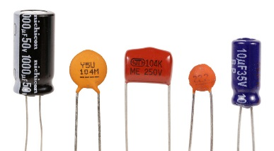

(22)A capacitor represents the amount of capacitance in a circuit. (23)The capacitance is the ability of a component to store an electrical charge. (24)You can think of it as the "capacity" to store a charge. (25)The capacitance is defined by the equation

**C = q/V**

where q is the charge in coulombs and V is the voltage.

(26)Capacitance is measured in Farads, but one Farad is much too big to be practical.

(27)Useful units are: Micro Farads (μF or uF) = 1/1,000,000th of a Farad , Nano Farads (nF) = 1/1,000,000,000th of a Farad, Pico Farads (pF) = 1/1,000,000,000,000th of a Farad.

(28)Capacitors less than 1uF can normally go in a circuit either way round. (29)Larger capacitors normally have a polarity (normally the negative end is marked) and have to go in a circuit the right way round.

(30)The symbol for capacitance is two parallel lines. Sometimes one of the lines is curved as shown below. (31)The letter "C" is used in equations.

   
Capacitor Symbol

(32)Capacitors store and release small amounts of electrical charge.

(33)In electronic circuits they are used to control the timing of circuits, “smooth out” electrical waveforms and to separate DC and AC components of a signal. (34)In a DC circuit, a capacitor becomes an open circuit blocking any DC current from passing the capacitor. (35)Only AC current will pass through a capacitor.

(36)Capacitors come in many different types that are designed for different applications. (37)For this circuit the type used isn't important so we've used the cheap and cheerful options. (38)The small capacitors are “ceramic discs” and the large capacitors are “electrolytic”.

(39)Several labelling schemes are in common use for capacitors. (40)The ceramic discs used in these circuits are labelled with three digit codes. (41)The first two digits are the value and the third digit is the number of zeros making up the capacitance in pF.

So: 10nF = 10,000 pF = “103” 100nF = 100,000pF = “104”

Michael Faraday

(22 September 1791 – 25 August 1867)

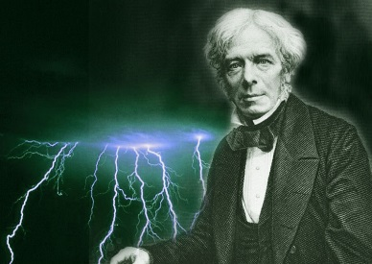

(42)Discovered the fundamental relationship between electricity and magnetism (amongst many things).

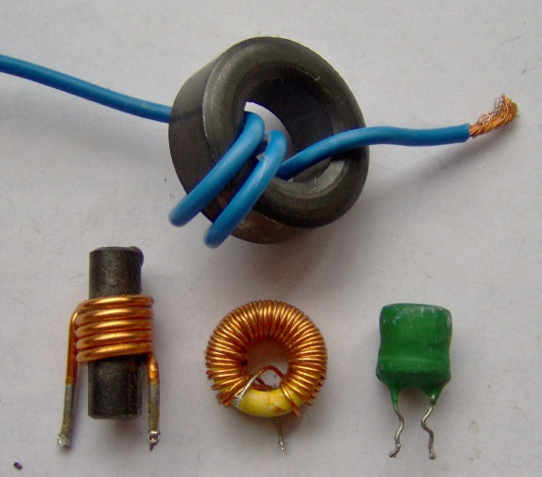

(43)Another important component of a circuit is an inductor. (44)It represents the amount of inductance in a circuit. (45)The inductance is the ability of a component to generate electromotive force due to a change in the flow of current.

(46)An inductor's ability to store magnetic energy is measured by its [inductance](http://www.newworldencyclopedia.org/entry/Inductance), in units of henrys. (47)The inductance of a coil is directly proportional to the number of turns in the coil. (48)Inductance also varies with the coil's radius and the material (or "core") around which the coil is wound.

(49)Inductors are used in electronic circuits to reduce or oppose the change in electric current.  (50)In a DC circuit, an inductor looks like a wire. (51)It has no affect when the current is constant. (52)Inductance only has an effect when the current is changing as in an AC circuit.  (53)Inductance is measured in Henrys. (54)The symbol for inductance is a series of coils as shown below. (55)The letter "L" is used in equations.

  Inductor Symbol

***Interesting Facts about Resistors, Capacitors, and Inductors***

* (56)The resistance of a material is the opposite or the inverse of the conductivity.
* (57)The Ohm is named after German physicist George Ohm.
* (58)The Farad is named after English physicist Michael Faraday.
* (59)The Henry is named after American scientist Joseph Henry.
* (60)Combinations of capacitors, inductors, and resistors are used to build passive filters that will only allow electronic signals of certain frequencies to pass through.

***http://www.physics-and-radio-electronics***.