UCP Assignment 2018: Design & Testing Report

Student Name: Ahmad Allahham
Student ID: 19170251
Date: 13/10/2018

Table of Contents
1. Function’s Purpose: 3
2. Converting the Input File to a Coordinate System 5
2.1 Implementation 5
2.2 Alternative Approach 6
3. Demonstration 6
3.1 Example 1: My own test file 6
3.2 Example: Charizard.txt 8
3.2.1 Normal Compilation 9
3.2.2 Debug Mode 10
3.3.3 Simple Mode 11

1. Function’s Purpose:

- int isFileEmpty(FILE* in) :
this function checks if the input file (presumed to have already been opened) is empty. It does so by reading a single character then checking if that character is the EOF (End of File) character. If it is, then it returns TRUE, else, it seeks back to the start of the file and returns FALSE.

- void initialiseLinkedList(LinkedList* list):
this function initializes list (a LinkedList pointer that is presumed to have already been allocated memory) by setting its head and tail parameters to NULL and its length parameter to 0.

- void insertLast(char currentCommand, void* currentData, LinkedList* list):
this function’s prupose is to insert the information provided to it at the end of the linkedList. It does so by creating a LinkedListNode and then supplying it with the imported parameters, casting the currentData to the appropriate type depending on the current command (which is checked using the supplied currentCommand character). During insertion, it must check if the linkedList is empty or has been populated by entries. If it is empty, it sets both the head and tail parameters inside the linkedList to point to the newly created linkedListNode. Else if it has entries, it makes the last node in the linkedList point its “next” pointer to the newly created linkedListNode, then the linkedList’s tail parameter is pointed at the last node.

- int isCommandValid(char* command):
this command checks if the supplied command string is one of the expected commands. It first changes the supplied command to uppercase using the function in the <ctype.h> library, “toupper()”. This function accepts a char and so we must convert the supplied command to uppercase one character at a time. Then, the command checks if the first character in command is either: ‘R’, ‘M’, ‘D’, ‘F’, ‘B’, ‘P’ (corresponding to the first character of each of the expected commands). If it is one of these letters, it returns TRUE, else it returns FALSE.
- char whichCommand(char* command)
this function simply returns the first character in the supplied command (as it has already been capitalized in the function isCommandValid() ).

- void initialiseStatus(Status* initialStatus)
this function initializes the supplied Status struct (the function is actually supplied a pointer to that struct) to its default values (x = 0, y = 0, angle = 0.0, fg = 7 (fg = 15 if simple mode is turned on), bg = 0 and pattern = ‘+’).

- void popOff(LinkedList* list, Node* currentNode)
this function uses a Node struct (struct different from the linkedListNode; does not contain a next pointer) to temporary store the contents of the popped off linkedListNode. It first creates a pointer to the first node in the linkedList, then it copies the contents of that node to the imported Node struct. After copying, it points the head parameter in linkedList to the next node and then frees the first node using the temp pointer created in this function. (this function does not free the data inside the linkedList as it is used after the node has been freed. This means that it is up to the user to free that data unit to avoid memory leaks).

- int isLinkedListEmpty(LinkedList* list)
this function checks if the linkedList is empty by checking if the length parameter inside of list is equal to 0. If so, it returns TRUE, else it returns FALSE.

- double calculateXMovement(double distance, double angle) /
double calculateYMovement(double distance, double angle)
these two functions calculate the x and y distance to be travelled from the current x and y coordinates to the new location. This calculation is done by multiplying the imported distance with the sin of the angle for y and with the cosine of the angle for x. It then returns the result.

- int roundNum(double x)
this function round the imported real value and exports it as an integer. It does so by adding 0.5 to the real value if its greater than 0 or subtracts 0.5 from it if its less than 0; effectively rounding the number when cast to an int.

- void logActivity(FILE* out, char command, double x1, double y1, double x2, double y2)
this function writes any occurrences of the commands “DRAW” and “MOVE” to a logfile called “graphics.log”. It also prints the current and the future (x,y) coordinates along with the command, while ensuring appropriate display. If “Debug mode” is turned on, it will also print these commands to the terminal along with the displayed ASCI characters.

2. Converting the Input File to a Coordinate System

2.1 Implementation
In order to interpret the the commands in the input file, I created a struct called Status. Status is a struct that contains information about the current (x,y) coordinates, angle, foreground and background colors as well as pattern. Every time a command is read from the input file, I would update the current status of the “pen” so to speak.
The program tokenizes every line read from the input file, breaking it down to three parameters: “command”, “value” and “testString”. In command, I stored the word that corresponds to the action done by the pen (ie: “MOVE”, “DRAW”, etc). In order to interpret all possible variations of capitalization in the command, I capitalized all the letters in the command and checked if it was valid prior to processing (mentioned in function: “isCommandValid()). The parameter “value” stored the value after the command. Depending on the command to be stored, the value was casted to an appropriate data type then error checked prior to storage. As for “testString”, it was used to check if the correct number of parameters is present on each line.
The first character from the command as well its casted value are stored in a linkedList using an “insertLast approach (discussed in function: insertLast()). After all the lines in the input file have been interpreted, the program begins to execute the commands, one at a time. The program reads the command char and its casted value into a struct called Node (a struct similar to a LinkedListNode, except it does not have a “next” pointer). This node is used as an external body that holds values temporarily (as each value is freed upon execution). After the contents of the first node is read are read into the Node struct, the linkedListNode is freed. Depending on the commandChar, the command is then executed along with its associated value.
The command “ROTATE” adds to the current angle (stored in the currentStatus Struct) the value stored with it. The commands “FG” and “BG” change the current foreground and background colors (stored in currentStatus Struct) to their stored value.The commands “MOVE” and “DRAW” first calculate the change in x and y coordinates necessary to move from the current coordinates (also stored in currentStatus struct) to the future coordinates (discussed in functions: “CalculateXMovement” & “CalculateYMovement”). It then adds this difference to the current (x,y) coordinates and stores then in a real-value called “x2” & “y2”. These parameters are then passed to the supplied function: “line()” present in effects.c, along with a pointer to the function: “drawFunction” (discussed above) and NULL if the command is “MOVE” or the current pattern (stored in currentStatus struct) if the command is “DRAW”.

2.2 Alternative Approach
An alternative approach would have been to immediately implement that commands without storing them into a linked list. Instead first reading all the commands and storing them into a data structure, we could have executed every command as that command as read. This would greatly reduce the complexity of the program, reduce the amount of space required to execute this operation (as we do not need to create a linkedListNode for every command read) and reduce the time complexity of this operation.

3. Demonstration
Below are two examples that show how the program is executed:

3.1 Example 1: My own test file
For this example, I used the below file is my input file:
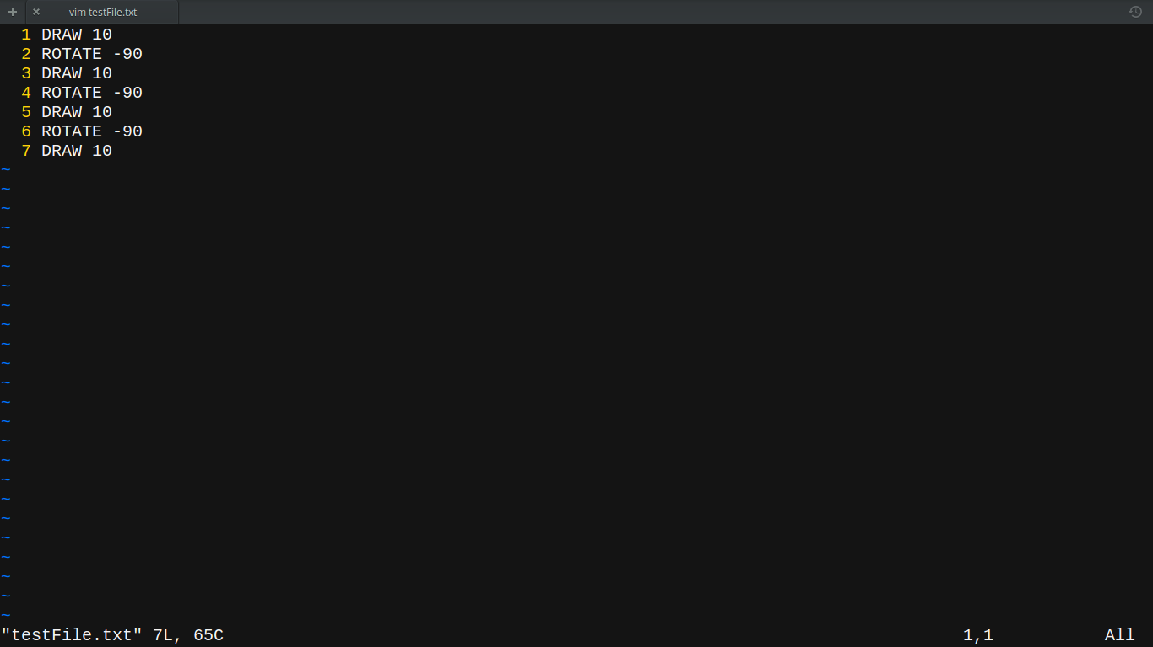

The command-line used to execute your program:
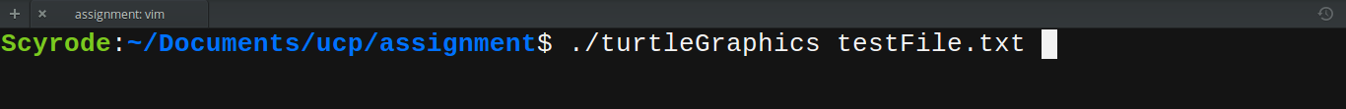
The program asks no user input other than the command line used to run the program. The output of this file is as follow:
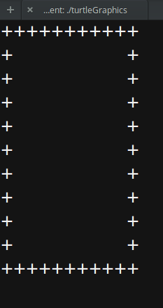

This example generates the following log entries:
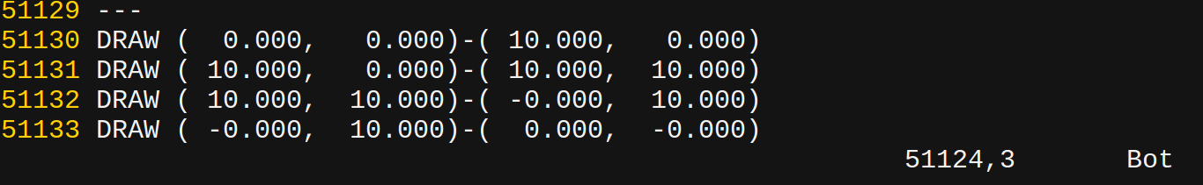

3.2 Example: Charizard.txt
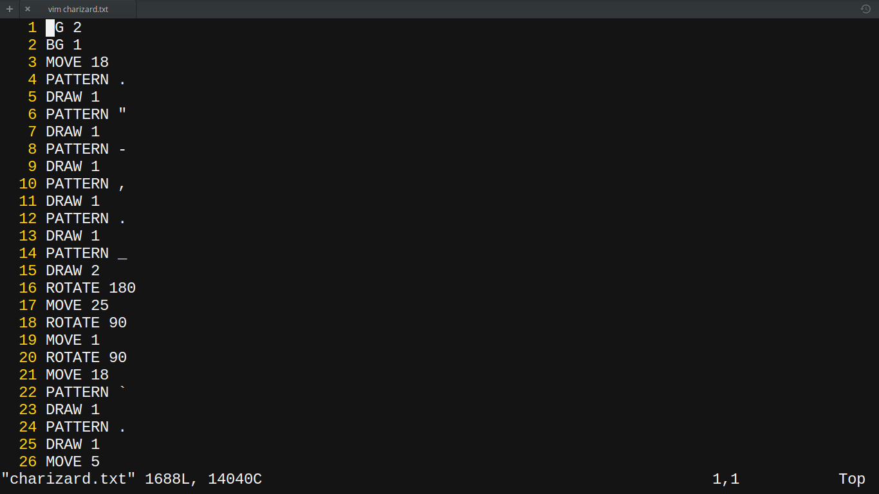
For this example, I used charizard.txt as my input file (there are too many commands and so only a snippet of the actual file is shown below:
The command-line used to execute your program:
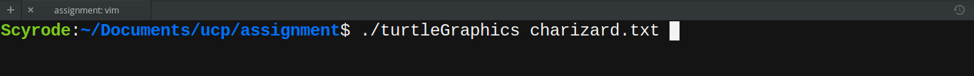
The program asks no user input other than the command-line shown above.

3.2.1 Normal Compilation
The output is as follows if the program is compiled with no extra flags:
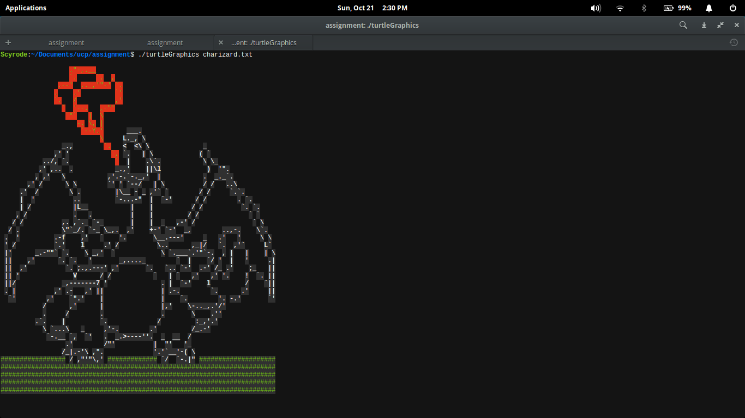

The program has two more viewing modes called: “Debug Mode” and “Simple Mode”. These modes are activated by defining the two constants: “TURTLEGRAPHICSDEBUG=1” and “TURTLEGRAPHICSSIMPLE=1”, respectively. When defined, these modes change the output of the program.

3.2.2 Debug Mode
To call “debug mode”, the user most compile the program using the following command:
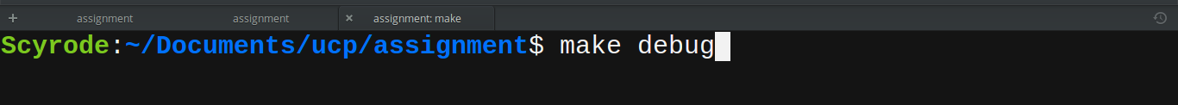
The following output is displayed when running the program using the program’s command-line execution (mentioned earlier):
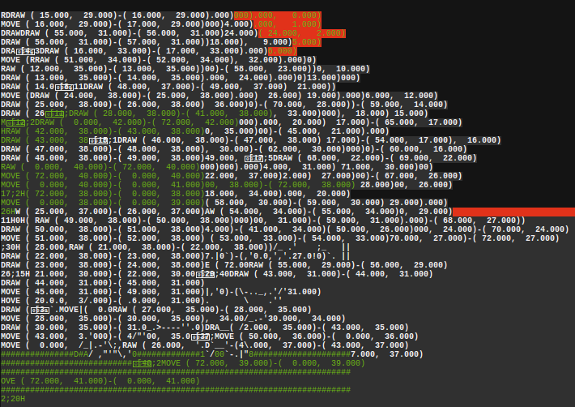

3.3.3 Simple Mode
As for “Simple Mode”, the user must compile the program using the following command:
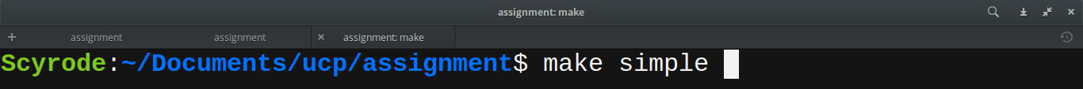
The following output is displayed when running the program using the program’s command-line execution (mentioned earlier):
