Tab 1

I would like to request a programme change from CSE to CS due to academic, personal, and professional reasons. I faced significant mental stress and family-related pressure which negatively affected m

Assumptions
The following assumptions explain the logic and standard conditions used to design the "Animal Kingdom" tribal network.
Hardware & Physical Connections
- The Hub Router: We assume that Router Elephant acts as the central hub. It requires multiple Serial ports because it physically connects to three different tribes (Lion, Dog, and Cat) simultaneously.
- Distance Simulation: We used Serial DCE cables for all connections between routers. This assumes the tribes are far apart geographically (WAN connections), even though they are logically close in the topology.
- Standard Cabling: We assume standard Ethernet Straight through cables are used for all local connections PCs to Switches, and all devices have stable power and physical security.
IP Addressing Rules
- VLSM Efficiency: The IP addressing scheme uses Variable Length Subnet Masking (VLSM) to minimize IP wastage. We assume the allotted subnets (Dog: /21, Cat: /22, Elephant: /25, Lion: /28) are sufficient for future growth within the defined "Max User" limits.
- Link Conservation: All connections between routers (WAN links) use a prefix of /30. This provides exactly 2 usable IP addresses per link, ensuring no IPs are wasted on the cables connecting the buildings.
- The Chief Rule: We assume that the Tribal Chiefs (Special Computers) and Servers must have Static IPs. This ensures they can always be found at the same address for security logs and administration. Regular tribe members use dynamic (DHCP) IPs.
Routing & Traffic Flow
- Protocol Selection (RIPv2): We chose RIP Version 2 as the routing protocol. Even though the network simulates long distances physically, it is logically small with only 4 routers. RIPv2 is simple, reliable for this size, and supports our specific subnets VLSM.
- No Backup Paths: The design assumes a single active path between tribes. If a cable is cut, connectivity is lost. No redundant backup routers were included in this specific simulation.
Network Services
- Centralized Management: We assume the Lion Tribe is the Capital. It hosts all critical servers WEB, DNS, Email, DHCP. If the link to the Lion tribe goes down, the other tribes lose these services.
- DHCP Relay: Because the DHCP server is far away (in the Lion tribe), we assume that the routers for Dog, Cat, and Elephant must act as Relay Agents. This is why the ip helper address command is required on their gateway interfaces.
- Identity: All users rely on the single domain animals.com for email and web services

Name | Host | Host + 2 | Block Size | Host Bit | Network
Dog | 1200 | 1202 | 2¹¹=2048 | 11 | 21
Cat | 800 | 802 | 2¹⁰=1024 | 10 | 22
Elephant | 100 | 102 | 2⁷=128 | 7 | 25
Lion | 7 | 9 | 2⁴=16 | 4 | 28

VLSM TREE
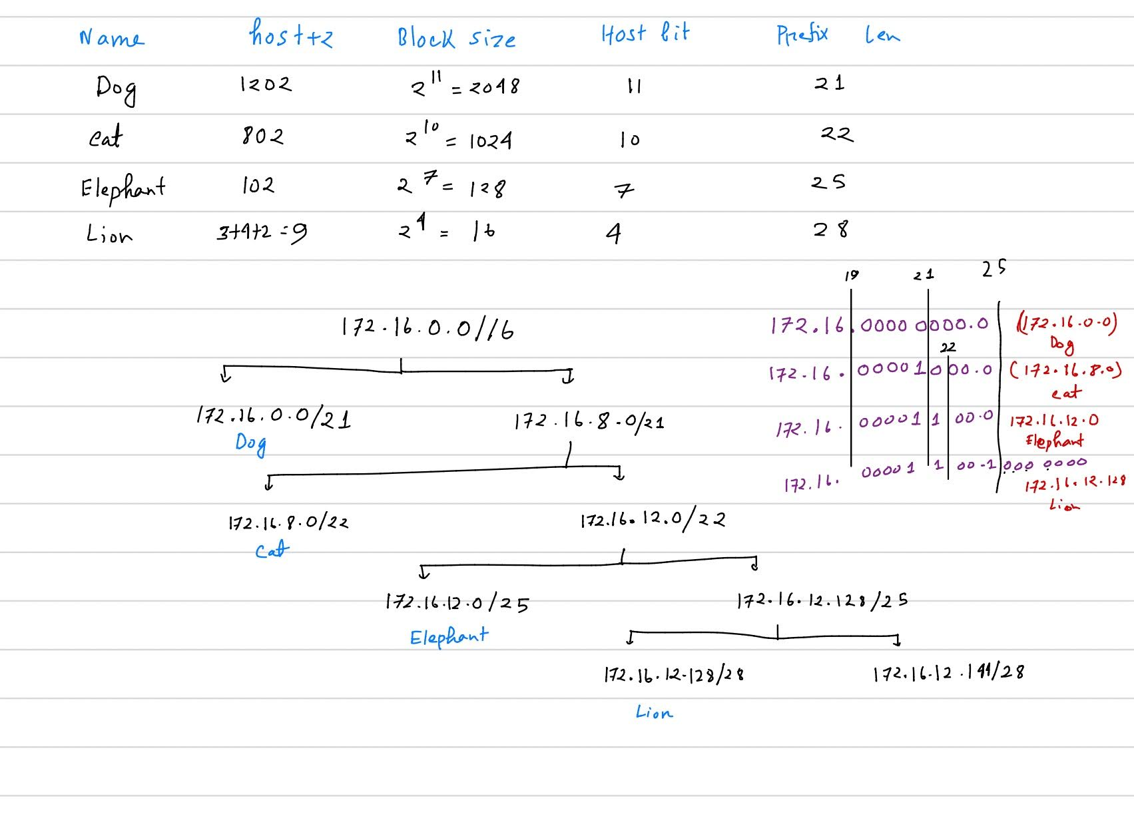

IP Address Table
Building | Host | Network Address | Subnet Mask | Usable Range | Default Gateway | Servers
Dog | 1200 | 172.16.0.0 | 255.255.248.0 | 172.16.0.2 - 172.16.7.253 | 172.16.0.1 | DNS  172.16.12.131
Cat | 800 | 172.16.8.0 | 255.255.252.0 | 172.16.8.2 - 172.16.11.253 | 172.16.8.1 | WEB  172.16.12.130
Elephant | 100 | 172.16.12.0 | 255.255.255.128 | 172.16.12.2 - 172.16.12.125 | 172.16.12.1 | Email  172.16.12.132
Lion | 7 | 172.16.12.128 | 255.255.255.240 | 172.16.12.130 - 172.16.12.142 | 172.16.12.129 | DHCP  172.16.12.133

Server IP Address Table
Server Name | Manual IP Address | Subnet Mask | Default Gateway
Web Server | 172.16.12.130 | 255.255.255.240 | 172.16.12.129
DNS Server | 172.16.12.131 | 255.255.255.240 | 172.16.12.129
Email Server | 172.16.12.132 | 255.255.255.240 | 172.16.12.129
DHCP Server | 172.16.12.133 | 255.255.255.240 | 172.16.12.129

Special Computer IP Address
Name | Super Computer IP | Subnet Mask | Default Gateway
Dog | 172.16.7.254 | 255.255.248.0 | 172.16.0.1
Cat | 172.16.11.254 | 255.255.252.0 | 172.16.8.1
Elephant | 172.16.12.126 | 255.255.255.128 | 172.16.12.1
Lion | 172.16.12.142 | 255.255.255.240 | 172.16.12.129

Inter Router (WAN) Link Table
Segment | Network Address | Mask | Router 1 IP | Router 2 IP
Lion-Elephant | 10.0.1.0 | 255.255.255.252 | 10.0.1.1 (Lion) | 10.0.1.2 (Elephant)
Elephant-Dog | 10.0.2.0 | 255.255.255.252 | 10.0.2.1 (Elephant) | 10.0.2.2 (Dog)
Elephant-Cat | 10.0.3.0 | 255.255.255.252 | 10.0.3.1 (Elephant) | 10.0.3.2 (Cat)
DHCP Server:
- Dog Pool:
  - Default Gateway: 172.16.0.1
  - DNS Server: 172.16.12.131
  - Start IP: 172.16.0.2
  - Subnet Mask: 255.255.248.0
  - Max User: 1200
- Cat Pool:
  - Default Gateway: 172.16.8.1
  - DNS Server: 172.16.12.131
  - Start IP: 172.16.8.2
  - Subnet Mask: 255.255.252.0
- Elephant Pool:
  - Default Gateway: 172.16.12.1
  - DNS Server: 172.16.12.131
  - Start IP: 172.16.12.2
  - Subnet Mask: 255.255.255.128
Web Server:
- IP Address: 172.16.12.130 (Static)
- Edit: index.html
<html>
<center><font size='+2' color='blue'>Welcome to the Animal Kingdom! </font></center>
</html>
DNS Server:
- Domain Name: www.animals.com
- Type: A Type
- Address: 172.16.12.130
Email Server:
- Domain Name: animals.com
- Users:
- lionking Pass: 1234
- dogchief Pass: 1234
- elephantchief Pass: 1234
- catchief Pass: 1234

Commands
Lion Router:
Router>en
Router#conf t
Router(config)#hostname Router_Lion
Router_Lion(config)#interface GigabitEthernet0/0/0
Router_Lion(config-if)#ip address 172.16.12.129 255.255.255.240
Router_Lion(config-if)#no shutdown
Router_Lion(config-if)#exit
Router_Lion(config)#interface Serial0/1/0
Router_Lion(config-if)#ip address 10.0.1.1 255.255.255.252
Router_Lion(config-if)#clock rate 64000
Router_Lion(config-if)#no shutdown
Router_Lion(config-if)#exit
Router_Lion(config)#ip route 0.0.0.0 0.0.0.0 10.0.1.2
Router_Lion(config)#ip route 172.16.0.0 255.255.248.0 10.0.1.2
Router_Lion(config)#ip route 172.16.8.0 255.255.252.0 10.0.1.2
Router_Lion(config)#ip route 172.16.12.0 255.255.255.128 10.0.1.2
Router_Lion(config)#ip route 10.0.2.0 255.255.255.252 10.0.1.2
Router_Lion(config)#ip route 10.0.3.0 255.255.255.252 10.0.1.2
Router_Lion(config)#exit

Elephant Router:
Router>en
Router#conf t
Router(config)#hostname Router_Elephant
Router_Elephant(config)#interface GigabitEthernet0/0/0
Router_Elephant(config-if)#ip address 172.16.12.1 255.255.255.128
Router_Elephant(config-if)#ip helper-address 172.16.12.133
Router_Elephant(config-if)#no shutdown
Router_Elephant(config-if)#exit
Router_Elephant(config)#interface Serial0/1/0
Router_Elephant(config-if)#ip address 10.0.1.2 255.255.255.252
Router_Elephant(config-if)#no shutdown
Router_Elephant(config-if)#exit
Router_Elephant(config)#interface Serial0/1/1
Router_Elephant(config-if)#ip address 10.0.2.1 255.255.255.252
Router_Elephant(config-if)#clock rate 64000
Router_Elephant(config-if)#no shutdown
Router_Elephant(config-if)#exit
Router_Elephant(config)#interface Serial0/2/0
Router_Elephant(config-if)#ip address 10.0.3.1 255.255.255.252
Router_Elephant(config-if)#clock rate 64000
Router_Elephant(config-if)#no shutdown
Router_Elephant(config-if)#exit
Router_Elephant(config)#router rip
Router_Elephant(config-router)#version 2
Router_Elephant(config-router)#no auto-summary
Router_Elephant(config-router)#network 172.16.12.0
Router_Elephant(config-router)#network 10.0.1.0
Router_Elephant(config-router)#network 10.0.2.0
Router_Elephant(config-router)#network 10.0.3.0
Router_Elephant(config-router)#passive-interface GigabitEthernet0/0/0
Router_Elephant(config-router)#exit

Dog Router:
Router>en
Router#conf t
Router(config)#hostname Router_Dog
Router_Dog(config)#interface GigabitEthernet0/0/0
Router_Dog(config-if)#ip address 172.16.0.1 255.255.248.0
Router_Dog(config-if)#ip helper-address 172.16.12.133
Router_Dog(config-if)#no shutdown
Router_Dog(config-if)#exit
Router_Dog(config)#interface Serial0/1/0
Router_Dog(config-if)#ip address 10.0.2.2 255.255.255.252
Router_Dog(config-if)#no shutdown
Router_Dog(config-if)#exit
Router_Dog(config)#router rip
Router_Dog(config-router)#version 2
Router_Dog(config-router)#no auto-summary
Router_Dog(config-router)#network 172.16.0.0
Router_Dog(config-router)#network 10.0.2.0
Router_Dog(config-router)#passive-interface GigabitEthernet0/0/0
Router_Dog(config-router)#exit

Cat Router:
Router>en
Router#conf t
Router(config)#hostname Router_Cat
Router_Cat(config)#interface GigabitEthernet0/0/0
Router_Cat(config-if)#ip address 172.16.8.1 255.255.252.0
Router_Cat(config-if)#ip helper-address 172.16.12.133
Router_Cat(config-if)#no shutdown
Router_Cat(config-if)#exit
Router_Cat(config)#interface Serial0/1/0
Router_Cat(config-if)#ip address 10.0.3.2 255.255.255.252
Router_Cat(config-if)#no shutdown
Router_Cat(config-if)#exit
Router_Cat(config)#router rip
Router_Cat(config-router)#version 2
Router_Cat(config-router)#no auto-summary
Router_Cat(config-router)#network 172.16.8.0
Router_Cat(config-router)#network 10.0.3.0
Router_Cat(config-router)#passive-interface GigabitEthernet0/0/0
Router_Cat(config-router)#exit

