Set 1

Q1. Write a Python function to calculate the factorial of a number. Use a coding assistant and document how you refine your prompt to ensure the function handles negative input and zeros.
(Each question carries 5 marks)

Prompt: write a python function to calculate the factorial of a number, also handle the edge cases such as negative numbers and zero as input.

AI Generated Code:
def factorial(n: int) -> int:
"""
Calculate n! with basic validation.

Args:
n: Integer whose factorial is required.

Returns:
Factorial of n.

Raises:
ValueError: If n is negative.
"""
if n < 0:
raise ValueError("Factorial is undefined for negative numbers.")
if n in (0, 1):
return 1

result = 1
for i in range(2, n + 1):
result *= i
return result

print(factorial(5))

Output:
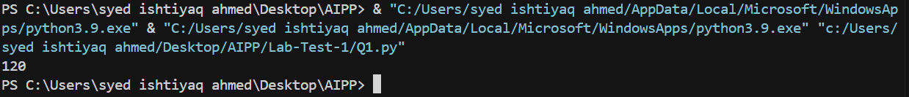

Q2. Given a list of student marks, compute the mean and list all students above the mean. Demonstrate zero-shot, one-shot, and few-shot prompts to guide an AI tool to solve this. Summarize the differences in approach.
(Each question carries 5 marks)
Zero-shot Prompting
Prompt: generate a fucntion to calculate the mean of the students_marks list and then list the student_marks that are greater than the calculated mean.

AI Generated Code:
students_marks = [30, 20, 15, 18, 31, 35, 40, 45, 10, 5, 16]

def marks_above_mean(marks):
"""
Calculate the mean of marks and return values above it.

Args:
marks: Iterable of numeric scores.

Returns:
Tuple of (mean, list of marks greater than mean).
"""
if not marks:
raise ValueError("Marks list must not be empty.")

mean_value = sum(marks) / len(marks)
above_mean = [mark for mark in marks if mark > mean_value]
return mean_value, above_mean

print(marks_above_mean(students_marks))

Output:
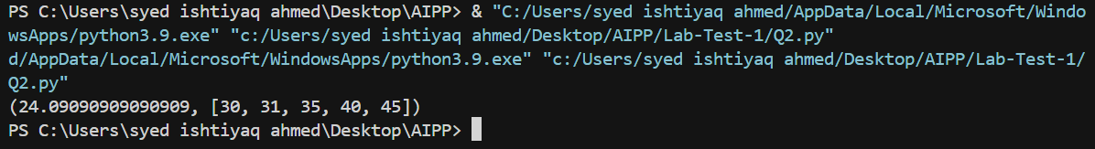

One-shot Prompting

Prompt: generate a fucntion to calculate the mean of the students_marks list and then list the student_marks that are greater than the calculated mean. For example:
for input of student_marks = [1,2,3,4,5] to the funtion it should print:
Mean value = 3, Students marks greater than the mean value i.e 3 = 4,5

AI Generated Code:
students_marks = [30, 20, 15, 18, 31, 35, 40, 45, 10, 5, 16]

def marks_above_mean(marks):
"""
Calculate the mean of marks and return values above it.

Args:
marks: Iterable of numeric scores.

Returns:
Tuple of (mean, list of marks greater than mean).
"""
if not marks:
raise ValueError("Marks list must not be empty.")

mean_value = sum(marks) / len(marks)
above_mean = [mark for mark in marks if mark > mean_value]
return mean_value, above_mean

def format_mean_output(mean_value, above_mean):
"""Format the result string to match the requested output."""
mean_str = (
str(int(mean_value))
if isinstance(mean_value, (int, float)) and mean_value.is_integer()
else f"{mean_value:.2f}"
)
above_str = ",".join(str(mark) for mark in above_mean) if above_mean else "None"
return (
f"Mean value = {mean_str}, "
f"Students marks greater than the mean value i.e {mean_str} = {above_str}"
)

if __name__ == "__main__":
mean, above = marks_above_mean(students_marks)
print(format_mean_output(mean, above))
Output:
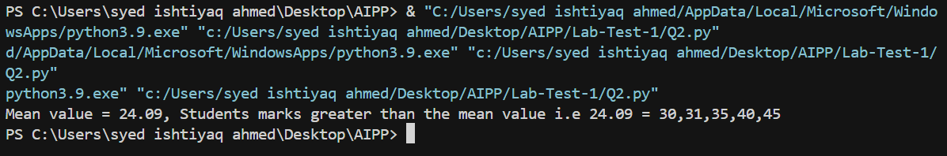

Few-shot Prompting

Prompt: generate a fucntion to calculate the mean of the students_marks list and then list the student_marks that are greater than the calculated mean. For example:
for input of student_marks = [1,2,3,4,5] to the funtion it should print:
Mean value = 3, Students marks greater than the mean value i.e 3 = 4,5
for input of student_marks = [1,'2','3',4,5] to the funtion it should print:
Mean value = 3, Students marks greater than the mean value i.e 3 = 4,5
(here the string values, if they can be converted to numbers then convert and find the mean, the students marks greater than mean)
for input of student_marks = [1,'2','-',4,5] to the funtion it should print:
Invalid values in the students marks list
(here the string values cannot be converted to numbers)

AI Generated Code:

students_marks = [30, 20, 15, 18, 31, 35, 40, 45, 10, 5, 16]
INVALID_MSG = "Invalid values in the students marks list"

def normalize_marks(marks):
"""Return a list of floats parsed from the incoming marks."""
normalized = []
for mark in marks:
if isinstance(mark, (int, float)):
normalized.append(float(mark))
continue
if isinstance(mark, str):
candidate = mark.strip()
if not candidate:
raise ValueError(INVALID_MSG)
try:
normalized.append(float(candidate))
except ValueError as exc: # pragma: no cover - informative branch
raise ValueError(INVALID_MSG) from exc
continue
raise ValueError(INVALID_MSG)
if not normalized:
raise ValueError("Marks list must not be empty.")
return normalized

def marks_above_mean(marks):
"""
Calculate the mean of marks and return values above it.

Args:
marks: Iterable of numeric scores (ints/floats/convertible strings).

Returns:
Tuple of (mean, list of marks greater than mean).
"""
normalized = normalize_marks(marks)
mean_value = sum(normalized) / len(normalized)
above_mean = [mark for mark in normalized if mark > mean_value]
return mean_value, above_mean

def _format_number(value):
return (
str(int(value))
if isinstance(value, float) and value.is_integer()
else f"{value:.2f}".rstrip("0").rstrip(".")
)

def format_mean_output(mean_value, above_mean):
"""Format the result string to match the requested output."""
mean_str = _format_number(mean_value)
above_str = (
",".join(_format_number(mark) for mark in above_mean) if above_mean else "None"
)
return (
f"Mean value = {mean_str}, "
f"Students marks greater than the mean value i.e {mean_str} = {above_str}"
)

if __name__ == "__main__":
try:
mean, above = marks_above_mean(students_marks)
print(format_mean_output(mean, above))
students_marks.append('1')
mean, above = marks_above_mean(students_marks)
print(format_mean_output(mean, above))
students_marks.append('-')
mean, above = marks_above_mean(students_marks)
print(format_mean_output(mean, above))
except ValueError as error:
print(error)

Output:
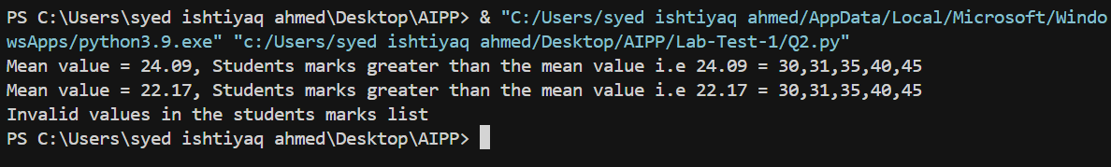

Observations:
- The zero-shot prompting provided a generic solution, no proper format of input and output.
- The one-shot prompting provided some-what specific solution when given an example input and output in the prompt.
- The few-shot prompting provided a specific solution which handled the edge cases that were mentioned in the prompt.

