Task 1

Description: Ask AI to generate a simple HTML homepage for a "Student Info Portal" with a header, navigation menu, and footer.
Expected Output:
- HTML code with <header>, <nav>, <footer>.
- Clean indentation, proper tags, and comments.

Prerequisites: GitHub Copilot in VS Code / Cursor AI Software, Internet Connection

Prompt: generate only HTML code (no CSS) for simple homepage of a Students Information Portal with a header, navigation menu, and footer

AI Generated Code:
<!DOCTYPE html>
<html lang="en">
<head>
<meta charset="UTF-8">
<meta name="viewport" content="width=device-width, initial-scale=1.0">
<title>Students Information Portal</title>
</head>
<body>
<header>
<h1>Students Information Portal</h1>
<p>Welcome to the official student portal</p>
</header>

<nav>
<ul>
<li><a href="#home">Home</a></li>
<li><a href="#student-info">Student Information</a></li>
<li><a href="#courses">Courses</a></li>
<li><a href="#grades">Grades</a></li>
<li><a href="#schedule">Schedule</a></li>
<li><a href="#announcements">Announcements</a></li>
<li><a href="#contact">Contact</a></li>
</ul>
</nav>

<main>
<section>
<h2>Welcome</h2>
<p>This is the homepage of the Students Information Portal. Use the navigation menu above to access different sections.</p>
</section>

<section>
<h2>Quick Links</h2>
<ul>
<li><a href="#student-info">View Student Information</a></li>
<li><a href="#courses">Browse Courses</a></li>
<li><a href="#grades">Check Grades</a></li>
<li><a href="#schedule">View Schedule</a></li>
</ul>
</section>
</main>

<footer>
<p>&copy; 2025 Students Information Portal. All rights reserved.</p>
</footer>
</body>
</html>

Output:
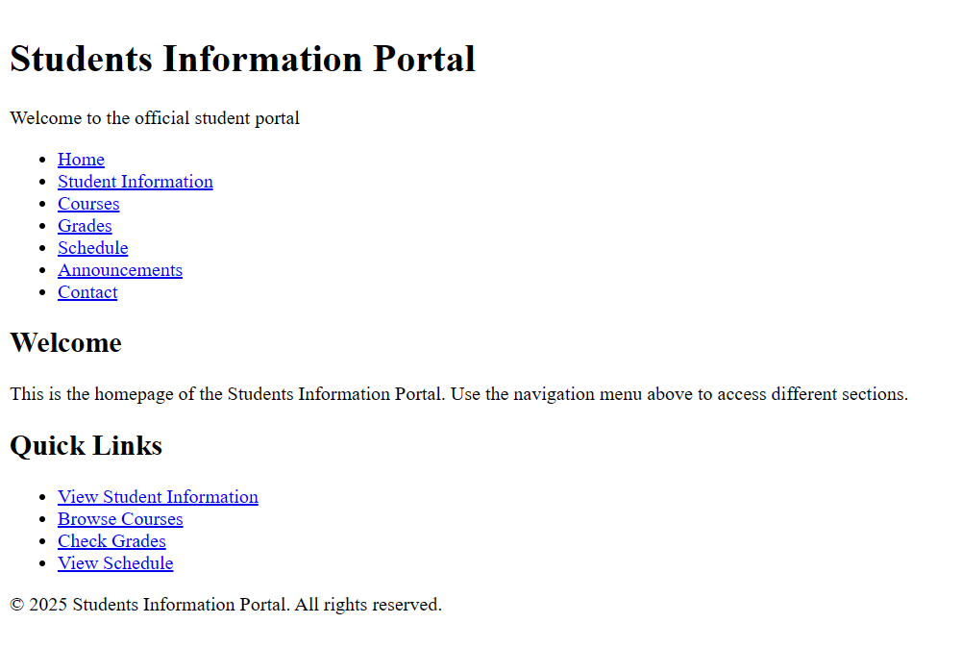

Task 2

Description: Use AI to add CSS styling to Task #1 homepage for:
- Responsive navigation bar.
- Centered content section.
- Footer with light gray background.
Expected Output:
- HTML + CSS combined.
- AI explains how CSS classes apply.

Prerequisites: GitHub Copilot in VS Code / Cursor AI Software, Internet Connection

Prompt: generate CSS code for the homepage of the Students Information Portal. Make the navigation bar responsive, center the content section and change the footer background color to light gray

AI Generated Code:
<!DOCTYPE html>
<html lang="en">
<head>
<meta charset="UTF-8">
<meta name="viewport" content="width=device-width, initial-scale=1.0">
<title>Students Information Portal</title>
<style>
* {
margin: 0;
padding: 0;
box-sizing: border-box;
}

body {
font-family: Arial, sans-serif;
line-height: 1.6;
}

header {
background-color: #333;
color: white;
text-align: center;
padding: 20px;
}

header h1 {
margin-bottom: 10px;
}

nav {
background-color: #444;
padding: 10px 0;
}

nav ul {
list-style-type: none;
display: flex;
flex-wrap: wrap;
justify-content: center;
gap: 10px;
}

nav li {
margin: 0;
}

nav a {
color: white;
text-decoration: none;
padding: 10px 20px;
display: block;
transition: background-color 0.3s;
}

nav a:hover {
background-color: #555;
}

main {
max-width: 1200px;
margin: 0 auto;
padding: 40px 20px;
text-align: center;
}

main section {
margin-bottom: 30px;
}

main section h2 {
margin-bottom: 15px;
}

main section ul {
list-style-type: none;
display: inline-block;
text-align: left;
}

main section ul li {
margin: 10px 0;
}

main section ul li a {
color: #0066cc;
text-decoration: none;
}

main section ul li a:hover {
text-decoration: underline;
}

footer {
background-color: #d3d3d3;
padding: 20px;
text-align: center;
}

footer p {
margin: 5px 0;
}

@media screen and (max-width: 768px) {
nav ul {
flex-direction: column;
align-items: center;
gap: 0;
}

nav a {
width: 100%;
text-align: center;
}

main {
padding: 20px 15px;
}
}
</style>
</head>
<body>
<header>
<h1>Students Information Portal</h1>
<p>Welcome to the official student portal</p>
</header>

<nav>
<ul>
<li><a href="#home">Home</a></li>
<li><a href="#student-info">Student Information</a></li>
<li><a href="#courses">Courses</a></li>
<li><a href="#grades">Grades</a></li>
<li><a href="#schedule">Schedule</a></li>
<li><a href="#announcements">Announcements</a></li>
<li><a href="#contact">Contact</a></li>
</ul>
</nav>

<main>
<section>
<h2>Welcome</h2>
<p>This is the homepage of the Students Information Portal. Use the navigation menu above to access different sections.</p>
</section>

<section>
<h2>Quick Links</h2>
<ul>
<li><a href="#student-info">View Student Information</a></li>
<li><a href="#courses">Browse Courses</a></li>
<li><a href="#grades">Check Grades</a></li>
<li><a href="#schedule">View Schedule</a></li>
</ul>
</section>
</main>

<footer>
<p>&copy; 2024 Students Information Portal. All rights reserved.</p>
</footer>
</body>
</html>

Output:

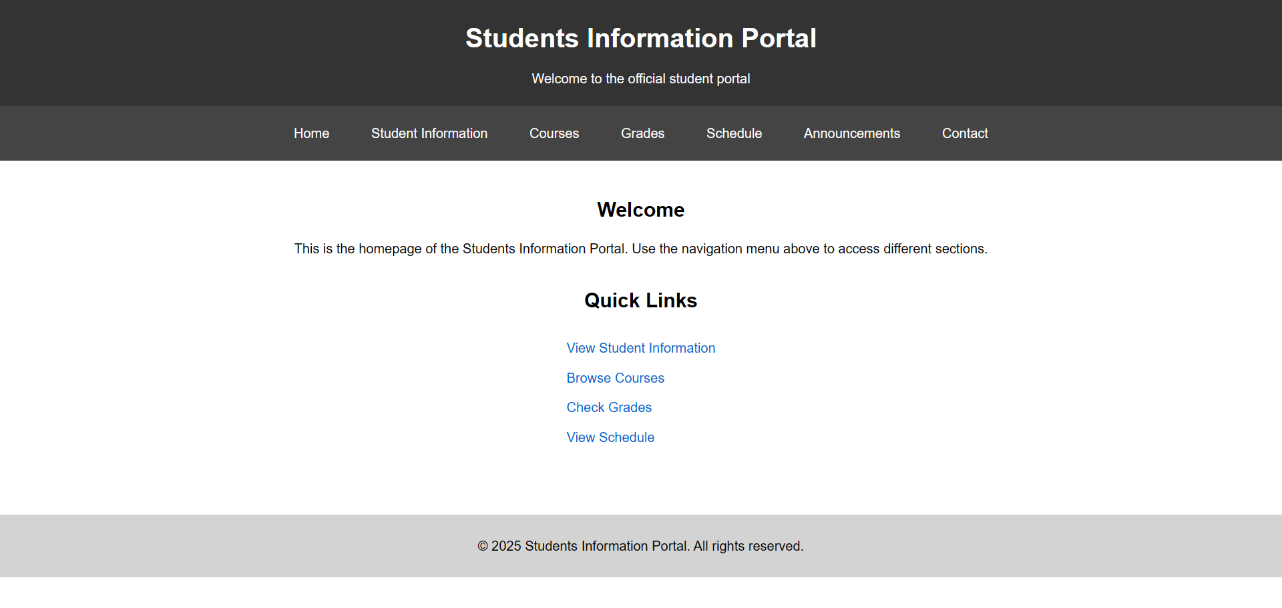

Task 3

Description: Prompt AI to generate a JS script that validates a simple login form (non-empty username/password).
Expected Output:
- Working on submit JS validation.
- Clear error messages if inputs are empty.

Prerequisites: GitHub Copilot in VS Code / Cursor AI Software, Internet Connection

Prompt: generate javascript code to validate non-empty username and password, if any one of them are empty then display error message

AI Generated Code:
<!DOCTYPE html>
<html lang="en">
<head>
<meta charset="UTF-8">
<meta name="viewport" content="width=device-width, initial-scale=1.0">
<title>Students Information Portal</title>
<style>
* {
margin: 0;
padding: 0;
box-sizing: border-box;
}

body {
font-family: Arial, sans-serif;
line-height: 1.6;
}

header {
background-color: #333;
color: white;
text-align: center;
padding: 20px;
}

header h1 {
margin-bottom: 10px;
}

nav {
background-color: #444;
padding: 10px 0;
}

nav ul {
list-style-type: none;
display: flex;
flex-wrap: wrap;
justify-content: center;
gap: 10px;
}

nav li {
margin: 0;
}

nav a {
color: white;
text-decoration: none;
padding: 10px 20px;
display: block;
transition: background-color 0.3s;
}

nav a:hover {
background-color: #555;
}

main {
max-width: 1200px;
margin: 0 auto;
padding: 40px 20px;
text-align: center;
}

main section {
margin-bottom: 30px;
}

main section h2 {
margin-bottom: 15px;
}

main section ul {
list-style-type: none;
display: inline-block;
text-align: left;
}

main section ul li {
margin: 10px 0;
}

main section ul li a {
color: #0066cc;
text-decoration: none;
}

main section ul li a:hover {
text-decoration: underline;
}

footer {
background-color: #d3d3d3;
padding: 20px;
text-align: center;
}

footer p {
margin: 5px 0;
}

@media screen and (max-width: 768px) {
nav ul {
flex-direction: column;
align-items: center;
gap: 0;
}

nav a {
width: 100%;
text-align: center;
}

main {
padding: 20px 15px;
}
}
</style>
</head>
<body>
<header>
<h1>Students Information Portal</h1>
<p>Welcome to the official student portal</p>
</header>

<nav>
<ul>
<li><a href="#home">Home</a></li>
<li><a href="#student-info">Student Information</a></li>
<li><a href="#courses">Courses</a></li>
<li><a href="#grades">Grades</a></li>
<li><a href="#schedule">Schedule</a></li>
<li><a href="#announcements">Announcements</a></li>
<li><a href="#contact">Contact</a></li>
</ul>
</nav>

<main>
<section>
<h2>Login</h2>
<form id="loginForm">
<div style="margin-bottom: 15px;">
<label for="username">Username:</label><br>
<input type="text" id="username" name="username" style="padding: 8px; width: 250px; margin-top: 5px;">
</div>
<div style="margin-bottom: 15px;">
<label for="password">Password:</label><br>
<input type="password" id="password" name="password" style="padding: 8px; width: 250px; margin-top: 5px;">
</div>
<div id="errorMessage" style="color: red; margin-bottom: 15px; display: none;"></div>
<button type="submit" style="padding: 10px 20px; background-color: #333; color: white; border: none; cursor: pointer;">Login</button>
</form>
</section>
</main>

<footer>
<p>&copy; 2025 Students Information Portal. All rights reserved.</p>
</footer>

<script>
document.getElementById('loginForm').addEventListener('submit', function(event) {
event.preventDefault();

const username = document.getElementById('username').value.trim();
const password = document.getElementById('password').value.trim();
const errorMessage = document.getElementById('errorMessage');

if (username === '' || password === '') {
errorMessage.style.display = 'block';
errorMessage.textContent = 'Error: Username and Password are required fields. Please fill in both fields.';
return false;
} else {
errorMessage.style.display = 'none';
errorMessage.textContent = '';
alert('Form submitted successfully!');
return true;
}
});
</script>
</body>
</html>

Output:

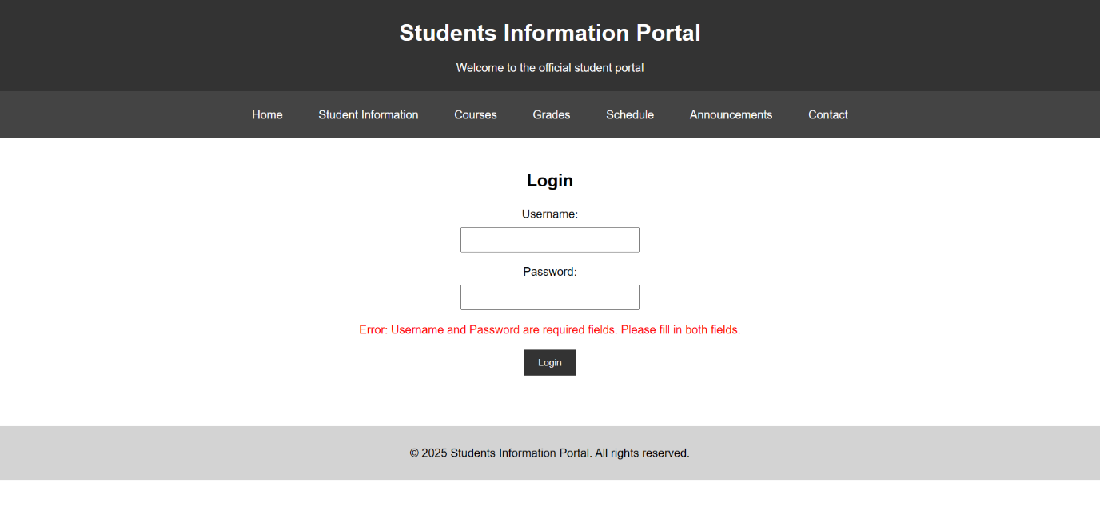

Task 4

Description: Ask AI to generate a Flask app that serves the HTML form (Task #3) and prints the username on successful login.
Expected Output: a Flask app that serves the HTML form (Task #3) and prints the username on successful login.

Prerequisites: GitHub Copilot in VS Code / Cursor AI Software, Internet Connection

Prompt: Task3.html serve this file using flask, and print the username on successful login

AI Generated Code:
from flask import Flask, request, send_file
import os

app = Flask(__name__)

@app.route('/')
def index():
html_file_path = os.path.join(os.path.dirname(__file__), 'Task3.html')
return send_file(html_file_path)

@app.route('/login', methods=['POST'])
def login():
username = request.form.get('username', '').strip()
password = request.form.get('password', '').strip()

if username and password:
print(f"Successful login! Username: {username}")
return f"<h1>Login Successful!</h1><p>Welcome, {username}!</p><a href='/'>Back to Login</a>"
else:
return "<h1>Login Failed!</h1><p>Username and password are required.</p><a href='/'>Back to Login</a>"

if __name__ == '__main__':
app.run(debug=True, port=5000)

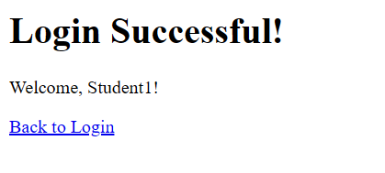
Output:

