Task 1

Description:
To configure a basic Distributed File System using HDFS on AWS EC2.
Tools Required
- AWS EC2
- Java
- Hadoop (Single-node setup)
Procedure:
- Launch an EC2 instance
- Install Java and Hadoop
- Configure NameNode and DataNode
- Start HDFS services
- Verify HDFS using web UI
Expected Outcome
HDFS is successfully configured on AWS EC2.

Prerequisites:
- Active AWS Academy account
  - Access to AWS Management Console
  - EC2 instance (Amazon Linux 2, t2.micro)
- Security Group configured with:
  - SSH (Port 22)
  - Custom TCP (Port 9870)
  - Key pair (.pem file) for SSH access
- Software Requirements:
  - Java (OpenJDK 8 or 11)
  - Hadoop (Version 3.x)

Process:
- Launch EC2 Instance
  - Created an EC2 instance using Amazon Linux 2 AMI.
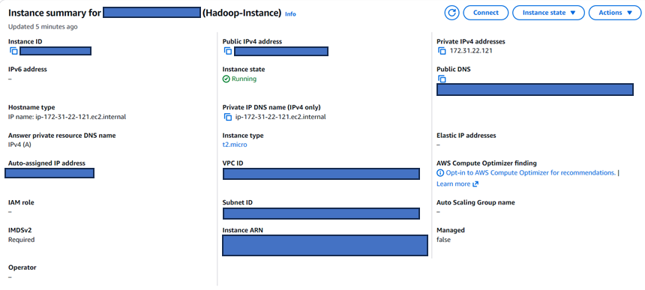
  - Selected t2.micro instance type.

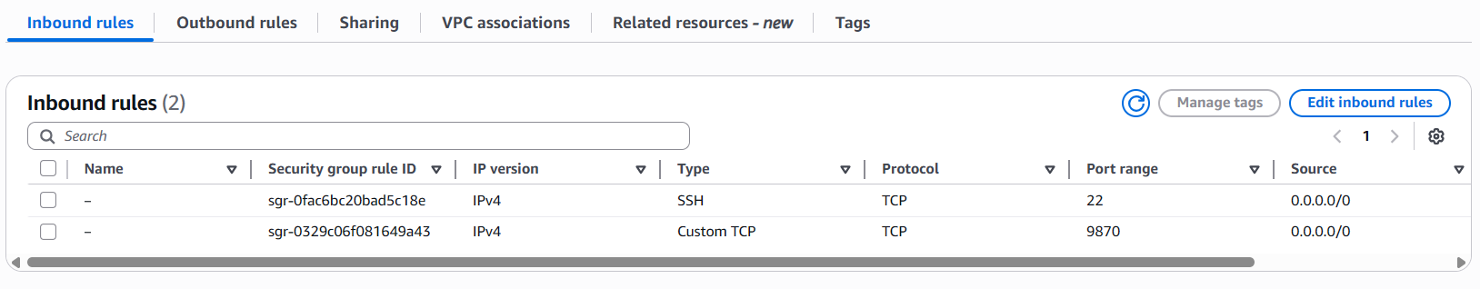
  - Configured Security Group to allow ports 22 and 9870.

  - Connected to the instance using SSH.
- Install Java
  - Installed OpenJDK on the EC2 instance.
  - Verified installation using:
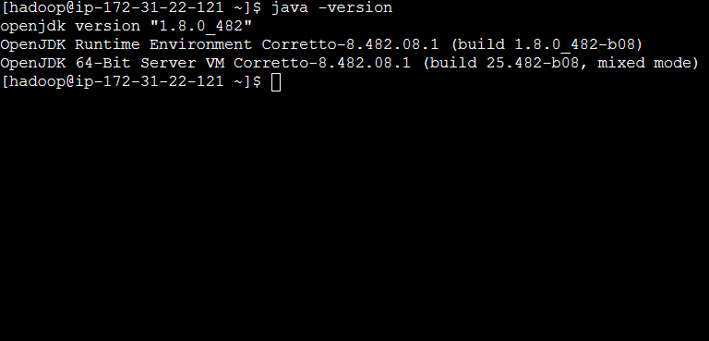
java -version

- Install Hadoop
  - Downloaded Hadoop 3.x package.
  - Extracted and configured Hadoop environment variables.
  - Verified installation using:
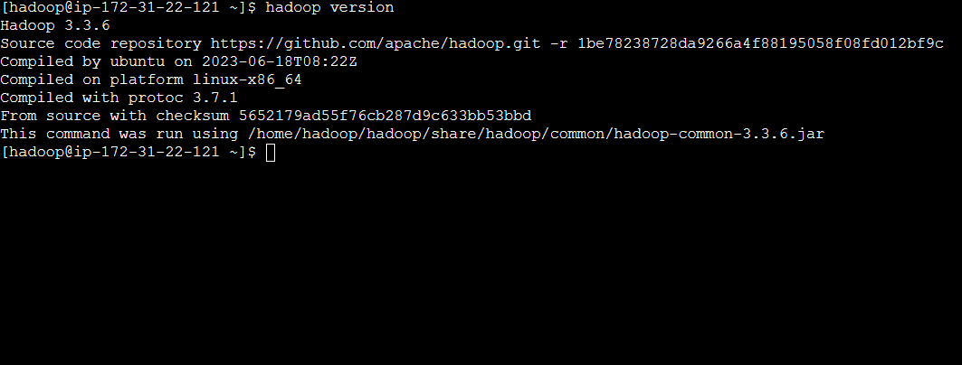
hadoop version

- Configure Hadoop
  - Edited configuration files:
    - core-site.xml (set fs.defaultFS)
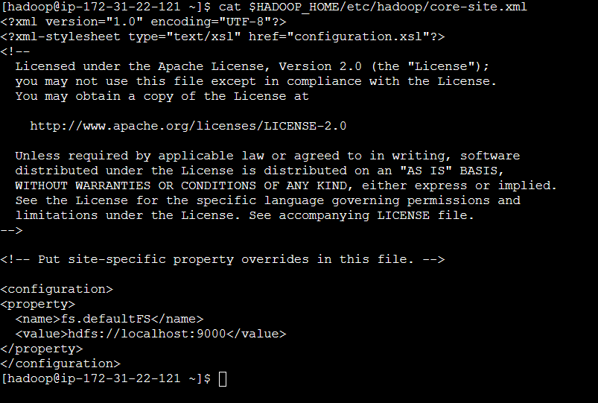
    - hdfs-site.xml (set replication factor and storage paths)
  - Created NameNode and DataNode directories.
- Configure SSH
  - Generated SSH keys for passwordless login.
  - Enabled SSH access to localhost for Hadoop services.
- Format NameNode
  - Initialized HDFS using:
hdfs namenode -format
- Start HDFS Services
  - Started NameNode and DataNode using:
start-dfs.sh
  - Verified services using:
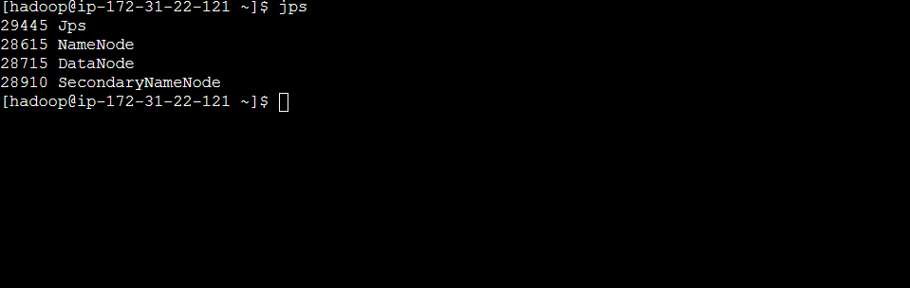
Jps

- Verify HDFS via Web UI
  - Accessed Hadoop dashboard through:
http://<Public-IP>:9870
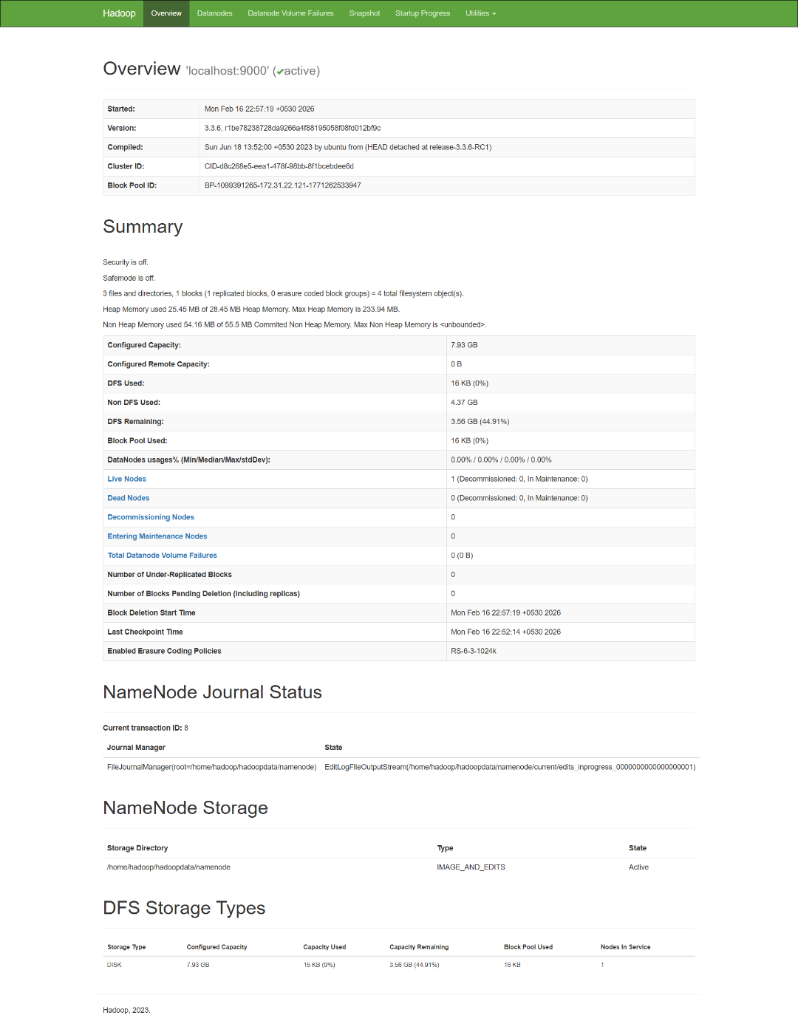
  - Confirmed cluster status and active DataNode.

- Test HDFS Functionality
  - Created directory in HDFS:
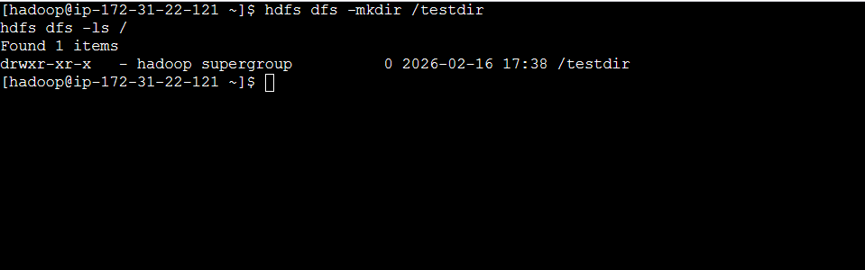
hdfs dfs -mkdir /testdir

  - Uploaded a sample file:
hdfs dfs -put sample.txt /testdir

  - Verified file upload using:
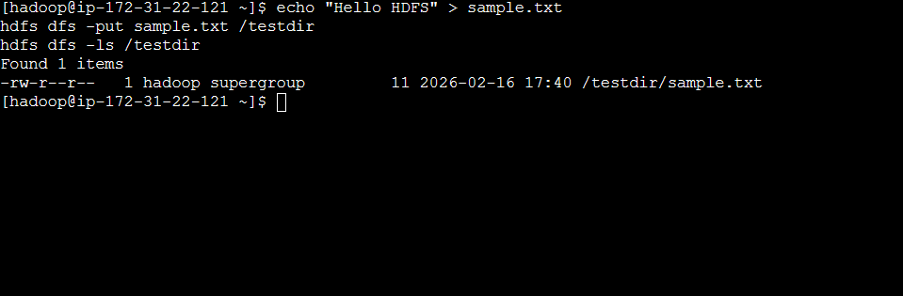
hdfs dfs -ls /testdir

Output:
- EC2 instance successfully launched and running.
- Java installed and verified.
- Hadoop installed and configured properly.
- NameNode and DataNode services started successfully.
- HDFS Web UI accessed through port 9870.
- Directory successfully created in HDFS.
- File uploaded and verified inside HDFS.

